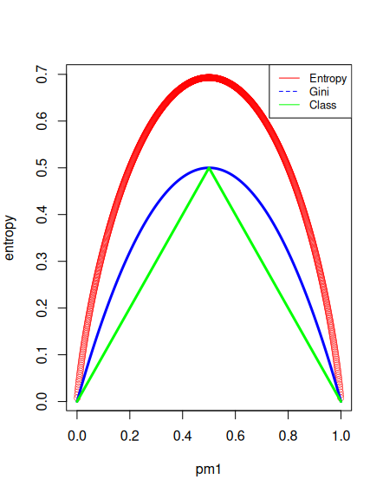
Question 3

I created a sequence from 0 to 2 stepping by .001. I defined pm1 by this sequence, and pm2 by 1 – pm1. I then created 3 formulas for each of the types of errors, and then plotted them. I got:

Question 9

a) I set the seed, and split my data into training and test

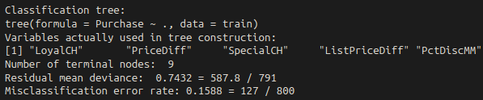
b) I created a tree, and printed the summary from the book’s code. The training error rate is displayed at the bottom, of .1588. There are 9 terminal nodes in total for this tree

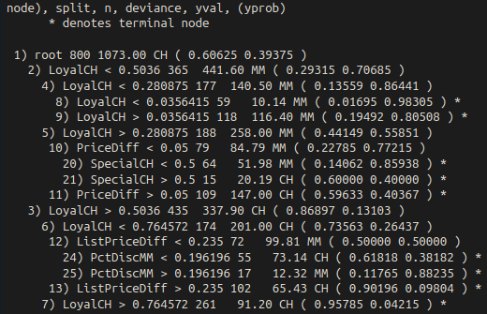
c) Here is the output: Following the path to nodes 8 and 9, tell us that the first split was LoyalCH at .5036. If the value is below .5036, then the next split is if the value is below .2809. If this is then true, the third split is if the value is < .03564, then the result is MM, and if not then the result is still MM. For any value of LoyalCH less than .28, the prediction is MM.

d) Pretty tree!

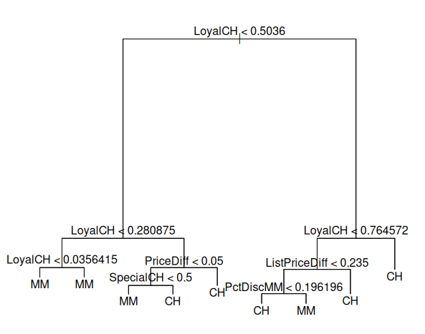
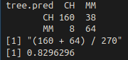
e) Here is my confusion matrix. The success rate is .829, meaning the test error rate is .171

f) I used the code from the book to do so

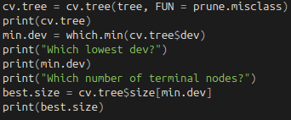

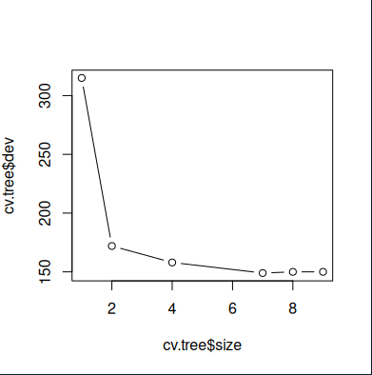
g) graph shown on right

h) The tree with 7 nodes corresponded to the lowest CV error rate

I) I pruned the tree
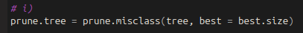
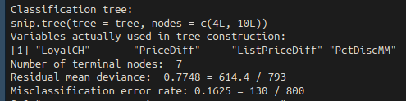
j) The train error rate for the pruned tree was .1625, which is better than that of the regular tree
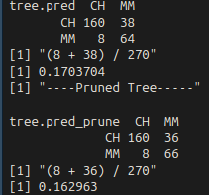
k) The test error rate for the pruned tree was better than the regular tree

