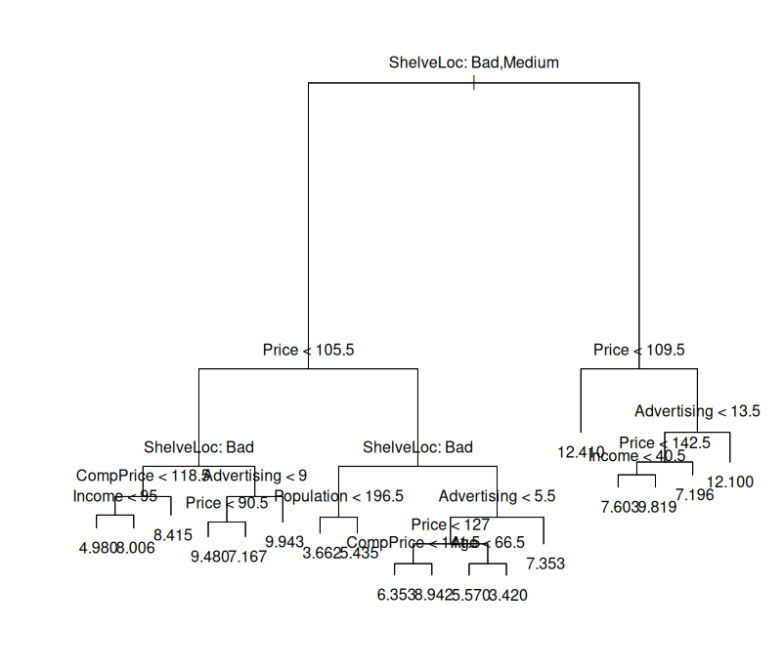
Question 8

a) I split the data into a test and training set at a 7-train to 1-test ratio. This gave me 357 training observations and 43 testing.

b) I created a tree and plotted it. It’s a little messy, but there’s a lot going on. I got a test MSE of 4.64

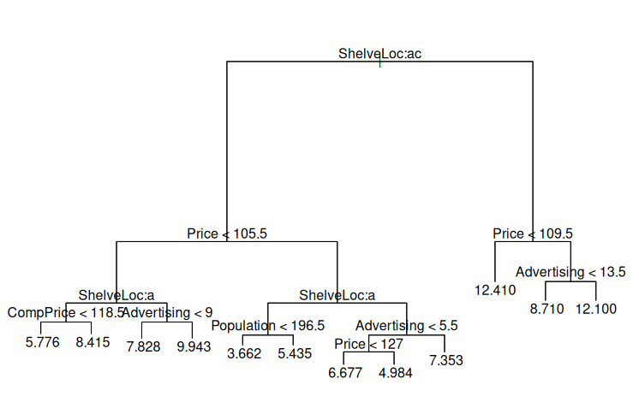
c) Pruning the tree using cross validation gave me a tree of size 12 terminal nodes instead of the initial 18 I had. I got a test MSE of 5.16, which actually performed worse. This makes sense in a regression setting, since trees are typically not the greatest at low observation regression

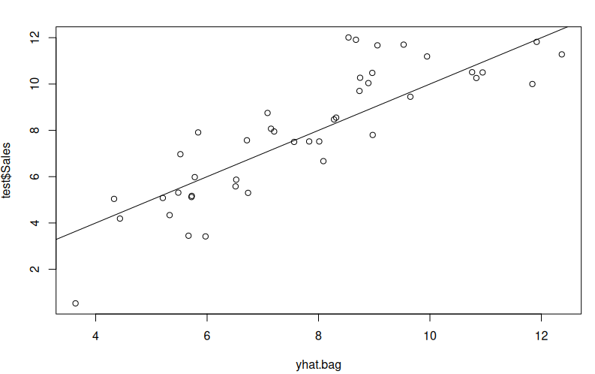
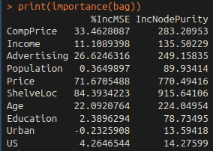
d) I bagged and plotted. The test MSE is 2.08. This is a significant decrease over the tree and pruned tree, which is a really good thing. After using importance(), the ShelveLoc was so extraordinarily important at a %IncMSE of 84, then Price at 71%, then CompPrice at 33, then Advertising 26%, and Age 22%.

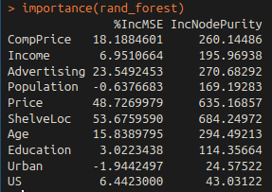
e) By using a random forest, I got a test MSE of 2.53, slightly worse than the bagged model. I chose an m of 3, which is roughly the square root of 10, the number of predictors used for the model. Here are the importances. According to the summary for the random forest model, mtry is 1 meaning it built a tree using only stumps, or an additive model. If m were larger, it might perform a little better, but then the results would be more correlated with each other since similar trees would get built.
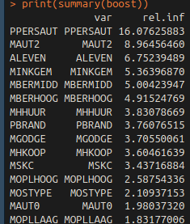
Question 11

a) I created a test and training set using rand
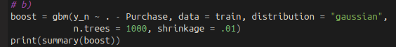
b) Here are the first few important predictors.

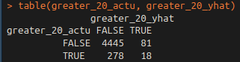
c) Based on this table, there are 99 observations that are predicted to be true, and only 18 of them are. This is a pretty bad rate, only 18% correct.

