Question 9
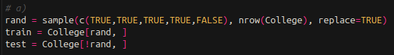
a) I set the seed to 1 and then split the college dataset 4/5 train and 1/5 test

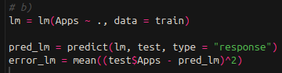
b) I created a linear model on the training data, and then ran a prediction on the test data. I got a test error of 1804734.

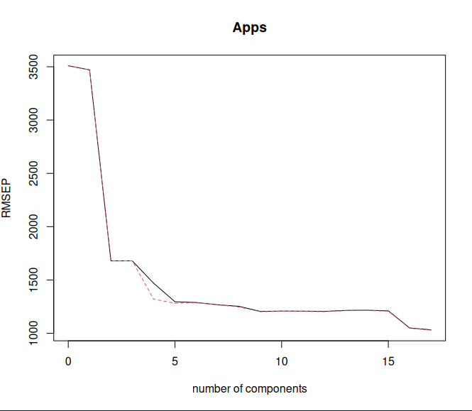
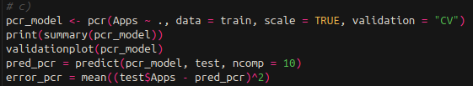
e) I then created a PCR model with cross validation to choose the M value. Here is the code and analytic plot of RMSEP for the number of components. The best number of components to use is 5 according to a rough visual estimate of the one standard error rule. The test error for 5 components is 5362426

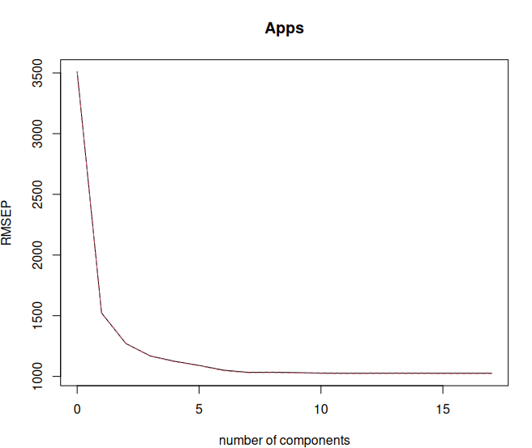
f) I repeated this process for PLS. Here is the diagnostic plot for best M by RMSEP. The best choice for M is 6, with a test error of 1991644. Plot shown below

