Question 8
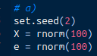
a) I set the seed to 2 and then created an X vector and e vector

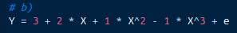
b) I set B0 = 3, B1 = 2, B2 = 1, B3 = -1

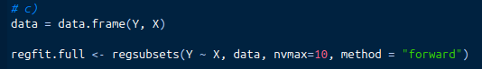
c) I can’t get regsubsets to work. I will be coming to ask you about it, I can’t find anything on google. Here’s how I set things up:

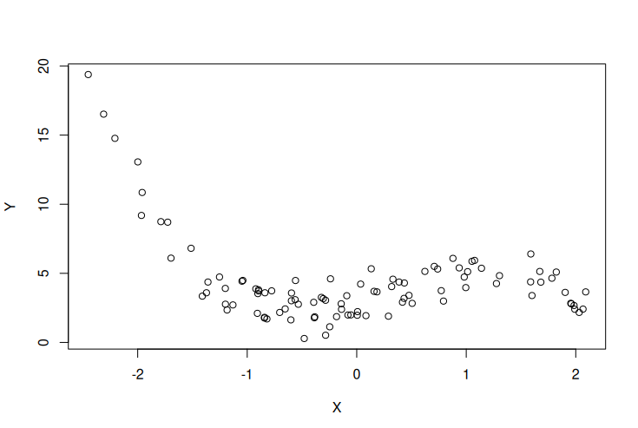
After plotting the data, this looks like:
This looks very cubic in nature, so I would assume that within the best subsets that the model with X^3 would fit this the best, but I wouldn’t be surprised if the X^5 model fit alright as well, because we can write X^3 as a function in X^5. As for forwards and backwards selection, I don’t know because I can’t get it to work

