Question 8

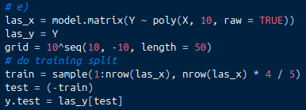
e) I did parts a and b, including setting the seed, X, e vectors, and creating a response Y vector. I then followed the book’s example to create a model matrix of the x vector with poly(X, 10, raw = TRUE) and created a grid of lambdas (like the book did, but I adjusted them to create smaller lambdas that performed better). I split into training and test at a 4/5 ratio

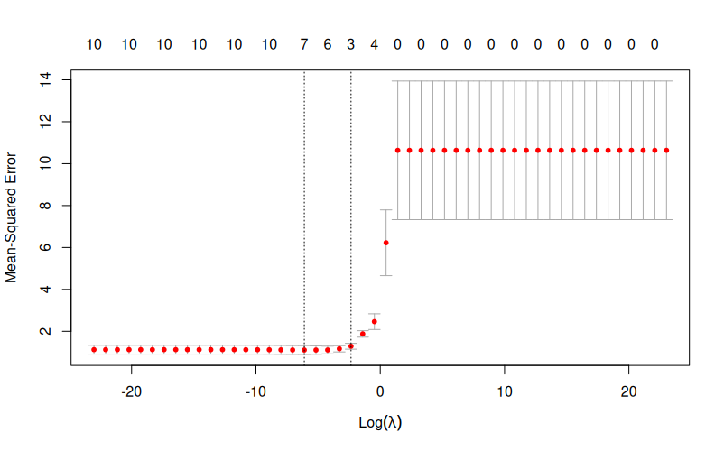
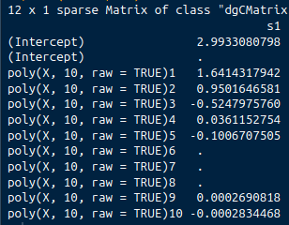
After this I created a lasso plot and plotted it. The best lambda (after extracting it from the model) was .0022. The final lasso coefficients are as follows:

This is interesting, because the intercept coefficient is incredibly close, as well as the X^2 term, but nothing else is really close to the true values.
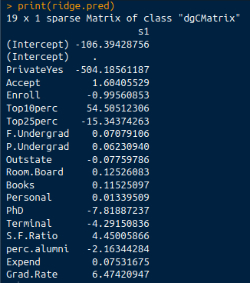
Question 9

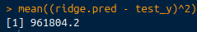
c) I copied a lot of code from Question 8 and made appropriate changes to use the College dataset. Here are my coefficients for Ridge regression, as well as the mean squared test error. Best lambda is 20.565

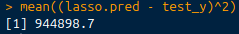
d) Same as c, but used lasso. Test error:

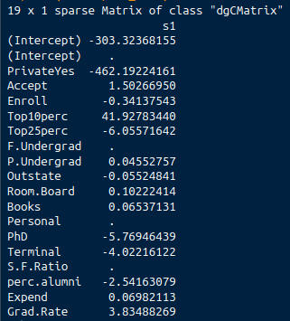
Coefficients:
best lambda is 11.498

Supp

