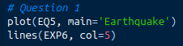
Question TS 1

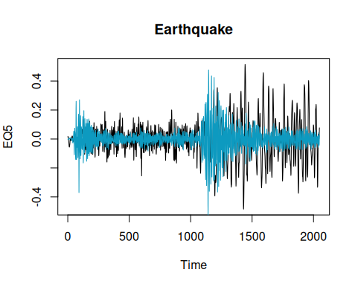
The datasets both look very similar on the same axis. The nuclear explosion dataset has a much bigger peak right at the beginning of the char, as well as around the 1100 mark in time, whereas the earthquake dataset has a lot of activity after 1100, it is much more spread out.

Sup 1
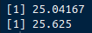
a) moving averages:
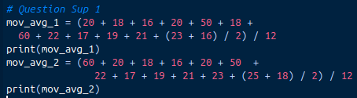
b) At my company, we do some cool calculations with averaging across years, we call it a rolling 12 calculation. I worked on a project that used SQL to see how much (on average) companies that purchase from us have spent on a moving (or rolling) 12 month average, to segregate them into buckets to see how much time and money we should spend getting them to continue to purchase products from us. Another example is things like number of service tickets, to see overall how much customer interaction we receive. An example that would not work well with a moving 12 month average would be if the number of books significantly increases and decreases from month to month. Those changes are not reflected well with such a large span of change of data

Sup 2

a)
1) since the mean of all the w subscript t is 0, their expected mean value is 0. xt is defined by
-.9*xt-1, so the mean function is the integral from -inf to inf of x * (-.9*xt-1 + wt) dx, which will be -.9xt
2) xt = cos(2pi*t / 4), mean function = cos(2*pi*t / 4)
3) same as 2, noise doesn’t change the overall mean function

b) I’m not exactly sure how to do this
1) We should be able to split the integral up over the x terms, and then pull the ¼ out of all of them. I think the answer is probably going to be the same as a) 1. We’d get the integral of all the x terms added together, which should be 4 * -.9xt, multiply by ¼ = -.9xt
2) The mean is always 0, 1 + 0 + -1 + 0 = 0, divided by 4 = 0 since cos(2pi * t / 4) is periodic at t = 4n where n is an integer.
3) should be the same as 2, the noise has mean 0, and the cos function has mean 0, so added together it will still be mean 0

