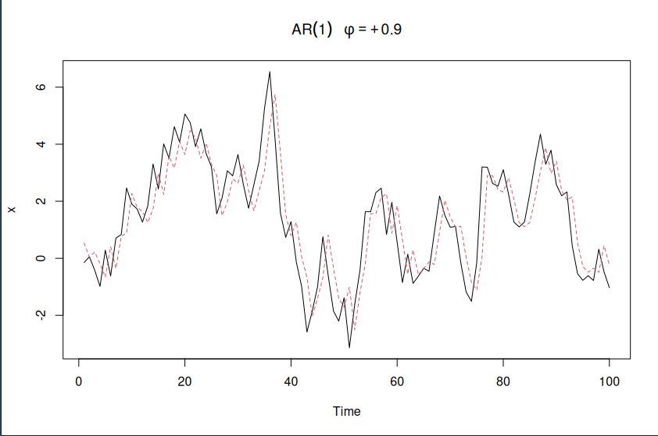
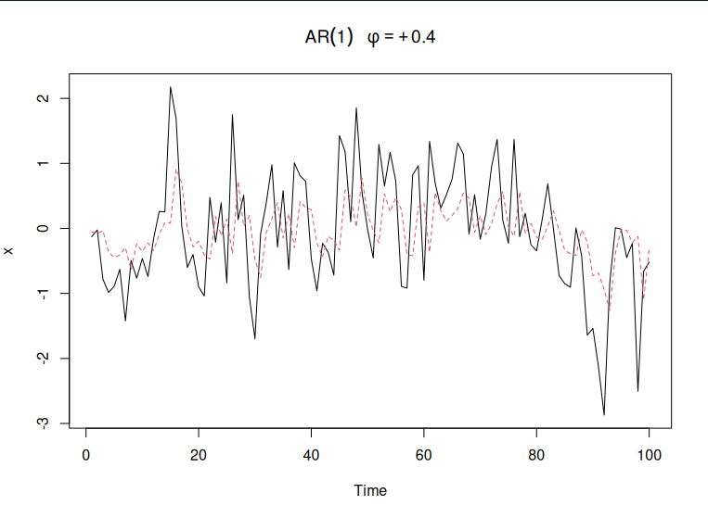
Question Sup 3

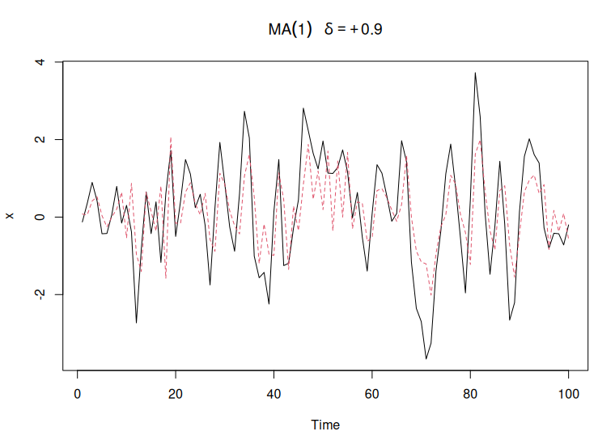
a) Here are the graphs I generated for AR with phi = .9 and .4. The phi = .4 graph has a much smoother AR plot than the .9, because it considers previous points significantly less. Overall it just looks like a smoother fit.

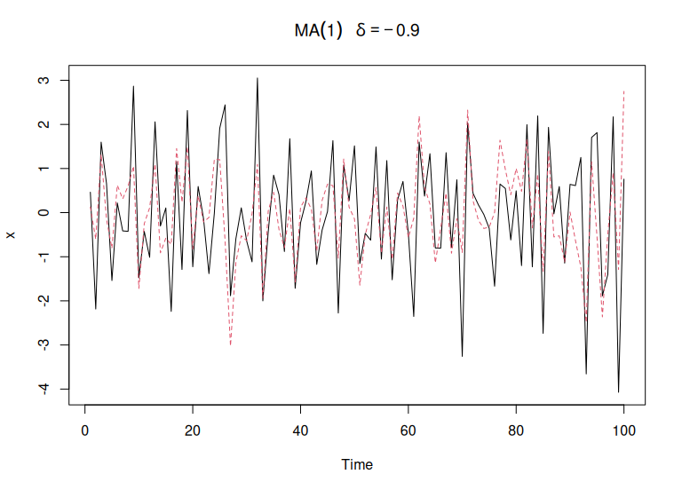
b) The MA graph with theta=.9 produced a result that’s almost more jagged than the original. This is due to using the future data to predict current data. The theta = -.9 produced a graph similar to AR with phi = .9.

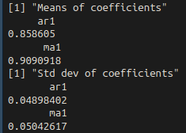
c) After running 100 AR and 100 MA simulations both with n=100, here are the results. The AR coefficient is lower than the MA coefficient, and has a slightly smaller standard deviation. This makes sense that the coefficient is smaller because AR only uses previous data to fit the model, so with a very jumpy graph, it doesn’t change quite as frequently since it’s only looking at previous data

