Supp

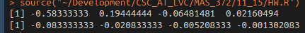
a&b) Here’s the r values I got as a result:
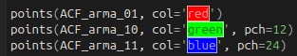
I think I did something a little wrong for the causality phi values, but my pi values are close! Just off by 1 index. Not sure what I did exactly.
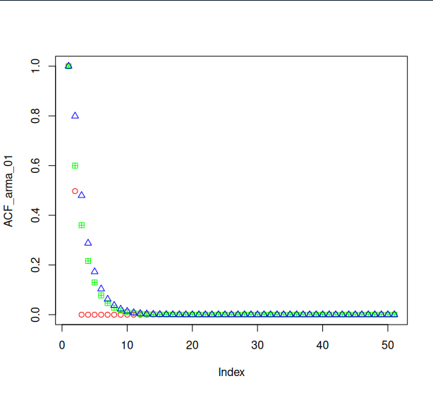
Question 3.8

Green is my AR(1) values, red is my MA(1) values, and blue is the ARMA(1,1) acf. For this example, the models that contain AR terms seem to do a much better job at having a smoother acf plot than the one that just has an MA term.

Question 3.9

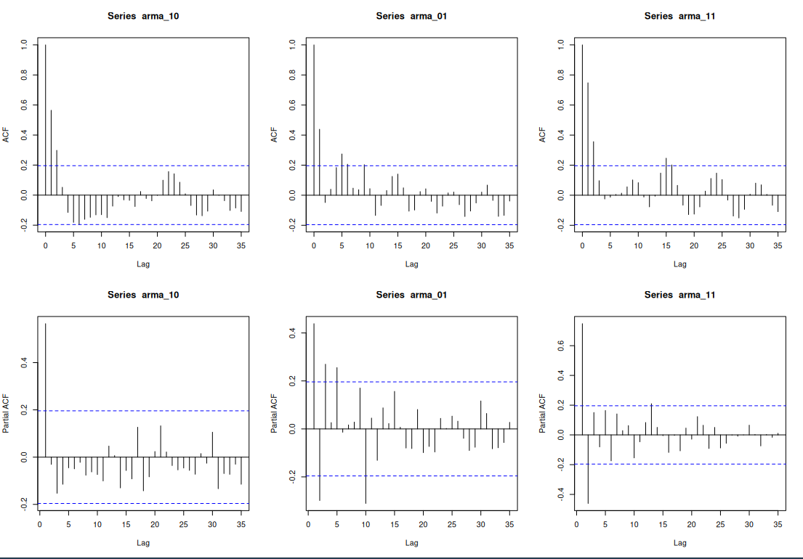
The top row are the ACF plots for my 3 simulated models, and the bottom row are the PACF plots. These seem to very closely mirror the theoretical quantities discussed throughout the readings! The tendencies of the ACF and PACF plots all match their respective spot in the table 3.1

