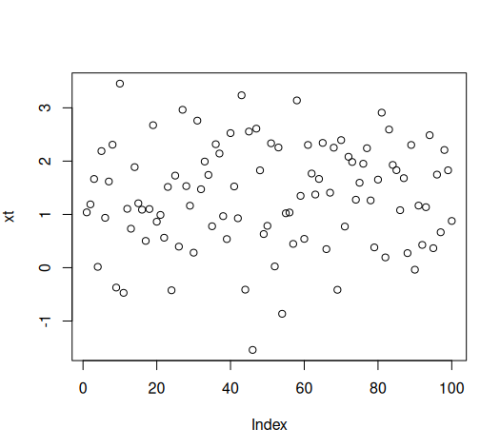
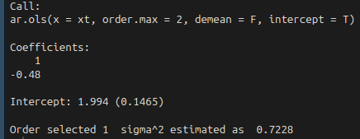
Sup 1

a) Donezo

b) After not demeaning and getting an intercept, here are the results. Pretty close to the true values I set for B0 = 2 and B1 = -.5
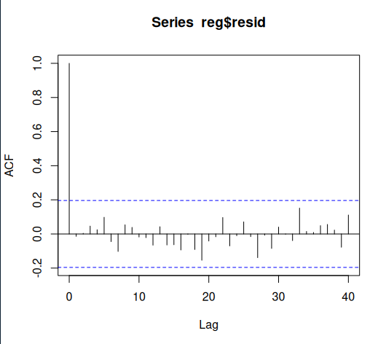
c) These residuals seem to trail off, They never fully really reach 0

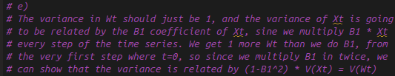
d) The output states the Variance of wt is .7728

e)

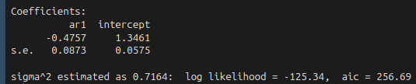
f) The coefficient for B1 is close, but the intercept term according to the book’s model is alpha, which is mu * (1 – phi1 – phi2 - … phi_p)

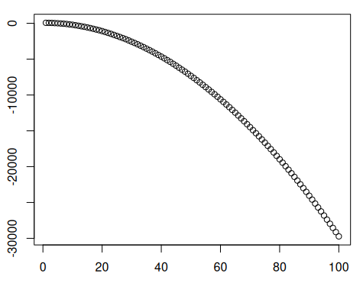
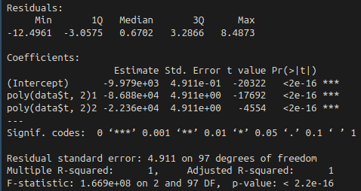
Sup 2

a) I did this. Xt looks strange… almost too correct

b) Fit did well!

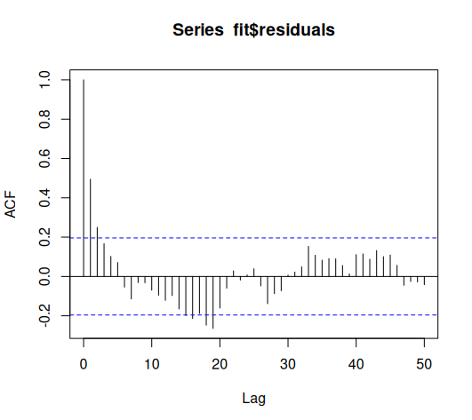
c) The ACF is kinda all over the place. Never really hits 0
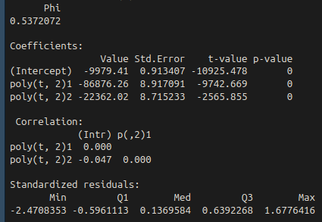
d) The GLS fit also seemed to do really well. Estimates are in the value column, std. Error in the std. Error column.

e) The standard error for the gls model is larger, but overall the models both seemed to perform almost the same. The GLS error is larger than the other since it takes into consideration potential correlation with previous time points, like we defined it in the xt definition, so there is more variance in the zt portion of each xt point.

f) I’m not going to paste it here, it’s literally the exact same as the Xt ACF graph
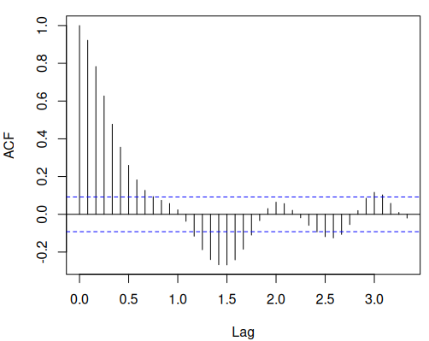
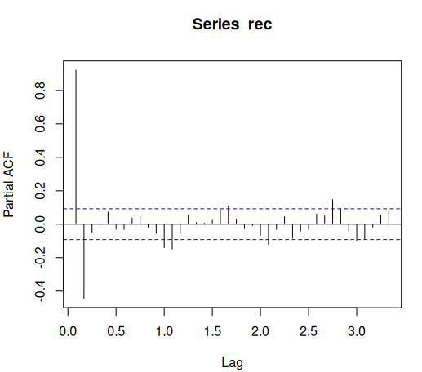

Sup 4

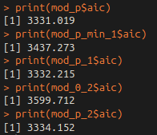
a) The ACF function trailed off, while the PACF function gave a hard cutoff after lag 2. This suggests that the AR(2) model fits best, and that we shouldn’t use an MA term since there is no significance in including one

b) Yes! The model I picked (ARMA(2,0)) at the top had the best AIC
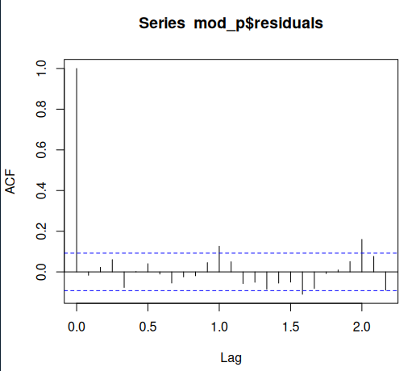
c) I used the predict function to predict 24 data points ahead, or 2 years worth of data.

d) The ACF of the residuals seems to definitely have a periodic nature over the 1 year marks. This is expected, as we were working with seasonal data.

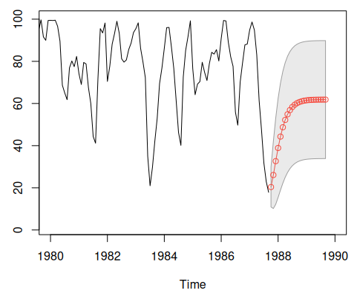
e) Yep, I get what all the code does!

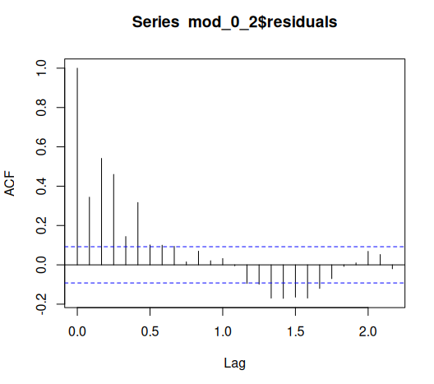
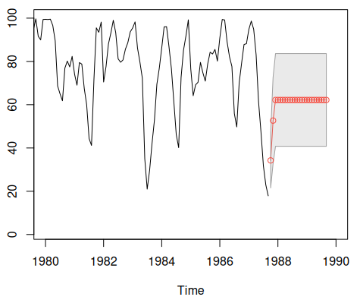
f) These residuals are significantly less close to 0. This doesn’t seem like a good fit. The prediction doesn’t turn out very well….

