Question 6

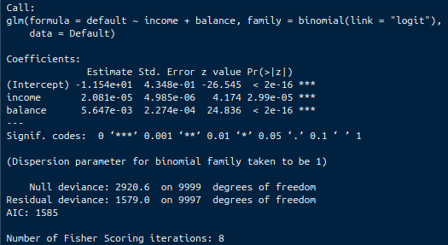
a) Here is the output of summary of my glm model. Standard errors for coefficients are shown in the Std. Error column

b) Done
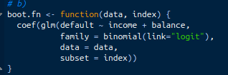
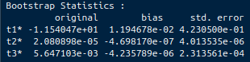
c)

d) The estimates are the exact same, but the bootstrap has some errors that are slightly smaller (for example, t1 and t2), with the standard error estimate for t3 being slightly larger. This is with a resample N of 100 times

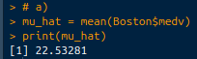
Question 9

a) I used the mean function for the mu_hat
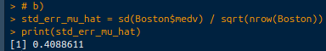
b) I used the formula from the hint for the standard error calculation
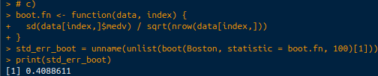
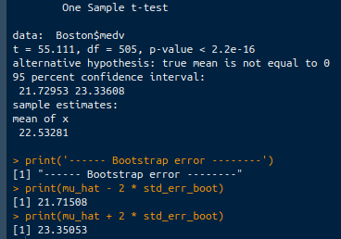
c) By bootstrapping 100 times, we receive an estimate to the standard error that is the same as the standard error

d) The bootstrap error interval is slightly different than the 95% confidence interval using all of the Boston data. It is slightly wider than the actual one sample t-test
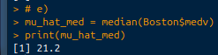
e) Median function

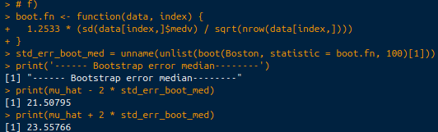
f) By doing a bootstrap resample, we receive a range of confidence for the median. In this case, with 100 samples, the range does not cover the true median value, which is very interesting

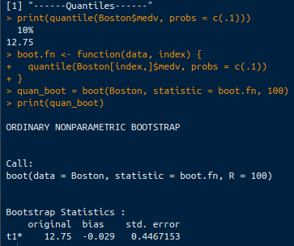
g & h) The result of the true data’s 10% is 12.75. Using bootstrap (with 100 resamples), we get the same result, however the standard error is around .45. This is due to the uncertainty with using random samples of data from the Boston$medv column.

