*Fruit Grading System*

**A PROJECT REPORT**

*Submitted by*

1. Jaydip Makawana (15CP009)

2. Drumil Shah (15CP012)

3. Tejas Bhadresha (15CP014)

***Towards Partial Fulfillment for the Award***

***Of***

**BACHELOR OF TECHNOLOGY**

*In*

**Computer Engineering**



**Birla Vishvakarma Mahavidhyalaya,**

**(An Autonomous Institution)**

VallabhVidyanagar, 388120

ANAND, GUJARAT

Faculty Guides:

Dr. U. K. Jaliya

Prof. Mahasweta J. Joshi

**Gujarat Technological University, Ahmedabad**



## CERTIFICATE

Date: 06/12/2018

This is to certify that the dissertation entitled “FRUIT GRADING SYSTEM” has been carried out by Drumil Shah, Jaydip Makawana and Tejas Bhadresha under our guidance in partial fulfillment of the degree of Bachelor of Technology in Computer Engineering (7th Semester) of BVM Engineering College, Anand during the academic year 2018-19.

**Guides**:

Dr. U. K. Jaliya Prof. Mahasweta J. Joshi

**Head of the Department**

**Dr. D. G. Thakore**

**DECLARATION**

we hereby declare that the project work entitled “FRUIT GRADING SYSTEM” submitted to the Birla Vishwakarma Mahavidhyalaya, Anand, is a record of an original work done by us under the guidance of Dr. U. K. Jaliya and Prof. Mahasweta J. Joshi and this project work is submitted in the partial fulfillment of the requirements for the award of the degree of bachelor of Technology in Computer Engineering.

Jaydip Makawana (15CP009)

Drumil Shah (15CP012)

Tejas Bhadresha (15CP014)

**ABSTRACT**

Nowadays quality assurance of food is a very sincere matter for every person’s day-to-day life. Many serious disease are affecting human life due to degraded quality of food. Also farmers are not getting desired price for their fruits based on quality. Due to this condition of farmers in India is getting worst.

So, there was an idea to bring together a group of remarkable IT concepts so that when we needed them, they could mend the problems that we never could.

Using recent trends in computer science like machine learning, we can overcome above mention issues. We have used machine learning technique to know the quality of fruit and classified them accordingly.

**ACKNOWLEDGEMENTS**

We have taken sincere efforts in this 7th semester’s project. However, it would not have been possible without the kind support and help of guides and classmates. We would like to give our sincere thanks to all of them.

We are highly indebted to Birla Vishvakarma Mahavidyalaya and heart fully to our project guides Dr. U. K. Jaliya and Prof. Mahasweta J. Joshi for their guidance and constant supervision as well as for providing necessary information regarding the project & also for their support in creating the project. It’s been great to have Prof. Mosin I. Hasan as our project coordinator.

And finally, we would like to thank our classmates who helped us in developing the project and people who have willingly helped us out with their knowledge.

Jaydip Makawana (15CP009)

Drumil Shah (15CP012)

Tejas Bhadresha (15CP014)

**List of figures**

|  |  |  |
| --- | --- | --- |
| **Figure No.** | **Name of figure** | **Page no.** |
| Figure 1 | Edge Detection | 9 |
| Figure 2 | Convolutional Neural Network | 10 |
| Figure 3 | Convolution Layer | 10 |
| Figure 4 | Convolution with 3×3 Filter | 11 |
| Figure 5 | Feature Map | 11 |
| Figure 6 | Strides | 12 |
| Figure 7 | ReLU Function | 13 |
| Figure 8 | Max Pooling | 14 |
| Figure 9 | Fully Connected Layer | 15 |
| Figure 10 | Working of CNN | 15 |
| Figure 11 | Dataset images | 18 |

**Table of contents**

|  |  |  |
| --- | --- | --- |
| **Chapter** | **Content** | **Page.no.** |
|  | **Declaration** | **II** |
|  | **Abstract** | **III** |
|  | **Acknowledgement** | **IV** |
|  | **List of figures** | **V** |
|  | **Table of contents** | **VI** |
|  |  |  |
| **1** | **Introduction** | **1** |
|  | 1.1 project statement | 1 |
|  | 1.2 general | 2 |
|  | 1.3 summary  1.4 Flowchart | 3  3 |
| **2** | **Literature Review** | **4** |
|  | Paper 1 | 4 |
|  | Paper 2 | 5 |
|  | Paper 3 | 6 |
|  | Paper 4 | 7 |
|  | Paper 5 | 8 |
| **3** | **Design approach** | **9** |
|  | 3.1 Introduction  3.1.1 CV2  3.1.2 CNN | 9  9  10 |
| **4** | **Implementation** | **18** |
|  | 4.1 Step for implementation | 18 |
| **5** | **Conclusion** | **19** |
|  | 5.1 Conclusion  5.2 Future work (Enhancements) | 19  19 |
| **6** | **References** | **20** |

**CHAPTER 1 – INTRODUCTION**

**1.1 Project Statement**

Outcome of this project is grading of fruit based on its quality which helps farmers and fruit vendor to identify good quality fruits and sale them for right price. If the quality of fruit is not up to the mark then it can be used in other ways around. This will lead to better health of people and economic revolution for farmers.

**1.2 General**

Nowadays quality assurance of food is a very sincere matter for every person’s day-to-day life. Many serious disease are affecting human life due to degraded quality of food. Machine learning based application helps make human life more productive. In recent time very large market is generated through services of quality assurance. Same things can be done towards fruit grading system. Most of the food may be degrade in terms of quality. With some good effort we can extend the existing system with a system with broad usage. New system is developed with a machine learning based application which provides the quality of the fruit.

So, there was an idea to bring together a group of remarkable IT concepts so that when we needed them, they could mend the problems that we never could.

The world demands a constant change in IT technology. Indeed, the wave of change today is fascinating and tries to cluster various new ideas and then décor their practical implementations. Thus, we thought of designing a machine learning based fruit grading application in order to provide easy check the quality of food. The idea further gained strength by interrogation of these same entities when we took a visit to existing face recognition and needs of our colleagues. We clearly interrogated the entities and figured out their problems and we finally arrived at a conclusion of creating this application software.

**1.3 Summary**

This software will first ask the user to take a picture of the fruit, then required process would be done. The application will provide the quality of that fruit with the help of textures, color and shape of the fruit.

Thus, our application can provide easy access to services from webcam without any additional cost.

**1.4 Flowchart**



**FLOWCHART OF SYSTEM**

**CHAPTER 2– LITERATURE REVIEW**

**Paper 1**

|  |  |
| --- | --- |
| **TITLE** | Image Processing and Machine Learning for Automated Fruit Grading System: A Technical Review |
| **JOURNEL** | International Journal of Computer Applications (0975 – 8887) |
| **AUTHORS** | Rashmi Pandey, Sapan Naik, Roma Marfatia |
| **METHOD** | Major part of India depends on the agriculture. Agriculture is a backbone of Indian Economy. India is at the lead position among alternate nations on the planet, underway of drain, heartbeats, jute and jute-like strands; second in oat crops, cotton and vegetables and natural products creation; and is one of the main maker of flavours and ranch trims and additionally fisheries. On the off chance that the general creation is great, it will specifically expand the yearly pay of the cultivators and at last the national pay of the nation. As of now scientists are attempting to create inventive and mechanized techniques utilizing new advances to build the generation of horticultural industry. |
| **CONCLUSION** | Usability of method is on how close the results derived from parameters from the known quality of fruit. In past grading method based on color can be easy to implement. The sorting speeds of them were also not too high, and the accuracy was more dependent on how close results generated using parameters to the actual quality. By combining new image technologies and high-speed image processing techniques has opened a new way for researchers to develop many new and improved technologies for grading of fruits. |

**Paper 2**

|  |  |
| --- | --- |
| **TITLE** | An Automated Machine Vision Based System for Fruit Sorting and Grading |
| **JOURNEL** | 2012 Sixth International Conference on Sensing Technology (ICST) |
| **AUTHORS** | Chandra Sekhar Nandi, Bipan Tudu, Chiranjib Koley |
| **METHOD** | In recent time, machine vision is used in many systems where visual is required. As examples, a system for mango grading based on computer vision, in the systems which checks color of potatoes and apples. There are methods of machine vision that does factory automation such as smart system to pack 2-D irregular shapes, automatic planning and optimization of production with machine vision and other computer techniques, camera image contrast enhancement for surveillance and inspection tasks, patterned texture material testing and closed-loop online process control in manufacturing applications which are based on computer vision. |
| **CONCLUSION** | In this paper test was conducted for varieties of mango, but same can be done for other fruits if it changes skin color with its quality.  There is research that shows that experts are judging mangos not just by its skin color but using its small and firmness. |

**Paper 3**

|  |  |
| --- | --- |
| **TITLE** | Machine Vision based Fruit Classification and Grading - A Review |
| **JOURNEL** | International Journal of Computer Applications (0975 – 8887) |
| **AUTHORS** | Sapan Naik, Bankim Patel |
| **METHOD** | We can classify fruits based on physical properties of fruits like color, size, shape, texture and defects. In recent times due to research activities in computer vision and low cost computer hardware and software, manual work of fruit classification and grading which was performed by labors now can be done easily with automated computer vision systems. There are other reasons for this automation is its accuracy, rapidity and less manual work. |
| **CONCLUSION** | This paper provides basic insights on how the grading of fruit can be done. Methods for feature extraction uses color, size, shape and texture and this is explained with SURF, HOG and LBP features. They mentioned algorithms of machine learning and data mining that can be used like KNN, SVM, CNN, and neural networks of other type. But still there are some issues which machine vision have to solve in near future for efficient quality grading and fruit classification. |

**Paper 4**

|  |  |
| --- | --- |
| **TITLE** | Color feature extraction techniques of fruits: a survey |
| **JOURNEL** | International Journal of Computer Applications (0975 – 8887) |
| **AUTHORS** | Ankur M Vyas, Bjial Talati, Sapan Naik |
| **METHOD** | Color is the main thing to grade fruits based on their quality and this paper shows some of the techniques for extraction color feature. In India there is no scientifically proven system for fruit grading. Here farmers are suffering from quality issues even though India is in the tops of the production of fruits and vegetables. Having an automatic standardized grading system reduces lots of money and labor hours. And most important their quality can be tested and graded accordingly. |
| **CONCLUSION** | Because non availability of automatic grading systems, development of economically efficient methods can be planed. We can use different methods for color feature extraction for verity of fruits and veggies. Different new methods can be created for the grading task. We can combine good things of different methods to make a system that gives way better results than current grading systems. |

**Paper 5**

|  |  |
| --- | --- |
| **TITLE** | Fruit Disease Detection using Color, Texture  Analysis and ANN |
| **JOURNEL** | International Journal of Computer Applications (0975 – 8887) |
| **AUTHORS** | Prof. Samadhan Sonavane, Ashwini Awate, Damini Deshmankar, Gayatri Amrutkar, Utkarsha Bagu |
| **METHOD** | We can measure quality of fruit with the help of observable features of specific fruit. Using proper methods like pesticides, fungicides and chemical applications diseases can be controlled which at the end helps improve quality of fruit. With automatic farming technologies farmer are helped with decision tools and automation techniques which combines product, knowledge and services for good production, grading and classification. This paper is based on monitoring diseases on fruits and suggesting solution for healthy production and productivity with the help of simple form of neural network called ANN. For training model two image datasets ware used, one for training of already stored infected area image and other for testing accuracy of model with query images. |
| **CONCLUSION** | An image processing based solution is proposed for detection of fruits like grapes, apples and pomegranates fruit disease. For Grapes -Black Rot, Powdery Mildew and Downy Mildew; For Apple -Apple Scab, Apple Rot, Apple Blotch; For Pomegranate -Bacterial Blight, Aspergillus Fruit Rot, Gray Mold diseases are detected and classified. After detecting diseases we can classify to treat the accordingly. This will promote Farmers in India to do smart farming which helps to take time to time decisions which also save time and reduce loss of farmers due to fruit diseases. The main objective of the paper was enhancement of the automatic detection of fruit disease. |

**CHAPTER 3 – DESIGN APPROACH**

In this project we use CNN (Convolution Neural Network) with 4 layers of neural network.

Before implementing our project using CNN, we first try to implement project using cv2 (OpenCV).

**3.1 Introduction**

**3.1.1 CV2 (OpenCV):-**

Computer machine learning and computer vision’s algorithms are supported by OpenCV.

OpenCV-Python is a library of Python bindings designed to solve computer vision problems.

In our first approach to implement project, we use OpenCV-python library and use it’s predefine functions.

We use **cv2.Canny ()** function to detect an edge.

We have use OpenCV to get image in form of array. This array representation is use to train a model.

Making array of image for every execution to train a model consume more time so we make a pickle file which store all images in form of array. So pickle file can use at a time of training the model. So execution will faster than previous approach.

Using OpenCV we detect an edge of below image. OpenCV algorithm give below output for edge detection.

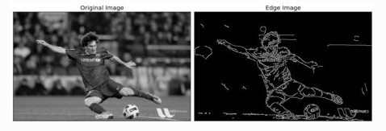

**Figure 1: Edge Detection [11]**

But due to our faculty advises we change our way to implement project using CNN (Convolution Neural Network) instead of Open-CV library.

**3.1.2 CNN (**Convolutional neural network**):**

We have used Convolutional neural network (ConvNets or CNNs) as a classifier of image.

CNN take image as input and make process on it. Based on some classify, it gave output related to categories. CNN seen an input image as array of intensity of colors (RGB) and it depends on the image resolution.

We have used convolution and Pooling before fully connected layers (FC) and applied Softmax function which classify it based on value 0 and 1.

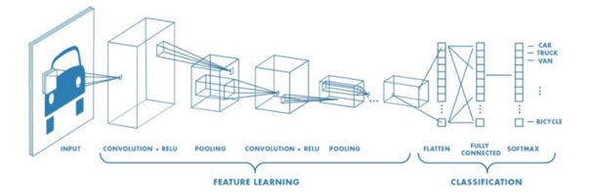

**Figure 2: Convolutional Neural Network [2]**

**Convolution layer:-**

Convolution layer is used to extract feature from input. First layer take image as input and extract features of that images. It use small group of pixel from image for extracting features. Here mathematical operations are used for to take image pixel matrix and filter.

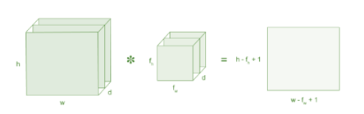

**Figure 3: Convolution Layer [2]**

Here, 5 x 5 image matrix has value 0 or 1. And 3 * 3 is filter matrix.

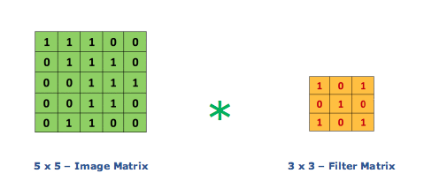

**Figure 4: Convolution with 3×3 Filter [2]**

Multiplication of 5 * 5 matrix with 3 * 3 matrix give feature map as output.

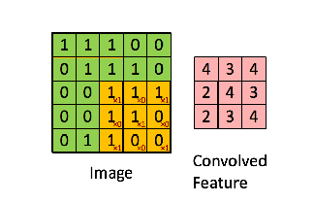

**Figure 5: Feature Map [2]**

**Strides:-**

Strides means how many number of pixel move for next operation. For example is there is stride 1 then move filter by 1 pixel. And if stride is 2 then there is move 2 pixel for filter. Below example if of stride 1.

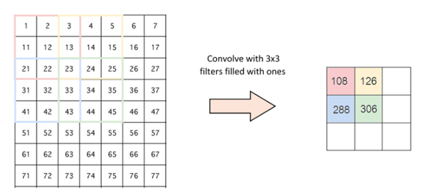

**Figure 6: Strides [2]**

**Padding:-**

What happen sometime filter is not fill properly for some images. At that time there is two option for this condition.

1. Fill that extra part of image with zeros for filter process. Here it means we simple remove that extra part or drop it. Its call zero padding.
2. Take only valid part of image. Here only part which is fit for filter is use. Its call valid padding.

**ReLU (Non Linearity):-**

Rectified Linear Unit for a non-linear operation.

Output: - ***ƒ(x) =* max(0, x).**

ReLU’s purpose is to introduce non-linearity in our ConvNet.

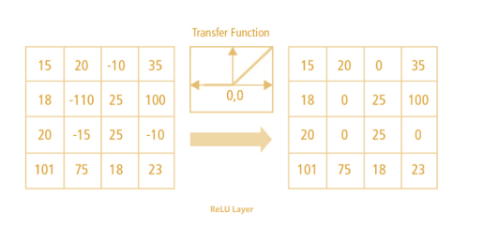

**Figure 7: ReLU Function [2]**

There is more two non liner functions are use and that is tanh and sigmoid. But ReLU is better than sigmoid and tanh.

**Pooling layer:-**

Pooling layer is used to reduce parameters. When images are with more pixel then reduction process must require.so pooling is do same things. Subsampling and down sampling is use for reduction. Here important information are remain there after reduction.

Type of pooling,

1. Max pooling:- take large element from map
2. Average pooling:- take average of map
3. Sum pooling: - take sum of map.

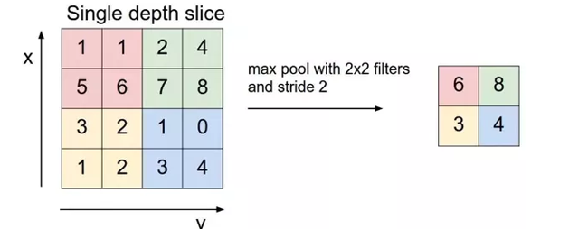

**Figure 8: Max pooling [2]**

**Fully connected layer:-**

All layer are connected and matrix flattened into vector. FC is a short name for fully connected layer.

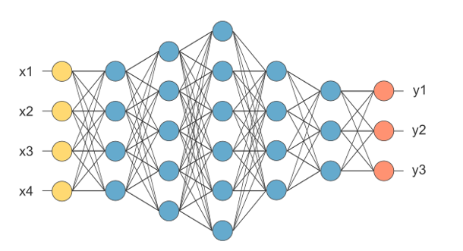

**Figure 9: Fully connected layer [2]**

Feature map is converted into vector. X1, x2, x3 so on is vector in above image. Fully connected layer will combine that all feature for making a model. Activation function are used to classify the output. Softmax and sigmoid are activation function.

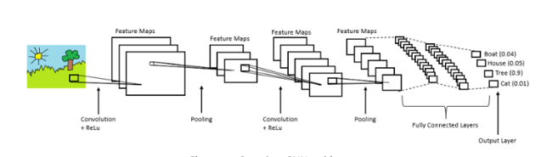

**Figure 10: Working of CNN [2]**

Then we use tensorflow library to generate a convolutional neural network.

**Tensorflow:-**

Tensorflow can be use in machine learning in which very high computation must be completed in less time. It is developed by google brain team. It is an open source library. Python is use for creating front end API of an application.

## Working:-

In tensorflow developers can create graph in which they can specify how the data flow in graph through each node of the graph. The nodes of the graph give an arithmetic operation and edge exist between nodes represent multidimensional array of data or it is called as tensor.

## Benefits:-

Abstraction of data is the main benefit of tensorflow.

Due to abstraction of data, Developers can focus on logic part of application.

**Use of tensor in our project:-**

In ‘model.py’ program we use tensorflow library.

’Conv2d’ is the user define function which type casting the input pixel value in float and

‘Maxpool2d’ is the function that extract the maximum value exist in 2 x 2 pixel matrix of the image. The size of the matrix is determine by kernel size.

For generating weights in CNN, we use tf.Variable() function.

**'Weight_conv1': tf.Variable(tf.random_normal([5, 5, 1, 32]))**

Here, weight_conv1 is the tensorflow variable which consist of 32 output weights generated by randomly.

The 1st and 2nd argument specify the filter size matrix and it 5 x 5 in this case.

Then 1 is the input depth and 32 is the output depth.

Likewise, we set the weights for 2nd layer of CNN randomly.

**'Weight_conv2': tf.Variable(tf.random_normal([5, 5, 32, 64]))**

Here the 32 input weights of the 1st layer is converted into 64 output weights of the 2nd layer and input of the 3rd layer. The filter size remain same as 5 x 5.

Then we have one fully connected layer which has 64 input weights and 1024 output weights.

**'Weight_fc': tf.Variable(tf.random_normal([625 * 64, 1024]))**

At last the output layer has 1024 input weights and 3 output weights according to our classes.

We also use bias which add with the input weight.

**CHAPTER 4 – IMPLEMENTATION**

**4.1 Steps for implementation:-**

* Made pickle files to store and labels separately.

• First of all the ‘data_fruit.py’ file read an image using ‘imread’ function of OpenCV, convert input image into 100 x 100 pixel image and store this image in the python list.

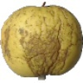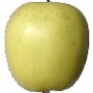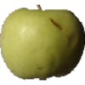

**Figure 11: Dataset images [1]**

• And then we made two pickle files to store the each and every pixel value of an image into pickle file

* Convolution layer take image as input.
* Define parameters, use strides as filter, padding, etc. if require. Use ReLU activation function.
* Performed Max Pooling for reducing dimensions of feature map.
* Added two convolution layers with max pooling.
* Given output of convolution layers to a fully connected layer.
* Added another fully connected layer.
* ReLU activation function is used for classification of output as grade of image.

**CHAPTER 5 – CONCLUSION**

**5.1 Conclusion**:-

Our software for fruit grading system has been a bloomed idea out of the design thinking procedure and has literally given us a new dimension to think upon. We have analyzed to our best and thus have created this software with our full efforts. Customers were facing a list of problems and confusion about whether the fruit has good enough to eat it or not. To solve this problem we came with the idea for this software using machine learning.

Due to mixing the bad quality fruits with the good quality fruits, the customer will not satisfy with product. So that dealer can lose customer. For checking each and every fruit with its quality grade, the bad quality fruit will never mix with good quality fruit and customer also satisfy with the product.

We can build such kind of software by using convolution neural network. Which take image of the fruit as an input and produce the grade of that fruit according to its characteristics (like fruit’s color, textures, shape, etc.).

**5.2 Future work (Enhancements):-**

The accuracy of the correct output is changing with changing the number of layers, weights and biases for corresponding each perceptron in the neural network. The accuracy will increase as increasing the number of layers in neural network. But complexity and time consumption for computation is also increase. And accuracy will decrease as decreasing the number of layers, but the time consumption for computation is also decrease.

So, by increasing number of convolution layers and fully connected layers we can be able to get better accuracy.

We can further increase accuracy by choosing best window size of filters, strides, activation function, and number of neurons in each layer and their weights and biases.

**CHAPTER 6 – REFERENCE**

[1] Fruit 360 Dataset | <https://www.kaggle.com/moltean/fruits>

[2] Convolutional neural networks | <https://www.medium.com/>

[3] Tensorflow | <https://www.infoworld.com>

[4] Tensorflow Methods | <https://www.tensorflow.org/api_docs/>

[5] Rashmi Pandey, Sapan Naik, Roma Marfatia “Image Processing and Machine Learning for Automated Fruit Grading System: A Technical Review” International Journal of Computer Applications (0975 – 8887)

[6] Chandra Sekhar Nandi, Bipan Tudu, Chiranjib Koley “machine vision; fruit grading and sorting; video image; maturity prediction; Gaussian mixture model” 2012 Sixth International Conference on Sensing Technology (ICST)

[7] Sapan Naik, Bankim Patel “Machine Vision based Fruit Classification and Grading - A Review” International Journal of Computer Applications (0975 – 8887)

[8] Ankur M Vyas, Bjial Talati, Sapan Naik “Color Feature Extraction Techniques of Fruits: A Survey” International Journal of Computer Applications (0975 – 8887)

[9] Prof. Samadhan Sonavane, Ashwini Awate, Damini Deshmankar, Gayatri Amrutkar, Utkarsha Bagu “Fruit Disease Detection using Color, Texture Analysis and ANN” International Journal of Computer Applications (0975 – 8887)

[10] Stack Overflow | <https://stackoverflow.com/>

[11] Image For Edge Detection | <https://www.google.com/>