It seems the parent category “Theater” has the highest number of successful campaigns in comparison to the other parent categories. Within “Theater”, “Plays” are by far most popular to receive contributions than other “theater” sub categories. On the other hand, if you are looking in terms of successful rates, “Music” category has the highest successful rate. In contrast, the most ineffective campaign seems to fall under the “Journalism” category. Could this mean people are more apt to donate to and promote the arts as opposed to news?

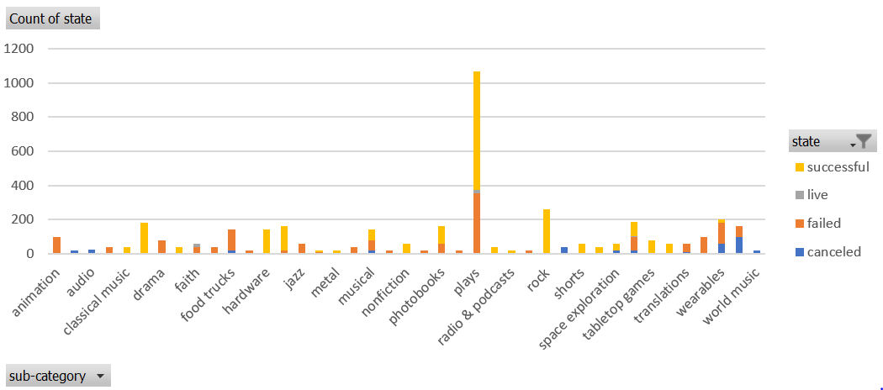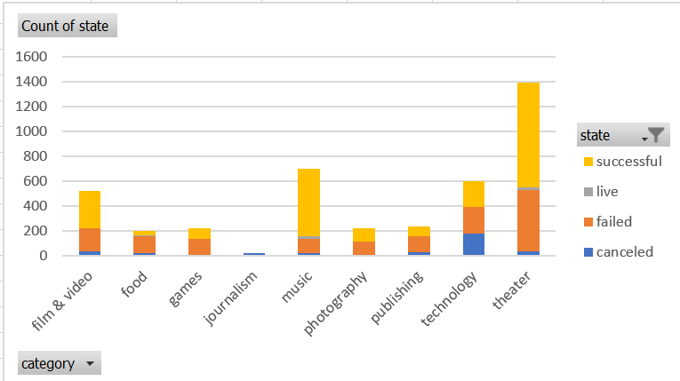

While we do not have population demographic to further drill down preference of contributions, the data seems to lend itself that the majority of contributions are made to Theater campaigns.

A timeline showing the success of campaigns shows a spike in campaigns as a whole between 2013 and 2015, sharply tapering off after 2015. What was happening to prompt people to not only create campaigns but also contribute to them? Successful and Failed campaigns tend to trend together.

