Parties table analyzation tutorial

**Requirements:**

* Windows 10, Windows 11, or MAC OS
* Tableau Desktop 2023.1
* All the necessary downloaded files needed which are the parties.csv, case_ids.csv collisions.csv, and victims.csv files

**Steps:**

***If the csv files required above are already downloaded on your local computer, you may skip to step 4.***

**Downloading the data**

1. Open up gitbash on your local computer and type cd command to change to root directory. Then type scp fvidrio@129.153.114.72:/home/fvidrio/ProjectFiles/case_ids.csv case_ids.csv

1. When asked for a password enter fvidrio. The file should start to download to your user directory on your local computer.

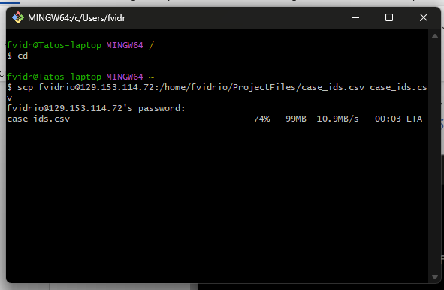

1. Repeat steps 2 and 3 for the remaining files parties.csv, collisions.csv and victims.csv (keep the same file path but just change the file name)

**Downloading and starting Tableau**

1. Click this link [Download Tableau Desktop](https://www.tableau.com/products/desktop/download) to open a browser tab and download the Tableau Desktop. Follow the instructions given on the website to download the correct version for your operating system. A free trial is available for 2 weeks but some professors on campus may be able to provide a product key for Tableau upon request.
2. Once Tableau is done installing, start the program. You may continue the program as a free trial or provide a product key if you have one available.

Tableau start page

**Connecting the data to Tableau**

1. At the start page under connect to a file, click on More… This will open a file browser window to look for data we want to connect to. Then navigate to the folder location where you had downloaded the files for this tutorial. Select the case_ids.csv file.

Find and select the case_ids.csv file

End result page

1. Once the data is finished being processed by Tableau, click and drag parties.csv under the files section into the table pane. This will take a several minutes to process. A relation will automatically be created by Tableau due to the tables having a shared field which is the case_ids.
2. Once finished, click on the tab sheet1 that is located towards the bottom of the window. This will take you to the first analyzation worksheet.

Click here for sheet 1 tab

**Party Sobriety visualization**

1. On the left side underneath the tables section, Click and drag Party Sobriety into the Columns pane. Then click and drag the parties.csv(count) to the rows pane. You will see that Tableau automatically creates a bar chart based on the dimensions and measures given.

Click & drag

1. We notice that there is a very small portion of the chart where the values are null. Because the amount of nulls are of little insignificance to the total count of records, we can right click on the null bar and click exclude. We can sort the graph from biggest to smallest by clicking the sort by descend button in the upper section of the window.

1. To show a label of the amount of records for each sobriety response, you can click and drag parties.csv(count) from the list of measures on the left, then drag into the label button in the Marks section. This will give us the final result of the bar chart.

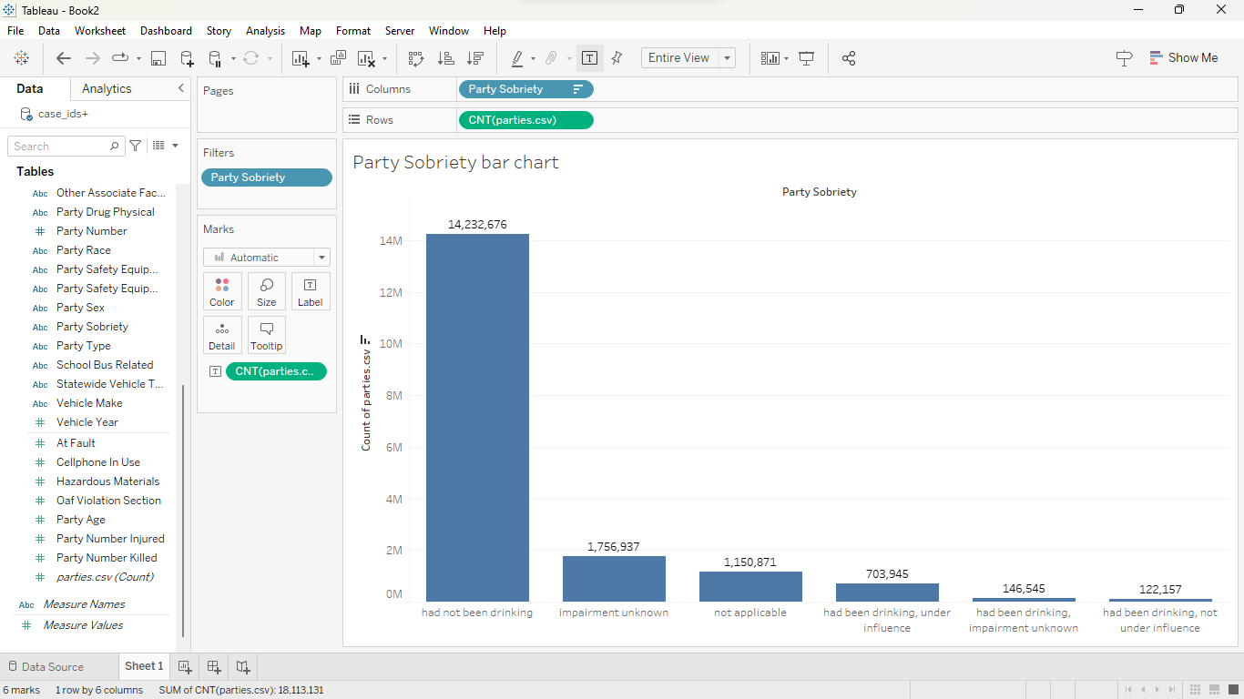

Click & drag

**Final Result**

**At Fault Pie Chart**

1. For our next visualization we will look at creating a pie chart based on the type of parties and will show the percentage of party types that were found at fault. First, click on the new worksheet tab found on the bottom of the window. Tableau will create a new blank sheet.
2. On the left pane under tables, click and hold the party type dimension and then drag it to the color tab in the Marks section. Next, click on the list at the top of the Marks section and select the pie option.

Click & drag

1. Click and hold the At Fault measure in the left pane and drag to the Angle tab in the Marks section. This will change the angles of each color, which represent the party types. There are some colored sections that would include “Null” or “6”. We can filter out these values by right clicking on those sections and select exclude.

Click & drag

1. Lastly, we can give the pie chart some labels by click and dragging the party type dimension and at fault measure both to the label tab in the Marks section. To make the sum of At Fault appear as a percentage of total, you can click on the At Fault drop down list in the Marks section. Next hover over Quick Table Calculation and select Percent of Total. This will give you the final result.

**Final Result**

