Blue Mountain Property Owners Association Guide

BMPOA Board of Directors

Table of Contents

# Blue Mountain Property Owners Association

Community Guide

2025 Edition

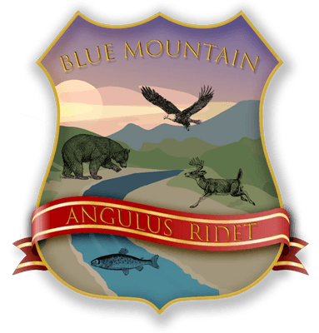

# Table of Contents

**Chapter I: Welcome to Blue Mountain**

About Our Community.....................................3

History and Development..................................4

**Chapter II: Governance**

Board of Directors.......................................5

Committees and Chairs....................................6

Meetings and Participation...............................7

**Chapter III: Community Life**

The Lodge................................................8

Deer Lake Recreation Area................................9

Community Events........................................10

**Chapter IV: Safety & Emergency**

Fire Safety.............................................11

Emergency Contacts......................................12

Evacuation Procedures...................................13

**Chapter V: Services**

Waste Management........................................14

Internet Services.......................................15

Roads and Maintenance...................................16

# Chapter I: Welcome to Blue Mountain

## About Our Community

Welcome to Blue Mountain Property Owners Association (BMPOA), a unique mountain community nestled in the beautiful Shenandoah Valley of Warren County, Virginia. Our community, established in the late 1950s, offers a perfect blend of natural beauty, privacy, and neighborly connection.

Blue Mountain began as a vacation retreat for Washington D.C. area residents seeking respite from city life. Today, we are home to both full-time residents and weekend visitors who share a common appreciation for our mountain's natural beauty and tight-knit community spirit.

### Our Mission

The Blue Mountain Property Owners Association exists to:

* Maintain and improve community infrastructure
* Preserve the natural beauty of our mountain environment
* Foster a sense of community among property owners
* Ensure the safety and well-being of all residents
* Protect property values through thoughtful governance

### Community Values

Our community is built on shared values that guide our decisions and interactions:

**Respect for Nature:** We are stewards of this beautiful mountain environment and work to preserve it for future generations.

**Good Neighbors:** We value privacy while maintaining a friendly, helpful community atmosphere.

**Responsible Development:** We balance property rights with community standards to maintain our mountain's character.

# Chapter II: Governance

## Board of Directors

The Blue Mountain Property Owners Association is governed by a nine-member Board of Directors consisting of five officers and four directors-at-large. Board members are elected by property owners and serve two-year terms.

### Current Board Members

2025 Board of Directors Contact Information

| Position | Name | Phone | Email |
| --- | --- | --- | --- |
| President | John Smith | (555) 123-4567 | president@bmpoa.org |
| First Vice President | Jane Doe | (555) 234-5678 | vicepresident@bmpoa.org |
| Second Vice President | Robert Johnson | (555) 345-6789 | vicepresident2@bmpoa.org |
| Secretary | Mary Williams | (555) 456-7890 | secretary@bmpoa.org |
| Treasurer | David Brown | (555) 567-8901 | treasurer@bmpoa.org |

### Board Responsibilities

The Board of Directors is responsible for:

1. Managing association finances and budget
2. Maintaining common areas and infrastructure
3. Enforcing community covenants and regulations
4. Organizing community events and communications
5. Representing property owner interests

### Board Meetings

Regular board meetings are held on the second Monday of each month at 7:00 PM at The Lodge. All property owners are welcome to attend. Meeting agendas are posted 48 hours in advance on the community bulletin board and website.

# Emergency Contact Information

**🚨 EMERGENCY - DIAL 911**  
For all life-threatening emergencies including fire, medical, or crime in progress

## Important Non-Emergency Numbers

| Service | Contact | Phone Number |
| --- | --- | --- |
| **Warren County Fire & Rescue** | Non-emergency line | (540) 636-3830 |
| **Warren County Sheriff** | Non-emergency line | (540) 635-4128 |
| **Virginia State Police** | Front Royal Office | (540) 829-7771 |
| **Warren Memorial Hospital** | Main Number | (540) 636-0300 |
| **Poison Control Center** | 24/7 Hotline | 1-800-222-1222 |
| **Rappahannock Electric Cooperative** | Power Outages | 1-800-552-3904 |

### Emergency Preparedness

**Register for Emergency Alerts:**

* Sign up for Smart911 at www.smart911.com
* Register for Warren County emergency alerts
* Download the FEMA app for emergency tips

**Emergency Radio Stations:**

* WZRV 95.3 FM - The River
* WFTR 1450 AM - Front Royal Radio
* NOAA Weather Radio - 162.475 MHz

--- title: Blue Mountain Property Owners Association Community Guide author: BMPOA Board of Directors date: 2025 subject: Community Guide and Regulations keywords: [BMPOA, Blue Mountain, Property Owners, Community Guide] lang: en-US toc: true toc-depth: 3 papersize: letter geometry: margin=1in ---