Problem 1: To code or not to code [25 points]

Coding reduces the Bit Error Rate but adds redundancy which reduces the throughput. In some situations (when the BER is sufficiently low), coding is not worth the added overhead. In other situations the use of coding is necessary. Consider a communication link that has the option to use a Hamming code (n=15,k=11,d=3).

1. How many bits can this code correct?

It can correct d-1/2 = 1 bit code error.

1. What is the probability that a received codeword has more errors than the error correction capability of the Hamming code (15, 11, 3)?

Correct rate Pc = (1-Pb)15 + 15Pb(1-Pb)14

Error rate Pe= 1 - Pc

1. Compute this probability for BER=10−3 and 10−4.

When Pb = 10-3:

Pe= 1 - Pc = 1 – (1 - 0.001)15 - 15*(0.001)*(1-0.001)14 = 0.000104

When Pb = 10-4:

Pe= 1 - Pc = 1 – (1 - 0.0001)15 - 15*(0.0001)*(1-0.0001)14 = 0.000001

1. What is the frame error rate for an uncoded communication (FER)? and coded communication (FERc)? Assume a packet length of L.

For uncoded: P1 = (1-Pb)L, FER = 1 - P1 = 1 - (1-Pb)L

For coded: P1 = (1-Pe)L, FERc = 1 - P1 = 1 - (1-Pe)L

1. What is the net throughput for coded and uncoded communication as a function of L and FER or FERc?

Assume bit rate is 1.

For uncoded:

Tu = L * (1 – FER) * (1 – Pb)

For coded:

Tc = CR * L * (1 – FER) * (1 – Pe) = (11/15) * L * (1 – FER) * (Pc)

1. Compute the net throughput for a communication with and without coding, for BER=10−3 and 10−4, and for L=50,100, 1000, 1500 bytes. Present the results in a table.

Uncoded:

L = 50

1 - FER(-3) = 0.951 T= 50 * 0.951 * (1-0.001) = 47.50

1 - FER(-4) = 0.995 T= 50 * 0.995 * (1-0.0001) = 49.75

L = 100

1 - FER(-3) = 0.905 T= 100 * 0.905 * (1-0.001) = 90.41

1 - FER(-4) = 0.990 T= 100 * 0.990 * (1-0.0001) = 98.99

L = 1000

1 - FER(-3) = 0.368 T= 1000 * 0.368 * (1-0.001) = 367.632

1 - FER(-4) = 0.905 T= 1000 * 0.905 * (1-0.0001) = 904.91

L = 1500

1 - FER(-3) = 0.223 T= 1500 * 0.223 * (1-0.001) = 334.1655

1 - FER(-4) = 0.861 T= 1500 * 0.861 * (1-0.0001) = 1291.37

|  |  |  |  |  |
| --- | --- | --- | --- | --- |
| BER/L | 50 | 100 | 1000 | 1500 |
| 10-3 | 47.50 | 90.41 | 367.632 | 334.1655 |
| 10-4 | 49.75 | 98.99 | 904.91 | 1291.37 |

Coded:

L = 50

1 - FERc(-3) = 0.995 T = (11/15) * 50 * 0.995 * (1 - 0.000104) = 36.48

1 - FERc(-4) = 0.99995 T = (11/15) * 50 * 0.99995 * (1 - 0.000001) = 36.66

L = 100

1 - FER(-3) = 0.990 T = (11/15) * 100 * 0.990 * (1 - 0.000104) = 72.59

1 - FER(-4) = 0.99990 T = (11/15) * 100 * 0.99990 * (1 - 0.000001) = 73.33

L = 1000

1 - FER(-3) = 0.901 T = (11/15) * 1000 * 0.901 * (1 - 0.000104) = 660.66

1 - FER(-4) = 0.99990 T = (11/15) * 1000 * 0.99990 * (1 - 0.000001) = 733.26

L = 1500

1 - FER(-3) = 0.856 T = (11/15) * 1500 * 0.856 * (1 - 0.000104) = 941.50

1 - FER(-4) = 0.9985 T = (11/15) * 1500 * 0.9985 * (1 - 0.000001) = 1098.35

|  |  |  |  |  |
| --- | --- | --- | --- | --- |
| BER/L | 50 | 100 | 1000 | 1500 |
| 10-3 | 36.48 | 72.59 | 660.66 | 941.50 |
| 10-4 | 36.66 | 73.33 | 733.26 | 1098.35 |

1. In which cases does it make sense to use coding?

When bit error rate is low (10-4) or data length L <= 100, use uncoded system. When big error rate is high(10-3) and data length >= 1000, use coded system.

Problem 2: Hamming Codes [25 points]

The goal of this assignment is to make sure that you know how to build a Hamming code. Consider Hamming code (n=15, k=11, d=3).

1. Build the Generator matrix G for this code?

G = $\left[\begin{matrix}1 & 1 & 1 & 1 & 1 & 0 & 0 & 0 & 0 & 0 & 0 & 0 & 0 & 0 & 0 \\ 1 & 1 & 1 & 0 & 0 & 1 & 0 & 0 & 0 & 0 & 0 & 0 & 0 & 0 & 0 \\ 0 & 0 & 0 & 0 & 0 & 0 & 1 & 0 & 0 & 0 & 0 & 0 & 0 & 0 & 0 \\ 1 & 0 & 1 & 1 & 0 & 0 & 0 & 1 & 0 & 0 & 0 & 0 & 0 & 0 & 0 \\ 1 & 0 & 1 & 1 & 0 & 0 & 0 & 0 & 1 & 0 & 0 & 0 & 0 & 0 & 0 \\ 1 & 0 & 1 & 1 & 0 & 0 & 0 & 0 & 0 & 1 & 0 & 0 & 0 & 0 & 0 \\ 1 & 1 & 0 & 1 & 0 & 0 & 0 & 0 & 0 & 0 & 1 & 0 & 0 & 0 & 0 \\ 1 & 1 & 0 & 1 & 0 & 0 & 0 & 0 & 0 & 0 & 0 & 1 & 0 & 0 & 0 \\ 1 & 1 & 0 & 1 & 0 & 0 & 0 & 0 & 0 & 0 & 0 & 0 & 1 & 0 & 0 \\ 1 & 1 & 1 & 0 & 0 & 0 & 0 & 0 & 0 & 0 & 0 & 0 & 0 & 1 & 0 \\ 1 & 1 & 1 & 0 & 0 & 0 & 0 & 0 & 0 & 0 & 0 & 0 & 0 & 0 & 1\end{matrix}\right]$

1. Code the following message (1,0,1,1,0,0,0,0,0,0,1)

[1,0,1,1,0,0,0,0,0,0,1] [G] = [1+0+0+1+0+0+0+0+0+0+1, 1+0+0+0+0+0+0++0+0+0+1, 1+0+0+1+0+0+0+0+0+0+1, 1+0+0+1+0+0+0+0+0+0+0,1,0,1,1,0,0,0,0,0,0,1] = [1,0,1,0,1,0,1,1,0,0,0,0,0,0,1]

1. Build the Parity check matrix H for this code?

H = $\left[\begin{matrix}1 & 0 & 0 & 0 & 1 & 1 & 0 & 1 & 1 & 1 & 1 & 1 & 1 & 1 & 1 \\ 0 & 1 & 0 & 0 & 1 & 1 & 0 & 0 & 0 & 0 & 1 & 1 & 1 & 1 & 1 \\ 0 & 0 & 1 & 0 & 1 & 1 & 0 & 1 & 1 & 1 & 0 & 0 & 0 & 1 & 1 \\ 0 & 0 & 0 & 1 & 1 & 0 & 0 & 1 & 1 & 1 & 1 & 1 & 1 & 0 & 0\end{matrix}\right]$

1. Is the following received message (1,1,0,1,0,0,0,0,0,0,1,0,0,0,1) a valid codeword

[1,1,0,1,0,0,0,0,0,0,1,0,0,0,1][HT] = [1,0,1] not valid.

Problem 3: Decoding of Convolutional Codes [25 points]

The goal of this assignment is to make sure that you know who to build to decode a convolutional code using Viterbi's algorithm. Consider the convolutional code presented on slide 51 in the Lecture 4 notes. Assume that the following message is received: (11,00,00,01,10,01,11,00,11). Explain how the Viterbi’s algorithm works and show on the Trellis diagram (step by step) how to decode it and what was the original message before coding?.

The algorithm compares received sequence with all possible transmitted sequences, and chooses the shortest path for each node, then traces back for the shortest valid path at the end.

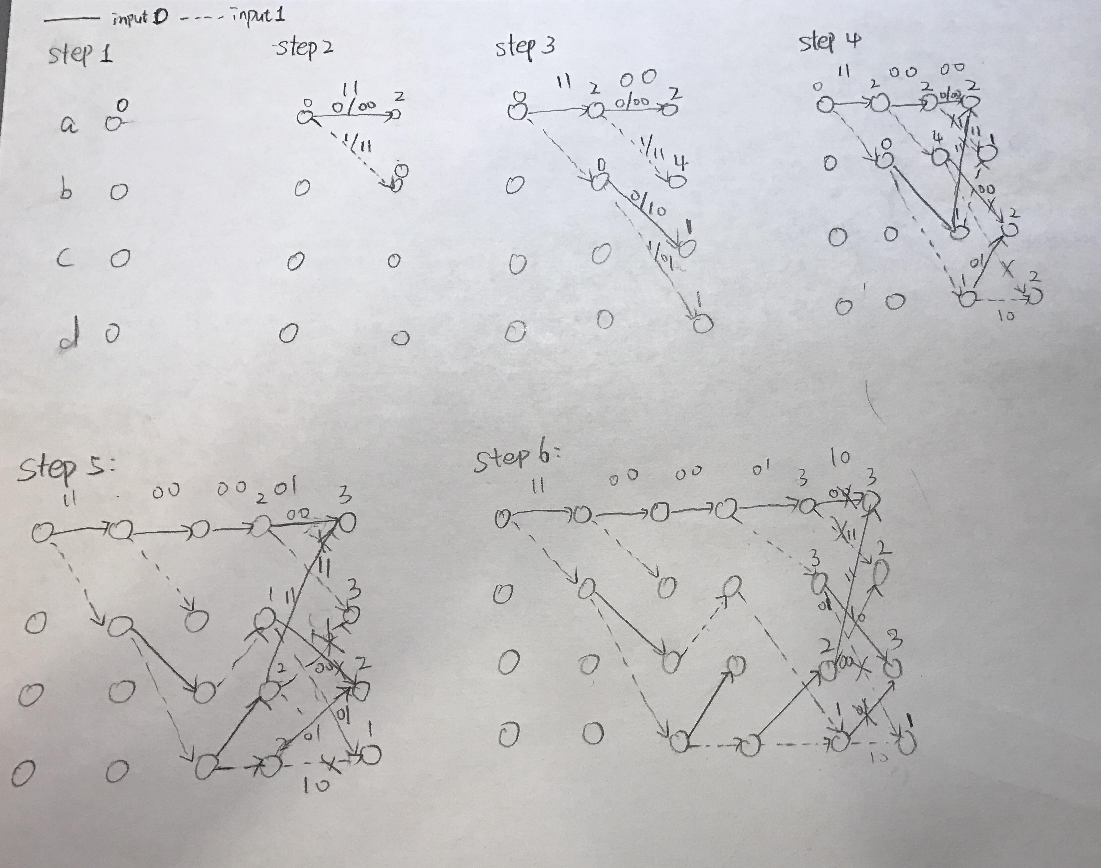

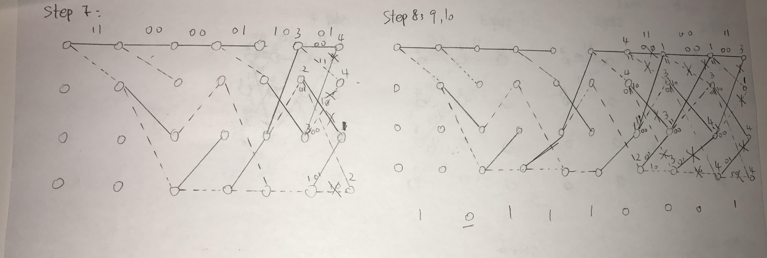

Problem 4: IEEE 802.11n Data Rate [15 points]

For IEEE 802.11n, determine the data rate for 16 QAM (per subcarrier) using a 2/3 coding rate with 2 parallel data streams (2x2 configuration). Hint:Lecture 1 slide 47. and assume OFDM symbol duration is 3.6e-6 seconds.

a-     For 20 MHz channel.

Data Rate = (48 * 2 * 2/3 *log216) / (3.6 * 10-6) = 71 Mbps

b-     For 40 MHz channel.

Data Rate = (108 * 2 * 2/3 *log216) / (3.6 * 10-6) = 160 Mbps

Problem 5: Number of Channels in FDMA Cellular System [15 points]

A cellular system uses FDMA with a spectrum allocation of 12.5 MHz in each direction (uplink and downlink), a guard band at the edge of the allocated spectrum of 10 kHz, and a channel bandwidth of 30 KHz. What is the number of available channels?

N = (Bt - 2Bg) / Bc = (12.5 * 106 – 2*(10*103)/(30 * 103) = 416