Note: To execute the script, run *python3 generateRandom.py*, it will generates three .txt file for the three heuristics. To draw the performance graph of each heuristic0, run *gnuplot plot.gnu*.

H0: Create a empty array L’, as long as there exist an area in L that not been covered in A, add that area into L’.

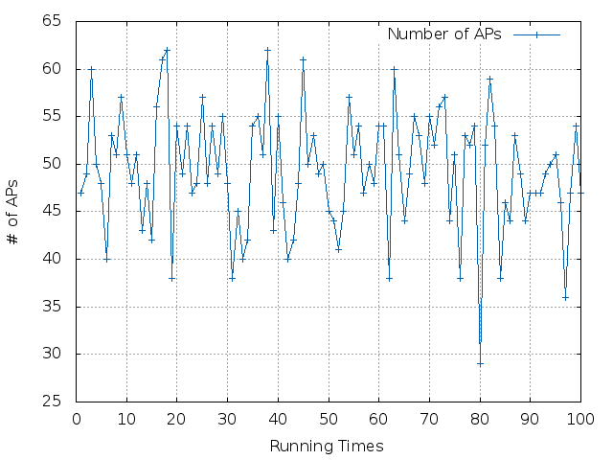

H1: sort L, which will find the proper AP quicker than H0.

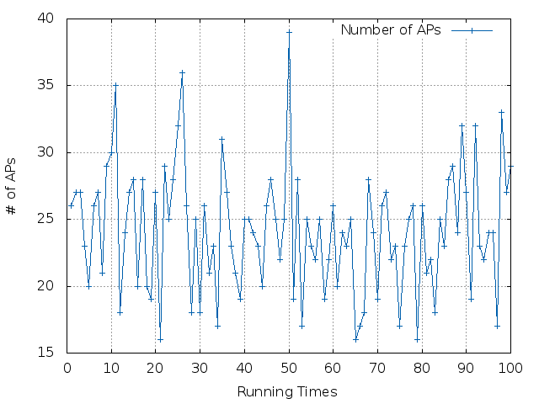

H2: use greedy algorithm to find the best suited AP each turn. The duplicated area is smallest compare to H0 and H1.

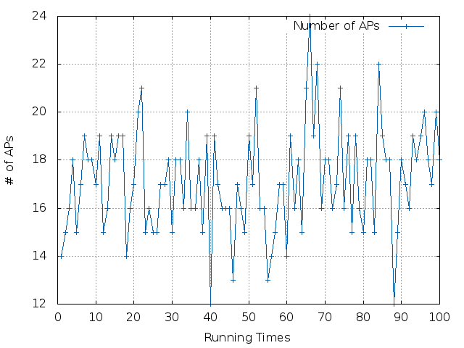

By comparing the performance graph of each heuristic, H0 has the largest length of L. Where H2 has the minimum size of L.