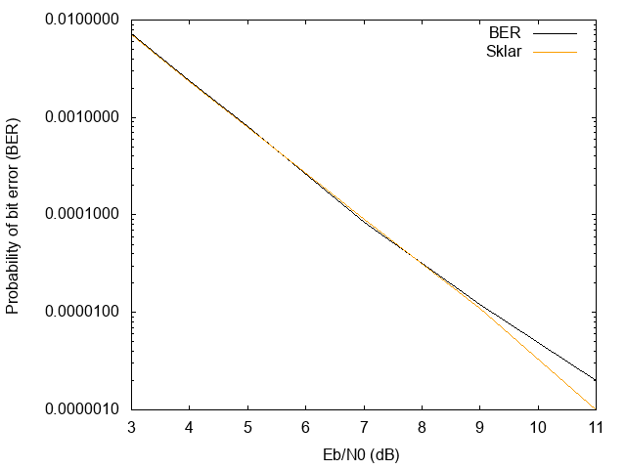

Graphic above shows the Bit Error Rate v.s. SNR under 0.5 bit rate(black line), the script uses Gaussian random variables with mean = 0 and variance = N0/2 to generate random noise, then uses optimal detection rule with threshold th = 0. Comparing to the Q-Function(yellow line), the two data agree with each other

When SNR is lower than 7. However when SNR becomes larger, it is obvious that the BER of Q-Function is smaller than the actual BER.

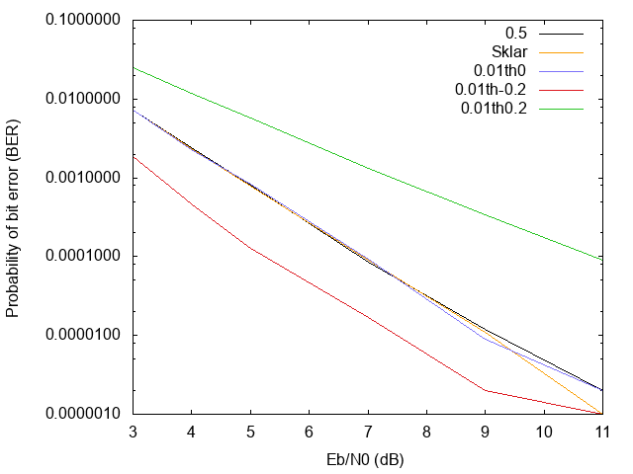

Graphic above shows the BER performance under 0.01 bit rate. The graphic compares 0.01 bit rate with different threshold. It also compares the BER under Q-Function and 0.5 bit rate. The data shows 0.01 bit rate with threshold -0.2 has the lowest BER and 0.01 bit rate with threshold 0.2 has the highest BER. It is because when P0 = 0.01, there are smaller probability of BER happened in 0 bits and higher BER happened in 1 bits. When we lower the threshold, we allow more error happened in 1 bits and vice versa. Thus when threshold is negative the results performs best and when threshold is positive the results performs worse.