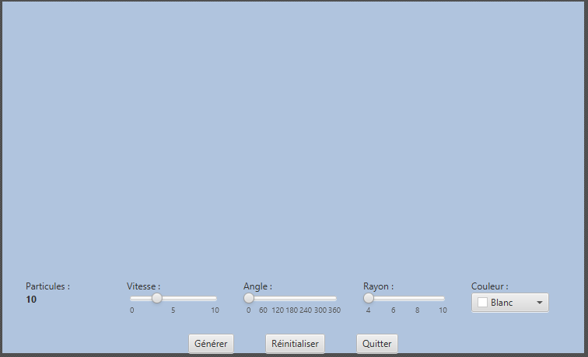

Pane

ColorPicker

Label

Button

Button

Button

Slider

Slider

Slider