Dealing With Non Functional Requirements: A Process Oriented Approach

Abstract- In requirement engineering Functional Requirements (FRs) deals with the behavior of the system in terms of the output of the system, while Non Functional Requirements (NFRs) impose the restrictions on the product being developed [1]. Till now NFRs have not received much attention and their second grade (or no) treatment makes the software unacceptable or less acceptable [2]. NFRs such as performance, reliability, maintainability, accuracy, security etc. should be considered at the early stage of development just like Functional Requirements. However, dealing with NFRs is a big challenge to software engineers for many years. From correctly identified domain specific NFRs, modeling those and to integrate those in the system from the early stage of development is very important to assure the customer satisfaction. In this work, we propose a grouping mechanism for elicitation of Non Functional Requirements. Then a set of steps are suggested to model and deal with the soft-goals of the NFRs. We believe that our work will help the developers in dealing with NFRs efficiently and effectively from the very first stage of development and will reduce the effort to make the software system in a cost efficient manner.

Keywords – Requirement Engineering, Non Functional Requirements, Domain specific, Soft-goal.

Introduction
Functional requirements (FRs) describe how a system should behave during operation, deals with the output; while non-functional requirements (NFRs) describe constraints on the quality attributes of the system’s operation. Non-Functioning testing is done based on the requirements and test scenarios defined by the client. Nowadays although Non-Functional aspects are very important in terms of quality attributes of software, still most of the time these are overlooked during development and these are checked after development of a software. The present approaches those deal with non-functional requirements of software, still has limitations either in their representational power or in their verification efficiency. It leads to the inconvenience to the software system and leads to project failure as the problems in NFR are not detected until very late process. This causes concern and affects the cost effectiveness of the software system. The development domains are also emerging from procedural to object oriented systems and even further to service oriented system- incorporating complexities in the NFR test scenarios of the systems.
We have divided our work in two phases. In the first phase we have tried to suggest an elicitation technique of domain specified NFRs, model them and address those NFRs during development of the software system in the early stage of SDLC. In the second phase, we have tried to suggest some steps to deal with NFRs during development. Here the decision making process is a critical one to refine the soft-goals of the system. This process will provide preliminary support for the usefulness of certain Non-Functional aspects of the framework, while raising some open issues. It will give a good solution to develop a cost efficient software system and will eventually improve the QoS.

II. Related Work
Inefficient handling of NFR is a big problem nowadays for the software industry as it causes project failure. Functional requirements are easy to model as there is a formal definition and structure. But there is a lack of well formed definition of NFR. Formal specification and characterize the NFRs are very much harder [7]. Elicitation process refers requirement gathering or discovering. Requirement elicitation is one of the most critical knowledge-intensive activities in software development process [8]. Some effort has been made on this regard. A UML use case based questionary approach was suggested to identifying and classifying NFR of a system [9]. Some attempts to conduct a detailed evaluation and proposes QoS-based service selection were made in the work in [10], [11], and [12]. The notion of multiple context models of measurements corresponding to different levels of abstraction was presented in a work that enables us to provide CASE tool support for the refinement of non-functional specifications [13]. A catalogue was defined for nonfunctional properties to be considered when service descriptions are developed [14]. Still, the lack of a complete framework from elicitation technique to dealing with NFR motivates us to give a re-thinking of this particular research domain.

III. Proposed Elicitation Technique
System development can be successful only with consistent requirement management. NFRs are one of the most important aspects in requirement management. Unfortunately still now, NFRs are treated as the additional requirement of a software system. Unawareness of NFRs by the stakeholders as well as ignorance by the software analysts increases the probability of system failure. Although the quality attributes may differ from different point of views. To identify proper domain specific NFRs we propose a model consists of three major sub steps:

Identify the stakeholders –
A ‘Five what’ method is proposed to identify the key stakeholders that give the answers of the following five questions:
- What is the fundamental impact of the stakeholder in the software system?
- What is the system need from the stakeholder?
- What is the dynamic significance of the stakeholder?
- What is the impact of the existence of the stakeholder?
- What is the identification impact of that stakeholder, experienced from other system?

From this analysis primary and secondary stakeholders are identified and the key stakeholders are selected. Key stakeholders are the people who can devise, pass, and enforce laws and regulations that may either fulfill the goals of your effort or directly cancel them out.

Identify the domains and the modules –
Domain analysis is a term used to describe the systematic activity of identifying, formalizing and classifying the knowledge in a problem domain [3]. In this work our target domains provide impact not only to the application domain, but also to the other domains. Domains are areas of expertise that can be applied to the creation of a system or set of systems. Domain knowledge is characterized by a set of concepts and terminology understood by practitioners in that area of expertise. It also includes an understanding of recurring problems and known solutions within the domain. Knowledge from several domains is usually required to build a single product. Figure 1 is a sample case study for an online shop where four domains are identified.
CUSTOMER DOMAIN
FUNCTIONAL DOMAIN
PHYSICAL DOMAIN
PROCESS
DOMAIN
Figure 1: Identified Domains

Software modules are building blocks of software applications, which perform a specific task. The Official IPM Glossary [4] defines a ‘software module’ as: “A small section of a program that carries out a clearly defined task. It has one entry point and one exit point.” Taxonomy of critical software modules techniques to identify critical components in software applications was suggested [5] by Jan Cappaert, Bart De Win and Bart Preneel, where modules has been classified as Security modules, Physical and logical location based modules, Business related modules and Quality related modules. However for any general application system some general modules are: Search, Login, Create Account, Logout, Sell, Handle Payment, Add Item, Delete Item, Calculate Total, Print Receipt, Check Product etc [6].

Mapping the modules with domain specified NFRs –
After domain analysis the relation with the modules and sub-modules are identified. If there is a relation between a particular module and / or sub-module with one or more domain, then according to each of the relation a mapping is done between them as shown in Figure 2.

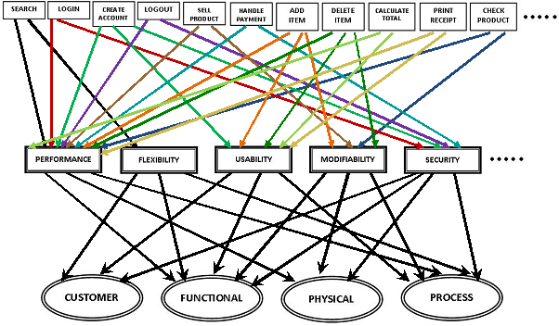
Figure 2: Mapping between different modules, sub-modules and domains

IV. Process to deal with NFRs
The proposed model is a step wise guidance to deal with NFRs [Figure 3]. After elicitation of domain specific NFRs for that particular system, a generalized list of actors and the NFRs has been prepared including few globally accepted NFRs. The control variables and other factors are integrated in non-functional perspective. NFR integration has been completed with the help of pre-specified NFR template and NFR graphs. The next step is a critical one where the decision modeling is done. The experienced team of decision makers illustrates the testable models. The basic units for representing NFRs, called softgoals [15] are refined to ‘satisfice’ [16] operationalization by contribution of offspring softgoals towards the achievement of its parent. After successful execution the next phase is to design use cases and also preparation of the software requirement specification (SRS).

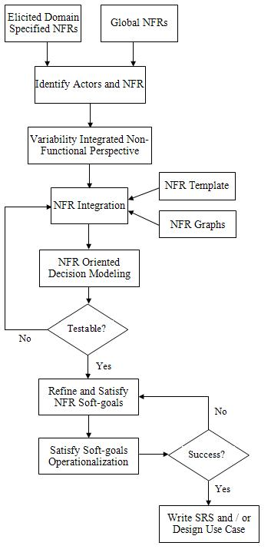
Figure 3: Stepwise process to deal with NFRs

V. Conclusion And Future Work
One of the major factors to develop good software is the well identification of the Non-Functional requirements and incorporation in the software system. In this work we have proposed an approach from elicitation and identification of Non-functional requirements to deal with them. This framework is based on two phases: Elicitation technique and Dealing with NFRs. Here we have also tried to introduce the softgoals. It is not possible to completely satisfy a softgoal. So, in this work the term ‘satisfce’ [16] has been used to indicate that the goal satisfying is accomplished within acceptable limits. As the part of this approach we have proposed some rules to be used in the identification process, requirements completeness and requirements validation. Here we are dependent on the experience of the decision making team to model NFRs which may vary and dependant on their experience and current mental state. Hence we conclude with a plan of our future work, to introduce an independent generic algorithm to make decision making process more precise and scientific.

VI. eferences

- G. Sousa, and J.F.B. Castro. “Supporting Separation of Concerns in Requirements Artifacts”. First Brazilian Workshop on Aspect-Oriented Software Development (WASP’04), 2004, Brazil.
- Pratima Singh, Anil Kumar Tripathi: “Treating NFR as First Grade for Its Testability”. Journal of Software Engineering and Applications, 2012.
- P. Loucopoulos, V. Karakostas. Systems Requirements Engineering. Maidenhead, Berkshire, UK: McGraw-Hill, 1995.
- Official IPM Glossary: http://www.mckinnonsc.vic.edu.au/la/it/ipmnotes/misc/glossary.htm
- Jan Cappaert, Bart De Win, Bart Preneel: “Identification and Classification of Critical Software Modules in Modern Applications”, October, 2005.
- Md. Mijanur Rahman and Shamim Ripon: “Elicitation and Modeling Non-Functional Requirements –A POS Case Study”, International Journal of Future Computer and Communication, Vol. 2, No. 5, October 2013.
- L. M. Cysneiros and E. Yu, “Non-functional requirements elicitation,” in Perspectives on Software Requirements, J. C. S. P. Leite, and J. H. Doorn, Ed. vol. 753, Springer US, 2004, pp. 115-138.
- E. Gottesdeiner, Requirements by Collaboration, Addison-Wesley, 2002.
- Md. Mijanur Rahman and Shamim Ripon, “Elicitation and Modeling Non-Functional Requirements –A POS Case Study”, International Journal of Future Computer and Communication, Vol. 2, No. 5, October 2013.
- Y. Liu, A.H.H. Ngu and L. Zeng, QoS Computation and Policing in Dynamic Web Service Selection, In Proceeding 13th International Conference, World Wide Web, 2004.
- Y. Mou, J. Cao, S.S. Zhang, J.H. Zhang, Interactive Web Service Choice-Making Based on Extended QoS Model, CIT 2005, pp.1130-1134.
- D.A. Menasce, QoS Issues in Web Services. IEEE Internet Computing, 2002, 6(6).
- Simone R¨ottger and Steffen Zschaler, “A Software Development Process Supporting Non-functional Properties”.
- Hanane Becha and Daniel Amyot, “Non-Functional Properties in Service Oriented Architecture – A Consumer’s Perspective”, JOURNAL OF SOFTWARE, VOL. 7, NO. 3, MARCH 2012.
- Geórgia Maria C de Sousa, Ismênia GL da Silva, Jaelson Castro, “Adapting the NFR framework to aspect-oriented requirements engineering”, Proceeding of XVII Brazilian Symposium on Software Engineering, pp.83-98, 2003.
- L. Chung, B. A. Nixon, E. Yu and J. Mylopouls, “Non Functional Requirements in Software Engineering”, Boston: Kluwer Academic Publishers. ISBN 0-7923-8666-3.

