Figures

Figures 1 Measurement of mental loop in the axial section
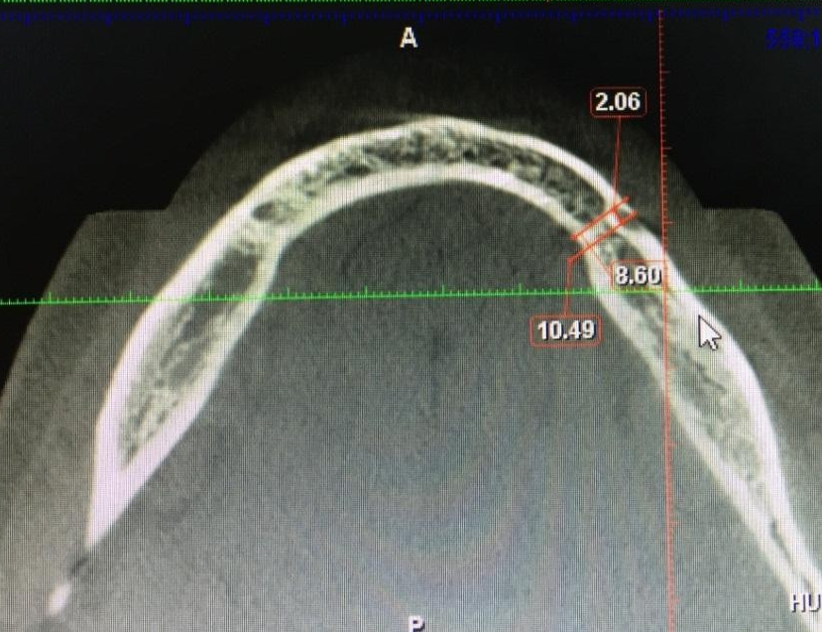

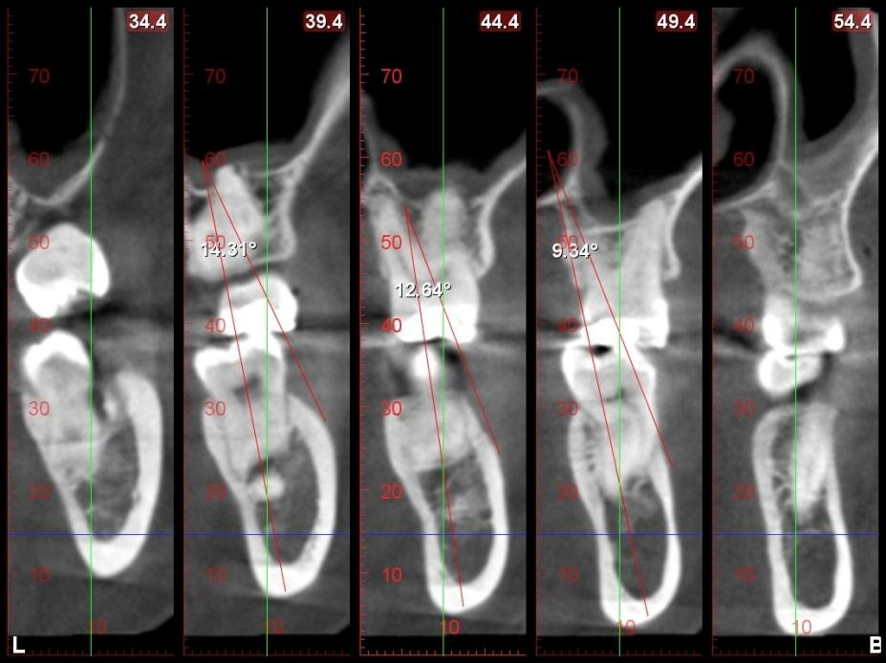
Figure 2 Measurement of angulation of ridge with reference to buccal shelf flush terminal

Figure 3 Lingual concavity measurement in the coronal implant view.

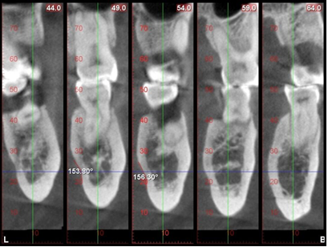

Figure No. 4 Morphological classification /Biotypes.
Class A: Acute undercut: Class B: Stream line: Class C: Kidney shape

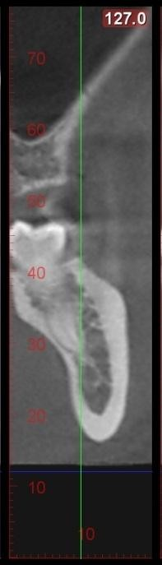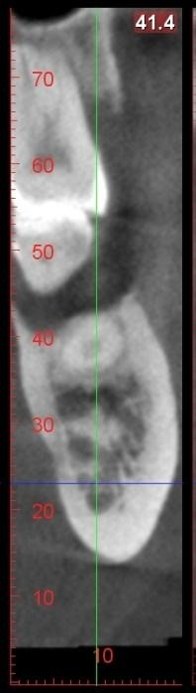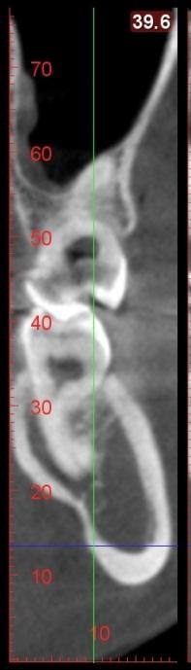

A B C

Figure 5 Presence of anterior canal axial section
