GRAPHS

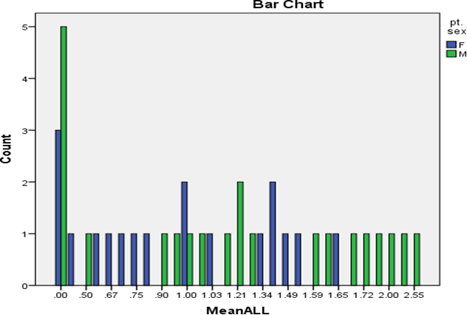

Graph 1 Gender wise comparison of mean anterior loop length in patients

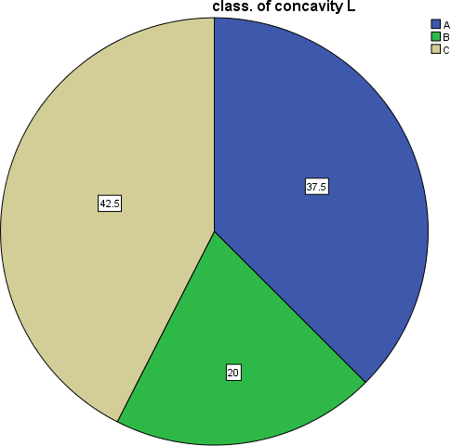

Graph No. 2 Classification of lingual concavity type on left side

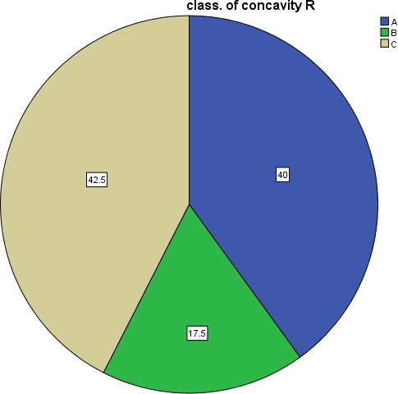

Graph No. 3 Classification of lingual concavity type on right side
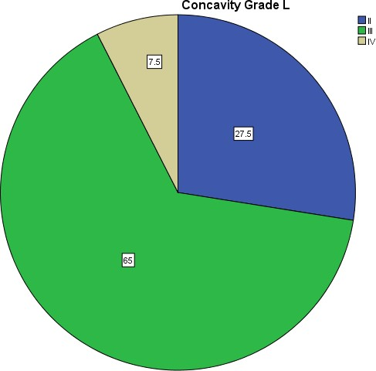
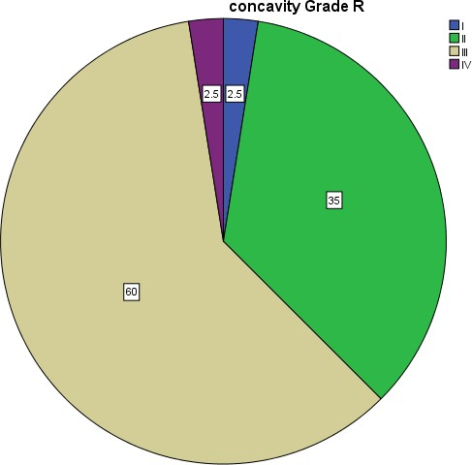
Graph No. 4 Classification of lingual concavity angulation on left side

Graph No. 5 Classification of lingual concavity angulation on right side

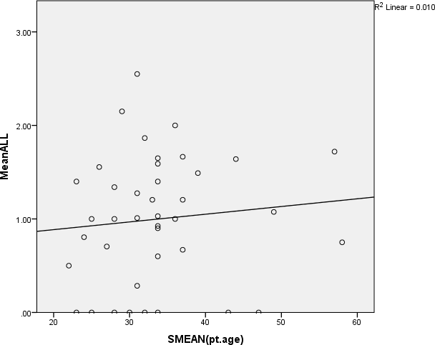
Graph No. 6
Correlation of age with mean anterior loop length

Graph 7 Lingual concavity angle and correlation with right side age and gender

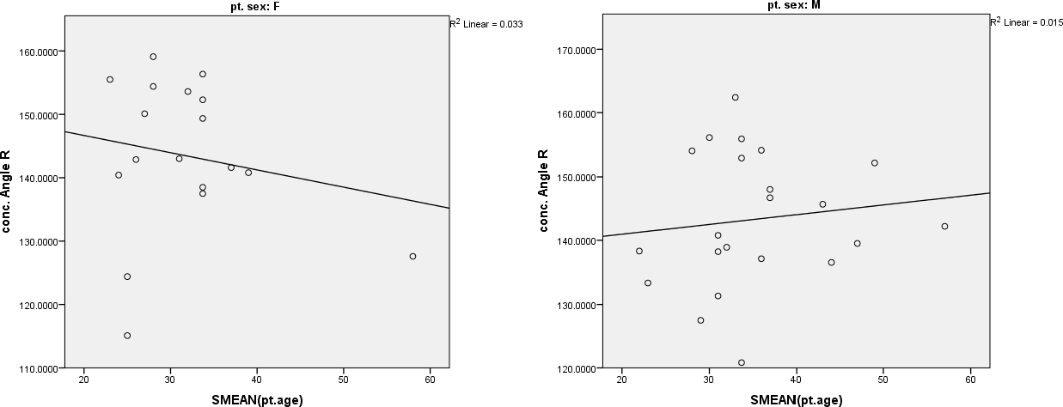

Graph 8 Lingual concavity angle and correlation with left side age and gender
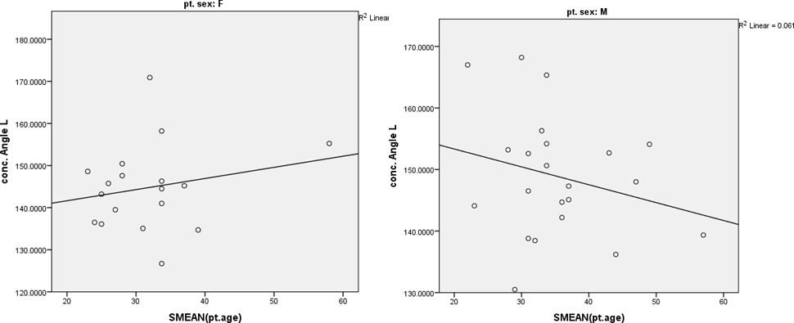

Graph 9 Classification of ridge inclination on right side

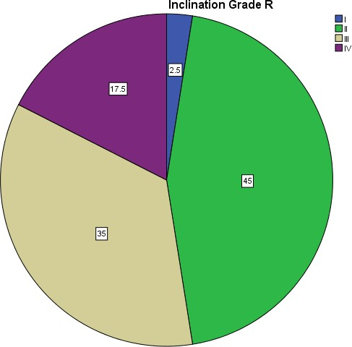

Graph 10 Classification of ridge inclination on left side

