The Correlation Between Sacredness and Architecture in
Madaba, Jordan
Dr. Jawdat Goussous
Sara Mahmood Bayyari
University of Jordan
School of Engineering
Department of Architecture

Abstract
This conducted research is to highlight the prominence of sacred architecture in Madaba, Jordan by bringing awareness to the tourism sector and the local public regarding Madaba’s attraction sites and showcasing its holy significance to the Christian community. It also discusses what makes Madaba’s historical timeline sacred enough to encourage tourism and demand recognition from the public. The research uses qualitative and quantitative analysis as a method of collecting information from the perspective of the public and input into the sacred archaeology of Madaba, tourism rates, recognition of its existence among locals.

Keywords: heritage; historical monuments; mosaic; Christianity; tourism; Byzantine; Roman era.

INTRODUCTION
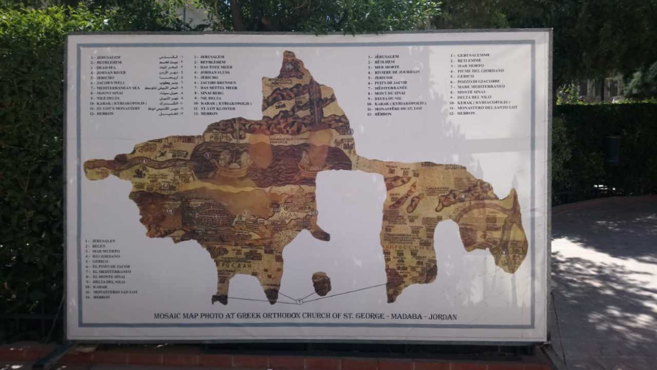
Madaba’s ethnicity goes back to the Bronze Age towards the beginning of the 4th millennium B.C. and the Iron Age c. 1200 and appears to be confined to the area of the west acropolis. It dates back to the Nabataeans and the Romans in 106 A.D. when Christianity became rooted in Madaba as the city expanded to the northern region to reach its furthest in the Byzantine period and shrank in area in the 9th century during the Islamic period. Many archaeologists, researchers and scholars visited the area of Madaba back in the 19th century to discover the magnificent art of the mosaics and interpret, analyse and link them to the biblical verses that created the city’s international reputation. When Madaba was shown to the public, with its ancient history that had been identified, it revealed some architectural characteristics that reflect the events it has gone through religiously, socially and most certainly geographically (figure 1) as there weren’t many available resources back in the day. A typical house would be made of mud bricks or stones. Christian migrants who came from Karak near the end of the 19th century situated their homes near their preferred church and the techniques for the finer homes were inspired by Karaki principles.
(Figure 1) The Madaba Map, author (2018).
One of the prime and most notable discoveries in Madaba are the mosaic which have a long history of being either stolen, destroyed, lost, or removed from their original discovered location; some have been found in houses as they were built directly over the mosaics. It is impossible not to be captivated by the scenery; the buildings themselves spoke of an obsolete rich historical architecture, simple yet mesmerizing. Palestinian architects coming from the areas around Jerusalem, Bethlehem and Nablus designed the fine homes in Madaba which show the uncanny resemblance in the structures between two regions. The Roman influence is evident from how the streets and buildings are structured and presented: “Rome and Italy, for some time the strongholds of western architectural usage, proved impregnable to the Semitic type” (Bernheimer, 1939). Not only that, but the impressive mosaic art on the floors and walls tell a story that is the foundation of Christianity, how the colours of the mosaic contrasted from dark coloured texts on bright walls spread among the churches. The survival of some of the rich mosaics, which are being protected by the government of Jordan, show the importance of the heritage of this city which is prideful for Jordanians to maintain the geographical importance of the land.
How did these sacred monuments affect Madaba’s history? How did the architecture develop throughout the years in light of natural disasters? How did the Roman Empire inspire sacred architecture in Madaba? What makes Madaba standout as one of the top Christian tourism sites?
This research emerges from the inspiration and visual beauty that a person might experience from visiting a prosperous city that tells many tales of religion, sacredness, architecture, new discoveries and excavations, memorials and many more flourishing eye-opening sites.

THE GREEK ORTHODOX CHURCH OF SAINT GEORGE
The church named after the venerated Roman soldier Saint George lies over the remains of a Byzantine church from the 6th century. Unbeknownst to the architects, the church was constructed over the most significant finding in the city’s history: the Madaba Mosaic Map.
The map was almost forgotten and uncared for before its value been determined. Gerasimus sent an architect from Jerusalem to inspect the map, finding it ‘unworthy’ because pieces of the mosaic were missing. Researchers assumed that the parts of the map went missing due to the construction of the Orthodox Church; others assume that the church had gone up in flames, along with the fragmented map.

“Did the Persians cause this catastrophe in 614? We don’t know” (Donner, 1992).

One of the reports on the discovery elaborated that:

“What seems even more remarkable, however, is that Schumacher, Séjourné and Bliss showed no awareness of the existence of the mosaic, although all three had been welcomed as guests by town’s residents (some of whom must have known of the mosaic’s existence) and had actually taken detailed measurements and described the byzantine structure after the completion of the Greek Orthodox chapel.” (Harrison, 2017)

These three scholars, who were interested in the mosaic art in houses such as Farid Al-Masri in 1895, traced the line of an ancient city wall, when inspecting the ruins while leading expeditions through the regions of biblical Moab and Gilead and much more.
In 1896, when the map received its due recognition, Kleopas Koikylides, the Librarian of the Patriarchate of Jerusalem, published a report on his visit to Madaba at the time. With it, in 1897, news of the map spread wildly, and international scholars descended on Madaba to conduct research on the map as it became a source for reading Byzantine history; it documents cities within the Holy Land such as Jerusalem and Neapolis during the 6th and 7th century.
The mosaic map pinpoints the characteristics and topography of Byzantine Palestine, cities like Jerusalem, Neapolis, Jericho, Bethlehem, Gaza, Karak, lower Egypt, the Mediterranean Sea, the Dead Sea, east and west of the Jordan River—the river which allegedly is the site where Jesus was baptized by John the Baptist. Till this day, with all the other mosaic art around, no other maps or art have been found that have the same accuracy as the Madaba Mosaic Map.

THE ROMAN ROAD
What’s interesting is the location of monuments that hold significant historical relevance and how close they are to each other, almost making some sort of a nest. Not even a few meters walking distance, a person can find the Martyr’s Church to the Burnt Palace, the Virgin Mary’s Church and the King Hussein bin Talal Mosque, which, in a way, feels like it combines the city in some sort of a force, a way to bring dominance and unity at the same time; this is what Madaba calls the Archaeological Park. The Decumanus road runs on an east-west axis which is adapted from the Romanian planning of cities that mimics a chessboard; it intersects with the Cardo, the north-south axis. The Decumanus, built between the 2nd and the 3rd century, holds most of the Byzantine churches and Islamic mosques. The changes in the architecture, mosaic art, the continuation of vandalism against these holy structures gave the road its major importance in Madaba’s heritage and continued to change during each century with its civilization.

CHURCH OF THE HOLY MARTYRS AND THE BURNT PALACE
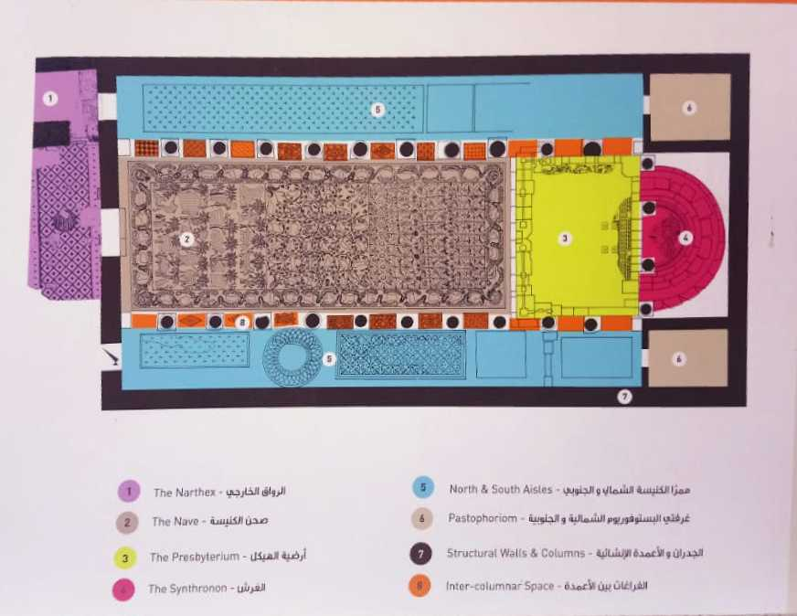
The Church of the Holy Martyrs (locally, Al-Khadir),is strategically located alongside renowned churches on the Roman road and can be dated back to the 6th century A.D. Much like the other unique structures noticed in Madaba, the Roman symbolism is indicated in this specific church (Figure 2).

“Succeeding generations of missionaries born and trained in Europe, generally Southern Europe, continued to bring out with them their own traditional ideas as to what was fitting for the House of God, and thus generations of converts became likewise conditioned. In architecture, the result was a great flowering of Southern European building styles outside of Europe” (Butler,1962).
(Figure 2) A diagram of the Martyrs’ Church, author (2018).

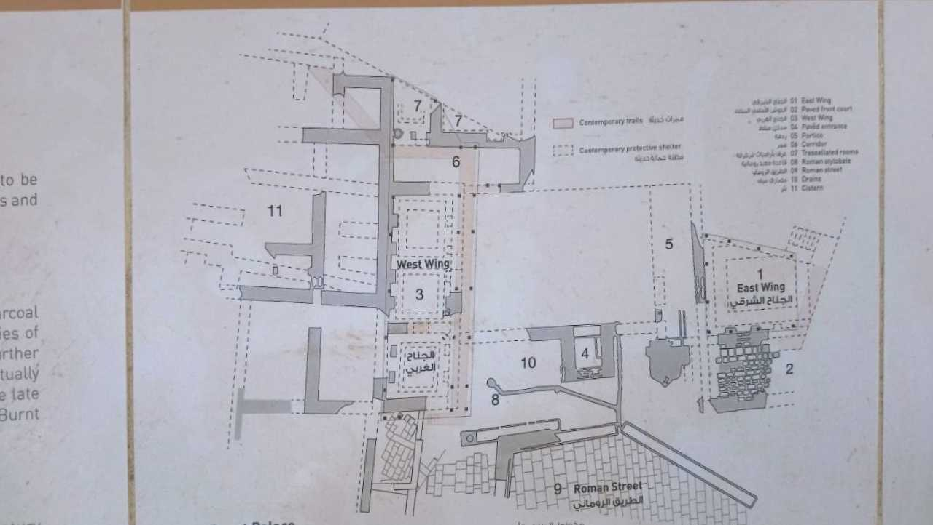
The name of the church emerged in 1994 when archaeologists found a mosaic inscription that translated to the church’s current name. In this compound of churches next to each other, on the northern side of the Martyr’s Church, is the first private building o the Byzantine-era Madaba to be explored, the Burnt Palace. As predicted from its name, one the private residence rooms had caught on fire giving the palace its notorious name. The aftermath of that disaster is the reason behind the notability of this church. In 1905 under a thick layer of charcoal and ashes in the courtyard, archaeologists found a mosaic pavement (which is yet another piece in the puzzle) which served as a decoration on the floor in the room that went up in flames. This is when they named it the “Burnt Palace” (Figure 3).
Another theory said that in the 7th century, an earthquake occurred, demolishing the palace and triggering the fire. This Burnt Palace, from the start of its construction in the late 6th century/early 7th century, also underwent numerous architectural changes through the Umayyad period and beyond. The main entrance’s door has door knockers in the form of a lion’s head, as did the doors in the interior. A continuous grid of mosaic trees, flowers, animals and birds, the central panel has a vast range of portraits of shepherds, ewes and lamps, dogs and rabbits.
(Figure 3) A map of The Burnt Palace and its surroundings, author (2018)

THE HIPPOLYTUS HALL AND VIRGIN MARY CHURCH
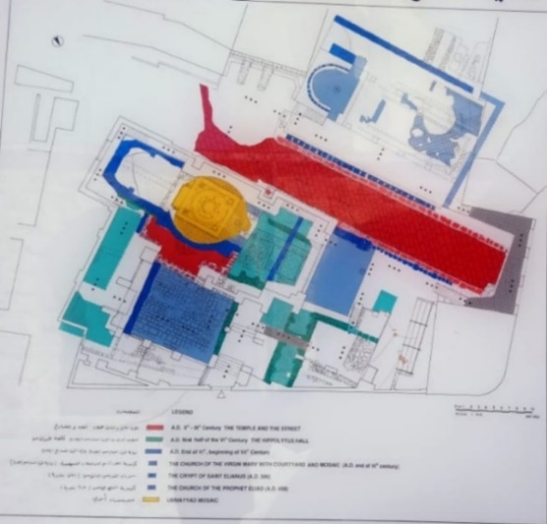
Both of these sacred architectural landmarks were stacked over each other, creating layers of stones and contain a mosaic art piece that was created during the days of Emperor Justinian (527-65 A.D.) in the classical Renaissance depicting more acanthus plants, flowers, trees, and birds. The famous tale of the tragedy that occurred to Hippolytus can be seen in a series of mosaics along the hall; of course, fragments of the artwork went missing—whether they were stolen or destroyed is unknown. Just like many sacred monuments in Madaba, an act of vandalism in 1981 destroyed the chapel.
(Figure 4) A diagram of the Hippolytus Hall and the Virgin Mary church, author (2018)

The Virgin Mary Church was built over the hall itself. The nave took the shape of the circular centre of a Roman temple which tells us that not all the remains of the temple went to waste or was unexcavated; moreover, the nave is supported by underground vaults and arches, with a courtyard in the eastern section of the church (Figure 4).
This mosaic can be dated to the 6th century making it the earliest known work from Byzantine Madaba. The Virgin Mary Church was the subject of several debates over the interpretation of the mosaic art laid on its pavement and what date it could lead back to. There is an ongoing investigation of the Greek inscription as some scholars argue over the real translation of the letters, even dismissing theories from renowned researchers. That empowered the religious reputation of the church and gains insight on Christian behaviour towards their philosophy and history.

ANALYSIS AND DISCUSSION
To go further in depth into this matter, a survey with a questionnaire was conducted to involve the public’s opinion and insight into what specializes Madaba’s heritage as a tourist attraction. In consensus, when asked to describe the city of Madaba in three words, it seemed that Madaba has built a reputation of being touristic, spiritual, multi-religious, filled with mosaics, and simple as it resides in the countryside, yet so rich and fast developing. The local residents of Madaba, comprising 14% of the surveyed, and people who visited, 67.4%, were asked in the questionnaire if Madaba’s experience differs from other cities in Jordan. There were mixed reactions between the two groups as some agreed with the question, mentioning the enormous number of Christian ruins and mosaics that can’t be found in any other city. The minority were those who said that it issimilar to other Jordanian cities in terms of its urban planning and architectural fabric, but it stands out for its historical importance.
Of those who never lived or visited 9.3% and of those who only heard of Madaba mostly know about it being a tourist attraction rather than its religious significance. Of these, 81.4% elaborated more on Madaba’s importance from the historical and tourism aspects; this audience appreciated Madaba as a remarkable city: it is called Mosaic City for its many magnificent Byzantine mosaics in churches that have stories to be told and explained. There is also a school for this craft to keep Madaba as a city of mosaic.
To follow up with the last question, participants were asked to suggest ways to better the recognition of Madaba as a tourist site. They mentioned that advertising through national television, radios, newspapers, educational books, giving out brochures, and to support all of this with a new signage system on the roads would make it easy for tourists to reach and to identify these sites. They think organizing the city’s buildings to make them harmonious with the historical buildings would make the city a part of the history and the visit to Madaba would become more memorable. Some even suggested filming movies and TV shows in Madaba would increase international and internal tourism. Tourism offices should be urged to add Madaba to trips to Aqaba, Wadi Rum, Petra, Jerash.
Mervat Al-Saidat, a resident in Madaba, elaborated further during an interview:

"Madaba is ancient, although it keeps up with everything new; with its people it’ll always keep its authenticity. The mosaics in Madaba are art, and their ability creates a canvas of that material which is extravagant. It preserves the human heritage for the benefit of the future generations and will put Madaba in historical category for those who are interested in human science and archaeology and architecture. Putting these ruins on the map of the tourism and archaeology world will create international awareness in the holy world and among those who are interested in such rich monuments. In addition, it creates awareness to local and international investors to develop infrastructure and services to both local citizens and tourists. It helps enhance the tourism industry in Madaba and Jordan, thus, will create jobs and participate in increasing the Gross Domestic Product (GDP) of the country."

CONCLUSION
History combines the acts of the people who came before us, their thoughts and studies, their beliefs and arts, their harmony and care, their planning and developing. It has played a huge role in creating an atmosphere filled with quaintness, relaxation, richness in such a small city like Madaba. Its value isn’t for nothing if all those archaeologists had excavated it for centuries and bringing awareness to its existence will most certainly be eye-opening for everyone to receive pleasure from visiting it.
Preserving Madaba’s archaeology and monuments is a duty of ours, and it keeps reminding us of its culture and complexity, its history through the ups and downs and conquests; it is a piece of the entire country’s existence and maintains a sense of permanency.

“As for really new ideas of any kind―no matter how ultimately profitable or otherwise successful some of them might prove to be―there is no leeway for such chancy trial, error, and experimentation in the high-overhead economy of new construction .... Old ideas can sometimes use new buildings. New ideas must use old buildings.” (Jacobs, 1961)

The survey didn’t prove that there is much understanding or motivation from the youth on history in general, let alone knowing what Madaba’s identity holds or realizing the name and reputation it could be having for the country if it understood the humbleness of what archaeology showed us throughout the years. Existence of unique historical objects can predetermine successful development of tourism in the region and Jordan literally has one of the biggest attractions for Christians who can live and experience, within hours, the story of a religion.
The lack of investments shadows the cultural heritage almost completely. The essentiality of educating the youth on historical and cultural heritage of the country on the whole is based on understanding important roles of cultural cognitive activity for a person and to enhance it by being a part of it. Despite the obsolete history of Madaba, it is still developing independently but still keeping with its initial rural characteristics and the hidden gem that is missing from international and internal recognition.

REFRENCES
- Bernheimer, R. (1939) An Ancient Oriental Source of Christian Sacred Architecture. Archaeological Institute of America, Vol. 43, No. 4 (Oct. - Dec., 1939), pp. 647-668
- Bikai, P. (25); Thomas A, D. (2) (1996) Madaba cultural heritage.
- Butler, J. (1962) Nineteen Centuries of Christian Missionary Architecture. University of California Press on behalf of the Society of Architectural Historians Vol. 21, No. 1 (Mar., 1962), pp. 3-17
- Di Segni, L. (1992) The Date of the Church of the Virgin in Madaba
- Donner, H. (1992) The mosaic map of Madaba: an introductory guide. Kampen : The Netherlands,, (1992)
- Gregory, C. (1897) The Madaba MapThe University of Chicago Press The Biblical World, Vol. 12, No. 4 (Oct., 1898), pp. 244-250
- Jacobs, J. (1961) The Death and the Life of Great American Cities.
- Piccirillo, M. (1976) New discoveries in Mountain Nebo.
- Piccirillo, M. (2007) Mount Nebo.Studium Biblicum Franciscam Guide Books
- Staller, S. (1966) Iron Age Tombs At Nebo, Jordan OFFPRINT of StudiiBibliciFranciscani Liber Annuus XV (1996)

