Integration of Disaster Management with Solar Technology for Disaster Relief

S. S. Author

***Abstract****: The benefits of solar power are widely known and accepted for general industrial, government and consumer use. The work in this paper demonstrates the significant benefits of the use of Photovoltaic Arrays for disaster response and compares their use to the normally deployed generators (gensets) which are commonly deployed in emergency response. In this paper, we consider the case of India, which has a large population and is highly vulnerable to natural disasters. [1] Society is seriously affected by the power outage caused during disaster, because electricity is the most common and basic infrastructure that supports modern life Most of today’s global service depend on electric power from basic lighting to advanced facilities such as communications and medical services. Modern life deteriorates without electrical power even for few hours thus a rapid delivery of emergency power is a crucial aspect of a successful response to disasters.*

*In this paper, we focus on the use of PV based generators for the Indian sub-continent and show that portable solar energy systems are especially effective when used to deliver critical services promptly. Renewable power also minimizes fossil fuel usage which in turn helps reduce carbon emissions reducing climate change.*

*Solar technology can be provided in a mobile format, e.g. Rapid-roll* [2] *which unfurls solar arrays like a carpet behind a truck, These array can be rapidly deployed to generate energy in the region of catastrophe delivering power rapidly to a mobile clinic with 120 beds/ Such a system is capable of an average of 11KWh of energy especially when connected to batteries that can store 24KWh for non-sunshine hours. The mobile solar power can also provide refrigeration for medical supplies, water filtration systems and communication equipment that are required during a recovery process. In the case when recovery lasts a long period of time, generators will need large amount of fuel which gives solar power an advantage. In India fuel emissions are increasing at the fastest rate for 7 years and even though India has the solar target of 100GW by 2022 only 28GW has been installed since 2011.[3] Given that India is world’s most disaster affected country and among the top 15 countries suffering power outages[1] and abundant sunshine[3.3] that solar power is highly suited for disaster relief operations providing significant relief and helping the country realize its solar mission target.*

# Introduction

Solar PV and related technologies have advanced considerably, while diesel gensets continue to dominate as emergency power supplies for disaster relief efforts. [3] The use of diesel power also generates greenhouse gases contributing to climate instability which in turn can lead to additional disasters [3.3].

Oil reserves continue to decrease - out of 20 big oil fields in the world, 16 have reached to the peak production level. To keep the average increase in global temperature below 1.5°C, it is important that 80% of the fossil fuel are left under the ground. But globally our dependency on fossil fuel are rapidly increasing with time. [3.1]

In the case of disaster, the Disaster Relief Team primarily focuses on the continual supply of diesel fuel for power generation, fleet vehicles, refrigerated storage, light towers and LP gas for kitchens, showers, laundries and hot water requirements for emergency services. [3.2]

There are considerable opportunities to make use of solar energy instead of diesel power when planning for disaster management for a country like India which has abundant sunshine throughout its varying landmass. [3.3]

India is most prone to natural disasters like flood, storms, earthquakes than anywhere else in the world having the highest fatality rates from natural disasters.[3.4] The country is also among the top ranked in oil consumption, CO2 emission and death due to air pollution.[3.5] To deal with these adverse situations, India has embarked on a very ambitious program to switch to solar power named the ‘National Solar Mission’ which is targeted to achieve 100GW of solar power by 2022.[3.6]

Solar power is well suited solution for its sustainable and stand-alone capabilities, but for general grid use will require considerable investment and re-engineering to surpass the use of fossil fuel generated conventional power. However, PV systems appear to be an effective approach to replace the emergency power from DG in India where around 5 million diesel generators are installed having the capacity of 15 KVA and more and consume the diesel worth 13 billion dollars in a year. [3.7] This article explores and identifies possible solar applications using emergency power for disaster relief. In India, the community is also supporting solar powered schools and hospitals which are deployed as shelters during disasters.

The present investigation identifies and evaluates widely available PV generators which can be used to support various disaster situations. The effectiveness of portable mobile solar generators is also investigated in the support of DC appliances such as LED lights, low voltage refrigerators, USB charging ports, hybrid boilers, water filter unit for medical services and emergency shelters during a disaster. Using data and statistics available for the duration for which emergency power is required, the cost is compared between solar power vs diesel generators. In addition, a pilot implementation of 150W Portable Solar Generator is evaluated which can be taken to any disaster or remote sites needing emergency power.

Data and statistics for these analyses from the regional and national bodies from the energy and disaster management agencies were used as explained in next sections.

# Benefits of Solar Technologies

Renewables are affordable and viable technologies for safe energy-generation to increase system resilience. Solar PV arrays can be used to replace diesel generators, to power mobile medical camps, and reduce reliance on fossil fuel.

Portable solar power systems are standalone devices that can be delivered to required locations on demand and can operate independently of the power grid. Compared to portable gas generators, the solar systems which need no external fuel.

Portable solar power is indispensable in a catastrophic situation, also they are very useful in various on-demand ad-hoc applications. Mobile PV systems can be brought to remote areas like construction sites and other places needing a temporary source of power. Stand-alone solar systems can be highly cost-effective for remote locations and houses and commercial organizations of rural areas where acquiring the grid power is highly expensive and difficult. Solar-enabled mobile vans and temporary camps are very useful in the consumer and commercial spaces.

Recent advances in solar power generation technology, that is the increased efficiency and storage, have resulted in increased calls for the use of solar power as an emergency backup system and for use in disaster response and recovery efforts [4].

The benefits of PV also compete favorably to those associated with maintaining and operating portable fossil-fueled generators, especially if the solar panel subsidy, solar tax credit, carbon credit [5] are also considered.

# Preparedness for Disaster – Diesel Generators or Solar Power

The key challenge in India, a home to 1.3 billion population, is the preparedness for disasters, as the country faces recurrent phenomenon of floods, droughts, cyclones, earthquakes and landslides due to its unique geographical and climatic situation. [6]

The earthquake prone land mass in India is around 60%; about 8% of the total area is vulnerable to cyclones; 68% of the area is drought prone and over 40 million hectares is susceptible to floods. [7] Also globally, natural disasters are becoming a serious concern due to increasing floods, cyclone, dust storms, hurricane and earthquakes causing power outages in large areas for a prolonged period. Blackouts due to electricity problems itself becomes a disaster situation and needs a serious attention on improving the reliability and sustainability of the electricity sources thus calling the need for renewable energy sources. The below table illustrates the various benefits and challenges of the use of PV and Diesel-powered generators

|  |  |  |
| --- | --- | --- |
| **Key Characteristics** | **Solar PV** | **Diesel Power** |
| Initial Investment | Very High  ($2k-3k / kW) | Moderate High  ($300-500 / kW) |
| Recurring Cost | Very Low  (Free) | High  (30-40 cents / kWh) |
| Reliability | High | High |
| Durability | 20 - 30 years (PV); 5 year (batteries) | 25,000 operating hours |
| Sustainability | Very High and never ending | Very Low  (will be finished in 50-60 yrs.) [7.1] |
| Special Considerations | Theft;  Skill Availability | Fuel spills |
| GHG Emissions and Environmental Damage | None | Very High |
| Optimal Use | Minimal load for rural areas having less affordability and remote areas where electricity grid is not available | Larger Loads |
| Weight | Moderate  (20-22 kg; 1kW) | Moderate  (13-15 kg; 1kW) |
| Dimension (power density) | Very High  (10 sq. m; 1kW) | Low  (1 sq. m; 1KW) |
| Portability | Moderate | Moderate |
| Scalability | High  (can add solar panels on demand0 | Low |
| Noise | None | High |
| Safe to operate | High | Low |
| Energy Subsidies and Government Target | Very High  (India govt. target to achieve 100GW by 2022) | Low and reducing  (taxes increasing / ban on over usage of diesel cars) |

In a disaster situation, the key response lies in supporting rescue, shelter, medical and communication capabilities by the disaster response teams. All these disaster relief services need electric power. In most of the disasters, the normal electricity power is disrupted thus dependent on alternative power sources, primarily diesel generators, to provide these services and resources. When recovery needs extended time, the generator will need large amount of fuel.

Government of India has launched a National Disaster Management Plan [7.1] which is the first national-level plan in the world for Disaster Risk Reduction aligned to the Sendai Framework. It forms a key aspect of strategy formulation for disaster preparedness and responding to the disasters. The Ministry and the relevant departments are given the responsibility of arranging alternative sources of power like generators, solar lanterns, portable lights, etc. until normal power supply is resumed. Worldwide, disaster management programs are devised which provide training and for disaster response teams detailing various methods of rescue and relief operations depending upon the conditions and damage. Simultaneously, communities are also concerned with environmental issues hence these programs, normally focused on rapid response also need to take into consideration a more renewable approach in the case of temporary power by using renewable sources

The ‘Pandit Jawaharlal Nehru National Solar Mission’, commonly known as the National Solar Mission, is an initiative of the Central and State Governments of India for promoting solar power. [3.6] This mission is also a part of the National Action Plan on Climate Change. The objective of the National Solar Mission is to make India the global leader in solar power implementation by making policies for its growth and spread across the nation. Th target of this mission was to achieve 20GW solar installed capacity by 2022 which has now been scaled up to 100GW by 2022[8].

With the solar plants established in Rajasthan, Gujrat and in smaller capacities in UP, Bihar, overall generating 3 million kWh over 20 years [9], the major Environmental and Economic Benefits to the country include:

* Diesel savings over 20 years will aggregate to 3.5 Lakhs Liters
* Equivalent to offsetting 2,000 tons of Carbon or taking 400 cars off the road
* Innovative financing solution: combination of part payment, capital subsidy and feed in tariff, with a per unit of cost of delivered electricity being cheaper than conventional power cost of Rs. 9.5/kWh

In India, the cost of diesel power has exceeded steeply in last 10 years and is more than the cost of solar power. Solar PV now-a-days generates power at an average cost of about Rs. 7-8.50/kWh in India. [3] An increase in price of more than 300% in last 15 years and 46% since 2010 is a matter of concern for industries that are dependent on power generated by diesel (the inflation rate during this period has been 3-5%). The average cost of diesel is Rs. 68/liter in 2019 and the diesel power cost is around Rs. 20/kWh in India. Besides that, the average diesel cost even more exceeds when the pilferage and evaporation losses are accounted for.

# Disaster Management and Solar Technologies

As of late, there has been some utilization of photovoltaics in disaster aid projects. [10] They have turned out to be a compelling option in contrast to gas or diesel control generators. PV modules can be a substitute for gas or diesel-controlled generators in a portion of the disaster activities. They are basic systems which enable a fast response to a disaster. Lighting, water treatment, communications and so on are required by the disaster relief specialists to work and these can be quickly met with solar power. The Florida Solar Energy Center (FSEC) and the National Renewable Energy Laboratory (NREL) have been the pioneers in utilizing photovoltaic power for crisis response. [11] They have both created and utilized PV fueled disaster systems for disaster response and recovery.

NREL conducted an analysis microgrid using the REopt model to find out the probability of sustaining a grid outage by using only generators with a supply of diesel fuel that was sufficient for 2 days, and then modelled the same scenario using a hybrid system which added solar panels and battery storage to the generator (1.9 megawatts PV, 411 kilowatt hours/329-kilowatt battery).

The results indicate that energy supply is more secure when solar energy and energy storage technologies are included in the grid system. The diesel fuel supply for the generator only lasted five days at most given the assigned critical energy loads. The hybrid system could provide power for up to 12 days, allowing the diesel fuel for the generator to last a greater length of time. The extended operation shown in Figure 1 depends on adequate controls for concurrent operation of these energy assets.

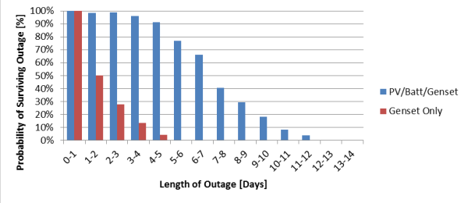

**Figure 1**. Modelled REopt Results Comparing Generator Energy Supply to a Hybrid System  
Source: Travis Simpkins and Dylan Cutler, NREL

This analysis shows the need for mobile solar systems which can aid to disaster relief efforts in the event of power outage. There are multiple range of categories in the mobile solar generators. These polar solar systems can be mounted onto trailers or carts and driven to the site where it is needed and utilized to power medical facilities and relief shelters during disaster, kitchens, campsites or whatever facility needs power supply. There are other small portable systems called solar suitcases i.e. small solar generators capsulated in boxes that may be carried by hand, is valuable as early response tools because it can be delivered to an emergency site on foot. These systems, though small, will power necessary emergency necessities like mobile lighting, medical devices, communication devices, computers, etc. alternative energy may also be engineered into dedicated complete devices like water filtration tanks required for clean water system amidst disaster.

More specialized systems are employed in disaster relief efforts like Canadian energy solutions company’s EnerDynamic Hybrid Technologies (TSXV: EHT) [4] that has developed a mobile car port with a PV electric cell roof that generates energy whereas providing shelter for vehicles. The structure is meant for robust conditions and severe weather so creating these carports appropriate for disaster response functions.

The other innovation from this company is the modular building which might be shipped to areas of emergency and assembled quickly in preparation for or within the immediate aftermath of a natural disaster. Despite the pre-configured style, these structures are engineered with the strength necessary to resist the severe conditions expected during a disaster. These standard building styles incorporate PV solar cells within the roof, permitting the building thus providing both shelter and independent energy supply, operational for its own heating and electricity for the disaster hit population.

In another analysis done by a solar solution provider -Renovagen’s company where they turned up with FAST FOLD [12] equipment on two days’ notice at a site hundreds of miles away from their base in Milton Keynes in UK. The company provided a rapid deployment replacing 3 generators which ran for 24 hours a day with 1 FAST FOLD system and 1 generator running for 6 hours a day. This saved approximately 87% of the fossil fuel they would normally consume over the same period.

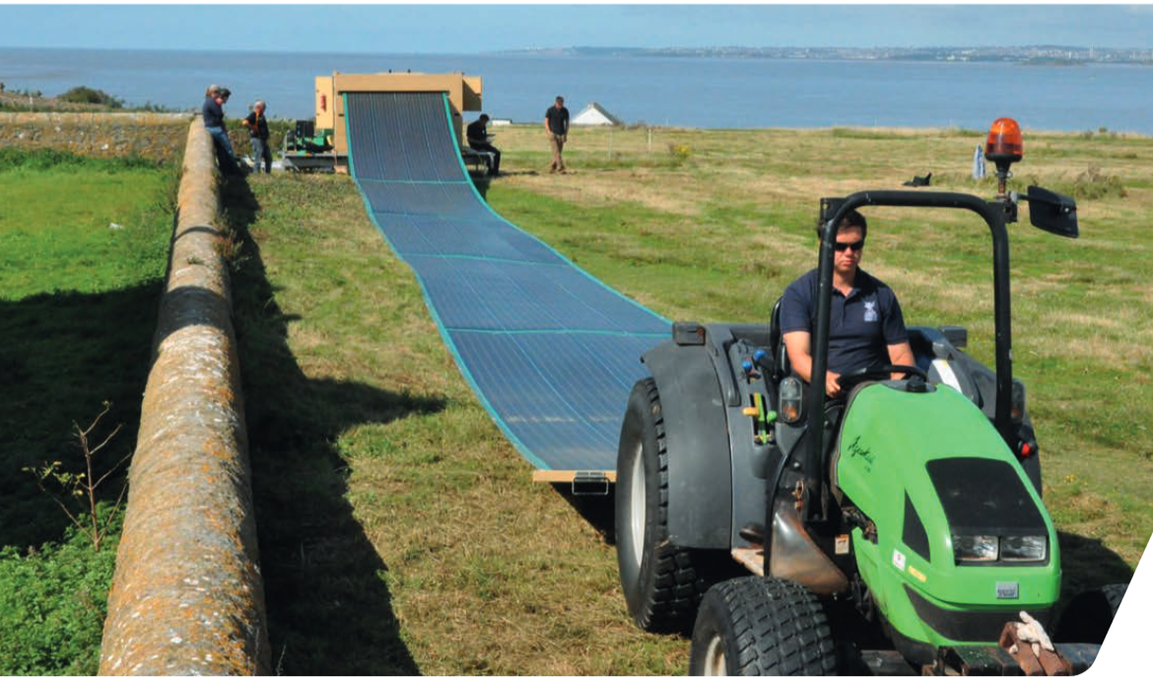

**Figure 2**: Rapid Roll unfurling solar arrays like a carpet from behind a truck [2]

The pioneer innovation for solar energy called the Rapid Roll [2] framework instead of diesel generators, claims to be a Game-Changer for Disaster Relief and for environment protection from future disasters.

Rapid Roll framework provides a system to unfurl the solar arrays like a rolled carpet from behind a van. making it a mobile solar technology.

These mobile high-proficiency solar panels could help produce instant energy in disaster territories. The Rapid Roll solar panels produce an average 11KW power, associated with the storage batteries of 24KW/h. That is about the energy needed by a family in a day. The best part is that these portable solar panels has the lasting capacity of around 10 years.

## Growing Natural Disasters and Increased Power Outages

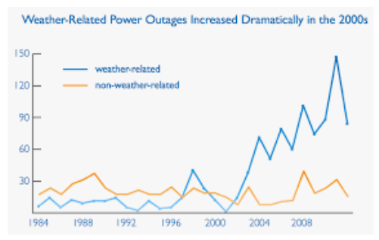

**Figure 3**: Weather-Related Power Outages Graph[13]

• India Blackout, 2012[14]: Two serious power outages influenced a large portion of northern and eastern India in 2012 on 30th and 31st July. The outage of 30th July hit more than 300 million people and was recoded as the biggest power blackout in the history by number of people affected, beating the record of January 2001 power failure in Northern India influencing 230 million people. An expected 32 gigawatts of generating capacity went down. An article in The Wall Street Journal expressed that of the influenced populace, 80 million were lacking direct access to power. Power was reestablished in the influenced areas between 31st July and 1st August 2012.

• NORMAN Storms, 2019[15] —Norman, a city of Oklahoma, USA comprising of nearly 4,000 habitations endured power blackouts on Thursday 3rd Jan 2019 as the consequence of ice and snow. Oklahoma Gas and Electric (OG&E) representative Karen Kurtz said roughly 3,000 OG&E clients were influenced, and, starting at 4 p.m. Thursday, 230 Norman inhabitants stayed without power. Over the state, OG&E detailed approximately 7,800 blackouts.

• Hurricane Maria ripped through Puerto RICO in Sep 2017[14] — the storm caused the worst natural disaster in that region. Even after a year later, the small U.S. territory continues to be reeling. Not solely was the storm the worst to hit a North American nation territory in eighty-five years, however Puerto Rico’s infrastructure and disaster response support was lamentably unequipped to retort to such a disaster, a reality underscored by the fact that the overwhelming majority of more than 3000 deaths occurred when the storm itself was over. As emergency responders and relief staff disorganized urgently to supply aid, the shortage of access to reliable electricity that took till August 2018 to completely recover, hampered these efforts severely and left lots of Americans missing with the basic needs.

## Application of Solar PV in Disaster Response

In developed countries like USA, PV frameworks have of late provided emergency power in the consequence of numerous past disasters:

• Northridge Earthquake, 1994: The quake caused boundless power blackouts all through the Los Angeles region and past. The whole Los Angeles Department of Water and Power frameworks went down. This prompted 1.3 million clients to be without power. Half of the clients recuperatedpower within six hours, and within 24 hours, 95 percent of the clients were back to normalcy. Notwithstanding the utility's convenient rebuilding of intensity, near 100,000 homes and business were without power for over 24 hours. Water supply was additionally disturbed because of breaks in the supply and conveyance lines. The utilization of PV kept a few correspondences joins working. It likewise provided capacity to Southern California inhabitants that had installed systems in their houses. (U.S. DOE 1995) [13]

• Hurricane Andrew, 1992: In the storm 3.1 million people suffered power outage. Water and waste water utilities were damaged intensely as the trees fell over the water distribution lines and the water pumps were also disabled due to power outage. Some areas like Miami resumed the power in 2 weeks while others suffered the power outage for a month. Long before the Hurricane, PV-powered solar lights were installed which remained as the only source of light during the disaster rescue and relief. The Florida Department of Transportation was already having variety of solar devices which they were using for road construction. That remained operational during the storm and after the storm was settled, the AM radio powered with the solar system transmitted route changes and road hazards in the disaster area. (U.S. DOE 1995)[13]

• Hurricane Hugo, 1989: On 21st Sep 1989, the classification 4 sea tempest hit South Carolina. Folly Beach, Charleston, Sullivan's Island, McClellan Ville and Isle of Palms were hit hard. Sea tempest Hugo left 26 individuals dead in South Carolina alone. The harm gauge would go as high as $7.2 billion (in 1990 dollars). Sixty structures in downtown Charleston were flattened. 11,928 additional homes were left uninhabitable and 5,100 homes were destroyed. Harm was accounted for in 29 counties, the clear majority of which were assigned as government disaster zones. 98% of the city's occupants lost power, and for a few, fixes were not made for over about 14 days. A portable solar PV generator —powered a community center for 6 weeks after the storm. (U.S. DOE 1995)[13]

• Superstorm Sandy had hit New York on 29th October 2012, and the worst hit region was the mid-Atlantic state, After the storm, they started investing in solar min-grids locating them at strategically safe place where the critical functionality can be operated in case of any future disaster. These strategic solutions however needed high initial investment, hence more inexpensive and simple solutions were needed in the regions which were suffering from energy poverty following disaster.

A picture containing sky, outdoor, ground, building

Description generated with very high confidence

**Figure 4**: Solar generators used during Superstorm Sandy in New York [16]

• Throughout Puerto Rico’s 11 months within the dark since September 2017[4], relief workers, non-profits, and America’s renewable energy firms worked to assist in giving the individuals within the hardest hit communities with electricity. several the best tools that they'd at their disposal were transportable renewable energy systems that allowed them access to reliable and free energy when Puerto Rico’s power grids had failed, permitting individuals access to light, clean water, communication services and tools for reconstruction of crucial infrastructure and resume the normal life.

As the portable portable renewable energy system industry continues to develop and these systems become more widely available, there’s hope that for future disasters responders will have access to the best possible tools to mitigate the devastation. We can’t prevent natural disasters, but we can be prepared for them.

# Solar is the solution

As we are aware the fossil fuel is reducing at a very high rate and if we do not switch to other form of energy at this stage, we will leave nothing for our coming generations. Fossil fuel on the earth is finite. People won't be able to burn and derive energy any more beyond the lasting periods which is as close as the following for some of the fuels: [7.2]

(i) Coal ... 120 years

(ii) Oil .... 250 years

(iii) Nuclear fuel … 200 years

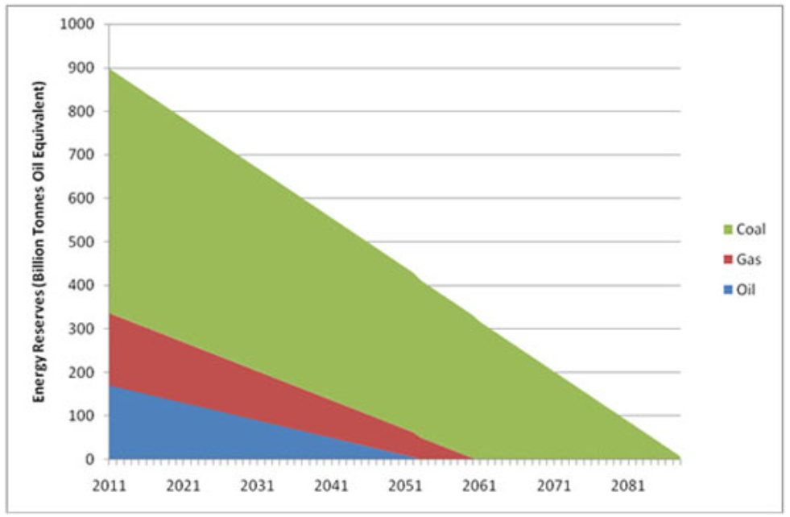

**Figure 5**: Graph showing future energy reserves for coal, gas and oil. [3.1]

Moreover, how far is it justifiable for the energy packs, which have taken millions of years to form to consume in the next few generations. Just because the future generation is not present to bid today we are claiming our stake on the entire coal blocks and the oilfields.

Solar energy being abundant in nature is a suitable alternative at this stage, since we now have the technology to channelize this solar energy for power generation. Half of the earth is always receiving incessant energy in the form of solar radiation.

Everybody realizes that regions hit with cataclysmic events require some investment, exertion, cash and frequently rely upon repetitive political negotiations before starting the recovery. Reestablishing power in such territories is one of the more urgent parts of disaster response.

The pilot implementation of a 150W portable solar generator as an alternative to diesel generators in India, proposes to be a better solution for Disaster Relief and for environment protection from future disasters.

Portable solar generator is compact enough to carry it at the emergency site inside a van or a truck. making it a mobile solar technology. The weight of the model is 14.3 kg and the dimension is 26.0 cm × 31.0 cm, 22.0 cm height smaller than a comparable 650-Watt diesel generator which generally has a dimension of 36.6 cm × 30.8 cm × 37.6 cm.

These mobile high-proficiency solar panels could help produce instant energy in disaster territories. The PV power can be enhanced by making use a PV extension port. The best part is that the solar panels used in these portable generators can last up to 10 years.

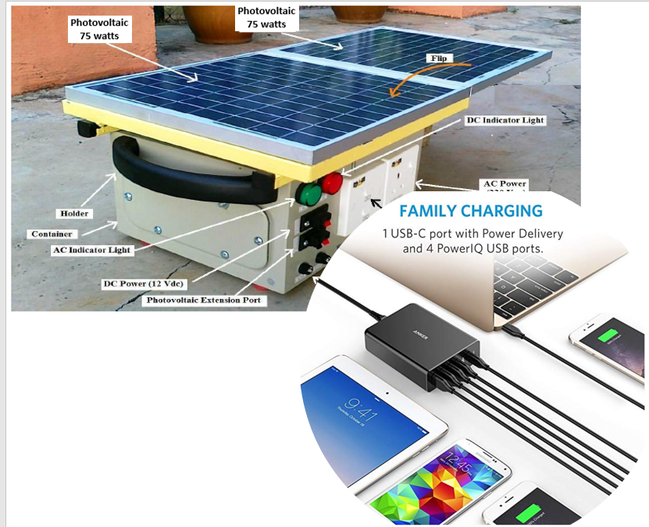

**Figure 6**: A pilot 150 Watts portable solar generator

The diagrammatic illustration of the pilot design is depicted in Figure 6. The output power of the portable generator is used to supply power to the AC load and DC (Direct Current) load simultaneously with USB-A, USB-C and DC cable. The DC output is having 12 Vdc which is protected by a 15 Ampere fuse whereas the AC output is having a single phase 220 Vac provisioned for low power emergency utilities like Small Fridge. The current of the main fuse is 20 Ampere and it is used for the protection of inverter and battery. For a cloudy weather or night hours, the provision of charging from electric power grid is also by changing the switch to AC input power port. Switches are also provided for switching between the DC and AC power. The circuitry design of the typical PV system is shown in Figure 6.1.

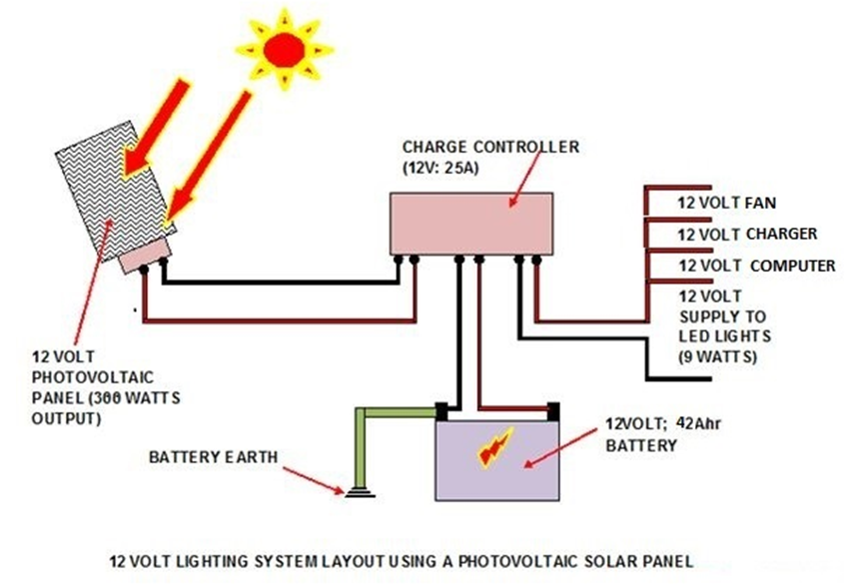

**Figure 6.1**: The PV system design for portable solar generator

## ROI calculation

The cost and ROI is calculated below. 650W diesel generator is consuming an average of 4.2-liter diesel operating for 8 hours. If we use it for 3 hours a day powering light, fan and mobile charging sockets with the cost of the diesel at Rs 52/day then the yearly cost would come to Rs 18,997.

To replace the diesel generator if we invest in Solar installation with 150W Solar Panel, 12V 105Ah Battery, 12V 10A Charge controller, 375VA Inverter, the total investment along with the installation charges would cost Rs 22,513.

|  |  |  |
| --- | --- | --- |
| Return | ₹ 18,997 |  |
| Investment | ₹ 22,513 |  |
| ROI | 84% |  |
| Payback Period | 1.2 | yrs. |

Here, the payback period is approximate a year. Moreover, after the return on initial investment, the solar panel will last upto 10 years without any recurring cost except the battery replacement at 3-4 years.

The entire solution can be scaled up or down and panels can be reused for future disasters to improve ROI / extend life usage and can feed to the grid when not in use.

## Analysis

Solar irradiance is the foremost necessary factors within the design and operation of the PV systems and it will have a big impact on the potency and power quality response of the full system. The results from the experiment were calculated by applying ADAM-VIEW Programme [17]. The PV panel’s peak performance of the day is shown in Figure 7. The peak energy generated by 150-Watt PV panel was 650 W-Hr. Since the average radiation in the country is between 4-5 hours a day, the power generated by the solar system will vary. Therefore, to produce sufficient energy, the PV size needs to be enhanced. Since the PV panels are virtually flat, it is suggested that the collectors should face north in the southern hemisphere and should face south in the northern hemisphere [18]. India being in northern hemisphere, it will get maximum sunshine while facing south.

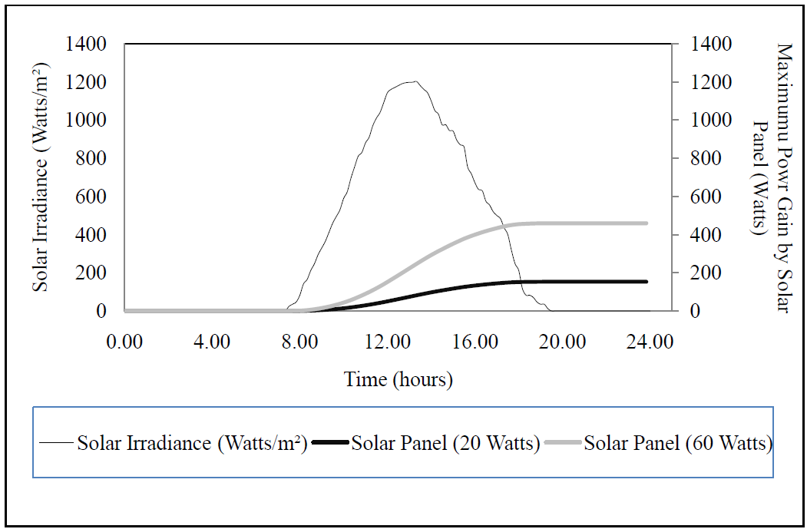

**Figure 7**: Peak power generated by PV at peak solar irradiance in a day

Figure 8 depicts the inverse relation between load and the duration of the operation time of solar generator. This gradient of the above graph explains the decrease by the increase in load. For a 5-Watt load, the PV generator operates until 96 hours, but for a load of 150 Watts the operation time reduces to 2 hours. The battery has a minimum threshold below which it will be dead, it cannot be completely discharged. Going beyond the threshold can decrease the battery life, generally the battery should have a minimum of 30% energy. The battery thus needs to be secured by making use of an inverter which is set to 10.5 V as a threshold voltage, and it will cut-off below that limit. In DC power, this battery is protected by using a PV charge controller having the threshold of 8V i.e. it cut-offs if the voltage drops to 8 V. The PV generator is best suited for powering the emergency camps during disaster situations using upto 150 Watts power lasting for 4-5 hours.

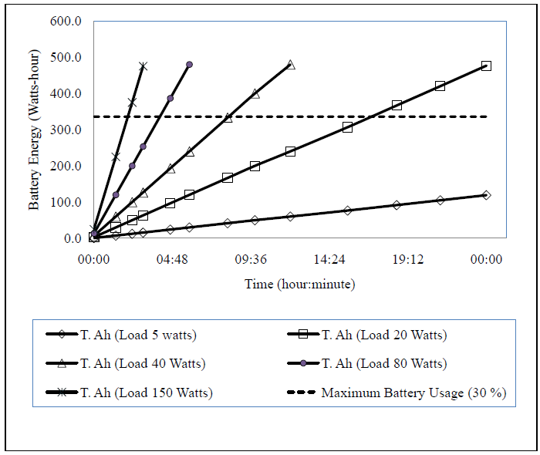

**Figure 8**: Load and duration of operation of the portable solar generator

## Result

The mobile PV generators have the potential to replace diesel generators in future remarkably for emergency power and to run small electrical, electronic and medical appliances needed during disaster response. The cost of maintenance is low where only the cost of battery is involved which needs to be replaced once every 3-4 years. It is small enough to carry in a trolley, lighter than diesel generator and transportable and efficient for use at emergency or remote sites and also as backup power supply when any mainstream power system fails during the disaster situations.

Assuming that 1,000,000 people are affected per outage due to natural disasters in India and there are 5 such outages in a year lasting for a week, we may calculate the total electricity that was needed as emergency power was 100 million kWh.

5 climate related outages x 7 days of outage per event x 1,000,000 affected people x 3kWh per person emergency need x 6.5 liter of diesel = 650 million liters of diesel needed per year.

If the need of emergency power is fulfilled by solar gensets instead of DG sets, we can save on 650 million liters diesel annually on one hand and contribute to 100 MW towards National Solar Mission. [20]

Moreover, when the investment is returned after a year, we would continue to get free energy for the future disaster responses without any fuel consumption for well over 30 years.

# Conclusion

Solar power is widely used after a major disaster in developed countries to provide access to reliable energy to overcome the power outage. The off-grid, low-cost and portable solar energy systems are made available to help the victims in providing the basic needs and to relief workers to perform the rebuilding process. [19]. India too needs a greater focus on adopting and investing in the solar energy solutions amidst the disaster response and recovery in the future which could contribute to the success of national solar mission. [20].

The author is trying to attain the focus of government’s solar mission towards government owned expenditure in which the disaster response and recovery is the big consumers of emergency power where solar can best fit due to its environment friendly nature. Keeping in mind, the operating cost, fuel transportation cost and environmental effect of diesel gensets in india, it is concluded that Indian government should focus on integrating solar technologies in place of diesel gensets for disaster management. It is further concluded that usage of diesel gensets cannot be ruled-out in the adverse scenario i.e. not having sunlight available in the initial days of disaster rescue and relief operation. However, for the normal scenario, if the ministries and the industries engaged with solar power generation or storage take an initiative in disaster response and recovery activity, this source of energy will ultimately reduce the dependency on gulf countries for diesel procurement.

India government is solely dependent on diesel as emergency response during natural disasters and other calamities. Portable solar solutions for emergency power is not only environment friendly but also once solar PV is installed, it will provide free energy for the life of the system, which is well over 30 years. The cost after the initial setup cost is lower than that of a diesel. In India Solar PV offers power at Rs. 7-8/KWh (8.6 cents/KWh) whereas diesel power costs Rs. 39-40/KWh (50 cents/KWh). [21] and thus it also becomes cost-effective in the long run.

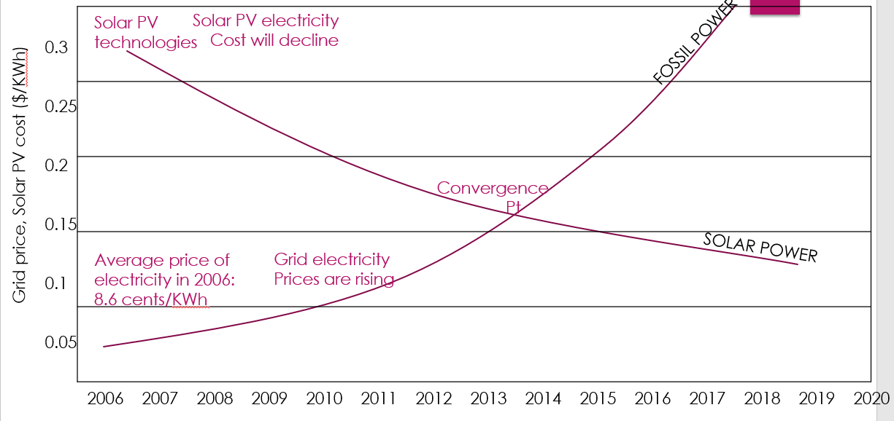

**Figure 9**: Cost Comparison – Solar Vs Fuel Power

We see that use of diesel and other non-renewable energy sources adds to climate change and stronger and frequent storms, and we also see that India’s investment on Solar is getting an efficient and valuable return if utilized as an alternative to diesel generators for emergency power response. It truly is the ideal opportunity for the integration of disaster management with Solar Technology for Disaster Relief.

# List of Abbreviations

GW Gigawatt

AC Alternating Current

DC Direct Current

DG Diesel Generator

GHG Green House Gas

KWH Kilo-Watt Hour

AHr Ampere Hour

UPS Un-Interrupted Power Supply

PV Photo Voltaic

ROI Return on Investment

INR India Rupees

MW Megawatt

GW Gigawatt

PV Photo Voltaic

DOE Department of Energy

# Acknowledgment

I would like to thank my guide Dr. Sumeet Singh Jasial and co-guide Dr. Gopal Prasad Sinha for guidance during my studies and in personal development. Additionally, I would like to show my appreciation to the fellow colleagues of my university Amity Noida and my organization IBM India Pvt. Ltd for help and cooperation in research activities. My biggest appreciation is to my family for support in all the activities and challenges that I’ve taken in my life.

# References

1. India Tops The List Of Disaster-Prone Countries; Available: https://www.indiatimes.com/news/india/india-tops-the-list-of-disaster-prone-countries-with-highest-displacement-of-people-331653.html (URL)

2. Roll-Up Solar Panels May Be Game-Changer for Disaster Relief; Available: https://www.nbcnews.com/mach/science/roll-solar-panels-may-be-game-changer-disaster-relief-ncna808111 (URL)

3 Analysis: Fossil-fuel emissions in 2018 increasing at fastest rate for seven years; Available: https://www.carbonbrief.org/analysis-fossil-fuel-emissions-in-2018-increasing-at-fastest-rate-for-seven-years (URL)

3.1 ecotricity - When will fossil fuels run out? Available: https://www.ecotricity.co.uk/our-green-energy/energy-independence/the-end-of-fossil-fuels (URL)

3.2 Disaster Management Group - Diesel Fuel & LP Gas Storage and Supply. Available: https://basecampservices.com/diesel-fuel-lp-gas-storage-and-supply/ (URL)

3.3 SMA - German Solar Engineering. At Home in India. Available: https://www.sma-india.com/company.html (URL)

3.4 Countries Most Prone to Natural Disasters. Available: https://www.worldatlas.com/articles/countries-with-the-deadliest-natural-disasters.html (URL)

3.5 Air pollution killing 620,000 Indians every year: Global Burden of Disease report. Available: https://www.downtoearth.org.in/news/air-pollution-killing-620000-indians-every-year-global-burden-of-disease-report--40316 (URL)

3.6. Renewable energy in India; Available: https://en.wikipedia.org/wiki/Renewable_energy_in_India (URL)

3.7 India has 5 million diesel generators, Loudcell. Available: https://yourstory.com/2014/11/loudcell-1-million (URL)

4. Turning on the Lights: Portable Renewable Energy Systems for Disaster Relief. Available; https://investingnews.com/innspired/portable-renewable-energy-systems-disaster-relief-technology/ (URL)

5. Dictionary meaning of carbon credit; Available: https://www.dictionary.com/browse/carbon-credit (URL)

6. Emdat - Annual Disaster Statistical Review 2016; Available: https://www.emdat.be/sites/default/files/adsr_2016.pdf (URL)

7. Disaster Management in India - A Status Report; Available: http://www.in.undp.org/content/india/en/home/library/environment_energy/disaster_managementinindiaastatusreport.html (URL)

7.1 “Limits to Growth” A book by Meadows in 1972, Available: http://donellameadows.org/wp-content/userfiles/Limits-to-Growth-digital-scan-version.pdf (URL)

7.2 Disaster Management Plan of India, Available: <https://ndma.gov.in/images/policyplan/dmplan/National%20Disaster%20Management%20Plan%20May%202016.pdf> (URL)

8. MNRE – National Solar Mission; Available: https://mnre.gov.in/file-manager/UserFiles/OM-year-wise-cumulative-target-for-100000MW-grid-connected-SP-project.pdf (URL)

9. Solar PV vs Diesel - Solar Power Vs Diesel Gensets Electricity- Energy Alternatives India - EAI.in; Available: http://www.eai.in/ref/ae/sol/cs/sd/solar_power_vs_diesel_generator.html (URL)

10. Florida Solar Energy Center; Available; http://www.fsec.ucf.edu/en/publications/pdf/fsec-cr-934-96.pdf (PDF)

11. Linking Solar Photovoltaics with Building Disaster-Resistant Communities; Available: https://aceee.org/files/proceedings/2000/data/papers/SS00_Panel10_Paper26.pdf (URL)

12. Renovagen: making renewable energy as portable, fast and easy as a diesel generator; Available: https://www.crowdcube.com/explore/investor/renovagen-making-renewable-energy-as-portable-fast-and-easy-as-a-diesel-generator (URL)

13. U.S. DOE 1995; Available: https://science.energy.gov/budget/fy1995/ (URL)

14. List of major power outages; Available: https://en.wikipedia.org/wiki/List_of_major_power_outages (URL)

15. Storm brings power outages; Available: https://www.normantranscript.com/news/local_news/storm-brings-power-outages/article_3dd7142d-f78b-5116-972a-0342b748a519.html (URL)

16. GTM – Green Tech Media; Available: https://www.greentechmedia.com/articles/read/role-for-solar-in-nepal-disaster-relief (URL)

17. Design and Performance of 20 Watts Portable Solar Generator; Available: iopscience.iop.org/article/10.1088/1757-899X/36/1/012040/pdf (URL)

18. Solar Photovoltaic Module Tilt Angle Scale; Available: http://www.eai.in/ref/invent/invent_1.html (URL)

19. Solar PV and Storage vs. Diesel Generator | Solar Plants; Available: https://www.solarplants.org.uk/2018/04/12/solar-pv-and-storage-vs-diesel-generator-off-grid/ (URL)

20. National Solar Mission; Available: https://en.wikipedia.org/wiki/National_Solar_Mission (URL)

21. EAI Consulting; Available: http://www.eai.in/ref/ae/sol/rooftop/solar-vs-diesel (URL)

**Shailja Sinha. Author** *IBM India Pvt. Ltd, Noida, UP 201310, India (Shailja.sinha@in.ibm.com).*IBM Accredited Advisory Project Manager and Research Scholar perusing PhD, Amity Business School, Amity University, Noida. Graduated from Institute of Engineering and Technology, Lucknow in 1996 with B. Tech (Comp) and Post-graduated from IGNOU in 2004 with MBA (Operations Research). Papers published in UGC approved National Journal of Comparative Law with article “The Right to Self-generate Electricity by Solar PV”. Available: https://www.academia.edu/37811763/NJCL_June_2017_VOL4_S1.pdf (URL) and in ABDC (Australian Business Deans Council) Journal IJEB with article “Management and Technology Reform for Gramin Saur Urja”. Available: https://www.academia.edu/38160642/Management_and_Technology_Reform_for_Gramin_Saur_Urja_by_Shailja_Sinha (URL). PMP certified and an FIE, Fellowship of Institution of Engineers India Ltd.

**Dr. Sumeet Singh Jasial. Author (Guide).** *Assistant Professor, Amity Business School, Amity University, Noida (ssjasial@amity.edu).* He did his PhD (Management) from Amity University, Noida.

**Dr. Gopal P Sinha. Author (Co-guide)** *Retd Director, CSIR-AIST, Ghaziabad (gopalpsinha@gmail.com).* He did his B.Sc. (Engineering) in Mechanical Engineering in 1967 and obtained his PGDBM (Equiv. to MBA) from XLRI in 1975 and then Ph.D. (Engineering.) in Industrial Engineering and Management from IIT, Kharagpur in 1983.