**ABSTRACT**:

**Purpose**: To measure the degree engagement, satisfaction with service channels and reason for dissatisfaction on the usage of digital self-service by telecom consumers.

**Design**: In order to study the first objective purposive survey done with random sampling for customers were using the different types of service channel. Service channels were explored though exploratory study.

The second objective was determined using Net Promoter Survey (NPS) with promoter, detractor and passive analysis.

Third objective was explored through qualitative research with multistage sampling, analysis done using semi structured interviews to systematically collect and analyzed the data to generate a model for factors analyzing customer’s reason for dissatisfaction towards digital app. Grounded theory approach has been used to code the verbatim and used for development of a model.

**Findings**: study shows call center is having highest users, NPS score of digital channel was better over call center. Six influencing dissatisfaction factors of digital self-service factors identified through axial coding are app speed, Unwanted information, Incomplete information, Information /service not available, App response failure rate, Difficult to navigate.

**Originality/Value:** This paper provides the insights on the self-service app of the mobile operators and model can be used to improve the digital self-service.

**INTRODUCTION**

According to the Assocham-PwC study data usage in India will grow from 71,67,103 to 10,96,58,793 million MB during period 2017 to 2022 (The Economic Times ,2019) This shows the digitalization acceleration in coming days, many companies like Swiggy, Zomato , Amezon , Flipkart , PlayTM are called as born digital companies which promotes only digital service channels for servicing the customers.

Affordability of data prices, cheaper mobile handset, faster data (Christoph Schmitz 2016) and cheaper servicing model are the key drivers of the digital drive in India (Christoph Schmitz et al. 2016). Traditional brick and mortar model has limitation on the cost of servicing, more manpower investment non-scalable on different geographic locations unlike digital model of servicing.

As telecom companies are going though huge financial loses (S Jasrotia et al. 2018) they are searching for different modes to reduce the cost of servicing and digital mode of service is the best cost effective solution for this problem.

The purpose of this research paper is

1. To measure degree of engagement with different service channels in the Indian telecom industry
2. To do comparative study on satisfaction level for call center and digital self-service
3. To examine factors affecting dissatisfaction for digital self-service users in Indian telecom industry

In order to study the first objective purposive sampling survey was done with the mobile consumers to understand different service models they are using for the service.

To explore the second objective Net Promoter Survey (NPS) was done for customers using digital self- service applications and call center of different operators.

Here self-service mobile application means, mobile applications developed by the mobile operators for servicing customer queries, requests complaints for their customer. And call center mean service provided by the mobile operators for servicing their customers.

For determination of the third objective in-depth interviews of customers who were using

Digital self-service application taken and a conceptual model was generated using Grounded theory approach. Grounded Theory Approach is qualitative type methodology that gives guidelines on data collection and analyzing the data – figure no 1. The theory was discovered by Glaser and Strauss (Glaser and Strauss 1967). The process of Grounded theory begins with “concrete data and ends with rendering them in an explanatory theory” (Charmaz and Belgrave, 2007). The Qualitative Interviews were examined using Grounded theory approach to identify reason for dissatisfaction of the customers on the digital self-service.

**LITERATURE REVIEW**

Capacity of the semiconductor circuit used is doubling every two years (Moore’s law 1965), results processing power of the semiconductor will surpass the human brain by 2020.

Labor costs, price of fuel, cost of real estate, increasing accessibility and betterment technology are encouraging factors for service firms to consider offering technology-based self-service options to consumers (Dabholkar 1996).

In the last decade, because of exponential growth in social media and digital technology, companies realized that there are other ways over purchases by which customers can contribute to company, like posting comments on social media or giving feedback on the website/ app. This results to the rise of the concept of customer engagement (CE), which is defined as “the mechanics of a customer's value addition to the firm, either through direct or/and indirect contribution” (V. Kumar 2017).

As per AMDOCS leading service provider to telecom industry, Digital self-service is widely service channel in telecom industry. Digital self-service failure can lead to dissatisfaction (Michael Peterson 2010) and results in uninstallation of mobile application which leads to losing a service opportunity through self-care.

This gives an opportunity to understand the current service channel, satisfaction of the exiting service channel and failure of the digital self-service channel.

**DIGITAL SELF-SERVICE**

As described in the launch of the Jio, Mr. Mukesh Ambani, Chairman of Reliance Industries said “data is new oil “and Digital is key to success for companies.

Below table no 1 shows that all operators are continuously pushing more facilities on their apps for inquiries/ request/complaints.

Digital self-service provides scalable and more accurate service to customers, (Christoph Schmitz et. al 2016) states that digital self-service is very important in service management.

**RESEARCH METHODOLOGY**

There has been very little study available on the digital self-service and its comparative study in Indian telecom specific market.

For mobile companies in order to reduce the cost of service it’s very important to move the customers to digital self-service, this paper provides insights on how many mobile consumers are using the digital self-service and their satisfaction level about the digital self-service applications and reason for dissatisfaction in present scenario.

The degree of engagement is a way of measuring how users are engage with the product/ service. The more users mean high level of engagement, this also means that more users are getting attracted toward the product/service and they are promoting this. (Wikipedia, customer engagement definition)

There are different types of the measuring the customer satisfaction like net promoter score, customer loyalty index, how much would you miss us? Repeat purchase rate, upselling ration, customer engagement number (Pascal 2016), (Userlike Live Chat 2019)

The most popular way of measuring customer satisfaction is the **Net Promoter Score (NPS)** (Gert Van Dessel 2011) Net promoter score was introduced by, Fred Reichheld in 2003, for understanding the relationship between people and loyalty in company (Reichheld, Fred 2003).

Net Promoter Score, asks one most important question: How likely are you to recommend product /service? Not only this but also asks how satisfied a customer is? (Reichheld Fred 2006).

For the first objective, 200 customers from Western & South part of the India were analyzed with purposive survey in order to obtain data of the service channels used by these customers. Samples were collected from the consumers who has used the service in last 30 days. List of the service channels were explored with the help of industry experts, articles and internet sites.

Then to explore the Second objective, digital self-service user and call cent users were taken (from 200 sample) for Net Promoter Score survey. Users were asked the questions about how satisfied they were while using the respective channel? and asked to rate this on the scale 0 to 10. This response is put on the NPS scale to find out the promoter, passive and detractors, finally NPS score. In order to avoid the biasness respondents were given options only once to give the feedback and no probing or discussion was allowed during feeling the NPS survey.

The detailed information on the NPS survey was given to customer, more than below information was kept in the questioner so that customer understands the scaling.

*10 represents “will definitely recommend: and 0 represent “will not at all recommend”*

Information on the promoters, detractors and passive scaling was shared with respondents with visual presentation in the forms of smiles along with verbal information

☺ - symbol was added over 10 & 9 scale which represent promoters

☹ - symbol was added over 0 to 6 scale which represent detractors

 symbol was added over 7 & 8 scale which represent passive

For 3rd objective multistage sampling is used, sample has been taken which were using the digital self-service (from 2nd objective sample) and a Grounded theory approach (Charmas K 1996) was used through analysis and collection of data (Strauss A. and Corbin J. 1998). In this study 45 digital self-service users were interviewed till the ***attainment of data saturation***. (figure no 2) Data saturation is a point when no new information is given by the respondents (Strauss, A. and Corbin J. M. 1990) Every interview was then converted into a verbatim.

Before staring the survey & interview, the complete information about the purpose of the was shared to the respondents. The interview was carried out in different languages like Hindi, English and then verbiages were converted into English for calibration of the information.

**ANALYSIS OF DATA**

The purposive sampling data collected for the first objective of 200 respondents was used. multistage sampling was used for objective 2& 3 with in-depth interview.

These responded were mixed kind of demographics on age, their visit to service channels, education and Gender (refer table no 2)

For 2nd objective NPS question is asked to the responded as how do you recommend the service you used? and then NPS score is calculated based on the promoter, passive & detractors with below methodology. (Reichheld Fred and Markey Rob 2011)

NPS Score = % of Promoters - % of Detectors (on overall valid responses)

NPS scale: 9, 10 promoters; 7,8; passive ;0 to 6 detractors

(Schneider et al., June 2008)

For determination of 3rd objective users of digital self- service were interviewed. The interviews were converted into a verbatim then performed open coding of the transcripts which generated general statements showing general of customers towards digital self-service and their preferences after that a round of axial coding (refer table no 3) was done and these statement were narrowed down and similar statements made one factor and like this total six factors were generated which gives reason for customer dissatisfaction towards digital self-service. The emerged conceptual model is given in Figure no 3 and all the factors have been summarized below.

**DISCUSSION OF THE STUDY**

Out of total 200 customers studied for the research, 81% of the customers are using the call center as service channel followed by the 30% digital channel.

Details are tabulated as below figure no. 04 on the breakup wise channels usage by the customers. Since customer’s request /complaint & inquiry is not getting answered on single service platform customers are using the multiple service channels.

After plotting the promoters, passive & detractors score Digital self- service NPS score is derived as +30.36 for digital self-service & for call center as -10.19. More detailing can be referred in the table no 04.

NPS score range is from -100 to 100 and “positive “ NPS score is termed as good , +50 score is excelled ,70+ score is referred as “ world class” (Amaresan, Swetha 2019).

Hence we can rate Digital self service NPS score as “ Good” And can be concluded that customers are happier while using the digital self-service mode of customer service channel than call center.

**FACTORS AFFECTING DISSATISFACTION FOR DIGITAL SELF- SERVICE IN INDIAN TELECOM INDUSTRY**

Customer service is very important in every industry but it varies from industry to industry and in service industry there is relationship among profitability and customer satisfaction. So, in service industry it is very important for telecom operators to retain customers so as to maintain their profitability and become market leader and satisfaction is one of key element to retain the customer (Keaveney, S.M. 1995).

Here investigated some factors that has led to dissatisfaction for the customer using the digital platform in telecom industry in India.

**App speed:**

Johnson (2015) has examined that for computing the satisfaction level of the mobile app, quality and speed performance of the app are important factors (Johnson 2015)

Customer: “App speed is very poor it took me 3 minutes just to open the app”

*“It takes long time to submit the request for IR activation though app “*

Customers were not able to distinguished between the app speed and network issue. But they were referring that all other applications were working only self-service app was very slow.

**Unwanted information:**

Feeding of unwanted information about the product when customer want service is major reason for dissatisfaction (Aitchison I. 2019) as per most of the respondents they said, that I want service from the app and they try to sold me new products.

*“so much unwanted information, I just want to activate the DND but I have to read all useless information like take this plan etc.”*

**Incomplete information:**

App with missing pictures, can lead to an unhelpful and unpleasant experience for users who like to get information (Suzanne Scacca 2018)

Customer “*I tried to redeem the vouch though app but it was not working, latter after calling to call center I got to know that it was valid only for 24 hrs.”*

*“on app 100% cashback of Rs 300 was mentioned, after inquiry I got to know that this offer is Rs 50 /- per month spread across 6 month)*

**Information / service not available:**

There is positive relationship between quality of mobile application and information/service available in the app (Alin Zamfiroiu 2014)

Because of technical feasibility few services are not available on the apps but this is never informed to customer during installation of the app.

Customer *“My balance is deducted because of caller tune this dispute resolution service is not available on APP”*

*“I don’t know how come my caller tune is activated. I tried to find out this service but it’s not available on App, I am forced to call at call center”*

*“I am facing network issue, unable to raise the complaint on network with app and forced to called at call center”*

**App response failure rate:**

An individual experiences several negative experiences such as bugs and errors, app response failure results in poor customer experience (Beniwal K. and Sharma A. 2013)

As per study by Venkata, 71 % app users have given the reason as app response failure rate for their dissatisfaction. (Venkata 2014). Propensity of churn is more for the app failure base (Keaveney, S.M. 1995).

Customer: *“Most of the time, while making bill the payment though app transaction failed”*

*“last time when I tried my IR pack activation was failed, after calling at call center they told me that it required some deposit”*

**Difficult to Navigate:**

61% of the customer love the app which are easy to use & navigate (Peggy Anne Salz 2017), While building any self-service platform service tab should be easily accessible to the user (Yuvraj Sharma et al. 2017), time taken to search the service also affects the factors influencing quality of mobile application (Venkata 2014).

Customer:

*“I am not able to find the email change request form on app in first attempt, my friend has guided me “*

*“It’s easy to search the store location on google than App”*

*“I am not able to locate my favorite caller tune in app”*

It has been found during exploring these apps that most of the time while developing apps by mobile operator’s preference will be given to upsell the exiting lager ticket products, hence service tab required more number of click to locate.

**PRACTICAL IMPLICATIONS:**

Companies needs to check the top call drivers at all touch point and put them at the front panel to avoid the dis-satisfaction on the navigation. This can put like this supposed operator is getting the top calls on the VAS related issues than front page of the app should have information on the VAS.

On app failure issues, companies must track these failures on regular interval and arrange the service recovery callback to all failure transactions customers this will help to win back the customer confidence level.

On the app speed, unwanted information, incomplete information, information / service not available companies should carry out the frequent universal acceptance test (UAT) of their mobile app at different geographical locations. This will help to identify the bugs, customer expectations and weak areas of the app which will help to increase the satisfaction

**CONCLUSION**

Customer’s first choice of touch point is a call center for inquiry, request or complaint, out of sample studied 81% of the customers are still using the call center service as mode of interaction.

Digital mode of interaction is has used by 29% of the users followed by visit to company store 15% and multiband outlet 11%.

Customers are reluctant to travel to company store or multiband store, since call center and digital self-service can be operated from anywhere and has lowest cost hence most preferred.

Live web based chat from website is not preferred by the telecom consumers as it required customer to go on internet and then logged in for the live chat option.

Multiple factors app speed, unwanted information, incomplete information, information / service not available, app response failure rate, difficult to navigate are the major reason for dissatisfaction for the digital self-user.

App speed is the nothing but how fast app resound to the given query, request and complaint to the user, hence customers are giving dissatisfaction on the app speed when other applications and internet is working fine on the mobile.

Unwanted information is now a days becoming issue for the digital mode of communication, companies tries to push and more promotional content on the app which is no more relevant to customer. As per customer he is getting information on the movie promotion, plan promotion where as he wanted a quick resolution on his complaint of balance deduction.

Incomplete information nothing also summery of product, customer expects that all information should be available whereas because of limitation on words/space detailed information is placed on the another link which customers things that incomplete information at the first place. Sometimes it also happens that customers don’t get the key information like validity of product, taxes information on the front panel resulting interpretation gap causes dissatisfaction to customer.

Information and service not available is gap between what customer expects and what company deliver on the service channel platform, non-availability of desired information like deactivation of VAS products gives high dissatisfaction to customers. Few VAS services needs to be deactivated though the handset only like WAP, content download hence customer becomes more anode and gives the dis-satisfaction score on NPS.

App failure rate is failure of the service delivery after request, hence customers puts the request but because of bugs its getting failed like payment transaction or failure between two system like payment gateway and app interface, customers are least bother on these technical issues when it comes to service delivery. They are giving the dis-satisfaction score when it comes to failure.

Difficult to navigation can be also taken to search the desired panel on the app. If it’s taking too much time to search the desired tab customers are giving the score as negative on NPS scale.

NPS for the Digital self-service channel is at 30 against call center -10, which shows that customer is happier while using the digital self-service than call center.

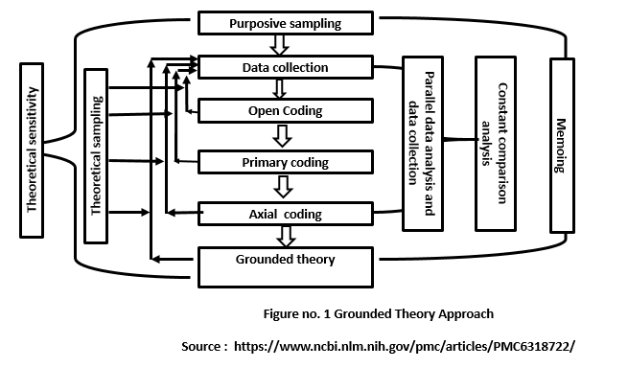

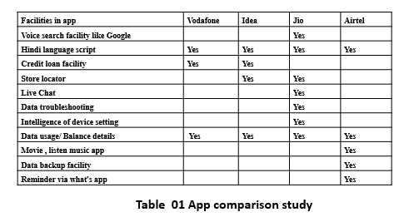

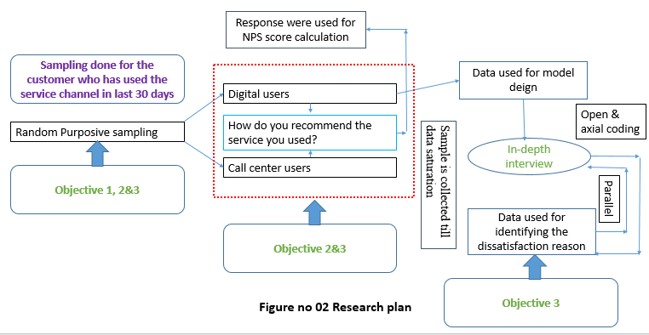

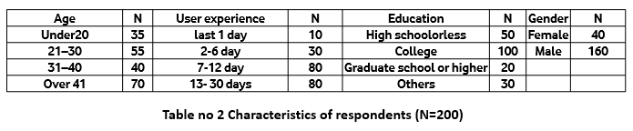

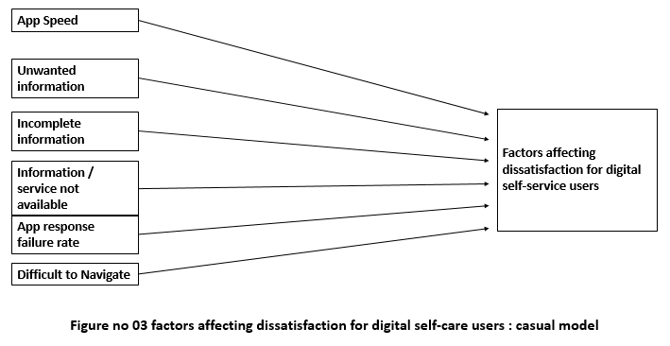

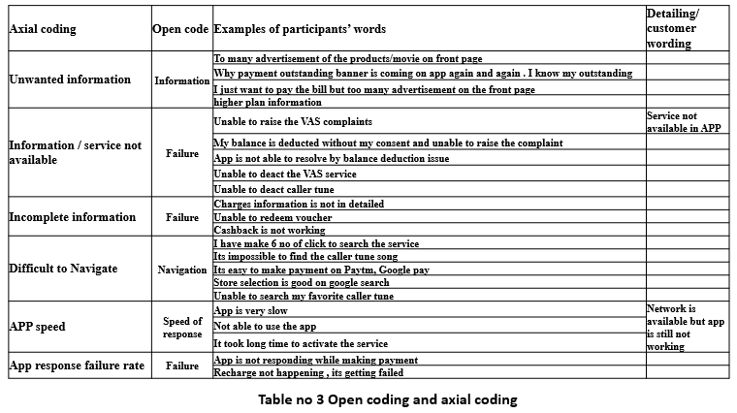

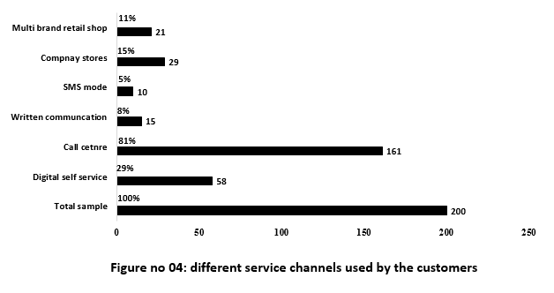

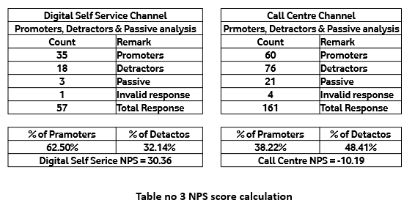

**REFERENCES**

Aitchison I., (2019). “Why Complexity Is Killing Your Customer Experience”. [online] Available at: https://www.copc.com/complexity-killing-customer-experience/ [Accessed 22 Nov. 2019].

Alin Zamfiroiu (2014), “Factors Influencing the Quality of Mobile Applications”, *Informatica Economică* vol. 18, no. 1/2014

Amaresan, Swetha (2019) . “What Is a Good Net Promoter Score?" . [online] available at https://offers.hubspot.com/customer-service-metrics?hubs_post- cta=author&_ga=2.40742562.1608903538.1576497516-1541934160.1575185627. [Retrieved 1 November 2019]

Beniwal , K. and Sharma, A. (2013),” Explosive growth of Mobile Technology and its Potential Impact on Youth & Education”, *IJAIEM. Volume2 issue4*

Charmas , k( 1996) . “The search of meanings- gorunded theory. In J. A. Smith R. Harre , & L. Van Langenhove (Eds.)”, *Rethinking methods in phycology (pp.27-49).London: Sage Publications*

Christoph Schmitz, Silke Bartschb, Anton Meyerc (2016) ,” Mobile App Usage and its Implications for Service Management – Empirical Findings from German Public Transport”, *Procedia - Social and Behavioral Sciences 224 ( 2016 ) 230 – 237*

C Schmitz (2016),” Mobile App Usage and its Implications for Service Management – Empirical Findings from German Public” Transport. *Procedia - Social and Behavioral SciencesMobile.*

Fred Reichheld (2003). “The One Number you Need to Grow “[online]. Available at <https://hbr.org/2003/12/the-one-number-you-need-to-grow>. Harvard business review ,81(12):46-54, 124 [ accessed on 1 Sep 2019]

Gert Van Dessel ( 2011), “ 4 stages of Net Promoter Score (NPS)” [online]. Available at https://www.checkmarket.com/blog/net-promoter-score-4-stages/ [accessed 20 Nov. 2019]

Glaser and Strauss (1967) , “Grounded theory” [online] Available at https://en.wikipedia.org/wiki/Grounded_theory [accessed 9 Oct. 2019]

Johnson (2015),” In-store mobile usage: Downloading and usage intention toward mobile location-based retail apps”, *Computers in Human Behavior 46:210-217 · May 2015*

Keaveney, S.M. (1995),” Customer Switching Behavior in Service Industries: An Explorative Study”, *Journal of Marketing, 59, 71-82. http://dx.doi.org/10.2307/1252074*

Kim, M, -K., Park, M. -C., & Jeong, D. -H. (2004),” The effects of customer satisfaction and switching barrier on customer loyalty in Korean mobile telecommunication services”, *Telecommunications Policy, 28, 145-59*

Markey, Rob. (2019),” The Benefits of a Competitive Benchmark Net Promoter® Score. Bain & Company”, [online]. Available at <https://www.bain.com/insights/the-benefits-of-a-competitive-benchmark-net-promoter-score/>. [Accessed 4 Sep 2019.]

Michael Peterson (2010),” Multi-channel customer management: Delighting consumers, driving efficiency”, *Journal of Direct, Data and Digital Marketing Practice July 2010, Volume 12, Issue 1, pp 10–15*

Moore’s law [1965],” Moore’s law”, [online] Available at https://en.wikipedia.org/wiki/Moore%27s_law [accessed 9 Oct. 2019]

P.A. Dabholkar (1996),” Consumer evaluations of new technology-based self-service options: An investigation of alternative models of service quality”, *International Journal of Research in Marketing, 13 (1) (1996), pp. 29-51*

Pascal (2016),” 6 Effective Methods for Measuring Customer Loyalty”, [online]. Available at https://www.userlike.com/en/blog/measure-customer-loyalty [accessed 19 Nov. 2019]

Peggy Anne Salz (2017),” How to build an app subscription model that works”, [ online article], Available at https://digitalcontentnext.org/blog/2017/10/10/build-app-subscription-model-works/ [ accessed on 15 Oct. 2019]

Rajkumar Venkatesan (2017),” Executing on a customer engagement strategy “, *Journal of the Academy of Marketing Science*

Reichheld, Fred (2003),” One Number You Need to Grow. Harvard Business Review”, [online] Available at https://www.bain.com/insights/the-benefits-of-a-competitive-benchmark-net-promoter-score/ [accessed on 4 October 2019]

Reichheld, Fred (2006)”, The Ultimate Question: Driving Good Profits and True Growth ([Nachdr.ed.)”, Boston, Mass*.: Harvard Business School Press. ISBN 978-1-59139-783-0*

Reichheld, Fred; Markey, Rob (2011),” The Ultimate Question 2.0: How Net Promoter Companies Thrive in a Customer-Driven World (Rev. and expanded ed.)”, Boston, Mass.: *Harvard Business Review Press. ISBN 978-1-4221-7335-0.*

S Jasrotia et.al., (2018),” Disruptions in Indian Telecom Sector: A Qualitative Study on Reliance Jio”, *IMJ , Volume 11 Issue 1*

Schneider, Daniel; Berent, Matt; Thomas, Randall; Krosnick, Jon (June 2008), “Measuring Customer Satisfaction and Loyalty: Improving the 'Net-Promoter' Score “, Van Haaften. Berlin, Germany: *Annual Conference of the World Association for Public Opinion Research (WAPOR).*

Strauss, A., & Corbin, J. (1998),” Basics of Qualitative Research: Techniques and Procedures for Developing Grounded Theory”, *Thousand Oaks, CA: Sage Publications, Inc.*

Strauss, A., & Corbin, J. M. (1990)”, Basics of qualitative research: Grounded theory procedures and techniques”, *Sage Publications, Inc.*

Suzanne Scacca (2018),” The Future Of Mobile Web Design: Video Game Design And Storytelling “, [online article ] available at https://www.smashingmagazine.com/author/suzanne-scacca/ [ accessed on 1 Oct 2019]

The Economic Times. (2019)”, Data usage in India to grow at 73% CAGR by 2022: Study”, [online] Available at: https://economictimes.indiatimes.com/industry/telecom/telecom-news/data-usage-in-india-to-grow-at-73-cagr-by-2022-study/articleshow/68341934.cms?from=mdr [Accessed 7 Dec. 2019].

Userlike Live Chat. (2019)”, 6 Effective Methods for Measuring Customer Loyalty”, [online] Available at: https://www.userlike.com/en/blog/measure-customer-loyalty [Accessed 1 Oct. 2019].

V. Kumar (2017)”,Customer Engagement - The Construct, Antecedents and Consequences”, *Journal of the Academy of Marketing Science*

Venkata (2014),” factors influencing quality of mobile Apps: role of mobile app development Life cycle”, *International Journal of Software Engineering & Applications (IJSEA), Vol.5, No.5, September 2014*

Yuvraj Sharma, Bharat Kumar Dak , Nivadit Acharya (2017) “, Emerging trends in mobile apps market and their potential impact on mobile users engagement in the global economy”, *Annual Research Journal of SCMS, Pune Vol. 5, March 2017*

Nomological validity of the Net Promoter Index question. BY Birgit Leisen Pollack and Aliosha Alexandrov. Journal of Services Marketing, Vol. 27 Iss: 2, pp.118 – 129

Timothy L. Keiningham; Bruce Cooil; Lerzan Aksoy; Tor W. Andreassen; Jay Weiner (2007). [*"The Value of Different Customer Satisfaction and Loyalty Metrics in Predicting Customer Retention, Recommendation, and Share-of-Wallet"*](http://www2.owen.vanderbilt.edu/bruce.cooil/documents/publications/msq2007.pdf) *(PDF)*. Managing Service Quality. **17** (4): 361–384. [*doi*](https://en.wikipedia.org/wiki/Digital_object_identifier):[*10.1108/09604520710760526*](https://doi.org/10.1108%2F09604520710760526).

Hill, Nigel; Roche, Greg; Allen, Rachel (2007). Customer Satisfaction: The customer experience through the customer's eyes. London, England: Cogent Publishing. p. 7. [*ISBN*](https://en.wikipedia.org/wiki/International_Standard_Book_Number) [*978-0-9554161-1-8*](https://en.wikipedia.org/wiki/Special:BookSources/978-0-9554161-1-8).

Schneider, Daniel; Berent, Matt; Thomas, Randall; Krosnick, Jon (June 2008). [*"Measuring Customer Satisfaction and Loyalty: Improving the 'Net-Promoter' Score"*](http://www.van-haaften.nl/images/documents/pdf/Measuring%20customer%20satisfaction%20and%20loyalty.pdf) *(PDF)*. van Haaften. Berlin, Germany: Annual Conference of the World Association for Public Opinion Research (WAPOR)*. Retrieved 13 Oct 2019*.

Preston, Carolyn C.; Colman, Andrew M. (14 September 1999). [*"Optimal number of response categories in rating scales: reliability, validity, discriminating power, and respondent preferences"*](https://www2.le.ac.uk/departments/npb/people/amc/articles-pdfs/optinumb.pdf) *(PDF)*. Acta Psychologica. **104**: 1–15. [*doi*](https://en.wikipedia.org/wiki/Digital_object_identifier):[*10.1016/s0001-6918(99)00050-5*](https://doi.org/10.1016%2Fs0001-6918%2899%2900050-5)*. Retrieved 16 November 2019*.

Satisfaction as a Predictor of Future Performance: A Replication. Jenny van Doorn , Peter S.H. Leeflang, Marleen Tijs International Journal of Research in Marketing (Impact Factor: 1.71). 12/2013

Hayes (2008), "The True Test of Loyalty," Quality Progress, June 2008, 20–26.

Timothy L. Keiningham; Bruce Cooil; Tor Wallin Andreassen; Lerzan Aksoy (July 2007). [*"A Longitudinal Examination of Net Promoter and Firm Revenue Growth"*](https://pdfs.semanticscholar.org/dfe0/4f3d83fee37a617d9cacfebc331605dc4bfc.pdf) *(PDF)*. [*Journal of Marketing*](https://en.wikipedia.org/wiki/Journal_of_Marketing). **71** (3): 39–51. [*doi*](https://en.wikipedia.org/wiki/Digital_object_identifier):[*10.1509/jmkg.71.3.39*](https://doi.org/10.1509%2Fjmkg.71.3.39).

Pearl, Judea (2009). [*"Causal inference in statistics: An overview"*](http://ftp.cs.ucla.edu/pub/stat_ser/r350.pdf) *(PDF)*. Statistics Surveys. **3**: 96–146. [*doi*](https://en.wikipedia.org/wiki/Digital_object_identifier):[*10.1214/09-SS057*](https://doi.org/10.1214%2F09-SS057). [*ISSN*](https://en.wikipedia.org/wiki/International_Standard_Serial_Number) [*1935-7516*](https://www.worldcat.org/issn/1935-7516)*. Retrieved 1 December 2019*.

[*Maurice FitzGerald - Satmetrix"*](https://web.archive.org/web/20151218162335/http:/uk.events.satmetrix.com/portfolio_page/maurice-fitzgerald-speaker-presentation/). September 2015. Archived from [*the original*](http://uk.events.satmetrix.com/portfolio_page/maurice-fitzgerald-speaker-presentation/) on 18 December 2015*. Retrieved 1 December 2019*.

[Net Promoter Score for Social Gaming," 28 February 2011.](https://web.archive.org/web/20121209122001/http:/radoff.com/blog/2011/02/28/net-promoter-score-social-gaming/) ["Would You Recommend Us?" Business Week, 2 October 2019.](http://www.businessweek.com/stories/2006-01-29/would-you-recommend-us)

[*Closing the loop"*](http://netpromotersystem.com/system-processes/closed-loop.aspx). The Net Promoter System. Bain & Company, Inc*. Retrieved 9 August 2015*.

Markey, Rob; Fred Reichheld; Andreas Dullweber (December 2009). [*"Closing the Customer Feedback Loop"*](http://hbr.org/2009/12/closing-the-customer-feedback-loop/ar/1). Harvard Business Review.

Reichheld, Fred; Markey, Rob (2011). [*The Ultimate Question 2.0: How Net Promoter Companies Thrive in a Customer-Driven World*](https://archive.org/details/ultimatequestion00reic_0/page/52). Boston, Mass.: Harvard Business Review Press. p. [*52*](https://archive.org/details/ultimatequestion00reic_0/page/52). [*ISBN*](https://en.wikipedia.org/wiki/International_Standard_Book_Number) [*978-1-4221-7335-0*](https://en.wikipedia.org/wiki/Special:BookSources/978-1-4221-7335-0).

Markey, Rob; Reichheld, Fred. [*"The Economics of Loyalty"*](http://www.bain.com/publications/articles/the-economics-of-loyalty.aspx). Loyalty Insights. Bain & Company, Inc*. Retrieved 19 October 2019*.