**IMPACT OF ADVERTISEMENT AND BRAND IMAGE ON CONSUMER BUYING BEHAVIOR OF ELECTRONIC PRODUCTS-HOME APPLIANCES (WASHING MACHINES, INVERTERS, AND MICROWAVE OVENS) IN THE NATIONAL CAPITAL REGION**

**ABSTRACT**

Advertisement and Brand image assumes a pivotal job to support up any business execution. In this day and age of hyper-rivalry and globalization, each organization is attempting to endure and to play out their best in the current condition to accomplish the ideal degree of their potential clients. India is presently assuming a significant job. Today the Indian market is developing on the planet and numerous organizations exist with various products offering particularly in electronic home appliances extend so it is imperative to focus on products and ruler i.e., the client. In the present situation, clients are progressively mindful of and sufficiently sound to settle on the most objective choice just to accomplish fulfillment. Home appliances are that without which a cutting edge home is viewed as inadequate, particularly in urban territories. So the analysts examined the effect of advertisement and brand image on consumer buying behavior of electronic products-home appliances in the national capital region. Home appliances products like washing machines, inverters, and microwave ovens are taken for this study. Deliberate arbitrary testing is affirmed for the present research and accordingly incorporated an example size of 80 family unit respondents for various brands of the item favored by consumers in the NCR. The examination configuration utilized in this study was spellbinding; the poll is utilized as an instrument to gather data from respondents. Methodology

**Keywords:** Advertisement, Brand Image, Consumer Buying Behavior, Electronic Products, Home Appliances

# 1. INTRODUCTION

Promotion and Brand picture improvement is very normal as exhibiting frameworks contemporarily. In any case, for present-day sponsors, publicizing and brand arranging as exhibiting methods are of mind-blowing importance as they accept a basic occupation in boosting the introduction of a relationship from various perspectives. As indicated by Klein (2000), a brand isn't conveyed in the assembling plant nowadays, yet rather it is characterized in the working environment. Klein explains that a brand isn't an impression of significant worth yet an impression of something that the promoters need it to address. Further, it was developed that instead of conveying things under a brand name, associations are somewhat organizing photos of these products such that they can arrange things in the cerebrums of the clients (Klein, 2000). Elevating serves to create a top of the mind cognizance of a brand, which further engages brand audit (Ingavale, 2013). The brand picture is a deduced framework that can determinedly affect people's buying practices and advancement fills in as a principle driving force for all endeavors as it is a significant source to arrange one's business commitments in the minds of the customers (Malik et al, 2013). The associations nowadays are dynamically looking for ways to deal with have a progressively impressive bit of the general business and experience into new markets to achieve their money related goals and to grow their business situating by expanding a high ground over others in their industry. To this end, gigantic capital is when in doubt tenaciously administered to the headway of new things, creative and bleeding-edge assessing, and turning out notification, glorious packaging, and such to arrange a customer neighborly brand in the mind of the clients with a point of view on getting a primary edge (Aremu et al, 2018).

The customer durables industry is a champion among the most powerful and speediest creating organizations in India and is seen as one of the most critical industries over the globe. Indian Consumer Durables part is tremendous in scope – including the scope of the family unit and modern hardware – forced air systems, clothes washers, TVs, air coolers, fridges, PCs and a wide scope of other families/indigenous apparatuses and accommodations (Kevin, 2014). Practically over 65% of the complete income for the division originates from the urban populace and the rest from the country network (CARE, 2018). It is seen that shoppers are very brand cognizant while settling on the acquisition of customer durables to dodge present buy frustration related to the nature of such items and their presentation (Dasar et al, 2013). The purchasers are affected fundamentally by commercial when the end objective is to accomplish the better of the two universes, i.e., quality and value (Rai, 2013). Subsequently, the significance of promoting and brand picture development in the shopper durables industry can't be undermined inferable from the tremendous extent of the business and the fickling purchaser desires inside this division. In this way the present investigation endeavors to investigate how buyers see diverse customer solid brands and how brand picture and publicizing can impact their buy choice, particularly with regards to white products (Thomas, 2015).

Each business person dreams to make his/her association a notable brand. Be that as it may, this can't be practiced except if significant ventures are made in limited time exercises wherein commercials are ruling the buyer showcase at present. The essential target of a promoter is to arrive at planned shoppers and affect their frames of mind, mindfulness and purchasing conduct (Malcolm, 2017). For this reason, humongous capital is spent to hold the enthusiasm of the clients in their business contributions. The potential advertisers need to comprehend the variables that can impact the potential clients in a manner that incites the conduct wanted by the advertisers. All things considered, promoting may potentially prompt a brand decision among shoppers (Zhang, 2015). Today, from one perspective, publicizing has a significant job in provoking clients to buy various items and administrations, however, then again, promoting and brand situating in the correlation of different exercises are probably going to cost a lot to most organizations as promoting necessities contrast crosswise over various verticals. In the present day business condition, each organization battles to accomplish the most noteworthy piece of the pie. For this reason, various organizations existing in various mechanical portions vest upon various methods for pulling in clients to turn into the market head (Sunderaraj, 2018). Consequently, as the prerequisites of publicizing and brand situating contrast crosswise over different verticals; in this way, their effect is additionally prone to be changed for the clients dependent on the business they have a place with. Along these lines, the need for the present investigation was perceived which endeavors to break down the effect of publicizing and brand picture on purchaser purchasing conduct with regards to white products (explicitly, Microwave oven, washing machine, and inverters). The present investigation is novel in its methodology as opposed to concentrating on a summed up perspective on the effect of publicizing and brand picture on buyers, it will be a small detail within a bigger landscape, yet, it would empower the development from increasingly broad to progressively explicit in a branch of knowledge (promoting and brand picture) which has just been concentrated satisfactorily something else (Marc, 2012).

The motivation behind this segment is to present the perusers with the elements of publicizing and brand picture improvement and to acquaint them with the very reason for this examination. The remainder of this paper is sorted out as pursues. In area 2, the destinations of the present investigation have been introduced to layout the heading of this exploration. Segment 3 shows the procedure embraced by the specialist to think about the effect of publicizing and brand picture improvement on customer purchasing conduct which incorporates legitimization for item choice and test received for the present examination. Segment 4 talks about the consequences of the investigation of the poll to portray the elucidations of this examination concerning the effect of publicizing and brand picture on customers with regards to white merchandise. In segment 5, discoveries of the investigation have been displayed alongside a talk subsequent to contrasting the outcomes and the current writing. The last part, for example, area 6 closes the examination, complements the ease of use of this investigation and the extent of further research in this specific situation (Matthew, 2018).

# 2. LITERATURE REVIEW

As exhibited in the past area, the prerequisites of promoting and brand situating contrast crosswise over different verticals, and thus, their effect is likewise prone to be shifted for the clients dependent on various ventures. Working from this conviction, the present study endeavors to contemplate the impacts of Advertisement and Brand Image on shopper purchasing conduct of a specialty fragment of electronic items, for example, the white merchandise (washing machines, inverters, and microwave ovens). As such, the present examination endeavors to investigate how shoppers see diverse customer sturdy brands and how brand picture and promotion can impact their buy choice, particularly with regards to white products. The accompanying section will abridge the information extricated from the references referred to for this examination dependent on which the exploration hole has been distinguished. The writing audited has been bifurcated into the accompanying subsections for the simplicity of study:

## 2.1 Overview of Advertising and Brand Image

In the present day current society, promoting expect a striking job in the showcasing of products and enterprises. Publicizing is a medium through which correspondence is activated. It tends to be enlightening and enticing; using the new or broad communications to provoke buyers to purchase merchandise and enterprises (Terkan, 2014). Promotions serve to create a top of the mind familiarity with a brand, which further empowers brand review (Ingavale, 2013). So also, Brand picture is of pivotal essentialness to any business substance, and the quality of a brand empowers an association to effortlessly sell certain items without noteworthy endeavors required to convince clients dependent on a few promoting systems (Lee et al., 2014). As characterized by Riezebos et al. (2003), "a brand picture is an abstract mental image of a brand shared by a gathering of purchasers." In the expressions of Winarso (2012), a brand picture can be viewed as a portrayal of the idea of the organization which passes on the representative significance to related clients through explicit traits of the items or administrations.

Aside from affecting buyer's behavior, advertising said to practice an effect on Brand Image improvement too in specific manners. Earlier writing has been examining such impact. In this regard, Linna (2018) embraced an examination of the effect of promoting through computerized mediums on the customer discernments identified with a specific brand. The examination utilized both essential just as auxiliary methods of information assortment. The auxiliary information for this examination was removed from online articles, digital books, contextual analyses, online study, and recordings. The hypotheses which were inspected included famous brand speculations and earlier research chips away at marking and promoting. The essential information was gathered through an online study that was focused on organization X's buyers. The consequences of the investigation set up that if the buyers have issues with or denounce the substance in the promotions they see or get; at that point, such notices hurt the general brand picture as the buyers will in general build up a negative frame of mind towards a brand. Chan et al. (2013) contemplated the effect of big-name supports as a method of promoting brand picture improvement in Chinese young people. The investigation utilized an example of 76 Chinese teenagers matured between 13 to 19 for a center gathering study. The interviewees were mentioned to recognize the particular components of notices (superstar supports) that they thought to be generally engaging. The consequences of this investigation displayed that the respondents best reviewed the big name endorsers who they saw as alluring, expressive, and clever. They perceived acclaim, great picture, and the presence of consistency between the big name's picture and the brand picture as the fundamental constituents which the advertisers ought to consider while choosing brand endorsers (Roberts, 2015).

Chaudhary et al. (2017) looked into the effect of print promoting on Brand Image improvement. The examination utilized organized surveys to accumulate the information applicable to this exploration. As a piece of the investigation, the examination utilized correlational strategies. The aftereffects of the investigation built up that there exists a positive huge connection between's print notice and brand picture advancement. It was inferred that promoting assumes a pivotal job in the making of brand picture mindfulness among shoppers. Karadeniz (2013) concentrated to investigate the effect of commercials on brand inclination in the white merchandise part. With the end goal of this investigation, right off the bat, the brand and ad ideas were evaluated, and afterward, the connection between them was expressed. The investigation members had been the clients of white merchandise marks in Istanbul. The information was gathered through surveys. From there on, after the surveys were recouped, the inclination for white merchandise dependent on the notices was assessed through the examination of the accumulated information. SPSS programming form 11.5 was utilized for undertaking recurrence examination, unwavering quality and legitimacy investigation, ANOVA and t-tests. Results uncovered that individuals will, in general, change their image if the promotions of the other related brands appear to be increasingly appealing to them or when the advertisements of the brand they use are upsetting/annoying in some way. Clearly, the past writing built up the significance of both promoting just as the brand picture independently just as thoroughly and the outline of these investigation factors affirms that publicizing assumes a job in the improvement of the brand picture.

## 2.2 Impact of Advertising on Consumer Buying Behavior

Promoting is said to have an indispensable job in inciting clients to purchase items and administrations. Numerous concentrates that were embraced have affirmed the effect of publicizing on customer purchasing conduct. One such study was finished by Sunderaraj (2018) wherein the specialist contemplated the effect of promoting on customer purchasing conduct in Sivakasi. For this examination, polls were controlled to 125 undergrads in Ayya Nadar Janaki Ammal College in Sivakasi with the end goal of essential information assortment. The investigation utilized Chi-Square and central expressive examination for meeting the examination goals. The aftereffects of this examination initiated that promotions assume a fundamental job in impacting the purchasing conduct of the buyers in Sivakasi.

In a comparable setting, Mwakasege (2015), in her investigation, intended to learn the effect of promoting on purchaser purchasing conduct with explicit reference to the Forever Living beautifying agents items. Surveys were utilized for the assortment of essential information alongside the meeting guides, just as close to home perception. Different reports were utilized for the assortment of auxiliary information. The examination configuration utilized for this investigation was the contextual investigation to explore the plan. An example of 100 respondents was utilized for this investigation. In light of the discoveries of the investigation, it was presumed that the job accepted by promoting in impacting shopper purchasing conduct is critical. Such impact is practiced by standing out for them, animating their enthusiasm, creating a longing to purchase the items being advertised. Dheeraj (2014) completed the exploration of the effect of various types of ads and special instruments offered by the pharmaceutical business on Consumer Purchase conduct. A review was directed, and information was investigated dependent on reactions gave by 329 shoppers and 150 Doctors. The investigation utilized factor examination, ANOVA and Chi-Square test for the testing of speculations. The consequences of the study affirmed that notice impacts the basic leadership process and the view of the buyers towards specific meds.

Later on, Fatima and Lodhi (2015) embraced an investigation on the effect of Advertisement on purchasing practices of the shoppers inside the Cosmetic Industry in Karachi. The investigation utilized an example of 200 youthful male or female clients of different brands of makeup to investigate the impact of a notice on their purchasing conduct while building observations and making mindfulness. For the investigation of the information, connection and relapse examination were utilized to recognize the connection between notice and shopper purchasing conduct. The aftereffects of their investigation indicated that commercials are valuable in building mindfulness among the individuals, however, they don't manufacture solid observations in the psyches of shoppers. In any case, both purchaser mindfulness and customer recognitions will inspire shoppers to purchase a specific item, as there exists a noteworthy positive connection between them. Roopa (2014) broke down the effect of notices on buyers purchasing conduct as for the acquisition of customer durables, for example, iceboxes and clothes washers. For this examination, the information was gathered from both essential just as the optional sources. Essential information was gathered through the circulation of surveys, and the optional information was amassed from books, diaries, look into papers and sites. An aggregate of 125 surveys was dispersed out of which 100 reactions were acquired. The consequences of this examination were investigated and exhibited utilizing illustrative measurements. The aftereffects of this investigation uncovered that most of the consumers buy buyer durables just affected by promotions.

## 2.3 Impact of Brand Image on Consumer Buying Behavior

As talked about in the past area, promoting affects customer purchasing conduct. On comparative grounds, this segment talks about the perspectives on the current scientists on the effect of the brand picture on buyer buy choices. In this regard, Tekin et al. (2016) embraced an investigation on the effect of the brand picture from a purchaser's viewpoint and pursued a contextual analysis of Louiss Vuitton-Moet Hennessy (LVMH). The examination utilized both essential and auxiliary methods for information assortment. The optional information was gathered basically from books, diary, online material, and different articles. The essential information was gathered through online surveys that were appropriated to 104 irregular members. The aftereffects of the investigation exhibited that extravagance brands like LVMH assume a significant job in affecting purchaser obtaining choice. In light of the examination of the essential and optional information, the principal discoveries of the investigation proposed that the brand picture has a significant capability of making an item or clearing it out from the shoppers' market.

Akkucuk and Esmaeili (2016) directed an exploration to look at the degree to which cell phone brands can impact the purchasing choices of shoppers. The examination was based on the Aaker model about brand value, and brand mindfulness, saw quality, brand devotion, and brand affiliation was picked develops for this investigation. For the investigation, a poll was circulated from December 2015 to March 2016 among 171 understudies of an outstanding college in the Istanbul region of Turkey. Comfort testing was utilized as an inspecting method. The consequences of the review led on 171 individuals lead to a perception that buys choices of a main part of the buyers are influenced by brand mindfulness and brand dependability. Brand affiliation and saw quality didn't appear to influence clients' buy choices as much as brand mindfulness, and brand dependability did. Abdullahi and Kabir (2018), in their investigation, inspected the effect of commercial and brand picture on purchaser purchasing conduct in Nigeria. The examination concentrated on just one organization and its clients, for example, Ammasco International Limited in Kano State, Nigeria. The objective populace for the investigation comprised of all oil clients in Ammasco in Kano State, Nigeria. An example of 320 people was taken for this investigation dependent on the comfort examining strategy. The survey (essential information) was utilized as an instrument for information assortment for this examination. The examination utilized numerous relapse investigations to test the guessed connections. The consequences of the investigation uncovered that the two promotions, just as the brand picture, have a positive and critical impact on customer purchasing conduct in Nigeria.

Ashraf et al (2017) led an exploration to look at the connection between buyer purchasing conduct and some different develops identified with marking with regards to the footwear business of Punjab, Pakistan. The essential information for this exploration was gathered by circulating a poll comprising of 16 inquiries dependent on the connection between the examination factors. The example size for this examination was 170 respondents which were chosen utilizing the straightforward irregular testing system. Various relapse and Pearson's connections were utilized as the strategies for dissecting the information accumulated through the surveys. The consequences of their investigation proposed that commercials impact the formation of the brand picture and increment the shopper's inclination provoking a client to make a buy. Thus, brand picture, brand affiliation, and brand faithfulness were seen as practicing a noteworthy positive effect on shopper purchasing conduct. Further, the examination distinguished that such effect was low on account of Narowal yet when very high on account of Punjab. Suhaily and Darmoyo (2017) concentrated to decide the effect of apparent value, item quality and brand picture on the purchaser buy the choice of Japan's hardware and the degree to which are these connections are intervened by customers trust (Gerald, 2017). The number of inhabitants in this exploration was picked to be the guests of the electronic city outlet in South Jakarta, and thusly, the polls were appropriated to 376 guests of Electronics City in Pondok Indah Mall and SCBD. Organized Equation Modeling (SEM) was utilized to examine the information gathered. The outcomes indicated that apparent cost and item quality have a critical positive effect on the buy choice. In addition, it was discovered that item quality, saw cost and brand picture practice a hugely positive effect on client trust, and purchaser trust, thusly, has a critical positive effect on the buy choice. Accordingly, the investigation highlighted that there is no immediate impact of the brand picture of the buy choice; rather, it is intervened by client trust (Linda and Eric, 2016).

# 3. RESEARCH GAP

According to the reviews demonstrated above, it tends to be said that this examination is one of a kind in its methodology as more or huge, the earlier writing has been talking about the effect of publicizing and brand picture independently on purchaser conduct. The impacts of publicizing and brand picture on customer conduct have been contemplated comprehensively to an extensively lesser degree. Besides, the connection between these examination factors have been analyzed essentially with regards to restorative, design, drug, footwear and attire industry and there is a shortage of writing concentrating the effect of promoting and brand picture on customer conduct with regards to home apparatuses or the white merchandise. The not many investigations in this field were likewise seen to be restricted just to it is possible that a couple of white merchandise (significantly cell phones, iceboxes, clothes washers, and other electronic items), and furthermore, no such examination was seen with regards to India. Subsequently, trying to connect these holes distinguished from the surveyed writing, the present investigation was believed to be basic. The present examination inspects the comprehensive effect of publicizing and brand picture on purchaser conduct with regards to the Indian buyer advertise. The classes of white products that have been chosen for this examination are Washing machines, Inverters, Microwave broilers, and Mixer Grinders. No earlier research on these sub-classifications further adds to the oddity of this exploration.

# 4. RESEARCH METHODOLOGY

## 4.1 Introduction

Research requires considering the ideas and theories adopted for the study, and the associated motivations (Shank, 2015). Since brand image and advertising play a notable role in any business for making it successful, therefore the core objective of research methodology is to explore and highlight the impact of branding and advertisement on consumer buying behavior by employing an efficient method. Furthermore, advertising is discerned to generate a top of the mind awareness of a brand, thereby enabling brand recall (Ingavale, 2013). The brand image is an implied mechanism that can positively influence people's buying behaviors and advertisement functions as a driving force for all industries as it is a valuable source to position one's business offerings in the minds of the customers (Malik et al., 2013).

Thereby, the study will manifest how people perceive any brand and how brand image and advertisement can influence the consumer buying behavior of people, especially white goods. This part thereby addresses methodological stances and philosophical assumptions as well as renders in-depth description regarding the selected methodology, research approach and strategy; specifically, the research paradigm, research approach, sample population and study area, sampling procedures, data collection, ethical considerations, methods of data analysis and presentation.

## 4.2 Research Paradigm

Research paradigms are characterized as a fundamental arrangement of convictions or perspectives that manage and coordinate analysts' reasoning and activities (Creswell, 2014; Mertens, 2014). Bryman (2017) claims that ideal models control the choice of the examination zone to be considered, the procedure to direct the exploration, and furthermore guarantee the outcomes are comprehended in a particular order (Entine, 2017). Various standards have been perceived; notwithstanding, the two most examined ideal models are the quantitative worldview (positivism) and the subjective worldview (interpretivism) (Creswell, 2014; Mertens, 2014). The present study asserts to study the buying behavior for the selected white goods, and thereby identify the factors influencing and impacting the buyers during the purchase of white goods. Subsequently, the study attempts towards finding a specific outcome for the pre-defined objectives of the research. Hence, for the existing research study positivism approach is discerned to be most suitable. This approach will be utilized for the logical and scientific accuracy of the data accumulated by administering quantitative questionnaires to the sought target population. Thus, positivism will follow the statistical approach for the analysis of the data (Yanow & Schwartz-Shea, 2015), thereby discovering the truth by linking different independent events in reality with the help of valid cognition (Clarke, 2009).

## 4.3 Research Design

Research design is determined as the overall setup or plan of the research that is combined to conduct the study logically, thereby forming a holistic strategy followed by the researcher for combining various aspects pertaining to the study coherently and logically. A study conducted by Salkind (2010) intended four different forms of research designs. The study broadly classified descriptive, explanatory, exploratory and experimental research designs. The purpose of the study is to identify the impact of branding on the purchase and impact of advertisement on the consumer buying behavior of white goods. Primarily, the focus of the research is towards a description of the impact of different modes of advertisements on the purchase decisions. Thus, the research design embraced in this study is descriptive since it is pointed towards the depiction of the circumstances, wonder, issues and so forth in an orderly way or endeavors at giving bits of knowledge about, state, the living states of a network, issues related with an industry or a firm, or portrays frames of mind towards an issue.

## 4.4 Research Approach

Research abides by a specific systematic process for describing the objectives, through proper organization of the data and procurement of the outputs with the predetermined guidelines (Ghauri & Grønhaug, 2010, p.13); it includes methods like data collection, analysis, and interpretation (Blaikie, 2019, p. 24). The approach adopted to conduct research and identify an explanation to the research question is of three types, namely, quantitative, qualitative, and mixed. The application of the research approach is contingent on the demand of the research (Williams, 2011). The present study is primarily based on the collection of data through a well-structured, non-disguised questionnaire. The notion behind the research is to analyze the buying behavior for selected white goods. The study is intended to take place by the distribution of a well-structured, non-disguised questionnaire in respondents in NCR and thereby generalize the results. As presented above, the current study is descriptive in nature, i.e. it is aimed at describing the events as they are and the measurement of the subjects only once is sought. Hence, the data collection approach used in this study is a quantitative approach wherein a questionnaire with pre-structured queries is distributed to the respondents to be easily able to quantify the data obtained through these questionnaires. The data so collected will thereby analyze using appropriate analytical techniques for outlining the impact in different modes of advertisements on the purchase decision.

## 4.5 Data Collection Methods

The selection of data collection method is associated with the philosophical suppositions of the researcher; primarily, a combination of the quantitative and qualitative approach is employed in the research (Saunders et al., 2012). The qualitative research contradicts a quantitative technique in a way that the research strategy built on that emphasizes words rather than quantification in data collection (Saunders et al., 2012). The quantitative aspect of the present study is based on the collection of primary data through a self-structured questionnaire. A close-ended questionnaire, the best tool for retrieving quick and effective responses from the population. The opinion on the consumption of electronic home appliances was discerned from the survey using 5 Likert scales. The sampling unit of the study was all the users of Home appliances in the NCR region. The sample population was the consumers in the age of 21-50 years. The following sampling was adopted to cover for covering a sample size of 80. The sample for the current study was heterogeneous to some extent since it included male, females, and also the people from different distances, educational status, and occupation and income group of regular and occasional buyers. Further, the responses retrieved from close-ended questionnaires are easier to understand, code and analyze, which increases the reliability of the research (Creswell, 2014). Moreover, the reason for choosing this method is to get data based on the convenience of the researcher and consequently, this type permits the researcher for measuring and analyzing the data. The study was conducted in the Croma Store of NCR region covering Gurgaon, Faridabad, Noida, Greater Noida, Ghaziabad, and Delhi. Among these, few areas were selected using the Systematic Sampling method covering 50 percent areas. The respondents were given a brief introduction to the purpose and importance of the study. Additionally, the respondents were given enough time to think over the answers for the questions in order to have a reliability of the response. Details pertaining to the demographics and buying behavior for selected white goods were taken as a part of the survey. The association between the variables is studied in in-depth than qualitative research. While, the secondary source for the study was collected from books, journals, research articles, magazines, reports, newspapers, and websites. Consequently, the purpose of this section is to introduce the readers with the dynamics of advertising and brand image development and to familiarize them with the very purpose of this study.

## 4.6 Sampling and Population

An appropriate sampling strategy in research saves money and time, gives higher truthfulness and fast results (Bakri, 2009); a sample should yield valid and reliable information if the suitable sample size is selected and necessary precautions are taken to decrease the sampling and measurement errors. Systematic random sampling is asserted for the present research and thereby included a sample size of 80 household respondents for different brands of the product preferred by consumers in the NCR region.

**Inclusion Criteria:**

* The respondents will include both males and females
* The individuals should be residents of NCR

**Exclusion Criteria:**

* Children will not be considered in the sample
* The individuals not residing in NCR will be excluded.
* The sample population for this study was chosen through a non-probability sampling, and random sampling (Taherdoost, 2016).

# 5. DATA ANALYSIS

**Aim:**

The aim of the study is to assess the advertising and brand image impact on consumer buying behavior of electronic products in home appliances in Delhi.

**Objective:**

The core objective of the research methodology is to explore and highlight the impact of branding and advertisement on consumer buying behavior by employing an efficient method. To do so following null hypothesis has been drawn:-

H01: There is no significant impact of different media formats on the purchase decision of white goods

H02: There is no significant relationship between the demographic profile of customers and purchase decision

**Demographic Profile of the Respondents:**

1. **Gender:** According to the responses received from the respondents, the gender ratio of the collected data of male vs. female is 4:6 wherein the male contribution is 33 (41.3%) whereas female contribution is 47 (58.8%). In general, the gender approach towards shopping is always different. Their perspective, motives, considerations, and rationales are also significantly different from each other. This could be because of their socialization and upbringing with various several factors. Here in the survey, significant numbers of female respondent 47 have participated.

|  |  |  |  |  |  |
| --- | --- | --- | --- | --- | --- |
| **Gender** | | | | | |
|  | | Frequency | Percent | Valid Percent | Cumulative Percent |
| Valid | Male | 33 | 41.3 | 41.3 | 41.3 |
| Female | 47 | 58.8 | 58.8 | 100.0 |
| Total | 80 | 100.0 | 100.0 |  |

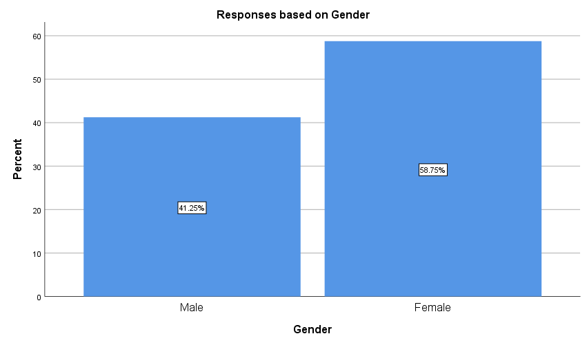

1. **Age Group:** Age group is the group in which respondent current age falls in. Here for the study, significant numbers of the respondent age is in between 21 to 30 years 25 (31.3%) followed by 31 to 40 years 17 (21.3%), 41 to 50 years 17 (21.3%), 51 to 60 years 17 (21.3%) and more than 60 years 4 (5%). Age is also called a sign of survival. It brings wisdom and knowledge. In this report, respondent from all age group has been considered for analysis because every stage or phase of life has its own essence and experience to share their views. From the collected data, it can be easily seen that youngsters are more prone towards shopping as compare with the elder generation.

|  |  |  |  |  |  |
| --- | --- | --- | --- | --- | --- |
| **Age Group** | | | | | |
|  | | Frequency | Percent | Valid Percent | Cumulative Percent |
| Valid | 21-30 | 25 | 31.3 | 31.3 | 31.3 |
| 31-40 | 17 | 21.3 | 21.3 | 52.5 |
| 41-50 | 17 | 21.3 | 21.3 | 73.8 |
| 51-60 | 17 | 21.3 | 21.3 | 95.0 |
| > 60 | 4 | 5.0 | 5.0 | 100.0 |
| **Total** | **80** | **100.0** | **100.0** |  |

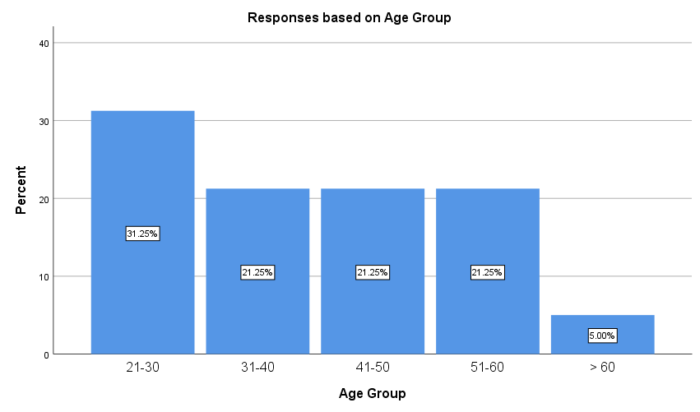

1. **Education:** Education profile of the respondents is being looked as the procedure through which people learn the market place working, so that the ability of consumer purchase behavior can be judged. For the gathered information, most of the respondents 37 (46.3%) are graduate (bachelor degree) followed by Master's Degree and above 18 (22.5%) and intermediate 17 (21.3%). Only few respondents are high school pass out 6 (7.5%) or uneducated 2 (2.5%). Hence, it can be inferred that 90% of the respondents are educated and know which product to shop especially in home division.

|  |  |  |  |  |  |
| --- | --- | --- | --- | --- | --- |
| **Education** | | | | | |
|  | | Frequency | Percent | Valid Percent | Cumulative Percent |
| Valid | Uneducated | 2 | 2.5 | 2.5 | 2.5 |
| High School or less | 6 | 7.5 | 7.5 | 10.0 |
| Intermediate | 17 | 21.3 | 21.3 | 31.3 |
| Bachelor Degree | 37 | 46.3 | 46.3 | 77.5 |
| Master's Degree and above | 18 | 22.5 | 22.5 | 100.0 |
| **Total** | **80** | **100.0** | **100.0** |  |

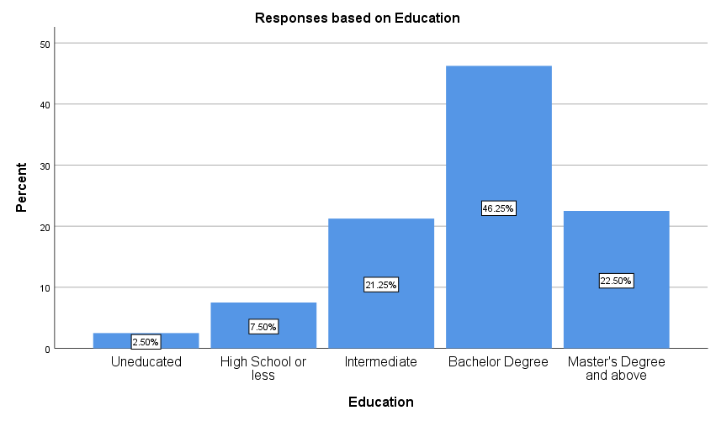

1. **Annual Income:** Income of the respondents tells the ability to spend. As per the collected data, 45 (56.3%) of the respondents annual income is greater than Rs. 700,000 lakhs followed by Rs. 5 lakh to Rs, 7 lakh 30 (37.5%). Remaining respondent 5 (6.3%) salary is less than Rs. 1lakhs. Hence it can be concluded that 94% of the respondents buying power is significant.

|  |  |  |  |  |  |
| --- | --- | --- | --- | --- | --- |
| **Annual Income** | | | | | |
|  | | Frequency | Percent | Valid Percent | Cumulative Percent |
| Valid | 10,0000 and less | 5 | 6.3 | 6.3 | 6.3 |
| 500001-700,000 | 30 | 37.5 | 37.5 | 43.8 |
| 700001 and above | 45 | 56.3 | 56.3 | 100.0 |
| **Total** | **80** | **100.0** | **100.0** |  |

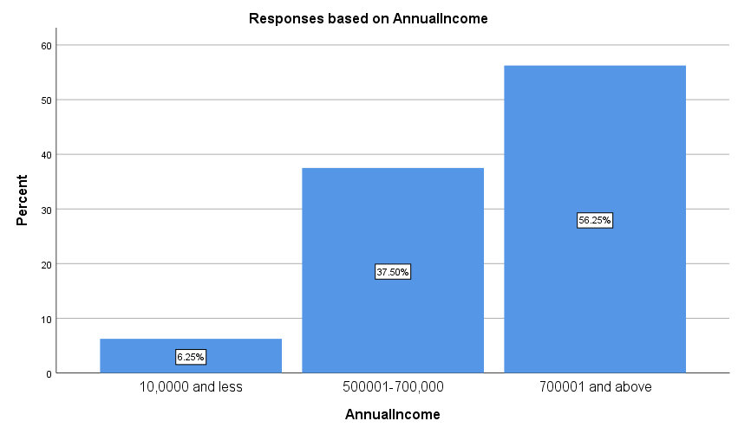

1. **Marital Status:** Marital status is one of the important demographic attribute which can influence consumer buying behavior of the home segment. Different marital status respondents, responses differently to the other attributes of home segment. As per the data significant number of the respondents 40 (50.0%) are unmarried followed by married 29 (36.3%) and divorced 11 (13.8%).

|  |  |  |  |  |  |
| --- | --- | --- | --- | --- | --- |
| **Marital Status** | | | | | |
|  | | Frequency | Percent | Valid Percent | Cumulative Percent |
| Valid | Single | 40 | 50.0 | 50.0 | 50.0 |
| Married | 29 | 36.3 | 36.3 | 86.3 |
| Divorced | 11 | 13.8 | 13.8 | 100.0 |
| **Total** | **80** | **100.0** | **100.0** |  |

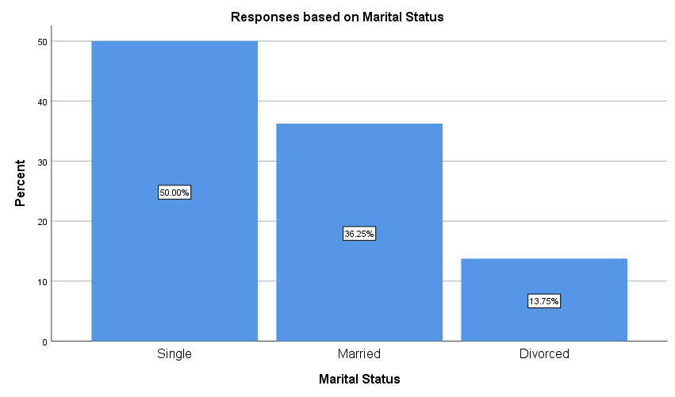

1. **Purchased home Appliance:** Aspertheresponses more than 50% respondents 42 (52.5%) buys home appliances where 38 (47.5%) respondents doesn’t buy home appliances. Major part of the data who doesn’t buy home appliances is male respondents.

|  |  |  |  |  |  |
| --- | --- | --- | --- | --- | --- |
| **Purchased home Appliance** | | | | | |
|  | | Frequency | Percent | Valid Percent | Cumulative Percent |
| Valid | Yes | 42 | 52.5 | 52.5 | 52.5 |
| No | 38 | 47.5 | 47.5 | 100.0 |
| **Total** | **80** | **100.0** | **100.0** |  |

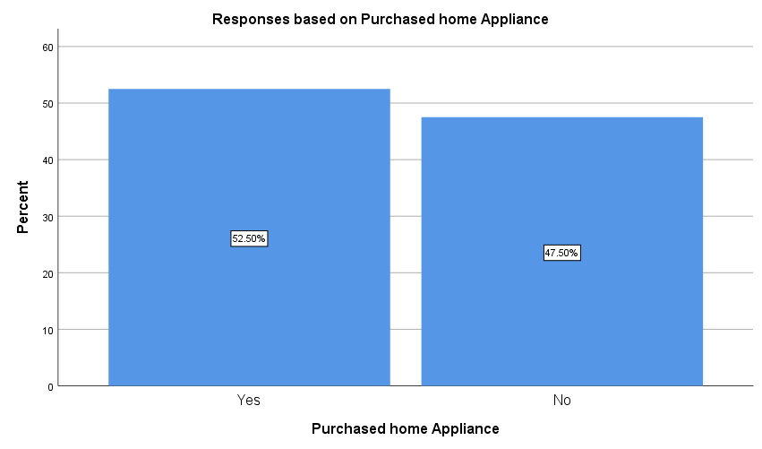

1. **Purchased Electronic:** As compared with buying home appliance, 70% of the respondents said yes for buying electronics whereas 24 (30%) of the respondents said that they don’t buy electronic products. Here it can be concluded that irrespective of the gender, 70% respondents buys electronic products.

|  |  |  |  |  |  |
| --- | --- | --- | --- | --- | --- |
| **Purchased Electronic** | | | | | |
|  | | Frequency | Percent | Valid Percent | Cumulative Percent |
| Valid | Yes | 56 | 70.0 | 70.0 | 70.0 |
| No | 24 | 30.0 | 30.0 | 100.0 |
| **Total** | **80** | **100.0** | **100.0** |  |

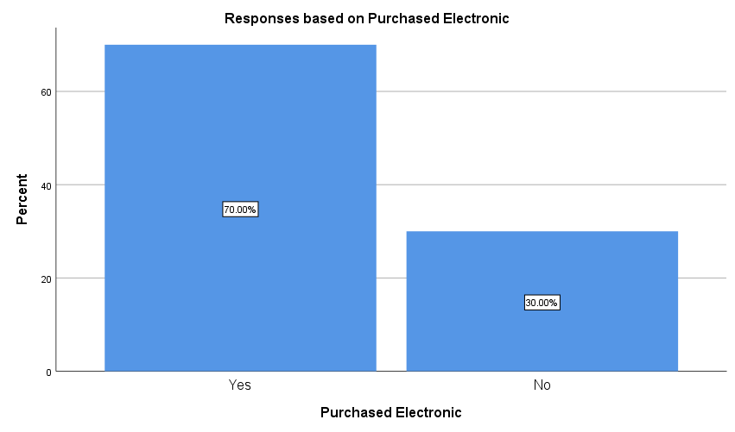

1. **Own Products:** Buying behavior of a consumer is the process in which a group or an individual use, select or dispose products, ideas, services or exchange to fulfill their requirements or desires. Carrying own product is an important factor for a company to understand the decision process of a buyer It could be an individual or a group of people. As per the responses received, microwave is the product which is being owned by the 29 (36.4%) respondents significantly followed by inverter 27 (33.8%). Other than these two products, respondents have oven 6 (7.5%), refrigerator 2 (2.5%), and washing machine 1 (1.3%). There are few other products 15 (18.8%) which respondents are owning.

|  |  |  |  |  |  |
| --- | --- | --- | --- | --- | --- |
| **Own Products** | | | | | |
|  | | Frequency | Percent | Valid Percent | Cumulative Percent |
| Valid | Refrigerator | 2 | 2.5 | 2.5 | 2.5 |
| Oven | 6 | 7.5 | 7.5 | 10.0 |
| Washing Machine | 1 | 1.3 | 1.3 | 11.3 |
| Inverter | 27 | 33.8 | 33.8 | 45.0 |
| Microwave | 29 | 36.3 | 36.3 | 81.3 |
| Others | 15 | 18.8 | 18.8 | 100.0 |
| **Total** | **80** | **100.0** | **100.0** |  |

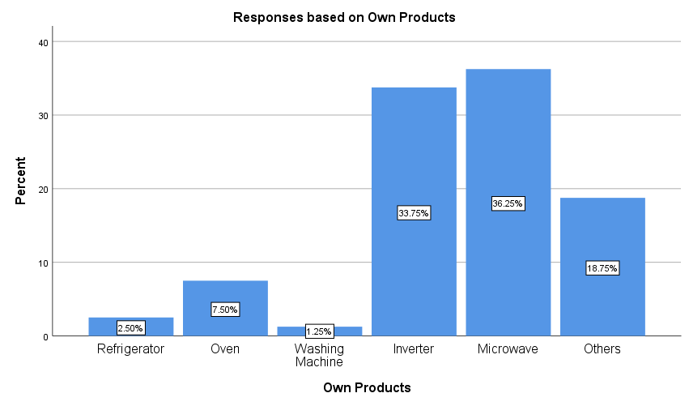

1. **Search Information about the Product:** As per the respondents, children 45 (56.3%) are the ones who search for the product before buying followed by spouse 24 (30%). There are only 7 (8.8%) respondents who search for the information of the product by themselves followed by parents 4 (5%).

|  |  |  |  |  |  |
| --- | --- | --- | --- | --- | --- |
| **Search Information about the Product** | | | | | |
|  | | Frequency | Percent | Valid Percent | Cumulative Percent |
| Valid | Myself | 7 | 8.8 | 8.8 | 8.8 |
| Spouse | 24 | 30.0 | 30.0 | 38.8 |
| Parents | 4 | 5.0 | 5.0 | 43.8 |
| Children | 45 | 56.3 | 56.3 | 100.0 |
| **Total** | **80** | **100.0** | **100.0** |  |

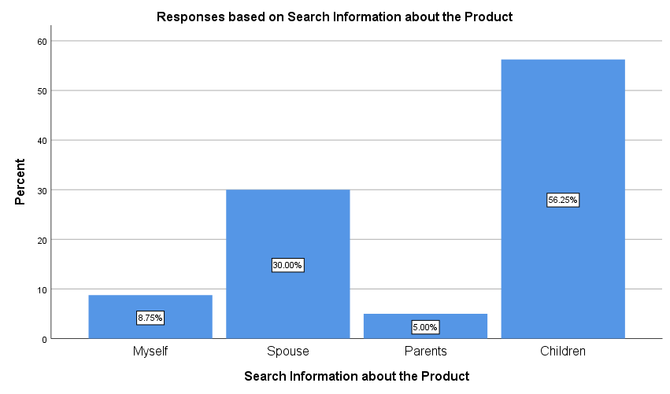

1. **Source of Information Collection:** Different people have different source of collecting information. As per the collected data most of the respondents 49 (61.3%) collect information from reference groups followed by media or advertising 27 (33.8%). It has been seen that most of the people conceal their knowledge in the dependence of the internal or external sources like friends and families, advertisement, social media, etc. and make their purchase decision based on the world of mouth or information they receive.

|  |  |  |  |  |  |
| --- | --- | --- | --- | --- | --- |
| **Source of Information Collection** | | | | | |
|  | | Frequency | Percent | Valid Percent | Cumulative Percent |
| Valid | Media | 27 | 33.8 | 33.8 | 33.8 |
| Reference groups | 49 | 61.3 | 61.3 | 95.0 |
| Workgroups | 4 | 5.0 | 5.0 | 100.0 |
| **Total** | **80** | **100.0** | **100.0** |  |

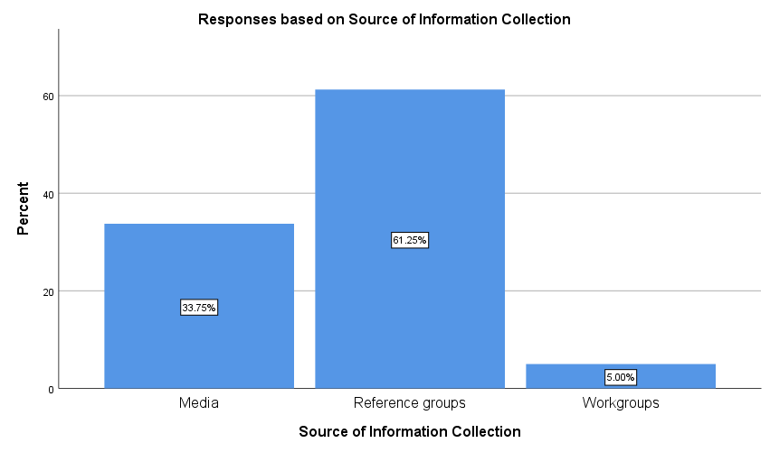

1. **Media Channel to Communicate for Advertisement:** Here data reveals that, lot of respondents 29 (36.3%) use internet to get information about the product followed by radio 28 (35%) and hoarding 19 (23.85). Only 4 (5%) respondents are interested in reading information through print media.

|  |  |  |  |  |  |
| --- | --- | --- | --- | --- | --- |
| **Media Channel to Communicate for Advertisement** | | | | | |
|  | | Frequency | Percent | Valid Percent | Cumulative Percent |
| Valid | Print media | 4 | 5.0 | 5.0 | 5.0 |
| Radio | 28 | 35.0 | 35.0 | 40.0 |
| Hoardings | 19 | 23.8 | 23.8 | 63.7 |
| Internet | 29 | 36.3 | 36.3 | 100.0 |
| **Total** | **80** | **100.0** | **100.0** |  |

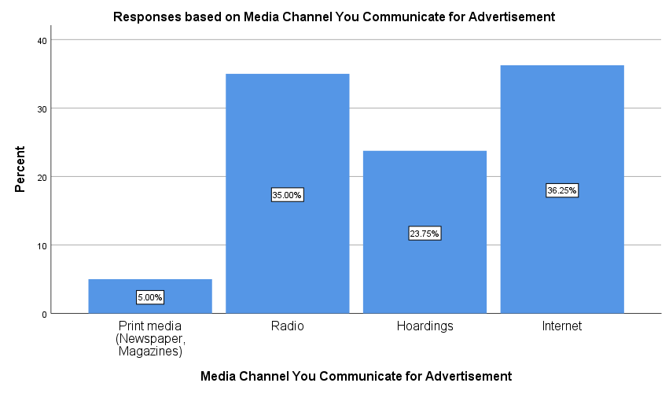

1. **Brand name is the most important criteria affecting the purchase decision of white goods:** As per the respondents 75 (93.8%) agreed in getting affected because of the brand name whereas only 5 (6.3%) of the respondents said they don’t go with the brand name while making decision for purchase. This hold true, because consumer brand perception finds its origin in the social perception theory. This theory scrutinises the shaping of inferences and notions about personalities (E. Aronson, T.D. Wilson & R.M.Akert, 2010). Brand perception deals with how a given brand is perceived by the consumer. The concept of Brand perception is intricately connected with brand attitude which mirrors the evaluation of a brand by the consumer on the basis of brand related notions, responses and associations (J. Olson & A. Mitchell, 1981); (S.T. Murphy & R.B. Zajonc, 1993). As these two concepts are closely intertwined we can replace one for the other. In addition to this, brand attitude presents itself as an advantageous facet which facilitates an extensive comprehension of the determining variables which have a bearing on consumer brand perception (B. Schivinski & D. Dabrowski, 2016).

|  |  |  |  |  |  |
| --- | --- | --- | --- | --- | --- |
| **Brand name is the most important criteria affecting the purchase decision of white goods** | | | | | |
|  | | Frequency | Percent | Valid Percent | Cumulative Percent |
| Valid | Strongly Disagree | 5 | 6.3 | 6.3 | 6.3 |
| Agree | 30 | 37.5 | 37.5 | 43.8 |
| Strongly Agree | 45 | 56.3 | 56.3 | 100.0 |
| **Total** | **80** | **100.0** | **100.0** |  |

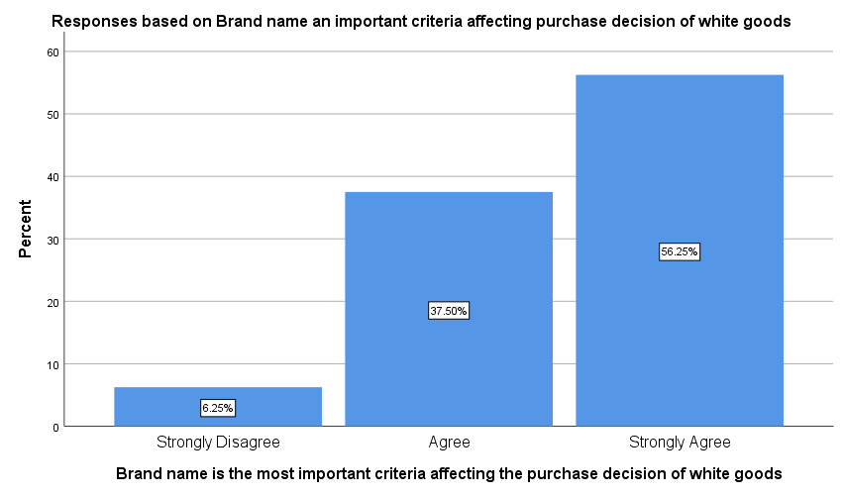

1. **Advertisement helps in creating favorable brand image:** Online advertisement is an instrumental in building brands and escalating traffic for any organization to gain success. As per the responses significant numbers of the respondents 55 (68.8%) agreed on advertisement helping in creating favorable brand image whereas 15 (18.8%) respondents doesn’t agreed on advertisement helping in creating favorable brand image. 10 (12.5%) respondents are neutral in responding on advertisement helping in creating favorable brand image. Irrespective of the type of the advertisement, it can be concluded that advertisement do help in creating favorable brand image and influencing consumer buying behavior.

|  |  |  |  |  |  |
| --- | --- | --- | --- | --- | --- |
| **Advertisement helps in creating favourable brand image** | | | | | |
|  | | Frequency | Percent | Valid Percent | Cumulative Percent |
| Valid | Strongly Disagree | 6 | 7.5 | 7.5 | 7.5 |
| Disagree | 9 | 11.3 | 11.3 | 18.8 |
| Neither Agree nor Disagree | 10 | 12.5 | 12.5 | 31.3 |
| Agree | 19 | 23.8 | 23.8 | 55.0 |
| Strongly Agree | 36 | 45.0 | 45.0 | 100.0 |
| **Total** | **80** | **100.0** | **100.0** |  |

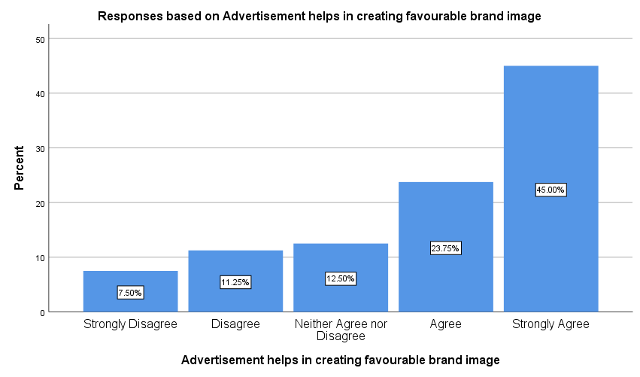

1. **Factors determining the buying behavior of white goods:** Factors contributing in influencing or determining consumer buying behavior are as follows accessibility (47.5%), guarantee and warranty (38.8%), after-sales service (36.3%), color (33.8%), design (30%), advanced features (27.5%), credit facility (25%) and size (21.3%).

|  |  |  |  |  |  |  |
| --- | --- | --- | --- | --- | --- | --- |
| **Factors determining the buying behaviour of white goods** | | | | | | |
| Factors | More Important | Important | Less Important | More Important | Important | Less Important |
| Accessibility | 38 | 20 | 20 | 47.5% | 25.0% | 25.0% |
| Durability | 1 | 26 | 51 | 1.3% | 32.5% | 63.8% |
| Design | 24 | 45 | 9 | 30.0% | 56.3% | 11.3% |
| Advanced features | 22 | 33 | 23 | 27.5% | 41.3% | 28.8% |
| Comfortability | 15 | 36 | 27 | 18.8% | 45.0% | 33.8% |
| Size | 17 | 60 | 1 | 21.3% | 75.0% | 1.3% |
| Colour | 27 | 37 | 14 | 33.8% | 46.3% | 17.5% |
| Price | 4 | 36 | 38 | 5.0% | 45.0% | 47.5% |
| Credit facility | 20 | 45 | 13 | 25.0% | 56.3% | 16.3% |
| Guarantee and warranty terms | 31 | 22 | 25 | 38.8% | 27.5% | 31.3% |
| After-sales service | 29 | 29 | 20 | 36.3% | 36.3% | 25.0% |

**Hypothesis Testing based on ten responses received from the Respondents**

H01: There is no significant impact of different media formats on the purchase decision of white goods

Vs.

H11: There is a significant impact of different media formats on the purchase decision of white goods

To assess the impact of impact of different media formats on the purchase decision of white goods one way Anova has been done on 80 data points.

|  |  |  |  |  |  |  |
| --- | --- | --- | --- | --- | --- | --- |
| **ANOVA** | | | | | | |
|  | | Sum of Squares | df | Mean Square | F | Sig. |
| 1. I like advertisements | Between Groups | 4 | 3 | 1.233 | 0.663 | 0.006 |
| Within Groups | 141 | 76 | 1.859 |
| **Total** | **145** | **79** |  |
| 2. Advertisement creates awareness regarding quality of products | Between Groups | 2 | 3 | 0.626 | 0.480 | 0.007 |
| Within Groups | 99 | 76 | 1.303 |
| **Total** | **101** | **79** |  |
| 3. It makes easy to understand the product features | Between Groups | 12 | 3 | 4.078 | 2.672 | 0.005 |
| Within Groups | 116 | 76 | 1.526 |
| **Total** | **128** | **79** |  |
| 4. Advertisement creates awareness about product availability | Between Groups | 1 | 3 | 0.422 | 0.360 | 0.008 |
| Within Groups | 89 | 76 | 1.173 |
| **Total** | **90** | **79** |  |
| 5. I often want consumer white goods seen in an advertisement | Between Groups | 0 | 3 | 0.053 | 0.052 | 0.010 |
| Within Groups | 77 | 76 | 1.018 |
| **Total** | **78** | **79** |  |
| 6. Advertisement increases the frequency of purchase | Between Groups | 0 | 3 | 0.071 | 0.066 | 0.010 |
| Within Groups | 81 | 76 | 1.070 |
| **Total** | **82** | **79** |  |
| 7. I feel that exposure to advertisements has enhanced my involvement in purchasing | Between Groups | 22 | 3 | 7.346 | 3.615 | 0.017 |
| Within Groups | 154 | 76 | 2.032 |
| **Total** | **176** | **79** |  |
| 8. I mostly purchase durable goods shown in advertisements | Between Groups | 4 | 3 | 1.450 | 1.243 | 0.030 |
| Within Groups | 89 | 76 | 1.166 |
| **Total** | **93** | **79** |  |
| 9. I feel television advertisements make the purchase of the durable goods easier | Between Groups | 0 | 3 | 0.153 | 0.218 | 0.009 |
| Within Groups | 53 | 76 | 0.702 |
| **Total** | **54** | **79** |  |
| 10. Advertisement increases the credibility of the product | Between Groups | 8 | 3 | 2.634 | 2.897 | 0.041 |
| Within Groups | 69 | 76 | 0.909 |
| **Total** | **77** | **79** |  |
| 11.Advertisements represent the benefits of the product | Between Groups | 31 | 3 | 10.252 | 8.233 | 0.000 |
| Within Groups | 95 | 76 | 1.245 |
| **Total** | **125** | **79** |  |
| 12. Advertisements encourage me to spend beyond their income | Between Groups | 12 | 3 | 3.845 | 7.332 | 0.000 |
| Within Groups | 40 | 76 | 0.524 |
| **Total** | **51** | **79** |  |
| 13.Advertisements create confidence in me for the product | Between Groups | 1 | 3 | 0.311 | 0.234 | 0.872 |
| Within Groups | 101 | 76 | 1.330 |
| **Total** | **102** | **79** |  |

As per the conclusion at 95% of confidence Interval below results indicate the following:

* Responses on I like advertisements are significant with p-value 0.006 (≤ 0.05,) Mean value between and within the group is (1.233, 1.859).
* Responses on advertisement create awareness regarding quality of products are significant with p-value 0.007 (≤ 0.05,). Mean value between and within the group is (0.626, 1.303).
* Responses on It makes easy to understand the product features are significant with p-value 0.007 (≤ 0.05,). Mean value between and within the group is (4.078, 1.526).
* Responses on Advertisement creates awareness about product availability are significant with p-value 0.008 (≤ 0.05,). Mean value between and within the group is (0.422, 1.173).
* Responses on I often want consumer white goods seen in an advertisement are significant with p-value 0.01 (≤ 0.05,). Mean value between and within the group is (0.053, 1.018).
* Responses on advertisement increases the frequency of purchase is significant with p-value 0.01 (≤ 0.05,). Mean value between and within the group is (0.071, 1.07).
* Responses on I feel that exposure to advertisements has enhanced my involvement in purchasing are significant with p-value 0.017 (≤ 0.05,). Mean value between and within the group is (7.346, 2.032).
* Responses on I mostly purchase durable goods shown in advertisements are significant with p-value 0.030 (≤ 0.05,). Mean value between and within the group is (1.45, 1.166).
* Responses on I feel television advertisements make the purchase of the durable goods easier are significant with p-value 0.009 (≤ 0.05,). Mean value between and within the group is (0.153, 0.702).
* Responses on advertisement increases the credibility of the product are significant with p-value 0.041 (≤ 0.05,). Mean value between and within the group is (2.634, 0.909).
* Responses on advertisements represent the benefits of the product are significant with p-value 0.000 (≤ 0.05,). Mean value between and within the group is (10.252, 1.245).
* Responses on advertisements encourage me to spend beyond their income are significant with p-value 0.041 (≤ 0.05,). Mean value between and within the group is (3.845, 0.524).
* Responses on advertisements create confidence in me for the products are not significant with p-value 0.872 (≥ 0.05,). Mean value between and within the group is (0.311, 1.33).

Hence over all it can be concluded that at 95% confidence level, results are significant. Therefore it can be inferred that there is a significant impact of different media formats on the purchase decision of white goods. H11 (alternate hypothesis) is accepted.

H02: There is no significant relationship between the demographic profile of customers and purchase decision

Vs.

H12: There is a significant relationship between the demographic profile of customers and purchase decision

Relationship has been checked between the purchase decision and the various demographic profile of the respondents in the below table. To do so bivariat correlation has been used at 95% confidence level on 80 respondents. In total there are 14 demographic variables has been used to find the relationship between purchase decision and various demographic profiles of the respondents. As per the results all the variables of the demographic profile like gender (0.009), age group (0.006), education (0.008), annual income (0.044), marital status (0.003), purchased home appliance (0.01), purchased electronic (0.002), own products (0.008), search Information about the Product (0.011), source of information collection (0.009), media channel to communicate for advertisement (0.006), brand name is the most important criteria affecting the purchase decision of white goods (0.044) and advertisement helps in creating favorable brand image (0.046) is significant (p-value ≤0.05). Hence at 95% confidence level it can be concluded that there is a significant relationship between the demographic profile of customers and purchase decision. H12 is accepted.

|  |  |  |  |
| --- | --- | --- | --- |
|  | *Purchase Decision* | | |
| **Variables** | **Pearson Correlation** | **Sig. (2tailed)** | **N** |
| Purchase Decision | 1 |  | 80 |
| Gender | 0.009 | 0.009 | 80 |
| Age Group | 0.053 | 0.006 | 80 |
| Education | 0.023 | 0.008 | 80 |
| Annual Income | 0.087 | 0.044 | 80 |
| Marital Status | 0.120 | 0.003 | 80 |
| Purchased home Appliance | 0.187 | 0.010 | 80 |
| Purchased Electronic | 0.153 | 0.002 | 80 |
| Own Products | 0.023 | 0.008 | 80 |
| Search Information about the Product | 0.182 | 0.011 | 80 |
| Source of Information Collection | 0.016 | 0.009 | 80 |
| Media Channel You Communicate for Advertisement | 0.306 | 0.006 | 80 |
| Brand name is the most important criteria affecting the purchase decision of white goods | 0.087 | 0.044 | 80 |
| Advertisement helps in creating favourable brand image | 0.083 | 0.046 | 80 |

**Findings**

From the study on assessing the advertising and brand image impact on consumer buying behavior of electronic products in home appliances in Delhi following are the findings of the study:

* 80 data points have been collected for the study.
* Entre analysis is being done through SPSS 25 version and micro soft excel.
* Study on the respondents have also being done and the responses are as follows:-
* 58.8% of the respondents are female.
* Significant numbers of the respondent age is in between 21 to 30 years 25 (31.3%) followed by 31 to 40 years 17 (21.3%), 41 to 50 years 17 (21.3%), 51 to 60 years 17 (21.3%) and more than 60 years 4 (5%).
* 90% of the respondents are educated and know which product to shop especially in home and electronic division.
* 94% of the respondents buying power are significant.
* 50.0% respondents are unmarried followed by married 36.3%.
* 52.5% respondents buy home appliances.
* Irrespective of the gender, 70% respondents buys electronic products.
* Microwave is the product which is being owned by the 36.4% respondents followed by inverter 33.8%.
* 56.3% children search for the product before buying.
* 36.3% respondents use internet to get information about the product followed by radio 28 (35%) and hoarding 19 (23.85).
* 93.8% respondents agreed in getting influenced because of the brand name.
* 68.8% respondents agreed on advertisement helping them in knowing about their favorable brand image.
* Factors contributing in influencing or determining consumer buying behavior are as follows accessibility (47.5%), guarantee and warranty (38.8%), after-sales service (36.3%), color (33.8%), design (30%), advanced features (27.5%), credit facility (25%) and size (21.3%).
* At 95% confidence level it can be concluded that, there is an impact of different media formats on the purchase decision of white goods.
* Significant relationship has been found between the demographic profile of customers and purchase decision.

# 6. CONCLUSION

* **Conclusion**

As brand image and promotion are assuming a significant job in any business to make it fruitful hence the center motivation behind this study is to investigate the effect of brand image and advertisement on Consumer Buying Behavior. In light of this study, the researchers presumed that, individuals in NCR mindful about various brands of home appliances. Information about home appliances varies dependent on the age level. Since the item isn't accessible for physical confirmations just advertisements are a source to impact and it impacts and draws in the consumers. The job of the advertisement is significant in affecting the buying behavior of the consumers. The promotion ought to be real, right and serve the educational needs of the consumers. A significant apparatus, or local machine, is normally characterized as an enormous machine that achieves some standard housekeeping task, which incorporates purposes, for example, cooking, nourishment safeguarding, or cleaning, regardless of whether in a family unit, institutional or mechanical setting. Significant appliances are separated from little appliances since they are enormous, hard to move, and for the most part, fixed set up somewhat. Another incessant quality of significant appliances is that they may have generous power prerequisites that require uncommon electrical wiring to supply higher flow than standard electrical outlets can convey.

The research specifically focuses on the impact of brand image and advertisement on consumer’s buying behavior towards electronic products (Washing Machines, Inverters, and Microwave ovens). Further, this proposed work find out the factors that are affected by the brand image and advertisement and ultimately impact consumer buying behavior. The reasons for choosing electronic products (Washing Machines, Inverters, and Microwave ovens) are because of the increasing preference of customers towards these products. The study would help the readers to know the consumer buying behavior in specific to electronic products like washing machines, Microwave ovens, and inverters, based on which the policymakers or advisors of the organizations can make suitable strategies to advertise the products and brand establishment in a better way in the competitive environment.

* Recommendations

In the light of our empirical results we want to make the following recommendations:-

1. Consumer’s buying behavior should be continuously observed while preparing the advertisement messages/Ads.
2. The advertisement messages must be clear so that the common consumers can also understand them.
3. Advertisement policy should be designed accordingly geographically, to keep in mind the socio economic status of the consumers.
4. Latest advertisement concepts of marketing should be introduced to achieve the maximum goal.
5. A creative way of advertisement must be adopted to catch the attention of the consumers.
6. The repetition of the ads on one type of media may reduce the interest of the viewers and, therefore, advertisements should be given on electronic and print media.
7. Awareness and comparison ads will very helpful to catch the attention of the consumers, towards the desired Home Appliances.

* **Future Scope**

In addition this study can be more accurate in future. Sample size can be increased. As this study was financial constrained which is only limited to people belongs to national capital region, so other cities will also be studied in near future.

* **Practical Implication**

This research provides the insight to the companies and business that how they can make better their marketing and promotional tools to capture their customers. With the help of this study Marketing Managers of companies can understand that how important a brand image and advertisement is to boost up any business. This is a real picture of society that brand image and advertisement playing a crucial role to change the people’s buying behavior.

# REFERENCES

* Ingavale, D. (2013). Impact of Advertisements on Purchase Decision of Youth with reference to Consumer Goods. Advances in Management. 6. 36-40.
* Malik, Muhammad & Ghafoor, Muhammad & Hafiz, Kashif & Nisar, Qasim & Hunbal, Hira & Noman, Muhammad & Ahmad, Bilal. (2013). Impact of Brand Image and Advertisement on Consumer Buying Behavior. World Applied Sciences Journal. 23. 117-122. 10.5829/idosi.wasj.2013.23.01.824.
* Aremu et al. (2018) Research Report.
* Dasar, P., Hundekar, D., & Maradi, M. Consumer Behavior on Consumer Durables with reference to Bijapur District. , Global Journal of commerce and management perspective; 2013; 2 (1): 36-46.
* Rai, N. (2013). Impact of Advertising on Consumer Behaviour and Attitude With Reference To Consumer Durables. International journal of managemnet research and business startegy ISSN 2319-345X Vol. 2, No. 2
* Zhang, Y., 2015. The Impact of Brand Image on Consume Behavior: A Literature Review. Open Journal of Business and Management, 3, 58-62.Retrieved from: http://dx.doi.org/10.4236/ojbm.2015.31006
* Riezebos, (2003). ”A brand image is a subjective mental picture of a brand shared by a group of consumers”, p. 63.
* Winarso, S. (2012). Pengaruh Nilai Pelanggan dan Citra Merek serta Hambatan Berpindah terhadap Kepuasan dan Loyalitas Pelanggan Maskapai Penerbangan Lion Air di Bandara International Sepinggan Balikpapan. Surabaya: Program Pascasarjana Universitas Airlangga.
* Chan, K., Ng, Y. L., & Luk, E. K. (2013). Impact of celebrity endorsement in advertising on brand image among Chinese adolescents. Young Consumers, 14, 167-179.
* Chaudhry et al. (2017). Impact of Print Advertising on Brand Image and Consumer Buying Behaviour. Journal of Marketing and Consumer Research www.iiste.org Vol.41, 2017.
* Mustafa Karadeniz (2013). The Effects of Advertisements on the Consumers’ Brand Preference of White Goods.
* Mwakasege, Getrude. (2015). Influence of Advertising on Consumer Buying Behaviour: Case Study of Forever Living Cosmetics Products. 10.13140/RG.2.1.2302.6329.
* Ingavale Deepa R., 2013. Impact of Advertisements on Purchase Decision of Youth with reference to Consumer Goods. Advances in Management, Advances in Management, 6(9).
* Klein, N. (2000) No Logo, Flamingo, London
* Gladwell, Malcolm (2017). *The Tipping Point: How Little Things* *Can Make a Big Difference*. Boston: Little, Brown and Company.
* Keller, Kevin Lane (2014). “The Brand Report Card,” *Harvard Business Review*, 78 (January–February), 147–54.
* Frank, Thomas (2015). *The Conquest of Cool: Business Culture, Counterculture, and Hip Consumerism*. Chicago: University of
* Chicago Press.
* Linda L. and Eric J. Arnould (2016). “Commercial Friendships: Service Provider–Client Relationships in Context,” *Journal of Marketing*, 63 (October), 38–56.
* Entine, Jon (2017), “The Myth of Social Investing: A Critique of Its Practices and Consequences for Corporate Social Performance Research,” *Organization & Environment*, 16 (September), 352–68.
* Gobe, Marc (2012). *Emotional Branding: The New Paradigm for Connecting Brands to People*. New York: Allworth Press.
* Haig, Matthew (2018). *Brand Failures: The Truth about the 100 Biggest Branding Mistakes of All Time*. Sterling, VA: Kogan.
* Roberts, Kevin (2015). *The Future beyond Brands*. New York: Powerhouse Books.
* Zaltman, Gerald (2017). *How Customers Think: Essential Insights into the Mind of the Market*. Cambridge, MA: Harvard UniversityPress.