**OPTIMIZATION OF SURFACE ROUGHNESS, MATERIAL**

**REMOVAL RATE AND CUTTING TOOL FLANK WEAR IN**

**TURNING AND DRILLING USING EXTENDED TAGUCHI APPROACH**

G.M.Swamy1, Dr.Nanjundeshwara Swamy2 ,Dr.Shakaragoud Nyamannavar3

Assistant Professor1,Department of Mechanical Engineering,JSSATE,Bangalore,VTU-Belagavi,Karnataka ,India

Associate Professor2, Department of Mechanical Engineering,JSSATE,Bangalore,VTU-Belagavi,Karnataka ,India

Professor3, Department of Mechanical Engineering,VIT,Puttur,VTU-Belagavi,Karnataka ,India

**ABSTRACT**

Manufacturing firms are drifted to develop newer innovation in machining process and the present research addresses the above needs and their progress by developing and starting to implement and study a highly sophisticated sensor and analysis platform for machining with the objectives of (i) advanced measurement and analysis of the turning and drilling process and (ii) advanced process monitoring and control in machining process. Machining process is used for the removing of excess materials of less resistance by using a sharp tool to get the required shape. The required geometric shapes with close tolerances and higher surface finish are obtained by the machining process which is difficult to get. The machining process is expensive among all manufacturing process available, because a substantial amount of material is removed. This option for manufacturing should be considered only when no other manufacturing process suits the purpose. The turning process is a basic machining process which is used to produce cylindrical end products. It is the most important operation used to shape products by a machine tool, called lathe. The various shapes such as straight, conical, curved and grooved can be produced from the lathe. The tools of different materials with optimum set of angles have been developed to get quality in the machining process. The removed material called chip which is on the tool face and leaves the work piece material.The metal cutting is common to all engineering industries to carry out the manufacturing of a product in one form or the other. Modern machining industries always aim at higher material removal rate to increase production rates. However, machining advanced materials is usually associated with high machining cost and low productivity. The machining process is considered as complex, due to a variety of input parameters such as properties of the work piece materials, machine tool geometry, machining parameters such as speed, feed and depth of cut, and the type of tool holding devices. Surface properties such as roughness are critical to the functionality of machined components. Increased understanding of surface generation mechanisms can be used to optimize machining processes and to improve component functionality. A surface machined by conventional metal removal processes such as turning consists of inherent irregularities left by a single-point tool which is commonly defined as surface roughness. Surface roughness is predominantly considered as the most important feature of practical engineering surfaces due to its crucial influence on the mechanical and physical properties of a machined part. Therefore, the estimation of the magnitude of surface roughness under given cutting conditions resulting from metal removal operations is one of the major goals in this area. Turning is a widely used machining operation in the manufacturing process. Surface finish, quality of work piece is an issue of main concern to the manufacturing industry and the inspection of surface roughness of the work piece is a very important technology.

In this work mainly some processes like turning, drilling, etc. were performed for the tool wear monitoring and optimization of drilling parameters. Taguchi method and Anova methods are used for the processing of results. Mild steel is used for the drilling in experimentation and the Inconel is used in the turning process. The cutting speed, feed rate, and depth of hole parameters are used for the experimentation and also these parameters were varying to understand the effects. The Taguchi analysis is used by the help of statistical Minitab software and the optimization of parameters were done. After the optimization the Anova methods are used for finding relative magnitude of each factor. The objective functions are used for the estimation of errors and the final output is obtained that is the surface roughness of the tested materials. Taguchi quadratic loss functions are used as the objective function in this experimentation. The signal data obtained by AE and Surface Roughness techniques will be analyzed to establish process parameters that have influence on the behavior of tool and on machining process. Obtained Acoustic Emission signals and surface roughness readings are then optimized based on Taguchi Method. Thus optimal parameters required for machining is determined. To optimize the process parameters like Cutting speed, Feed rate, depth of hole in drilling mild steel, based on key accuracy characteristics of drilled holes like Surface Roughness (Ra, Rt and Rz), AE counts, flank wear. To conduct the Taguchi analysis, Statistical MINITAB software is used. After the process parameters are optimized, ANOVA will be performed to determine the relative magnitude of the each factor on the objective function and to estimate the error. This work is arranged and organized in mainly six chapters and each chapters which explains about the work and processing.

**Keywords**: Tool wear, cutting force, ANOVA, AE, Taguchi, INCONOL, TSM.

**1. INTRODUCTION**

Machining is the most widely utilized technique to eliminate the undesirable material from the work piece. This is utilized to accomplish the ideal surface quality of engineering components. In the machining procedure, expulsion of undesirable material is achieved with the assistance of a cutting device, which is harder than the work piece. Because of the high cutting powers and temperatures, the tool device life and the part finish are influenced. It is because of the frictional connection between the tool apparatus and the work piece material. To guarantee the enhancement of the efficiency and the nature of the item, successful counter measures is required for controlling the temperature at the cutting zone. Hence, appropriate lubrication is essential for controlling the heat created in machining. It impacts the cutting temperature, cutting forces, tool instrument life, and energy utilization. As of late, advances have been created. These incorporate flood cooling, least quantity lubrication/near dry machining, strong lubricant helped machining and cryogenic cooling. The capacity for controlling these impacts and for enhancing the machining execution, analysts and producers have been utilizing strong lubricants and cutting liquids before.

In engineering businesses, turning is important and for the most part utilized production task. The metal expulsion analysis centers on the machine parameter settings, properties and characteristics of work materials and devices. For accomplishing the above tasks, picking the appropriate machining circumstances are essential. A few parameters are consolidated in the turning task, categorized input and output parameters. Feed rate, cutting speed, number of passes, work material, depth of cut, device geometry, material properties of device and work piece, cutting liquid qualities and properties, and so forth are the distinctive input parameters included. Likewise, manufacturing time, manufacturing cost, tool device life, surface roughness, dimensional precision, cutting temperature, cutting powers, power utilization, and so on are the output parameters. The most normally utilized criteria for assessing the machinability is tool apparatus life and tool instrument wear. It is the proportion of tool apparatus device and assessment of work piece material.

Optimization permits determination of most reasonable machining circumstances, which is a critical operation in machining. Each output parameters are picked as an element of a set of input parameter with the end goal of optimization. Ideal input parameter setting is much critical for accomplishing the ideal aims of the procedure. This is not chosen on a trial base or by using the administrator's capability. In aerospace business, nickel based alloys, particularly Inconel 718, are exceptionally huge. This is a result of mechanical properties at its high temperature, similar to high tensile stress, rupture stress, and resistance from oxidation and corrosion, and so on. Consequently, for harsh and get finish turning activity, researching the machinability of Inconel 718 is vital. For machining such materials, carbide tooling is typically favored. This is a result of its great balance of fracture strength and resistance from thermal shocks. The tool device assessment is exceptionally significant in assembling industries, as it helps in expanding the item quality, decreases cost and great process control. Tool device condition is characterized as the adjustment in cutting device geometry. State of the tool apparatus can be observed by utilizing direct technique and indirect strategy. This incorporates surface harshness and acoustic emission approach, respectively. Drilling is the best and efficient activity by which a hole is made or enlarged, particularly in strong materials. This is finished utilizing an distinct kind of end cutting device known as drill. Processing is another sort of metal cutting technique utilized for high manufacturing machining achieved with the tool device known as milling cutter.

Tool status monitoring systems (TSM) is the integration of several monitoring approaches through sensor fusion. Sensors are used to catch the essential facts about the machining operation, like accelerometers (or), acoustic emission (AE) sensors and load cells. It depends on the accuracy and utilization. Due to the quick energy discharge within a material, a transient elastic wave is discharged known as acoustic emission. In response to this wave, an electric signal is produced by the sensor, known as AE signal. Facts such as AERMS (acoustic emission root mean square voltage), counts, amplitude, hit and energy are obtained by the use of advanced AE sensing techniques. This requires analysis and therefore poses challenges for researchers in this area.

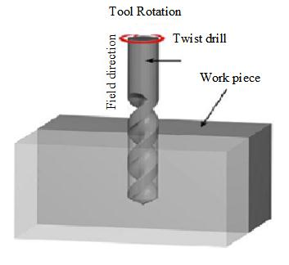**EXPERIMENTAL SET UP:**

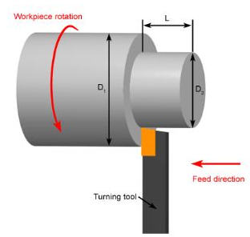

(1)Basic Turning Operations in Lathe (2) Schematic of Drilling Process

In turning, a work piece pivoting about its axis is served by single point cutting instrument which removes the undesired material along these lines creating the ideal part. A gathering of machine's "carriage", "cross slide", and "compound rest" helps in device development. These equipment are given a chuck in which the work piece is fixed from one end. The opposite end is the dead centre upheld at tail stock. The carriage goes through the bed way which is parallel to the axis of the work piece and this axis is known as "Z" axis. The axis perpendicular to the motion of the work piece is known as "X" axis. The part finish and in addition the efficiency is assessed by the cutting speed, feed and depth of cut. Different variables incorporates geometry of cutting tool device, type of cutting device, stock machinability, angle of the tool device with reference to the work piece, capacity of machine and overall conditions.

In manufacturing, drilling is widely used, refers to the process of creating or enlarging a hole using a particular type of end cutting tool, known as drill. Drilling is considered as the less expensive and most effective method, shown in figure 1.6. It is one of the less complex, moderate and accurate tool used in manufacturing and production. It comprises of a spindle which imparts the rotary motion to the tool and a table in which the work rest for feeding the tool into the work. Because of their incredible length to diameter proportion, drills are sufficiently capable to make profound holes. It must be used with attention with the ultimate objective to make holes precisely and keeping the drill from breaking. In addition, because of the chip formation, discarding the chips and the usage of cutting fluids is significant. The movement of chips shaped inside the work piece is inverse to the axial motion of the drill.

**SCOPE OF THE RESEARCH WORK**

Detection of tool wear is important to diminish down time, decrease rejects, enhance quality and enhance personnel safety. Machine activities like turning is a standout amongst the most vital and basic machining process. The phenomena, like breakage of the single point cutting tool, deformation, and so on are usually experienced in lathe activities. Thus the monitoring of single point cutting tool for machine is a vital task with a high level of economic significance. End of these issues even up to a certain degree will enhance the machining activities.

To monitor tool wear in drilling activity, attempt has been made utilizing acoustic emission signal, surface roughness, and process parameter optimization using Taguchi method. Using HSS tool on mild steel, analyses have been done on a vertical drilling machine. Acoustic emission parameters and surface roughness parameters estimated during the test have been connected with the flank wear created on the device. In this way the feasibility of the above mentioned methods have been set up and have been observed to be effective in analyzing tool wear in drilling.

**CONTRIBUTION OF RESEARCH**

A standout among the most encouraging tool monitoring methods depends on analysis of Acoustic Emission. Thus it is proposed in present report to research the tool wear utilizing signal analysis for single point cutting tool (Carbide Inserts). The signal information acquired by AE and Surface Roughness methods will be examined to set up process parameters. These have effect on the behavior of tool and on machining process. Acquired acoustic emission signals and surface roughness readings are then improved dependent on Taguchi method. In this way optimal parameters required for machining is determined. For optimizing the process parameters like cutting speed, feed rate, depth of hole in drilling mild steel, depending on the key characters such as surface roughness (Ra, Rt and Rz), AE counts, flank wear. For performing the Taguchi analysis, Statistical MINITAB software is utilized. After optimizing, ANOVA will be accomplished to decide the relative magnitude of the every elements on the objective function and to calculate the error.

**LITERATURE SURVEY**

**OVERVIEW**

Machining is a standout amongst the most critical assembling forms in the industry. The procedure of abolishing solid from a work piece in the method of chips. Machining methods gives strength for diminished machining time and vitality utilization. Machining process relies upon the material part, tool geometry and in addition the accessibility of machine apparatus. Metal machining process in mechanical and fabricating segment was examined. Axis of the work piece while cutting instrument moves in a direct movement includes turning. For all turning activities machine is utilized as the machine. Various metals are utilized for the turning procedure, however Inconel 718 assumes a fundamental job for turning process. There are a few machines are utilized for turning. To achieve a few conflicting targets of the procedure, it is fundamental to improve the setting of info factors. Consequence of surface roughness in the machined material was separated. Resultant to the examinations, the impact of turning parameters on surface quality, apparatus wear, rigidity and chip morphology have been separated. Acoustic outflow method and wear analysis utilizing surface roughness estimation system and advancement of inconel-718 was talked about in this chapter.

|  |  |  |  |  |  |
| --- | --- | --- | --- | --- | --- |
| **S.NO** | **Author &Year** | **Research Findings** | **Research Objective** | **Merits /Demerits** | **Result** |
| 1 | (Chanda*et al* 2018) | * The serious values of the cutting parameters are projected using both time and frequency response. | * Nonlinear dynamics of the thin cylindrical work piece are considered. | * Study the nonlinear responses and constancy of tool. | * This study will supports to identify critical system parameters to have a chatter free turning operation. |
| 2 | (Impero*et al* 2015) | * Analyzing the drilling tool life, which is affecting the Drilling Tool Life. | * To study the effect of Drilling Tool Material and Forces variation on the drilled work piece. | * Optimization of drilling tool was not considered. | * Optimize the drilling forces and tool geometry by analysis of deformation due to changing in drilling tool material. |
| 3 | (Liu *et al* 2018) | * Dry milled samples showed longer fatigue life and more excellent corrosion. | * Influence of machining parameters and tool wear on the service performance of 17-4PH stainless steel were investigated. | * Admirable service performance of the high-speed dry milled samples. | * The single-factor test was adopted, and the optimal cutting parameters were determined. |

**METHODOLOGY AND EXPERIMENTAL SETUP**

Exploration of acoustic emission is grand among the best ideal apparatus observing procedure. Thus it is wished-for an existing explosion to inquiries the Tool wear using signal analysis for single point cutting tool (Carbide Inserts). The AE obtained by the signal data and to setup the process parameters by analyzing the surface roughness procedures, which have an impact on the performance of the tool and the machining process. Based on Taguchi method the acquired acoustic emission and surface roughness readings are optimized. Along these ideal parameters required for machining is resolved. To improve the process parameters like cutting speed, feed rate, depth of the hole in drilling mild steel, in view of fundamental exactness qualities of drilled holes corresponding surface roughness (Ra, Rt, and Rz), AE counts, flank wear. To the direct examination of Taguchi, the statistical MINITAB software is recycled. After the process parameters are enhanced, ANOVA will be performed to choose the overall size of each factor on the objective function and to evaluate the 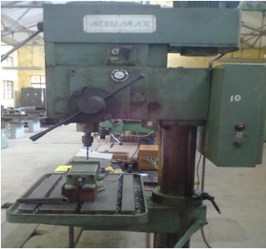error.

Experimental Setup

(1)Experimental Results in Turning Process with Inconel 718

|  |  |  |  |  |
| --- | --- | --- | --- | --- |
| **S. No.** | **Speed** | **DOC** | **Feed** | **Surface Roughness (Ra)** |
| **Rpm** | **mm** | **mm/rev** | **µm** |
| 1 | 2000 | 0.6 | 30 | 3.78 |
| 2 | 2000 | 0.6 | 56 | 3.74 |
| 3 | 2000 | 0.6 | 65 | 3.56 |
| 4 | 2000 | 0.8 | 30 | 2.41 |
| 5 | 2000 | 0.8 | 56 | 2.37 |
| 6 | 2000 | 0.8 | 65 | 2.12 |
| 7 | 2000 | 1.0 | 30 | 1.28 |
| 8 | 2000 | 1.0 | 56 | 1.54 |
| 9 | 2000 | 1.0 | 65 | 1.38 |
| 10 | 2000 | 1.5 | 30 | 1.05 |
| 11 | 2000 | 1.5 | 56 | 0.84 |
| 12 | 2000 | 1.5 | 65 | 0.57 |
| 13 | 2500 | 0.6 | 30 | 4.21 |
| 14 | 2500 | 0.6 | 56 | 4.14 |
| 15 | 2500 | 0.6 | 65 | 3.75 |
| 16 | 2500 | 0.8 | 30 | 3.68 |
| 17 | 2500 | 0.8 | 56 | 3.63 |
| 18 | 2500 | 0.8 | 65 | 3.57 |
| 19 | 2500 | 1.0 | 30 | 3.22 |
| 20 | 2500 | 1.0 | 56 | 2.87 |
| 21 | 2500 | 1.0 | 65 | 2.74 |
| 22 | 2500 | 1.5 | 30 | 1.35 |
| 23 | 2500 | 1.5 | 56 | 1.28 |
| 24 | 2500 | 1.5 | 65 | 1.14 |
| 25 | 3000 | 0.6 | 30 | 2.55 |
| 26 | 3000 | 0.6 | 56 | 2.46 |
| 27 | 3000 | 0.6 | 65 | 2.32 |
| 28 | 3000 | 0.8 | 30 | 1.18 |
| 29 | 3000 | 0.8 | 56 | 1.04 |
| 30 | 3000 | 0.8 | 65 | 1.00 |
| 31 | 3000 | 1.0 | 30 | 2.01 |
| 32 | 3000 | 1.0 | 56 | 1.84 |
| 33 | 3000 | 1.0 | 65 | 1.53 |
| 34 | 3000 | 1.5 | 30 | 1.00 |
| 35 | 3000 | 1.5 | 56 | 0.62 |

Experimental Results in Drilling Process wild Mild Steel

|  |  |  |  |  |  |
| --- | --- | --- | --- | --- | --- |
| **S. No** | **Spindle Speed (rpm)** | **Feed (mm/rev)** | **Point angle and Helix Angle (degree)** | **Hole Diameter (mm)** | **Surface Roughness (Ra) µm** |
| 1 | 1500 | 1.5 | 1 | 8.02 | 1.82 |
| 2 | 1500 | 2.5 | 1 | 8.04 | 1.81 |
| 3 | 1500 | 3.5 | 1 | 8.03 | 1.80 |
| 4 | 2000 | 1.5 | 1 | 8.02 | 1.88 |
| 5 | 2000 | 2.5 | 1 | 8.01 | 1.78 |
| 6 | 2000 | 3.5 | 1 | 8.02 | 1.75 |
| 7 | 2500 | 1.5 | 1 | 8.03 | 1.73 |
| 8 | 2500 | 2.5 | 1 | 8.03 | 1.67 |
| 9 | 2500 | 3.5 | 1 | 8.02 | 1.65 |
| 10 | 3000 | 1.5 | 1 | 8.03 | 1.58 |
| 11 | 3000 | 2.5 | 1 | 8.01 | 1.63 |
| 12 | 3000 | 3.5 | 1 | 8.02 | 1.71 |
| 13 | 1500 | 1.5 | 2 | 8.20 | 1.63 |
| 14 | 1500 | 2.5 | 2 | 8.21 | 1.61 |
| 15 | 1500 | 3.5 | 2 | 8.23 | 1.70 |
| 16 | 2000 | 1.5 | 2 | 8.22 | 1.67 |
| 17 | 2000 | 2.5 | 2 | 8.21 | 1.82 |
| 18 | 2000 | 3.5 | 2 | 8.23 | 1.83 |
| 19 | 2500 | 1.5 | 2 | 8.22 | 1.87 |
| 20 | 2500 | 2.5 | 2 | 8.21 | 1.82 |
| 21 | 2500 | 3.5 | 2 | 8.22 | 1.58 |
| 22 | 3000 | 1.5 | 2 | 8.22 | 1.63 |
| 23 | 3000 | 2.5 | 2 | 8.23 | 1.68 |
| 24 | 3000 | 3.5 | 2 | 8.23 | 1.73 |

**CONDITION MONITORING AND OPTIMIZATION OF MACHINING PARAMETERS**

In recent years, the industrial surroundings have experienced extreme changes. A standout amongst the most significant developments has been the trend towards cost savings through various means like a decrease in staff numbers while in the meantime wanting to enhance the product quality and reduce the production time. In this chapter, the condition monitoring system and its methodology are planned with the surface roughness and robust design strategies. The condition monitoring which is used for watching and analyzing the overall processes and conditions. Acoustic emission technique is one for the most part utilized condition monitoring method. One of the most commonly used condition monitoring methods is AE. The acoustic emission technique is used to analyze the signals and the waves. The quality requirements and its validation function are explained in this chapter. These conditions are helpful for evaluating the idea of the specimens and materials. Classifications of product/procedure parameters are defined and the Taguchi orthogonal array creation and processing are studied. This part depicts the inspecting and testing techniques of metal products and materials and also furthermore clarifies their parameters. The scientific condition is determined for figuring and examining the quality, orthogonal array for the experimentation.

**CONDITION MONITORING: - AN INTRODUCTION**

One of the most essential exercises in the manufacturing industry is machining, which includes rotating, grinding, penetrating and so on. The new pattern in assembling technology is that the enhancement of the automatic machining system it does not need any supervision or little supervision. To ensure the machine condition and work portion quality the machine tool automation requires monitoring the techniques. Among a couple of regions of on the going interest, online monitoring of the state of a cutting tool and the surface roughness of the machined work piece become key from this popular situations. Spans earlier people have used their ears or screwdrivers as a congregation antenna of various sensations and noise while the machine was in the operation, Prasad et al. The condition monitoring system which is for checking and examining the general methods and conditions used in the processes. The advanced condition monitoring system consists of numerous sensors and hardware system incorporated with a software program which examinations the signals. Once in the past, various effective monitoring procedures have been produced for machine checking and diagnosis: for instance, visual checking, thermal monitoring, and electrical monitoring. These systems are mainly focused on extracting the pertinent signals or highlights from the gear wellbeing data. Various standard procedures have been exploited to process and analyze this information. These procedures join normal estimation methods, such as simple threshold methods, system identification, and statistical methods. The fundamental shortcoming of these techniques is that these techniques may be required an accomplished machinist. This insufficiency has provoked the utilization of the computational understanding framework to the issue if condition monitoring, Pandiyan et al.

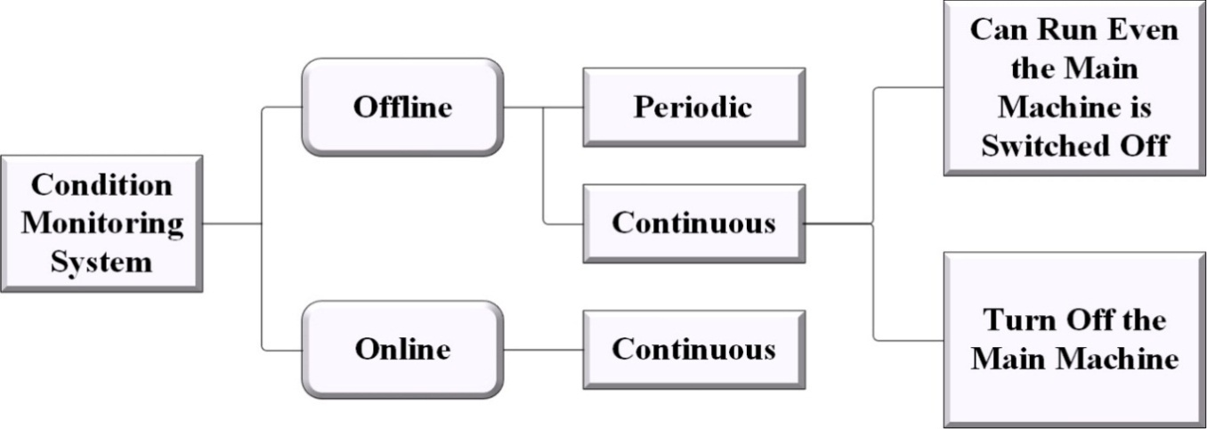

**Figure:** Condition Monitoring System

In figure, it demonstrates the fundamental design of the condition monitoring system. Condition monitoring in a machine or machining process is the main use of a condition monitoring system. These frameworks work in two modes offline mode and online mode. Offline mode has periodic and continuous methods that are used to screen the conditions.

Due to the complex nature of online monitoring, it has been recognized that the product module, for example, as intelligent agents can be consumed to promote vulnerability and popularity of the system. The pattern recognition techniques like neural systems and support vector machines require information from the machines having the failure and the machines having no failures to be able to successfully train and then later be able to classify the machine failure and no failure classes. All machines or hardware’s exuded or show both the essential and secondary signals and parameters which are required to assess the execution of the gear. Observing the essential signs are named as execution checking, Silva et al. The execution checking covers the going with an area,

* Decisive the combinations of the total estimation of the layout to the magnitude worth sum.
* Computing the characterizations input-output relationship.
* Quantifying and all the similar time looking yield parameters inside a strategy of standard working conditions. The prompt estimation of steam or weight of a tapping system is an instance of execution checking.

Every last another signal, which shows up as output loss like vibration, sound, warm, synthetic, and physical changes, are named as assistant signals. Checking of fundamental signals alone does not help in the productive evaluation of interests and condition of machines. As helper signals are generally an outcome of loss in yield, checking of these signals ends up unavoidable for apparatus prosperity watching and concentrated diagnostics. Arranged sorts of observing structure are utilized in different fields and some basic condition checking systems are vibration observing and investigation, warm imaging, and acoustic transmission. In this examination work, the acoustic radiating methodologies are utilized for observing the condition in the condition checking structure, Zhu et al.

**EXPERIMENTAL RESULTS AND DISCUSSION**

Here examining about the surface roughness and experimental techniques to determine the surface roughness on metals. The roughness analyzer is utilized to discover the roughness of the material rapidly and precisely in the surface of the material. A roughness analyzer shoes the deliberate roughness depth (Rz) and the mean roughness of the material (Ra) in the micrometer or microns (µm), total height of the material (Rt). The investigations were improved for the different cutting rate, feed rate and depth of the hole. Surface roughness bring up the condition of machined surface. The surface dimension of the metal is estimated by the gloss is obviously qualified it is known as the surface roughness. Which assumes an imperative job for characterizing a surface of a material. The procedure parameters are upgraded with the insightfulness of the various execution of the work piece surface roughness, flank wear and the contrasted outcomes and the outcomes acquired from the underlying arrangement of the readings. Statistical Minitab software is utilized for the improvement of parameters by utilizing the Taguchi strategies. After the optimization the overall extent of each factor are recognized. The surface roughness is the output gotten after the test techniques. Surface complete is critical in the mechanical enterprises. The mechanical parts is generally viewed as an essential factor in their execution and wear administration of the parts and that are liable to the dry friction, machine tools bits, threading dies, rolls, clutch plates and brake drums and so on. The level of surface roughness is additionally required for the wear in specific parts. The Ra is the average roughness and it is expressed in units of height.

**Experimental Data Collection**

Experimental data are gathered by utilizing the L9 orthogonal array for the surface roughness (Ra, Rt, and Rz). Data acquired after estimating the response variables of the materials like surface roughness (Ra, Rt, and Rz), flank wear and AE include are classified in below table.

**Table :** L9 Orthogonal Array for Surface Roughness (Ra, Rt, Rz) Flank Wear and AE Counts

|  |  |  |  |  |  |  |  |  |
| --- | --- | --- | --- | --- | --- | --- | --- | --- |
| **Run** | **Speed**  **Rpm** | **Feed**  **mm/rev** | **Depth of hole**  **mm** | **AE Counts** | **Flank Wear**  **(µm)** | **Surface Roughness** | | |
| **Ra (µm)** | **Rt (µm)** | **Rz (µm)** |
| 1 | 225 | 0.104 | 5 | 17508 | 190 | 2.71 | 3.58 | 17.55 |
| 2 | 225 | 0.211 | 10 | 17376 | 270 | 3.18 | 3.53 | 12.20 |
| 3 | 225 | 0.315 | 15 | 17836 | 310 | 3.74 | 5.03 | 14.20 |
| 4 | 310 | 0.104 | 10 | 17326 | 210 | 2.66 | 3.23 | 12.60 |
| 5 | 310 | 0.211 | 15 | 17242 | 265 | 3.72 | 4.32 | 15 |
| 6 | 310 | 0.315 | 5 | 16713 | 209 | 4.36 | 5.83 | 17.30 |
| 7 | 450 | 0.104 | 15 | 17043 | 180 | 1.74 | 2.26 | 11.15 |
| 8 | 450 | 0.211 | 5 | 17217 | 150 | 2.21 | 2.71 | 13.05 |
| 9 | 450 | 0.315 | 10 | 18063 | 200 | 1.89 | 2.27 | 12.40 |

In table, it demonstrates the consequence of surface roughness estimation of the 9 tests. The speed of the cutting metal (Rpm), feed rate of the metal (mm/rev), deep of the hole (mm), AE counts, flank wear (µm) will be examined. Statistical analysis was directed on the roughness data. Firstly ANOVA is utilized to dissect the significant impacts of the variables and perceive the components contributing the surface roughness. Speed and feed level of the material abatements the estimation of AE was expanding by increasing these components to the material it will builds the AE of the material. Here we can see that the surface roughness of the material height of the material and the normal peak to valley of five consecutive examining lengths within the measuring length. Chiefly we involved the three dimensions of rates in various feed, depth of hole. These components demonstrates the expanding and diminishing dimensions of acoustic emission. Increment of depth of entire demonstrates the expansion in acoustic emanation. AE indicates high at the 450 Rpm speed and 0.315 feed and depth of entire at 10mm it demonstrates the ideal AE at18063 however the flank wear indicates high at 270 on 220 Rpm speed.

***Details of ANOVA:***

**Table :** ANOVA for the Response Surface Roughness (Ra)

|  |  |  |  |  |  |
| --- | --- | --- | --- | --- | --- |
| Source | DF | Seq SS | Adj SS | Adj MS | F |
| Speed | 2 | 46.7832 | 46.7832 | 23.3916 | 57.27 |
| Feed | 2 | 11.2421 | 11.2421 | 5.6211 | 13.76 |
| Depth of hole | 2 | 3.7562 | 3.7562 | 1.8781 | 4.60 |
| Error | 2 | 0.8169 | 0.8169 | 0.4084 | - |
| Total | 8 | 62.5985 | 62.5985 | - | - |

**AE COUNTS OBSERVATION**

Number of times the acoustic release signal adequacy surpasses a preset edge amid any chosen segment of test. With the gear designed and setup finish, AE testing may start. The sensor is coupled to the test surface and held set up with tape or adhesive. An administrator at that point screens the signs which are energized by the incited worries in the protest. At the point when a valuable transient, or burst flag is effectively acquired, parameters like amplitude, counts, estimated zone under the rectified signal envelope (MARSE), span, and rise time can be accumulated. Counts refers to the quantity of pulses discharged by the estimation hardware if the flag sufficiency is more notable than the limit, Monti et al. Depending upon the extent of the AE event and the qualities of the material, one hit may deliver one or numerous counts. While this is a generally straightforward parameter to gather, it for the most part should be joined with plenty fullness and additionally span estimations to give quality data about the state of a signal, Hase et al. The ideal dimensions of the control factors which give ideal AE include are abridged the Table for gentle steel material. Least the AE counts to top, least will be the tool wear and most extreme will be the device life.



**Figure :** Counts to Peak and Rise Time of Various Parameters

In figure , it demonstrates the counts to crest and rise time of different properties, for example, normal frequency, resonation frequency, flag quality, and frequency centroid. The main chart demonstrates the estimations of normal recurrence and RSM. The RSM esteems are increments than the normal recurrence. In the second diagram the resonation recurrence and initiation frequency esteems are appeared. The resonation recurrence have the most notable raise than the initiation recurrence. The third diagram demonstrates the signal quality and outright vitality levels. Outright vitality and flag quality are raises and the estimations of flag quality demonstrate the greatest than the total energy.

**ANOVA-EXPERIMENTAL PREDICTION RESULTS**

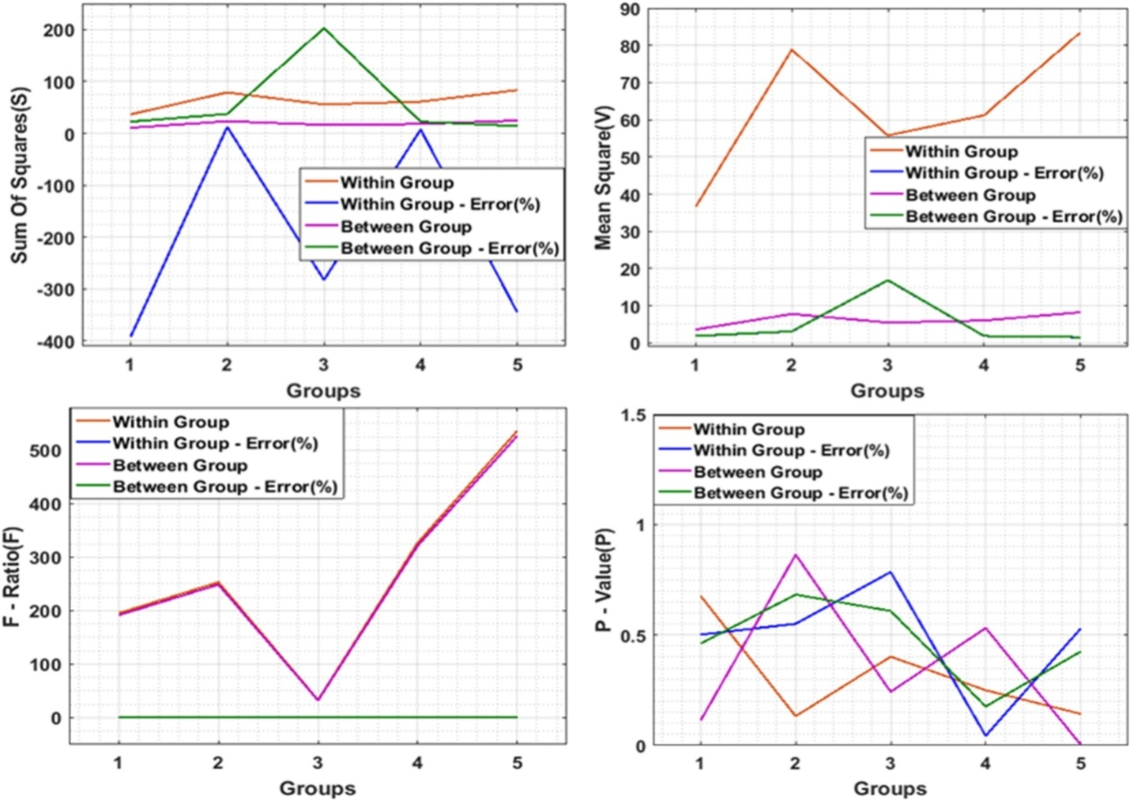

**Figure :** Anova Results of Drilling Hole Diameter

In figure , it demonstrates the Anova consequences of the penetrating gap breadth. Diverse parameters, for example, entirety of squares, mean square, f-proportion, and p-esteem are utilized in gatherings. In the outcomes the total of squares esteem ends up most extreme at gathering esteem 3. The between gathering indicates most extreme qualities in total of squares. On account of mean square qualities the most extreme qualities are with the inside group.

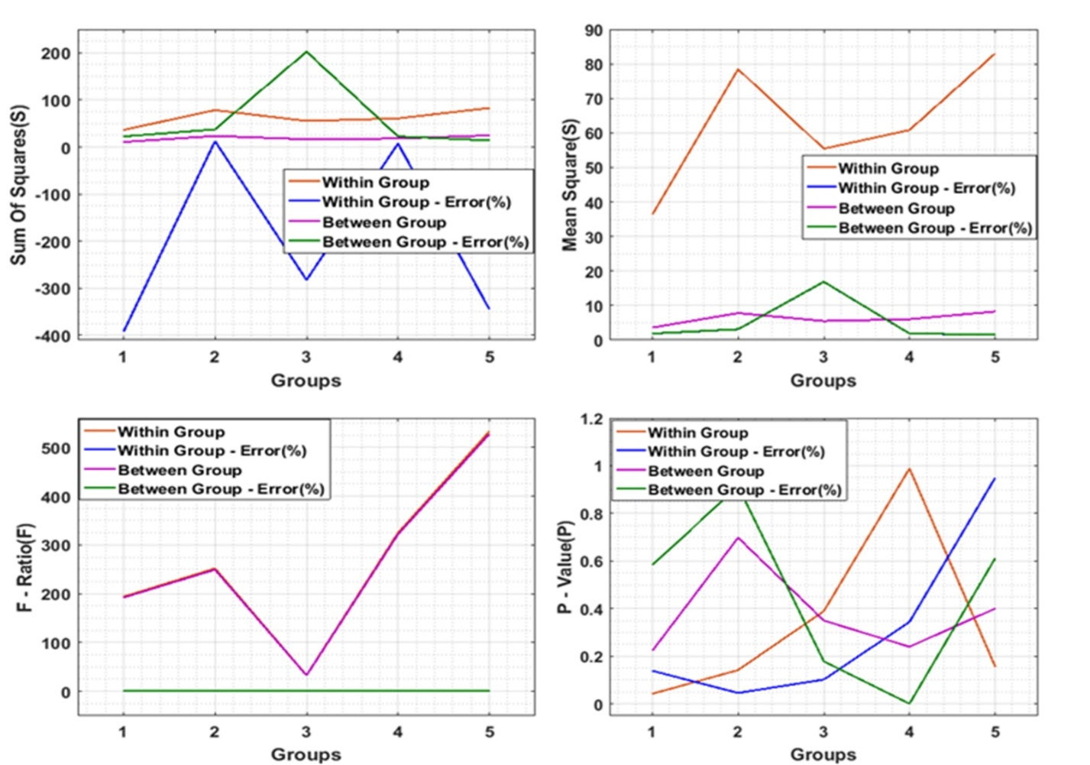

**Figure :** Anova Results of Drilling Surface Roughness

In figure , it shows the Anova consequences of drilling surface roughness. The total of squares esteem are higher on account of between gatherings condition. The mean square qualities are most extreme at inside the gathering conditions. The between gathering condition the f-proportion esteems getting enhanced their qualities.

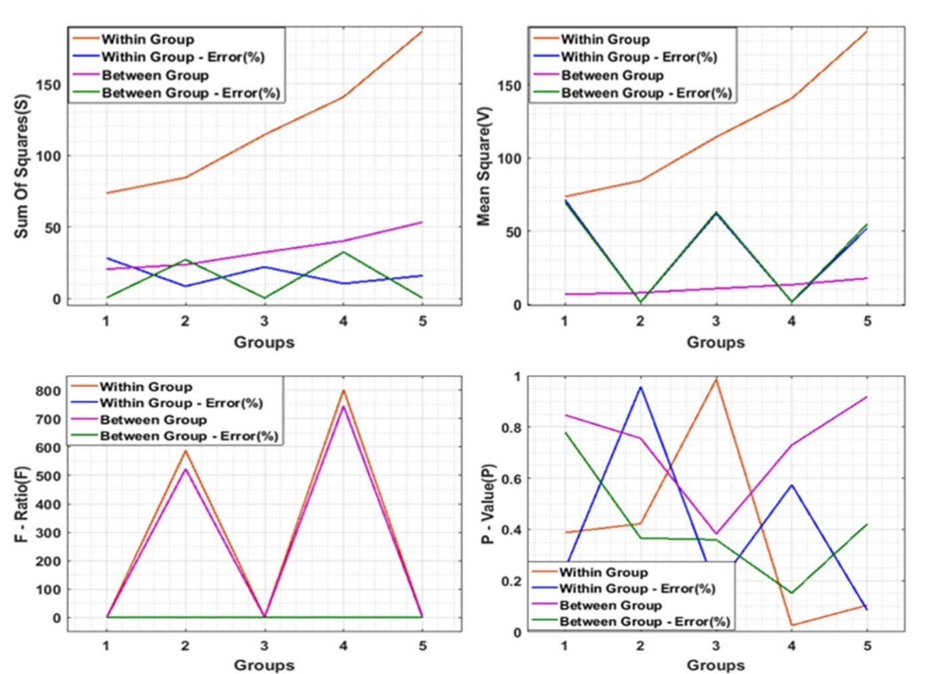

**Figure :** Anova Results of Turning Process

In figure , it demonstrates the Anova results for the turning procedure and the inside gathering condition have the enhancements in the whole of squares and mean square qualities. The f-proportion esteems have more prominent enhancements and more noteworthy diminishments. On account of p-values the between gathering condition have greatest qualities.

***Prediction using Drilling Data:***

**Table :** Drilling Data Used for Prediction

|  |  |  |  |  |  |
| --- | --- | --- | --- | --- | --- |
| **S. No** | **Spindle Speed (rpm)** | **Feed (mm/rev)** | **Point angle and Helix Angle (degree)** | **Hole Diameter (mm)** | **Surface Roughness (Ra) µm** |
| 1 | 1500 | 1.5 | 1 | 8.02 | 1.82 |
| 2 | 1500 | 2.5 | 1 | 8.04 | 1.81 |
| 3 | 1500 | 3.5 | 1 | 8.03 | 1.80 |
| 4 | 2000 | 1.5 | 1 | 8.02 | 1.88 |
| 5 | 2000 | 2.5 | 1 | 8.01 | 1.78 |
| 6 | 2000 | 3.5 | 1 | 8.02 | 1.75 |
| 7 | 2500 | 1.5 | 1 | 8.03 | 1.73 |
| 8 | 2500 | 2.5 | 1 | 8.03 | 1.67 |
| 9 | 2500 | 3.5 | 1 | 8.02 | 1.65 |
| 10 | 3000 | 1.5 | 1 | 8.03 | 1.58 |
| 11 | 3000 | 2.5 | 1 | 8.01 | 1.63 |
| 12 | 3000 | 3.5 | 1 | 8.02 | 1.71 |
| 13 | 1500 | 1.5 | 2 | 8.20 | 1.63 |
| 14 | 1500 | 2.5 | 2 | 8.21 | 1.61 |
| 15 | 1500 | 3.5 | 2 | 8.23 | 1.70 |
| 16 | 2000 | 1.5 | 2 | 8.22 | 1.67 |
| 17 | 2000 | 2.5 | 2 | 8.21 | 1.82 |
| 18 | 2000 | 3.5 | 2 | 8.23 | 1.83 |
| 19 | 2500 | 1.5 | 2 | 8.22 | 1.87 |
| 20 | 2500 | 2.5 | 2 | 8.21 | 1.82 |
| 21 | 2500 | 3.5 | 2 | 8.22 | 1.58 |
| 22 | 3000 | 1.5 | 2 | 8.22 | 1.63 |
| 23 | 3000 | 2.5 | 2 | 8.23 | 1.68 |
| 24 | 3000 | 3.5 | 2 | 8.23 | 1.73 |

In table , it demonstrates the penetrating information that are utilized for the forecast purposes. These table demonstrates the axle speed, feed, gap breadth, and surface roughness with point edge and helix edge one and two. These qualities are utilized in the experimentation for the expectation of results. The outcomes are appeared in underneath,

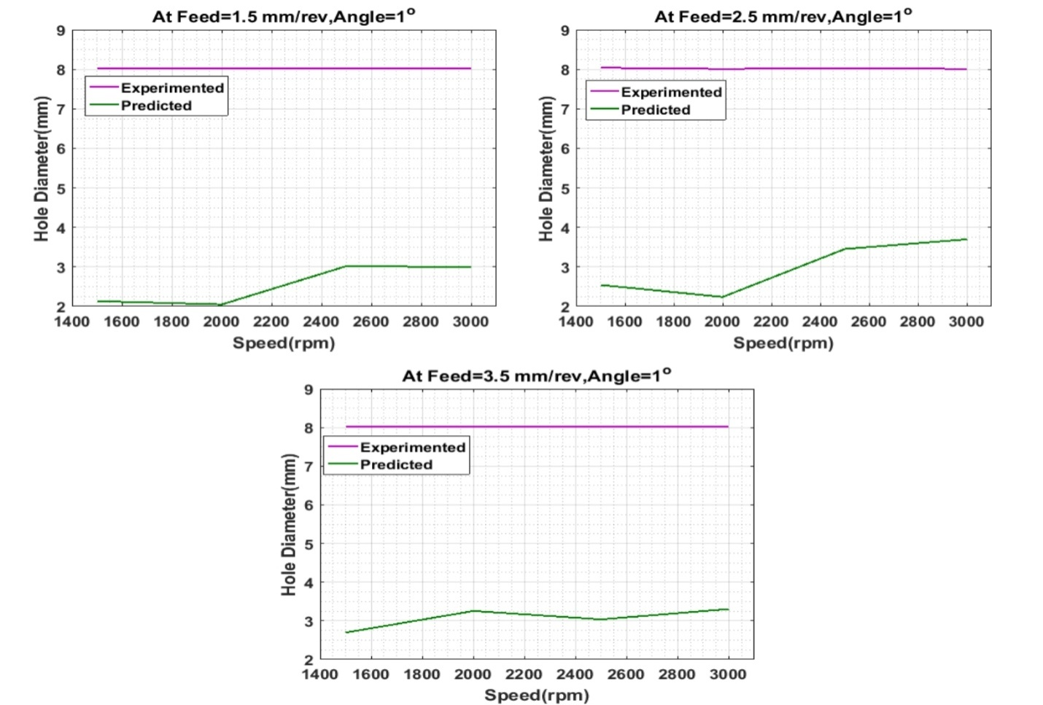

**Figure :** Experimental and Predicted Results of Hole Diameter with Speed at Angle 1 Degree

In figure , it demonstrates the exploratory and anticipated consequences of gap breadth with the speed. In these figures the point is set to 1 and feed rate is changes to 1.5, 2.5, and 3.5 rev/mm. The trial results demonstrates a straight-line in the above tree conditions. At feed rate 2.5 mm/rev, point 1 degree, the anticipated qualities demonstrates a steady outcomes than the other two. The opening measurement is increments when the speed increments and the anticipated outcomes indicates less qualities than the test results.

**CONCLUSION AND FUTURE SCOPE**

**6.1 RESEARCH CONCLUSION**

In the past decades, the industrialization is constituted with a relevant utilization of computer integrated manufacturing to establish an initiative manufacturing stream which is considered to be more advanced in maintaining the machine processing techniques. Modern machining industries always aim at higher productivity to obtain high profit. To accomplish this target, industries aim at higher material removal rate through different metal cutting operations. Metal cutting process is complex due to a variety of input variables in machining; machine tool chosen to perform the process, properties of work piece, selected cutting parameters (speed, feed and depth of cut, cutting tool geometry and material. Some of the essential factors that influence metal cutting operations are the cutting tool materials and cutting fluids. New cutting inserts are being developed by the manufacturers for obtaining better performance on the end product. Machining industries started concentrating on the selection of a proper cutting fluid, as it is the prime factor which controls the cutting temperature of any machining process. The increase in the cutting temperature is directly related to the tool life, and surface finish of the product. Care must be taken in the selection of suitable cutting fluids to ensure getting lower cutting temperatures, reduced cutting forces, better surface finish and dimensional accuracy of the finished part. Many machining processes were optimized by the researchers for improving the surface roughness quality of the product.

In this research, the optimization parameter is mainly concerned with the depth of cut usually decided based on part geometry and material to be removed and can be assumed constant. Optimization of cutting parameters is valuable in terms of providing high precision and efficient machining. One of the effects of cutting force in the milling operation with low diameter tool is tool deflection. Optimization of cutting parameters is essential for a manufacturing unit to respond effectively to severe competitiveness and increasing demand of quality product in the market. In cutting process, optimization of cutting parameters is considered to be a vital tool for improvement in output quality of a product as well as reducing the overall production time. The experimental results showed that the Taguchi parameter design is an effective way of determining the optimal cutting parameters for achieving low tool wear and low work piece surface temperature.

**COMPREHENSIVE RESEARCH OBJECTIVE**

In this section the objective of the proposed research are illustrated in a descriptive format. The following will specifies the step by step procedure induced in the formulation of the corresponding study.

* To optimize the process parameters like Cutting speed, Feed rate, depth of hole in drilling mild steel, based on key accuracy characteristics of drilled holes like Surface Roughness (Ra, Rt and Rz), AE counts, flank wear.
* Determine the technique used to solve the present problem, i.e., Robust Parameter Design.
* The objective functions are formed based on Taguchi’s quadratic loss function for each performance characteristics, i.e., Surface finish, flank wear AE signals.
* After the objective functions are formed, control factors and their levels are identified.
* The values for the control factors are selected based on operators (Drilling operators) experience, literature survey and some pre-experimental analysis.
* The matrix experiments are conducted on mild steel.
* After the experiments are conducted, response variables are tabulated and analysis is conducted.
* To conduct the Taguchi analysis, Statistical MINITAB software is used. Based on this analysis, process parameters are optimized.
* After the process parameters are optimized, ANOVA will be performed to determine the relative magnitude of the each factor on the objective function and to estimate the error.
* The verification experiments are conducted using the optimized process parameters and the performance characteristics is measured and compared with the results obtained from the initial set of readings.

**RESEARCH EXTENSION AND FUTURE SCOPE**

Tool wear monitoring and the drilling mild steel process along with the concurrent optimization process parameter can be extended to the future research by inducing distinct processes. In order to initiate an efficient elaboration method it is relevant to improve the optimization process to minimize the tool wear in the overall drilling process. The crucial possibilities in the elaboration of the current research are deliberated in the following section.

* Influence of several other machining factors like type of drill (coated and uncoated), drill material, drill geometry, drilling conditions (dry and wet run) and few material factors like fibre volume fraction, fibre orientation, material thickness etc., with sufficient number of levels, could be considered for tool flank wear study could be taken up for the future work.
* Mathematical regression equation generated using RSM, for drill flank wear measurement could be used as a reference for drill flank wear prediction under specified work material, drill and machining conditions,
* Modelling and simulation techniques used in the present research could be used for 168 comparative analysis. As a future work, the simulation of process parameters could be further extended by considering Genetic Algorithm (GA) or any other Artificial Intelligence approaches for fine tuning the results.
* Sequentially, the corresponding scope for extending the drill flank wear study and plotting wear mechanism plots for different GFRP / Drill combination for high speed machining conditions, Balaji et al.
* A set of experimental work in drilling of GFRP composite could be carried out for wear mechanism study corresponding to the drill process parameters recommended in the “Safety Zone” in order to validate the minimized tool wear, Mohan et al.
* Systematic approaches used in this research add to the body of knowledge in the area of GFRP composite drilling for the selected combination of work and tool material under the specified context. The methodology applied in this research with regard to DoE, ANOVA, RSM, ANN, Wear rate and Wear transition mechanism mapping could be applied to other similar studies in the area of GFRP composite machining, Khan et al.
* Over the recent industrial scenario demands the application of GFRP composites in key areas such as aircraft, automotive, defence, and aerospace. Since the machining of composites is a very complex process due to abrasive nature of fibres, the demand for optimized cutting tools and cutting conditions are increasing day by day.
* Consequently, enhancement of the operational performance and tool life of the cutting tool has become a key research area in composite machining. So, to add some input to this, in the present research wok, various advanced research tools and techniques were used to optimize the drill performance while machining GFRP composites.
* The outcomes of this research (usage of appropriate machining factors and conditions) can be applied for the minimization of the drill wear and increase of the productivity of small scale industries, which deal with GFRP composite machining.

**REFERENCES**

[1] M. Sharif, S. Pervaiz and I. Deiab, "Potential of alternative lubrication strategies for metal cutting processes: a review", The International Journal of Advanced Manufacturing Technology, vol. 89, no. 5-8, pp. 2447-2479, 2016.

[2] X. Teng, W. Chen, D. Huo, I. Shyha and C. Lin, "Comparison of cutting mechanism when machining micro and nano-particles reinforced SiC/Al metal matrix composites", Composite Structures, vol. 203, pp. 636-647, 2018.

[3] G. Ingarao, "Manufacturing strategies for efficiency in energy and resources use: The role of metal shaping processes", Journal of Cleaner Production, vol. 142, pp. 2872-2886, 2017.

[4] Y. Wu, Y. Zhou, J. Li, H. Zhou, J. Chen and H. Zhao, "A comparative study on wear behavior and mechanism of styrene butadiene rubber under dry and wet conditions", Wear, vol. 356-357, pp. 1-8, 2016.

[5] K. Salonitis, L. D’Alvise, B. Schoinochoritis and D. Chantzis, "Additive manufacturing and post-processing simulation: laser cladding followed by high speed machining", The International Journal of Advanced Manufacturing Technology, vol. 85, no. 9-12, pp. 2401-2411, 2015.

[6] W. Cai, F. Liu, X. Zhou and J. Xie, "Fine energy consumption allowance of workpieces in the mechanical manufacturing industry", Energy, vol. 114, pp. 623- 633, 2016.

[7] Q. Zhong, R. Tang, J. Lv, S. Jia and M. Jin, "Evaluation on models of calculating energy consumption in metal cutting processes: a case of external turning process", The International Journal of Advanced Manufacturing Technology, vol. 82, no. 9- 12, pp. 2087-2099, 2015.

[8] P. Bilga, S. Singh and R. Kumar, "Optimization of energy consumption response parameters for turning operation using Taguchi method", Journal of Cleaner Production, vol. 137, pp. 1406-1417, 2016.

[9] S. Debnath, M. Reddy and Q. Yi, "Influence of cutting fluid conditions and cutting parameters on surface roughness and tool wear in turning process using Taguchi method", Measurement, vol. 78, pp. 111-119, 2016.

[10] R. Maruda, G. Krolczyk, P. Nieslony, S. Wojciechowski, M. Michalski and S. Legutko, "The influence of the cooling conditions on the cutting tool wear and the chip formation mechanism", Journal of Manufacturing Processes, vol. 24, pp. 107- 115, 2016.

[11] A. Khorasani, I. Gibson, M. Goldberg, E. Doeven and G. Littlefair, "Investigation on the effect of cutting fluid pressure on surface quality measurement in high speed thread milling of brass alloy (C3600) and aluminium alloy (5083)", Measurement, vol. 82, pp. 55-63, 2016.

[12] A. Fernández-Valdivielso, L. López de Lacalle, G. Urbikain and A. Rodriguez, "Detecting the key geometrical features and grades of carbide inserts for the turning of nickel-based alloys concerning surface integrity", Proceedings of the Institution of Mechanical Engineers, Part C: Journal of Mechanical Engineering Science, vol. 230, no. 20, pp. 3725-3742, 2016.

[13] V. Vijayaraghavan, A. Garg, L. Gao, R. Vijayaraghavan and G. Lu, "A finite element based data analytics approach for modeling turning process of Inconel 718 alloys", Journal of Cleaner Production, vol. 137, pp. 1619-1627, 2016.

[14] W. Akhtar, J. Sun and W. Chen, "Effect of Machining Parameters on Surface Integrity in High Speed Milling of Super Alloy GH4169/Inconel 718", Materials and Manufacturing Processes, vol. 31, no. 5, pp. 620-627, 2014.

[15] İ. Asiltürk, S. Neşeli and M. İnce, "Optimisation of parameters affecting surface roughness of Co28Cr6Mo medical material during CNC lathe machining by using the Taguchi and RSM methods", Measurement, vol. 78, pp. 120-128, 2016.

[16] H. Bensouilah, H. Aouici, I. Meddour, M. Yallese, T. Mabrouki and F. Girardin, "Performance of coated and uncoated mixed ceramic tools in hard turning process", Measurement, vol. 82, pp. 1-18, 2016.

[17] M. Mia and N. Dhar, "Prediction of surface roughness in hard turning under high pressure coolant using Artificial Neural Network", Measurement, vol. 92, pp. 464- 474, 2016.

[18] P. Nieslony, G. Krolczyk, K. Zak, R. Maruda and S. Legutko, "Comparative assessment of the mechanical and electromagnetic surfaces of explosively clad Ti– steel plates after drilling process", Precision Engineering, vol. 47, pp. 104-110, 2017.

[19] G. Casalino, A. Losacco, A. Arnesano, F. Facchini, M. Pierangeli and C. Bonserio, "Statistical Analysis and Modelling of an Yb: KGW Femtosecond Laser Micro- drilling Process", Procedia CIRP, vol. 62, pp. 275-280, 2017.

[20] B. Ramesh, A. Elayaperumal, S. Satishkumar, A. Kumar, T. Jayakumar and D. Dinakaran, "Influence of cooling on the performance of the drilling process of glass fibre reinforced epoxy composites", Archives of Civil and Mechanical Engineering, vol. 16, no. 1, pp. 135-146, 2016.

[21] Z. Li, Z. Yang, Y. Peng, F. Zhu and X. Ming, "Prediction of chatter stability for milling process using Runge-Kutta-based complete discretization method", The International Journal of Advanced Manufacturing Technology, vol. 86, no. 1-4, pp. 943-952, 2015.

______ ****_______