# INTRODUCTION AND BACKGROUND

# Introduction

The motive of this chapter is to give an overview of the retail industry. Besides explaining the problem modelled in this thesis, this chapter will also provide a brief objective for studying the thesis problem.

This study mainly focuses on analysing an optimized delivery pattern to retail stores of a retail chain partner in Malaysia. This initiative is intended to directly optimize the truck load through an efficient delivery pattern.

The need for the study emerge due to the problem for a Fast Moving Consumer Goods (FMCG) case company to address their delivery pattern and truck loads issues. A thorough study is needed in order to review current delivery patterns without impacting inventory days at stores, stores sales as well as avoiding Out Of Stock (OOS) situation at stores.

Store sales profiles, history of delivery loads as well as store locations at Peninsular Malaysia will have vital roles in this study. The final result of this research, will provide an efficient delivery pattern for all stores without impacting the store sales performance.

## Rising Demand for Convenient Store

Consumer needs are evolving as many households now opt to do smaller weekly shops than previously, supplementing these weekly shopping expeditions with regular top-up purchases. The range and quality of the products sold in convenient stores (including independent brands and petrol kiosks) continues to improve, with leading supermarket chains also venturing into the smaller format of convenient stores such as MyMydin, the owner of Mydin supermarkets.

A research by Lim Yoke Mui (ymlim@usm.my), Nurwati Badarulzaman (PhD) (nurwati@usm.my), A.Ghafar) found that there is a significant correlation between places of residence with the shopping premises that shoppers patronise. Shoppers found usually shop at places nearest to their home. The survey shows that 83% of the respondents takes about 30 minutes or less to travel to their shopping place.

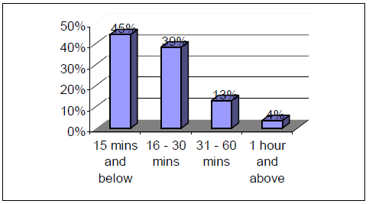

It has also become part of the local culture to stop and have a drink or something to eat during all hours of the day, in the mid of a travel and even late at night. The in-store services and convenient options that cater to the on-the- go lifestyles of many Malaysian consumers plays a vital role in the growth of convenient stores (including independent brands and petrol kiosks).

Based on the research conducted by marketingmagazine.com.my to understand the retails shoppers, they found roughly two-thirds of respondents use in-store banking services (64%) and about half of the respondents use fast food (53%), pharmacy (48%) and postal services (46%). [*https://marketingmagazine.com.my/retail-insights-understanding-malaysian-shoppers/*](https://marketingmagazine.com.my/retail-insights-understanding-malaysian-shoppers/)

It proves, that the way to stay relevant and connected to ever-changing consumer demand is to find pockets of unsatisfied demand and provide the products and services that will keep consumer satisfied and coming back time after time.

Convenience stores (including independent brands and petrol kiosks) in Malaysia is expected to experience growing popularity as consumers increasingly value time and seek quick-fix meal solutions. A rising number of an urban consumers is discarding home-cooking, attracted by the variety of fresh food, hot snacks and meal replacements available in convenient stores.

Convenient stores offer speed of service to time-starved consumers, who want to get in and out of the store quickly. These shoppers recognize this channel of trade for its convenient locations, extended hours of operation, one-stop shopping, grab-and-go food service, variety of merchandise, and fast transactions. These key players offer the services to their customer as per consumer behaviour, and have a meaningful number of stores countrywide to exploit growth going forward.

Besides, convenient stores across Southeast Asia are expanding their fresh food offerings to lure customers away from traditional eateries and boost sales, a move that is paying off in some of the region’s most competitive markets.

The focus on fresh food is also helping convenient stores to face down competition from the rise of e-commerce. Convenient store sales of fast-moving consumer goods, which includes fresh foods, grew at a record 8% in Southeast Asia last year, according to research firm Nielsen. The total number of convenient stores, meanwhile, was 74,000 as of 2018 and has been rising at an annual rate of 10% recently.

The strong sales growth was due to expanded food lineups aimed at customers who do their shopping in smaller but more frequent trips. Food is now so important for convenient stores that many of them are now “competitors to some of the larger quick-serve restaurant chains,” according to Nielsen Managing Director Vaughan Ryan.

Convenient stores are often just a short walk or drive away in cities and have an advantage over e-commerce when it comes to meeting immediate needs. Nevertheless, it does not reduce the threat posed by e-commerce in retail. Hence, there are many retail chains establishing partnerships with online markets to extend their service to consumers via e-commerce as well. As such, they turn their rivals into partners.

Apart from expanding their network, retailers are also revamping existing stores, adding spaces to offer food and lifestyle products to boost profit margin and increase footfalls. Analysts said such offerings are gaining popularity as urban consumers, often strapped for time, are seeking to grab a bite on the go. And with the recent increase in minimum wage level in National Budget 2019, Retail Group Malaysia expects to stoke up consumer spending and overall retail sales will likely grow 4.5% this year compared with last year's 4.4%.

There are also many established retail chains are now investing in getting themselves equipped with central kitchens with research and development facilities besides having central distribution centre alone. These retailers are investing in central kitchen which cater for the fresh and frozen food while the ambient central distribution centre will cater for dry products such as snacks, candies, healthcare and magazines. This is intended to simplify their on-site kitchen in the store for only light utilization such as heating using microwave oven and using boiled water as well as to centralize the production and maintain the product quality.

Table below shows the progress of a leading retail chain in Japan which started operating in late 70s. Contrary to latest formats of retail businesses, this retailer started the business with fresh food. They begin to create the network for multiple distribution per day to replenish fresh foods to their stores and eventually moved to frozen food in the beginning of 80s. The warehousing and new IT solutions were introduced later in 90s and only in year 2004 they begin to fetch dry and ambient products in their store.

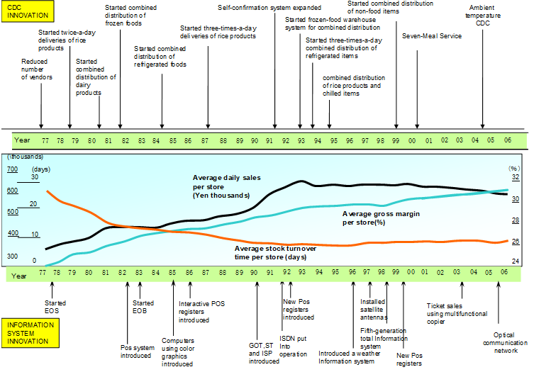

Most of the retail businesses in Malaysia will begin with dry and ambient products unlike the Japanese firm above. The recent booming retailer in Malaysia, Familymart, however, chose to follow the above method by introducing fresh and frozen food instead of concentrating in dry and ambient products. As such, they have lesser pool of industry rivals to be managed in the beginning of the business and by the time the rivals grow, the retailer would have have a strong hold in the field.

## Motivation

Fulfilling a retail store’s demand with right SKU at the right time in the right volume is extremely important for a retail chain because the loss of sales due to out-of-stock issue is very expensive. Besides loss of sales, it also cost them the customers. In the highly competitive business of modern retail, a good order planning system brings many advantages.

Firstly, it increases the availability of stocks by Point-of-Sales value for each store. Every retail chain has their own parameters of store profiling and one of the important metrics will be the sales or revenue of stores. Order plans for these high performing stores are scheduled twice or thrice a week in order to increase the frequency of replenishment of stocks and to avoid out-of-stock situation. Maintaining a good planogram logistics and stock availability at stores are the keys that drives an efficient order pattern system.

Secondly, those low performing stores will be handled separately under a different order plan whereby the replenishment cycles will be reduced but still not causing an out-of-stock situation yet not overstocking the stores. Order pattern is key for efficient stock management and operation at stores.

Thirdly, it facilitates truck allocations and requirements by stores and zones. The order pattern is scheduled in the order of priority of store and volume. This avoids wrong forecast of truck allocations and delivery scheduling.

As already stated before, order pattern management is an integral part of retail logistics. Maintaining a balanced order pattern is an important factor in the development of a retail chain business. Understanding the extremely important role of order pattern management so that store orders, replenishments, sales and inventories stay healthy is well worth the effort and has been a fertile field for researchers.

A detailed study on scenarios such as daily replenishment which is being followed by some new emerging retails chains or once a month replenishment method which is being followed by some established retails chains will cast two entirely different sets of challenges. Both ways are not necessarily a well-balanced order pattern system for an ambient retail business in particular.

When orders are being replenished every day to all stores, it will increase the number of drop points for the trucks every day. And every additional drop points will incur an additional charge for the trucking. Besides, there will be need arise to increase the number of trucks deployed because a normal 5 tonner truck can accommodate only for maximum of 8 drop points per day while there are 696 stores to be served. This is due to the fixed time for unloading and handover (minimum of 30 minutes) to stores regardless of the order volume. This will also cause stores to increase order cycle as well as receiving cycles.

## Research Purpose and Problem

The purpose and problem studied in this paper are motivated by a practical situation arising in the retail sector and is related to order pattern for an established retail chain business in Malaysia. The retail economy is getting more competitive, and business growth with higher market share and customer base is ever more critical. Inventory management at stores became an obstacle to the cost and loss reduction in the retail industry, and it affects improvements to service. While overstocking the inventory at stores, increases the risk of unsold items, write-offs, and reduces capital that can be directed to other aspects of business, lack of the same causes other problems such as out-of-stock, loss of sales, loss of client base and customer dissatisfaction.

While compiling a critical point of their current inventory management method, the business has witnessed the problems regarding inventory at stores caused by the imbalanced order patterns. In the beginning, the items at stores were ordered at high volume but with lesser replenishment cycles. As such, the stores needed a bigger storage area. Besides, inventory days at store was higher since replenishment will be calculated for 21 days inventory. Hence, there was huge inventory holding cost and high write offs and the stocks fall below threshold.

Furthermore, the risk for out-of-stock scenario is higher due to a wrong forecast which will cause loss of sales since there is no immediate replenishment is possible. Operationally, loading more stocks to store will constraint the inventory DCC as holding stocks are high. And high sales store might have to be fulfilled in 20ft or 40ft truck loads but stores can accept only 8 tonner trucks. Hence, number of trucks will increase which will subsequently increase the CO2 footprint.

All the risks mentioned above have resulted in an overstocked situation at store and a high amount of write-off. The daily revenue is the primary store income, and the loss due to write-off is unrecoverable, so when a product is nearing the threshold, the store management’s goal is to do whatever it takes to sell the product, eg: via promotion, or discounted price. In completing that task in this stressful situation, the inventory management cost is often set aside.

To avoid over stocking in the future, and as well not letting out-of-stock situation at stores, the objectives can, therefore, be further detailed on how the company can produce a balanced order pattern in terms of the loads to the stores as we as the loads to the DC and trucking and delivers them from the best sources within acceptable lead time. By proper selection of the order pattern by store profiling and the best distribution mode, it could minimize the inventory at store by increasing replenishment cycle, minimize distribution lead-time and maximize stocks availability at stores. This has to be achieved across the seven hundred stores in relation to their respective location and the distribution centre.