**TITLE : Prevalence of Vitreoretinal Complications after Intravitreal injections in**

**Norfolk and Norwich University Hospital**

**Inroduction :**

An estimated 388,880 Intravitreal injections are given per year in theUK and around 5.9 million in the US making it easily the the most common intraocular procedure worldwide & likely the most commonly performed surgical procedure in Modern Medicine . Intravitreal injection is a safe procedure and the rate of complication following this procedure is quite low. Due to the fact it is such a widely practised procedure and a lot of patients receive consecutive injections this aspect needs to be studied in detail and also needs reporting in a large scale.

**PURPOSE OF THE STUDY :**

* To Identify and study cases of retinal tears and retinal detachment following intravitreal treatment IVI (injections and implants)
* To Assess minimal estimated risk compared to normal population

**Materials & Methods :**

* **Design of the study :** Single-center, Retrospective review of prospectively collected data .
* **Methodology :**

All patients who had received intravitreal injections from January 1st 2010 till September 1st2019 in Norfolk and Norwich Hospital were evaluated using medisoft .

All patients had been provided with informed consent before each injection. All injections were performed in a sterile environment with the patient in a supine position. The Periocular skin and eyelids were cleaned with topical povidone-iodine 5 % before each injection. After topical anesthesia with topical povidone iodine was instilled into the cul-de-sac 2 minutes prior to injection. An eyelid speculum was used in each injection. The injections were performed through the inferonasal quadrant, either 3.5 or 4 mm posterior to the limbus for pseudophakic and phakic individuals, respectively. 30-gauge needle was used for all injections

ThePatients who received intravitreal injection of any ocular drug or implant and presented with retinal tear or retinal detachment within 6 months of receiving the injection or a year after a implant were included in the study. The patients who had developed retinal tears or detachment due to other reasons like Tractional retinal detachment due to diabetic retinopathy were excluded from the study and also the patients who presented more than 6 months after last IVT injection or a year after receiving the implant.

The following data was collected for each patient : Age , gender, underlying retinal disease, number of Injections received prior to the complication and the drug or implant received and the complication they had after the procedure.

.

**RESULTS :**

* In our study a total of 6835 eyes of 5453 patient were injected , the total number of injections were 62,532 .The Average age of patients was 66 +/- 14.27 (Range 19-100) .The number of injections per patient prior to the complication was 9.76+/-2.20 .The mean Time interval between the injection and the complication in days was 51.25 ±12.74 .
* The number of complications recorded were 8 patients had retinal detachments , 1 had a retinal tear and 21 patients had sub macular haemorrhage (SMH)

**FIG 1 : Indications of Injections who had a retinal detachement /tear after injection**

AMD was the most common Indication in our study

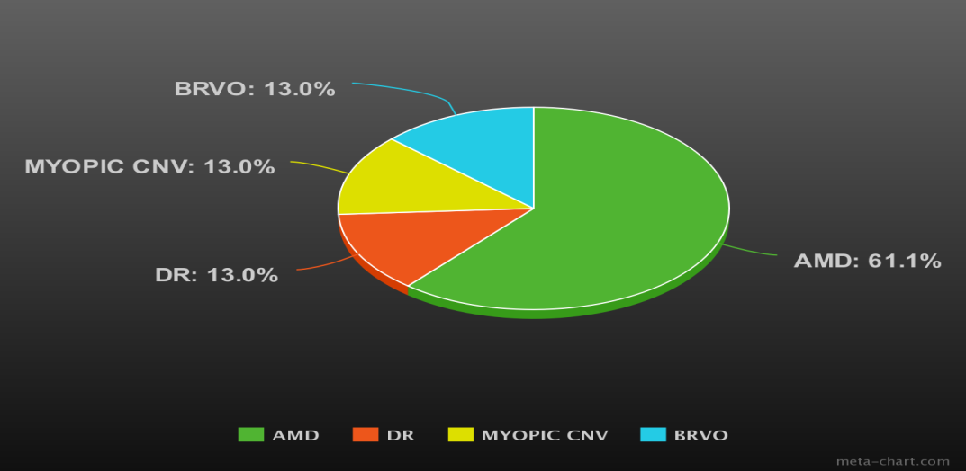

**FIG 2: Number of cases of Retinal detachment /Tear per year**

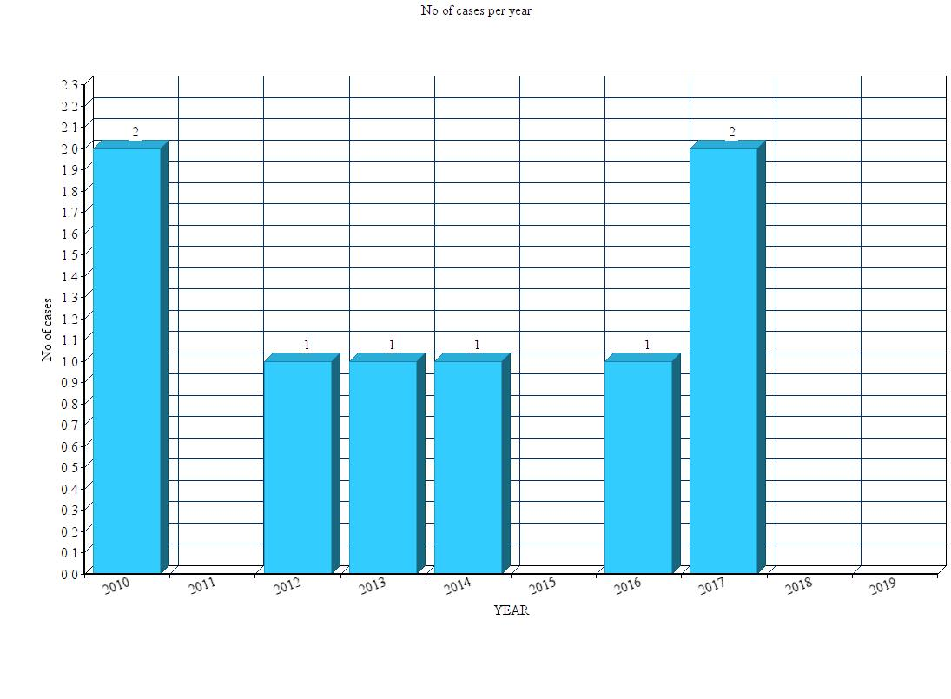

**Table 1 : Mean number of injections per eye with respect to different medications**

|  |  |  |  |  |  |
| --- | --- | --- | --- | --- | --- |
| **Drug** | **Avastin 1.25mg/0.05ml** | **Avastin 2.5mg/0.10 ml** | **Implants**  **(Ozurdex /Iluvein)** | **Eylea 2 mg/0.05 ml** | **Lucentis 0.5mg** |
| **Mean No of injections per eye** | **3.26** | **1.29** | **1.25** | **7.55** | **8.76** |

**Table 2:Prevalence of Retinal Detachment/Tear after IVI**

|  |  |  |  |  |  |  |
| --- | --- | --- | --- | --- | --- | --- |
|  | **No. of Patients/eyes** | **No . of IVT injections** | **No . of patients who had the complication** | **Mean No Injections**  **before the complication** | **Prevalence per injection** | **Prevalence**  **Per eye** |
| **RRD/RT** | **5453/6835** | **62532** | **9** | **8.24+/-2.12** | **0.02%** | **0.15%** |

**Table 3 Case analysis of each Retinal Detachment /Tear following IVI**



**Discussion:**

Our study is one of the largest studies to study the rate of Retinal detachment and tears following Intravitreal Injections. There were a total of 62,532 injections given in our study.

The prevalence of Retinal detachment /tear following Injections was 0.15% per eye and 0.02% per injection. This rate is quite low comparing the annual incidence of Primary Retinal detachment (RRD) in the general population .The estimated annual incidence of Primary RRD according to the Scottish retinal detachment was 12 per 100,000 which gives you a prevalence rate of 0.024% which is quite comparable to our study.

The mechanism of development of Retinal detachment/tear after an intravitreal injection or implant as indicated in literature is either due to a faulty technique or induction of PVD. The first mentioned cause is usually the cause when injecting implants .We had a curious case of a patient developing bilateral retinal detachment after receiving bilateral Iluvein implants done at different times. The usual cause of patient developing RRD after implants is usually accidental faulty injection but in this case the procedure was done in a safe manner but the patient had developed RRDs in both eyes after an average of 209 days. The cause of RRD in this case is not particularly clear and further long studies regarding the degradation of implants and the effects it has on the retinal might give an insight into this.

The prevalence rates of retinal detachment/tear per injection in different major trials were 0.03 in ANCHOR, 0.05 in BRAVO and 0.17 in SCORE. A meta analysis of these major trails showed the prevalence rate per injection to be 0.089 per injection. The rate per injection in our study was lower than that. The rates of reporting in these studies according to the results produced in different years for example ANCHOR had published their two year results and seven year results and the rate of RRD was different in the two results. This could be due to patients dropping out in the seven year follow up due to various reasons thus leading to a different result. Our study is a one time retrospective analysis so is not affected by such changes of these major trials.

The reporting of this complication is not uniform, it is either reported as prevalence per eye or per injection, either of which has it’s merits, however, as the treatment involves more than one injection in most cases, reporting it as risk per eye might be more representative of the risk. Furthermore, 6 out of 9 patients who presented with retinal detachment during the course of treatment with IVI suffered a reduction in their vision after retinal repair surgery. Therefore, this is a serious complication despite the perceived low risk.

The different indications for which the injections were received had no bearing on the development of complications except in one case the patient was treated for MYOPIC CNVM in which case High myopia was a pre-disposing factor. Adequate precautions should be taken in such cases.

There were a few short comings of our study , the first one being a retrospective study it is difficult to study exactly the reason which lead to the particular complication in each case ,and the second being missing cases as we would have missed if the patients presented to other units, or if treatment of retinal tear in eye casualty was not recorded on Medisoft.

**Conclusion:**

The risk of developing Retinal detachment and tears after intravitreal injections is quite low Both the risk per injection and per eye per course of injection should be reported in research and when consenting a patient to these treatments.Prevalence per eye may be more representative of risk than prevalence per injection