**Abstract**

Herbal medicines are gaining importance these days over the contemporary medicines owing to their minimal side effects. Bacopa monnieri has been considered as an efficient traditional medicine since vedic times and has considerable reputition in Ayurveda as a memory and intellect enhancer. It has also been used as a cure for various other ailments and nervous disorders. The natural products has gained much preference, hence Bacopa and its neuropsychotropic actions need to be studied in much detail, to know about the pathways it affects, its molecular basis of action. However, it is also imperative to look into the adverse effects caused by Bacopa. Several studies (both in-vitro and in-vivo model) have been done in this light to establish its neuroprotective effects. This review is the compilation of the medicinal effects of Bacopa, also the molecular basis of action in neuroprotection and memory enhancement. A brief mention of the toxicity and adverse effects has also been done. With the increase in pollution, radiation and free radical damages the incidences of neurodegenerative diseases like alzheimers is rising. It is now imperitive that we look for promising neuroprotective and memory enhancing drug that help to cope with the harmful effects of pollution and free radical. To establish Bacopa as a herbal medicine it still needs to be weighed for its promised benefits and the unwanted harmful effects and we need to take caution while advising supplementation in different age groups. The present review summarizes our current knowledge of pharmacological actions-clinical and non clinical, major bioactive compounds in Bacopa, mechanism of action of Bacopa and possibility of interaction of herb with conventional drugs.

This review reitirates the medicinal and neuroprotective benefits of Bacopa monnieri. It is essentially a valuable medicinal herb with cognition enhancing properties mediated via several mechanisms and is fairly non toxic. BM is a highly promiment herb used in ayurveda since ancient times. it has been traditonally used for increasing memory, concentration, cognition and in reducing stress-induced anxiety. Since ancient times it is best known as a neural tonic and memory enhancer[1,2].It is considered to be a “medhya rasayana”, an herb that sharpens the mind and the intellect. It is also used for itsantioxidant properties [3] and as a cure for various ailments likeepilepsy, cardiovascular diseases, ulcers, ascites, enlargement of spleen, indigestion, inflammations, leprosy, anaemia. [4,5]

***Bacopa monnieri***(Family: *Scrophulariaceae*; Genus: *Bacopa*; Species: *B. Monnieri)* also known as brahmi, is one of the ancient medicinal plants traditionally used in various systems of medicine [10]. It is popular for aquarium use as it grows in wet , tropical environments and thrive underwater.

Brahmi is a perennial, creeping herb, succulent, juicy, glabarous with rooting at nodes that grow in prostratic way on wetland, marshy areas and muddy shores, in semi-shaded conditions. Bacopa monnieri generally grow in tropical Asia like in India, Africa, North and South America, Europe, Australia, China, Sri Lanka, Taiwan and other places [11,12,13].

Leaves are simple, ovate, opposite with punctate patterns. These are oblanceolate, fleshy, decussate, sessile, grow in cluster of 2 or alternately.Flower are solitary, axillary, white or purple tinged with long slender pedicels that flowers mainly in September –October. It bears yellow brown coloured ellipsoid seed [14].

Bacopa has been used traditionally as a neurological tonic in general, for allaying anxiety, as a cognition enhancer, memory and intellect booster for centuries in Ayurveda-The traditional Indian System of Medicine. It is been named "Brahmi," after the name of Lord Brahmā, The creator(in Hindu mythology).

**Medicinal properties of Bacopa**

Several studies have been performed to study the neuroprotective roles of Brahmi, apart from the other medicinal properties that it possesses. It is reported to have antioxidant [15,16], anti-inflammatory [17], analgesic [18], tranquilisining [19,20], antipyretic action [21].It is a potent free radical scavenger. It is studied to have broncho-vasodilator and smooth muscle relaxant and mast cell stabilizing properties [22]. It is also known to have antiulcer[23], anticancer[24], hepatoprotective action[25].

Bacosides, the active ingredients of Bacopa monneiri are believed to be responsible for these benefits. These Bacosides show powerful anti-oxidant properties, reduce inflammation and blood pressure, boost brain function, help to reduce ADHD symptoms, prevent anxiety and stress and posses anti-cancer properties as well.

1. **Sedative properties**

Studies have also shown that Brahmi Rasayana possesses sedative effect, prolonged the hypnotic action of pentobarbitone, and caused a variable blockade of conditioned avoidance response. It also offered protection against electroshock seizures and chemoconvulsions.

1. **Cognition**

Some research shows that taking specific Bacopa extracts improves some measure of memory in otherwise healthy older adults. Also, taking Bacopa extract seems to improve some measures of memory and hand-eye coordination in children aged [6-8](tel:6-8) years.

1. **Antidepressant and antianxiety effects**

Early research suggests that taking 30 mL of Bacopa syrup daily for 4 weeks reduces symptoms of anxiety, including nervousness, racing heart, trouble sleeping, headaches, tiredness, difficulty concentrating, and stomach discomfort.

1. **Anti-epileptic effects**

Early research suggests that taking Bacopa extract for 5 months prevents seizures in some people with epilepsy.

1. **Anti-arthritic**

Bacopa Monnieri contains many antioxidant, antibacterial, and anti inflammatory properties. These properties reduces redness and irritation associated with eczema and psoriasis, and increases the ease and comfortability of joint movement that may be affected by arthritis and previous injuries. Brahmi also contains naturally occurring Nitric Oxide, which plays a role in inflammation and pain perception. This also improves joint pain associated with arthritis, as well as muscle soreness. Aside from skin and joint health, brahmi oils and powders have been used to strengthen hair and promote healthier, longer, fuller hair with less split ends. It has also been known to reduce dandruff.

1. **Anti-cancer**

Test-tube and animal studies have found that Bacopa monnieri may have anticancer properties.  
Bacosides, the active class of compounds in Bacopa monnieri, have been shown to kill aggressive brain tumor cells and inhibit the growth of breast and colon cancer cells in test-tubestudies  
Additionally, Bacopa monnieri induced skin and breast cancer cell death in animal and test-tube studies .Research suggests that the high levels of antioxidants and compounds like bacosides in Bacopa monnieri may be responsible for its cancer-fighting properties.

1. **Anti-diabetic**

Brahmi has been historically used in the treatment of various conditions that present with oxidative stress-induced damage. This makes it a candidate in the management of hyperglycaemia-induced oxidative stress that underlies diabetic complications.

1. **Anti-microbial**

Among the various extracts, diethyl ether extracts of B. monnieri has an antibacterial potency against Staphylococcus aureus (gram positive), and ethyl acetate extract showed effects on E. coli (gram negative) at higher concentrations of [300](tel:300) microgam mL-1. The ethanolic extract has potent antifungal activity against the fungus (Aspergillus flavus, and Candida albicans) compared to diethyl ether and ethyl acetate-ether. Both extracts (diethyl ether and ethyl acetate) has a minimum antifungal effect while these extracts showed more inhibitory effects on tested bacteria.

1. **Anti-oxidant**

Bacopa monnieri extract exhibits interesting antioxidant properties, expressed by its capacity to scavenge superoxide anion and hydroxyl radical, and to reduce H2O2 induced cytotoxicity and DNA damage in human fibroblast cells. Results showed promise in conquering the disease and protecting the brain from damage by the antioxidant activity of the extract in the hippocampus, frontal cortex and striatum.

1. **Anti-parkinsonism**

Bacopa monnieri helps in coping with combined hypoxic, hypothermic and immobilization stress that could lead to the onslaught of ‘free radicals’ during the progress of PD.

1. **Alzheimer’s disease**

Bacosides, particularly bacosides a and b, are found in high concentrations in Bacopa Monnieri. Bacosides affect the neurotransmitters of the brain, and improve cognitive function, and the function of the Central Nervous System. Studies show that patients between [50-65](tel:50-65) years of age who had Alzheimer’s and were given brahmi supplements showed improved short term memory, as well as decreased instances of anxiety and agitation.

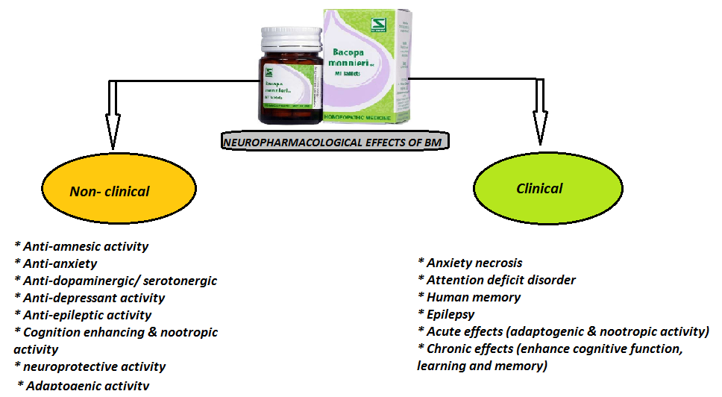

**Bioactive molecules**

In this delicate herb, numerous neuroboosting compounds are found, the most active among them are bacoside A and bacoside B5.

Saponins (specifically Bacosides A and B) are the active ingredients that are responsible for the memory enhancing effects of Bacopa. They are believed to have procholinergic effects.

Bacosides are triterpenoid saponins, comprise a family of 12 called [bacopasides](https://en.wikipedia.org/wiki/Bacopaside) I–XII.[[9]](https://en.wikipedia.org/wiki/Bacopa_monnieri#cite_note-9)

The constituent most studied has been [bacoside A](https://en.wikipedia.org/wiki/Bacoside_A), which was found to be a blend of bacoside A3, bacopacide II, bacopasaponin C, and a jujubogenin isomer of bacosaponin C.[[14]](https://en.wikipedia.org/wiki/Bacopa_monnieri#cite_note-14)Saponins are glycosides, a sugar unit attached to an aglycone portion (the sapogenin Chemical structureof Bacoside-A,B and C are represented as 3-0-α-L-arabinopyranosyl- 20-0-α-L-arabinopyranosyl-jujubogenin, 3-0-[α-L-arabinopyranosyl (1-2)α-L-arabinopyranosy] pseudojujubogenin and 3-0-[β-D-glucopyranosyl (1-3){α-L-arabinofuranosyl (1-2)}) α-L-arabinopyranosy] pseudojujubogeninrespectively [13].

The chemical constitution of Bacopa monnieri was found as:

**Alkaloids** such as Hydrocotyline, Brahmine and Herpestine. [3] Glycoside such as Asiaticoside and Thanakunicide.



**Flavonoids** such as Apigenin and Luteonin. Saponins such as D-mannitol, Acid A, Monnierin [C51H82O213H2O] Bacoside A [C41H68O134H2O] and Bacoside B [C41H68O135H2O].

Additional **Phytochemicals** such as Betulinic acid, Wogonin, Oroxindin, Betulic acid, Stigmastarol, beta-sitosterol, numerous **Bacosides** and**Bacopasaponins**, amino acids like alpha alanine, Aspartic acid, Glutamic acid, and Serine, and its esters, Heptacosane,Octacosane, Nonacosane, Triacontane, Hentriacontane, Dotriacontane, Nicotine, [4] 3-formyl-4-hydroxy-2H-pyran (C6H6O3), and its 7- glucoside.

Brahamoside, Brahminoside, Brahmic acid, Isobrahmic acid, Vallerine, pectic acid, fatty acids, tannin, volatile oil, ascorbic acid, thanakunic acid and asiatic acid [5–10]. Jujubacogenin and pseudojujubacogenin [11].

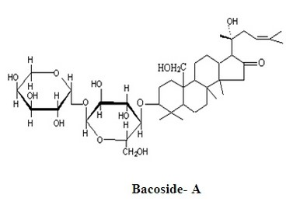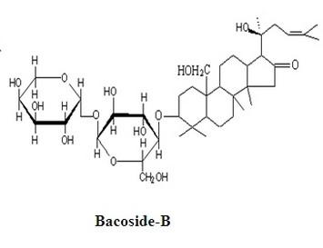

Nevertheless, Several in-vivo and in vitro studies have revealed its potential medicinal properties, including its nootropic utility in humans. Studies also suggest potential improvementin dementia, Parkinson's disease, and epilepsy.[2,5]Current understanding suggests that BM acts via the following mechanisms—anti-oxidant neuroprotection (via redox and enzyme induction), acetylcholinesterase inhibition and/or choline acetyltransferase activation, β-amyloid reduction, increased cerebral blood flow [6], and neurotransmitter modulation (acetylcholine [ACh], 5-hydroxytryptamine [5-HT], dopamine [DA]) [7,8,]. BM appears to exhibit low toxicity in model organisms and humans; however, long-term studies of toxicity in humans are yet to be conducted [2].In modern biomedical studies, bacopa has been shown in animal models to inhibit the release of the pro-inflammatory cytokines TNF-α and IL-6. However, less is known regarding the anti-inflammatory activity of Bacopa in the brain [9]. This review will integrate molecular neuroscientific mechanisms involved and their impact in behavioral research.In 2019 US Food and Drug administration warned manufacturers of dietary supplement product containing Bacopa against illegal and unproven claims that the herb can treat various diseases like Epilepsy, Alzheimers and other neurodegenerative diseases

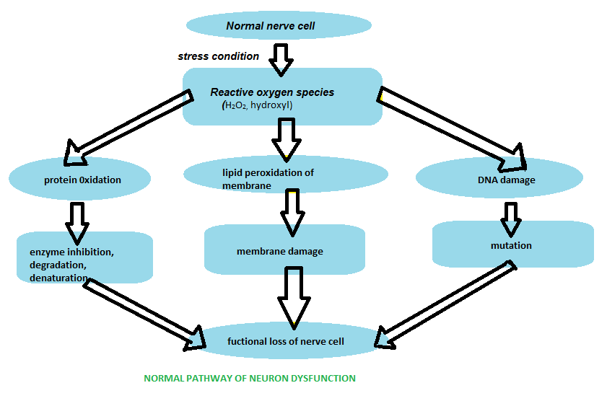

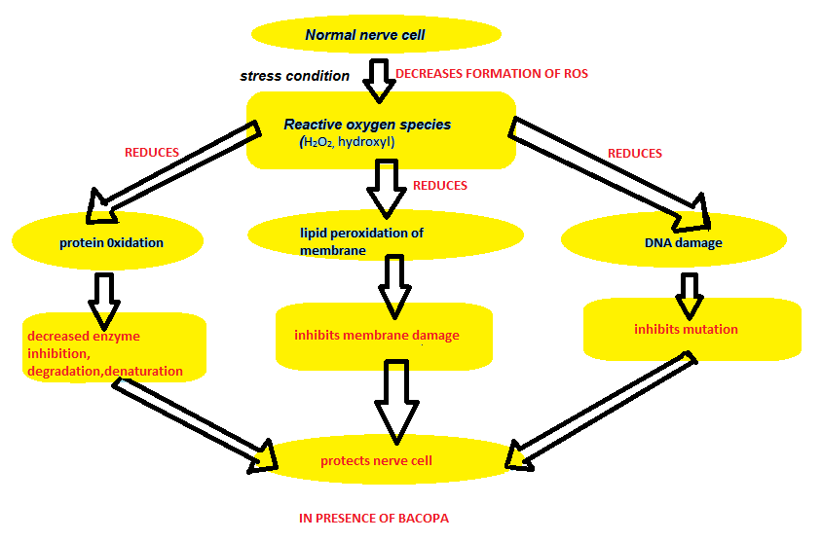

**Molecular Mechanism underlying effects of *Bacopa monnieri***

Bacopa contains alkaloids (nicotine, herpestine), flavinoids (luteolin, apigenin) and saponins ( bacoside A3, bacopaside-1, bacopaside-2, bacopa saponin-C). various studies showed that Bacopa has cognition and memory enhancing properties.

It was found that Bacopa primarily inhibits 3 enzymes- COMT, PEP, PARP. It also has an antagonistic effect on 5HT6, 5HT2A receptors, which are associated with memory, learning disorders and age related memory impairment.

COMT controls dopamine metabolism and modulates memory function. Entacapone (COMT inhibitor) is used as adjuncts to levadopa and parkinson’s disease. It forms an important component of prefrontal dopaminergic signaling pathway.

Bacopa monnieri increases concentration of dopamine and serotonine in aged rat brain. Hence, inhibition of COMT enhances memory and cognition.

Neuropeptidases (PEP, insulin regulated amino peptidases) cleaves short peptides, which is involved in positive reinforcement, social interactions, emotions, stress responsivity. Inhibition of PEP increases Ca+2 concentration. Calcium is involved in neurotransmitter release which in turn is responsible for cognition enhancement.

Bacopa monnieri decreases whole brain AChE activity. Dysfunction of cholinergic neuron activity in hippocampus is seen in neurodegenerative diseases.

Bacopa also antagonizes 5HT6 receptors which can be used for cognition dysfunction and sleep promotion. 5HT6 receptor blockade enhances cholinergic and glutaminergic neurotransmission which increases dopamine.

Oxidative stress is important for age related memory disorder. Stress leads to secondary injuries which produces DNA strand breaks, which leads to neuronal death.

Bacopa also inhibits activity of PARP enzyme & generation of free radical. So, involved in neuroprotection.

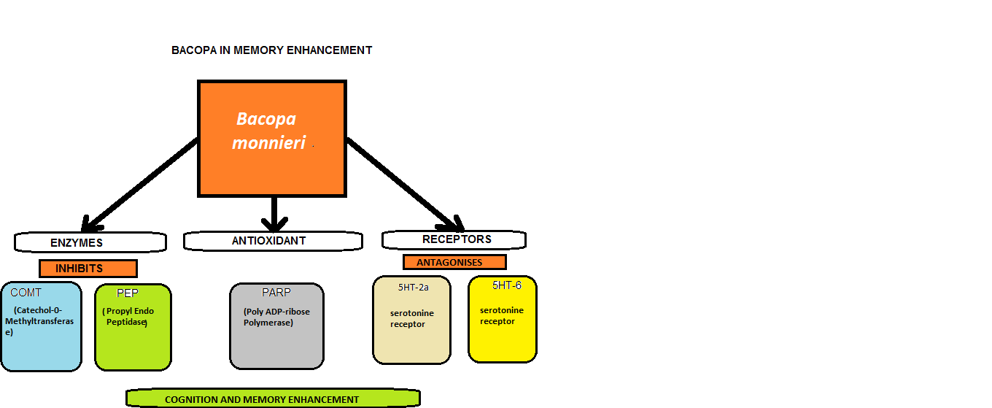

FORMS AND DOSAGE OF BACOPA

**Forms and Dosing of Bacopa**

|  |  |
| --- | --- |
| **Forms** | **Dosage** |
| Daily doses in traditional practice | 5–10 g of nonstandardized, powdered herb, 30 mL of syrup, or 8–16 mL of infusion |
| Capsules, often standardized to 20%–50% bacosides | 200–400 mg/day in divided doses for adults; 100–200 mg/day in divided doses  for children |
| Tinctures 1:2 fresh plant or 1:4 recently dried herb, | 2–30 mL/day in divided doses |

(extracted fromKathy Abascal, BS, JD, RH (AHG)and Eric Yarnell, ND, 2011)

SIDE EFFECTS OF CONSUMPTION OF BACOPA

It is safe for adults if consumed orally for a period of 12 weeks. The most commonly reported adverseside effects of *B. monnieri* in humans are nausea,increased intestinal motility, and gastrointestinalupset (Singh and Dhawan, 1997; Pravina et al.,2007). Apart from these xerostomia, fatigue, GI and urinary tract congestion, ulcers, bradycardia, lung conditions like asthma, emphysema and increase in thyroid hormone levels have been reported.

***Toxicology analysis***

Aqueous extracts of *Bacopa monnieri* may elevateserum thyroxine and decrease spermatogenesis,sperm count, and fertility in male mice (Singh andrSingh, 2009). The rat LD50 was found to be 2400mg/kg following a single oral administration (Allan

et al., 2007).

Toxic elements such as Cd, Cr, Hg, As, Rb, and Pbare present in the *B. monnieri* herb (Kumar et al.,2005; Narg et al., 2007; Singh and Garg, 1997;Behera et al., 2014a; Behera et al., 2014b; Shuklaet al., 2007; Treleaven et al., 1993; Ernst, 2002).

These environmental toxicants cause poisonouseffects on both plants and animals. The toxic andheavy metals such as Pb, Hg, etc.,have been aregular constituent in the Indian traditionalAyurvedic medicines. The efficacy and side effectsof these elements are evaluated by various authors.It has been expected that these may cause seriousharm to patients taking such remedies.

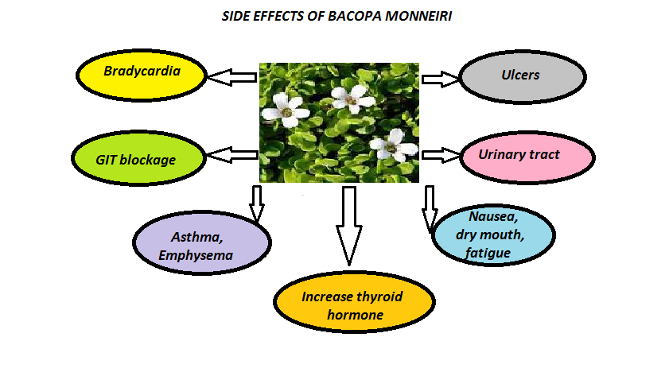

|  |  |  |  |
| --- | --- | --- | --- |
| **Model used/study design** | **dosage** | **Protective effect seen** | **references** |
|  |  | Bacopa strengthens memory and intellect | Medhya; Kumar, 2006; Singh, 2013; Singh et al., 2008 |
| To investigate the effect of bacosides on induced experimental amnesia in mice, using Morris water maze test, all the agents were administered 30 min before the acquisition trials on each day and repeated for 4 consecutive days, and on 5th day during the retrieval trials. | Scopolamine( 3 mg/ kg,ip), sodium nitrite (75 mg kg(-1), ip) and BN[52021](tel:52021) (15 mg kg(-1), ip) | The alcoholic extract of Bacopa monnieri improved acquisition, consolidation, and retension of memory in a foot shock-motivated brightness-discrimination test and a conditioned-avoidance test in rats | Kishore and Singh, 2005 |
| Administration of Bacosides in aged wistar rats to study age related changes in neurotransmission action, behavioural paradigms, hippocampal neuronal loss and oxidation status | 200mg/kg for three months | Protective effect against age-associated alterations in the neurotransmission system, behavioral paradigms, hippocampal neuronal loss, and oxidative stress markers | Rastogi et al., 2012a, 2012b |
| Meta analysis  To investigate the effect of standardized extract of Bacopa monnieri and Melatonin on Nrf2 pathway in Okadaic acid induced memory impaired rats | OKA ([200](tel:200) ng) was administered intracerebroventricularly (ICV) to induce memory impairment in rats. Bacopa monnieri (BM-40 and 80 mg/kg) and Melatonin (20 mg/kg) were administered 1 hr before OKA injection and continued daily up to day 13. | Standardized extract of Bacopa prevented okadaic acid-induced cognitive dysfunction in rats by decreasing oxidative stress and neuroinflammation and downregulating the expression of nuclear factorerythroid 2 related factor 2 | Dwivedi et al., 2013 |
| Administration of standardized extract of Bacopa | 300 and 600 mg treatment for 12 weeks | Improvement in attention, cognitive processiong, and working memory in healthy elderly volunteers partly via the suppression of AchE activity | Peth-Nui et al., 2012 |
| In-vivo double blind placebo controlled cross over study in humans | Each capsule contained 160 mg Bm extract | Improvement in cognitive performance of normal healthy volunteers | Downey et al., 2013 |
| In-vivo oral administration of Bm to male wistar rats and were tested for spatial memory and density of cholinergic neurons | Alcoholic extract of Bacopa at 20/40/80mg/kg for a period of 2 weeks before and 1 week after induction of AD in rats | Improvement in cognitive function and prevented neurodegeneration in the animal model of AD | Uabundit et al., 2010 |
| Administration of ethanolic extract of Bacopa leaves to PSAPP mice | 40/160mg/kg for two and eight months | Reduces Aβ1-40 and Aβ1-42 levels in the cortex of PSAPP mice | Holcomb et al., 2006 |
| To evaluate the neuroprotective potential of BM against cognitive impairment, in colchicine-induced dementia | Bacopa at the dose of 50mg/kg | Neuroprotective effect in the colchicines model of dementia through its antioxidant effects and restoration of Na+K+ ATPase and AchE activities | Saini et al., 2012a, 2012b |
| To examine the effects of standardized extract of BM on behavioral changes of Wistar rats when administered the extract for various durations and in varying doses | Bacopa at the dose of 20mg/kg, 40mg/kg, and 80mg/kg | Memory enhancing effect due to neuronal dendritic growth-stimulating property | Vollala et al., 2011 |
| To examine the acute effects of an extract of Bacopa monniera on cognitive function in normal healthy human subjects. The study was a double-blind, placebo-controlled independent group design in which subjects were randomly allocated to one of two treatment conditions | Single dose of 300mg Bacopa monnieri extract ( containing 55% combined bacosides A and B) | No significant change in cognitive function at two hours | Nethan et al., 2001 |
| Seventy-six adults aged between 40 and 65 years took part in a double-blind randomized, placebo control study in which various memory functions were tested and levels of anxiety measured | Bacopa administration (300mg for subjects under 90 kg and 450mg for subjects over 90kg, equivalent to 6g and 9g dried rhizome, respectively for six weeks) | Significant improvement in retention of new information in 40 to 65 years old healthy adults | Roodenrys et al., 2002 |
| To examine the chronic effects of an extract of B. monniera on cognitive function in healthy human subjects. | Bacopa administration 300mg/day (containing 55% combined bacosides) for 12 weeks | Significant improvement in verbal learning, memory consolidation, and faster information processing | Stough et al., 2001 |
| To calculate the effect sizes of positive cognitive effect of the pharmaceutical modafinil in order to benchmark the effect of two widely used nutraceuticals Ginseng and Bacopa |  | Neurocognitive enhancement in healthy human subjects | Neale et al., 2013 |
| To evaluate effects of Bacopa monnieri whole plant standardized dry extract on cognitive function and affect and its safety and tolerability in healthy elderly study participants | Standardized B. monnieri extract [300](tel:300) mg/day or a similar placebo tablet orally for 12 weeks. | Enhancement in auditory verbal learning tests results and delayed word-recall memory scores | Calabrese et al., 2008 |
| To study the efficacy of standardized Bacopa monniera extract (SBME) in subjects with age-associated memory impairment (AAMI) without any evidence of dementia or psychiatric disorder. | Standardized 125mg Bacopa extract twice a day for 12 weeks to over 55years of subjects with memory impairment | Significant progressive improvement in mental ability, memory, and associated learning | Raghav et al., 2006 |
| Meta analysis  Randomized, placebo controlled human intervention trials on chronic ≥12 weeks dosing of standardized extracts of Bacopa monnieri without any co-medication were included in the study |  | Improves cognition | Kongkeaw et al., 2013 |
| To evaluate the neuroprotective potential of BM against cognitive deficits in colchicine-induced model of AD with an aim to understand if its beneficial action is mediated through attenuation of oxidative stress. | Standardized extract of Bacopa 50 mg/kg body weight/day for a period of 15 days. | Scavenge free radicals, preserve mitochondrial activity and restore tyrosine hydroxylase levels  BM administration attenuated oxidative damage, as evident by decreased LPO and protein carbonyl levels and restoration in activities of the antioxidant enzymes. The activity of membrane bound enzymes (Na(+)K(+) ATPase and AChE) was altered in colchicine treated brain regions and BM supplementation was able to restore the activity of enzymes to comparable values observed in controls. | Saini et al., 2012 |
| To examine the effect of the botanical, on aggregation of alpha synuclein, degeneration of dopaminergic neurons, content of lipids and longevity of the nematodes. |  | Anti-parkinsonism effect | Jadiya et al., 2011 |
| To evaluate whether alcoholic extract of Bacopa monniera (AEBM), an antioxidant and memory enhancer can slow the neuronal injury in a 6-OHDA-rat model of Parkinson's | 20 and 40 mg/kg bodyweight of AEBM for 3 weeks | Neuroprotective effect in the 6-OHDA rat model of Parkinsonism | Shobana et al., 2012 |
| To examine the neuroprotective properties of BM against rotenone induced oxidative damage and neurotoxicity in adult male flies | BM powder for 7 days in the diet exhibited significant diminution in the levels of endogenous oxidative markers | Neuroprotective effect against paraquat- and rotenone-induced oxidative stress, neurotoxicity and lethality in Drosophila melanogaster | Hosamani & Muralidhara, 2009, 2010 |
| Effect of chlorophyll o BM Valeriana wallichii on ischemia and reperfusion induced cerebral injury in mice | Aqueous extract of Bacopa (2g BM and V. wallichii in the form of powder and was stirred vigorously in a 30ml warm distilled water for 20min) | Attenuate the ischemia-reperfusion-induced brain injury | Rehni et al., 2007 |
| To test whether B. monniera could alleviate the ischemia induced brain injury and cognitive dysfunction in Wistar rats. The effect of B. monniera on transient intracarotid artery (ICA) occlusion induced ischemia by testing the neurobehavioral and biochemical parameters on treated and control rats | [120](tel:120)mg kg(-1), [160](tel:160)mg kg(-1) and [240](tel:240)mg kg(-1) P.O. | Improvement in cognitive function and ameliorated cerebral injury in the transient intracarotid artery occlusion rat model of stroke through its anti-oxidant action | Saraf et al., 2010b |
|  | Administration of Bacopaside 1 for 6 days at 3/10/30mg | Amelioration in neurological defecit, cerebral infract volume, and edema in a rat model of transient focal ischemia by improving cerebral energy metabolism and by anti-oxidant actions | Liu et al., 2013a |
|  |  | Bacoside A ameliorated the epileptic- like seizures in Caenorhabditis elegans | Pandey et al., 2010 |
|  |  | Prevent behavioural impairment and GABA receptor dysfunction in epileptic rats | Mathew et al., 2010a, 2010b, 2010c, 2011, 2012 |
| Administration of Bacosides to investigate the neuroprotective effect against age related chronic neuro-inflammation in wistar rat brain on 3 months treatment | Orally once with bacosides at the dose of 200 mg/kg for 3 months | Amelioration of age associated neuroinflammation signified by decrease in pro-inflammatoty cytokines, iNOS protein expression, total nitrite and lipofuscin content in middle aged and agedbrain cortex on long term Bacoside treatment. | Rastogi M et al., 2012 |

DISCUSSION:

It is unrealistic to expect this herb to be curative for a diseasesuch as Alzheimer’s. However, bacopa has a real role toplay as part of any treatment for patients in which anxiety, depression,or mental function are issues. Ayurvedic colleaguestypically use bacopa as a mental/nervous restorative to calmand balance the mind. Ayurvedic clinical applications rangefrom treating insomnia and attention-deficit hyperactivitydisorder to depression and dementia. Bacopa is also used toameliorate the mental/emotional aspects of hypothyroidism.‡

We should use it similarly in our practices. In summary,bacopa combines attributes of an adaptogen, a multifacetednervine, and a cognitive enhancer that is greatly needed inour botanical apothecary.

**Herb drug Interaction**

Drying medications (Anticholinergic drugs)Interaction   
Bacopa might increase levels of certain chemicals in the body that work in the brain, heart, and elsewhere. Some drying medications called "anticholinergic drugs" can also these same chemicals, but in a different way. These drying medications might decrease the effects of Bacopa, and Bacopa might decrease the effects of drying medications.  
  
Some of these drying medications include atropine, scopolamine, some medications used for allergies (antihistamines), and some medications used for depression (antidepressants).

Medications for Alzheimer's disease (Acetylcholinesterase (AChE) inhibitors)Interaction   
Bacopa might increase certain chemicals in the brain, heart, and elsewhere in the body. Some medications used for Alzheimer's disease also affect these chemicals. Taking Bacopa along with medications for Alzheimer's disease might increase effects and side effects of medications used for Alzheimer's disease.  
Various medications used for glaucoma, Alzheimer's disease, and other conditions (Cholinergic drugs)Interaction   
Bacopa might increase certain chemicals in the brain, heart, and elsewhere in the body. Some medications used for glaucoma, Alzheimer's disease, and other conditions also affect these chemicals. Taking Bacopa with these medications might increase the chance of side effects.  
  
Some of these medications used for glaucoma, Alzheimer's disease, and other conditions include pilocarpine (Pilocar and others), donepezil (Aricept), tacrine (Cognex), and others.  
Thyroid hormoneInteraction   
The body naturally produces thyroid hormones. Bacopa might increase how much thyroid hormone the body produces. Taking Bacopa with thyroid hormone pills might cause too much thyroid hormone in the body, and increase the effects and side effects of thyroid hormone.

**References**

1) Singh hk, Dhawan bn. Effect of bacopa monniera linn. (brahmi) extract on avoidance responses in rat. J Ethnopharmacol 1987;5:205–214.

2) Sebastian Aguiar, Thomas Borowski. Neuropharmacological review of the nootropic herb bacopa monnieri. Rejuvenation research volume 16, number 4, 2013 doi: 10.1089/rej.2013.1431

3) Tripathi YB, Chaurasia S, Tripathi E, Upadhyay A, Dubey GP. Bacopa monniera Linn. as an antioxidant: Mechanism of action. Indian J Exp Biol 1996;34:523–526.

4) Ghosh T, Maity TK, Das M, Bose A, Dash DK. In vitro antioxidant and hepatoprotective activity of ethanolic extract of Bacopa monnieri. IJPT 2007;6:77–85.

5) Rastogi M, Ojha R, Prabu PC, Devi DP, Agrawal A, Dubey GP. Prevention of age-associated neurodegeneration and promotion of healthy brain ageing in female Wistar rats by

long term use of bacosides. Biogerontology 2012;13:183–195.

6) Liu X, Yue R, Zhang J, Shan L, Wang R, Zhang W. Neuroprotective effects of bacopaside I in ischemic brain injury. Restor Neurol Neurosci 2012; online publication.

7) Ahirwar S, Tembhre M, Gour S, Namdeo A. Anticholinesterase efficacy of Bacopa monnieri against the brain regions of rat. Asian J Exp Sci 2012;26:65–70.

8) Gray NW, Brimijoin S. Amyloid-beta increases acetylcholinesterase expression in neuroblastoma cells by reducing enzyme degradation. J Neurochem 2003;86:470–478.

9) Nemetchek et al. The Ayurvedic plant *Bacopa Monnieri* inhibits inflammatory pathways in the brain. J Ethnopharmacol.2017 February 02; 197: 92–100. doi:10.1016/j.jep.2016.07.073.

10) Behera S., Mallick B., Tiwari T.N., Mishra P.C., 2016. A Short Review on Physico-Chemical Properties of *Bacopa monnieri* L. International Journal of Medicinal Plants. Photon 110, 735-741.

11) Daniel M., 2005. Medicinal Plants: Chemistry andProperties. Science Publishers, Enfield, 225.

12) Warrier P. K., Nambiar V. P. K., Ramankutty C., Ramankutty R, Nair Vasudevan, 1996. Indian Medicinal Plants: A Compendium of 500 Species. Orient Blackswan, University of Michigan, 238.

13) Khare C. P., 2003. Indian Herbal Remedies: Rational Western Therapy, Ayurvedic, and Other Traditional Usage, Botany, Springer-Verlag Berlin Heidelberg, 89.

14) Mathew J., Paul J., Nandhu M.S., Paulose C.S., Bacopa monnieri and Bacoside-A for ameliorating epilepsy associated behavioral deficits. Fitoterapia 81 (2010) 315–322

15) Russo A, Borrelli F, Campisi A, Acquaviva R, Raciti G, Vanella A. Nitric oxiderelated

toxicity in cultured astrocytes: Effect of Bacopa monniera. Life Sci.

2003;73:1517–26.

16) Pawar R, Gopalakrishnan C, Bhutani KK. Dammarane triterpene saponin fromBacopa monniera as the superoxide Inhibitor in polymorphonuclear cells.Planta Med. 2001;67:752–4.

17) Jain P, Khanna NK, Trehan T, Pendse VK, Godhwani JL. Anti-inflammatory effects of an Ayurvedic preparation, Brahmi Rasayan, in rodents. Indian J Exp Biol. 1994;32:633–6.

18)Afjalus S., Chakma N., Rahman M, Salahuddin M. Kumar S., Assessment Of Analgesic, Antidiarrhoeal And Cytotoxic Activity Of Ethanolic Extract Of The Whole Plant Of Bacopa Monnieri Linn, IRJP,2012,3(10)

19) Sairam K, Dorababu M, Goel RK, Bhattacharya SK. Antidepressant activityof standardized extract of Bacopa monniera in experimental models ofdepression in rats. Phytomedicine. 2002;9:207–11.

20) Chowdhuri DK, Parmar D, Kakkar P, Shukla R, Seth PK, Srimal RC. Anti-stress effects of bacosides of Bacopa monnieri: modulation of HSP to expression, Sol and cytochrome P450 activity in rat brain. Phytother Res. 2002;16:639–45

21) Vijay R., Shukla J. and Saxena R., PROPAGATION OF BACOPA MONNIERI (BRAHMI): IMPORTANT MEDICINAL PLANT., CIBTech Journal of Biotechnology,2015, ISSN: 2319–3859

22) Al-Snafi, Ali. The pharmacology of Bacopa monniera. A review. International Journal of Pharma Sciences and Research. (2013). 4. 154-159.

23) Sairam K, Rao VC, Babu DM, Goel KR. Prophylactic and curative effects ofBacopa monniera in gastric ulcer models. Phytomedicine. 2001;8:423–30.

24) Elangovan V, Govindasamy S, Ramamoorthy N, Balasu-bramanian K. In vitrostudies on the anticancer activity of Bacopa monniera. Fitoterapia. 1995;66:211–5.

25) Menon BR, Rathi MA, Thirumoorthi L, Gopalakrishnan VK. Potential effect ofBacopa monnieri on nitrobenzene induced liver damage in rats. Indian JClin Biochem. 2010;25(4):401–4.

https://www.genome.jp/db/pcidb/kna_species/10357