**CHAPTER-1**

**INTRODUCTION**

**1.1 INTRODUCTION**

At present due to rapid urbanization, massive construction activities are going on for that we require a vast amount of construction materials as well as skilled labour. In the construction industry, the most important construction material is concrete. Concrete is a composite material consist of cement, coarse and fine aggregate, water, admixture. But nowadays the meaning of the concrete is completely changed as tremendous studies are undergone from past decades and still going on. At present concrete become a material composite of basic ingredients and with different pozzolanic materials like bagasse ash, rice husk ash, micro silica, fly ash, GGBS, lime stone powder and many other made for specific application. Using this material in concrete production leads environmental friendly disposal of waste products produced from different industries. One of the major outcome in past decade is self-compaction concrete. Self-compaction concrete (SCC) is a modified form of concrete without external energy for compaction it can flow and compact under its own weight.

Self-compaction concrete (SCC) is also known as super workable concrete, self-levelling concrete, self-consolidating concrete, high flow ability concrete, etc. The composition of SCC was the same as normal concrete in addition to that it requires more fine material for getting flow ability characteristic without segregation. For that filler material like fly ash, rice husk ash, bagasse ash, etc. and high range water reducing admixture is required. Here we are using rice husk ash and bagasse as filler material.

**1.2 HISTORY OF SELF COMPACTION CONCRETE**

The concept of self-compaction concrete was introduced in 1986 by Professor Hajime Okamura. However, the prototype was first developed in 1988 in Japan by Professor Ozawa at the University of Tokyo. The idea of self-compaction concrete is evolved because of the researcher’s evidence that normal concrete structures performing poor due to lack of strength because of non-uniformity and poor compaction. To make durable concrete, sufficient compaction by skilled workers is required. It was understood that there was no guarantee of achieving full compaction on-site so that the focus turned into elimination of compaction by vibration or any other means. After that the Japanese contractors took up the idea and developed their own SCC technologies. Each company developed their own mix design and trained their staff to act as technicians for testing SCC mixes on site. One of the most important thing is that each large contractors developed their own testing methods and testing equipment. In early 1990s there was only a limited public knowledge about SCC but slowly the advantages of self-compaction concrete is understood by people and construction companies throughout the world and various countries have tried and developed their own way of SCC mix designs and their testing methods. However, till now there is no specific mix design and testing methods are available for SSC. Among all different guidelines followed for SCC, European Federation of National Association representing for Concrete (EFNARC) suggested specifications are widely used for production and testing of SCC.

**1.3 APPLICATION OF SCC**

SCC can be applicable where vibration of concrete is simply impossible. And at the time of faster construction requirement.

* Under water construction
* Repair works
* congested reinforcement
* To solve problems related to cast-in-place concrete
* In situations like lack of skilled labour for proper compaction
* Areas with high concentration of rebar and pipes

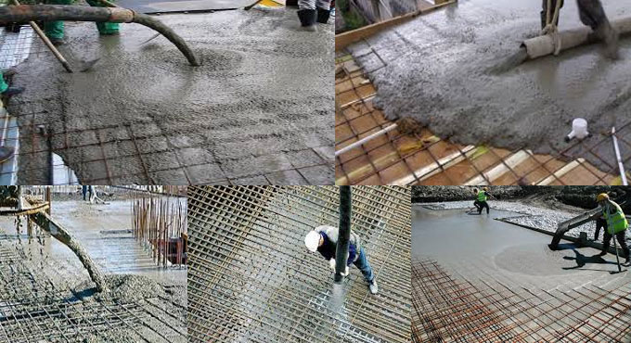

**Fig. 1.1 SCC in congested reinforcement**

[https://www.concreteconstruction.net](https://www.concreteconstruction.net/)



**Fig. 1.2 SCC in anchorage of Akashi Kaikyo Bridge, Japan, 1998**

<https://commons.wikimedia.org/wiki/File:Akashi_Kaikyo_Bridge_Anchorage1958.JPG>

**1.4 ADVANTAGES OF SELF COMPACTION CONCRETE**

Using Self-Compaction Concrete has several advantages over normal conventional concrete. Some of the advantages are:

* Due to SCC faster construction is possible
* Requires less skilled labour leads reduction in overall cost of construction
* Eliminates the problems associated with vibration
* Superior surface finish
* Can be placed easily in congested reinforcement and thinner concrete sections
* SCC can be used to create structural and architectural shapes that are not achievable by conventional concrete
* Improves quality and durability of concrete
* Greater flexibility in design
* Gives better Bond to reinforcement steel
* Possibilities of utilization of waste material which are difficult to dispose
* SCC can be placed at greater heights even up to 600m

**1.5 DISADVANTAGES OF SELF COMPACTION CONCRETE**

* The main disadvantage of SCC is there is no specific mix design
* The cost of material is higher not only due to admixture but also due to increased quality control and testing needed for concrete
* It require more trail mixes
* Costlier than conventional concrete
* Higher paste volume results in greater shrinkage and creep
* Should have more care while selecting material for self-compacting concrete.

**1.6 BASIC PRINCIPLES OF SELF COMPACTING CONCRETE**

SCC compact itself under its own weight and completely fills the formwork without additional external energy for vibration. In structural member with high percentage of reinforcement, it fills all voids and gaps completely.

Self-compacting concrete consist of the same constituents as normal concrete which are cement, aggregate, water additives and admixtures. In principle, the fresh and hardened properties of self-compacting concrete, which depends on mix design, should not be different from normal concrete (N.C) the only exception is we need high flowable concrete without any segregation. For that usage of high amount of super plasticizer for reduction of the water content and for better workability, the high powder content as “lubricant” for the coarse aggregates, as well as the use of viscosity-agents to increase the viscosity of the concrete have to be taken into account while designing the mix for self-compacting concrete. Self-compacting concrete should have a slump flow greater than 65 cm (approximately) after pulling the flow cone.

**Fig. 1.3 Basic principles for production of SCC**

**1.7 DEFINITIONS**

**1.7.1 Additives**

In concrete finely-divided inorganic material is used in order to improve certain properties or to achieve special properties. This specification refers to two types of inorganic additions:

* Nearly inert additions
* Pozzolanic or latent hydraulic additions

**1.7.2 Admixture**

The material added during the mixing process of concrete in small quantities to reduce the segregation and sensitivity of mix due to variation in other constituents to moisture content.

**1.7.3 Binder**

The combined cement and hydraulic addition in a self-compacting concrete

**1.7.4 Powder**

Material of particle size smaller than 0.125 mm. it will also include this size of fraction of the sand.

**1.7.5 Mortar**

The fraction of the concrete comprising paste plus those aggregates less than 4mm.

**1.7.6 Paste**

The fraction of the concrete comprising powder plus water and air.

**1.7.7 Filling Ability**

The ability of SCC to flow into and fill completely all spaces within the formwork under its own weight.

**1.7.8 Passing Ability**

The ability of SCC to flow through tight openings such as spaces between steel reinforcing bars without segregation or blocking.

**1.7.9 Segregation Resistance**

The ability of SCC to remain homogeneous in composition during transport and placing.

The deign mix of SCC should satisfy Filling Ability, Passing Ability and Segregation Resistance property in order to be called as SCC and these abilities can be checked through the test provided by EFNARC guidelines.

**1.8 SELF-COMPACTING CONCRETE MIX DESIGN**

SCC should be designed in such a way that it has high fluidity, least or no segregation and low risk of blocking. Generally SCC has high cement paste volume, low coarse aggregate and water content, and a proper dosage of super plasticizer. The fine aggregate/coarse aggregate ratio of self-compacting concrete is normally about one, which is slightly higher than the normal concrete. Most of the methods for designing SCC use empirical rules and differ from conventional concrete design methods.

**1.9 MIXING OF SELF-COMPACTING CONCRETE**

All common mixers can be used for mixing SCC. Truck mixers can be used, but these are less efficient and require more attention and longer mixing times. The mixing time of SCC is longer as compared with normal concrete.

Producing SCC will lead to smaller margins and more difficulties for the plant operator, who will need more training and experience. During the initial period it is necessary to carry out more tests. But when the test results show a variation similar to traditional vibrated concrete the test intervals can be reduced to normal levels. Super plasticizers should be added towards the end of mixing to get better flow ability.

**1.10 MATERIAL AND TEST METHODS**

**1.10.1 General**

The basic components of the mix composition of SCC are the same as used in conventional concrete however, to obtain the required properties of fresh concrete, in SCC a higher proportion of ultrafine material and the incorporation of chemical admixture, in particular effective super plasticizers, are necessary. Generally used filler materials are fly ash, limestone powder, blast furnace slag and silica fume and quartzite powder.

A comparison of a typical mix composition of SCC and conventional concrete is shown below

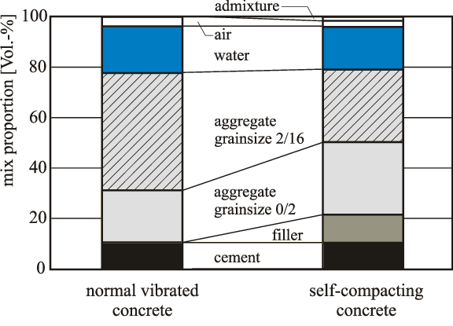

**Fig 1.4 Mix composition of SCC in comparison with normal vibrated concrete**

**1.10.2 The material used in producing SCC are**

* Cement
* Coarse aggregate
* Fine aggregate
* water
* Mineral admixture
* Chemical admixture

The ingredients of a concrete can be classified into two groups namely active and inactive. Active group consist of cement and water, whereas inactive comprises fine and coarse aggregates.

**1.10.3 Cement**

Ordinary Portland cement available in local market of standard brand was used in the investigation. The cement used has been tested for various properties as per IS4031-1988 and found to conform various specifications as per IS 12269-1987.

**1.10.4 Coarse Aggregate**

Crushed angular granite metal of 10mm size from local quarry was used as coarse aggregate. The cleaned coarse aggregate was tested for various properties such as specific gravity, fineness modulus, bulk modulus etc.

**1.10.5 Fine Aggregate**

The locally available river sand was used as fine aggregate in the present investigation. The cleaned fine aggregate was tested for various properties such as specific gravity, fineness modulus, bulk modulus etc. and are conforming to standard specifications.

**1.10.6 Water**

Water used for mixing and curing is fresh portable water, confirming to IS: 3025-1964 part22, part23, and IS: 456-2000.

**1.10.7 Mineral Admixture**

Mineral admixtures are less energy intensive, industrial by-products that require less or no processing. Mineral admixtures are basically supplementary cementitious materials, fillers, powders depending upon their role in fresh and hardened state. These materials possess little or no cementitious value but will in finally divided form and in presence of moisture reacts with cement at ordinary temperature to form compounds possessing cementitious properties. Mineral admixtures help in advancement of hydration and especially in improving the hydration product. Mineral admixtures basically include limestone powder (LSP), fly ash (FA), ground granulated blast furnace slag (GGBS), silica fumes (SF), sugar cane bagasse ash (SCBA) and rice husk ash (RHA). These mineral admixtures also contribute towards properties of hardened concrete through physical and chemical properties including hydraulic or pozzolanic activity. These materials react chemically with Calcium hydroxide released from hydration of Portland cement to form cement compounds. These materials often added to concrete to make concrete mixtures more economical, reduce permeability, increase strength or influence other concrete properties.

The use of supplementary cementing materials can significantly improve durability properties. However different dosages and combinations of supplementary materials yield dramatically different results. The use of mineral admixture in concrete may bring lots of benefits like increased flow and strength, decreased shrinkage, reduced water demand etc. but some problems may also be caused. A careful decision has to be made regarding the selection of amount and the type of mineral admixture for particular application. In general, mineral admixture has both negative as well as positive effect on water demand, temperature rise, strength development, freeze-thaw resistance, chemical attack resistance etc. They also have effect on volume stability and microstructure. With continuously graded aggregates, the use of mineral admixture in the presence of Super-plasticizers usually result in minimizing the voids, paste and hence the cement requirement. They also add to stability of the system. This could result in increased economy, high performance and increased durability. In this project work, RHA and SCBA are being used as a partial replacement of ordinary Portland cement.

**1.10.7(a) Usage of Mineral admixture**

* Reduce the permeability in concrete
* Improves the micro structure of concrete so concrete become denser and stronger
* Improves strength and durability properties of concrete
* blended concretes decreases the temperature effect that occurs during cement hydration
* It also decreases initial and final setting time of cement
* Ability to pack more closely to aggregate surface
* Presence of the mineral admixture in the interfacial zone results in the production of more homogenous microstructure and a better bond between paste and aggregate.

**1.10.8 Chemical Admixtures**

The most commonly used chemical admixtures in SCC are

* High range water reducers(HRWR)
* Viscosity modifying agent(VMA)

**High range water reducers/Super plasticizers**

In order to maintain deformability along with flowability in paste, a superplasticizer is must in the concrete. To limit the amount of water required for obtaining a fluid mixture, super plasticizers are necessary. With a superplasticizer, the paste can be made flowable with little decrease in viscosity. The super plasticizer reduces the w/c ratio

The requirements for superplasticizer in SCC are summarized below

* High dispersing effect for low water to powder ratio
* Maintenance of the dispersing effect for at least two hours after mixing
* Less sensitivity to temperature changes.

For achieving the SCC, an optimum combination of w/c ratio and superplasticizer dosage can be derived for fixed aggregate content in concrete. The traditional high range water reducers are either melamine or naphthalene based sulphonates. They cover around the cement graules at a very early stage of the concrete mixing process. The sulphonic groups of the polymer chains increase the negative charge of the cement particle surface and disperse these particles by electrostatic repulsion. The electrostatic mechanism causes the cement paste to disperse and has the positive consequences of requiring less mixing water for a given concrete or making it more flowable.

One of the new generation high range water reducers is polycarboxylic ether with long side chains. At the beginning of the mixing process it initiates the same type of mechanism as the traditional HRWR, additionally the side chains linked to the polymer’s backbone generates a stearic hindrance, which greatly stabilizes the cement particles ability to separate and disperse. With this process, flowable concrete with greatly reduced water content is obtained. This new range carboxylic ether has been found to have lower slump loss.

**Viscosity Modifying Agent (VMA)**

Viscosity modifying agents are water-soluble polymers that increase the viscosity of mixing water and enhance the ability of concrete to retain its constituted suspension. These admixtures are also known as Anti-washout admixtures or Anti-Bleeding admixtures. The basic function of VMA is to stabilize the concrete mixture, VMA restricts the dosage of superplasticizer. Commonly used viscosity modifying agents in concrete include cellulose derivatives and polysaccharides of microbial sources.

**1.11 TRANSPORTATION OF SELF COMPACTING CONCRETE**

Generally, self-compacting concrete should be transported in truck mixers to the Construction site if it is not produced at the construction site. If it is produced at construction site, concrete has to be distributed either by using concrete pump, skip or chute. If truck is used, then truck operator should be well trained. After each and every trip, the truck drum should be cleaned thoroughly. Checking the drum should be incorporated in to the procedure before filling it. During transportation to the site and the waiting time the drum should rotate at a low speed (not less than one rotation per minute). If it is not maintained properly, segregation may take place. Before delivery at the construction site the truck drum should be rotated at full speed (10-20 rotations per minute) for 3minutes.Before using SCC at the construction site, slump test and

visual investigation should be made. Placing of self-compacting concrete is very easy than compared to normal concrete. The formwork should be properly checked before concreting. Errors in the formwork can lead to leaking of concrete.

**1.12 TESTING METHODS FOR SELF COMPACTABILITY**

SCC tests methods have two main purposes. First is to judge whether the concrete is self-compactable or not, and the second is to evaluate deformability or viscosity for estimating proper mix proportionality. Conventional workability tests, devised for normal range of concrete mixture are not adequate for SCC, because they are not sensitive enough to detect the tendency to segregation. Therefore test equipment’s were fabricated for judging the following characteristics.

* Filling ability
* Passing ability
* Resistance to segregation

Many different test methods have been developed to characterize the properties of SCC. So far no single method or combination of methods has been achieved universal approval. Similarly no single method has been found which characterize all the relevant workability aspects and hence, each mix design has been tested by more than one test method for different workability parameters. Following are the existing tests for fresh SCC.

* Slump Cone Test
* L - Box Test
* V - Funnel Test
* J - Ring Test

**1.13 RESEARCH OBJECTIVES**

* To impart effective replacement of Ordinary Portland Cement by Rice Husk Ash and Sugar cane bagasse ash in Self-Compacting Concrete (SCC).
* To achieve effective workable Self-Compacting Concrete with and without partial replacement of Ordinary Portland Cement by Rice Husk Ash and sugarcane bagasse ash
* To study the workability of manufactured Self-Compacting Concrete using rice husk ash and sugar cane bagasse ash as partial replacement of Ordinary Portland Cement as per EFNARC standards.
* To achieve targeted design strength of design Self-Compacting Concrete using Rice Husk Ash in percent of 2, 4, 6, 8, etc. and combination of sugar cane bagasse ash in percent of 5, 10, 15, 20 etc. as partial replacement of Ordinary Portland Cement.

**1.14 STRUCTURE OF THESIS**

This thesis work is split into eight chapters. Chapter I of this project work deals with the introduction to the topic, i.e. self-compacting concrete evaluation of self-compacting concrete and advantages disadvantages of concrete. Chapter II of this project work deals with the study of various literatures pertaining to the thesis work. Chapter III deals with the materials used in the experimental program of the project work. Chapter IV deals with the SCC mix design with partial replacement of cement with RHA and SCBA. Chapter V deals with experimental investigation different type of tests done on self-compacting concrete for getting fresh and hardened properties. Chapter VI deals with the Inference and Analysis of the results obtained from the various tests performed in Chapter V. Chapter VII deals with the conclusion and Future Scope of this project Work. Chapter VIII deals with references that are taken for completion of this project work.

**CHAPTER I-Introduction**

This Chapter deals with the Introduction to the topic, Self-Compacting Concrete advantages and disadvantages, basic principal of self-compacting concrete, material used in this project and the organisation of this thesis work.

**CHAPTER II-Literature Review**

This chapter deals with study of Literature used in the project work along with the mention of latest related works. In this part of the thesis, various literatures from the development of SCC in Japan in 1980‘s till date were collected and studied.

**CHAPTER III-Material Properties**

This chapter deals with the materials used in the project work and the various sets of tests performed for investigating the physical properties of these materials in order to confirm the feasibility of these materials in Concrete mix design.

**CHAPTER IV- Mix design**

This chapter deals with the mix design adopted in the experimental work and proportion of different ingredients required for the self-compacting concrete.

**CHAPTER V-Experimental investigation**

This chapter deals with objective of this experimental work, different phases in this work and different type of tests conducted for self-compacting concrete in terms of fresh and hardened properties.

**CHAPTER VI- Results and discussions**

This chapter deals with the discussion of the results obtained from the tests discussed in IV and V.

**CHAPTER VII-Conclusions**

This chapter deals with the conclusion and the future scope of this thesis work. Based on the experimental results obtained and its rational discussion, conclusions were made which will specify the future perspective of the project work done.

**CHAPTER VII- References**

This chapter deals with references that are taken for completion of this project work.

**CHAPTER-2**

**LITERATURE REVIEW**

**2.1 INTODUCTION**

This chapter discussed about the literature study on the body of works based on replacement of cement with Rice Husk Ash (RHA) and replacement of cement with Sugar cane bagasse ash (SCBA) in concrete design to pave the path for practical realization of this concept in the construction industry. The limited study available on self-compacting and ordinary concrete with RHA and SCBA is enclosed herein. This chapter deals with the review of literatures used in the project work and discusses about the different investigation for effective use of RHA and SCBA as replacement in general so far. In this part of the thesis, the various literatures that have been studied are presented in a chronological order dating back to 1980‘s when the development of SCC took place in Japan to the present times. Various research works done by the researchers of different parts of the world available in the form of literatures, here literatures available on the use of rice husk ash as partial replacement of cement and sugar cane bagasse ash as partial replacement of cement is mentioned in the following Literature Review. The chapter also includes the motivation and objective of this research work.

**2.2 LITERATURE REVIEW**

**Saloma, Hanafiah and Niko Setiawan(2018)** In this experimental study author concluded that 10% substitution of RHA shows best performance. The result of the slump flow test on fresh concrete shows a decrease in the diameter of fresh concrete along with the increase use of RHA. Slump flow test on fresh concrete showed the largest diameter at w/c = 0.325 with value of 77.25 cm and the smallest diameter at w/c =0.275 with value of 59.50 cm. The result of the V-funnel test on fresh concrete shows the increase of flow time as RHA use increases. The V-funnel test on fresh concrete showed the fastest flow time at w/c = 0.325 with value of 4.88 seconds and the longest flow time at w/c = 0.275 with value of 23.43 seconds. The result of L-box test on fresh concrete shows a decrease ofH2/H1 ratio along with increase of RHA use. The L-box test on fresh concrete showed the largest H2/H1 ratio at w/c = 0.325 with value of 1.00 and the smallest H2/H1 ratio at w/c = 0.275 with value of 0.78.

**Amreen Khatun,Khushpreet Singh,Raju Sharma(2018)** In this experimental study of Self-Compacting Concrete with Bagasse Ash by using Nan su Method concludes that workability of treated self-compacting concrete with 0.9% dosage of VMA meets the criteria for various tests conducted on workability of SCC at 10% optimum percentage replacement of bagasse ash. For mechanical properties it has been concluded that the 10% is the optimum percentage of bagasse ash and it is seen that compressive strength, split tensile and flexural strength for treated SCC is higher than controlled self-compacting concrete. Abrasion test is conducted for 10% replacement of bagasse ash based SCC has shown less wear and tear and sulphate attack test for SCC has shown less deterioration and it is concluded that 10% replacement of bagasse ash has good durability properties. Microstructure tests for XRD,SEM concluded that bagasse ash is silica rich material. The partial replacement of bagasse ash with cement up to 10% in treated SCC will be alternate material for replacement and it will be greener material by reducing the carbon emissions and also help in reducing the cost of construction.

**S Baliram and B Suraj(2018)** In this experimental study author concluded that M40 grade RHA and SCBA concrete for H2SO4 solution exposure in 28 days, the number of alternative showed better compressive strengths. The compressive strength and Split tensile strength reduced with the increase in concentrations of sulphuric acid in curing water. At more than a few replacements of RHA and SCBA gives most strength and indicates top resistance to sulphuric acid attack. Utilization of Rice Husk Ash and Sugarcane bagasse ash and its utility are used for the development of the building industry, material science. It is the possible alternative solution of safe disposal of Rice Husk Ash and Sugarcane bagasse ash. RHA and SCBA becomes greater economical barring compromising concrete strength than the trendy concrete. It turns into technically and economically variable.

**C Chandana Priya, M V Seshagiri Rao, V Srinivasa Reddy(2018)** The present review of literature shows the possibility of designing high strength SCC with high volume fly ash replacement taking a step towards eco- friendly and sustainable concrete practices. Also high volume fly ash blended cement can be manufactured with clinkers of cement and fly ashes that have a variety of chemical and physical structures. It is also observed that such cements are conforming to ASTM standards. The review related to cement replacement with fly ash shows that there is a change in properties like compressive strength, split tensile strength and flexural strength. It can be noticed that fly ash concretes possess enhanced durability than that of normal concrete. The self-compacting concrete with high volume fly ash replacement has shown lower chloride ion permeability than normal concrete. The previous research studies indicate that the chloride penetration depth of SCC mixes with fly ash replacement is less than that of SCC with 100% ordinary Portland cement. High volume fly ash replacement is performing better thanconventional SCC mixes in achieving long term durability characteristics. The SCC made with high volume fly ash replacement is going to be economical, eco- friendly and sustainable material having scope of further research and investigation for the emerging generation construction projects.

**Elias Molaei Rais, Javad Vaseghi Amiri, Mohammad Reza Davoodi**(2018) In this experimental study author concluded that The addition of RHA decreases the workability of the SCC. When 20% RHA is added to the mixture, the workability falls near the minimum limits specified in EFNARC. The results exhibited that the addition of RHA to the SCC decreases the passing and filling ability of the SCC, and therefore, for achieving acceptable workability more superplasticizer should be utilized. By adding RHA from 5% to 20%, the compressive strength for water to binder ratio of 0.50 at 28 days, increases by 8% and 2.6%, and then decreases by 5.8% and 11%, respectively, with respect to the control concrete (SCC-0-28-0.50). Initial strength increment was probably because of highly reactive RHA particles that react with water and calcium hydroxide to produce more C-S-H resulted in denser microstructure of SCC. By increasing the age of SCC containing 10% RHA from 3 to 270 days, the compressive strength increases by 3%, 7.7%, 2.6%, 2.8%,6.4%, and 11.5%, respectively, as compared to the control SCC specimens at the same age and water to binder ratio of 0.50. With an increase in water to binder ratio from 0.38 to 0.68,compressive strength of SCC containing 10% RHA increases 4.5%, 11%, 2.6%, 4%, 1.9%, and 15.7%, respectively, with respect to the control SCC specimens at the same water to binder ratio. By adding RHA from 5% to 20%, the splitting tensile strength for water to binder ratio of 0.50 at 28 days, increases by 4.8%, 4.2%, and 2.5%, and then decreases by 16.9%, respectively, compared to the plain concrete (SCC-0-28-0.50).With the increase of the age of SCC containing 10% RHA from 3 to 270 days, the splitting tensile strength increases by 5.2%,5.9%, 4.2%, 4.9%, 5.7%, and 5.9%, respectively..

**Ifrah Mushtaq, Sandeep Nasier (2018)** investigates the workability and Strength characteristics of Self-Compacting Concrete (SCC) prepared by partially replacing cement (ordinary Portland cement) with fly ash at different replacement levels (10%, 15%, 20%, 25% and 30%). The Guidelines of European Federation of National Associations Representing for Concrete (EFNARC) was followed for mix designing purpose. The experiments were carried out by adopting a water-powder ratio of 0.43.

**Boeini Sampurna, D.S.V.S.M.R.K.Chekravarty(2018)** Glass Fiber Reinforced Concrete is a recent introduction in the countryside of concrete technology. Efforts are life form made in the ground of concrete knowledge to expand high performance concretes by means of fibres and other admixtures in concrete awake to certain size. To improve the concrete properties, the system be name alkali resistant glass fiber reinforced concrete inside the present sight the alkali resistance glass fiber have been used.

**Ratandeep Kumar, Ashfaq Malik,Vivek Kumar Kashyap(2018)** studies the replacement of sand by Coconut shell powder as well as replacement of cement with RHA. In this paper, both materials are replaced. Partial replacement done with the 10% cement with RHA is constant and for sand replaced with coconut shell powder at 0%, 5%, 10%, 15%, 20%, 25% in this project .The test result says the 20% replacement of sand and 10% replacement of cement gives maximum compressive strength

**B. Preethiwini(2017)** presents the production of High strength self-compacting concrete by replacing plastic scraps from waste plastic material. The fine aggregate is substituted with the plastic scrap at dosages 0%, 5%, 10%, 15%, and 20% by weight of the fine aggregate. The optimum percentage for the self-compacting concrete was evaluated by testing the specimen for its compressive and tensile strength.

**Vijay Kumar, S.R. Pandey(2017),** In this article rice husk ash has been partially replaced with cement with a varying percentage of 0%, 5%, 10%, 15%, 20%, 25% and 30% and the influence of rice husk ash on the mechanical property of self-compacting concrete was investigated. They concluded that Incorporating RHA as a partial replacement, the slump flow value, V-funnel, L-box & J-Ring Tests fulfilled EFNARC guideline for SCC up to 20% replacement of cement, the target strength for M30 grade concrete was achieved up to a replacement of 20% of cement by RHA. RHA up to 20% replacement resist chemical attacks like acid attack and sulphate attack

**M. Abdur Rahman (2017)** their study focuses on comparison of fresh and hardened properties of self-compacting concrete containing varying amount of 0%, 5% and 10% RHA with varying dosage of super-plasticize of 2% to 4.5% as an admixture. The comparison is done at different dosages of super-plasticizer keeping cement, water, coarse aggregate, and fine aggregate contents constant. The fresh properties of SCC for flow spread shows that by increasing the amount of RHA the spread decreases but increases with the increasing amount of super-plasticizers due to high flow ability incorporated by it. They concluded that the10% rice husk ash at 4% super plasticizer proved the higher compressive strength as compared to other mixes

**Hanafiah,Saloma and Putri Nurul Kusuma Whardani (2017)** they studied behaviour of SCC with Bagasse Ash as partial replacement of cement with variations of w/c as 0.275, 0.300, 0.325 and the percentage of bagasse ash substitution were 0%,10%, 15%, and 20%,by using bagasse ash as partial replacement, the result of compressive strength at the age 28 days was obtained highest result with w/c = 0.275 as 67.239 Mpa and the lowest result with w/c = 0.300 as 41.813 Mpa. Compressive strength test shows satisfied values for 15% replacement the addition of SCBA 20% caused the decrease of compressive strength because the excessive addition of SCBA can cause the damage for chemical reactions in concrete

**Alireza Joshaghani (2017)** they selected SCBA and RHA to replace cement in concrete. Binary blends containing Portland cement, SCBA and RHA were produced to be compared with the control mixture consisting only cement in fresh properties and hardened properties the compressive strength increased slightly with increasing SCBA and RHA content from 10-20%, while there was a significant decline in the compressive strength at the replacement levels of 25% and 30%

**Srikanthan. L Ramya. B. L (2017)** According to author usage of Structuro 203 as Superplasticiser in SCC and Fine Aggregate is replaced with varying percentage of RHA 0%, 10%, 20%, 30%, up to 10% replacement by RHA satisfy the requirement of fresh properties of SCC, hardened properties like compressive, flexural, tensile strength values decreased at all stages of replacement compare with 0% replacement but up to 10% replacement getting satisfactory results.

**Kumar S. Sinde, Dr.S.S.Angalekar(2016)** According to author by using SCBA, in the mix of river sand it helps to reduce cement requirement up to certain extent and improve the workability Exceeding segregation, bleeding by increase the chemical admixture, and chemical admixture gives better flow ability of concrete. In addition, partial replacements of ordinary Portland cement with agricultural waste such as SCBA. Contributes to useful disposal of the waste materials, and reduce the consumption of cement thus lowering adverse effect on the environment. The requirement of water increased as the percentage of SCBA got increased. The workability of the concrete is depending upon the percentage use of SCBA in the mix. It has been shown in this study that 30% SCBA can be used to achieve the targeted mean strength 40MPa in river sand mix. Expected test results were obtained as per mix design such as compressive strength, split tensile strength and flexural strength.The greater surface and larger average particle are highly suitable for the workability also enhance water absorption. The SCC can replace the control with 28 days compressive strength (40MPa) without extra cost. The hardened property of three different regions SCBA has a different test results with small variation. From the compressive strength result concludes that the strength of river sand mixes with 10% SCBA increased at the age of 14 days and 28 days may due to the Pozzolanic properties of SCBA.

**N.Raviteja, K.V.Ramana(2016)** According to author Fresh properties results showed that with increase in amount of RHA workability decreased. However by using LSP in combination with RHA as cement replacement gave good workability results.Maximum compressive and split tensile strengths at 7 and 28 days were obtained by mix containing 15% of RHA as cement replacement. Whereas flexural strength of this mix (15% RHA) same as that of control mix. Using LSP in combination with RHA as cement replacement resulted in to lower strength values. However SCC mix containing 75% of cement, 15% of RHA, 10% of LSP gave higher compressive strength (28days) than that of control mix.

**Yogeshkumar Patel, Nilaykumar Patel, DR.P.J.Patel,R.N.Ghosh(2015)** According to author the optimum content for the RHA mix self-compacting concrete is as 12% for the given properties of the ingredients. For mix design all the criteria given in the European code should be satisfied. Extreme care should be taken for the quality control, no deleterious material should be there in mix. As the rice husk ash is the agricultural by product, it can be conclude from the literature review that the use of rice husk ash in self-compacting concrete increase the mechanical properties as well as durability properties with respect to ordinary self-compacting concrete in addition to effective cost reduction by replacement of the cement to rice husk ash by weight. Water/cement ration is inversely proportional to the strength of the concrete

**Shriram H. Mahure, V. M. Mohitkar(2014)**.author obtained the fresh properties of concrete within the limit as specified by EFNARC up to replacement of 20% cement by RHA. The SCC mixes with replacement of 20% cement by RHA gave optimum results. Flexural and Split tensile strength was much better than target strength for M30 grade of concrete. RHA being pozzolanic material shown much better performance after 90 days curing as compared with the same at 28 days. It was observed that the water absorption within acceptable limit. Hence the concrete will be impermeable.

**Kawade et al. (2013)**According to author cement is partially replaced with SCBA with varying percentages 0%, 10%, 15%, 20%, 25% and 30% .From this investigation it was concluded that the results obtained with the use of bagasse ash at 15% replacement of cement was found to be optimum in attaining higher compressive strength than the normal concrete.

**Shazim Ali Memon et al (2011)** conducted a study of substantiate the feasibility of developing low cost SCC using RHA. Test has been carried out on fresh and hardened properties of SCC using RHA as compared to control concrete. The compressive strengths developed by the SCC mixes with RHA were comparable to the control concrete. Cost analysis showed that the cost of ingredients of specific SCC mix is42.47% less than that of control concrete.

**Noor – ul –amin (2011)** In this paper, the physical and mechanical characteristics of concrete due to the utilization of bagasse ash has been studied by conducting test such as compressive strength, split tensile strength, chloride diffusion and resistance to chloride ion penetration. The results of above test showed that bagasse ash becomes the effective mineral admixtures with the optimum replacement of 20% cement which reduced the chloride diffusion by more than 50% without giving any adverse effects in concrete.

**Srinivasan and Sathiya (2010),** according to them partial replacement of cement by 10% bagasse ash gives significantly higher compressive strength, tensile strength and flexural strength when compared to normal concrete

**K. Ganesana et al(2008)** investigated Rice husk ash blended cement with respect to assessment of optimal level of replacement for strength and Permeability properties of concrete. The properties of concrete investigated include compressive strength, splitting tensile strength, water absorption, sorptivity, total charge-passed derived from rapid chloride permeability test (RCPT) and rate of chloride ion penetration in terms of diffusion coefficient. This particular RHA consists of 87% of silica, mainly in amorphous form and has an average specific surface area 36.47 m2/g. Test results obtained that up to 30% of RHA could be advantageously blended with cement without adversely affecting the strength and permeability properties of concrete.

**M.A. Ahmadi(2007)** studied the Mechanical properties up to 180 days of self-compacting and ordinary concrete with rice-husk ash (RHA). Two different replacement percentages of cement by RHA, 10% and 20%, and two different water/cementetious material ratio (0.40 and 0.35), were used for both of self-compacting and normal concrete specimens. The results are compared with those of the self-compacting concrete without RHA, with compressive, flexural strength and modulus of elasticity. It is concluded that RHA provides a positive effect on the Mechanical properties at age after 60 days. Also specimens with 20% replacement of cement by RHA have the best performance.

**Ganasan et al. (2007)** that the effects of RHA (Rice Husk Ash) and BA (Bagasse Ash) as replacement of cement at 25% - 30% and 15% - 20%, respectively, showed better durability characteristics of concrete. Besides, it has been disclosed that the RCPT (Rapid Chloride Penetration Test) and Chloride diffusion coefficient test enhanced the refinement of pores and had improved the micro structural characteristics of RHA and BA blended concrete.

**Ganesan et al. (2006)** substitution of cement with 20% of bagasse ash attained the optimum level, especially with reference to compressive strength, split tensile strength, flexural strength, water absorption, permeability characteristics, chloride diffusion and resistance to chloride ion penetration

**Ravindra Krishna.M, A.V. Rama Prasad, Seshagiri Rao M.V & Ranga Raju (2005)** Durability studies carried out in the investigation through acid attack revealed that RHA concrete in present investigation is 81% more durable in term of acid durability factors compared to reference concrete

**Manu Santhanam and Subramanian.S (2004)** have discussed in detail the existing research about various aspects of self-compacting concrete, mix design, test methods, construction related issues, including materials and properties. By using the viscosity modifying agents of the pseudo plastic variety complied with high-range water reducing agents for dynamic control of flow dynamic control of flow he observed the segregation is increasing. The rheological parameter yield stress and plastic viscosity has made it easy to describe the role of superplasticizer, particle packing and pseudo plastic viscosity modifying agent in SCC. Their research also explained in detail the prescribed variant of SCC based on the type of application and placing conditions.

**Rama Rao.G.V. Seshagiri Rao.M.V. et al (2004)**  Authors have done studies on M40-M80 grade concrete by taking optimum percentage of 10% RHA as admixture. They observed at higher percentages, the workability is getting reduced drastically requiring high percentage of super plasticizer.

**Chai Jaturapitakkul and Roongreung (2003)** According to author about 200Kg of rice husk ash is produced from 1000Kg of rice grain. After rice husk was burnt, above 20% of rice husk i.e. 40Kg would become RHA. It contains high amount of si, most of which is in amorphous from which make RHA a pozzolanic material according to ASTM C 618(1997). The pozzolana which has high fineness in presence of moisture reacts with Caat room temperature providing cementing property. The main products in the cement hydration, are Calcium Silicate Hydrate (C-S-H) Calcium Aluminate Hydrate (C-A-H) and calcium Hydroxide Ca. CSH and CAH are the cementing materials which contribute to the strength of the concrete. The CAH produces lower compressive strength than that of CSH, while Ca reacts with Siand A to form pozzolanic material resulting in additional CSH and CAH in mixture, improving some of the properties of the concrete like reduced bleeding, increased compressive strength, reduced permeability etc. RHA used by them was of specific gravity of 2.18 and blaine’s fineness of 18050 c.

**Nan sua, Kung-Chung Hsub, His-Wen Chai (2001)** proposed a new mix design method for self-compacting concrete, to ensure that the concrete obtained has flowability, self-compacting ability and other desired SCC properties. The amount of aggregate requires is determined, and the paste of binder is then filled into the voids of aggregates. Thus by using appropriate material properties the amount of aggregates, binders and mixing water, as well as type and dosage of superplasticizer to be used are determined. Fresh properties like Slump flow, V-funnel, L-box, U-box and compressive strength tests were carried out successfully to examine the performance of produced high quality SCC. This method is simple when compared to the method developed by the Japanese Ready-Mixed concrete association, as it is easy for implementation, simple, less time consuming, saves cost and requires a smaller amount of binders.

**Seshagiri Rao. M.V., Janardhana.M.,etal (1999)** Author’s studies reveal that with addition of 60% FA and 30% RHA the 7 days and 28 days compressive strengths are observed to have improved by about 43% which is due to significant contribution of RHA as an admixture. There is marginal improvement in flexural strengths in high fly ash concretes with RHA as an admixture. There is a clear cut improvement in stress-strain behaviour of fly ash concretes up to 60% FA and with 30% RHA as an additional admixture. The behaviour is almost identical to that of ordinary concretes. Similarly the moduli of elasticity of fly ash concretes with and without RHA are slightly low with a marginal improvement in fly ash + RHA concretes. The fly ash concretes with RHA are more durable in terms of permeability, freezing and thawing, shrinkage, sulphate and acid resistance.

**M.Ouchi, Hajima Okamura (1997)** They had done investigations on the effect of super plasticizer (a chemical admixture) on flowability and viscosity of mortar in self-compacting concrete. From experimental results, it is found that the ratio of funnel speed to flow area of mortar with a fixed amount of superplasticizer is almost constant, independent of the water-powder ratio. The higher the amount of superplasticizer the lower is the ratio of funnel speed to flow area. This ratio is proposed as an index for the effect of super plasticizer on mortar flowability and viscosity from the viewpoint of achieving self-compactability. This index is useful to evaluate the amount of superplasticizer for proper flowability and viscosity of mortar.

**Badawe B.R & B.R Kumbhar P.D (1997)** the concrete with RHA as an admixture is almost similar to that of silica fume in terms of relative silica. Significantly improvement in permeability of concrete with RHA compared to the controlled OPC concrete is observed. The chemical resistance of RHA concrete improved significantly with respect with the addition of RHA as a pozzolanic material the durability of concrete can be improved in multiple directions

**Kazumasa Ozawa et al (1989)** completed the first prototype of self-compacting concrete using materials already in the market. By using different types of super plasticizer, he studied the workability of concrete and developed a concrete, which was more workable. It was suitable for rapid placement and had a very good permeability, Ozawa (1989) carried out experiments by focusing on the influence of mineral admixture, like fly ash and blast furnace slag, on the flowing ability and segregation resistance of self-compacting concrete. He found out that the flowing ability of the concrete improved remarkably when Portland cement was partially replaced with fly ash and blast furnace slag. After trying different proportions of admixtures, he concluded that 10-20% of fly ash and 25-45% of slag cement, by mass showed the best flowing ability and strength characteristics.

**Chandraprasirt. P. (1983) and cook(1984)** concluded that to get a high degree of reactivity the finely ground RHA with a fineness of 9000-16000 sq.cm/gm (Blaine’s apparatus) is necessary and that can be obtained with electrical mortar steel ball mills

**Mehata. P.K. and Peritz (1978)** According to them the use of Rice husk ash reduces the temperatures in high strength mass contents. By maintaining combustion temperature below 500°C, under oxidizing conditions for prolonged periods or up to 680°C with a hold time less than one minute, amorphous silica can be produced.

**Mehta. P.K. (1977)** did investigations on the properties of blended cements made from RHA. For both lime RHA and Portland RHA cements, RHA containing silica in a highly reactive form is an excellent ingredient. Portland RHA cement when replaced up to 50% by ash showed considerably high compressive strength than OPC even at as early as 3 and 7 days. This show RHA cements has resistance to organic and mineral acids.

**Mehta. P.K. (1977)** concluded that due to acid resistance property Rice husk ash cements and concretes are more durable in acid environment. So in mortars and concretes made with reactive aggregates, RHA can be used as mineral admixture

**CHAPTER-3**

**MATERIAL PROPERTIES**

**3.1 GENERAL**

This section provides detailed view of the properties of used materials, i.e. cement, fine aggregate, coarse aggregate and super plasticizer. The constituent materials used to make Self-Compacting Concrete (SCC) usually meet the criteria of EN 206. The materials are appropriate for concrete use should not contain damaging ingredients in such quantities that may be detrimental to the quality or the durability of the concrete, or cause corrosion of the reinforcement.

Based on the properties of the ingredients, the mix was designed for M30 grade of self-compacting concrete incorporating EFNARC guidelines with the use of IS 10262-2009. The concrete specimens were cast to study the following properties of the cement concrete.

**3.2 INTRODUCTION**

Concrete is composed of cement and aggregates combined with water. It is the most widely used construction material has several desirable properties like high compressive strength, stiffness and durability under usual environmental factors. At the same time concrete is brittle and weak in tension. Plain concrete has two deficiencies, low tensile strength and a low strain of fracture. These shortcomings are generally overcome by reinforcing concrete. A strong stone-like mass is formed from a chemical reaction of cement and water. The concrete paste is plastic and can be mould into any form or troweled to produce a smooth surface. Hardening of concrete starts immediately after mixing, precautions are taken to avoid rapid loss of moisture. Excess of water, however, produces a concrete that is more porous and weaker. The quality paste formed by the cement and water largely determines the character of the concrete. Proportioning of the ingredients of the concrete is referred to as designing the mixture, and for most structural work the concrete is designed to give compressive strengths of 15 to 35MPa. Normally the full hardening period of concrete is at least 7 days. Gradual increase in strength take place and maximum strength is achieved at 28 days.

**3.3 MATERIALS USED**

Raw materials required for the concrete use in the present work are

* Cement
* Coarse aggregate
* Fine aggregate
* Water
* Rice husk ash
* Sugar cane bagasse ash
* Chemical Admixture

**3.4 Ordinary Portland cement**

Ordinary Portland cement is used for general constructions. The raw materials required for manufacture of Portland cement are calcareous materials, such as limestone or chalk and argillaceous materials such as shale or clay. The manufacture of cement consist of grinding the raw materials, mixing them intimately in certain proportions depending upon their purity and composition and burning them in a kiln at a temperature of about 13000 C to 15000C. The material sinters and partially fuses to form nodular shaped clinker. The clinker is cooled and ground to a fine powder with addition of about 2 to 3% of gypsum, the product formed by using the procedure is a “Portland cement”. In this present experimental work MAHA GOLD 53 grade ordinary Portland cement conforming to IS: 12269-1983was used. The cement to be used for concrete making should be fresh and should have uniform colour. It should not contain any lumps and should be free from foreign matter.

As the selection of the grade of cement depends upon Durability Characteristics, Speed of construction, Environmental conditions and Functional Requirements like strength, fineness, setting time, chemical properties etc. The typical content of cement for self-compacting concrete is 350-600 Kg/m3. More than 500 Kg/m3 cement can be dangerous and increase the shrinkage. Less than 350 Kg/m3 may only be suitable with the inclusion of other fine filler, such as fly ash, pozzolanic materials, etc.

**3.4.1 Physical properties and tests conducted on cement**

The following tests as per IS 4031:1988 are done to ascertain the physical properties of the cement. The results of the tests are compared to the specified values of IS: 4031-1988. The various tests conducted on cement are

* Fineness of cement
* Consistency
* Initial and final setting time
* Specific gravity of cement
* Compressive strength of cement

**3.4.1 (a) Fineness of cement**

Fineness of cement is that property of cement which indicates the particle size distribution and specific surface of cement. It has greater effects on hydration rate, setting time, and the rate of strength gain. The finer the cement, the faster is the strength development. Fineness of cement is determined by sieve test by sieving it through 90µm (IS Sieve no: 9) the proportion of cement, whose grain size is larger than the specified mesh size, is thus determined. After sieving, the residue left over the sieve should be less than 10%.

**Calculation:**

Fineness = *100

**3.4.1 (b) consistency**

The standard consistency of cement paste defines as the consistency, which will permit the Vicat’s plunger to penetrate to a point 5-7mm from the bottom of the mould. This test is done to determine the quantity of water required to produce a cement paste of standard consistency. For determining the setting time, compressive strength and soundness, the percentage of water required to produce a cement paste of normal consistency is used. Consistency depends upon the composition of cement. This test was conducted as per the procedure given in IS: 4031-1988.

**Calculation:**

Standard consistency (%) = ×100

**3.4.1 (c) Initial and final setting time**

The period elapsed between the times when water is added to the cement and the time when the paste starts losing its plasticity. At which the needle fails to pierce the test block to a point 5.0 ± 0.5mm measured from the bottom of the mould shall be the initial setting time. Experimentally it is determined during the Vicat’s apparatus and is performed as per IS: 4031-1988. The initial setting time is noted when the Vicat’s needle penetrates to a depth of 33-35mm from the top.

The period elapsed between the time when water is added to the cement and the paste has completely lost its plasticity and attains sufficient firmness. At which the needle makes an impression on the surface of test block while the attachment fails to do so shall be the final setting time. This is also determined during the Vicat’s apparatus and is performed as per IS: 4031-1988.

**3.4.1 (d) Specific gravity of cement**

Specific gravity is defined as the ratio of mass (or weight in air) of a unit volume of material to the mass of the same volume of water at the stated temperature. To determine the specific gravity of cement specific gravity bottle is used. Kerosene is used instead of water in order not to react with cement.

**Calculation**

W1 = Weight of empty bottle = 31gm

*W2 =* Weight of bottle + 1/3rd filled Cement *=* 82*gm*

W3 = Weight of empty bottle + Kerosene = 72gm

W4*=* Weight of bottle + 1/3rd filled Cement + Kerosene *=* 90.6gm

W5 = Weight of Cement =25gm

Specific gravity of cement =

=

= 3.15

**3.4.1 (e) Compressive strength of cement**

Take 200gm of cement and 600gm of standard sand in the proportion 1:3 by weight in a pan. (The standard sand shall be of quartz, of light, grey or whitish variety and shall be free from silt). The sand grains shall be angular, the shape of grains approximating to the spherical form, elongated and flattened grains being present only in very small quantities. Mix the cement and sand in dry condition with a trowel for 1minitues and then add water. The quantity of water shall be (p/4+3) % of combined weight of cement and sand where, p is the % of water required to produce a paste of standard consistency determined earlier. Add water and mix it until the mixture is of uniform colour. The time of mixing shall not be < 3 minutes & not > 4 minutes. Immediately after mixing the mortar, place the mortar in the cube mould and prod with the help of the rod. The mortar shall be prodded 20 times in about 8 sec to ensure elimination of entrained air. If vibrator is used, the period of vibration shall be 2minitues at the specified speed of 12000+-400 vibrations /minutes. Then place the cube moulds in temperature of 27±2oC and 90% relative humidity for 24 hours. After 24 hours remove the cubes from the mould and immediately submerge in clean water till testing. Take out the cubes from water just before testing. Testing should be done on their sides without any packing. The rate of loading should be 350 kg/cm2/minute and uniform. Test should be conducted for 3 cubes and report the average value as the test result for both 7day and 28 day compressive strength.

**Table 3.1 Physical properties of cement**

|  |  |  |
| --- | --- | --- |
| **S No** | **Property** | **Experimental values** |
| 1 | Fineness of cement | 7.5% |
| 2 | Specific gravity | 3.15 |
| 3 | Normal consistency | 30% |
| 4 | Initial Setting time | 92min |
| 5 | Final Setting time | 194min |
| 6 | Compressive strength at 3 days | 27.31MPa |
| Compressive strength at 7 days | 53.38MPa |
| Compressive strength at 28 days | 80.33MPa |

**3.5 AGGREGATES**

Aggregates are the important constituents in concrete. They give body to the concrete, reduce shrinkage and effect economy. Aggregates occupy 70 to 80 percent of volume of concrete. Aggregates are obtained either naturally or artificially. Aggregates can be classified on the basis of sizes as fine aggregate and coarse aggregate.

**3.5.1 Coarse Aggregate**

Aggregates whose particle size is retained on IS sieve of size 4.75 mm are termed as coarse aggregates. The coarse aggregate used in this investigation are obtained from local crushing unit having 10mm size. The aggregates are free from dust before used in concrete. The results of various tests on coarse aggregate are given in table 3.2.

The following tests have been conducted on coarse aggregates:

* Specific gravity
* Bulk density
* Sieve analysis
* Water absorption

**3.5.1 (a) Specific gravity**

Specific Gravity is defined as the ratio of mass of material to the mass of the same volume of water at the stated temperature. The experiment was conducted as per IS: 2386-1963 using pycnometer and the values are tabulated.

**Calculations**

W1= Weight of empty bottle = 626gm

W2= Weight of empty bottle +2/3 of coarse aggregate = 1631gm

W3= Weight of empty bottle + coarse aggregate +water = 2313.77gm

W4= Weight of empty bottle + water = 1674gm

Specific gravity of coarse aggregate =

=

**= 2.75**

**3.5.1 (b) Bulk Density**

Bulk density is defined as weight of material to the volume of the container. The experiment was conducted as per IS 2386:1963 and the values are tabulated

**Calculation**

Volume of container (0.15 x 0.15 x 0.3) = 0.00675m3

Weight of empty container = W = 3.050kg

Weight of container + coarse aggregate (loose state) = W1 = 13.09kg

Weight of container + coarse aggregate (compact state) = W2 = 13.87kg

Bulk density of coarse aggregate in Loose state = kg/m3

=

= 1487.4Kg/m3

Bulk density of coarse aggregate in Compacted state = kg/m3

=

= 1603Kg/m3

**3.5.1 (c) Sieve analysis**

The process of dividing a sample of aggregates into fractions of same particle size is known as a sieve analysis and its purpose is to find fineness modulus. Sieve analysis was carried out as per procedure given in IS: 383-1970 and values are tabulated.

**Table 3.2 Sieve analysis of coarse aggregate**

|  |  |  |  |  |
| --- | --- | --- | --- | --- |
| **Sieve size** | **Weight of aggregate retained (gm)** | **% of total weight retained** | **Cumulative % of weight retained(w)** | **% cumulative passing** |
| 25mm | 0 | 0 | 0 | 100 |
| 20mm | 5500 | 55 | 55 | 45 |
| 16mm | 3000 | 30 | 85 | 15 |
| 12mm | 400 | 4 | 89 | 11 |
| 10mm | 500 | 5 | 94 | 6 |
| 4.75mm | 570 | 5.7 | 99.7 | 0.3 |
| Pan | 30 | 0.3 | 100 | 0 |
| Total | -- | -- | 522.7 | -- |

Total ∑w =522.7

Fineness modulus = sum of % of cumulative weight retained /100

= 522.7/100

= 5.227

**3.5.1 (d) Water absorption**

It is the capability of an oven dried sample to hold water determination of water absorption is necessary because it has a bearing on the amount of water to be added for mixing.

**Table 3.3 Physical properties of coarse aggregate**

|  |  |  |
| --- | --- | --- |
| S No | Property | Experimental  Value |
| 1 | Specific gravity | 2.75 |
| 2 | Fineness modulus | 5.227 |
| 3 | Bulk density (loose) | 1487 Kg/m3 |
| 4 | Bulk density (dense) | 1603 Kg/m3 |

**3.5.2 Fine aggregate**

Aggregates passing through 4.75mm and retained on 150µ sieve are termed as fine aggregates. The fine aggregate used here is natural sand obtained from the river Godavari conforming to grading zone-II of table 3 of IS: 10262-2009. The results of various tests on fine aggregate are given in table 3.4

The following tests have been conducted on Fine aggregates:

* Specific Gravity
* Bulk density
* Sieve analysis (fineness modulus)

**3.5.2 (a) Specific Gravity**

Specific Gravity is defined as the ratio of mass of material to the mass of the same volume of water at the stated temperature. The experiment was conducted as per IS: 2386-1963 using Pycnometer and the values are tabulated.

**Calculations**

W1= Weight of empty bottle = 612.5gm

W2= Weight of empty bottle +2/3 of Fine aggregate = 1461.5gm

W3= Weight of empty bottle + Fine aggregate +water = 2067.10gm

W4= Weight of empty bottle + water = 1532.50gm

Specific gravity of Fine aggregate =

=

**= 2.70**

**3.5.2 (b) Bulk Density**

Bulk density is defined as weight of material to the volume of the container. The experiment was conducted as per IS 2386:1963 and the values are tabulated.

**Calculation**

Volume of container (0.15 x 0.15 x 0.3) = 0.00675m3

Weight of empty container W = = 3kg

Weight of container + Sand (loose state) W1= = 13.26kg

Weight of container + Sand (compact state) W2= = 14.1kg

Bulk density of sand in Loose state = kg/m3

=

= **1520 Kg/m3**

Bulk density of sand in Compact state = kg/m3

=

= **1644Kg/m3**

**3.5.2 (c) Sieve analysis**

The process of dividing a sample of aggregates into fractions of same particle size is known as a sieve analysis and its purpose is to find fineness modulus. The sieve analysis was carried out as per procedure given in IS: 383-1970 using locally available river sand and values are tabulated.

**Table 3.4 Sieve analysis of Fine aggregate**

|  |  |  |  |
| --- | --- | --- | --- |
| **Sieve size** | **Cumulative %of weight retained** | **% passing** | **Grading limits for zone –II sand by IS 383-2016** |
| 4.75mm | 0.8 | 99.2 | 90-100 |
| 2.36mm | 19.87 | 80.13 | 75-100 |
| 1.18mm | 43.66 | 56.34 | 55-90 |
| 600µ | 57.07 | 42.93 | 35-59 |
| 300µ | 71.06 | 28.94 | 8-30 |
| 150µ | 90.5 | 9.5 | 0-10 |

The sample satisfies the requirement of grading zone II as per IS-383-2016 Fineness modulus = sum of % of cumulative weight retained /100

= 282.96/100

= **2.83**

**Table 3.5 Physical properties of Fine aggregate**

|  |  |  |
| --- | --- | --- |
| S No | Property | Experimental  Value |
| 1 | Specific gravity | 2.7 |
| 2 | Fineness modulus | 2.83 |
| 3 | Bulk density (loose) | 1520Kg/m3 |
| 4 | Bulk density (dense) | 1644Kg/m3 |
| 5 | Grading | Zone-II |

**3.6 WATER**

Water is the least expensive but most important ingredient of concrete. The quantity and quality of water is required to be looked in to very carefully. In practice very often great control on the properties of all other ingredients is exercised, but the control on the quality of the water is often neglected. Since quality of the water effects strength, it is necessary for us to go in to the purity and quality of water. The water, which is used for making solution, should be clean and free from harmful impurities such as oil, alkali, acid, etc. in general, the distilled water should be used for making solution in laboratories. Water containing less than 2000 milligrams per litre of total dissolved solids can generally be used satisfactorily for making concrete. Although higher concentration is not always harmful they may affect certain cements adversely and should be avoided where possible. A good thumb rule to follow is, if water is pure enough for drinking it is suitable for mixing concrete.

**Table 3.6 Physical properties of water**

|  |  |  |
| --- | --- | --- |
| **S No** | **Property** | **Value** |
| 1 | pH | 7.1 |
| 2 | Taste | Agreeable |
| 3 | Appearance | Clear |
| 4 | Turbidity(NT units) | 1.75 |

**3.7 RICE HUSK ASH**

One of the mineral admixtures used in this project work is the Rice Husk Ash. The mineral admixtures with pozzolanic properties such as rice-hush ash (RHA), fly ash (FA), silica fume (SF), ground blast-furnace slag (GGBS), sugar cane bagasse ash and Meta-Kaolin (MK) are commonly used as a partial substitution of Portland cement during construction. These admixtures are often added to modify the physical and chemical properties of cementitious mixes. The mineral admixture used in this project work is the Rice Husk Ash. Rice husk is an agricultural residue obtained from the outer covering of rice grains during the milling process. The ash produced by controlled burning of the rice husk between and incinerating temperature for 10 -12 hours, transforms the silica content of the ash into amorphous phase. The reactivity of amorphous is directly proportional to the specific surface area of ash. The ash so produced is pulverized or ground to required fineness and mixed with cement to produce blended cement.

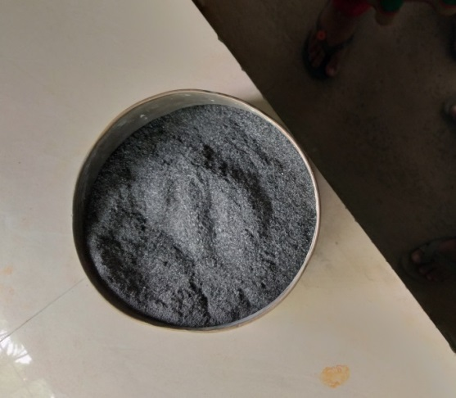

**Fig 3.1 Rice husk ash**

Worldwide more than 100 million tonnes per year of rice husks are available worldwide for disposal. Each ton of paddy rice produces about 200 kg of husks, which on combustion yield approximately 40kg of ash. This means that there is a potential for producing 20 million tonnes of rice husk ash every year. The ash formed during open-field burning or uncontrolled combustion generally contains a large proportion of silica and when ground to a very fine particle size develops highly pozzolanic properties. The combustion of rice husks produce approximately 20% high silica ash. As crystalline silica is hazardous to human health, the burning temperature of rice husk ash must be controlled to keep silica in an amorphous state.

**3.7 Physical properties of Rice husk ash**

|  |  |  |
| --- | --- | --- |
| **S No** | **Property** | **Value** |
| 1 | Specific Gravity | 2.09 |
| 2 | Colour | Black |

**3.8 Chemical properties of Rice husk ash**

|  |  |
| --- | --- |
| **Components** | **Mass%** |
| Silicon dioxide (Si) | 86.94% |
| Calcium Oxide (CaO) | 0.3 – 2.25% |
| Ferric Oxide ( | 0.1% |
| Sodium(N) | 0.1 -0.8% |
| Aluminum Oxide(A) | 0.2% |
| Magnesium Oxide (MgO) | 0.2 – 0.6% |
| Loss of ignition | 5.83% |

**3.8 SUGAR CANE BAGASSE ASH**

Sugarcane bagasse consists of approximately 50% of cellulose, 25% of hemicelluloses of lignin. Each ton of sugarcane generates approximately 26% of bagasse (at a moisture content of 50%) and 0.62% of residual ash. The residue after combustion presents a chemical composition dominates by silicon dioxide (sio2). In spite of being a material of hard degradation and that presents few nutrients, the ash is used on the farms as a fertilizer in the sugarcane harvests. In this sugarcane bagasse ash was collected during the operation of boiler operating in Sankili sugar factory Regidi, Amadalavalasa Mandal, Srikakulam District, and Andhra Pradesh. The production of sugarcane varies from year to year, the main factor for such variations being climatic conditions, the average annual yield being about 5.6 million tons Bagasse. Bagasse ash is at present considered to be a waste product with little or no use. It has negative value, in that, the sugar factories have to spend money to dispose

of it. Moreover, it is a potential environmental pollution. It is estimated that about 20,000 tons of bagasse ash are produced every year. This represents about 0.3 per cent of cane crushed or about 2.8 per cent of the dry weight of bagasse.

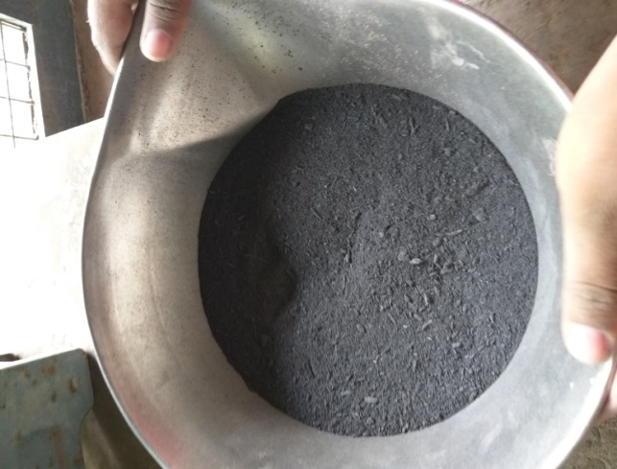

**Fig 3.2 Sugarcane bagasse ash**

Though, SCBA is a valueless agricultural waste of sugar industry it is a pozzolan or pozzolanic material used to replace part of cement because its chemical composition consisted of high SiO2 is the main phase of pozzolanic reaction in cement. Initially, the hydration reaction is the first reaction of cement and water to form calcium hydroxide (CH) and calcium silicate hydrate (C-S-H). Subsequently, the pozzolanic reaction is the second reaction between CH, from hydration reaction, and SiO2, a pozzolan from SCBA, to originate the second phase of C-S-H. The C-S-H from pozzolanic reaction is a supplementary cementing phase to increase the compressive strength of cement and workability when certain percentage of cement is replaced.

**3.9 Physical properties of Bagasse ash**

|  |  |  |
| --- | --- | --- |
| **S No** | **Property** | **Value** |
| 1 | Specific Gravity | 2.2 |
| 2 | Colour | Black |

**3.10 Chemical properties of Bagasse ash**

|  |  |
| --- | --- |
| **Components** | **Mass%** |
| Silicon dioxide (Si) | 70.5 |
| Calcium Oxide (CaO) | 4.7 |
| Potassium (O) | 12.16 |
| Ferric Oxide ( | 1.89 |
| Sodium(N) | 3.82 |
| Aluminum(A) | 1.36 |
| Magnesium Oxide (MgO) | 4.68 |
| Titanium ( | <0.06 |
| Loss of ignition | 0.78 |

**3.9 CHEMICAL ADMIXTURE**

The most widely used chemical admixtures in construction industry for high range water reduction are the Super-plasticizers. The Super-plasticizer used in this project is MYK Armix EmmeCrete SP111. It is supplied as a brown liquid instantly dispersible in water. Armix EmmeCrete SP111 has been specially formulated to give high water reductions up to 20% without loss of workability or to produce high quality concrete of reduced permeability.

It can be used with all types of cements except high alumina cement. Armix EmmeCreteSP111 is compatible with other MYK admixtures when added separately to the mix. Site trails should be carried out to optimum dosage.

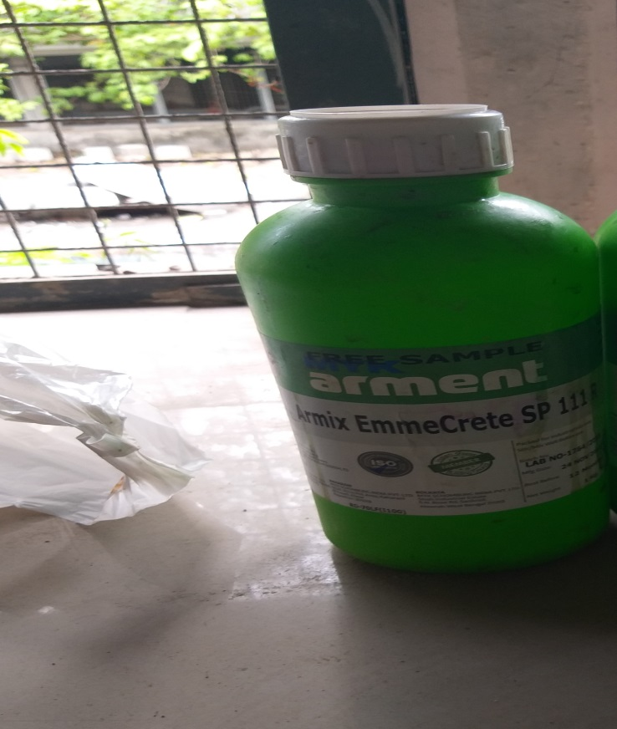

**Fig 3.3 MYK Armix EmmeCrete SP111**

**Properties:**

* Appearance : Light brown
* State : Liquid
* Chloride content : Nil
* Dosage range : 0.6% - 2%
* Specific Gravity : 1.20 + 0.05 at 27°C

**Uses:**

* To produce pump able concrete
* To increase workability without extra water
* To improve cohesion, minimizing segregation and give better finish.
* Chloride free
* Can be used with concrete containing micro silica and their cement replacements.

**Advantages:**

* Improved workability - Easier, quicker placing and compaction.
* Increased strength - Provides high early strength if water reduction is taken advantage of.
* Increased quality - Denser, close textured concrete with reduced porosity and hence enhanced durability.
* Higher cohesion - Risk of segregation and bleeding minimized; thus aids pumping of concrete

**Dosage:**

The optimum dosage of Armix EmmeCrete SP 111 to meet specific requirements should always be determined by trials using the materials and conditions that will be experienced in use. The normal dosage range is between 0.6-2 percent by weight of cement.

**Over Dosage:**

An over dose above the recommended level of admixture may result in high workability, air entrainment and retardation of setting time depending on the ambient temperature of cure. As such, more than the recommended dosage may be used if necessary by ascertaining the performance in the lab trials only before using in actual site conditions.

**Health and safety:**

Armix EmmeCrete SP111 is non-toxic. Any splashes on the skin should be washed immediately with water. Splashes to the eyes should be washed immediately with water and Medical advice should be sought**.** And it is non-flammable.

**3.10 SUMMARY**

The test results were performed to achieve a better mix proportion with fulfilment of strength as well as the desired workability with optimum cement content. On the basis of the test results shown in this chapter, the final mix proportions will be performed later in the Chapter 4. The tests on the materials, to be used in the mix design, shows that the physical properties of the tested materials are in the range of the desired criteria as per IS codes.

**CHAPTER-4**

**MIX DESIGN**

**4.1 INTRODUCTION**

Self-compacting concrete mix does not have any standardized test methods or specified mix design procedure to follow. It shall satisfy the total performance criteria for the concrete in both the fresh and hardened state. This section describes mix design methodology by the European Federation of National Association representing for concrete (EFNARC) technique and fine-tuned by using different guidelines to get the mix with the required fresh and hardened properties. Here we are designing self-compacting concrete having minimum compressive strength of 30MPa.

**4.2 MIX PROPORTIONING**

Before any SCC is produced and used at site the mix has to be designed and tested.in this process, local material should be tested to achieve new concrete mixes with right mixing sequence and mixing time valid for the plant and also suitable for the element to be cast. Various kinds of fillers can result in different strength, shrinkage and creep but they will usually not to be higher than that of conventional concrete. To achieve fluidity, homogeneity we should focus on three different aspects:

* Reduce the coarse aggregate content in order to reduce the friction, or the frequency of collision between the particles and increasing the overall fluidity of concrete
* Increase the paste content to further increase fluidity
* Managing the paste viscosity to reduce the risk of aggregate blocking when the concrete flows through obstacles.

Set required performance

Select material (from site)

Evaluate alternative materials

Design and adjust mix composition

**NOT OK**

**OK**

Verify or adjust performance in laboratory

Verify performance in concrete plant or at site

**Fig. 4.1 General Mix design procedure**

**4.3 MIX COMPOSITION AS PER EFNARC SPECIFICATIONS**

In designing the mix it is mostly useful to consider the relative proportions of the key components by volume rather than by mass. Indicative typical ranges of proportions and quantities in order to obtain self-compacting ability are given below:

* Water/powder ratio by volume of 0.80 to 1.10.
* Designation of desired air content -2%
* Total powder content - 160 to 240 litres (400 - 600kg) per cubic meter.
* Coarse aggregate content normally 28 to 35 percent by volume of the mix.
* Water cement ratio is selected based on requirements in EN 206. Typically water content does not exceed 200 litre/m3
* Maximum sizes of aggregates are restricted to 20mm.
* Aggregate of size 10 to 12mm is desirable for structures having congested reinforcement
* Material of particle size less than 0.125mm contribute to the powder content
* Super plasticizer used with a water reduction greater than 20%

**4.4 PROCESS OF MIX DESIGN**

In general, for efficient designing of SCC mixes, the sequential procedure of design is:

* Designation of air content (mostly 2%)
* Determination of coarse aggregate volume
* Determination of fine aggregate content. Design of paste composition
* Determination of optimum water powder ratio
* Determination of super plasticizer dosage in mortar
* Finally the concrete properties assessed by standard tests.

**4.5 ADJUSTMENT OF THE MIX**

Laboratory trials should be used to verify properties of the initial mix composition. If necessary, adjustments to the mix composition should then be made. Once all requirements are fulfilled, the mix should be tested at full scale.

In the event that satisfactory performance cannot be obtained, then consideration should be given to fundamental redesign of the mix. Depending on the apparent problem, the following courses of action might be appropriate:

* Using additional or different types of filler, (if available).
* Modifying the proportions of the sand or the coarse aggregate.
* Using a viscosity modifying agent, if not already included in the mix.
* Adjusting the dosage of the super-plasticizer the viscosity modifying agent.
* Using alternative types of super-plasticizer (and/or VMA), more compatible with local materials.
* Adjusting the dosage of admixture to modify the water content, and hence the

Water/powder ratio.

**4.6 MIX DESIGN FOR M30 GRADE SELF COMPACTION CONCRETE**

**4.6.1 Stipulations for Proportioning**

1. Grade designation = M30
2. Type of cement = OPC 53 grade confirming IS 12269
3. Maximum nominal size of aggregate = 10mm
4. Minimum cement content = 320 Kg/m3
5. Maximum water-cement ratio = 0.45
6. Workability = 100 mm (slump)
7. Exposure condition = Severe
8. Method of concrete placing = Pump able
9. Degree of supervision = Good
10. Type of aggregate = crushed angular aggregate
11. Chemical admixture = MYK Armix Emmecrete SP 111R

**4.6.2 Test data for materials**

1. Cement used = OPC 53 grade confirming

IS 12269

1. Specific gravity of cement = 3.15
2. Specific gravity of coarse aggregate = 2.75
3. Specific gravity of fine aggregate = 2.70
4. Specific gravity of rice husk ash = 2.09
5. Specific gravity of sugar cane bagasse ash = 2.20
6. Water absorption
   1. Coarse aggregate = 0.4%
   2. Fine aggregate = 1.0%
7. Free surface moisture
   1. Coarse aggregate = Nil
   2. Fine aggregate = Nil
8. Sieve analysis
   1. Coarse aggregate = 5.227
   2. Fine aggregate = 2.83

**4.6.3 Mix design**

1. **Target strength for mix proportioning**  = Fck +1.65S

(S=5, standard deviation from IS10262)

=30+1.65*(5)

=38.25 N/mm2

1. **Selection of water cement ratio**

As per Table 5 of IS 456- 2000, maximum water cement ratio= 0.45

Water cement ratio W/C =0.45

1. **Selection of water content**

As per Table 2 of IS 10262- 2009, maximum water content for 10mm aggregate is 208Kg

Maximum water content for 10mm aggregate =208Kg

1. **Calculation of cement content**

Water cement ratio W/C =0.45

Cement content = 462.2Kg/

1. **Proportion of volume of coarse aggregate and fine aggregate content**

As per Table 3 of IS 10262- 2009, volume of coarse aggregate per unit volume of total aggregate for zone 2 of 10mm size for water-cement ratio of 0.50= 0.46

But our water cement is 0.45. Therefore water cement ratio lowers by 0.05, the proportion of volume of coarse aggregate is increased by 0.01(@ of -/+ 0.01 for every 0.05 change in W/c ratio)

Volume of coarse aggregate for water- cement ration 0.45 is = 0.47

Volume of final aggregate = 0.53

**Mix calculation:**

Mix calculations per unit volume of concrete shall be as follows:

1. Volume of concrete = 1 m3
2. Volume of cement =

=

= 0.146

1. Volume of water =

=

=0.208

1. Volume of all aggregates

Assume air content =2%

Volume of all aggregates =0.98-0.146-0.208

=0.626

1. Mass of coarse aggregate =0.626*0.47*2.75*1000

=809.11 Kg

1. Mass of fine aggregate =0.626*0.53*2.7*1000

=895.81 Kg

**4.6.4 Mix proportions 1 concrete for Trail**

**Table 4.1 Mix proportions of Trail**

|  |  |  |  |
| --- | --- | --- | --- |
| **Cement**  **(Kg/)** | **Fine aggregate(Kg/)** | **Coarse aggregate**  **(Kg/)** | **Water**  **(Kg/)** |
| 462.22 | 895.81 | 809.11 | 208 |
| 1 | 1.94 | 1.75 | 0.45 |

**4.7 CONVERTING INTO SELF COMPACTION CONCRETE**

As per EFNARC water content should not exceed 200 l/ so

Cement content (200/0.45) = 444.44 Kg/

Fine aggregate = 895.81 Kg

Coarse aggregate = 809.11 Kg

Total aggregate = 1704.92 Kg

Take 50% of total aggregate as fine aggregate

So total coarse aggregate = 852.5 Kg

Total fine aggregate = 852.5 Kg

Super plasticizer dosage = 0.8%

**4.7.1 Mix proportions:**

**Table 4.2 Mix proportions of SCC Trail**

|  |  |  |  |  |
| --- | --- | --- | --- | --- |
| **Cement**  **(Kg/)** | **Fine aggregate(Kg/)** | **Coarse aggregate**  **(Kg/)** | **Super plasticizer**  **(Kg/)** | **Water**  **(Kg/)** |
| 444.44 | 852.50 | 852.50 | 3.55 | 200 |
| 1 | 1.917 | 1.917 | 0.00798 | 0.45 |

**4.8 PROPORTION OF DIFFERENT MATERIAL BY MASS**

**Fig. 4.2 Proportion of different material**

**4.9 MIX PROPORTIONING**

**Table 4.3 Mix proportions of all mixes**

|  |  |  |  |  |  |  |  |  |  |
| --- | --- | --- | --- | --- | --- | --- | --- | --- | --- |
| **S No** | **Mix** | **Cement**  **Kg/** | **RHA**  **Kg/** | **SCBA**  **Kg/** | **F.A**  **Kg/** | **C.A**  **Kg/** | **Water**  **Kg/** | **S.P%** | **W/P ratio** |
| 1 | R0B0 | 444.45 | 0 | 0 | 852.5 | 852.5 | 200 | 0.8 | 0.45 |
| 2 | R2B0 | 435.56 | 8.89 | 0 | 852.5 | 852.5 | 200 | 0.9 | 0.45 |
| 3 | R4B0 | 426.67 | 17.78 | 0 | 852.5 | 852.5 | 200 | 1 | 0.45 |
| 4 | R6B0 | 417.78 | 26.67 | 0 | 852.5 | 852.5 | 200 | 1.2 | 0.45 |
| 5 | R8B0 | 408.89 | 35.56 | 0 | 852.5 | 852.5 | 200 | 1.4 | 0.45 |
| 6 | R4B5 | 404.44 | 17.78 | 22.23 | 852.5 | 852.5 | 200 | 1.2 | 0.45 |
| 7 | R4B10 | 382.22 | 17.78 | 44.45 | 852.5 | 852.5 | 200 | 1.4 | 0.45 |
| 8 | R4B15 | 360.00 | 17.78 | 66.67 | 852.5 | 852.5 | 200 | 1.7 | 0.45 |

**4.10 CLOSURE**

In this chapter detail explanation of M30 grade concrete mix design calculations are presented. With respect mix design, summary of mix proportions presented for M30 grade concrete. In the next chapter the concept of making self-compacting concrete and testing procedure are explained in details.

**CHAPTER-5**

**EXPERIMENTAL INVESTIGATION**

**5.1 INTRODUCTION**

In this chapter, the experimental set up and the test procedure adopted for determining the effects on adding mineral admixture rice husk ash and sugar cane bagasse as partial replacement of cement for M30 grade self-compacting concrete using ordinary Portland cement in terms of modification in workability and mechanical properties of self-compacting concrete.

* 1. **OBJECTIVE OF TESTING**

The main objective of this project is to study fresh and hardened properties of self-compacting M30 grade concrete by replacing cement with rice husk ash (RHA) 2%,4%,6%,8% up to the optimum then putting optimum RHA as constant and again cement is replaced with sugar cane bagasse ash(SCBA) with varying percentages 5%,10%,15%,20% up to optimum value. Then Comparing hardened properties of optimum percentage replacements with normal self-compacting concrete. In the present investigation studies have been carried out in three phases. They are

1. In phase one study the physical properties of material and development of M30 grade SCC mix and study the fresh and hardened properties of normal SCC mix
2. In phase two cement is partially replaced with RHA up to optimum value in terms of fresh and hardened properties
3. In phase three putting optimum RHA as constant and again cement is replaced with sugar cane bagasse ash(SCBA) with varying percentages up to optimum values and study the fresh and hardened properties of optimum mix.
   1. **PHASE-I**
      1. **Physical properties of materials**
4. Study on physical and chemical properties of cement, coarse and fine aggregate
5. Study on physical and chemical properties of admixtures
   * 1. **Mix Proportions of SCC**

Based on EFNARC method of mix design, mix proportions for M30 grade with 10mm size of coarse aggregate was developed and their fresh and hardened properties are studied.

* 1. **PHASE-2**

Rice husk ash was partially replaced with different percentages to the cement in reference self-compacting mix. The mix which have followed EFNARC specifications in fresh state and which yielded relatively high compressive strength were selected for further investigations

**Table 5.1 No. of specimens prepared for determining optimum percentage of RHA**

|  |  |  |  |
| --- | --- | --- | --- |
| S No | % RHA | 7 Days | 28 Days |
| 1 | 0 | 3 | 3 |
| 2 | 2 | 3 | 3 |
| 3 | 4 | 3 | 3 |
| 4 | 6 | 3 | 3 |
| 5 | 8(up to optimum value | 3 | 3 |

* 1. **PHASE-3**

The optimum mix percentage of Rice husk ash which was selected from the phase-2 is putting constant replacement percentage in cement with different percentages of sugar cane bagasse ash. The mix which was satisfied EFNARC specifications in fresh state and which yields relatively high compressive strength was selected as optimum mix percentage replacement of cement with RHA and SCBA.

**Table 5.2 No. of specimens prepared for determining optimum percentage of RHA+SCBA**

|  |  |  |  |
| --- | --- | --- | --- |
| S No | %SCBA+(optimum %RHA) | 7 Days | 28 Days |
| 1 | 5%SCBA +optimum %RHA | 3 | 3 |
| 2 | 10%SCBA+optimum %RHA | 3 | 3 |
| 3 | 15%SCBA +optimum %RHA | 3 | 3 |
| 4 | 20%SCBA +optimum %RHA | 3 | 3 |
| 5 | 25%SCBA (up to optimum)+optimum %RHA | 3 | 3 |

* + 1. **Mechanical properties of optimum SCC Mix**

Cubes, cylinders and beams were cast and their mechanical properties like compressive, tensile and flexural strengths at 7, 28 days were determined by conducting tests on hardened self-compacting concrete.

|  |  |  |  |
| --- | --- | --- | --- |
| Test  Specimens | Number of specimens | | |
| Control mix | M30  OPC+OPTIMUM RHA% | M30  OPC+OPTIMUM RHA%+OPTIMUM SCBA % |
| Cubes | 6 | 6 | 6 |
| Cylinders | 6 | 6 | 6 |
| Beams | 6 | 6 | 6 |
| Total | 18 | 18 | 18 |

**Table 5.3 No. of specimens prepared for determining hardened properties**

* 1. **MIXING OF INGREDIENTS**

The whole mixing process was carried out in a power operated concrete mixer. Fine aggregate, cement and filler material were put in the concrete mixer first and mixed in the dry state for few seconds. Later superplastisizer thoroughly mixed with water was added to the material in the concrete mixer. Then it was allowed to mix thoroughly and finally coarse aggregate was added to it, mixed till a mixture of uniform colour and consistency were achieved. To produce self-compacting concrete with RHA and SCBA different percentage of these mineral admixtures were added to mix along with coarse aggregate.

* 1. **TESTING METHODS FOR SELF COMPACTABILITY**

The workability tests done for ordinary conventional concrete mixes are not adequate for self-compacting concrete because, they are not sensitive to detect all the characteristics of self-compacting concrete mix. Hence different test methods have been developed to characterize the properties of self-compacting concrete, but till no single method has been found to characterize all the relevant workability aspects of SCC. Hence each mix has to be tested by more than one testing method for different workability parameters. Those are

* Filling ability
* Passing ability
* Resistance to segregation

**Table 5.4 List of Testing Methods for workability properties of SCC**

|  |  |  |
| --- | --- | --- |
| **S NO** | **METHOD** | **PROPERTY** |
| 1 | Slump flow by Abrams cone | Filling ability |
| 2 | Slump Flow | Filling ability |
| 3 | J-Ring | Passing ability |
| 4 | V-funnel | Filling ability |
| 5 | V-funnel at | Segregation resistance |
| 6 | L-box | Passing ability |
| 7 | U-box | Passing ability |
| 8 | Fill box | Passing ability |
| 9 | GTM screen stability test | Segregation resistance |
| 10 | orimet | Filling ability |

**Table 5.5 Acceptance criteria for Self-compacting Concrete**

|  |  |  |  |  |
| --- | --- | --- | --- | --- |
| **S no** | **Method** | **unit** | **Typical ranges of values** | |
| **Minimum** | **Maximum** |
| 1 | Slump flow by Abrams cone | mm | 650 | 800 |
| 2 | T50 cm Slum flow | sec | 2 | 5 |
| 3 | J-Ring | mm | 0 | 10 |
| 4 | V-funnel | Sec | 8 | 12 |
| 5 | V-funnel at T5 minutes | Sec | 0 | +3 |
| 6 | L-box | H2 /H1 | 0.8 | 1.0 |
| 7 | U-box | H2 /H1 | 0 | 30 |
| 8 | Fill box | % | 90 | 100 |

**5.8 TESTS ON FRESH STATE**

The following testing methods are used in this experimental investigation to characterize the workability properties and for the final acceptance of self-compacting concrete mix proportions.

* Slump flow test
* J -Ring test
* V- Funnel test
* L-Box test

**5.8.1 Slump Flow Test**

**Introduction**

The slump flow test is used to assess the horizontal free flow of SCC in the absence of obstructions. It was first developed in Japan for use in assessment of under water concrete (UWC). The diameter of the concrete circle is a measure for the filling ability of the concrete.

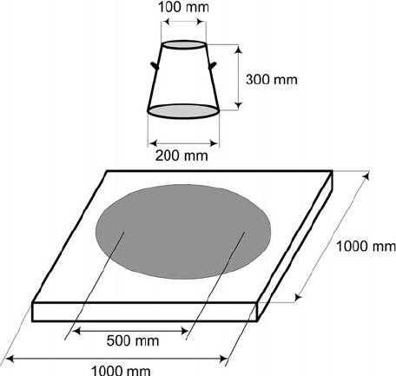

**Fig. 5.1 Slump Flow Test**

**Assessment of Test**

This is most commonly used test, and gives a good assessment of filling ability. It gives indication of quality control test to detect the segregation.

**Equipment**

* Mould in the shape of a truncated cone with the internal dimensions 200mm diameter at the base, 100mm diameter at the top and height of 300mm
* Base plate a stiff non absorbing material
* Trowel
* Scoop
* Ruler
* Stop watch

**Procedure**

* To perform this test about 6 liters of concrete is needed
* Base plate and inside of slump cone are moistened
* Base plate was placed on a suitable ground and the slump cone is placed centrally on the base plate
* The cone is filled with concrete without tamping and simply the top of the concrete is leveled with the trowel
* Surplus concrete present around the base of the cone is removed
* The cone is lifted vertically and allows the concrete to flow out freely.
* The final diameter of the concrete in two perpendicular directions is measured.
* Average of the two measured diameter is calculated (this is the slump flow in mm)

**Interpretation of results**

A slump flow ranging from 650 to 800mm is considered necessary for a concrete to be self-compacted. At slump of more than 800mm the concrete might segregate and at slump flow less than the 650mm the concrete may have insufficient flow to pass through highly congested reinforcement. The higher the slump flow value, the greater its ability to fill formwork under its own weight. In the case of severe segregation, most coarse aggregate will remain in the center of the pool of the concrete whereas mortar and cement paste remains at the concrete periphery. In case of minor segregation, a border of mortar without coarse aggregate can occur at the edge of the pool of concrete. If none of these phenomena appear it is no assurance that segregation will not occur since this is a time related aspect that can occur after a longer period

**5.8.2 J-Ring Test**

**Introduction**

J-Ring test denotes the passing ability of the concrete. The equipment consists of rectangular section 30 mm x 25 mm open steel ring drilled vertically with holes to accept threaded sections of reinforcing bars 10 mm diameter 100 mm in length. The bars and sections can be placed at different distance apart to simulate the congestion of reinforcement at the site. Generally these sections are placed 3 times the maximum size of aggregate. The diameter of the ring formed by vertical section is 300 mm and height 100 mm.

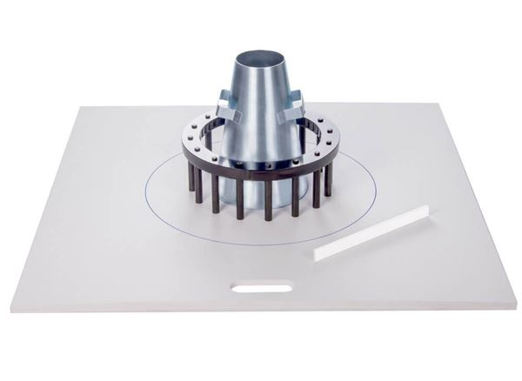

**Fig. 5.2 J-Ring Test**

**Assessment of Test**

This is most commonly used test, and gives a good assessment of passing ability.

**Equipment**

* Slump cone without foot pieces
* Base plate at least 700 mm square
* Trowel
* Scoop
* Tape
* J-Ring rectangular section 30 mm x 25 mm planted vertically to form a ring 300mm diameter. Generally at spacing 48mm

**Procedure**

* To perform this test about 6 litres of concrete is needed**.**
* Place the J-ring centrally on the base plate and the slump cone centrally inside the J-ring, and fill the slump cone.
* Raise the cone vertically and allow the concrete to flow out through the J-ring.
* Measure the final diameter in two perpendicular directions and calculate the average diameter.
* Measure the difference in height between the concrete just inside the J- ring bars and just outside the J-ring bars.
* Calculate the average of the difference in height at four locations in mm.

**Interpretation of results**

The measures of the passing ability and filling ability are not independent. To characterize filling ability and passing ability, the horizontal spread of the concrete sample is measured after the concrete passes through the gaps in the bars of the J-ring and comes to rest. Also, the difference in height of the concrete just inside the bars and the just outside bars is measured at four locations. Smaller the difference in heights, greater will be the passing ability of the concrete.

**5.8.3 V-Funnel Test**

**Introduction**

The test was developed in Japan and used by Ozawa et al(62). This test is used to determine the filling ability of the concrete. The funnel is filled with about 12 litres of concrete and the time taken for it flow through apparatus measured. After this the funnel is refilled with concrete and left for 5 minutes to settle. If the concrete shows segregation then the flow will increase significantly

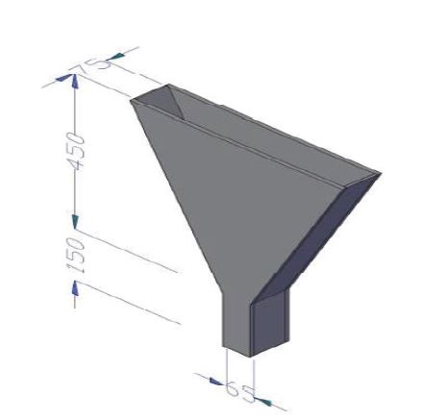

**Fig. 5.3 V-Funnel Test**

**Assessment of Test**

Though the test is designed to measure flowability, the test result is affected by concrete properties other than flow alone. High flow time can be associated with low deformability due to a high paste viscosity, and with high inter-particle friction. While the apparatus is simple, the effect of the angle of the funnel, and the wall effect on the flow of concrete are not clearly defined.

**Equipment**

* V-Funnel
* Bucket
* Trowel
* Scoop
* Stopwatch

**Procedure for Flow Time**

* To conduct this test about 12 liters of concrete is needed
* The V-Funnel should be placed on firm ground
* Inside surfaces of the funnel should be moistened
* The trap door is closed and the apparatus is filled with concrete without compacting and the top of the funnel is leveled with the trowel
* The trap door should be opened within 10 seconds and the concrete is allowed to flow out under gravity
* Start the stopwatch when the trap door is opened, and record the time for the discharge to complete
* The whole test has to be performed within 5 minutes

**Interpretation of Result**

This test measures the ease of flow of the concrete. A funnel test flow time less than 6 seconds is recommended for concrete to qualify for SCC. According to EFNARC standards a flow time () of 10 seconds is considered appropriate for SCC, and should be less than +3 seconds.

Prolonged flow times may give some indication of the susceptibility of the mix to blocking. After 5 minutes of setting, concrete will show a less continuous flow with an increase in flow time.

**5.8.4 L-Box Test**

**Introduction**

This test is based on Japanese design for under water concrete. It is possible to measure different properties such as filling ability, passing ability and to some extent segregation with the L-Box. The apparatus consists of a rectangular section box in the shape of L, with a vertical and horizontal section. Vertical reinforcement bars are placed at the intersection of the two areas of the apparatus. A moveable gate separates the two sections (vertical and horizontal). The vertical section is filled with concrete and then the gate lifted to allow the concrete flow into the horizontal section. When the flow has stopped, the height of the concrete (H2) at the end of the horizontal section is expressed as a proportion of that remaining in the vertical section (H1). It indicates the slope of the concrete at rest. This is an indication of passing ability.

The horizontal section of the box can be marked at 200mm and 400mm from the gate and the times taken to reach these points measured. These are known as and times and are an indication for the filling ability.

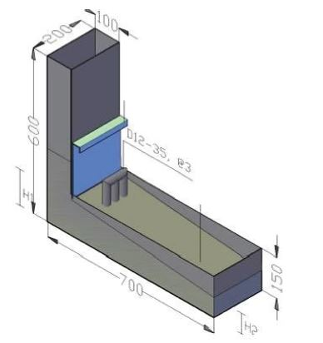

**Fig. 5.4 L-box Test**

**Assessment of Test**

This is a widely used test, suitable for laboratory and site use. It assesses filling ability, passing ability of SCC, and segregation is also detected visually.

**Equipment**

* L-box of a stiff non absorbing material
* Trowel
* Scoop
* Stopwatch
* Ruler

**Procedure**

* To perform this test about 14 liters of concrete is needed
* Apparatus should be kept on a firm ground and the sliding door is closed
* The inside surfaces of the apparatus are moistened
* The vertical section of the apparatus is filled with concrete and leaves it to stand for 1 minute
* Sliding gate of the apparatus is lifted and the concrete is allowed to pass or flow out into the horizontal section
* Start the stop watch and the times taken for the concrete to reach the 200mm and 400mm distance are recorded
* The distances H1 and H2 are measured after the flow has been stopped
* The blocking ratio H2/H1 is calculated
* The whole test has to be performed within 5 minutes

**Interpretation of Test Results**

If the concrete flows as freely as water, at rest it will be horizontal, so H2/H1 i.e. blocking ratio is equal to 1. Therefore the nearer this test value is to unity, the better is the flow of the concrete.

According to EFNARC standards, typical acceptance criteria for SCC with a maximum aggregate size up to 20mm are shown in Table 5.5.

These typical requirements shown against each test method are based on current knowledge and practice. Values outside these ranges may be acceptable if the producer can demonstrate satisfactory performance in the specific conditions.

* 1. **FRESH AND HAEDENED PROPERTIES**
     1. **Testing of SCC in Fresh State**

To get properties such as filling ability, passing ability, and segregation resistance by conducting Slump cone, V-Funnel and L-Box tests SCC was tested in fresh state.

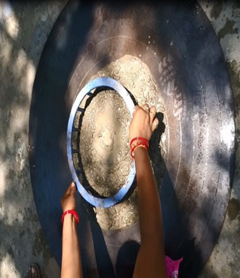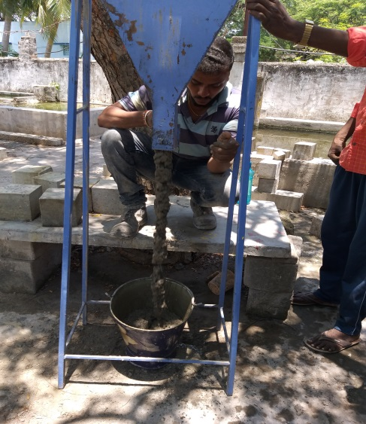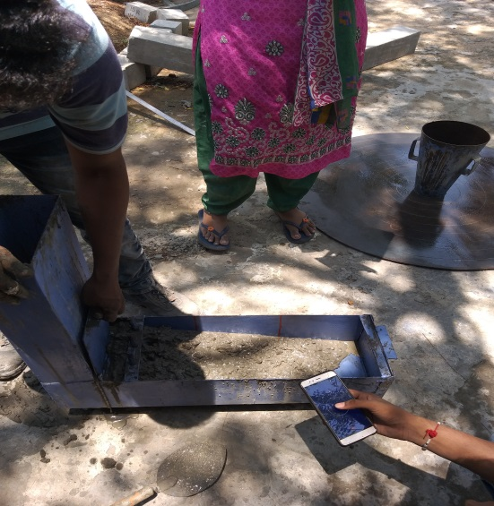

**Fig. 5.5 Testing of SCC in fresh state**

* + 1. **Casting of Specimens**

After testing SCC for fresh properties, the mix was placed, filled in moulds, allowed to flow and settle itself in the moulds excess concrete was removed with trowel.

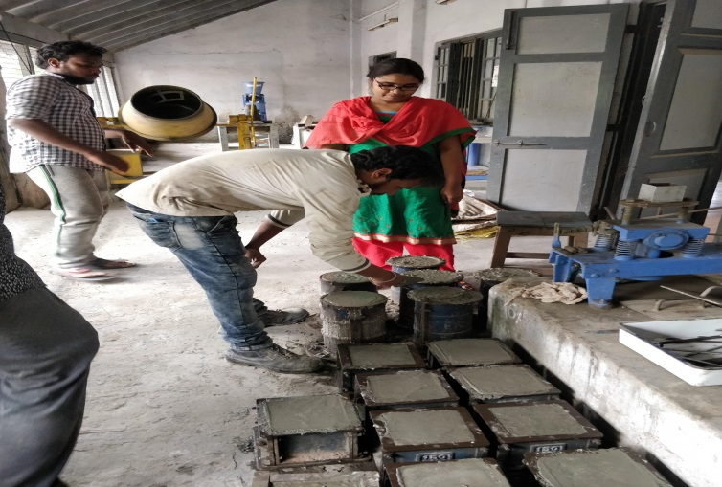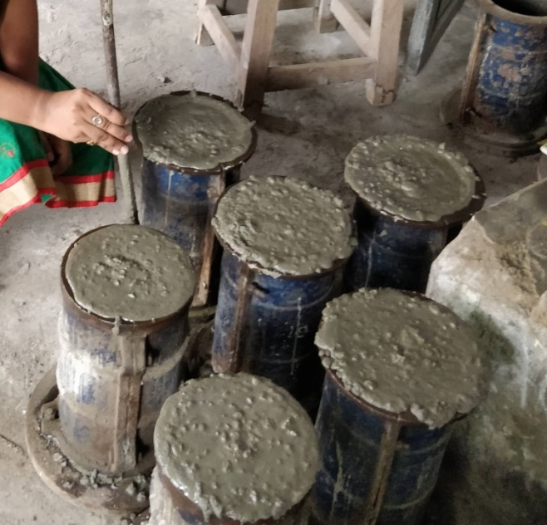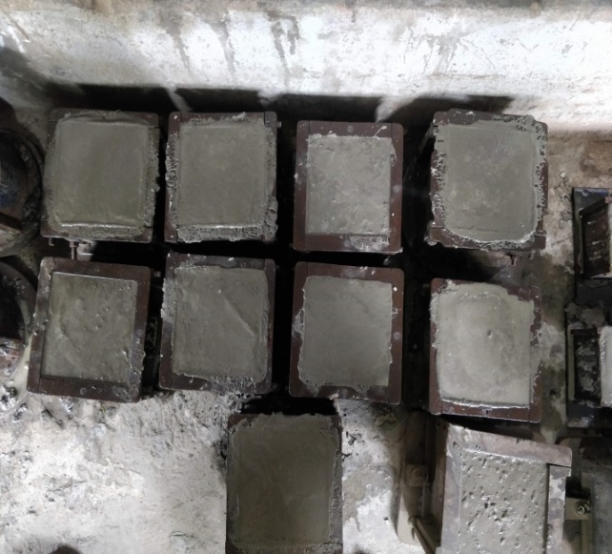 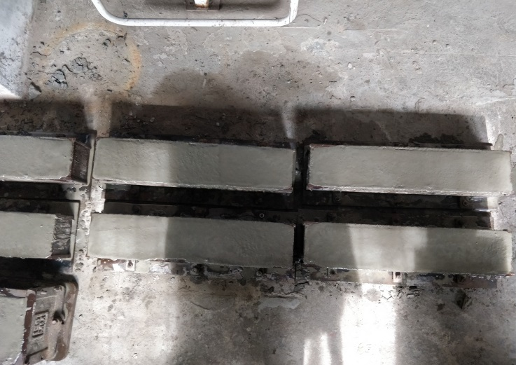

**Fig. 5.6 Casting of Specimens**

* + 1. **Curing of Specimens**

The specimens were left in the moulds undisturbed at room temperature for about 48 hours after casting. The specimens after removing from the moulds were immediately transferred to curing ponds containing clean and fresh potable water.

* + 1. **Testing of Specimens in Hardened State**

The specimens which were cast at standard conditions were tested as per standard testing procedure. After the specimens were taken out from the curing tank their surfaces were wiped off and tested as per IS 516-1959. For testing of specimens a time schedule was maintained to ensure their proper testing on the due date and time.

* + - 1. **Compression Test**

Compression test is most common test conducted on hardened concrete, partly because it is an easy test to perform, and partly because most of the desirable characteristics properties of concrete are qualitatively related to its compressive strength. Compression test was conducted on 150mm×150mm×150mm cubes.

Concrete specimens were removed from curing tank and cleaned. In the testing machine, the cube is placed with the cast faces at right angles to that of compressive faces, then load is applied at a constant rate of 1.4 kg/cm2/minute up to failure and the ultimate load is noted. The load is increased until the specimen fails and the maximum load is recorded. The compression tests were carried out at 3days, 7days & 28 days. For strength computation, the average load of three specimens is considered for each mix. The average of three specimens was reported as the cube compressive of strength provided the individual variation is not more than 15% of average value.

Cube compressive strength =

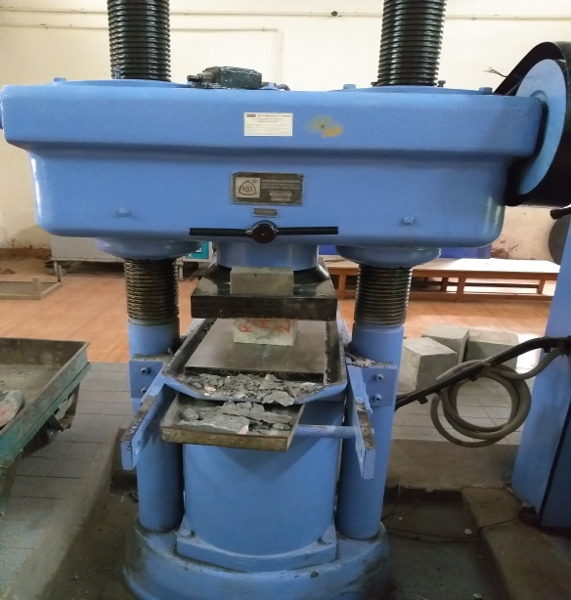

**Fig. 5.7 Compressive strength test setup**

* + - 1. **Split tensile strength test**

This test was developed in Brazil in 1943. Sometimes this test is also called as Brazilian test. However at about the same period this test was also develop spread in Japan independently.

The cylinder specimen is of the size 150 mm diameters and 300mm height was cast to determine the split tensile strength of concrete. The test is carried out by placing a cylindrical specimen horizontally between the loading surfaces of compression testing machine and the load is applied until failure of cylinder, along its longitudinal direction. The cylinder specimens are tested at 7 days and 28 days. The average of three specimens was reported as the split tensile strength provided the individual variation is not more than 15% of average value.

Split tensile strength =

Where

P = compressive load on the cylinder.

L=length of the cylinder.

D=diameter of the cylinder.

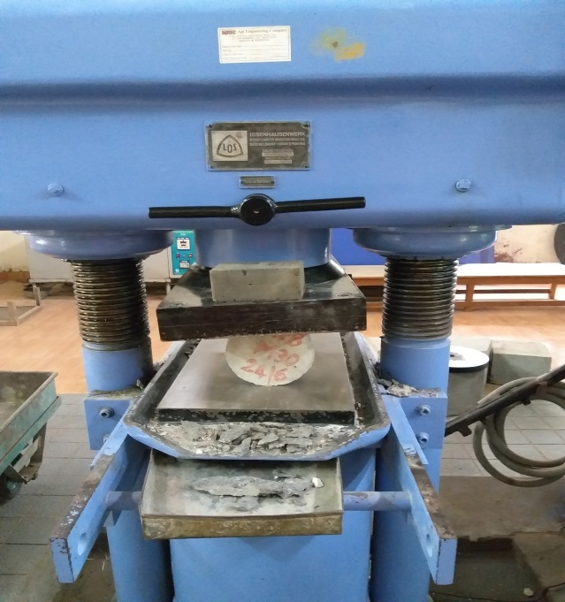

**Fig. 5.8 Split Tension strength test setup**

* + - 1. **Flexural strength test**

In the flexural strength test theoretical maximum tensile stress reached at the bottom fibers of the test beam is known as the modulus of rupture. When concrete is subjected to bending stress, compressive as well as tensile stresses are developed at top and bottom fibers respectively. The strength shown by the concrete against bending is known as flexural strength. If the largest nominal size of aggregate does not exceed 20mm, the dimension of specimen may be 150mm×150mm×700mm.

The bed of testing machine should be provided with two rollers, 38mm in diameter, on which the specimen is to be supported and these two rollers should be mounted at one thawed points of the supporting span that is spaced at 13.3 cm center to center. The load is divided equally between the two loading rollers and the rollers are mounted in such a manner that the load is applied axially and without subjecting the specimen to any torsion stress or strains. The load is applied without shock and increasing continuously at a rate such that the extreme fiber stress increases at approximately 0.7kg/cm2/minute i.e., at a rate of loading of 400kg/minute for the 15cm specimen. The load is increased until the specimen fails and the maximum load applied to the specimen during the test is recorded.

The flexural strength of the specimen is expressed as the modulus of rupture ‘’ which, if ‘a’ equals the distance between the line of fracture and the nearest support measured on the center line of the tensile side of the specimen, in cm, is calculated to the nearest 0.05MPa as follows.

=

f = =

When ‘a’ greater than 20 cm for a 15cm specimen,

=

when ‘a’ is less than 20cm but greater than 17cm for 15cm specimen or less than13.30cm, But greater than 11.00cm for a 10cm specimen.

Where,

P = ultimate load in N

L = span of the beam in mm

b = width of the specimen in mm

d = depth of the specimen in m

The flexural beam specimens are tested at 7 days and 28 days. The average of three specimens was reported as the flexural tensile strength.



**Fig. 5.9 Two point load measurement for flexural strength**

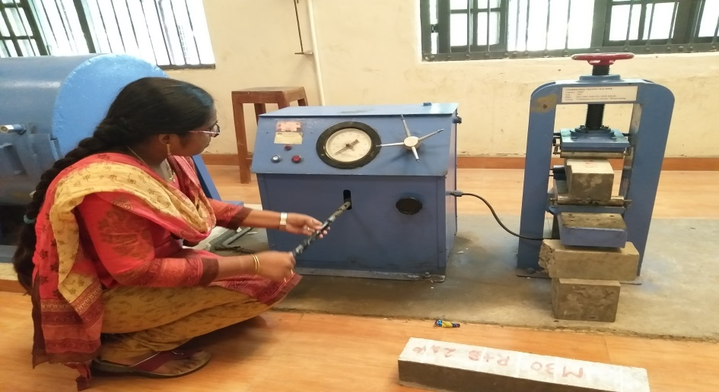

**Fig. 5.10 Flexural strength test setup**

* 1. **Closure**

In this chapter experimental works are presented. Objective of testing, process of

Manufacturing of concrete, workability of fresh concrete and testing of hardened concrete procedures are explained in detail. The method described will be used to study the Observations of fresh and hardened concrete properties.

**CHAPTER-6**

**RESULTS AND DISCUSSIONS**

**6.1 INTRODUCTION**

In this chapter, the experimental observations discussed are presented. The test results for getting optimum mix with RHA and test results for getting optimum mix combination of RHA and SCBA are presented. And the test results such as workability tests, compressive strength, split tensile strength and flexural strength of hardened concrete of M30 grade concrete replacement of cement with optimum percentage of RHA and SCBA at the ages of 7days, 28 days and 56 days are detailed.

**6.2 TEST RESULTS FOR GETTING OPTIMUM WIX WITH RHA**

**6.2.1 Super plasticizer dosage:**

**Table 6.1 SP dosage for varying RHA percentages**

|  |  |
| --- | --- |
| **% RHA** | **SP Dosage** |
| **0** | **0.8** |
| **2** | **0.9** |
| **4** | **1** |
| **6** | **1.2** |
| **8** | **1.4** |

**Fig. 6.1 SP dosage Vs. varying % of RHA**

**Observation:**

With increase in percentage replacement of RHA super plasticizer dosage is increased due to unburnt carbon. The percentage increment of RHA requires more water. So usage of super plasticizer is increased.

**6.2.2 Slump Flow Test Results**

**Table 6.2 Slump Flow Values**

|  |  |
| --- | --- |
| **% RHA** | **mm** |
| **0** | **652** |
| **2** | **670** |
| **4** | **664** |
| **6** | **653** |
| **8** | **645** |

**Fig. 6.2 Slump Flow values vs. varying % of RHA**

**Observations**

In this filling ability test for zero percentage replacement of RHA the slump flow value is less compare with increase in percentage replacement with RHA. And by increasing percentage replacement the slump values are steadily decreased.

**6.2.3 J-Ring Test Results**

**Table 6.3 J-Ring Test Values**

|  |  |
| --- | --- |
| **% RHA** | **Mm** |
| **0** | **9** |
| **2** | **8.5** |
| **4** | **9** |
| **6** | **10** |
| **8** | **11** |

**Fig. 6.3 H2-H1 Vs. varying % of RHA**

**Observations**

In this passing ability test J-Ring value for zero percentage replacement is high and at 2% replacement value is decreased later with increase in percentage replacement of RHA the values are steadily increased. It means increase in percentage of RHA decreases passing ability.

**6.2.4 V-Funnel Test Results**

**Table 6.4 V-Funnel Test Values**

|  |  |
| --- | --- |
| **% RHA** | **T-sec** |
| **0** | **8.4** |
| **2** | **7.6** |
| **4** | **8.2** |
| **6** | **9** |
| **8** | **9.8** |

**Fig. 6.4 V-Funnel value Vs. varying % of RHA**

**Observations**

In this filling ability test V-Funnel values for zero percentage replacement is high and at 2% replacement V-Funnel value is decreased and with increase in percentage replacement of RHA the V-Funnel values are steadily increased. It means the percentage increase in percentage replacement of RHA decreases filling ability.

**6.2.5 L-Box Test Results**

**Table 6.5 Blocking Ratio Values**

|  |  |
| --- | --- |
| **% RHA** | **Blocking Ratio** |
| **0** | **0.83** |
| **2** | **0.86** |
| **4** | **0.85** |
| **6** | **0.83** |
| **8** | **0.79** |

**Fig. 6.5 Blocking Ratio Vs. varying % of RHA**

**Observations**

In this passing ability test the blocking ratio in L-Box for zero percentage is less compare with increase in percentage replacement of RHA. With increase in percentage replacement the blocking ratio values steadily decreases. It means the percentage increase of RHA decreases passing ability.

**6.2.6 Hardened Properties Results**

**Table 6.6 Hardened Properties Results for RHA in MPa**

|  |  |  |
| --- | --- | --- |
| **Material** | **RICE HUSK ASH** | |
| **Specimen** | **Cubes** | |
| **Percentage** | **7D** | **28D** |
| **0** | **29.86** | **41.42** |
| **2** | **28.84** | **40.69** |
| **4** | **27.03** | **39.82** |
| **6** | **26.59** | **38.07** |
| **8** | **25.86** | **36.62** |

**Fig. 6.6 Compressive Strength Vs. varying % of RHA**

**Observation**

* Fig 6.6 indicates the comparison of compressive strength among 0%, 2%, 4%, 6%, 8% for 7 and 28 days
* Compressive strength for 0% replacement is higher among all percentage replacement of RHA but up to 4% replacement the compressive strength getting target mean strength than it decreases then target mean strength.

**6.2.7 OPTIMUM DOSAGE**

* After replacing cement partially with RHA 2%, 4%, 6%, 8% it was known that up to 4% Replacement, fresh properties of self-compaction concrete is satisfied. And getting target mean strength.
* So we decided to take RHA optimum as 4%
* Now replaced cement with 4% RHA replacement remains constant and varying percentages SCBA 5%, 10%, 15% up to optimum.

**Table 6.7 Hardened Properties Results for Optimum RHA in MPa**

|  |  |  |  |  |  |  |  |  |  |
| --- | --- | --- | --- | --- | --- | --- | --- | --- | --- |
| **Material** | **RICE HUSK ASH** | | | | | | | | |
| **Specimen** | **Cubes** | | | **Cylinders** | | | **Beams** | | |
| **Percentage** | **7D** | **28D** | **56D** | **7D** | **28D** | **56D** | **7D** | **28D** | **56D** |
| **R0B0** | **29.86** | **41.42** | **42** | **2.08** | **2.70** | **2.92** | **4.36** | **5.75** | **6** |
| **R4B0** | **27.03** | **39.82** | **40.98** | **1.74** | **2.22** | **2.36** | **4.15** | **5.25** | **5.75** |

**Fig. 6.7 Proportion of different material with RHA**

**6.3 TEST RESULTS FOR GETTING OPTIMUM MIX WITH RHA AND SCBA**

**6.3.1 Super plasticizer dosage**

**Table 6.8 SP dosage for cement replacement with constant Optimum**

**RHA percentage and varying SCBA percentages**

|  |  |
| --- | --- |
| **% RHA+%SCBA** | **SP Dosage** |
| **R0BO** | **0.8** |
| **R4B5** | **1.2** |
| **R4B10** | **1.4** |
| **R4B15** | **1.7** |

**Fig 6.8 SP dosage Vs. cement replacement with constant Optimum**

**RHA percentage and varying SCBA percentages**

**Observation**

Increase in percentage replacement of SCBA with constant optimum RHA percentage the super plasticizer dosage is increased.

**6.3.2 Slump Flow Test Results**

**Table 6.9 Slump Flow Values**

|  |  |
| --- | --- |
| **% RHA+%SCBA** | **mm** |
| **R0BO** | **652** |
| **R4B5** | **680** |
| **R4B10** | **684** |
| **R4B15** | **676** |

**Fig. 6.9 Slump Flow values Vs. cement replacement with constant Optimum**

**RHA percentage and varying SCBA percentages**

**Observations**

In this filling ability test the slump values increase with increase in percentage replacement of SCBA combination with constant RHA percentage increase up to 10% replacement then slump value decreases but satisfying EFNARC guidelines.

**6.3.3 J-Ring Test Values**

**Table 6.10 J-Ring Test Values**

|  |  |
| --- | --- |
| **% RHA+%SCBA** | **mm** |
| **R0BO** | **9** |
| **R4B5** | **8** |
| **R4B10** | **7** |
| **R4B15** | **8** |

**Fig. 6.10 J-Ring values Vs. cement replacement with constant Optimum**

**RHA percentage and varying SCBA percentages**

**Observations**

In this passing ability test the J-Ring values decreases with increase in percentage replacement of SCBA combination with constant RHA percentage up to 10 % replacement then decreases with increase in percentage replacement

**6.3.4 V-Funnel Test Results**

**Table 6.11 V-Funnel Test Values**

|  |  |
| --- | --- |
| **% RHA+%SCBA** | **T-sec** |
| **R0BO** | **8.4** |
| **R4B5** | **8** |
| **R4B10** | **7** |
| **R4B15** | **8.7** |

**Fig. 6.11 V-Funnel values Vs. cement replacement with constant Optimum**

**RHA percentage and varying SCBA percentages**

**Observations**

In this filling ability test V-Funnel values decrease with increase in percentage replacement of SCBA combination with constant RHA percentage up to 10% then increase with increase in percentage replacement.

**6.3.5 L-Box Test Results**

**Table 6.12 L-Box Test Values**

|  |  |
| --- | --- |
| **% RHA+%SCBA** | **Blocking Ratio** |
| **R0BO** | **0.83** |
| **R4B5** | **0.86** |
| **R4B10** | **0.88** |
| **R4B15** | **0.82** |

**Fig. 6.12 L-Box values Vs. cement replacement with constant Optimum**

**RHA percentage and varying SCBA percentages**

**Observations**

In thus passing ability test the L-Box values increases with increase in percentage replacement of SCBA combination with constant RHA percentage up to 10% then values are decreased with increase in percentage replacement

**6.3.6 Hardened Properties Results for RHA+SCBA**

**Table 6.13 Hardened Properties Results for RHA+SCBA**

|  |  |  |
| --- | --- | --- |
| **Material** | **RHA+SCBA** | |
| **Specimen** | **Cubes** | |
| **Percentage** | **7D** | **28D** | |
| **R0B0** | **29.86** | **41.42** | |
| **R4B5** | **27.62** | **40.95** | |
| **R4B10** | **29.43** | **42.29** | |
| **R4B15** | **27.03** | **39.38** | |

**Fig. 6.13 Compressive Strength Vs. cement replacement with constant Optimum**

**RHA percentage and varying SCBA percentages**

**Observations**

Compressive strength values decreases with increases in percentage replacement of SCBA combination with constant RHA percentage compare with zero percentage replacement but at 10% replacement compressive strength increases with increasing age.so we are taking 10% SCBA percentage as optimum with combination of 4% RHA in cement replacement.

**6.3.7 OPTIMUM DOSAGE**

* After replacing 4% RHA and varying percentages of SCBA 5%, 10%, 15%, at 10% of SCBA we are satisfying fresh properties and getting high strength compare with normal self-compaction concrete.

**Table 6.14 Hardened Properties Results for Optimum RHA+SCBA in MPa**

|  |  |  |  |  |  |  |  |  |  |
| --- | --- | --- | --- | --- | --- | --- | --- | --- | --- |
| **Material** | **RICE HUSK ASH** | | | | | | | | |
| **Specimen** | **Cubes** | | | **Cylinders** | | | **Beams** | | |
| **Percentage** | **7D** | **28D** | **56D** | **7D** | **28D** | **56D** | **7D** | **28D** | **56D** |
| **R4B10** | **29.43** | **42.29** | **42.73** | **1.94** | **2.29** | **2.49** | **4.52** | **5.5** | **5.87** |

**Fig. 6.14 Proportion of different material mix with RHA+SCBA**

**6.4 HARDENED PROPERTIE RESULTS FOR OPTIMUM MIX**

|  |  |  |  |  |  |  |  |  |  |
| --- | --- | --- | --- | --- | --- | --- | --- | --- | --- |
| **Specimen** | **Cubes** | | | **Cylinders** | | | **Beams** | | |
| **Mix proportions** | **7D** | **28D** | **56D** | **7D** | **28D** | **56D** | **7D** | **28D** | **56D** |
| **R0B0** | **29.86** | **41.42** | **42** | **2.08** | **2.70** | **2.92** | **4.36** | **5.75** | **6** |
| **R4B0** | **27.03** | **39.82** | **40.98** | **1.74** | **2.22** | **2.36** | **4.15** | **5.25** | **5.75** |
| **R4B10** | **29.43** | **42.29** | **42.73** | **1.94** | **2.77** | **2.98** | **4.52** | **5.8** | **5.87** |

**Table 6.15 Hardened Properties Results for optimum mix proportions**

**6.5 COMPRESSIVE STRENGTH RESULT FOR OPTIMUM MIX**

**Fig. 6.15 Compressive Strength Vs. RHA+BA percentages**

**6.6** **COMPARISON COMPRESSIVE STRENGTH RESULTS**

**Fig. 6.16 Compressive Strength Vs. RHA+BA percentages**

**Observations and Discussions:**

* Fig 6.16 indicates the comparison of compressive strength results for 0% of RHA and 4% of RHA and optimum percentage of RHA 4%+SCBA 10%
* The compressive strength carried out for 7,28,56 days
* The compressive strength of RHA 4%+SCBA 10% is high compare with RHA 4% alone.
* The compressive strength of all percentages increases with increasing age

**6.7 SPLIT TENSILE STRENGTH RESULT FOR OPTIMUM MIX**

**Fig. 6.17 Split Tensile Strength Vs. RHA+BA percentages**

**6.8 COMPARISON OF SPLIT TENSILE STRENGTH RESULTS**

**Fig. 6.18 Split Tensile Strength Vs. RHA+BA percentages**

**Observations and Discussions:**

* Fig 6.18 indicates the comparison of split tensile strength results for 0% of RHA and 4% of RHA and optimum percentage of RHA 4%+SCBA 10%
* The split tensile strength carried out for 7,28,56 days
* The split tensile strength of RHA 4%+SCBA 10% is high compare with RHA 4% alone.
* The split tensile strength of all percentages increases with increasing age

**6.9 FLEXURAL STRENGTH RESULT FOR OPTIMUM MIX**

**Fig. 6.19 Flexural Strength Vs. RHA+BA percentages**

**6.10 COMPARISON OF FLUXURAL STRENGTH RESULTS**

**Fig. 6.20 Flexural Strength Vs. RHA+BA percentages**

**Observations and Discussions:**

* Fig 6.20 indicates the comparison flexural Strength results for 0% of RHA and 4% of RHA and optimum percentage of RHA 4%+SCBA 10%
* The flexural Strength carried out for 7,28,56 days
* The flexural Strength of RHA 4%+SCBA 10% is high compare with RHA 4% alone.
* The flexural Strength of all percentages increases with increasing age

**CHAPTER-7**

**CONCLUSIONS**

The project work deals with the use of Rice Husk Ash and sugar cane bagasse ash as partial replacement of cement in Self-Compacting Concrete. This project encompass the laboratory tests for finding out physical property of the material used in the concrete design such as specific gravity, fineness modulus for fine aggregate (sand) and coarse aggregate. The tests were conducted as per Indian Standards for aggregate. The project further includes the assessment of the fresh properties of concrete such as workability test for each replacement of cement with Rice Husk Ash (RHA), and Sugar cane bagasse ash (SCBA) and assessment of the hardened properties of concrete such as compressive strength, split tensile strength, flexural strength for M30 grade of concrete for partial replacement of cement with optimum dosage of combined RHA and SCBA for different ages.

* Workability of self-compacting concrete mix without mineral admixture is less compare with self-compacting concrete mix with mineral admixture.
* Dosage of super plasticizer increases with increasing percentage of RHA replacement in cement.
* Workability is decreasing with increasing percentage replacement with RHA but increased with respect to normal self-compacting concrete mix.
* No segregation or bleeding is observed during usage of MYK Armix EmmeCrete SP111 and with addition of RHA during the entire work.
* Compressive strength results also decreases with increasing percentage replacement with RHA. But up to 4% replacement of RHA achieves target mean strength at 7 days is 27.03 MPa, 28 days is 39.82MPa and 56 days is 40.98 MPa.
* The increase in percentage of compressive strength from 7 days to 28 days is 47.3% and 28 days to 56 days is 29.13%.
* With increase in percentage of SCBA the workability properties increases up to 10% replacement and then slightly decreases.
* Dosage of super plasticizer increases with increasing percentage of SCBA replacement.
* Compressive strength results are slightly increasing compared with RHA replacement up to 10% then decreases. 7 days compressive strength of RHA+SCBA is 29.43 MPa, 28 days is 42.29MPa and 56 days is 42.73 MPa.
* The increase in percentage of compressive strength from 7 days to 28 days is 43.7% .
* The 28 days compressive strength of RHA+BA is 42.29MPa which is more than R4B0 mix 39.82MPa and R0B0 mix 41.42 MPa.
* The maximum increase of split tensile strength for 28 days shown in RHA+SCBA mix combination that is 2.92 MPa compare with R0B0 mix 2.92 MPa and R4B0 mix 2.36 MPa.
* The maximum increase of flexural strength for 28 days shown in RHA+SCBA mix combination that is 5.8 MPa compare with R0B0 mix 5.75 MPa and R4B0 mix 5.25 MPa.
* Concrete mix replacement with varying percentage of RHA the strength decreases at any age but after combining with SCBA at 7 days the compressive strength 29.43MPa shows less but at 28 days 42.29Mpa giving good strength when compared with normal self-compaction concrete at 28 days 41.42 MPa.
* Thus the optimum percentage of concrete mix with combination of 4% RHA and 10% SCBA gives self-compacting concrete with all fresh and hardened properties as per standards.
* Usage RHA and SCBA as partial replacement of cement can effectively reduce the cement content in self-compacting concrete mix. And it is economic and environmental friendly.

**CHAPTER-8**

**REFERENCES**

1. Ahmadi M.A., Alidoust O., Sadrinejad I., Nayeri, M., ―Development of Mechanical Properties of Self-Compacting Concrete Contain Rice Husk Ash‖, International Journal of Civil and Environmental Engineering, Vol no. 1, pp 100-103., 2007.
2. Alireza Joshaghani “Workability retention and mechanical properties of self-compacting concrete (SCC) with sugar cane bagasse ash(SCBA) and rice husk ash(RHA)” ResearchGate, ISBN: 978-1-53612-795-9, December 2017.
3. Amreen Khatun,Khushpreet Singh,Raju Sharma,"utilization of bagasse ash as a partial replacement of cement in self-compacting concrete", International Journal of Civil Engineering and Technology, Volume 9, Issue 7, pp. 1078–1088,ISSN: 0976-6316, July 2018.
4. Badawe B.R & B.R Kumbhar P.D “Improvement in Durability characteristics of Concrte using Pozzolanic Mineral as admixture”, International conference on maintenance and durability of concrete structures, March4-6, 1997, JNTU Hyd, pp7-12.
5. Boeini Sampurna, D. S. V. S. M. R. K. Chekravarty, “Experimental Investigation On M50 Grade Self-Compacting Concrete Using Glass Fibre”, International Journal of Civil Engineering and Technology, Vol no. 9, Issue 5, pp. 61–68, May 2018
6. B. Preethiwini,“Comparative Study On Durability Characteristics Of High Strength Self-Compacting Concrete”, International Journal of Civil Engineering and Technology, Vol no. 8, Issue 3, pp 942–949, March 2017.
7. Chandraprasirt.P.1983 and Cook, “Rice Husk Ash Cements-their Development and Applications”, UNDO and Govt.of Australia, 1984.
8. C Chandana Priya, M V Seshagiri Rao, V Srinivasa Reddy “Studies on durability properties on high strength self-compacting concrete-a review”, International Journal of Civil Engineering and Technology,Vol no. 9,Issue 11,pp2 2218-2225, ISSN 0976-6316, November 2018.
9. Chai Jaturapitakkul and Boonmark Roongreung. “Cementing material from calcium carbide residue –RHA”. Journal of materials in civil engineering ASCE Oct2003, Vol.15:2, 470-475.
10. Elias Molaei Rais, Javad Vaseghi Amiri, Mohammad Reza Davoodi, “Mechanical performance of self-compacting concrete incorporating rice husk ash”, Construction and Building Material, 177 pp.148–157, 2018
11. Ganesan, K, Rajagopal, K & Thangavel, “Chloride resisting Concrete containing rice husk ash and bagasse ash”, Indian Journal of Engineering &Materials Sciences, Vol no. 14, Issue 6, pp. 257-265, 2017.
12. Ganesan, K, Rajagopal, K & Thangavel, “Evaluation of bagasse ash as supplementary cementitious material”, Cement & Concrete Composites, Vol no.29, Issue 6, pp. 515 – 524, 2006
13. Hanafiah,Salomaand. “The Behaviour of Self-Compacting Concrete (SCC) with Bagasse Ash” American Institute of Physics Conference Proceedings, **1903**, 050005, November 2017.
14. Ifrah Mushtaq, Sandeep Nasier, "Self-Compacting Concrete Design And Performance Using Fly Ash", International Journal of Civil Engineering and Technology, Vol no. 9, Issue 4, pp 436–445, April 2018.
15. Kawade, UR, Rathi, VR & Vaishalid, “Effect of Use Bagasse Ash On Strength of Concrete”, International Journal of Innovative Research in Science, Engineering and Technology, vol. 2, no. 7, pp. 2997-3000, 2013.
16. K. Ganesan, K. Rajagopal, K. Thangavel. “Rice Husk Ash blended cement: Assessment of optimal level of replacement for strength and permeability properties of concrete” Construction and Building Materials, pp. 1675–1683,2008.
17. Kumar S. Sinde, Dr.S.S.Angalekar,"To study the hardened properties of SCC by effectiveness range of SCBA of different regions", International Research Journal of Engineering and Technology, Vol.no 3, Issue 8, ISSN: 2395 -0056, August 2016.
18. M. Abdur Rahman, Shabir Ahmed “Utilization of rice husk ash as a pozzolan in self-compacting concrete”International Journal of Civil Engineering and Technology Vol no. 8, Issue 1,pp. 98–108, January 2017
19. Manu Santhanam and Subramanian.S “Current, Developments in Self-compacting concrete”, The indian concrete journal,pp 11-21, June 2004.
20. M.Ouchi, Hajima Okamura, “Effect of Superplasticizer on Self-compactability of Fresh Concrete”, Journal of the Transportation Research Board,1997 PP 37-40.
21. Mehta. P.K. and Peritz., “Use of Rice Husk Ash to reduce Temperature in High Strength Mass Concrete”, American Concrete Institute Journal, Vol.75, N0.2, Feb1978.
22. Mehta. P.K., “Properties of Blended Cements made from Rice Husk Ash”, American Concrete Institute Journal, September.1977.
23. Mehta. P.K. “Factors influencing durability of concrete structures”. International conference on Maintenance and Durability of concrete structures, March 4-6,1997, JNTU Hyderabad. pp. 7-12.
24. Nan sua, Kung-Chung Hsub, His-Wen Chai “A simple mix design method for self-compacting concrete” Cement Concrete Research 31(2001) 1799-1807.
25. N.Raviteja, K.V.Ramana, “Study of Strength Properties of Self-Compacting Concrete with Rice Husk Ash and Lime-Stone Powder as Admixtures”, International Journal of Innovative Research in Science,Engineering and Technology Vol. 5, Issue 12, ISSN(Online) : 2319-8753,December 2016
26. Noor – ul – amin , “Use of Bagasse Ash in Concrete and Its Impact on the Strength and Chloride Resistivit”, Journal of Materials in Civil Engineering,vol.23, no. 5, pp. 717 – 720, 2011.
27. Ozawa, K., “Development of high performance concrete based on the durability design of concrete structures”, EASEC-2, Vol.1, pp. 445-450, 1989.
28. Rama Rao.G.V., Seshagiri Rao.M.V,Siva Sankar Reddy T. “High performance Rice husk ash concrete mix proportioning using design factor method” ICACC-2004. Proceedings of International Conference on Advaces in concrete and construction.Vol no 2,pp679-690, 16-18 December 2004.
29. Ratandeep Kumar, Ashfaq Malik, Vivek Kumar Kashyap, ―Partial Replacement Of Cement With Rice Husk Ash And Fine Aggregates By Coconut Shell Powder In Concrete, International Journal of Civil Engineering and Technology, Vol no. 9, Issue 4, pp 544–551, April 2018.
30. Ravindra Krishna.M, A.V.Rama Prasad, Seshagiri Rao M.V& Ranga Raju “Durability studies on high strength concrete made with FA & RHA as minerak Admixture” 2nd National conference on Advances in materials and Mechanics of concrete structures 12-13 Aug 2005 IIT Madras.
31. Saloma, Hanafiah, Niko Setiawan “The effect of w/c and rice husk ash (RHA) on mechanical properties of self-compacting concrete (SCC)”, International Journal of Civil Engineering and Technology, Volume 9, Issue 9, pp. 957–967, ISSN: 0976-6316,September 2018.
32. S Baliram and B Suraj, “Sulphuric acid attack on m40 grade self-compacting concrete”, International Journal of Civil Engineering and Technology, Vol no 9, Issue 9, pp. 222–229, ISSN Online: 0976-6316, September 2018.
33. Seshagiri Rao.M.V., Janardhana.M., Rao.K.R.M., Ravindra Kumar.B. “High Fly Ash Concrete with RHA as an admixture. Journal of Institution of Engineering,(India).pp.57-63.
34. Shazim Ali Memon, Muhammad Ali Shaikh, Hassan Akbar, “Utilization of Rice Husk Ash as viscosity modifying agent in Self-Compacting Concrete” Construction and Building Materials 25 (2011) pp.1044–1048, 2011.
35. Shriram H. Mahure, V. M. Mohitkar, “Effect of Rice Husk Ash on Fresh and Hardened Properties of Self-Compacting Concrete”, International Journal of Scientific & Engineering Research, Vol no. 5, Issue 7, ISSN 2229-5518, July 2014.
36. Srikanthan. L Ramya. B. L, "Experimental Study on Self-Compacting Concrete by using Rice Husk as a Partial Replacement of Fine Aggregate with Structuro203 Superplasticiser",International Journal for Innovative Research in Science & Technology Vol no.4 Issue 1, ISSN: 2349-6010,June 2017
37. Srinivasan & Sathiya, “Experimental study on Bagasse ash in Concrete”, International Journal for Service Learning in Engineering, Vol no 5, Issue 2, pp. 60-66, 2010.
38. Vijay Kumar, Dr.S.R. Pandey. **“**Mechanical Behaviour of Self-Compacting Concrete Using Rice Husk Ash as Partial Replacement of Cement A Comparative Study”,International Journal of Innovative Research in Science,Engineering and Technology, Vol no. 6 Issue 6,June 2017 ISSN 2319-8753
39. Yogeshkumar Patel, Nilaykumar Patel, DR.P.J.Patel,R.N.Ghosh, “Draw out optimum content of rice husk ash for self-compacting concrete”, International Journal of Advance Engineering and Research Development, Vol.no.2, Issu 2, ISSN: 2348-4470, February 2015.

# CODE BOOKS

# “Specification and Guidelines for Self-Compacting Concrete" by EFNARC

# IS 456:2000, Recommended code of practice for plain and reinforced concrete, Bureau of Indian Standard, New Delhi.

# IS 10262-2009, Recommended guide lines for concrete mix, Bureau of Indian Standard, New Delhi.

# IS 383 -1970 “Specifications for Coarse and Fine Aggregates from Natural Sources for Concrete”, Bureau of Indian Standards, New Delhi.

# IS 516-1959, Methods Of Tests For strength Of Concrete, Bureau of Indian Standard,New Delhi

TEXT BOOKS

M.S Shetty, Concrete Technology, New Delhi: S.Chand & Company ltd, 2012