**Formulation And Characterization Of Curcumin Liposomes**

Authors: Deepak singh*

research scholar iftm university, moradabad, india

Prashant upadhyay

faculty iftm university, moradabad, india

Address for correspondance: Opposite GGIC Ekta colony

Mandi samiti linepar moradabad -244001

Uttar Pradesh

**Abstract:**

**Purpose**: The purpose of present study was formulation and characterization of liposomes containing curcumin**. Methods:** Formulation excipients were selected using drug excipients compatibility study. Prepared liposomes were subjected to various evaluation parameters like particle size study, optical microscopy, drug release study, FTIR e.t.c. **Result:** Total nine formulations (F1, F2, F3, F4, F5, F6, F7, F8, and F9) were prepared. **Conclusion:** In present work liposomes were prepared by using phospholipid as carrier.From IR and DSC it was observed that curcumin was compitable with other excipients used in formulation. Formulation was selected as best due to its high entrapment efficiency and desirable drug release.

**Keywords:** Phytoconstituents, Soya Lecithin, Vesicular Carrier

1. **Introduction**

Curcumin is a bright yellow colored chemical obtained from rhizome of *Curcuma longa* plants. It is a principal constituent of turmeric (Curcuma longa) belonging to the family Zingiberaceae. It has many applications in pharmaceuticals like herbal supplement, flavourig agent, cosmetic ingredient and food coloring agent[1].

Curcumin is the main natural polyphenol found in the rhizome of *Curcuma longa* and in other species of curcuma. Although Curcumin has no confirmed medicinal use, (wilkepedia) Curcuma longa has been traditionally used in Asian countries as a medical herb due to its antioxidant, anti-inﬂammatory, antimicrobial and anticancer properties.(MDPI) Curcumin has long history of administration in traditional medicine in China, India and Iran for the treatment of many diseases such as diabetes, liver disease, rheumatoid diseases, atherosclerosis, infectious diseases and cancers[2].

Curcumin (1,7-bis(4-hydroxy-3-methoxyphenyl)-1,6-heptadiene-3,5-dione), is a symmetric molecule, also known as diferuloyl methane.( The Chemistry of Curcumin: From Extraction to Therapeutic Agent Kavirayani Indira Priyadarsini) Chemically, curcumin is a [diarylheptanoid](https://en.wikipedia.org/wiki/Diarylheptanoid), belonging to the group of curcuminoids, which are [natural phenols](https://en.wikipedia.org/wiki/Natural_phenol). It exists in [enolic](https://en.wikipedia.org/wiki/Enol) form in [organic solvents](https://en.wikipedia.org/wiki/Organic_solvent), and as a [keto](https://en.wikipedia.org/wiki/Ketone) form in water. [ITs](https://en.wikipedia.org/wiki/Curcumin).ITs) chemical instability, water insolubility and low bioavailability limits bioactivity of curcumin[2].

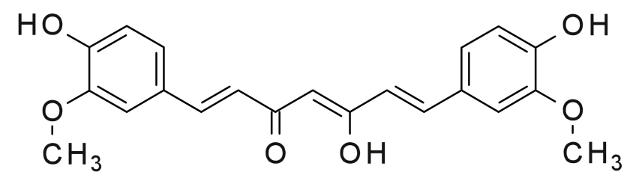

Fiigure 1: Enol form

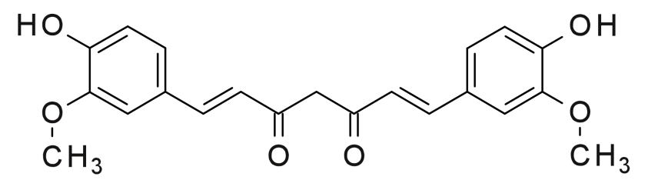

Figure 2: Keto form

However its poor aqueous solubility and rapid intestinal and hepatic metabolism restricted its use.[4] Different stretigies such as liposomes, solid dispersions, micells, nanogels and microspheres have been employed to improve its bioavailablity. Liposomes have been studied for many years and shown promising approach for in vivo delivery of curcumin.[3] Liposomes are small artificial vesicles of spherical shape made up of cholesterol and phospholipids. Due to their small size and hydroplilic- lipophilic characteristics liposomes provides promising approach in drug delivery. liposomes has been used extensively as a carrier for anumber of molecules in pharmaceuticl and cosmetic industry.[10]

1. **MATERIALS AND METHODS**
   1. **Materials**

Curcumin purchased from , Soya Lecithin purchased from , other chemicals and solvents were of analytical grade.

* 1. **Methods**

**2.2.1 Preformulation studies**

Preformulation is initial step in formulation of various dosage form. It is a process of choosing Suitability of drug with new compounds by determining their physiochemical properties. It confirms the absence of interaction between drug and excipients. The preformulation study was performed for the present work were:

1) FTIR

2) Standard calibration curve

**2.2.1.1 Fourier Transform Infra Red spectroscopy**

IR spectra of curcumin and other excipients used in the formulation were recorded by using **“Perkin-Elmer FTIR**.” The sample for Ir spectroscopy was prepared by mixing sample with spectroscopic grade KBr and then compressed in to pellets. The pellets was scanned in the IR range from 500 to 4000 cm-1 .

**2.2.1.2 Differential Scanning calorimetry**

Differential Scanning Calorimetry studies were carried out using “Schimadzu DSC-60.7 In this study curcumin was mixed with phosphatidylcholine and DSC of curcumin, Phosphatidylcholine and mixture of drug with phosphatidylcholine was carried out. The temperature range was from 25 to 600º C, heating rate 10ºC/min and flow rate of nitrogen was 30 ml/min during the study. Approximately 5mg of samples were taken in aluminum pan sealed and the thermogram was recorded.

**2.2.1.3 Standard graph of Curcumin**

Different concentrations of curcumin was prepared in pH 7.4 phosphate buffer to obtain standard curve. The absorbance was measured at 425nm. The values of absorbance related to concentration were given in result section.

**2.2.2 Formulation**

The conventional film method was used for the preparation of liposomes. Curcumin, phospholipid, cholesterol and tween 40 were dissolved using chloroform then mixture was dried to a thin film at 500c using rotary evaporator. Then obtained film was hydrated with phosphate buffer saline (PBS) of pH 6.5 in which tween 40 was dissolved for 30 minute at 600c. All liposome dispersions were sonicated with a probe sonicator.[4]

Table 1: Formuartion table

|  |  |  |  |  |  |
| --- | --- | --- | --- | --- | --- |
| **Formulation Code** | **Drug(mg)** | **Soya Lecithin(mg)** | **Cholesterol(mg)** | **Span40(mg)** | **PBS(ml)** |
| **F1** | **20** | **40** | **5** | **5** | **1** |
| **F2** | **20** | **40** | **10** | **5** | **1** |
| **F3** | **20** | **40** | **15** | **5** | **1** |
| **F4** | **20** | **45** | **5** | **5** | **1** |
| **F5** | **20** | **45** | **10** | **5** | **1** |
| **F6** | **20** | **45** | **15** | **5** | **1** |
| **F7** | **20** | **50** | **5** | **5** | **1** |
| **F8** | **20** | **50** | **10** | **5** | **1** |
| **F9** | **20** | **50** | **15** | **5** | **1** |

**2.2.3 Evaluation of curcumin liposomes**

**2.2.3.1 Particle size and zeta potential**

The prepared liposomes were evaluated for their particle size and zeta potential using Zetasizer. The formulations were diluted to 1:1000 with the aqueous phase of the formulation to get a suitable kilo counts per second (kcps). Analysis was carried out at 25°C with an angle of detection of 90°.

**2.2.3.2 Liposome Morphology**

The morpholopolgy of lipopsomes was carried out by Transmission Electron Microscopy (TEM). The sample was placed on a carbon film coated on a copper grid for Transmission Electron Microscopy. TEM studies were performed at 8 kV. The copper grid was fixed into sample holder and placed in vacuum chamber of the transmission electron microscope and observed under low vacuum.

**2.2.3.3 Encapsulation efficiency**

The encapsulation efficiency of liposomes prepared was calculated using following formula using UV Visible spectrophotometer at a λmax 425nm. Liposomes prepared without drug were treated in similar manner and served as blank for the above study. The formula used to calculate encapsulation efficiency was given below

Encapsulation efficiency = ------- Entrapped drug (mg) X100 / Total amount of drug added (mg)

**2.2.3.4 In vitro drug release studies**

Dialysis membrane method was used for In vitro release studies. The prepared liposomal formulation was placed inside a dialysis membrane immersed in aqueous buffer of volume 100 ml (Phosphate buffer pH 7.4).The sample was withdrawn at predetermined time intervals and by measuring absorbance of sample at 425 nm the amount of curcumin was determined using a UV-Visible spectrophotometer.[5]

1. **Result and discussion**

## 

## 3.1. UV SPECTRUM OF CURCUMIN

UV-visible spectrophotometer is generally used for structural information of various drugs to obtain specific information on the chromophoric part of the molecules in solution when exposed to light in the visible/ultraviolet region of the spectrum absorb light of particular wavelength depending on the type of electronic transition associated with the absorption. The UV spectrum is generally recorded as a plot of absorbance versus wavelength.

Double beam UV-visible spectrophotometer (Shimadzu, UV-1800, Japan) was used to know the λmax of drug. A 4 µg/ml solution of Curcumin in methanol was scanned in the range of 400-800 nm.

**3.1.1.) ESTIMATION OF CURCUMIN**

**3.1.1.1.) ESTIMATION OF CURCUMIN BY UV-VISIBLE SPECTROPHOTOMETER**

The standard stock solution of Curcumin (1mg/ml) was prepared in methanol. This solution was diluted with methanol, to obtain various dilutions from 1-7 µg/ml. Absorbance of these solutions was recorded at 423 nm against methanol as blank using UV-visible spectrophotometer and standard curve was plotted against concentration. From the calibration curve intercept, slope, straight line equation and correlation coefficient were obtained.

**Figure 3:** UV spectrum of Curcumin in methanol

**3.1.1.2)DETERMINATION OF ABSORPTION MAXIMA IN METHANOL**

Absorption maxima of Curcumin were found to be at 423 nm similar to literature as shown in **figure 3:**



**3.1.2) PREPARATION OF STANDARD CURVE OF CURCUMIN IN METHANOL**

**Table 2:** Calibration curve of Curcumin in methanol (λmax= 423nm)

|  |  |  |
| --- | --- | --- |
| **Sr.no.** | **Concentration µg/ml** | **Absorbance** |
| 1 | 1 | 0.117±0.004 |
| 2 | 2 | 0.245±0.001 |
| 3 | 3 | 0.384±0.002 |
| 4 | 4 | 0.515±0.002 |
| 5 | 5 | 0.639±0.001 |
| 6 | 6 | 0.766±0.003 |
| 7 | 7 | 0.895±0.004 |

**Figure 4 :** Graph of standard calibration curve of Curcumin in methanol

**Table 3:** Result of regression analysis of UV method for estimation of Curcumin

|  |  |
| --- | --- |
| **Statistical parameters** | **Results** |
| λ max | 423 nm |
| Regression equation  ** Y=mx+C | 0.129x-0.009 |
| Slope (b) | 0.129 |
| Intercept (C) | -0.009 |
| Correlation coefficient (r2) | 0.999 |

**Discussion: -** The calibration curve for Curcumin was obtained by using the 1 to 7 µg/ml concentration of Curcumin in methanol. The absorbance was measured at 423 nm. The calibration curve of Curcumin as shows in graph indicated the regression equation Y=0.129x-0.009and R2 value 0.999, which shows good linearity as shown in **Table 3** and **Figure 2**.

**3.2) SOLUBILITY STUDIES**

The spontaneous interaction of two or more substances to form a homogenous molecular dispersion is called solubility.

For quantitative solubility study, excess amount of drug was taken in thoroughly cleaned culture tubes containing 3 ml of different solvents and Culture tubes were tightly closed. These Culture tubes were shaking on water bath shaker at 25°C for 24 h at room temperature. After 24 h each sample was centrifuged 15,000 rpm and supernatant was withdrawal. After that supernatant was filtered and filtrates was suitably diluted and determined spectrophotometrically.

**3.2.1) SOLUBILITY STUDIES OF CURCUMIN IN VARIOUS SOLVENTS**

**Table 4:** Solubility studies of Curcumin for different solvents

|  |  |  |
| --- | --- | --- |
| **Sr.no** | **Solvent** | **Solubility in (mg/ml) (mean±SD)** * |
| 1 | Water | 0.001±0.000 |
| 2 | 0.1N HCL | 0.002±0.000 |
| 3 | pH 6.8 | 0.001±0.000 |
| 4 | pH 7.4 | 0.003±0.000 |
| 5 | Ethanol | 7.421±0.004 |
| 6 | Methanol | 11.189±0.045 |
| 7 | Acetonitrile | 11.680±0.045 |
| 8 | Acetone | 23.928±0.090 |

* Each value is mean of three independent determinations

**Figure 5:** Solubility study of drug in different solvents

**Discussion:**From the above data, it was clearly seen that Curcuminis highly soluble in Acetone, Acetonitrile,Methanol followed by Ethanol(**Figure 5 and Table 4**).

**3.3.Compatibility study using IR and DSC**

**3.3.1 IR Spectroscopy**

IR Spectra of standard curcumin standard consist characteristics band values. The recorded spectra of curcumin sample and curcumin excipients physical mixtures consist characteristic band values of standard curcumin.

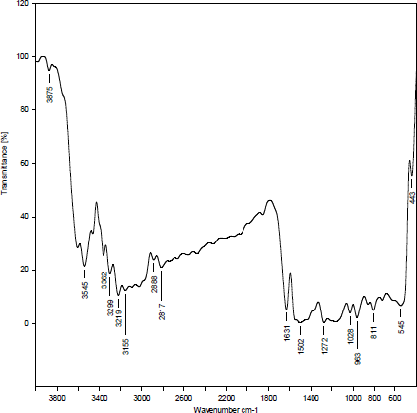

**Figure 6: T-IR Spectrum of curcumin**

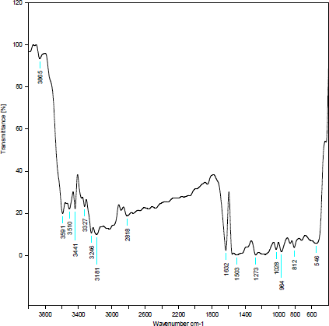

**Figure 7: FT-IR Spectrum of curcumin liposomes**

**3.3.2 Differential scanning calorimetry (DSC):**

Curcumin, Soya lecithin and physical mixture of curcumin and soya lecithin were placed in a aluminium crimp cell and heated at 100c/min. from 0 to 4000c in the atmosphere of nitrogen. Peak transition onset temperatures were recorded by means of an analyzer**.** Differential scanning calorimetryof curcumin showed a sharp endothermic peak at 1780C. Curcumin excipients Physical mixture also showed same thermal behviour as individual component.

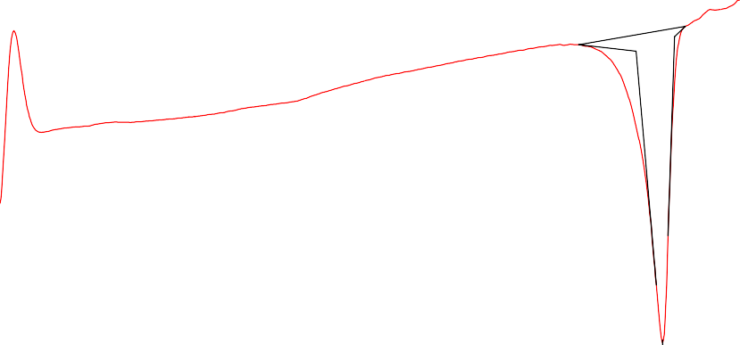

200.00

150.00

100.00

Temp [C]

50.00

-1.00

0.00

Peak 178.91 C

Onset 172.92 C

Endset 181.64 C

Heat -93.82 mJ

-18.76 J/g

Aluminum Seal 30[ml/min]

Drug and excipient interaction study

Cell:

Flow Rate:

1.00 Annotation:

Molecular Weig ht: 0.00

Thermal Analysis of Curcumin

File Name: Curcumin.tad

Detector: DSC-60 Sample Weight: 5.000[mg]

DSC

mW

**Figure 8: DSC of curcumin**

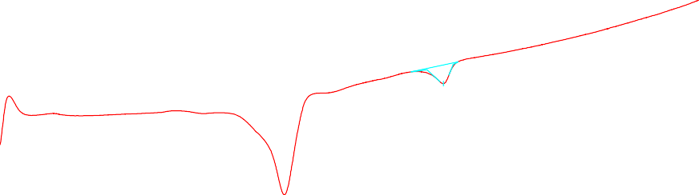

Temp [C]

200.00

100.00

-1.00

0.00

177.02 C

Onset 171.44 C

Endset 180.39 C

Heat -11.58 mJ

-2.32 J/g

1.00

Peak

2.00

3.00

Sample Weight: 5.000[mg]

Cell: Aluminum Seal Atmosphere: Nitrog en

Flow Rate: 30[ml/min]

Annotation: Drug and excipient interaction study

4.00

DSC-60

Detector:

Thermal Analysis Result of Curcumin liposomes

DSC

mW

**Figure 9: DSC of curcumin liposomes**

**3.4 Drug Entrapment**

The Drug entarapment from batch F1 to F9 were studied. Batch showed maximum drug entrapment compare to other batches.

|  |  |
| --- | --- |
| **Formulation Code** | **%Drug Entapment** |
| **F1** | **88.13** |
| **F2** | **87.44** |
| **F3** | **83.43** |
| **F4** | **72.98** |
| **F5** | **79.10** |
| **F6** | **68.75** |
| **F7** | **77.13** |
| **F8** | **69.39** |
| **F9** | **72.13** |

**Table 5: % Drug Entrapment**

**3.5 Liposome Morphology**

According to morphological evaluation of optimized batch by scanning electron microscopy it was observed that the sizes of liposomes were in nano meter.The SEM photograph of batch was given in figure

**3.7 In vitro release**

The result of in vitro release were gien in table 6.

**Table 6: In vitro drug release**

|  |  |  |  |  |  |  |  |  |  |
| --- | --- | --- | --- | --- | --- | --- | --- | --- | --- |
| **Time(hrs)** | **F1** | **F2** | **F3** | **F4** | **F5** | **F6** | **F7** | **F8** | **F9** |
| **0** | **0** | **0** | **0** | **0** | **0** | **0** | **0** | **0** | **0** |
| **2** | **10.8** | **5.75** | **7** | **9.05** | **7.75** | **4.8** | **9.90** | **5.8** | **4.7** |
| **4** | **20.07** | **8.25** | **20.25** | **18.45** | **8.35** | **13.0** | **18.05** | **8.30** | **6.8** |
| **6** | **28.35** | **14.9** | **27.8** | **26.1** | **22.80** | **22.0** | **28.05** | **16.10** | **9.11** |
| **8** | **37.70** | **27.7** | **36.45** | **35.35** | **28.25** | **35.7** | **35.90** | **23.2** | **16.32** |
| **10** | **45.5** | **39.95** | **46.25** | **43.10** | **45** | **42.21** | **42.80** | **33.6** | **24.50** |
| **12** | **58.75** | **54.70** | **52** | **56.05** | **53.55** | **51.5** | **50.45** | **40.90** | **37.38** |

The conventional film method was used for the preparation of liposomes. Curcumin, phospholipid, cholesterol and tween 40 were dissolved using chloroform then mixture was dried to a thin film at 500c using rotary evaporator. Then obtained film was hydrated with phosphate buffer saline (PBS) of pH 6.5 in which tween 40 was dissolved for 30 minute at 600c. All liposome dispersions were sonicated with a probe sonicator.(Yan Chen)

1. **CONCLUSION**

In present work liposomes were prepared by using phospholipid as carrier.From IR and DSC it was observed that curcumin was compitable with other excipients used in formulation. Formulation was selected as best due to its high entrapment efficiency and desirable drug release.

**References**

1. <https://en.wikipedia.org/wiki/Curcumin>
2. Noorafshan, Shoeil A. E, Shoeil. The Therapeutic Effects of Curcumin. Current Pharmaceutical Design. 2013; 19:11.
3. Ting F, Yumeng Wei1, Robert J Lee, Ling Zhao. Liposomal curcumin and its application in cancer. International Journal of Nanomedicine. 2017; 12:6027–6044.
4. Chen Y, quingquing Wu, Zhenghai z, Ling Y, Xuab L, Lei Z. Preparation of curcumin loaded liposomes and their skin permeation and their pharmacodynamics. Molecules. 2012; 17: 5972-5987.
5. Maheswaran A, Brindha P, Mullaicharam AR, Masilaman K. Liposomal drug delivery system: A Review. International Journal of Pharmaceutical sciences. 2013; 23(1):295-301.
6. Maheswaran A, Brindha P, Mullaicharam AR, Masilamani. Design, Development and Evaluation of Curcumin Liposomes World Journal of Pharmacy and Pharmaceutical Sciences. 2013; 3(1): 480-492
7. Akbarzadeh A, Sadabady R, Davan S, Woo Joo S, Samiei M, Hanifehpour Y, Kouhi M, Nejati- Koshki. Liposomes: classification, preparation and application. Nanoscale Research Letters. 2013; 8: 102.
8. Kamble A, Badde S, Kumar A, Pokharkar VB. Devlopment and Characterzation of Liposomal Drug Delivery System for Nimesulide. IJPPS. 2010; 2(4): 87-89.
9. Gaur K, Kori ML, Tyagi LK, Singh V, Nema RK, Tripathi P. Licofelone- Novel Analgesic and Anti-Inflammatory Agent for Osteoarthritis: An Overview. J Young Pharm. 2009; 1:67-71
10. Akbarzadeh Abolfazl, Sadabady Rogaie Rezaei, Davan Soodabeh, Woo Joo Sangi, Samiei Mohammad, Hanifehpour Younes, Kouhi Mohammad, Nejati- Koshki. Liposomes: classification, preparation and application. Nanoscale Research Letters, 2013; 8:102
11. Bahareh Sabeti, Mohamed Ibrahim Noordin, Shaharuddin Mohd, Rosnani Hashim, Afendi Dahlan and Hamid Akbari Javar Development and Characterization of Liposomal Doxorubicin Hydrochloride with Palm Oil BioMed Research International. 2014;1-6.