**Philosophical acceptance of quantum theory!**

Yash Shrivastava

Independent reseacher

H.no 215 Durgesh vihar Colony,

J.K road, Bhopal, Madhya Pradesh, India

[yash.shrivastavazamasu@gmail.com](mailto:yash.shrivastavazamasu@gmail.com) & +91-9171482983

**Abstract-**

Quantum theory has been the most successful theory of the 20th century as it has passed countless experimental test and it has proven true in all of the cases but its philosophical issues are the major problem in theory like collapse of wave function, measurement problem, non-locality, entanglement and information, role of observer, consciousness and decoherence. In this work these problems are resolved by taking concepts like principle of quantum superposition from Schrodinger cat [1] experiment and Copenhagen interpretation [2][3] rigorously made analogous to football match to show philosophically that quantum theory is a complete theory. This analogy is made to show that the laws of quantum mechanism when applied to classical mechanism gives same result as it gives in quantum world.

**Keywords-**

Principle of quantum superposition, Copenhagen interpretation, Analogy, football match

**PACs numbers-**

(03.65.Ta), (03.65.-w), (03.67.-a), (03.65.ud).

**1-Introduction-**

Danish physicist Niels Bohr and German physicist Werner Heisenberg from 1925-1927 interpret the meaning of quantum mechanism which is known as Copenhagen interpretation (CI). Eight years later in 1935 Austrian physicist Erwin Schrodinger published a paper in the name of “The present situation in quantum mechanism” in which he reflects the flaw of Copenhagen interpretation applied to everyday objects. In thought experiment of Schrodinger he enclosed a cat in box which has poison flask which will be hammered if geiger counter detect any radioactive activity and cat will die, there is 50-50% chance that geiger counter will detect any radioactivity. Just before box will be opened cat is in the state of superposition that is it can be alive or dead simultaneously. Upon opening the box human observer will conclude that whether cat is alive or dead (See appendix A). Schrodinger used human observer to predict the outcome of the experiment but in this work observable (measuring apparatus) is used to show that if observable is a device rather than human observer then Copenhagen interpretation holds true in real world too. There are few assumptions are made to simplify this analogy which are:-

1= Observable gives accurate information about we want to measure.

2= Observable gives information about wave nature or particle nature of subatomic particle but not both at the same time.

3= Observable doesn’t make contact with two player simultaneously in this analogy.

3= Outcome of the match doesn’t consider in this analogy.

4= This analogy is made for understanding purpose and analogy does not lies beyond this work.

**2- Preparation of states-**

Two non-relativistic states are prepared in three dimensional space with ten indistinguishable particles each (mainly fermions) by finite well potential from David J. Griffiths- Introduction to quantum mechanics [4]. Our aim is to theorise well as a state and only take inside the well solutions (oscillatory function).

|  |  |
| --- | --- |
| Figure (2).a  ()=  is a positive potential, For 10 particle in 3-D, In region $–a<x<a , V\left(x\right)=-Vo$ $$=\frac{-ℏ}{2}\sum_{N}^{10}{ }\frac{1}{m} ∇^{2}Ψ(x1,x2,…x10)-Vo(x1,x2,…x10)Ψ(x1,x2,…x10)=EΨ(x1,x2,…x10) or \frac{∂^{2}Ψ}{∂x^{2}} = -l²Ψ$$ $$l=\sqrt{2m(E+Vo)/ℏ}$$ 3-D Time independent Schrodinger equation $∇^{2}$ is laplacian operator, N is number of particles, is a state function, is position of particle, E is discrete energy, $ℏ$ is reduced Planck’s constant. Although E is negative for bound state, it must be greater than $–Vo, E>Vmin, l$ is real and positive, general solution $$Ψ\left(x\right)=\operatorname{Asin}\left(lx\right)+\operatorname{Bcos}\left(lx\right) for (-a<x<a)$$ A and B are arbitrary constant.  Energies of wide deep well is $$En+Vo≅\frac{n²π²ℏ²}{2m(2a)²}$$ Here $E+Vo$ is the energy above the bottom of well, for any finite well $Vo$ only finitely bound states are present and $2a$ is width of well. $Ψ$ is linear and oscillatory function inside well. | Figure (2).a  ()=  is a positive potential, For 10 particle in 3-D, In region $–a<x<a , P\left(x\right)=-Po$ $$=\frac{-ℏ}{2}\sum_{N}^{10}{ }\frac{1}{m} ∇^{2}ϕ(x1,x2,…x10)-Po(x1,x2,…x10)ϕ(x1,x2,…x10)=Eϕ(x1,x2,…x10) or \frac{∂^{2}ϕ}{∂x^{2}} = -l²ϕ$$ $$l=\sqrt{2m(E+Po)/ℏ}$$ 3-D Time independent Schrodinger equation $∇^{2}$ is laplacian operator, N is number of particles, is a state function, is position of particle, E is discrete energy, $ℏ$ is reduced Planck’s constant. Although E is negative for bound state, it must be greater then $–Po, E>Pmin, l$ is real and positive, general solution $$ϕ\left(x\right)=\operatorname{Asin}\left(lx\right)+\operatorname{Bcos}\left(lx\right) for (-a<x<a)$$ A and B are arbitrary constant.  Energies of wide deep well is $$En+Po≅\frac{n²π²ℏ²}{2m(2a)²}$$ Here $E+Po$ is the energy above the bottom of well, for any finite well $Vo$ only finitely bound states are present and $2a$ is width of well. $ϕ$ is linear and oscillatory function inside well |

**3-Principle of quantum superposition-**

In the famous thought experiment of Schrodinger there is two states whether a cat is alive or dead, these two states are superimposed and probability of getting either of the state is one (which we will take as another state **Ψ**) until the box is open. Here we are using Dirac bra-ket notation [5].

$$Bold psi |Ψ〉=\frac{|Cat alive〉+|Cat dead〉}{\sqrt{2}}$$

We will give notations to states of cat, if cat is alive it’s in the state of Ψ (psi) and if cat is dead it’s in the state of Φ (phi). Superposition of well as states is shown in Figure (3).a.

$$|Ψ〉=\frac{|Ψ〉+|Φ〉}{\sqrt{2}}$$

In this work spin of particle (up and down) is also taken in consideration, therefore

$$|Ψ〉=\frac{|⇵〉+|⇵〉}{\sqrt{2}}$$

Normalizing after superposition in 3-dimensional space with 10 particle each for both state by Max born rule [6] we will get (see figure (3).b),

$${\left|Ψ\right|}^{2}=\int_{V}^{P }{ |}Φ ^{*}\left(x,t\right)Ψ\left(x,t\right)|^{2}d^{3}xₙ=1$$

Indeterminacy in quantum world is a result of Max Born statistical interpretation of quantum mechanics which states that we can just know the probability density of finding a particle in certain region of space and not it’s exact position prior to measurement. This view is called indeterministic view.

**4-Analogy from football match-**

We will first name the effects which we are using in this analogy that are wave function, Eigenstates and eigenvalues, measurement, principle of complementarity [7], collapse of wave function, quantum states , spin, energy state, degeneracy[8], quantum entanglement [9], quantum decoherence , quantum tunnelling , quantum zeno effect [10].

We will take analogy on the basis of club football in which players from different countries play.

1= Football field = Wave function $|Ψ〉$

2= Two teams= Two states or eigenstates (|Ψ〉 and |Φ〉)

3=Players (Dot) = Particles or eigenvalues (Fermions)

4= Players leg (left and right) = Spin|

5= Formation= Energy state and degeneracy

6=Players national teammates= quantum entanglement (non-local theory)

7=Player out of play to talk with coach= Quantum decoherence

8= Nutmeg= Quantum tunnelling

9= Juggling= Quantum zeno effect

10= Ball= Observable (Measuring apparatus)

11= Quantum physicist sitting in room of building outside stadium= Observer (Figure (4).a)

**5-Measurement-**

Observer sitting in the room will have field diagram in which its measurement will take place (Figure (5).a). Figure (5).b shows the measurements of field after the match is over and its result are:-

1= Each dot represent contact of observable (ball) with the player (eigenvalue) in the field i.e. measurement is taken.

2=Each dot represent single measurement of wave or particle nature of subatomic particle. Particle nature is shown by dot in figure (5).b and wave nature is shown by figure (5).c.

5=Each dot represent that whole wave function ($Ψ$) is collapsed to $Ψ$ state or $Φ$ state after the measurement take place. Analogous to collapse of wave function in CI.

6= Each dot represent spin of the particle either up or down on the basis of one direction either x, y, z according to principle of quantum mechanics.

7=All dot obey principle of complementarity, it depends on observer which complementary property he has to choose, here we have chosen by position and momentum basis in figure (5).c.

8=Rectangular boxes in figure (5).b gives us information about energy states and degeneracy.

9=When one measurement (dot) is taken it result in left leg makes contact with the ball and just after that another measurement is taken which result in the right leg make contact with ball, we will assume that both players are national teammates and they have played together in the past. We will conclude that this field in non-local field i.e. faster than light communication takes place but this information is not useful as Einstein advocated.

10= When player go out of the field to talk with coach and come to the field with some instruction it will change the state of system i.e. quantum decoherence

11=Nutmeg is kicking the ball through an opponent's legs in order to get the ball past them and back to the original player. As player kicks the ball measurement takes place and probability amplitude is 1(PA=1). Opponents is consider as classical potential barrier (E<V), after the ball crosses legs of opponent probability amplitude of finding the player decreases (PA<1) but energy of the area at ball side will remain same as before when ball crossed legs and player will come near to ball in curve path i.e. quantum tunnelling which is represented by figure (5). d

12==Single player in the field is juggling with his either of the foot at same spot represent quantum zeno effect which is represented by figure (5).e

**6- Result-**

Indeterministic view of quantum theory link with deterministic view of classical mechanics which results in deterministic view of quantum theory in classical mechanics or

Indeterministic view of quantum theory link with indeterministic view of classical mechanics which results in deterministic view of quantum theory in classical mechanics.

**7- Discussion-**

Our findings suggest that if we replace conscious observer with unconscious observer which has no effect on the outcome of experiment than Copenhagen interpretation holds true in real world. Both Schrodinger cat experiment and football analogy share almost all similarity that is superposition of states, single outcome of measurement, collapse of wave function, object or particle is in both states prior to measurement.

**8- Conclusion-**

In this study we concluded that rules of quantum mechanics gives same result in classical mechanics if applied rigorously. This analogy is made to show that we do not need to prove why quantum mechanics is right but we just need to show why it is not wrong. Elimination of conscious observer gives striking result in quantum world.

**9- Acknowledgement-**

I readily acknowledge my ineptness to my parents whose support, dedication and honest efforts have given me an immense help in doing this research.

I would like to thank Dr. David. J. Griffiths for sharing their pearls of wisdom with me during the course of this research, although they may not agree with all of the interpretation of this paper. Any errors are my own and should not tarnish the reputation of the esteemed person .

**10-References-**

1) Erwin Schrödinger *Naturwissenschaften***23***p 807 (1935)*

2) Werner Heisenberg  *Zeitschrift für Physik* **43** p 172 (1927)

3) Max Born*Science***122***p 675 (1955)*

4) David J Griffiths Introduction to quantum mechanics *Prentice Hall*, New York Section 2.6 p 60 (1995)

5) P A M Dirac *Mathematical Proceedings of the Cambridge Philosophical Society* **35** p 416 (1939)

6) Max Born, J A Wheeler, W H Zurek *Princeton University Press* **37** *p 863 (1926)*

7) Niels Bohr Nature **121** p 580 (1928)

8) Eugen Merzbacher *Quantum Mechanics* (3rd ed.) (John Wiley, New York, 1998)

9) Albert *Einstein*, Boris Podolsky, Nathan Rosen *Phys Rev* **47** p 777 (1935)

10) E C G Sudarshan, B Misra [*Journal of Mathematical Physics*](https://en.wikipedia.org/wiki/Journal_of_Mathematical_Physics)  **18** p 756 (1977)

**11-Appendix-**

1- ) Appendix A

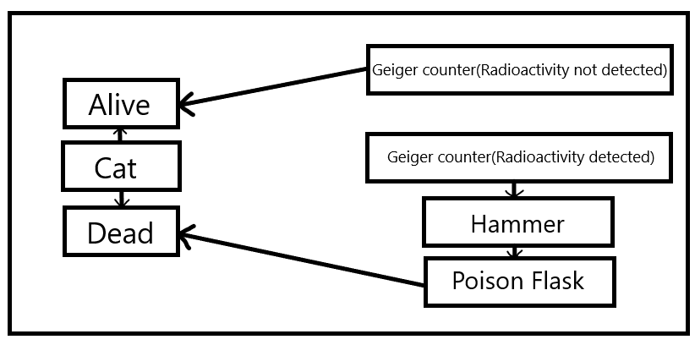

2- ) Appendix B

Similarity from Schrodinger cat experiment-

1-> Both uses principle of quantum superposition.

2-> Both have two states prior to measurement.

3-> Both uses measurement to conclude the result.

Dissimilarity from Schrodinger cat experiment-

1-> Analogy uses observable (measuring apparatus) to conclude the result rather than human observer.

2-> Measurement is taken by measuring apparatus and not by human, therefore role of consciousness is excluded.

3-> Measurement is done by unconscious observer.

**12- Figures-**

**12.1-Plain figures-**

1=Figure (2).a 2=Figure (3).a

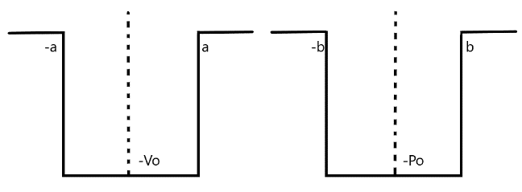 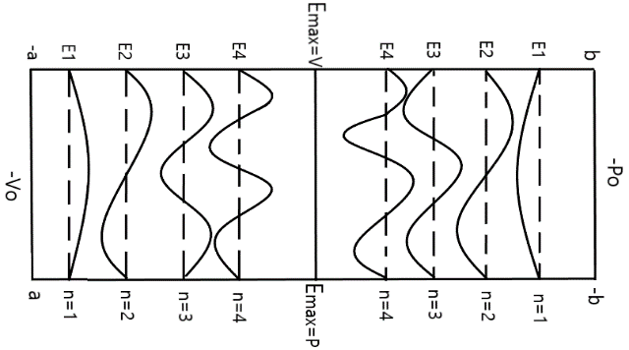

3=Figure (3).b 4=Figure (4).a

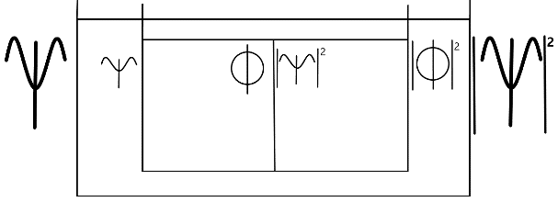 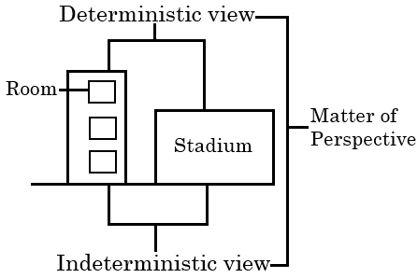

5=Figure (5).a 6=Figure (5).b

 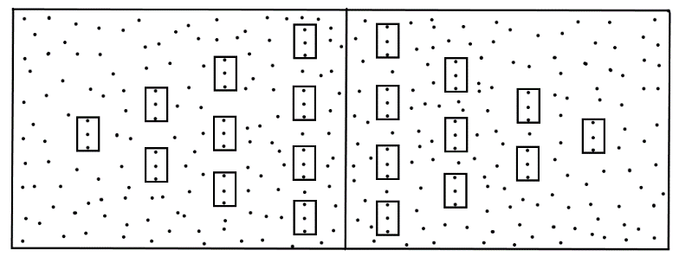

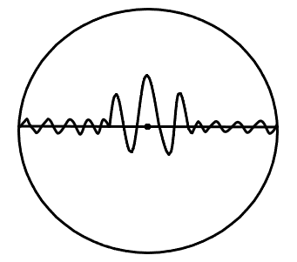7=Figure (5).c

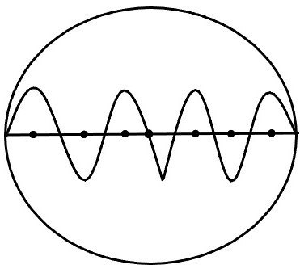

8=Figure (5).d 9=Figure (5).e

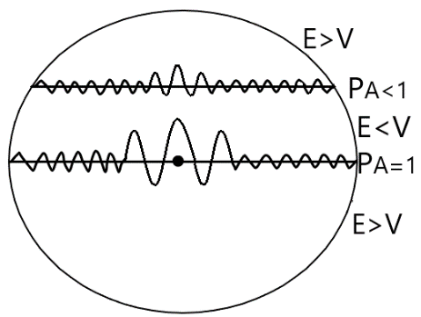 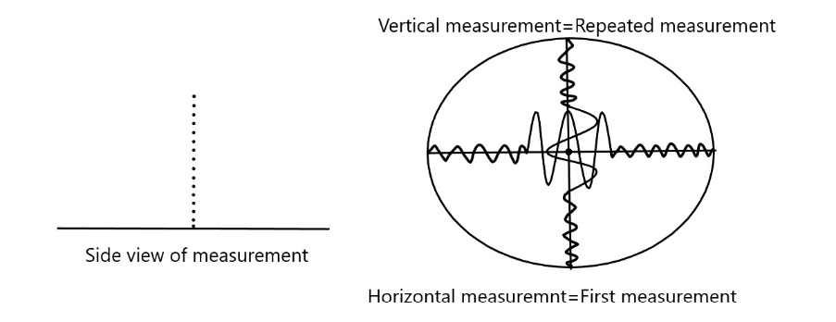

**12.2- Figure Captions-**

**Fig.1**= Finite potential well as two states.

**Fig.2**= Superposition of states as well.

**Fig.3**= Probability of finding a particle in either of the states.

**Fig.4**= Developed situation.

**Fig.5**= Football field diagram.

**Fig.6**= Measurement of field.

**Fig.7**= Measurement of wave or particle and position $(Δx)$-momentum $(Δp)$ uncertainty.

**Fig.8**= Measurement of quantum tunnelling.

**Fig.9**= Measurement of quantum zeno effect.