**NONLINEAR FINITE ELEMENT ANALYSIS OF A TENSION TESTED 3D PRINTED PLA SAMPLE**

**1Mohammed Alharbi, 2Ing Kong and 3V.I. Patel**

1,2 and3 Mechanical Engineering Department, La trobe University, Australia

Email:1 alharbi@qec.edu.sa and 2I.Kong@latrobe.edu.au

**Abstract:** In this study Finite Element Analysis (FEA) is used to simulate a uniaxial tension test for a 3D printed solid PLA specimen. This study deals with the aluminum material which assigned in the Solidworks. Solidworks enhances great capabilities of modeling or designing. It provides complete engineering environment where it has capabilities of testing the specimen with different standards and studies. Before performing the finite element analysis, there is need to assign the material as aluminum. So, in Solidworks FEA, it assigns the material where it appropriate and start the process of the FEA. After applying the finite element analysis, it shows tensile, flexural and impact of forces in applications. All the tests are carried out as per ASTM standard. The study compares between experimental results obtained by a published research and the simulation work. Stress-strain plot obtained by FEA is found very close to experimental results. The result shows the displacement and tensile strength. It also visualizes with the graphical representation. At the end, experimental results are very close to comparatively with the FEA simulated results. So, its great achievement of technology which is very useful for the future studies and experiments through CAD software.

**Keywords**: 3D Printing, Finite Element Analysis, SolidWorks Simulation, PLA, Validation.

1. **INTRODUCTION**

This study reveals which material is suitable or how we choose the material of a part or specimen? While every material has own importance based on its strength, weight, thickness, and cost. The basic selection of the materials dependents on the requirements of the user or customer. It’s very hard to select an accurate material before testing. At this stage, CAD software provides great advantages where it saves the time, and money while it provides accurate results. Such as Solidworks, Solidworks has great capabilities of modeling or designing along with several methods of testing such as part displacement, thermal analysis, frequency and linear analysis etc. So, in this study, there is need to focus on tensile testing. While, there are used several techniques to determine mechanical properties of a material. However, Solidworks provides engineering environment where aluminum material shows their properties. The material properties could modify accordingly which saves the time and money at the same time. The material could modify as per testing requirements. The common ones are, uniaxial compression test, plane strain compression test, compression test and mostly the and particularly uniaxial tensile test. Finite element Analysis is very useful to test the tensile strength of the material.

Materials behavior under tension loading is represented by stress-strain curves as shown in Figure 1. For a given material grade, the curve can be obtained by performing tensile testing as per relevant testing standards (ASTM, and ISO, etc.) [6]. The curve starts with a linear zone (i.e. elastic zone) where stress and strain both increases at the same ratio. The linear zone is distinguished by the ability of materials to return back to its original shape as long as stresses are kept within the linear zone boundaries. The linear zone is followed by a yielding zone, which is a starting point for the plastic zone, which is once reached, materials cannot return to its original shape on its own. The plastic zone continues till the ultimate tensile strength (UTS) point which is followed by fracture point.

Materials behavior under tension loading is represented by stress-strain curves as shown in Figure 1. For a given material grade, the curve can be obtained by performing tensile testing as per relevant testing standards (e.g. ASTM, DIN, ISO, etc.) [6]. The curve starts with a linear zone (i.e. elastic zone) where stress and strain both increases at the same ratio. The linear zone is distinguished by the ability of materials to return back to its original shape as long as stresses are kept within the linear zone boundaries. The linear zone is followed by a yielding zone, which is a starting point for the plastic zone, which is once reached, materials cannot return to its original shape on its own. The plastic zone continues till the ultimate tensile strength (UTS) point which is followed by fracture point as shown in Figure 1.

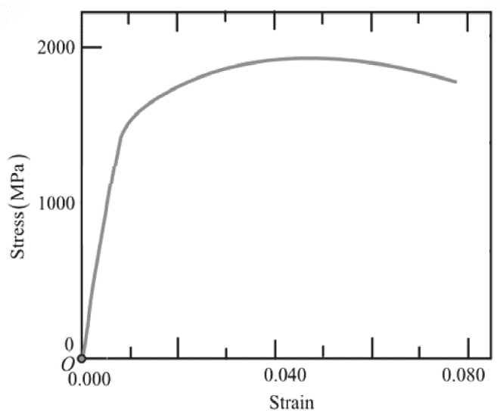

**Fig.1. Typical stress – strain curve**

1. **METHODOLOGY**

**2.1. Material Testing**

Published researches done by Daniel Farbman and Chris D. McCoy [2] is used as a reference for the experimental work. The study involved a tension testing for 3D printed PLA with 100% infill (i.e. solid) which is used for comparison and validation against Finite Element model results in section 2.2. Test specimens were 3D-printed with 100% infill as per the dimensions shown in Figure 2.

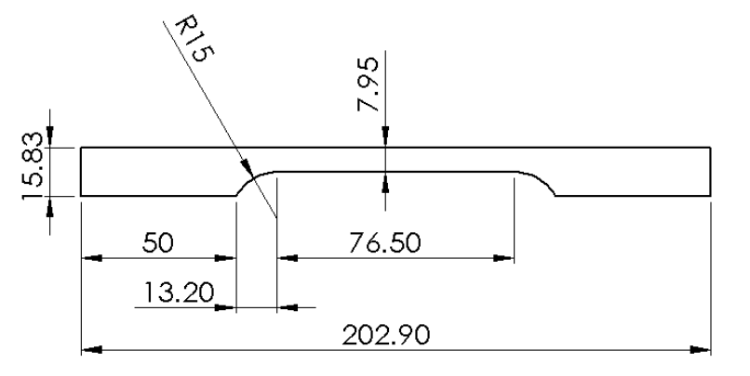

**Fig. 2. Tension test specimen dimensions**

Specimens where tested according to ASTM D638 at a crosshead velocity of 3 mm/min at maximum load of 4,303 N [2]. The stress-strain curve from the experimental work is shown in Figure 3.

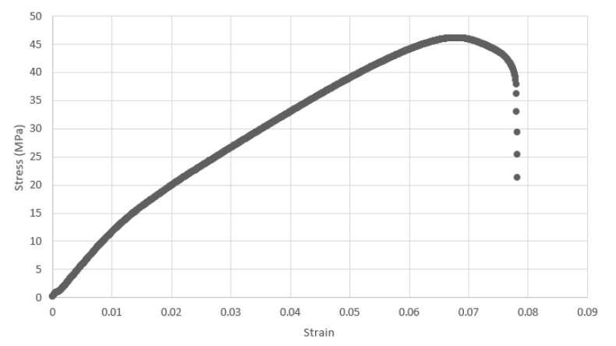

**Fig. 3. Experimental stress-strain curve [1]**

Based on the stress-strain curve, yield strength was evaluated using the 0.2% offset method. The main mechanical properties for the tested material can be summarized in Table 1.

|  |  |
| --- | --- |
| **Property** | **Value** |
| Density, ρ | 1,240 kg/m3 [2,3] |
| Elastic modulus, E | 973 MPa [2] |
| Poisson’s ratio, υ | 0.36 [4] |
| Yield strength | 15.7 MPa [2] |
| Ultimate tensile stress | 44.81 MPa [2] |

**Table 1 – Mechanical properties for PLA [2,3,4]**

**2.2. Finite Element Modeling**

3D model for the specimen is built according to match the tested specimen geometry shown in Figure 2. For simplification and reducing analysis processing time, a surface model was used. The model was set up to have the tension load applied to the specimen top and have the bottom section fixed. A meshed model showing the boundary conditions and mesh is assigned as standard high-quality mesh with maximum size of 2 mm, as shown in Figure 4, in order to ensure accurate results.

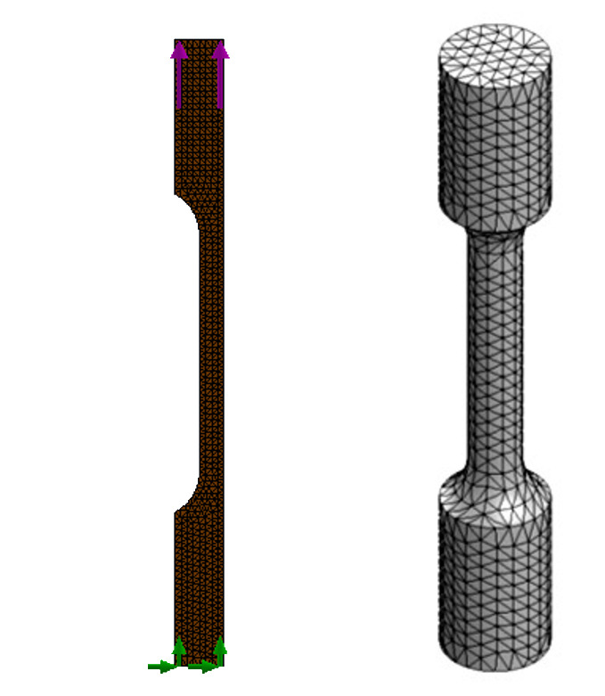

**Fig. 4. Meshed FE model showing**

A Von Mises plasticity material model is used to simulate the non-linear behavior of the specimen in the plastic region. Curve fitting for stress-strain curve, shown in Figure 3, was done using GetData Graph Digitizer [5] as shown in Figure 5. Stress-strain numerical values along with mechanical properties were fed into SolidWorks in order to define the plasticity material model.

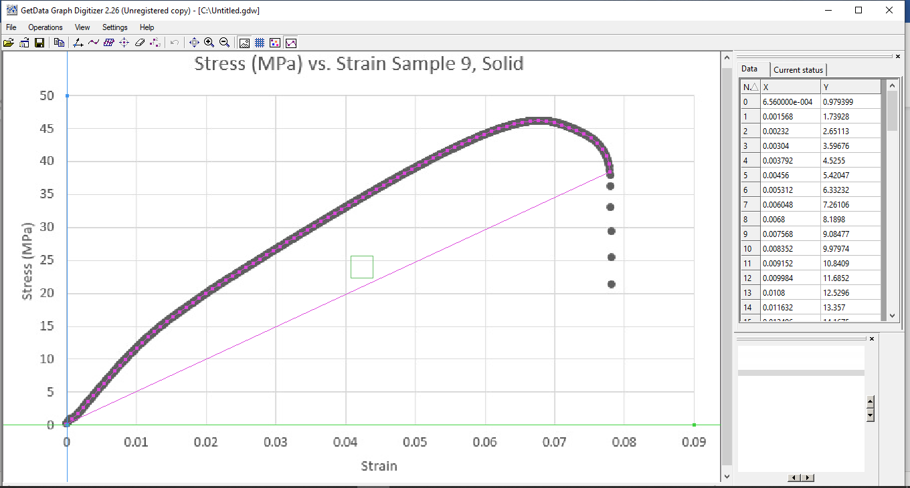

**Fig. 5. Curve fitting for experimental stress-strain curve using GetData [5]**

The study type used is nonlinear with the ability to simulate large strain models in order to simulate both linear and nonlinear behaviors of the material under the tension load.

1. **RESULTS AND DISCUSSION**

**3.1. Finite Element Model Results**

FE model analyzed the model to the point just before the failure. From the results, it can be observed that the model captured a realistic behavior for the specimen, where the maximum stress value is very close to the experimental ultimate tensile strength. It can also be noted that the maximum stress point is located at the specimen centerline within the necking zone as shown in Figure 6.

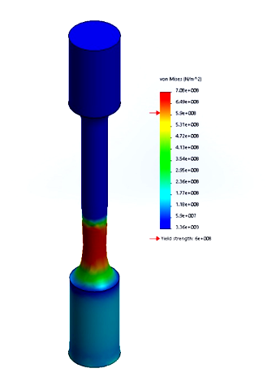

**Fig. 6. Von Mises stress plot**

The model shows that the maximum resultant displacement and strain are 2.227 mm and 1.615e-2 respectively as shown in Figures 7 and 8 which shows that the material is brittle.

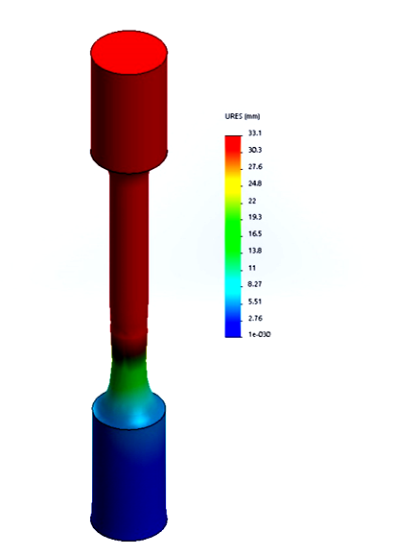

**Fig. 7. Resultant displacement plot**

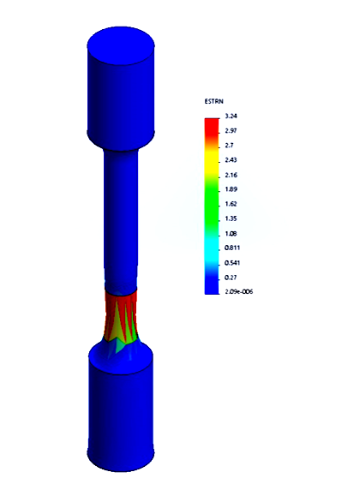

**Fig. 8. Strain plot**

**3.2. Experimental Work Validation**

On comparing Finite Element results against the experimental results, it can be noted that they are very close in terms of the material behavior where both stress-strain curves have the same trend and both yield and ultimate tensile strength points are very close to each other as shown in Figure 10.

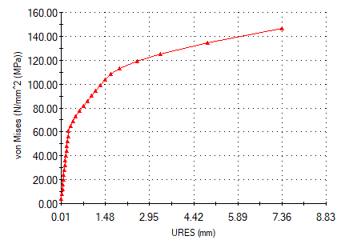

**Fig. 9. Finite Element Analysis stress-strain curve**

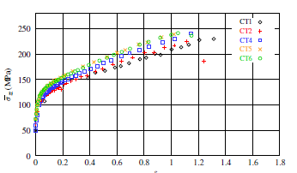

**Figure 10 – Experimental average stress - natural strain curve (CT4 in blue) [2]**

**Fig. 11. Finite Element Analysis stress-strain curve comparison with experiments data**

Errors for yield and ultimate tensile strengths from FE work against experimental work are computed as shown in Table 2.

|  |  |  |  |
| --- | --- | --- | --- |
| **Property** | **FE result** | **Experimental result** | **Error%** |
| Yield strength | 15.4 MPa | 15.7 MPa | -1.91% |
| Ultimate tensile stress | 49.3 MPa | 44.81 MPa | +10% |

**Table 2 – Comparison between FE and experimental results**

**CONCLUSIONS AND FUTURE WORK**

Finite Element could successfully capture the behavior of solid PLA specimen under uniaxial load tension where the experimental results were very close to the simulated results.

Recommended future work can include using a FE package that can use explicit dynamic in order to simulate the failure behavior and compare it to published experimental work.

**REFERENCES**

[[1] Stress–strain curve. Wikipedia. [Online] [Cited: December

29,2019].

https://en.wikipedia.org/wiki/Stress\%E2\

%80\%93strain\_curve.

[2] Daniel Farbman, Dr. Chris McCoy. Materials Testing of 3D Printed

ABS and PLA Samples to Guide Mechanical Design. Blacksburg,

Virginia, USA: ASME, 2016.

[3] SD3D. PLA Technical Datasheet. [Online] [Cited: December

29,2019].

https://www.sd3d.com/wp-content/uploads/

2017/06/MaterialTDS-PLA\_01.pdf.

[4] Jonathan Torres, Jos´e Cotelo, Justin Karl & Ali P. Gordon. Mechanical

Property Optimization of FDM PLA in Shear with Multiple

Objectives. 67, 2015, JOM, pp. 1183–1193.

[5] GetData Graph Digitizer. [Online] [Cited: December 29,2019].

http://getdata-graph-digitizer.com/index.

php.

[6] “What's AISI, ASTM, DIN, BS, ANSI, JIS, AFNOR AS and ASME Standards?” Otai Special Steel, 4 Dec. 2016, www.astmsteel.com/steel-knowledge/aisi-astm-din-bs-ansi-jis-afnor-as-asme-standards/.