***A COMPARITIVE ASSESSMENT OF BOND STREGTH OF PEEK CROWNS TO NATURAL TEEETH WITH TWO DIFFERENT RESIN CEMENTS***

**ABSTRACT:**

The purpose of this study was to evaluate tensile bond strength of PEEK (polyetheretherketone) a polycrystalline material with two self-adhesive cements (Rely X Unicem, G-CEM LinkAce). Teeth were prepared to receive copings with a chamfer bur at high speed cooled with an air/water spray and PEEK copings were fabricated and specimens required to debond the crowns was measured using universal testing machine. The data was analysed by paired t test. Despite the different bond values in cements, paired t test disclosed significant difference between groups in the mean amount of bond strength (p-value=0.04). Regarding the results of the study it was concluded that G-CEM LinkAce presented higher bond strength.

Keywords: G-CEM LinkAce, PEEK, RelyX Unicem, Tensile bond strength.

INTRODUCTION:

The popularity of all-ceramic restorations has increased in recent years due to their superior esthetic appearance, biocompatibility1 and metal free structure2. Some of the materials which have been used till date include alloys, ceramics, zirconia, and high performance polymers. All these, though excellent, have their advantages and disadvantages. Hence, the search has always been on for a better material. One such material, which has made its invasion into dentistry in the recent times is polyetheretherketone (PEEK). The success of full ceramic restorations in serving for a long time in the mouth depends on the success of bonding between the ceramic, adhesive agent and tooth structure. Although improved mechanical properties are important for the long-term performance of a ceramic material, the clinical success of fixed ceramic prostheses seems to be strongly dependent on the cementation procedure. It is a semi crystalline, high temperature resistant, thermoplastic polymer. The elasticity of material lies within the range of bone, so it resembles the most natural material. It is biocompatible and chemically stable to nearly all organic and inorganic chemicals3. Due to its excellent physical and biological properties, this composite material is used both in general medicine and in dentistry as implant, provisional abutment and implant supported bar or clamp material. PEEK is available in different types such as unfilled, carbon filled and glass filled.

Self-adhesive resin cements are dual cured resin cements which are designed to overcome limitations of both traditional and resin-based cements and simplify the bonding process.Self-adhesive cements simplify bonding procedures and most importantly shortening the “windows of contamination “and better adhesion can be achieved than with a contaminated total-etch cement4. Self-adhesive cements can bond to an untreated tooth surface that has not been micro abraded or pretreated with an etchant, primer, or bonding agent thus, cementation is accomplished in a single step.This study has been planned out with the aim of observing the bond strength of resin cements to PEEK.

MATERIALS AND METHODS

Thirty freshly extracted premolar teeth were selected for this study .Teeth were prepared according to standard protocol carried on with the diamond cutting burs by producing depth-orientation grooves on the buccal and occlusal surfaces, with a round-end tapered diamond as reference for removing tooth structure. A chamfer finish line of 0.7mm depth was prepared using round ended tapered bur.

*Fabrication of PEEK copings by CAD-CAM technique:*

Prepared tooth was sprayed with titanium dioxide and scanned. Using software, a three dimensional virtual image of the specimen was made. The PEEK blank was inserted in the work piece spindle and the door of the milling unit was closed .The milling procedure was completed and PEEK copings were fabricated and polished with 1 µm diamond paste, then alumina air balsting was done for 10 seconds with 2.8 bar pressure away from 10mm vertical distance using rocatec system to improve the bonding strength of PEEK with resin cements.

*Resin Bonded cements****:***

Specimens were divided into two groups 1 and 2 and bonding was done with two different resin cements. Group 1 were bonded with Rely X Unicem self adhesive universal resin cement. Rely X Unicem was available in automix syringe form, the working time was 2 minutes and the excess cement was removed in gel state with explorer and then the surfaces were cured for 20 seconds. Group 2 were bonded with G-CEM LinkAce this cement was available in double barrel automix syringe form, through which the cement was directly extruded into the restoration. The working time was 3 minutes 30 seconds by applying normal pressure, on restoration the surfaces were cured for 20 seconds.

Universal Testing Machine

The specimens were placed in the machine between the grips and a device extensometer was attached which was useful to measure tensile tests .The bonded specimens were placed on the table and held with clamp from top and below with upper and lower cross heads of the machine so that the bonded specimens base was parallel to the tensile force direction. Specimens were stressed in an occlusso-gingival direction at a crosshead speed of 1mm/min. A jig was attached to the load cell and pulled apart by an upper chain. The maximum load necessary to de-bond was recorded in Newton(N) and calculated in MPa as a ratio of Newton to the cylinder (the calculated bond strength was determined by dividing the strength at which bond failure occurred by the bonding area).

**RESULTS**

Statistical Analysis:Data was analyzed by Microsoft excel and graph pad prism software. Data was summarized by Mean ± SD for continuous data. The comparison between two groups was done by paired t test. All p-values less than 0.05 were considered as statistically significant.

Paired t test results

|  |  |  |  |  |  |
| --- | --- | --- | --- | --- | --- |
|  | |  | | | |
| Procedures | | N | | Mean | SD | P value | |
| Relyx | | 15 | | 5.42 | 0.91 | 0.004 | |
| g cem | | 15 | | 6.73 | 1.39 |
|  | |  | |  |  |  | |

There was significant difference in the mean tensile strength among two groups (p<0.004).Paired ‘t’ test showed that group B had significantly higher mean score than group A.

Graph 1: Graphical representation showing mean tensile bong strength values

*Graphical bar diagram representation depicting that G-CemLinkAce resin cement showeing higher tensile bond strength than Rely XUnicem resin cement*.

DISCUSSION:

In the present study PEEK copings were fabricated with CAD-CAM technique in which, three dimensional virtual image of the specimen was made. Tamrakar AK et al5 (2014) stated that the designing of the restoration is done using CAD software, which in turn sends commands to the CAM unit, for fabricating the restoration.

The PEEK surface requires treatment since it has low surface energy. Sandblasting is an efficient method for modifying the surface morphology of materials like metals and polymers. Ourahmoune et al6 (2014) studied how sandblasting altered surface morphology in several polymeric materials based on PEEK. The authors noted that sandblast-mediated alterations in surface morphology changed wettability and led to an apparent stabilization of roughness parameters after a certain surface treatment time.

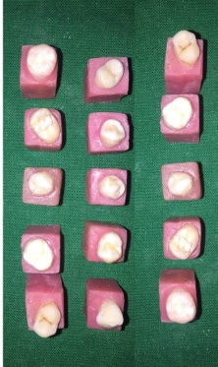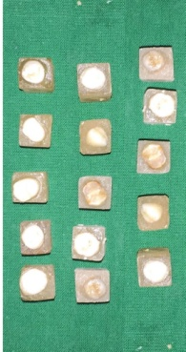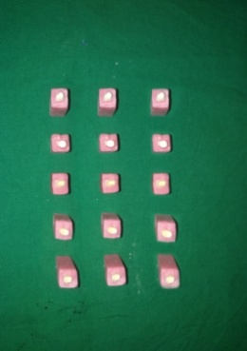

A B C D

Fig:A(Group 1 specimens);B(Group 2 specimens);C(Preperation of natural teeth);

D(Prepared tooth specimens)

They also observed that sandblasting resulted in higher levels of roughness in the fiber-reinforced materials than in the non-reinforced materials .

To achieve optimum retention and bond at the resin-substructure interface multiple mechanical and chemical methods for surface treatment are advocated. The surface of PEEK is very dense and plain, the structure is compact and there are no free chemical connections on the surface which makes it resistant to chemicals. Zhou L7 (2014) had stated that the incorporation of roughness with 50 microns alumina before surface conditioning is essential to maximize the surface area and increase the bond strength eventually. Therefore 50 microns alumina particles were selected and the PEEK surface was sandblasted as per manufacturer’s protocol. Kern8 (2009) had stated that the incorporation of roughness, is of advantage to achieve adequate bond strength. To minimize possible surface damage effects as a result of air abrasion at relative high pressures, air-abrasion at lower pressures appears to be an effective method for forming strong durable bonds. It had also been documented by Tetelman9 (2008) that sandblasting changes the surface morphology of PEEK and enhances the penetration of adhesive cements into composite material and subsequent micromechanical interlocking, resulting in higher bond strength .This is in accordance with the present

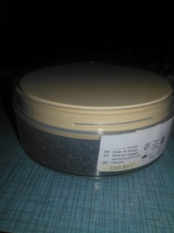

Fig E(PEEK Blank)

study where sandblasting aided in increased bond strength.

Previous studies compared the adhesion of resin cements to PEEK with and without surface treatment ,Hallmann L et al10 (2012),and Zhou L et al7 (2014) tested surface treatments commonly used in dental laboratories, such as sandblasting with alumina and silica coating (Rocatec). Sproesser O et al1 (2014) tested more experimental surface treatments for dental PEEK such as chemical attack with 98% sulfuric acid at different exposure times and Stawarczyk B et al12 (2014) tested cold active gas inert plasma treatment. The association between surface treatments and application of silane agents or adhesives was also tested. These studies concluded that surface treatment of PEEK is needed to obtain adhesion to resin cement. Nevertheless, no established protocol was developed for cementing single crowns or fixed dental prosthesis using a PEEK infrastructure. The manufacturer’s recommended cementation protocol is to produce roughness using diamond burs on the inner surface followed by acetone

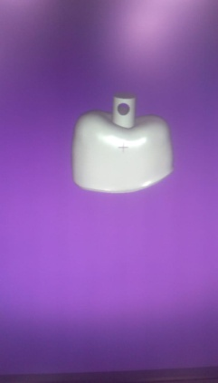

Fig F:(PEEK Coping)

Degreasing prior to luting system application; however, this protocol is difficult to standardize.

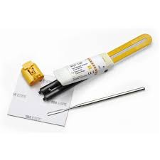 

Fig G:(Rely x Unicem) Fig H:(G-CEM LinkAce)

After fabrication of PEEK copings they were sand blasted and divided into two groups, Group 1 and Group 2. Where Group 1 copings were cemented with Rely X Unicem resin cement and Group2 copings were cemented with G-CEM Link-Ace resin cement. These are self-curing, transparent, two-paste adhesive resin cement. Equal amounts of resin cements were extruded, mixed for 20 seconds and applied to the intaglio surfaces of PEEK copings. Excess cement was removed using disposable mini brush .

Piwowarczyk A et al13 (2004) stated that the Self-adhesive dual-cured resin cements are relatively new category of resin luting agents whose organic matrix consists of multifunctional phosphoric-acid methacrylates. These phosphoric-acid groups condition the tooth surface and contribute to adhesion.

The use of Rely X Unicem in operative and prosthodontic applications without etching the enamel or dentin was evaluated by Bishara et al14 (2005). In a study by De Munck et al15 (2004) it has been reported that resin based adhesive luting materials were widely used for the fixation of inlays and onlays, crowns, bridges, posts and veneers. The first self-adhesive universal resin cement designed for universal application was Rely X Unicem. It is presented in capsules that can be used for adhesive cementation of indirect ceramic, composite and metal based restoration as well as crowns and bridges (3M ESPE Technical Product Profile 2002).

Sakalauskaite E et al16 (2008) had stated that the cementation technique is simple and have the potential to decrease postoperative sensitivity. Gerth HU et al17 (2006) concluded that the resin cements are able to bond to tissues without any previous applications, such as etching, priming, or bonding. Caughman WF et al18 (2001) stated that the dual-cured resin cements have two polymerizing mechanics, light polymerization and chemical polymerization that leads to extensive use of these cements in practice.

A universal testing machine (UTM) also known as universal tester, materials testing machine or materials test frame was used to test the tensile strength of resin cements in the present study. The bonded specimens were placed in UTM with a cross-head speed of 1mm/min. The acrylic resin blocks were held by a collet, allowing the whole system to self-align. Specimens were positioned in the jig with the specimens perpendicular to the loading direction .The jig was attached to the load cell and pulled apart by an upper

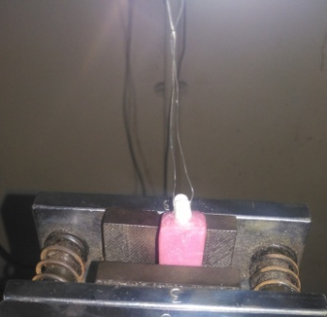 

Fig I:(Debonding of specimen) Fig J:(Universal Testing Mchine)

chain. The tensile bond strength was calculated.

In the present study the highest tensile bond strength value obtained for RelyX Unicem resin cement was 6.657MPa,whereas the lowest value was 3.946MPa.Highest tensile bond strength value obtained for G-CEM resin cement was 9.56MPa,whereas the lowest value was 4.5MPa,which was in accordance with the study conducted by Piwowarczyk et al13 (2007) where Rely X showed low bond strength 4.77MPa and G-CEM resin cement showed 6.6MPa this was because of increased chemical interaction of G-CEM with calcium from hydroxyapetite, which may explain the higher bond strength of this cement in this study compared to other resin cements, and the reason for reduced bond strength of Rely X was due to high level of fillers and high viscosity of the cement.

The mean for Rely X Unicem was 0.91MPa with standard deviation of 5.42MPa.The mean for G-Cem was 1.39MPa with standard deviation of 6.73MPa. In present study the bond strength values could be influenced by numerous parameters related to specimen design or test mechanics which cannot be standardized or might be because of heterogenecity in tooth structure and composition, sample preparation. Our findings indicate that resin cements helps in establishing a durable bond between the tooth and a sandblasted PEEK material. In accordance with study conducted by S.Hattar19 (2015) Rely X showed 3.70±6.81MPa and G-CEM showed 4.48±5.94MPa, this might be because light–cured cement exhibit a high viscosity and limited penetration. Moreover cements need to be applied with some pressure .

Unicem and G-CEM LinkAce to be 6.0 and 8.8 MPa respectively which is in conformity with our study. This implicates the fact that the value of the bond strength on its own does not always directly correlate to the strength of the material, but the bond strength and the surface area considered together provides a more accurate evaluation.

CONCLUSION:

Within the limitations of this in vitro study, following conclusions were drawn:G-CEM LinkAce resin cement had shown highest bond strength than RelyXUnicem resin cement.

REFERENCES:

1.Sproesor O, Schmidlin P R,UhrenbacherJ ,Roos M ,Gernet W ,Stawarczyk B .

Effect of sulfuric acid etching of polyetheretherketone on shear bond strength to resin cements . *J Adhes Dent2014 ; 16:465-72.*

2.Kitakayam S ,Toru N ,Rena M, Lei Z Masaomi I,Akihiko W,Richard M.Effect of an internal coating technique on tensile bond strength of resin cements toZirconia ceramics. *Dent Materials J .2009; 28(4):446-453*

3.Kurtz S M ,Devine J N ,PEEK biomaterials in trauma , orthopedic and spinal implants,*Biomaterials 2007 :28 ; 4845-4869*

4.Burgess JO, Ghuman G. A practical guideto the use of luting cements; a prereviewedpublication. Originally publishedas an insert to Dental Economics*, 2008.*

5.Tamrakar AK,Manu R,Rizwana M.CAD-CAM in prosthodontics-A futuristic overview *Annals of Dental Speciality Vol.2;1:2014.*

6.Ourahmoune R, Salvia M, Mathia TG, Berthel B, Fouvry S, Mesrati N. Effect of

sandblasting substrate treatment on single lap shear strength of adhesivelybonded

PEEK and its composites. *In18th international conference on compositematerials*

*2011(pp. 2-7).*

7.Zhou L, Qian Y, Zhu Y, Liu H, Gan K, Guo J. The effect of different surface

treatments on the bond strength of PEEK composite materials*. Dent Mater.*

*2014;30(8):e209-15.*

8. M. Kern, A. Barloi, and B. Yang. Surface Conditioning Influences Zirconia Ceramic Bonding *JDent Res 2009,88(9):817-822.*

9.Tetelman E D,Babbush C A.A new transitional abudments for immediate aesthetics and function*. Implant Dent 2008:17:51-58.*

10.Hallmann L, Mehl A, Sereno N, Hämmerle CHF. The improvement of adhesive

properties of PEEK through different pretreatments. *Appl Surf Sci 2012;258:7213-8*.

11.Stawarczyk B, Bähr N, Beuer F, Wimmer T, Eichberger M, Gernet W, Jahn D,

Schmidlin PR. Influence of plasma pretreatment on shear bond strength of self adhesive resin cements to polyetheretherketone. *Clin oral invest.2014;18(1):163-70.*

12.Piwowarczyk A,Lauer HC, Sorensen JA. In vitro shear bond strength of cementing agents to fixed prosthodontic restorative materials.*J Prosthet Dent 2004;92:265-273.*

13.Bishara SE,Oonsombat C, Soliman M M,Warren JJ,LaffoonJ AjlouniR.Comparision of bonding time and shear bond strength between a conventional and a new integrated bonding system*. Angle Orthod 2005,75(2):237-42*.

14.De Munck .J ,Vargas M,Van Landuyt .K,Hikitha .K.2004.Bonding of an auto adhesive luyting material to enamel and dentin*. Dent Mater.20,963-971.*

15. Saskalauskaite E, Tam L E, Mc Comb D.Flexural strength,elastic modulus,and Ph profile of self-etch resin luting cements .*J Prosthod*ont 2008;17:262-268.

16. Gerth HU, Dammaschke T,ZUCHNER H, Schafer E. Chemical analysis and bonding reaction of RelyX Unicem and Bifix composites-A comparative study.*Dent Mater 2006;22:934-731.*

17. Caughman WF, Daniel ME, Chan CN, et al. Curing potential of dual –polymerizable resin cements in simulated clinical situations.JProsthet Dent2001;85:479-484.

*18.* Susan Hattar ,Muhanad M,Hatamleh, Bond strength of self-adhesive resin

Cements to tooth structure .The Saudi Dental Journey 2015.