Formulation and evaluation of *calotropis gigantea* topical gel for antimicrobial and antifungal activity

Meena kurup1*, Dr. Pasupathi A, Fasna fazal2

1. Department of pharmaceutics, Vinayaka mission’s college of pharmacy, Vinayaka mission research foundation(deemed to be university), Salem, Tamilnadu.
2. Department of pharmaceutics, KVM College of pharmacy, cherthala

**ABSTRACT**: In pharmaceutical worlds, gel is the most convenient and patient friendly dosage form in the treatment of bacterial and fungal infection. The plants *calotropis gigantea* has been found to be used traditionally for its various therapeutic properties. In the present study a gel formulated by incorporating a herbal extract for its antimicrobial and antifungal activity.The gel where prepared using the concentrated Ethyl Acetate extract of dried leaf of *Calotropis gigantea*. The topical gel formulation where evaluated for its pH, appearance, homogenicity, viscosity spreadability and skin irritation studies. Antimicrobial studies performed by ditch plate method in in multiplication manner by using molar hinton Agar medium ignis a pathogenic bacterial strains is E coli. The antifungal activity of formulation were carried out by Gel diffusion method. The bacteria culture used were Candida albicans. Herbal gel where found 2 process compare table antimicrobial and antifungal effects so it can be used as a eco friendly dosage forms for the treatment of various microbial infections.

**Keywords:** *Calotropis gigantea,* antimicrobial and antifungal activity, topical gel.

**INTRODUCTION**

Traditional medicines play an important role in the health service around the world. A large number of Indian medicinal plants are attributed to various pharmacological activities, as they contain different classes of phytochemicals. There is a continuous need of development of newest active antimicrobial and antifungal drug, because of the emergence of new infectious diseases and drug resistance2. Most recently plants got a great attention of scientists for development of alternative drug to cure several lethal diseases. Plant selected for president works is *Calotropis gigantea*, which contain high percentage of phytochemicals that having antimicrobial and antifungal activity3. This is an attempt made to study the antimicrobial and antifungal activity of the extract and the extract in a formulation that is a topical gel. Gel formulations are used to deliver the drug topically because of easy application, increase in the contact time and minimum Side effects as compared to other topical preparations and oral administration1.

The plants *calotropis gigantea* has been found to be used traditionally for its various therapeutic properties like antibacterial, antidiarrheal, hepatoprotective, anthelmintics, antitumor, antihyperglycemic, anticonvulsant, sedatives, anti ulcer and antimalarial activity.

The growing popularity of natural and herbal medicinesis due to the easy availability of raw material, cost effectiveness and least number of reported adverse reactions prompted us to investigate and evaluate antimicrobial and antifungal potential of calotropis gigantea by incorporating into a topical gel and assessing its antimicrobial and antifungal activity.

**Experiment**

Collection of plant materials

*calotropis gigantea* leaves were collected from the local area of Ramamangalam in Ernakulam District, Kerala and identified by department of Botany, M G university, kottayam.

Extraction of calotropis gigantea leaves

The fresh *calotrpis gigantea*  leaves where collected from the plant and dried it by using hot air oven then it was extracted by migration method by using Ethyl Acetate as a solvent. The extraction mixtue as kept for 48 hours by providing intermittent shaking for 6 hours. After specified time it was filtered and the obtained extract was heated in a heating Mantle and evaporated by using a reflection condenser the solvent was recollected. After a short period of time the concentrated extract was removed from the heating Mantle and saved for preparation of topical gel3.

Chemical composition of calotropis gigantea gel

|  |  |
| --- | --- |
| **INGREDIENTS** | **QUANTITY TAKEN** |
| Carbopol -934 | 1.0 g |
| Hydroxy Propyl Methyl Cellulose  K4M ( HPMC ) | 1.0 g |
| Methyl Paraben | 1.5 ml |
| Propyl paraben | 0.5 ml |
| Triethanolamine | q.s |
| Purified water | 100 ml |
| Calotropis gigantea leaves extract (ml) | 5 g |

Formulation

Carbopol 934 and HPMC K 4M was weighed in required quantity and sufficient amount of distilled water where mixed in a separate beaker. After which it was continuously stirred by mechanical stirrer till the polymer is soaked in the water and kept at room temperature for 24 hours. Then mix the to polymer and add required quantity of methyl paraben and propyl paraben . Add small quantity of triethanolamine with continuous staring to achieve neutral Ph. Finally *calotropis gigantea* leaf extract was added to gel with continuous staring till drugs get dispersed completely.

EVALUATION OF FORMULATED TOPICAL GEL

1. COLOUR

Formulated topical gel was evaluated for its colour. Visually colour was checked.

1. ODOUR

Odour was found by smelling the product.

1. TASTE

Taste was checked manually by tasting the formulation.

1. SMOOTHNESS

The smoothness was tested by rubbing the gel formulation between the fingers.

1. CONSISTENCY

The consistency was checked by applying on skin.

1. GREASINESS

The greasiness was assessed by the application on to the skin

1. DETERMINATION OF pH

The pH of the formulation was determined by using digital pH meter.1.5 gm of gel was accurately weighed and dispersed in 15 ml of distilled water and stored for two hours. The measurement of pH of the formulation was carried out in triplicate and the average values are taken.

1. DETERMINATION OF EXTRUDABILITY

In this method, the formulated gel was filled in standard capped collapsible aluminium tube and Sealed with crimping to the end. The weights of the tubes were recorded. The tubes were placed between two glass slides and were clamped.500 g was placed over the slides and then cap was removed. The amount of the extruded gel was collected and weighed. The percent of the extruded gel was calculated.

1. DETERMINATION OF HOMOGENEITY

All the developed gels were tested for homogeneity by visual inspection after the gels have been set in the container. They were tested for appearance and presence of any aggregates.

1. DETERMINATION OF ANTIMICROBIAL ACTIVITY

The in-vitro anti-bacterial study of formulated topical gel was performed by ditch plate method in triplicate manner by using Muller Hinton Agar medium against a pathogenic Bacterial strain Escherichia coli .E coli was initially cultured in nutrient broth and incubated at 37 degree Celsius for 24 hr and then cultured cells were tend to multiply in the agar plates. A narrow ditch is made in the agar plate and the formulated topical gel were placed over the ditch and incubated at 37 degree Celsius for 24 hr. The diameter of zone of inhibition (ZOI) was measured in millimetres (mm).

1. DETERMINATION OF ANTIFUNGAL ACTIVITY:

The antifungal activity of all developed batches of formulation were carried out by Gel  
diffusion method. The bacteria culture used were *Candida albicans*. The antifungal test  
was performed using the agar well diffusion. The nutrient media was prepared. The zone  
of inhibition developed, if any, was then measured for the particular compound with each  
fungal strength.The nutrient media was Sabouraud dextrose agar. Preparation of culture mediaWere Candida Albicans. The antifungal test as performed using the agar well diffusion. The nutrient media was prepared. The zone of inhibition developed, if any, was then measured for the particular compound with each fungal strength. The nutrient media was Sabouraud dextrose agar.

Procedure for anti-fungal study:  
Inoculate 5ml of culture into prepared culture media aseptically and poured into sterile petri  
plates and kept for cooling. Then drill holes 4mm deep. Then 0.5gm of gel were added into the holes. Control experiments were carried out under similar condition by using griseofulvin for antifungal activity as standard drugs . Plates were then incubated at 35°C for 24hr. The zone of inhibition was measured in millimeter.

RESULTS AND DISCUSSION

The herbal topical gel was formulated from the *Calotropis gigantea* leaves extract natural ingredient and small amount of synthetic agents. By trial process, formulations were prepared to achieve extrudability , homogeneity etc. The formulated herbal topical gel was dark green in colour and showed the good homogeneity with absence of lumps.

1. PHYSICAL EXAMINATION

|  |  |  |
| --- | --- | --- |
| SL NO | PARAMETERS | OBSERVATIONS |
| 1 | Colour | Dark green colour |
| 2 | Odour | Characteristic |
| 3 | Taste | Bitter |
| 4 | Smoothness | Smooth |
| 5 | Consistency | Gel Consistency |

1. DETERMINATION OF pH

The pH of the formulation was found to be 6.91.

1. EXTRUDABILITY

|  |  |
| --- | --- |
| Net weight of formulation on tube (g) | 10.96 g |
| Weight of topical gel extruded (g) | 8.24 g |
| Extrudability amount percentage | 75.18 |

1. HOMOGENICITY

Homogenicity of the preparation was found to be good.

1. ANTIMICROBIAL ACTIVITY

The formulated herbal Calotropis gigantea topical gel exhibited fairly good anti-E coli activity as compared to the standard drug Erythromycin. The formulation exhibited an impressive ZOI of 2.6 cm when taken 10 microgram/ml of formulation, whereas Erythromycin exhibited 3 cm of ZOI, when taken 10 microgram/ml of it. Therefore it may be concluded that formulated herbal topical gel have potential to exhibit antimicrobial activity.

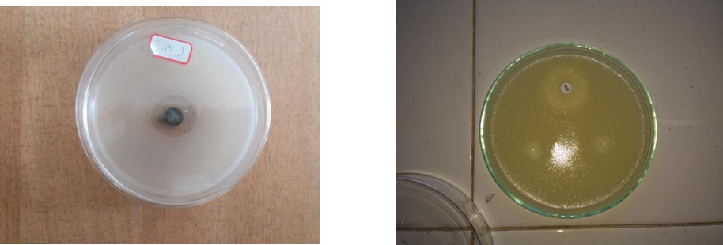

1. ANTIFUNGAL ACTIVITY

|  |  |
| --- | --- |
| Formulation | Antifungal activity |
| Topical gel | 20mm |
| Standard drug(Grisiofulvin) | 18mm |

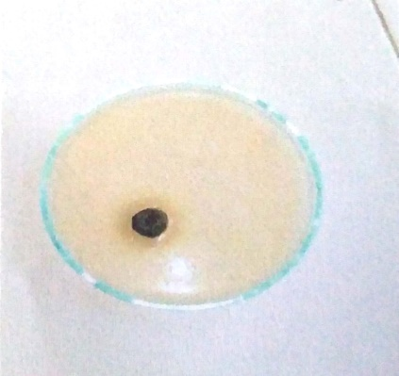 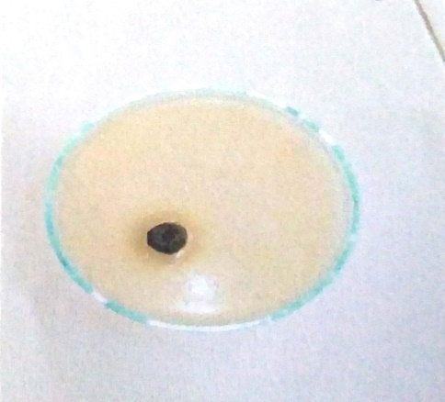

CONCLUSION

This research work was carried out to develop a new topical herbal gel formulation for topical applicaton .The prepared herbal gel was further evaluated for pH , extrudability, antimicrobial activityand antifungal activity. This herbal gel is safe with minimum side effects. The formulated herbal gel is capable of producing anti microbial activity against E-coli and antifungal activity against *Candida Albicans*.

REFERENCE

1. www.Pharma tips.in : Pharmaceutical Gels –Introduction

2. Ahmed, K.K.M , Rana, A.C & Dixit ,V.K. Calotropis species – a comprehensive review. Pharmacognosy Magazine.2016; 1(2): 48-52

3. Rathod , Nanu R, Raghuveer, Chandra, Ramesh . Hypoglycemic Effect of Calotropis gigantea Linn. Leaves and Flowers in Streptozotocin –Induced Diabetic rates. Oman Medical journal. 2011;26(2): 104-108

4. Ankitha V. Paliwal, Manjusha Dole. Formulation and Evaluation of Herbal gel containing extract of Calotropis gigantea leaves. International Journal of Science and Research.2016; 7(5):139

5. Rajasekaran Aiyalu , Arulkumaran Govindarjan, Arivukkarasu Ramasamy. Formulation and Evaluation of topical herbal gel for the treatment of arthritis in animal model. Brazilian Journal of Pharmaceutical Sciences.2016; 52(3): 493-496.

6. Shaveta Sharma , Shweta Pawar, Upendra K. Jain. Development And Evaluation of Topical gel of Curcumin from Different combination of Polymers & Evaluation of Herbal gel. International Journal of Pharmacy and Pharmaceutical Science.2012;4(4):452-456

.7. Muadhamm, Saeedi, K. Morteza –Semnani. The treatment of atopic dermatitis with licorice gel. Journal of Dermatological Treatment.2003;14(3):153-157

8. Divya Jyothi , Marina Koland. Formulation and Evaluation of an Herbal anti-inflammatory gel containing Trigonella Foenum Greacum Seed extract. International Journal of Pharmacy and Pharmaceutical Sciences.2016;8(1):41-44ournal of Pharmacy Research.2010;3(3):539-542.

9. Mohammed Haneefa KP, Shahima Hanan K , Guru Prasad Mohanta .Formulation and Evaluation of herbal gel of Pothos scandens. Asian Pacific Journal of Tropical Medicine.2010;6(4):988-992

10. Deepak P.Pawar, Prashant B. Shamkuwar. Formulation and Evaluation of herbal gel containing Lantana camara leaves extract.Asian Journal of Pharmaceutical and Clinical Research.2013;6(3):122-124

11. Goutham Pramanik, Sudipta Das, Pallab K.Haldar. Formulation and Evaluation of Herbal gel containing Clerodendron infortunatum leaves extract. International Journal of Pharm Tech Research.2011;3(1):140-143

12. Gaurav Kumar , Loganathan Karthik. In vitro anti- Candida activity of Calotropis gigantea. Journal of Pharmacy Research.2010;3(3):539-542.

13. Gaurav Kumar, Loganathan Karthik. Anti bacterial activity of aqueous extract of Calotropis gigantea leaves – An in vitro study. Journal of Pharmacy Research.2010;4(2):141-144 reatment.2003;14(3):153-157

14. R.Bhramaramba ,Sudheer Babu. Formulation and Evaluation of Herbal gel containing Terminalia chebula leaves extract. Scholars Academic Journal of Pharmacy.2015;4(3):172-176