**Utilization of EDPuzzle, an interactive tool in teaching practices**

**Abstract:** Implementation of a communicative, student-centered learning environment can be an important tool in teaching practices. However, as limited research supports the incorporation of flipped learning by using an interactive tool like EDPuzzle, the current study, therefore, conducted the survey on 20 students for a Civil Engineering, structural based problematic module. Further, it implemented a qualitative as well as quantitative methodology. In-class and out-class activities were undertaken to keep the students engaged and assess student performance. Enhancing the students' mathematical and analytical skills was then evaluated by the researcher. A survey was conducted using survey monkey, and it contained close-ended questions. When assessed the group from Fall 2018 before implementing the EDPuzzle to Spring 2018, after implementation, the results showed an increased percentage of exam clearance from 85.11% to 97.06%. Finally, teachers can be suggested to use a flipped classroom model to enhance classroom engagement. Moreover, since technology is constantly changing, the interactive tool, EDPuzzle will furnish an idea to the teachers about the incorporation and use of this technology.

**Keywords:** *EDPuzzle, student engagement, out-class activities, coursework assessments, in-class activities, out-class activities.*

**Introduction:**

An enhanced attentiveness to improve the learning capacity of students by the integration of the digital tools in the curriculum have been observed in the past few years (Baker, 2016). Inclusion of such tools thus adds a dynamic to the traditional way of Teaching and creates enhanced learning spaces (Alvarado, Coelho, & Dougherty, 2016). This paper will, therefore, focus on how these interactive tools address and support learning.

One such assessment tool that the researcher has chosen to study in the present paper is EDpuzzle. It allows instructors to either upload a video from their computer or use a video hosting website to find a public video (Monk & Silmon, 2013). EDpuzzle contains a video editing process that takes the instructors through various steps, from adding audio that can completely replace the original sound, to cropping the video according to own requirements. EDPuzzle also aids in adding audio notes, by keeping the original audio track intact, and also aids in adding instructor comments or assessment questions, either open-ended or multiple choice at the end or intermittently (Fayombo, 2012, Kolas, 2015).

As put forth by Umass (2019), different types of learning can take place through EDpuzzle. They are listed as Behaviorism, Social Constructivism, Teaching with Technology, Connectivism, and Cognitive Constructivism. The key features of EDPuzzle, as identified by Baker (2016) includes:

* Cost: It is free of charge
* Availability: The platform gets available to the instructors as they log in with an EDpuzzle, Google or Edmodo account. Also, guests can access without any necessary login.
* Accessibility: Video editors cannot add transcripts or captioning to the videos as closed captioning is enabled for videos that have that let on the video-sharing site.
* Analytics: The teachers can check and respond to the student’s assessment results in EDpuzzle. The student’s progress bars can also be viewed along with the video sections that were watched and the number of times each section of a video was watched.

Other features except these include feedback, grading the quizzes, cropping videos, and adding voice in the videos. Another feature of EDpuzzle is the probability of embedding quizzes in sites such as Blackboard or Moodle or the possibility of assigning it to individual students or specific classes (Mischel, 2018). The platform can monitor the data provided on how each student performs. Once students create their EdPuzzle student account, the possibility of flipping the classroom increases as they can easily access any video assigned to them in their classroom or at home. If, while watching the videos, the students open new tabs in the same window, EDpuzzle videos will stop automatically. However, when a new window is opened, the videos will not stop (Mu & Paparas, 2016). Since the videos are public, the instructors can use or modify anyone else’s EDpuzzle videos (Aydın & Demirer, 2016).

This study, therefore, aims to evaluate the use of EDpuzzle (Interactive Video tool) by adopting it in in-class and out-class activities as well as coursework assessments by engaging students effectively and enhance their performance as a part of an educational strategy to develop their attributes at Middle East College (MEC). The results from the feedback given by students and faculty indicated that EDpuzzle enhanced student’s problem-solving skills, interaction skills and boosted their confidence.

**Methodology:**

According to Shuell (1990), one of the fundamental tasks of the teachers involves engaging students in learning activities so that students effectively achieve the desired outcomes. Previous semesters were more of transferring the information to the students (filling the empty passive vessels with knowledge) by copying the solved problems from the whiteboard. Hence, engaging and making students understand mathematical and analytical concepts became an area of significant concern.

The present research was carried out in the Middle East College, Oman in the spring of the year 2018. The research work was analyzed carrying out both qualitative and quantitative data like feedback from both students and teachers, end semester performance, in-class and out-class activities, and so on. Survey Monkey was used to analyze and receive feedback from the participants. The current study undertook 20 students for the analysis and through in-class and out-class activities, assessed the efficacy of the EDPuzzle. For the out-class activities, the researcher developed 20 lecture-based interactive videos in MEC multimedia laboratory for active and innovative classroom sessions. In-class activities were conducted with the help of popsicle sticks, cardboard, and paper activities in groups. The students were asked to solve the question by joining the EDPuzzle classroom group code. EDPuzzle was used to monitor the progress, assess and grade the students’ performance.

**Modeling and Analysis:**

The main aim of this research is to enhance the student learning experience and also Student engagement in and out of the class using e-tools. One of the goals of MEC institutional strategy on which the current research is mainly focused on is the skills that enable the students to guide one another towards a goal. The in-class activities were conducted by using the following model.

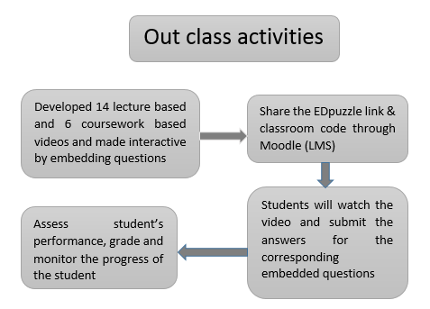

Figure 1:-Out Class Activities

Similarly, the in-class activities used the following model.

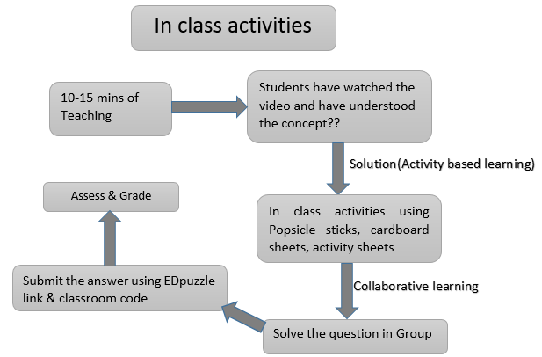

Figure 2:-In Class Activities

The feedback of students was recorded after conducting the activities. One of the students asserted, “Use these type of videos for all modules”. Another student said, “Thanks, helped me to interpret and think in completing my coursework”. Another student was helped due to regular feedback; the student stated, “Regular feedback given helped me". Another student provided brief feedback saying, "I liked the way in which you made interactive videos, also there were supporting videos related to concept especially from youtube and Khan's academy which helped us to search more videos from it and understand the concept".

**Result and Discussion.**

Similarly, peer feedback was also taken from 12 individuals for the analysis of the study. A five-point Likert scale was used for qualitative analysis of the results. Two-course works were used to compare and analysis of the research.

Figure 6

Figure 5

Figure 4

Figure 3

Average coursework marks were also observed to be increased the student participation and understanding of the concepts. When students were asked if Edpuzzle could be used in most of the Modules, 67% of the students' strongly agreed' to it, 22% 'agreed' on it, whereas 11% asserted that they 'neither agree nor disagree' as shown in Figure 3... When asked if the students were satisfied with the reliability of this teaching method, 45% and 44% marked 'Strongly agree' and 'agree' respectively. The remaining 11% opted for 'disagree ‘shown in Figure 4. When students were asked for the efficacy of the feedback, 56% marked 'agree', 22% opted for 'strongly agree' whereas 22% chose 'neither agree nor disagree ‘as shown in Figure 5. Lastly, when asked if EDPuzzle is good to understand mathematical and analytical skills and keeps you engaging, 56% 'strongly agree', 33% marked 'agree', and 11% opted for 'disagree' as shown in Figure 6.

Increase in student participation and understanding the concepts

Figure 7

The analysis showed that average marks scored in coursework-2 have increased by almost 13.32% as compared to coursework-1 as shown in Figure 7. Also, the practice was started in Fall 2018, and when compared to the results of the same study from Spring 2018, the pass percentage has increased from 85.11% to 97.06%.

**Conclusion and recommendation:**

Several feedback was received from the student's survey and from the faculties. Survey results have been analyzed, which has shown a positive impact on the use of EDPuzzle in teaching practices. Implementation of EDPuzzle in and outside the class enhanced student’s engagement in active learning and increased their performance (Fayombo, 2012) in terms of mathematical, analytical and cognitive thinking skills (Littlefield, 2018) as evident from the results. It has also been found that the platform of EDpuzzle allows teachers to shape their lessons around the video content, give them the ability to pull videos from various sources, embed quizzes, and assess students’ performance. Enhancing the learning environment can thus be done by utilizing this tool in different modules with LMS or MEC Moodle. In the future, hands-on training or workshop will be conducted with peers and can be used in future allotted modules/research activities.

**References:**

1. Mazur, E. (2007) Derek Bok Center Series on College Teaching. 1, From Questions to Concepts: Interactive Teaching in Physics. Derek Bok Center for Teaching Learning, Production Company [online]available from< https://harvardmagazine.com/2012/03/twilight-of-the-lecture> [18 May 2019]
2. Kolås, L. (2015). Application of interactive videos in education. In 2015 International Conference on Information Technology Based Higher Education and Training (ITHET) (pp. 1-6). IEEE.
3. Mu, H., & Paparas, D. (2016). Ready for the flipped classroom? Preliminary experiences of the new approach in teaching economics to non-major students. Applied Economics and Finance, 3(2), 45-53.
4. Aydın, B., & Demirer, V. (2016). Flipping the drawbacks of the flipped classroom: effective tools and recommendations. Journal of Educational and Instructional Studies In The World, 6(1), 33-40.
5. Baker, A. (2016). Active Learning with Interactive Videos: Creating Student-Guided Learning Materials. Journal of Library & Information Services in Distance Learning, 10(3-4), 79–87.
6. Alvarado, N. C., Coelho, D., & Dougherty, E. (2016). Mobile apps for ELLs: Supporting language learning with engaging digital tools. Argentinian Journal of Applied Linguistics, 4(1), 43-58.
7. Fayombo, G. (2012) 'Active learning: Creating excitement and enhancing learning in a changing environment of the 21st century’. Mediterranean Journal of Social Sciences. 3(16), 107 – 128.
8. Monk, J., and Silman, C. (2013) Active Learning in Primary Classrooms: A Case Study Approach.New York: Routledge.
9. Littlefield, A. (2018) 'Increasing Cognitive thinking Skills with Edpuzzle'. Nurse Educator 44(2), 78.
10. Mischel, L. J. (2018) 'Watch and Learn? Using EDpuzzle to Enhance the Use of Online Videos'. Management of Teaching Review
11. Shuell, T. J. (1990) 'Phases of Meaningful Learning'. Review of Educational Research 60(4), 531–547.
12. Umass (2019) Online tools for teaching and learning[online] available from <https://blogs.umass.edu/onlinetools/assessment-centered-tools/edpuzzle>[ 18 May 2019]