**MINIMIZING SURFACE ROUGHNESS IN MILLING OF GFRP USING OPTIMIZATION TECHNIQUE**

**Abstract**

Fibre Reinforced Plastic (FRP), an advanced polymeric matrix composite material, is extensively utilized in a collection of applications that includes robots, machine tools as well as aircraft. Machining of Glass Fibre Reinforced Plastic (GFRP) composite is a significant action in the combination of these advanced resources into engineering application. Because of Machining damage, disproportionate cutting parameter may outcome in rejection of the complex parts in the final stage of their manufacturing cycle. An indicator of surface quality is Surface roughness is one among the main customer necessities for machined components. This study applied modeling and simulation techniques to formative the solution of the optimum cutting situations to attain the minimum surface roughness while ending milling GFRP. Examine a pair of experimental machining information; the mathematical model is made by using Response Surface Methodology (RSM). The best model has been acknowledged to prepare the simulated annealing (SA) of the fitness function. Subsequently, it had been found that through utilizing simulated annealing, the minimum surface roughness can be obtained.

**Keywords:** Glass Fibre Reinforced Plastic (GFRP); Surface Roughness; Mathematical Model;

End Milling; Simulated Annealing (SA).

**1 INTRODUCTION**

Glass fibre reinforced plastic (GFRP) combination are very commonly utilized in marine industries, automobile as well as aerospace due to their prospective qualities including “a high strength to weight ratio”, along with a high exact “stiffness. The machining of GFRP has” required producing near to shape dimension. “The machining of a” combined differs from the traditional “machining of metals” because of the combination of non-homogeneous as well as anisotropic nature. Between numerous industrial machining processes, milling may be an essential machining procedure. The commonest metal removal procedure would be End milling that comes across. It is commonly utilized in the spread of producing industries comprising the automotive sectors as well as aerospace, where quality is a crucial think about the assembly of slots as well as dies. The surface qualities are significant in milling as they considerably improve corrosion resistance, fatigue strength as well as creep life. Surface roughness additionally impacts many useful characteristics of components, like heat transmission, wearing along with the skill of having a resisting fatigue, lubricant or coating. Thus, the specified surface end is typically specified and therefore the suitable procedures are preferred to succeed in the specified quality. The ultimate surface roughness in ending milling operation is influenced by several factors influence. [1, 2].

Surface roughness is quality which can pressure the dimensional precision, the functionality of production cost as well as the mechanical pieces. For these causes, there was lots of development along with research through the goals of optimizing reducing circumstances to attain “a determined surface roughness”. [3, 4]

Due to “the inhomogeneous nature of composite materials, the response” of theirs “to machining” might engage “undesirable consequences” like fibre pullout, surface burning, as well as rapid tool wear, with delamination, pitting as well as smearing. Every “of these responses are” exclusively associated to the cutting equipment force utilized for the work portion edge [5, 6]

Several optimization procedures that could be categorized as conventional as well as “non-conventional (soft computing)”, can be efficiently utilized “to optimize the cutting conditions” which influence the value of “surface roughness” (Ra). Researchers mainly used RSM between the traditional optimization procedures. [7]

In manufacturing industries, the optimal machining variables are of the vast problem in which the economic system of “machining operations plays a” vital role within “the competitive market”. The optimizations of machining parameters have been addressed by several researchers. The RSM could also be a dynamic as well as foremost essential “tool of Design of Experiment (DOE) where” within the connection among input decision variables along with its process output(s), it's mapped to attain the goal of minimization or maximization of the output attributes using RSM.[8, 9]

Previous researchers used several of the recognized soft computing methods in machining applications are ant colony optimization (ACO), “genetic algorithm (GA), tabu search (TS), and particle swarm optimization (PSO)”. Among the options in utilizing soft computing which “is the application of SA in estimating the” best cutting parameters, especially for the Ra value in ending of the milling process. [10-12]

In the end milling process, the utilization of a “genetic algorithm for the optimization of” reducing circumstances to forecast surface roughness has been extremely restricted [13]. The integrated genetic programming, as well as genetic algorithm approach, had been presented to forecast “surface roughness based on cutting parameters” (spindle speed, depth of cut as well as feed rate) additionally, on vibrations among the workpiece as well as cutting tool [14]. “For the cutting conditions of feed rate, axial depth of cut”, along with cutting speed, GA has been utilized to expect surface roughness (Ra) “value that is lower than the values of experimental” outcomes [15]. The selection of parameters is of great concern from an economical point of view. The optimization of machining parameters has been addressed by various researchers. The RSM could also be a dynamic as well as primary essential equipment of the Design of Experiment (DOE) where within the connection among input decision variables as well as its process output(s), it's mapped to get the goal of minimization or maximization of the output qualities. RSM was effectively used for optimization as well as the prediction of cutting parameters [16, 17]. Several recognized soft computing methods used by earlier researchers in machining applications are particle swarm optimization (PSO), “tabu search (TS), genetic algorithm (GA), and ant colony optimization (ACO)”. Among the options in utilizing “, soft computing is the application of SA in estimating the best cutting parameters”, especially for the Ra value in end milling process [18]. SA was utilized to enhance “the cutting parameters for multi-pass milling” procedure [19]. Best “cutting parameters for minimizing” manufacture price “on the rough machining of high-speed milling” (HSM) SKD61 tool steels operation based on polynomial network was studied [20]. SA had also been recognized in the optimization of machining conditions for lowest surface roughness [21] and wire electrical discharge machining has also been widely utilized in the machining of conductive materials [22,23]. Deepak and Davim [24] experimented with graphite laced GFRP. They analyzed the process parameter during machining with Abrasive jet machining. Grey relation was used as an optimisation technique to find the influence of process parameters. They found feed rates to be more influential.

Abeer[25] studied the prediction of surface roughness using RSM as well as ANN in milling of GFRP. They found cutting speed and feed to be more influential. The deviation between experimental and tool were within the appreciable level. Shankar et al [26] in milling of mild steel using the technique of taguchi coupled with grey relation. They analyzed the result of process parameters on surface roughness as well as tool wear. From the result they found the speed to be most influential and the tool is effective in the evaluation of machining parameters. Ashish [27] carried out a research on the optimization for surface roughness in CNC end milling of aluminum. From the experiment and analysis, they found the speed to be an important factor and Taguchi as a tool of optimization. Ritesh et al [28] studied the optimization of HSS drill for marine applications using Topsis approach. From the experimental results using Minitab found the deviation in value to be less than 6%.Kawin et al [29] conducted turning experiment on bagase ash reinforced aluminium composite. From the result it was found that Taguchi tool was efficient in optimising parameter for surface roughness.

Although, the different abilities of “SA, its application in optimization of cutting conditions for several machining performances” have been provided a less interest through researchers. In this work, simulated annealing is used because it usually exhibits easy implementation as well as fast convergence. Consequently, it had been discovered which by utilizing simulated annealing, the minimum surface roughness can be obtained.

**2** **Experimental Details and Measurements**

**2.1** **Materials and experimental setup**

The Table 1,2 and 3 below shows the chemical, composition and dimensional specification of the specimen for conducting the experiment.

**Table 1** Chemical Composition of Specimen

|  |  |
| --- | --- |
| Fibre Type | Glass Fibre (E-Glass) |
| Fibre Forms | Chopped Strand |
| Fibre direction | Unidirectional |
| Matrix Material | Polyester Material (Polylite® 41660-02**Reichhold** ) |
| Filler Material | Calcium Carbide |
| Manufacturing Process | Sheet Molding Compound (SMC) and Compression Molding |

**Table 2** Percentage of Compositions

|  |  |
| --- | --- |
| Glass fibre | 25 % |
| Matrix material | 45% |
| Filler material | 30 % |

**Table 3** Dimension of the Specimen

|  |  |
| --- | --- |
| Length | 510mm |
| Breadth | 250mm |
| Thickness | 10mm |

Basically for sheet molding compound method chopped strand was used. This gives the required properties for the composite material. The roving’s which had been cut or chopped into short lengths of between 4 as well as 50 mm are called chopped strand. The fibers are combined with fillers and resin for compression molding. Fibre lengths below 4 mm are available for ‘milling’ will provide the adequate properties in regard of milling. The sheet molding processes are shown in Figure 1.The chemical composition are demostrasted in table 1. The specimen plate was fabricated by unidirectional fiber and the angle of inclination of the fibre was 00 as shown in table 2..The percentage of composition are shown in table 3. Titanium Nitride (TiNamite) and Aluminium Titanium Nitride (TiNamite A) coated K10 end mill having four flute each with Square Ends were selected based on previous results. The two being coated tools are shown in Figure 2. The milling operation has been conducted utilizing a common Milling machine with a longitudinal feed of 18 mm/min, spindle speed of 45-1400 rpm, along with “cross feed range of 16-800 mm/min. The” range of feed was 6.3-315 m/min in vertical direction as well as work area was of 300 X 1000 mm dimension. Vibration and also displacement were eliminated through fixation.

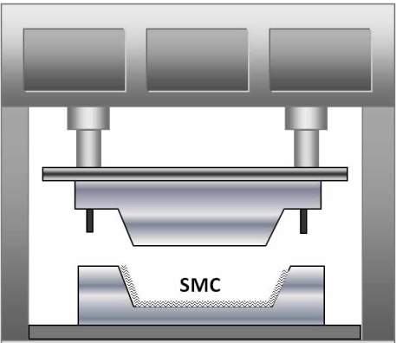

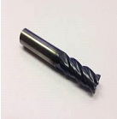**Figure 1** Compression molding setup for sheet fabrication model



(a) (b)

**Figure 2** Four Flute K10 End Mill a) “Titanium Nitride (Ti-N) b) Titanium Aluminium

Nitride” (Ti-AN or Ti-AlN)

**2.2** “**Design of experiment**

The Cutting” “feed f (mm/min), depth of cut d (mm)” as well as speed v (rpm) was the three parameters under investigation. A complete factorial experimental design among the sum of 30 experiment runs has been performed. Respective levels as well as the factors are demonstrated “in Table 4.The surface roughness had been the response variable recorded for each run. The treatment of experimental result is dependent on the analysis of variance (ANOVA). The analysis of variance of the experimental” information because the surface roughness produced throughout the “end milling of GFRP is” concluded “to study the relative” meaning “of the cutting speed, depth of cut”, feed as well as tool material.

**Table 4** Factor and Respective Levels

|  |  |  |  |  |
| --- | --- | --- | --- | --- |
| **FACTORS** | **NOTATION**  **USED** | **LEVELS** | | |
| **-1** | **0** | **1** |
| “CUTTING SPEED (rpm) | A | 100 | 700 | 1300 |
| FEED(mm/min) | B | 50 | 350 | 650 |
| DEPTH OF CUT (mm) | C | 1 | 2 | 3” |

**2.3 Measurements of “surface roughness**

Texture of a surface is” way of measuring Surface Roughness. It is quantified through “the vertical deviations of a real surface from its” perfect from. “If deviations are small the surface is smooth, if deviations are” large, the surface is rough. Roughness viewed as “frequency, short wavelength component of a measured surface. The surface roughness” (Ra) has been calculated utilizing Surfcoder SE 1700.The measurements has been prepared by the cut-off (0.8mm) based to ISO as demonstrated in figure 3. The outcomes are being tabulated as shown in table 5 and 6.

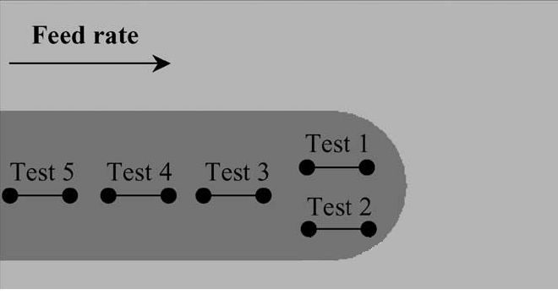

**Figure 3 “**Measurements of Surface Roughness Were Made With the Cut-Off 0.8mm According to ISO”

**Table 5 “**Experimental results obtain from machining surface and cutting parameters” for Titanium Nitride Coated Tool

|  |  |  |  |  |  |
| --- | --- | --- | --- | --- | --- |
| **StdOrder** | **Run Order** | **“Speed**  **(m/min)** | **Feed**  **(mm/min)** | **Depth of cut**  **(mm)** | **Surface roughness”**  **(Micron)** |
| 10 | 1 | -1 | 1 | 0 | 1.6526 |
| 12 | 2 | 0 | -1 | -1 | 1.4028 |
| 8 | 3 | -1 | 0 | -1 | 2.0106 |
| 9 | 4 | 0 | 0 | 0 | 1.6556 |
| 3 | 5 | 0 | 1 | 1 | 1.7324 |
| 14 | 6 | 1 | 0 | 1 | 1.1073 |
| 4 | 7 | -1 | 0 | 1 | 1.5324 |
| 15 | 8 | 0 | 1 | -1 | 1.9526 |
| 2 | 9 | 0 | 0 | 0 | 1.6346 |
| 5 | 10 | -1 | -1 | 0 | 1.9106 |
| 11 | 11 | 0 | -1 | 1 | 1.7626 |
| 1 | 12 | 1 | 1 | 0 | 1.4121 |
| 13 | 13 | 1 | 0 | -1 | 1.8016 |
| 6 | 14 | 0 | 0 | 0 | 1.7256 |
| 7 | 15 | 1 | -1 | 0 | 1.8324 |

**Table 6 “**Experimental results obtain from machining surface and cutting parameters” for Aluminium Titanium Nitride Coated Tool

|  |  |  |  |  |  |
| --- | --- | --- | --- | --- | --- |
| **StdOrder** | **Run Order** | **Speed**  **(m/min)** | **Feed**  **(mm/min)** | **Depth of cut**  **(mm)** | **Surface roughness**  **(Micron)** |
| 10 | 1 | -1 | 1 | 0 | 1.68151 |
| 12 | 2 | 0 | -1 | -1 | 1.51911 |
| 8 | 3 | -1 | 0 | -1 | 1.97056 |
| 9 | 4 | 0 | 0 | 0 | 1.53929 |
| 3 | 5 | 0 | 1 | 1 | 1.66345 |
| 14 | 6 | 1 | 0 | 1 | 1.6205 |
| 4 | 7 | -1 | 0 | 1 | 1.25612 |
| 15 | 8 | 0 | 1 | -1 | 1.6205 |
| 2 | 9 | 0 | 0 | 0 | 1.70355 |
| 5 | 10 | -1 | -1 | 0 | 1.95064 |
| 11 | 11 | 0 | -1 | 1 | 1.73369 |
| 1 | 12 | 1 | 1 | 0 | 1.48837 |
| 13 | 13 | 1 | 0 | -1 | 1.6205 |
| 6 | 14 | 0 | 0 | 0 | 1.77296 |
| 7 | 15 | 1 | -1 | 0 | 1.78504 |

**2.4 Simulated Annealing Method**

A nature-inspired technique is simulated annealing algorithm that was modified since the procedure of gradual cooling of metals in nature. Generally annealing are associated with heating at temperature that is high until every molecules could move about freely and then controlled cooling, before thermal mobility is vanished. The ideal crystal will be the one where every atom is set up in a reduced level lattice; therefore the crystal gets to the least energy. At the temperature of *T*, the solid is approved to attain a definite thermal equilibrium position. The probability of getting in the energy level of *E* is driven through the Boltzmann distributions are shown in Equation 1:

***Pr* (E) *= $\frac{1}{Z\left(T\right) } ×exp⁡(-\frac{E}{KB.T})$*** (Equation 1)

Where parameter *KB* is the Boltzmann constant as well as the exponential phrase *will be* the Boltzmann coefficient. *Z (T)* is a normalization factor as well as is also based on the temperature *T.*



**Figure 4 Distribution of probability for three different temperatures**

With the reduce temperature, the Boltzmann distribution concentrates on a state with lowest energy and finally as the temperature will come near zero, that become the only possible state as showing Figure. 4.

**3.** **Result and Discussion**

**3.1 RSM Modeling**

A regression model was created to calculate the surface roughness values. Box-Behnken design method of RSM was used for modelling. For surface roughness the second order Mathematical Model was developed within a confidence level of 95% as shown in Equation 2 and 3. ***Surface roughness (Titanium Nitride Coated) (Ra) = 1.61692 + 0.000237 (A) + 0.000471 (B) + 0.099723 (C) - 1.66E-07 (A) (A) + 4.42E-07 (B) (B) + 0.000836 (C) (C) + 5.24E-08 (A) (B) - 9.00E-05 (A) (C) --4.84E-04 (B) (C) (Eq. 2)***

***Surface roughness (Aluminium Titanium Nitride Coated) (Ra) = 1.86592 - 7.26E-04 (A) + 0.000269 (B) + 0.103982 (C) - 0.04861 (C) (C) + 0.000214 (A) (C) --2.26E-04 (B) (C) (Eq 3)***

Subsequently, Equation (2) and (3) will be suggested as the aim purpose for optimization solution of the SA.

**3.2 SA Optimization Process**

SA is based on taking Points which improve the goal, “the algorithm avoids being” caught in a local minimum, as well as is capable to discover worldwide for much more potential solutions. An annealing routine was systematically selected to reduce “the temperature as the algorithm proceeds. As the temperature” reduces, the algorithm reduced its extent of investigate for the to converge to a minimal. A main component of the SA process was the way the inputs were randomized. According to the temperature, input values are randomized. The goal of the optimization procedure was to establish the best values of the procedure parameters which results the “minimum value of Surface Roughness” Ra. To produce the optimization issue, the regression model that was suggested in Equation (2) & (3) was brought to become the fitness function of the optimization solution.

The minimizations of the fitness function value were through the borders of the procedure “parameters. The variety of values of experimental” procedure variables shown in Table 5and 6 were choosing to provide the limits of the optimization solution as well as provided as follows:

100 ≤ X1 ≤ 1300 (Equation 3a)

50 ≤ X2 ≤ 650 (Equation 3b)

1 ≤ X3 ≤ 3 (Equation 3c)

The procedure parameters which leads to the least Ra of the regression model are specified in Table 5 and 6 will be choice for first points for the SA solution with provided as follow:

INITIAL POINT OF X1 = 700 (Equation 4a)

INITIAL POINT OF X2 = 350 (Equation 4b)

INITIAL POINT OF X3 = 2 (Equation 4c)

Mainly, to get the optimal solutions, several criteria have to be recognized through the SA algorithm as mentioned in Table 7.

**Table 7** “Combination of SA parameter rates leading to the optimal solution”

|  |  |
| --- | --- |
| “Parameters | Setting value/function type |
| Annealing function | Boltzmann Annealing |
| Re-annealing interval | 100°C |
| Temperature update function | Exponential Temp |
| Initial temperature | 100°C |
| Acceptance probability function | Simulated Annealing” |

Through utilizing the fitness function developed in Eq. (2 & 3), the limits of procedure parameters developed in Equation. (3a)-(3c), the first points formulated in Equation (4a)–(4c), as well as the SA parameters specified “in Table 3, the Matlab Optimization Toolbox is” subsequently used to identify “the minimum values of Ra at the optimal points. The” outcomes of tool used are shown in figures 5, 6, 7 along with 6. As demonstrated in Figure 7 as well as 8, it was noticed that the minimum Ra value is 0.84655. The set values of procedure parameters which results the minimum Ra value are 889 rpm for cutting speed, 3 mm depth of cut and 340 mm/min for feed, and Aluminium Titanium Nitride Coated for tool material. It was suggested which the optimal solution is attaining at the 8804-th iteration of the SA algorithm. Table 8 demonstrates a comparison of the values obtained experimentally.

**Table 8** Comparison of the surface roughness results of Experiment and SA

|  |  |  |
| --- | --- | --- |
| **Technique** | **Tool material** | **Surface roughness (Ra)**  **In Micron** |
| **Experimental** | Titanium Nitride Coated | **1.1073** |
| **SA** | Titanium Nitride Coated | **0.92908** |
| **Experimental** | Aluminium Titanium Nitride Coated Tool | 1.25612 |
| **SA** | Aluminium Titanium Nitride Coated Tool | **0.8465** |

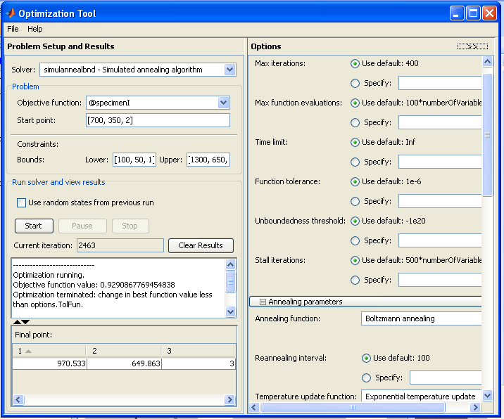

**Figure 5 The results of the Optimization Tool Using MATLAB**

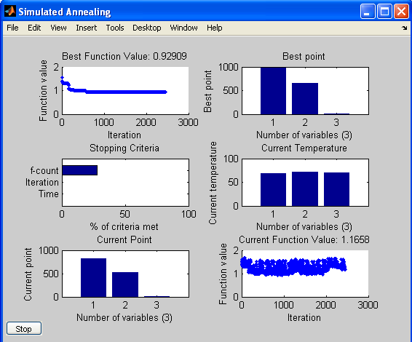

**Figure 6 the results of iteration of Optimization Tool**

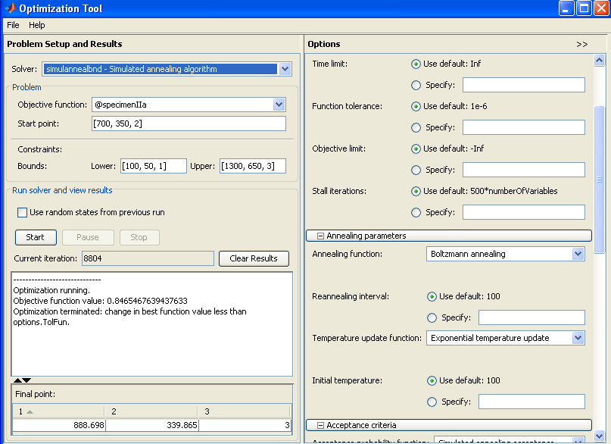

**Figure 7** The results of the Optimised Parameter

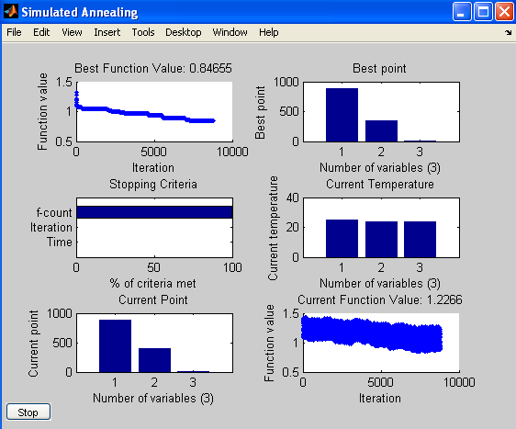

**Figure 8** The results of the Optimization Toolbox for iteration

**3.3 Influence “of cutting parameter on surface roughness”**

From evaluation of table 5 & 6 it was discovered that Cutting Speed as well as Feed had been discovered to be the mainly influential parameter between the core “factors in case of surface roughness”. Besides the factors, the interactions between cutting feed as well as speed, cutting speed as well as depth of cut, feed rate as well as depth of cut had been found to be more significant. This is contrary to the conclusion of numerous researchers. Additional the effect of depth of cut were less influential revealing the uniformity of glass fiber in the composite and filler material ,thereby reducing the interaction between the tool and fiber. Thus matrix crazing generally observed has been eliminated, which has resulted in good surface roughness.

**3.4 IR Thermography**

Radiography was performed utilizing the Balteu 160 kV unit, as the samples being examined had a reduced atomic number. The parameters were 75 kV and 21.3 milli-Ampre respectively.The IR thermography was conducted to assess the damage .Figure 9 shows the image of thermograpahy.

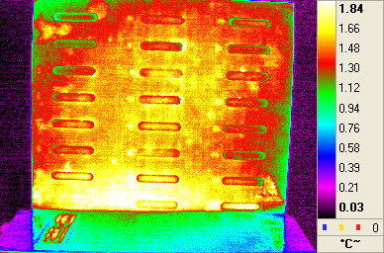

“Thermographic Image of the Composite Panel clearly revealing the Impact Damage” Areas

**Impact Damage Areas**

**Figure 9 IR Thermography Image for Damage Assessment**

This test was conducted to assess the damage resulted from experiment carried out using RSM technique. Further from the literature it is found that milling of GFRP results in damage and also the surface roughness value is usually in the higher side. Thus to validate our obtained value of surface roughness with least damage the test was conducted. From the image it is evident that with the Fabricated combination of GFRP, Coated Tool and with controlled parameters a good surface roughness value with least damage can be obtained .

**CONCLUSION**

**F**or the calculation of surface roughness, a mathematical model was developed. This technique is convenient for the prediction of the consequences of different influential mixtures of machining parameters through conduct of least quantity of experiments. This study further have applied SA technique for the optimal solutions of cutting situations which can produce a minimum *Ra* value in end milling of GFRP. The regression model equation “has been selected to be the fitness function equation for the SA optimization”. It has been found that with SA we can obtain surface roughness of less than one micrometer which is acceptable for most of the applications as in contrast to the experimental. It was also been found that the optimal value for every cutting conditions suggested through the SA fulfils the range of coded value of the experimental design. The goal of the optimization procedure had also been to establish the best values of result variables which might cause the minimum *Ra* value. Thus, with **889 mm/min for cutting speed,3 mm depth of cut,** **340 mm/min for feed as well as** **Titanium Nitride Coated** tool material the best *Ra* value obtained was **0.92908micron and with Aluminium Titanium Nitride Coated** is **0.84655 micron**. As such the developed model RSM could also be used in combination with other optimisation tool to further improve the machinability of Glass Fiber Reinforced Composites.

**REFERENCE**

1. Koenig WC, Grass P, Willerscheid H (1985) “Machining of fiber reinforced plastics” Annal CIRP 34:537–548.
2. Komanduri R (1993) “Machining of fiber-reinforced composites” ASME Mech Engin 114:58–644
3. Ramulu et al. (1993) Effect of the direction on surface roughness measurement of machined graphite/epoxy composite, composite manufacturing. 4 (1), pp. 39-51.
4. Erisken, E. (1999) Influence from production parameters on the surface roughness of a machine short fibber reinforced thermoplastic. International Journal of Machine Tools and Manufacturing. 39:1611-1618.
5. Koenig WC, Grass P, Willerscheid H (1985) “Machining of fiber reinforced plastics” Annal CIRP 34:537–548.
6. Komanduri R (1993) “Machining of fiber-reinforced composites” ASME Mech Engin 114:58–644.
7. Mukherjee, I.; Ray, P.K. (2006) A review of optimization techniques in metal cutting processes. *Computer & Industrial Engineering*, 50: 15–34.
8. Benardos, P.G. and Vosniakos, G.-C. (2003) " Predicting surface roughness in machining: a review ", International Journal of Machine Tools & Manufacture 43 833–844.
9. Indrajit Mukherjee, and Pradip Kumar Ray, (2006) "A review of optimization techniques in metal cutting processes ", Computers & Industrial Engineering 50 15–34.
10. Khan, Z.; Prasad, L.B.; Singh, T. (1997) Machining condition optimization by genetic algorithms and simulated annealing.*Computers Operations Research*, 24(7): 647–657.
11. Wang, Z.G.; Rahman, M.; Wong, Y.S.; Sun, J. (2005) Optimization of multi-pass milling using parallel genetic algorithm and parallel genetic simulated annealing. *International Journal of Machine*
12. Zain, A.M.; Haron, H.; Sharif, S. (2009) Application of GA to optimize cutting conditions for minimizing surface roughness in end milling machining process. *Expert Systems with Applications*, doi:10.1016/j.eswa.2009.12.043.
13. A.M. Zain, H. Haron, S. Sharif, An overview of GA technique for surface roughness optimization in milling process. In IEEE proc inter symp on infor technol, IT Sim, 4 (2008) 1-6.
14. M. Brezocnik, M. Kovacic, Integrated genetic programming and genetic algorithm approach to predict surface roughness, Mater. Manuf. Process., 18(3) (2003)475–491.
15. H. Oktem, T. Erzurumlu, F. Erzincanli Prediction of minimum surface roughness in end milling mold parts using neutral network and genetic algorithm, J. Mater. Des., 27(9) (2006)735–744.
16. P.G. Benardos, and G.-C. Vosniakos, Predicting surface roughness in machining: a review", International Journal of Machine Tools & Manufacture, 43 (2003) 833–844.
17. I. Mukherjee, and P. K. Ray, A review of optimization techniques in metal cutting processes, Computers & Industrial Engineering 50 (2006) 15–34.
18. Z. Khan, L.B. Prasad, T. Singh, Machining condition optimization by genetic algorithms and simulated annealing, Computers Operations Research, 24(7) (1997) 647–657.
19. Z.G. Wang, M. Rahman, Y.S. Wong, J. Sun, Optimization of multi-pass milling using parallel genetic algorithm and parallel genetic simulated annealing. International Journal of Machine Tools & Manufacture 45 (2005) 1726–1734.
20. H. Juan, S. F. Yu, B.Y. Lee, The optimal cutting-parameter selection of production cost in HSM for SKD61 tool steels, International Journal of Machine Tools & Manufacture, *43*(7) (2003) 679-686.
21. A.M. Zain, H. Haron, S. Sharif, Application of GA to optimize cutting conditions for minimizing surface roughness in end milling Ti-6Al-4V, Machining Science and Technology: An International Journal, 14(1) (2009)43-62.
22. Y. S. Tarng,, S. C. Ma, L. K. Chung, Determination of optimal cutting parameters in wire electrical discharge machining. Int. J. of Machine Tools and Manufactur*e*, *35*(12), (1995) 1693-1701.
23. S. S. Mahapatra and A. Patnaik, Optimization of wire electrical discharge machining (WEDM) process parameters using Taguchi method, Int J Adv Manuf Technol, 34 (2007)911–925.
24. D. Deepak and J. Paulo Davim,Multi-Response Optimization of Process Parameters in AWJ Machining of Hybrid GFRP Composite by Grey Relational Method,Procedia Manufacturing,35 (2019),1211-1221.
25. Abeer, Prediction of the Surface Roughness for Milling of GFRP CompositesUsing R.S.M. and ANN, Engineering Research Journal, 42( 3),(2019), 201-210.
26. Subramaniam Shankar, Thangamuthu Mohanraj, and Sevagoundanoor Karuppusamy Thangarasu (2016). Multi-response milling process optimization using the Taguchi method coupled to grey relational analysis. Materials Testing: Vol. 58, No. 5, pp. 462-470.
27. Ashish Saxena,Sushant and Anubhav Khandelwa, Surface roughness optimization in end milling using taguchi method and anova, International journal of research in aeronautical and mechanical engineering, Vol.5, Issue.6, 2017, pp.9-16.
28. Ritesh Bhat, Nanjangud Mohan, Sathyashankara Sharma, Achutha U. Kini, Shivamurthy Shivakumar, Nithesh Naik,Multi response parametric optimisation in machining of marine application based GFRP composite with HSS drill: Application of TOPSIS approach,Materials Today: Proceedings,2020.
29. N. Kawin, D. Jagadeesh, G. Saravanan, K. Periasamy,Optimization of turning parameters in sugarcane bagasse ash reinforced with Al-Si10-Mg alloy composites by Taguchi method,Materials Today: Proceedings,Volume 21, Part 1,2020.