Power transformers are currently being monitored manually which doesn’t provide data and information about occasional overloads and overheating conditions of transformer windings and transformer oil, thus resulting in the reduction in transformer life. Proposed model significantly takes care of most of the problems faced in power distribution transformers, monitoring and controlling through IoT, IoT (Internet of Things), Sensors.

**HARDWARE REQUIREMENTS**

1. Raspberry Pi
2. NTC for temperature sensing (LM324 based sensor circuit for NTC)
3. Moisture and Humidity sensor (HT11)
4. flow meter (Tiny Turbine Flow sensor for Prototype)

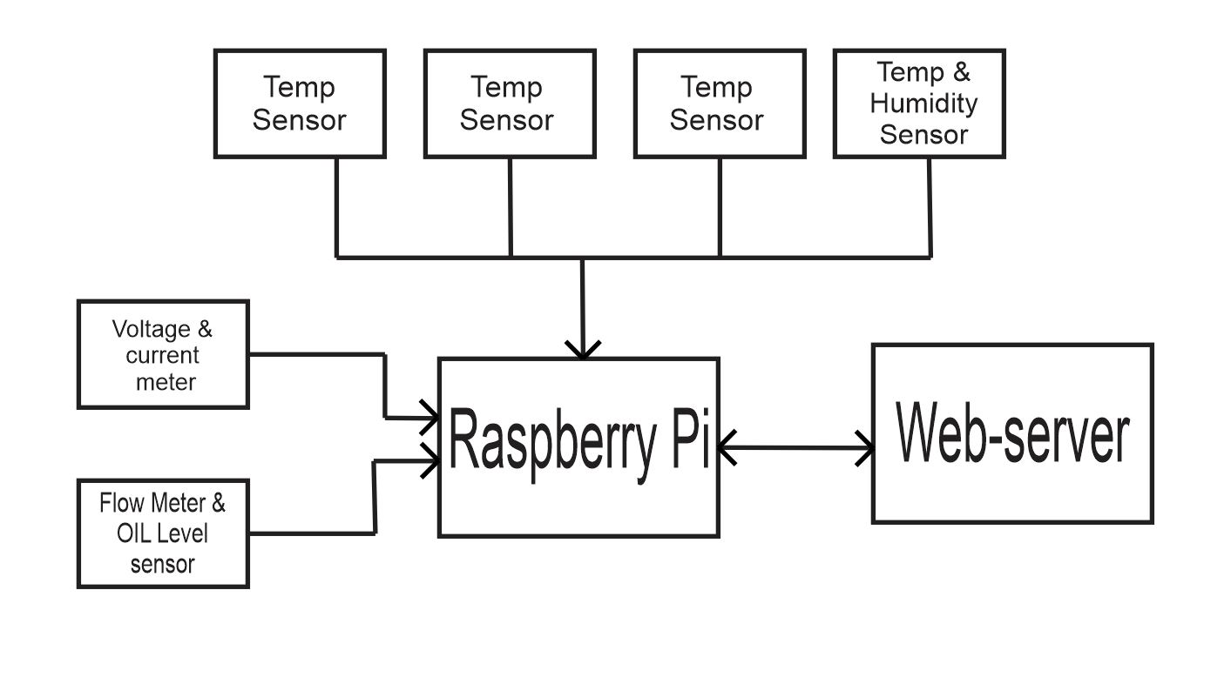

Figure 6: Basic Block Diagram of the System

**Software Requirements**

1. MATLAB
2. Proteus

**Research objectives**

1. The main aim of this system is transformer monitoring and controlling through IoT.
2. Online key monitoring of various parameters involved in health of transformer system
3. Embedded system sensors deployed for remote and real time monitoring.
4. Winding temperature, Top and bottom oil temperatures, Ambient temperature, Load current, Oil flow (pump motor), Moisture in oil, Dissolved gas in oil, Bushing condition, LTC monitoring etc. are covered in the Smart Transformer solution.

**Scope of Work:**

Smart Transformer is an easy and reasonable solution for managing and controlling of various power transformer parameters using IoT. This is a significant step towards realization of Smart Grid which will ultimately help in improving power quality, provide efficient transmission and distribution, quicker rerouting during equipment failure or outages, reduction in peak demand, better economics, sustainable generation, better automation and hence managing the ever growing demand of electricity which is one of the most weighty challenges faced by our country.