**Studies on effect of Low Density Polyethylene (LDPE) on Ethylene Vinyl Acetate (EVA)/ Thermoplastic Rubber (TPR) Blends for Yoga Mat Applications**

*Vikas Aery*

**Abstract:**  In the present work, various Ethylene Vinyl Acetate (EVA)/ Thermoplastic Rubber (TPR) blends were prepared using compression moulding technique. The developed polymer blends were compatibilized with different composition of Low Density Polyethylene (LDPE). The various synthesized binary and ternary polymer blends were characterized in terms of mechanical, morphological and thermal properties. It was found that both tensile and tear strength increased by increasing LDPE composition in ternary blends. It can be attributed to increased interfacial adhesion and compatibility provided by LDPE between EVA and TPR. However, no significant change in compression set values was obtained for different ternary blends. Fourier Transform Infrared Spectroscopy (FTIR) study was done to identify the functional groups involved in different polymer blends. Scanning Electron Microscopy (SEM) study was done on various blends and it was found that adding LDPE into binary blends resulted to smaller and finer distribution of pores. Thermal properties of both binary and ternary blends were also studied by thermo-gravimetric analysis (TGA).

**Keywords:** EVA, TPR, LDPE, Polymer blends, Tensile strength, FTIR

|  |
| --- |
| † To whom correspondence should be addressed.  Email address: vikas.aery@outlook.com  (Vikas Aery ) |

**Introduction**

Yoga has become an essential lifestyle component of a healthy life. Various materials, both natural and synthetic, have been used for practicing yoga. Recently polymeric mats have gained importance due to light weight, good fastness properties and durability. Polyvinyl chloride (PVC) has been extensively used for yoga mats. However, PVC mats are more toxic and difficult to dispose after the usage, so the development of new material is of great interest. Ethylene Vinyl Acetate (EVA) based polymers can be a good alternative.

EVA has numerous advantages such as low cost, easily availability, good flexibility. However, it has low abrasion resistance and easy deformation. These drawbacks can be overcome by blending it with suitable thermoplastics using copolymerization. In literature, EVA-LDPE have been widely used for various applications including footwear, automobile sheets, packing films, electric cable insulations, flooring, mats, swimming kickboards, etc.1-7.

Perez et al (1997)8 studied the effect of addition of EVA on technical properties of LDPE/EVA blended foam used for various applications. The static mechanical properties, dynamic mechanical properties, creep-recovery behavior, thermal expansion, and thermal conductivity of LDPE foam and LDPE/EVA foam were investigated. They concluded that static and dynamic modulus, and thermal stability decreases with increasing EVA in LDPE/EVA blends.

Nga et al (2018)9 studied to investigate the effect of EVA on mechanical properties of LDPE/EVA blends. They prepared a series of blend by adding 0, 3, 6, 9, 12 and 15 wt% of EVA. They found that tensile strength decreased from 10.9 MPa to 8.6 MPa. Bending strength decreased linearly from 9.63 MPa to 5.46 MPa. Charpy impact strength decreased from 47.5kJ/m2 to 6.3kJ/m2. On the contrary, elongation in 100% LDPE was 78.3%; with the appearance of EVA, elongation of the LDPE/ EVA blends increased up to 109.1%.

In literature, thermoplastic rubber has been blended with other polymers to improve the mechanical properties of the original polymer, to achieve better processing behavior, and lower of compounding cost10-12. Styrene-Butadiene-Styrene (SBS) copolymer has been recommended for poly-blending as SBS in HDPE might improve impact strength. Conversely, small amount of crystalline polyolefin (LDPE) in SBS might increase hardness and strength without excessive sacrifice of soft flexible rubbery properties studied by Deanin and Chang (2015)13.

Wang et al (2014)14 concluded that the shape recovery of SBS/LDPE blends was improved by the addition of LDPE. This is due to the fact that SBS consist of both rubbery and plastic properties and LDPE is a switch polymer. These two phase contribute the shape recovery and fixing performances respectively. SBS are most frequently used as compatibilizer for PE with other polymers like PE/PS15-16. Among the elastomeric polymer, EVA is the thermoplastic copolymer widely used in the production of polymeric foam (insole & midsole of footwear, mats etc.). SBS was used in compatibilizing EVA with polystyrene and waste ground rubber tire powder17. The adhesion performance and compatibility of EVA/SBS blends for hot met adhesive was studied. The properties of SBS/EVA were enhanced by incorporating EVA-g-MAH as compatibilizer18. In the literature, blends of SBS/ LDPE and EVA/LDPE are used for various purposes. So herein, attempt was made to improve the compatibility of EVA/SBS by adding LDPE for yoga mat applications.

In this work, various EVA/TPR blends were prepared using compression moulding. The developed polymer blends were compatabilized with different composition of LDPE. The various synthesized polymer blends were characterized in terms of mechanical properties including tensile strength, tear strength, and compression set. Scanning Electron Microscopy (SEM) was conducted to study the morphological properties. Functional groups in various blends were identified by Fourier Transform Infrared Spectroscopy (FTIR). Thermal behavior of blends has been investigated using thermo gravimetric analysis (TG/DTA).

**Experimental**

**Materials**

Thermoplastic Rubber (TPR) used in this work is Styrene Butadiene Styrene (SBS) having hardness 40 shore A as shown in Figure 1a. It was supplied by Vikas Ecotech Ltd, Delhi. Ethylene Vinyl Acetate (EVA) with 19% Vinyl Content, melt flow index 2.5g/10min (Figure 1b) was supplied by Seetec, Delhi. The Low density Polythene (LDPE) (Figure 1c) was supplied by LG Group. The other chemicals required like reinforcing agent Silica (supplied by Insilico) was used to resist the abrasion of the polymer, filler Calcium carbonate, a processing aid stearic acid (from Godrej). Zinc oxide (Active grade) as activator, the blowing agent ADC (Azo-die-carbon amide) for expansion of the polymers was of commercial grades. The main feature & sources of materials used in this work are summarized in Table1.

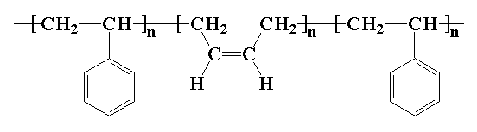

**(a)**

**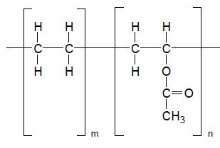  
 (b)**

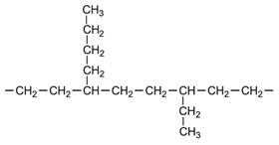

**(c)**

**Figure 1.** (*a) Thermoplastic Rubber (TPR-SBS)*

*(b) Ethylene Vinyl Acetate (EVA)*

*(c) Low density Polythene*

**Table 1** Raw Material Detail

|  |  |  |  |
| --- | --- | --- | --- |
| **Material** | **Characteristics** | **Value** | **Source** |
| EVA | Density (gm/cm3) | 0.939 | Lotte Chemical Corporation, Mumbai |
| Vinyl Content (%) | 19 |
| MFI (gm/10min) | 2.5 |
| Hardness (D Scale) | 38 |
| TPR | Specific gravity | 1.08 | Vikas Ecotech Ltd, New Delhi |
| MFI (gm/10min) | 6.0 |
| Hardness (Shore A) | 40 |
| LDPE | Density (gm/cm3) | 0.922 | Reliance Polymers, New Delhi |
| MFI (gm/10min) | 4 |
| Calcium Carbonate | Bulk Density | 0.8 | Gilcal |
| Silica | Bulk Density | 0.27 | Insilco Ltd, Noida |
| Zinc oxide | Bulk Density | 0.54 | JG chemicals Pvt Ltd, West Bengal |
| Stearic Acid | Bulk Density | 0.94 | Godrej Industries Ltd, Mumbai |
| MP (oC) | 69.3 |
| DOP | Specific gravity | 0.985 | KLJ Plasticizer Ltd, New Delhi |
| Flash Point(oC) | 216 |
| ADC | Density (gm/cm3) | 1.65 | HPL Additives Ltd, |
| DCP | Active Oxygen Content (%) | 5.8 | Mas Chemicals Industries Ltd. Gujrat |

**Compounding Procedure**

LDPE was incorporated in various concentration (0%, 5%, 10% and 15%) with 90/10, 80/20, 70/30, 60/40 (EVA/TPR) blends. The blends were prepared in an industrial open roll mixer at temp 90 -100oC. The roller temperature of the roll mixer was maintained by circulating tap water through the roller. The rollers rotate with the speed 20 rpm. The Compounding Recipes of the blends are given in Table2. Sample A indicates 90:10 (EVA/TPR), B indicates (80:20), C (70:30), D (60:40). The subscript shows percentage of LDPE. For e.g. A0 means 90/10 EVA/TPR consist of 0% LDPE. Similarly C15 means blend contains 15% LDPE. Similar subscripts were given to the other blends as shown in Table3. The mixing was done in two stages. In first Stage the melting of EVA, TPR and LDPE were done separately by putting the material one by one between the rolls of Open roll mixer. Then mixing of these three polymers in said ratio was done for about 3 minutes. The filler, reinforcing agent and processing aids was then introduced into the blend. It took 10-12 minutes for this material to be mixed properly and subsequently addition of activator and blowing agent was done. These blends were covered properly to prevent moisture absorption and kept it for 24 hours for ageing at room temperature. In the second stage of mixing re-melting of the blend was done in an open roll mixer again, cross-linking agent was added at this stage.

**Table 2** Mixing and Molding Parameters

|  |  |
| --- | --- |
| **PARAMETER MIXING MOULDING** | 10% silica, 20% calcium carbonate, 2.5% stearic acid, 2.3% zinc oxide, 1% DOPa and 23.5% ADC band after remixing before in 2nd stage 0.75 % DCPc |
| Temperature (oC) 90 to 100 120  Time (minutes) 12 35  Mixer Speed (rpm) 20 -  Pressure Applied (ton) - 1 |

*.**aDioctyl Phthalate, bAzo-die-carbon amide, cDicumyl peroxide*

**Table 3** Blends with various composition of polymers



*A0, B0, C0 and D0 has shown blend with 0 % LDPE. Similarly, B10 means blend contained 10% LDPE and D15 with 15% LDPE.*

**Sheet Preparation**

Once mixing was done, the blends were cut into sheets approximately half of the mould size. Compression moulding was used to fabricate the polymer blend using a hydraulic press (supplied by Jin Jiang Wen Shu Machine Co. Ltd, China) at 120 + 10oC with 1 ton pressure. Before this, the loaded mould was preheated in a press for 3 minutes without applying pressure, in order to ensure uniform heat flow throughout the material. For all the blends the temperature was kept at 120oC with 1 ton Pressure for 35 minutes. The resulting sheets were obtained in expanded form (expansion varies from 70 % to 80 %). This is because of the gases generated in the polymer matrices upon blowing agent decomposition, Park et al (1991)19 NH2-CO-N=N-CO-NH2. As soon as blended sheets were taken out of the hydraulic press, these sheets were put into fresh water for 10 min to make it stable and place it in dust free area.

**Characterization**

**Tensile and Tear Properties**

The molded sheets were first split into 3mm thickness, and then cut into tensile strength specimen by punching the die for the measurement of tensile and tear strength. The tests were performed according to the ASTM D 412 method by using Asian Micro data Acquisition System. Measurements were done at speed 300 mm/min with load cell 1kgf. Prior to measurements, the samples were conditioned in a conditioning chamber, as per standard. Three measurements were conducted for each sample; the results were averaged to mean value.

**Compression Set**

The compression set of a material is the measurement of permanent deformation remaining after removal of a force that was applied to it. The tests were performed in Compression set apparatus, Prolific Engineering Model as per standard ASTM D395. For each sample 3 specimens in round shape with thickness 7mm + 0.2 mm were held under a constant load. The specimen is compressed to 75% of its original height for 24 hours at room temperature. The specimen thickness was noted after 30 min release from the Compression. Compression set is given by CB

% Compression set = CB = [(to-ti)/ to-tn)]*100 ………………. **(Eq 1)**

Where to = Original specimen thickness

ti = Specimen thickness after testing

tn = Spacer thickness = 4.70mm

**Fourier Transform Infrared Spectroscopy (FTIR)**

The functional characteristics of EVA/TPR and EVA/TPR/LDPE blends with wavenumber in the range of 650-4000 cm-1 corresponds to %Transmittance were investigated by Perkin Elmer Spectrum 400FT-IR/FT-FIR Spectrometer. The sample was placed in the FT-IR cell and the spectra were recorded.

**Scanning Electron Microscopy (SEM)**

The Morphology of EVA/TPR and EVA/TPR/LDPE blends were examined by high resolution scanning electron microscopy (JSM-6100 Scanning Microscope) JEOL, Japan. Cellular structure of samples was prepared by using Azo-die-carbon-amide (ADC).

**Thermo-gravimetric (TG/DTG) Analysis**

The thermal degradation test was performed on various EVA/TPR and EVA/TPR/LDPE polymer blends. TG/DTA analysis was done in Exstar TG/DTA 6300 instrument in nitrogen atmosphere with 10oC heating rate in the range of 0 to 650oC.

**Results and Discussion**

**Tensile Strength**

Figure 2 shows the variation of tensile strength for different EVA/TPR/LDPE polymer blends. It was observed for blend A0, the tensile strength was found to be 8.28 Kgf/Cm2. As the percentage of LDPE increased as in A5 to A15, tensile strength gradually increased from 8.45kgf/cm2 to 9.22kgf/ cm2. For polymer blend B0, the tensile strength found to be 9.22 Kgf/Cm2. Similar trend of increasing tensile strength i.e. 9.33 Kgf/Cm2, 9.49 Kgf/Cm2 and 9.51 Kgf/Cm2 was found for A5, A10, and A15 polymer blends respectively. For polymer blend C0, tensile strength was found to be 6.28 Kgf/Cm2. Again the tensile strength has shown increasing trend from 6.39 Kgf/Cm2 for C5 to 7.67 Kgf/Cm2 for C15. The tensile strength for D0 was 4.61 Kgf/Cm2 which further increased to 4.72 Kgf/Cm2, 5.78 Kgf/Cm2 and 5.88 Kgf/Cm2 with respect to D5, D10 and D15 polymer blends. It was noted that the tensile strength for binary blend first increased and then decreased with increasing concentration of SBS. It can be due to poor interfacial bonding between EVA matrix and SBS copolymer. Further, the tensile strength was increased with the addition of LDPE in each EVA/SBS blend. The enhanced tensile strength of ternary blends (EVA/SBS/LDPE) suggests that LDPE formed a disperse phase that could result in increasing interfacial adhesion and compatibility between EVA and SBS18 and 20. It was also noted that higher concentration of SBS could help to improve the compatibility as well. As shown in Figure 2, there was 21.59% improvements in tensile strength of ternary blend D15 (60/40/15) as compare to binary blend D0 (60/40). This can be ascribed to polyethylene is compatible to B block of SBS and formed a disperse phase in SBS13. However, there was 10.19% improvement in tensile strength of blend containing higher percentage of EVA as in A15 (90/10/15) then A0 (90/10). This can be attributed to vinyl acetate in EVA slow down the crystallization of LDPE, which may result lesser improvement in the mechanical properties 21. The increment of tensile strength can be attributed to better crosslinking in polymer phases 6.

**Figure 2.** *Effect on tensile strength of the blend with increase in weight percent of LDPE in different weight ratio of TPR/EVA (A: 90/10, B: 80/20, C: 70/30, D: 60/40)*

**Tear Strength**

Figure 3 shows the significant enhancement of tear strength with increasing concentration of LDPE in EVA/TPR blends. It was found that the tear strength for A0 blends was 4.07kgf/cm. As LDPE concentration increased in A5, A10, A15, the tear strength increased to 4.27kgf/cm, 4.70kgf/cm and 4.93kgf/cm, respectively. For blends B0, the similar increasing trend of tear strength was found. The tear strength for blend B0 was 3.37kgf/cm and when 5% LDPE was added as in B5, the tear strength went to 3.50kgf/cm. For B10, the tear strength was found to be 4.40kgf/cm, which increased to 4.43kgf/cm for B15. For blend C0, the observed tear strength was 2.40kgf/cm. It increased to 2.73kgf/cm, 3.00kgf/cm and 4.57kgf/cm for blends C5, C10, C15, respectively. For blends D0 to D15 it was noted that the tear strength was 1.87kgf/cm, 2.13kgf/cm, 2.93kgf/cm, and 3.03kgf/cm respectively. The tear strength depends on the stress dissipation near the cracked tip. This may due to breakages of chain entanglement or arresting of the growing crack with some additives. The addition of LDPE in EVA/TPR blends resulted in inter-connected structure of porous membrane or branched tear path that may resulted in high energy expended for the propagation of tear. This may have enhanced tear strength10 and 20. It was in expected that increasing LDPE improves the compatibility of EVA/TPR blends.

.

**Figure 3.** *Effect on Tear Strength of the blend with increase in weight percent of LDPE in different weight ratio of TPR/EVA (A: 90/10, B: 80/20, C: 70/30, D: 60/40)*

**Compression set**

Compression set is a measure of permanent deformation of the material. It represents the material ability to withstand irreversible deformation under force. Lower the value helps the material to retain its shape after being pressed hence higher the material durability**.** Figure 4 shows the effect of LDPE on compression set properties of different blend. For blend A0, the compression set was found to be 75.02%, and for samples A5, A10, A15, the compression set was 74.64%, 74.24%, 74.64%, respectively. For blend B0, the compression set was found to be 60.93%. When LDPE was incorporated as in B5, B10, B15, the compression was found to be 60.28%, 61.33%, 61.11% respectively. For blend C0, the compression set was 60.26%. It reduced to 58.67% for blend C5, 58.29%, and 58.67% for blend C10 & C15, respectively. For blend D0, D5, D10, D15, the compression set was found to be 59.92%, 59.97%, 59.97%, 58.57%, and 57.33% respectively. To fact that there was no significant variation found with the incorporation of LDPE. This can be ascribed to the walls of the pores may buckle during the elastic regime of compression, which might have little effect on the compression set of the polymer blends 22.

**Figure 4***. Effect on permanent deformation of the blend with increase in weight percent of LDPE in different weight ratio of TPR/EVA (A: 90/10, B: 80/20, C: 70/30, D: 60/40)*

**FTIR Analysis**

Figure 5a represents the FTIR spectra of sample A0 & A10 blend. The peaks at 2917.4cm-1 and 2849.6cm-1 corresponds to the asymmetric stretching vibration and symmetric stretching vibration of (CH2) group, respectively. The peak at 1737.9cm-1 was due to strong stretching vibration of carbonyl group (C=O) for EVA polymer, 1462.8cm-1 attributed to scissoring of methylene group. The peaks at 1370.9cm-1 and 1238.2cm-1 corresponds to rocking vibration of methyl group. The peak at 964.1cm-1 can be attributed to the C-H bending vibration in C=C of SBS molecule chain23. The peak at 874.0cm-1 can be attributed to stretching of (-C-O-O-) 24-26. It was found that peaks of ternary blend A10 was same as binary blend A0. No additional peaks obtained suggest that no new functional group were provided by LDPE in binary blends. However, intensity of the peaks was changed by the incorporation of LDPE attributed to increase in the amount of the functional group associated with the molecular bond. Similar kinds of results were obtained for polymer blends C0 and C10 as shown in Figure 5b.

**Figure 5a.** *FTIR Spectra for A0 (10/90) and A10 (10/90/10)*

**Figure 5b.***FTIR Spectra for C0 (30/70) and C10 (30/70/10)*

**SEM Analysis**

SEM Micrographic images of EVA/TPR and EVA/TPR/LDPE blends with a magnification of 100 times were taken. Figure 6a shows that A0 blend has more open and closed pores. By incorporating LDPE, the formation of higher concentration of closed pores was favored as shown in Figure 6b. These pores were associated with viscosity of the blends. As if the viscosity of the blend is too low during expansion it results in open pore structure. However if the viscosity is too high it results in closed pore structure27. The lower size, combined with finer distribution indicated the existence of interfacial adhesion between the polymer blend28. Since EVA and SBS are incompatible polymers they formed relative more open pore structure, when the LDPE was incorporated in polymer blend (EVA/SBS) the polyethylene migrated and stay at EVA-SBS interface. LDPE is compatible with ethylene block of EVA and Butadiene block of SBS, thus SBS established adhesion with the EVA matrix through SBS interphase. Better interfacial adhesion due to incorporation of LDPE in EVA/TPR blends can also justify the improved mechanical properties of the blend. Similar observation was found for the blends C0 & C10 as shown in Figures 6c & 6d.

**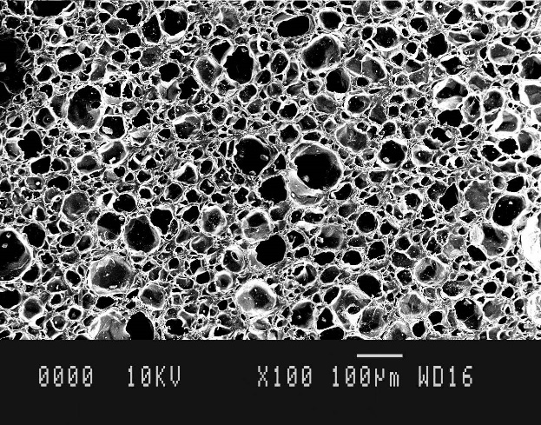 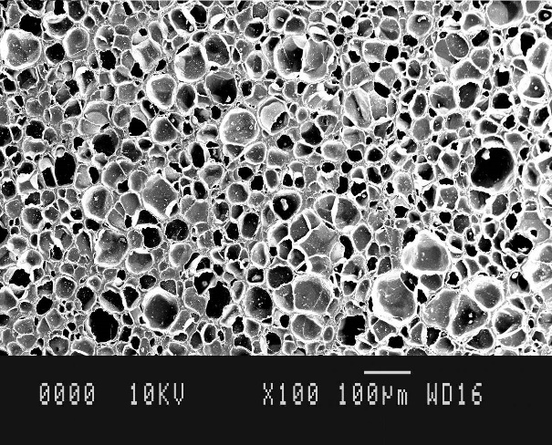   
Figure 6a.** *A0 (90/10) EVA/TPR blends* **Figure 6b.** *A10 (90/10/10) EVA/TPR/LDPE blends*

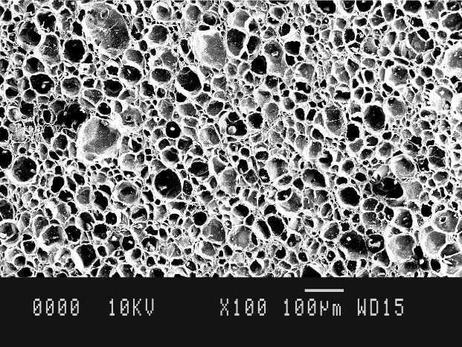

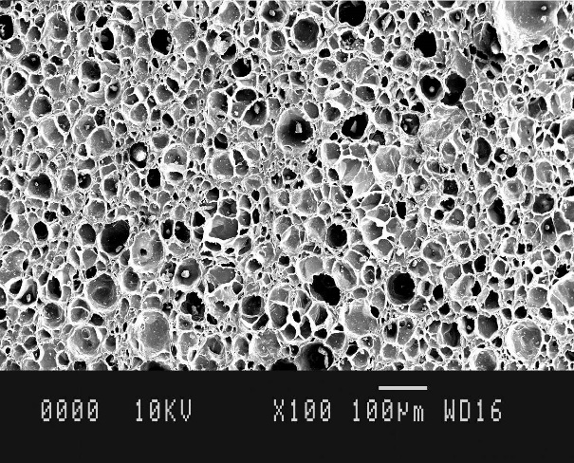 **Figure 6c.** *C0 (70/30) EVA/TPR blends***Figure 6d.** *C10 (70/10/10) EVA/TPR/LDPE blends*

**TGA/DTG/DTA Analysis**

The Thermo-gravimetric plots of peroxide cured EVA/TPR and EVA/TPR/LDPE polymer blends have been given in Figure 7 (a, b, c, d). Figure 7a represented the DTA, TGA and DTG curve for A0 polymer blend under nitrogen atmosphere. TGA curve suggests that the polymer A0 samples were thermally stable up to 300oC, only 4.97% degradation took place. However, 86.3% degradation took place up to 500oC. It was also found that 11.35 wt% residue was left after the complete degradation of EVA/TPR blend at 646oc. Similarly for sample A10 as shown in Figure 7b, 5.55% degradation occurred at 300oC and 87.41% degradation took place at 500oC. The residue left after complete degradation was 10.25wt% at 646oC.

DTG curve tells the rate at which decomposition take place. The temperature of the DTG curves corresponding to rate of mass loss has been shown in Figure 7a. It was found that for sample A0, degradation took place in three stages. 1st stage took place at 350oC with the degradation rate 0.325 mg/min. 2nd degradation at 449oC with the rate 1.422 mg/min. and finally 3rd degradation took place with the degradation rate 0.381 mg/min at 493oC. However, for sample A10 as shown in Figure 7b, only two degradation rates were found. 1st degradation was completed at 455oC with 1.383 mg/min degradation rate and 2nd degradation took place up to 490oC with the 0.358 mg/min degradation rate. The former degradation can be attributed to the elimination of acetic acid from the vinyl acetate section. The later degradation can be ascribed to degradation of polyethylene segment present in EVA and degradation of butadiene present in SBS polymer 29-31. The polythene is sensitive to heat and crystallinity of polythene is slightly decreased by heating32-33. This can be the reason, when LDPE was incorporated as in polymer blend A10; the thermal stability of the binary blend effected, thermal stability reduces slightly, however degradation rate reduces as compare to blend A0. The DTA curve provided the additional information of enthalpy change during phase conversion. As in polymer blend A0, the exothermic peak indicated that crystallization phase occurred with (-3.08 mV.s/mg) enthalpy change and A10 (-2.48 mV.s/mg) enthalpy change. Similar behavior was found for blend C0 & C10. As can be seen from Figure 7c & 7d, the thermal behavior of binary blend C0 and ternary blend C10, It was found that both binary and ternary blends were thermally stable up to 300oC with approximately 7.53% mass loss. For blend C0 23.45% mass loss occurred at 400oC and 20.83% mass loss was found for blend C10. At 500oC, the observed mass loss for C0 and C10 was 78.6% and 79.7% respectively. After complete degradation the residue left was 18.05% and 17.15% for C0 and C10 respectively. It was found that for sample C0, degradation took place in three stages. 1st stage took place at 425oC with the degradation rate 0.550 mg/min. 2nd degradation at 457oC with the rate 1.327 mg/min. and finally 3rd degradation took place with the degradation rate 0.319 mg/min at 491oC. However, for sample C10 as shown in Figure 7d, only two degradation rates were found. 1st degradation was completed at 452oC with 1.673 mg/min degradation rate and 2nd degradation took place up to 486oC with the 0.317 mg/min degradation rate.



**Figure 7a*.*** *DTA, TG, DTG analysis of sample A0 (EVA/TPR) blend 90/10*

.

**Figure7b.** *DTA, TG, DTG analysis of sample A10 (EVA/TPR/LDPE) blend 90/10/10*



**Figure7c.** *DTA, TG, DTG analysis of sample C0 (EVA/TPR) blend 70/30.*



**Figure7d***. DTA, TG, DTG analysis of sample C10 (EVA/TPR/LDPE) blend 70/30/10.*

**Conclusions**

In this study EVA/TPR blends were compatibilized with LDPE for yoga mat applications. EVA/TPR/LDPE blends in various compositions were made using compression moulding technique. It was found that tensile and tear strength was increased by the incorporation of LDPE in EVA/TPR blends. However, addition of LDPE in blends did not have significant effect on compression set properties. FTIR spectra of various blends were studied. It was found that the incorporation of LDPE intensified the intensity of various functional groups present in binary blends without the formation of additional one. SEM morphological study also suggested that incorporation of LDPE improved interfacial adhesion between EVA/TPR blends. Thermal properties were also studied using TGA/DTG/DTA analysis. All blends were found fairly stable up to 300oC. For ternary blend A10 having 10% LDPE composition, the rate of degradation decreased from 1.422mg/min to 1.383 mg/min with respect to A0. This study suggests that good quality ternary blends (EVA/TPR/LDPE) can be made for yoga mat applications.

**Acknowledgement:** We would like to thank Nivia Synthetics Pvt Limited, Jalandhar for preparing and testing of various samples**.**

**References**

1. Maria Dolores Landete-Ruiz, Juan A. Martinez-Diez, Miguel Angel Rodriguez-Perez, Jose Antoniode Saja and Jose Miguel Martin-Martinez, J. Adhesion Sci. Technol **16**, 1073 (2002).
2. J. Peon, J.F. Vega, M. Aroca, J. Matinez Salazar, Polymer 42 (2001).
3. J.A Reyes Labarta, M M Olaya, A Marcilla, J of App Polym Sci **110**, 3217 (2006)
4. Bo Kyoung Jung, Geon Wook Park, Jae-Keun Yu, Hyo Jun Kim, Dong Gun Kim, Minguen Kim, and Kyu Hyun, Polym. Korea **44**, 264 (2020).
5. M. Faker, M. K. Razavi Aghjeh, M. Ghaffari, S.A.Seyyedi, Eur Polym **44**, 1834 (2008)
6. Mahmoud Borhani Zarandi and Hajjat Amrollahi Bioki, Eur. Phys. J. Appl. Phys. **63**, 21101 (2013)
7. G.Takidis, D. N. Bikiaris, G. Z. Papageorgiou, D.S. Achilias, I. Sideridou , J. App Polym. Sci. **90**, 841 (2003).
8. M.A. Rodriguez-perez, A. Duijsens, J. A. De Saja, J. App Polym. Sci. **68**, 1237 (1998).
9. Pham Thi Hong Nga, Le Thi My Hoa, Zhang Xiao Wei, Appl. Mech. Mater **889**, 223 (2018).
10. Baby Kuriakose, S. K. DE, J Mater Sci **20,** 1864 (1985).
11. Buthaina A. Ibrahim and Karrer M. Kadum, Int. J. Eng. **12**, 19 (2012).
12. Ruey-Sheng Shih, Shiao-Wei Kuo, Feng-Chih Chang, Polymer **52**, 752 (2011).
13. Rudolph D. Deanin and Young-Shun Chang, J Elastom Plast **18**, 35 (2015).
14. Yongkun Wang, Guangming Zhu, Yusheng Tang, Jiangiang Xie, TingTing Liu, Zhe Liu, J Polym Res **21**, 404 (2014).
15. M.K. Razavi Aghjeh, M. Khodabandelo, M. Khezrefaridi, J. App. Polym. **114**, 2235 (2009).
16. Jingshen Wu, Baohua Guo, Chi- Ming Chang, Jianxiong Li, Hoi- Shuen Tang, Polymer **42**, 8857 (2001).
17. Zhaobo Wang, Yixin Zhang, Fanglin Du, Xin Wang, Mater Chem Phys **136**, 1124 (2012).
18. Yu Wang, Shijuan Li, Weiyu Yao, Hui Chen, Weihong Guo, Mater. Res. Express **6**, 1(2019).
19. Park C. P, D. Klempner, K. C. Frisch, “Polyolefin foam” in Handbook of polymeric Foams and Foams Tech. Vol **9**, p 187 (1991).
20. Elham Shokri, Reza Yegani, Setareh Heidari, Zahra Shoeyab, Chem Eng Res des **100**, 237 (2015).
21. Qing ping SHI, Dong li Ll, Wen cai XU, Mater Sci. forum **689**, 321 (2011).
22. Youming-Chen, Raj Das, Mark Battley, Int. J. Eng. Sci. **120**, 220 (2017).
23. Xiong Xu, Jianying Yu, Canlin Zhang, Song Xu, Lihui Xue, and Dong Xie, Polym. Korea **44**, 947 (2016).
24. Aurelio Ramirez-Hernandez, Celia Aguilar-Flores, Alejandro Aparicio-Saguilan, Dyna **86**, 198 (2019).
25. Pudun Zhang, Jiasui He, Xin Zhou, Polym. Test **27**, 153 (2008).
26. R. Kochetov, T.Christen, F.Gullo, 1st International Conference on Electrical Materials and Power Equipment - Xi'an – China 49 (2017).
27. Matheus VG Zimmermann, Marcos Aur elio Colombo, Diego Pizza and Ademir J Zattera, Prog Rubber Plast Re **35,** 23 (2019).
28. H.A. Khonakdar, S.H. Jafari, A. Yavari, A. Asadinezhad, U. Wagenknecht, Polym bull **54**, 75 (2005).
29. H.Varghes, S.S. Bhagawan, S.Thomas, J. Therm. Anal. Calorim **63**, 749 (2001).
30. Robert A. Shanks, Sherri McRae, Muthukumaraswamy Pannirselvam, Conference Paper 229 (2009).
31. Ting-Ting Su, Heng Jiang, Hong Gong, Polym Plast Technol Eng **48**, 535 (2009).
32. A. Martinez-Romo, R. Gonzalez-Mota, J.J. Soto-Bernal, I. Rosales-Candelas, J spectrosc 1 (2015).
33. Siqin Dalai, Chen Wenxiu, Radiation effect on LDPE/EVA blends, J. App. Polym. **86**, 1296 (2002).