Dear all,

Thanks for coming today at the meeting and sorry for the issues we had with microphone/chat.

So lets get to what we decided for next meeting (Thursday 15th of October at 2 pm, here the link to the meeting <https://eu.bbcollab.com/guest/9cdecee91ca3433eb2a8cb5f1e421a12> )

1. We will meet again next week (together in collaborate) and then every week for this term (we will agree on dates/time each time). The first couple of meeting will be run all together then we will start meeting up 1to1 to look at your progress and I will guide you in what primers to design etc… (as this would be different from person to person).
2. The plan for your work (ideally, then hickups can happen, but we will have time to adjust the target on the way):

Week 2: We will meet up all together… before the meeting you have to:

Fill in the checklist document that I have attached in the email. Please name the checklist file in the following format (read the rest of this document first)

**CHECKLIST – Supervisor Name - Student Name – P number – YY/MM/DD**

**For Week 2:**

-Decide on the plant you want to work on (ideally a superfood, but a medicinal plant or spice would be good as well, as many time these overlap. Please though, remember that you are a BMS students o if the plant has some health benefit would be better).

-when you chose your plant target you need to look in literature for known contaminants (we want plants with at least one known contaminant/adulterant and this has to be a plant not a chemical compound), look up for what test as usually done (if any) to discriminate it from the adulterant. In most cases these will be chemical tests but there could be also DNA test, this is still ok in some cases but in most case this would mean that your research would not be innovative enough… maybe you should considered another plant as target. Then you would use the NCBI website (<https://www.ncbi.nlm.nih.gov/>) to check if there are DNA barcoding for the target plant.

Remember to set “Nucleotide” and write the scientific name of your target plant (later you would do the same with your contaminant plant) + the barcoding region you want to look at (start with Internal transcribed spacer = ITS) then the others in the PowerPoint I am attaching.

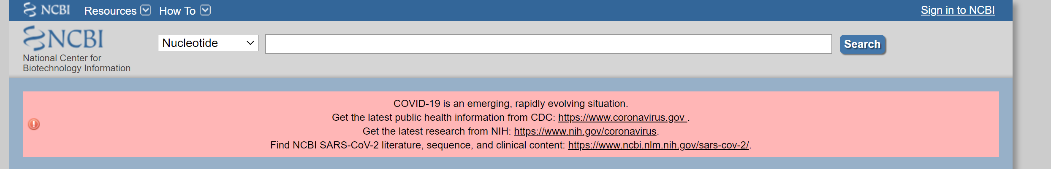

This will generate something like this:

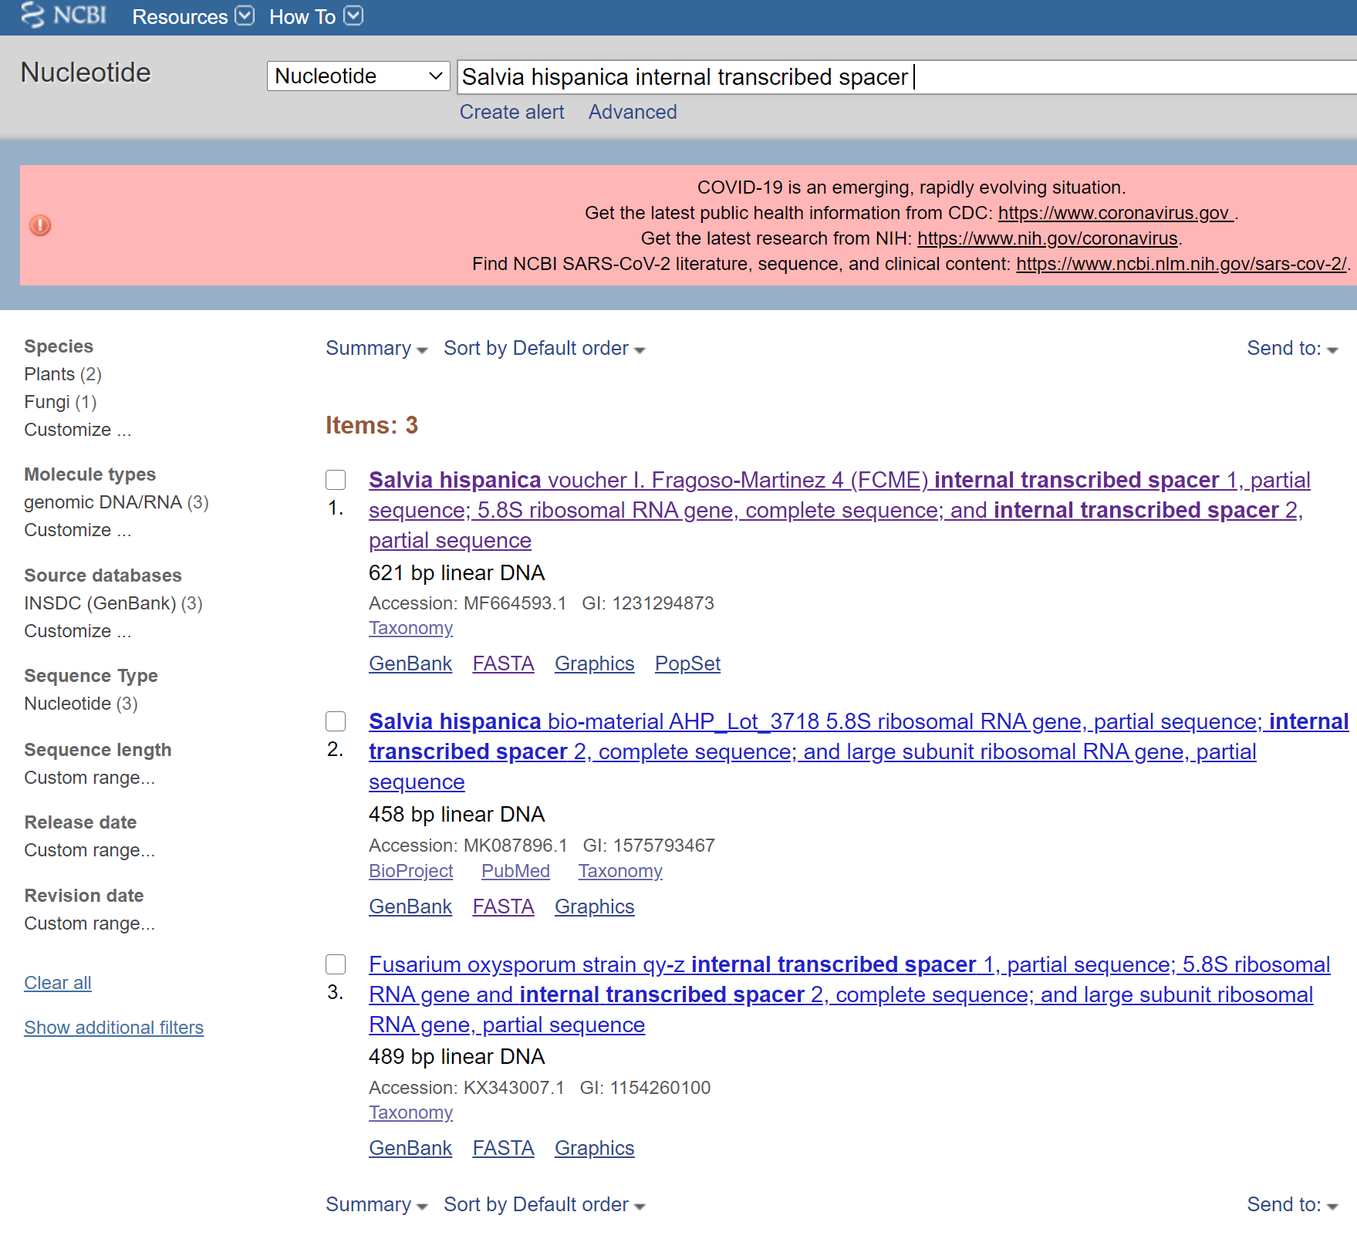

Click on the first one (usually) or another, preference should be given to “vouchered samples” (which means they should be used as reference).

This will open another page with a lot of info.

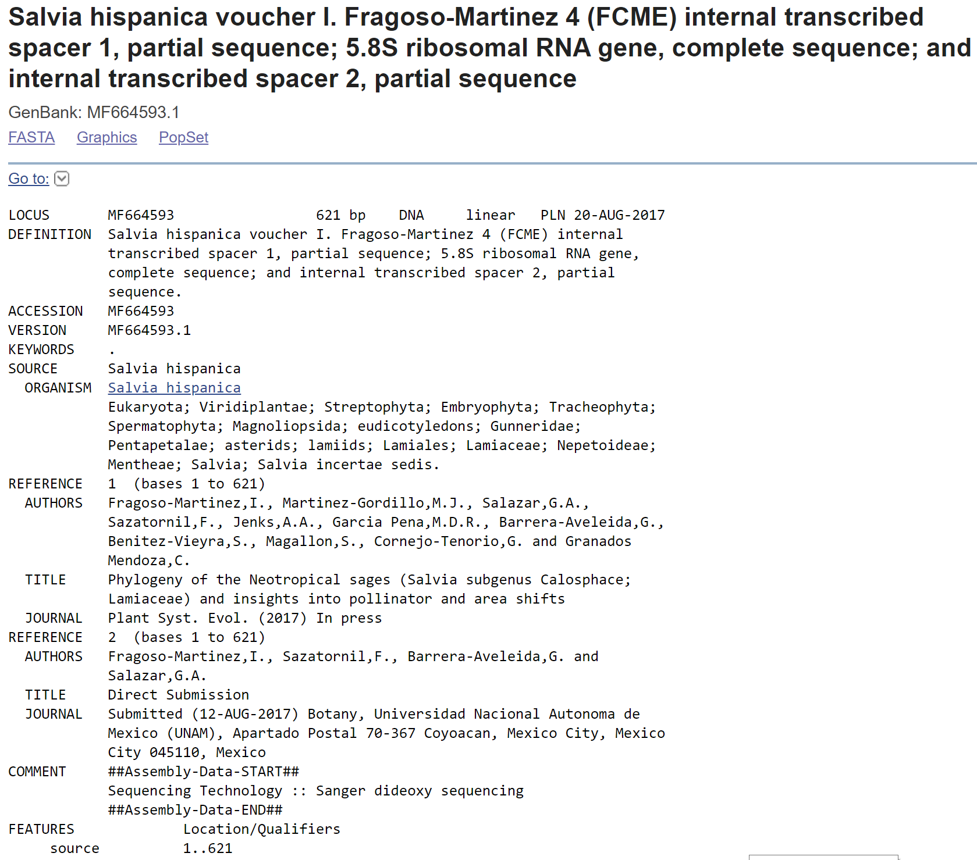

What you need is the FASTA format, click on it (top/left)

And save this on a word document (like below, remembering to copy the > symbol

>MF664593.1 Salvia hispanica voucher I. Fragoso-Martinez 4 (FCME) internal transcribed spacer 1, partial sequence; 5.8S ribosomal RNA gene, complete sequence; and internal transcribed spacer 2, partial sequence

TCGATACCTGCAAAGCAGACAGCGAACTCGTGTTTAACAACGGCGGCGTGCGGCGGGGGCGATCCCCGTC

CCGCGCTCGTCTCCCCCGCCGGCGTGCTCCCTCGGTGCCACGCCGTGCGGGCTAACGAACCCCGGCGCGG

AATGCGCCAAGGAATACTCAACGAAGCGTCCTCCCCCCGCACCCCGTTCGCGGACCGTGTGGGGGCGACT

GGATGTCTCGCAAATGTCATAACGACTCTCGGCAACGGATATCTCGGCTCTCGCATCGATGAAGAACGTA

GCGAAATGCGATACTTGGTGTGAATTGCAGAATCCCGTGAACCATCGAGTCTTTGAACGCAAGTTGCGCC

CGAAGCCATTCGGCCGAGGGCACGTCTGCCTGGGCGTCACGCATCGCGTCGCCCCCCGCCCCGCGCTTAG

CGAAAGGGCGGGGAGCGGAGACTGGCCTCCCGTTCGCCATTGGTGTGCGGCTGGCCCAAATGCGATCCCT

CGGCGACTCGCGTCACGGCAAGTGGTGGTTGAACACTCAATCTCTTGCGCCGTCGTGCCGCTGTGTCGTT

CTTACGGGTGTCGAAAAACGACCCTGCGGTGGCGGGGCCTCACGGCTCCTCACCTTCGACC

Copy the sequence in the BLAST website (too look for similar sequences) (<https://blast.ncbi.nlm.nih.gov/Blast.cgi>)

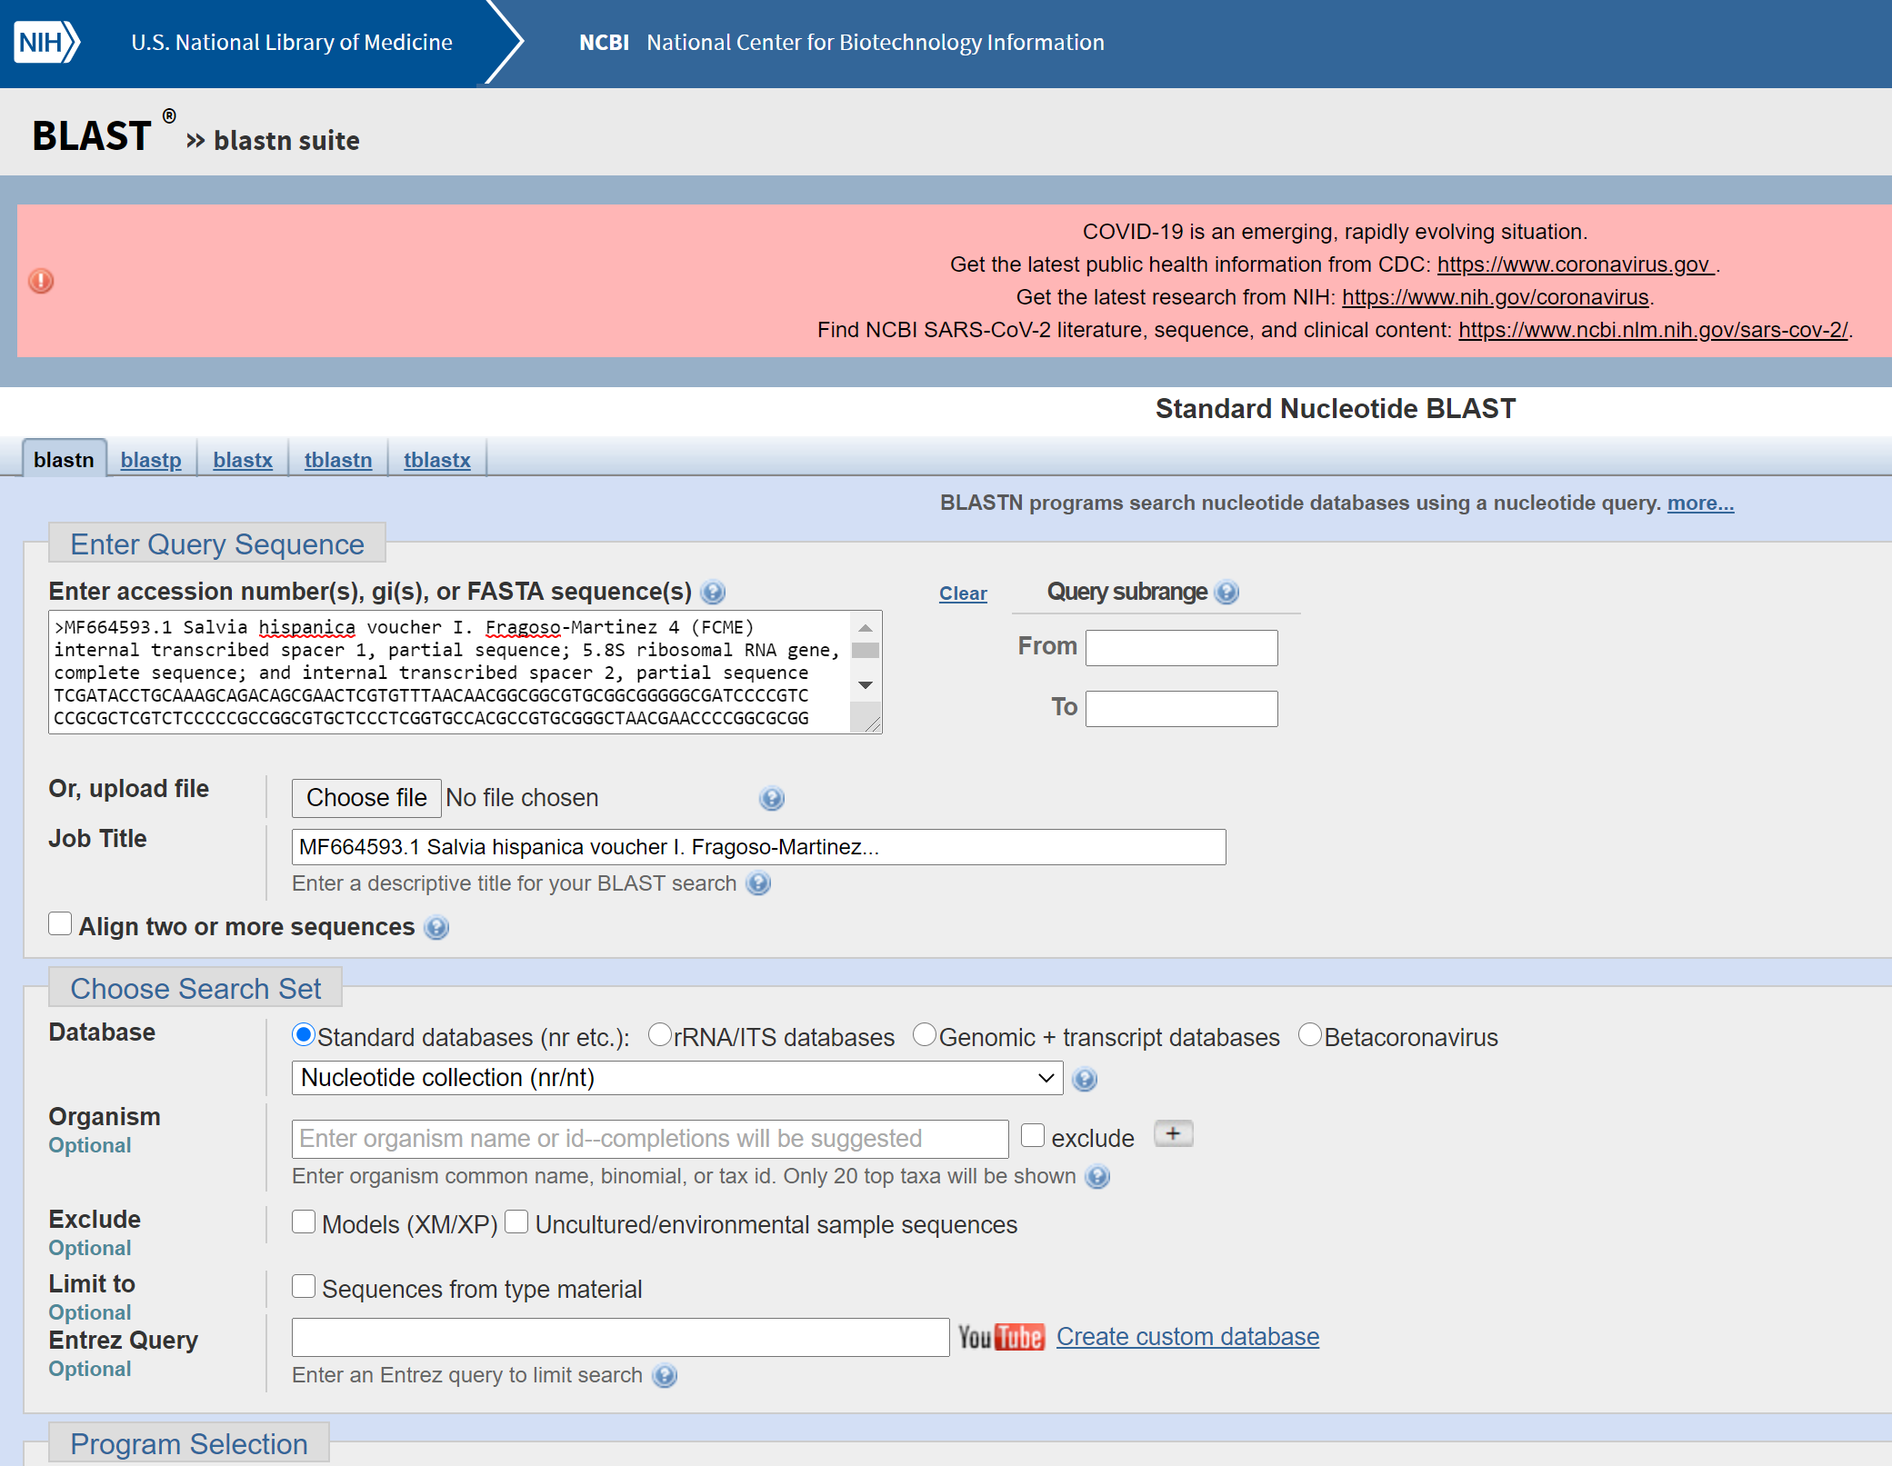

And press BLAST (bottom)

This will generate a list of sequences for different plants

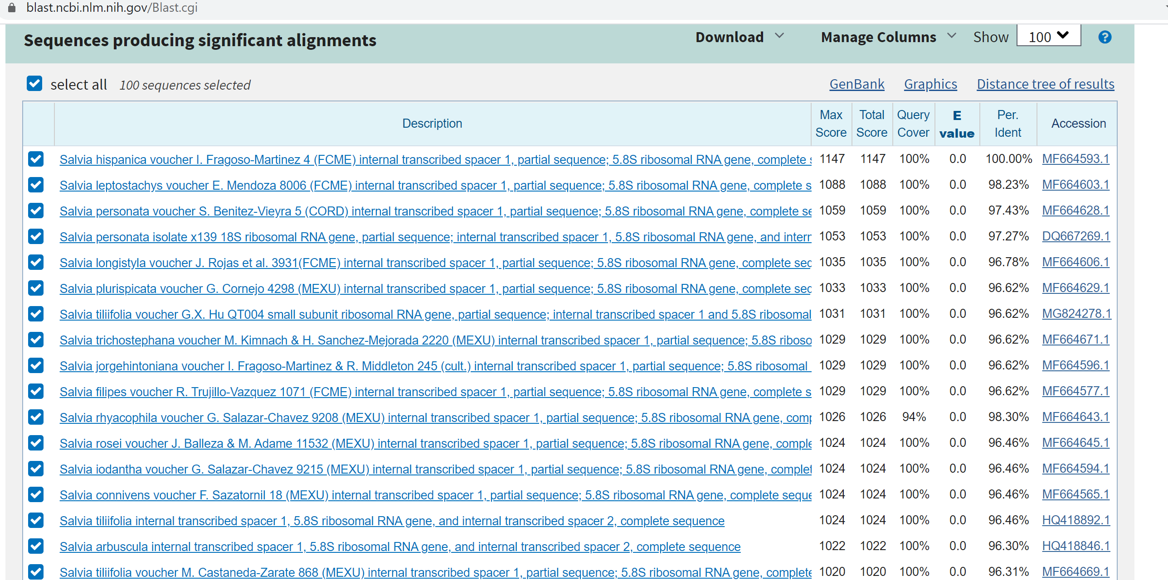

You need to click on each of them,

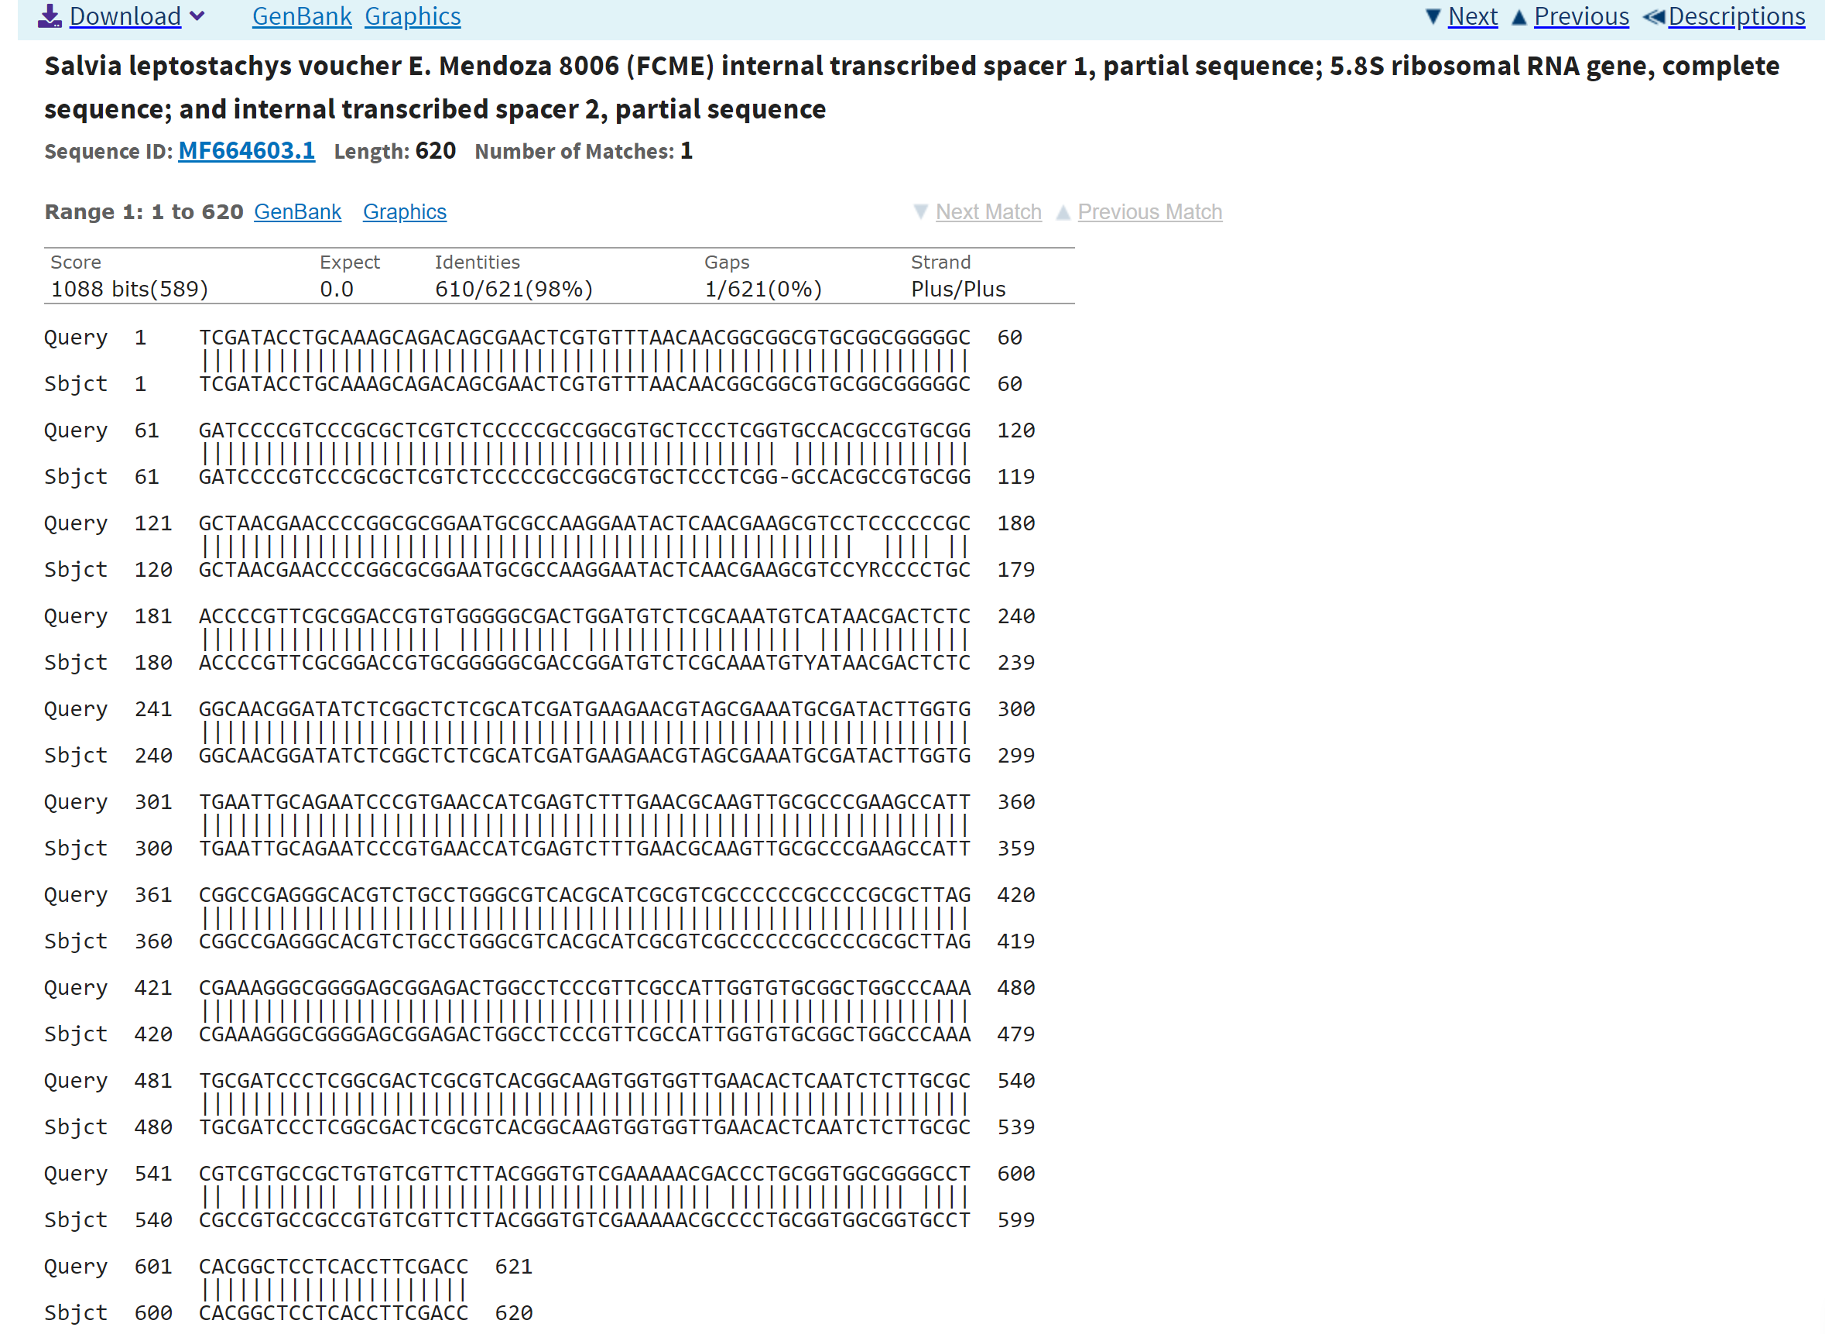

And click on the sequence ID number. Then Save the FASTA format of the sequence as before in the same word document….

What you are doing is collecting the sequences that you will use later on (I will go through this next time) for generating an alignment to use for the primer design.

When you have collected enough sequences, you can repeat this process with the adulterant/contaminant specie.

How many sequences are enough??? I do not have a good answer for this, more you have, more stringent/specific your primers will be… but also it may get more difficult designing the primers… in the case of my example, Salvia hispanica… there are 900 species of salvia, more or less, so in teary I should collect 900 , but not all of them will be present on the NCBI database… up to you.

If you have more than one contaminant you will have to repeat this again…

Once you have done so, prepare a summary table (you have all the info needed now, collected on your word document.

|  |  |  |  |  |
| --- | --- | --- | --- | --- |
| Scientific name | Common name | Reference number | Region amplified | Target/contaminant |
| *Salvia hispanica* | Chia | MF664593.1 | ITS | target |
| *Salvia ….* |  |  |  |  |
| *Glycine max* |  |  |  | contaminant |
| *Sun flower* |  |  |  |  |
|  |  |  |  |  |

**Week 3: (we will meet up all together). Before the meeting:**

You will generate your alignment and start to have a look at primer design. I will go though this in the week 2 meeting

**Week 3- week 5:** work on Literature research/ introduction (as by then target plants/contaminant should be defined, this should include- general info about superfood or herbal medicine or spice, maybe something about regulations for the market, define why testing is important.. talk about adulteration/contamination, test used for detecting contaminations or authenticity of the plant e.g. chemical test-physical test… what are the issue with these test, introduce DNA barcoding.. pro/cons… barcoding regions, what they are, are they the same for animal, why, maybe talk a bit more about the barcoding region that you will be using, linked with the limitations you could talk about way to solve the problem e.g. minibarcoding-species specific primers… talk about your target plant… why is it important, what are the contaminant… in the final intro you will also add a brief section about your aim )

Week 5/6 : we will have 1 to 1 meeting… have a look at your alignment/start deciding about primers design

Week 7-8: 1 to 1 meeting …by then you should have well defined primers and show me your “lab book”… take note of what you do during each day/week

Week 9-11: write your first draft of M&M and results. Implement the feedback received for the introduction.

During Christmas period Draft of conclusion & discussion

January Full and complete draft.

February first final draft submission

Some extra information:

**Thesis (80%)**

The thesis still has a minimum limit of 5000 ±10% words in the DMU journal template format. This is excluding references, appendices, title page and contents list, but does include figure legends. Appendices should be minimal in length. If ethics was sought/required the completed application should be attached. Referencing should be performed using a referencing management programme (Endnote, Refworks Mendeley, etc.) and presented in Harvard (DMU) format.

This means that for the intro you would be looking at about 1000/1500 words. M&M will be the shortest (let’s say 500 words). Result section won’t be lengthy either (750-1000 words). Discussion 1000-1500 words. The rest will be reference etc… So, try to write a good 1000 words for the Literature review due in week 5… easier to remove info (if you go over in term of words count).

**Viva voce (20%)**

The viva section will remain as previous years, although as last year, may be conducted (partially) online. Students will be asked three seen questions from a bank. Vivas will be second marked as above.