MUSIC RECOMMENDATION SYSTEM

Jolepalyam Himakar
Computer Science & Engineering
PES UNIVERSITY
Banglore,India
jolepalemhimakar21@gmail.com

Druva M Hegde
Computer Science & Engineering
PES UNIVERSITY
Banglore,India
druvahegde20@gmail.com

Abstract— In this project we are analysing million song datasets. We have designed a recommendation system for a user and have also predicted the growing trend in the consumption of music over a past few years. We have designed a recommendation system based on popularity, collaborative filtering and SVD. We have used ARIMA model for the prediction of growing trend in music.)
Keywords— million song dataset, recommendation, collaborative filtering, SVD, forecasting time series, Arima

Introduction
In the modern world where everything is highly digitalized and almost everyone has access to internet ,people now have access to millions of songs online which often confuses them to choose the right kind of songs ,that is the reason why many people still stick to their old favorite songs instead of going ahead and exploring other songs trying to diversify their music interest.
It’s of dire importance to both the artist as well as the people to have an efficient music recommendation system, It will help them by recommending the user the right type of music he/she would listen to, the user will not have to spend his/her precious time browsing over net searching for new songs or artists to listen to , similarly it will also help those artist who have great musical skills but not enough popularity to gain popularity,fame and money. Thus, an efficient music recommender system is necessary in the interest of both music service providers and customers. Both academics and business professionals have worked on providing music suggestion services. Users will have no more pain to make decisions on what to listen to while music companies can maintain their user group and attract new users by improving users’ satisfaction. For instance, some people choose music with a visible preference for style, while others place more emphasis on timbral resemblance. The recommender must concentrate on various attributes in order to provide recommendations to these two diverse listeners.
THERE are many music streaming websites like Spotify,Resso,Pandora who are working to build an efficient recommendation systems. These companies generate revenue by helping their customers discover relevant music and charging them for the quality of their recommendation service. Thus, there is a strong thriving market for good music recommendation systems.
We in our project have tried to make the task of music recommendation easy to the users by applying various models. The models we have tried are popularity based, collaborative filtering and SVD. We have also tried to check how relevant the artists are in modern time with the rapid evolution of technology and would it actually effect the growth and how technology has impacted their growth.

Related Work
A song recommendation system based on the two well-liked algorithms Content Based Filtering and Collaborative-Based Filtering was proposed by Parmar Darsna [1] to help users find specific items of interest. Based on user data, the content-based technique suggests musical genres. Speechiness, loudness, and acoustical quality are examples of subjective music qualities based on content. Using the k-mean clustering procedure, these attributes are stored in the database. The collaborative based strategy suggests user rating and cross-user content sharing. This approach looks for cosine similarity between users by taking into account the user rating given to a particular piece of music. Cold-Start is handled by recommending most popular tunes to new user. The dataset is acquired from MovieLens Website. Both content-based and collaborative systems require a significant amount of data about past buying and rating experiences. (Cold-start). Furthermore, these methods are generally not well suited to domains in which the product is highly customized. We have used popularity based and collaborative based recommendation approach from this paper, but instead of using cosine we have used Pearson’s coefficient.
In [2] authors have discussed about the item based collaborative filtering method for music recommendation system with matrix factorization technique-SVD. Since user logs are one type of implicit feedback, their method takes user interest into account without explicitly considering user feedback. The fundamental flaw is that they haven't provided is enough justification for why we suggest a product to a user. If users are curious in the reasoning behind a particular item's recommendation, this can be a major issue. We used SVD to solve the sparsity issue and time complexity issues.
But Kuo and Shan’s (2002) approach are unable to accurately express this desire for the users during suggestion. Furthermore, unlike the collaborative approach, this system cannot produce any unexpected suggestion outcomes due to the inherent nature of the content-based filtering strategy [6]. A groundbreaking technique for collaborative music suggestion [5] is Ringo in Sharadanand and Maes (1995). Each user in Ringo is asked to give ratings on a few musical items. The personal profile is made up of these evaluations. To calculate the degree of similarity between two user profiles, various approaches are presented.
Only user profiles that are comparable to the target users are taken into account for collaborative recommendation.
The weighted average of the ratings taken into account will then determine whether a musical item is recommended.
A group music recommendation system called GroupFun was created by Popescu et al. [4] that employs a voting mechanism to identify the genuine musical preferences of group users and a probability weighted sum methodology to gauge their overall happiness with the recommended songs.
Using keywords like song titles, reviews, artist names, etc. to filter web page data, Whitman et al. [3] suggested a method for explicit processing of singers' free text meta information in the music recommendation engine, comparing 5 recommended singers and 5 random selections.
The method is proven to be able to better apply the singer's recommendation when the average of the five singers they recommend is higher than it is now. The data base for many music-based personalized recommendation systems based on labels is the cultural metadata of music. Their general idea is to use the social tags provided by users to comprehensively evaluate the relevance of singers or songs. The label not only reflects the category and content characteristics of the music itself, but also reflects the user's preference for music, and has strong flexibility and openness. It also has some problems. On the one hand, the acquisition of cultural metadata requires the presence
of a large number of highly viscous users; on the other hand, it is prone to prejudice, and songs on the long tail of
music is ignored by the audience.

Proposed Solution
This section provides an overview of the dataset and how we have done the preprocessing of the data and the methodology used for recommendation.

A)Dataset
The dataset we are using is million songs dataset from Kaggle provided by Columbia University Laboratory. It is open source since the dataset is too large, we have decided to select only a subset of the dataset for faster analysis and due to memory constraints. The dataset was already cleaned. This dataset contains 10,000 songs and 76,353 users. We have taken two csv files. They are-1) triplet.csv (user, song, count) (user, song, count) and 2) metadata.csv Information about the music's metadata Including the album, artist, and the date of release Listen count. Issues encountered in our dataset are there is no user information on what he likes or dislikes, no information on the genre means that content-based filtering is not possible and a subset of the dataset must be created on our own because the complete dataset is too large to our recommendation model.

B)Preprocessing
We had very few data pertaining to year 2010 which actually prevents us from making accurate analysis. So, we had to drop all the rows pertaining to year 2010.There are some missing values in songs like title and release (percentage of missing titles: 0.001, percentage of missing releases: 0.0005). Since percentage of missing values is very less, we decided to drop these rows. We have no explicit rating of the user so we had to convert the listen count to explicit rating by using the formula: listen count of that song by that user / total listen count of that user. All rows with duplicate songs are dropped.

C)Methodology
The first model we have tried to use for recommendation is popularity based. It will just recommend the popular songs for the users. This approach is great initially when we have little idea about the user or the user is new. So it will prevent the cold start when the user is new. But the main disadvantage in this is there is no personalized recommendation to the user and accuracy of this model is also very less.
The next approach we have done is collaborative filtering. In this the first approach we have used is item-item similarity-based recommendation. We have constructed a co-concurrence matrix by taking the rows as songs of a particular users and columns as all the songs in the dataset excluding the user songs. After that we have used Jaccard’s Index to find the intersection of listen count of songs the user and the other people have listened to. This helps us to convert the implicit rating into explicit rating. Then add all the rows and find the maximum value in the column and recommend it to the user.
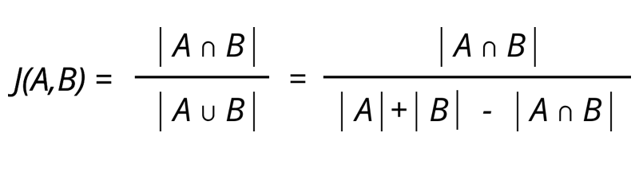
The disadvantage in this approach is that for every item we have to keep constructing the new co-concurrence matrix so the memory requirement is very high even the time complexity is very high so in the real world when recommendation have to be in the real time it will be a problem. To solve the problem pertaining to memory and time we have tried to use SVD.
A number of domain-specific characteristics have an impact on listening histories (e.g., genre, artist). In general, these characteristics are not at all visible, thus we must deduce these 'latent' factors from the data. Latent variables are used to describe both users and songs. Here, to handle such a large amount of data, we build a sparse matrix from user-song triplets and directly operate on the matrix, instead of looping over millions of songs and users. We used truncated SVD for dimensionality reduction. We constructed a sparse matrix by taking the user as rows and songs as columns. We used fractional listen count as the rating. Then we applied SVD on the given matrix to find the ratings of the song’s user have not listened to. This reduces the time complexity and also the memory can be saved using SVD.
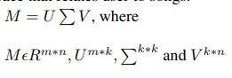
The next approach we have tried is collaborative filtering based on user-user similarities. We have tried to find the similarity between the users by making use of Pearson’s correlation coefficient. We have taken five most similar users, assigned weight to the songs these particular users have listened to based on the similarity order and recommended songs which the other user has not listened to. The disadvantage in this approach is that for every user we have to keep constructing the new co-concurrence matrix so the memory requirement is very high even the time complexity is very high so in the real world when recommendation have to be in the real time it will be a problem. The drawback of this strategy is that we must continually create a new co-concurrence matrix for each user, which has a high memory need and a high time complexity. This will cause issues in the real world where recommendations must be made in real time.
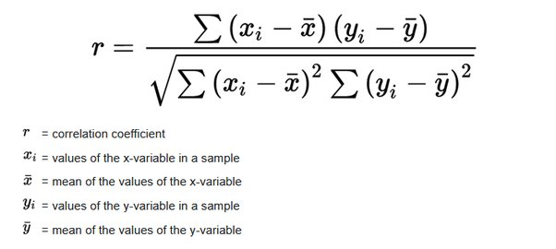
To solve the problem of space complexity pertaining to the user we have used KNN, we found the five similar users and recommended the songs based on this. Now all the users closer to that user can be recommended with same songs.
We have also tried to predict the growth in music trend for the next ten years. We performed Augmented Dickey Fuller (ADF) test to check the stationarity. After that we decomposed the growth to observe the trend and seasonality. We have used ACF, PACF plot to find p, d, q and we have confirmed these parameter values by making use of auto-ARIMA.

Experimetal results and Inferences
In a dataset we found that above 75% of the users listened to the songs only once. And only 25% of the users listened to the same song more than once. We found that number of unique users are 76353, number of unique songs are 10000, number of unique artists are 3375 and no of unique albums are 9567.We have found that the most popular artist in the dataset is Coldplay followed by Kings of Leo, Florence the machine and Dwight Yolkam. The most popular song is You’re the one, Undo and Revelry. The most popular album was if there was a way followed by Vespertine Live and Only by the night. We tried to plot the time series data of listen count and have found that the listen count increases exponentially especially around late 1990’s this probably could be due to the increase in connectivity throughout the world. So this we can conclude that the way more users listening to songs now so its of dire importance to recommend the songs to the user. We have also tried to decompose the time series data and found out that there is no seasonality and there is only upward trend. We have also forecasted the listen count using ARIMA model it showed us that the predicted count in 2014 is around 800000 which is way more than the current count of 543523. So, from this we came to know that music does not depend on season and people listen to music throughout the year.
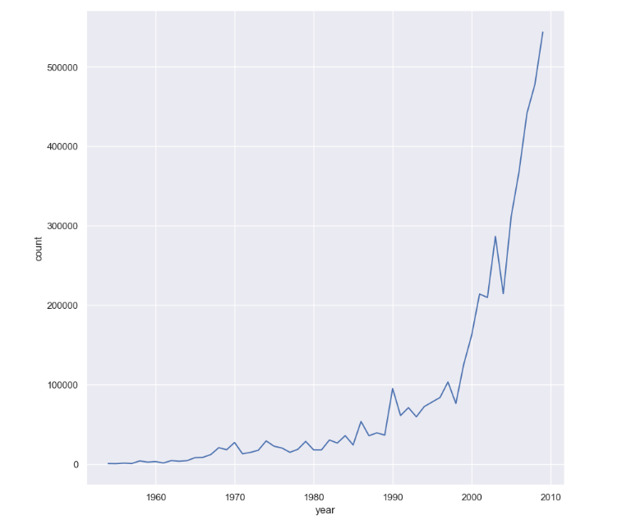
We have plotted the popularity graph of some of the artists and from our analysis we found that Beyonce popularity has been increasing from early 2000s and popularity has only been increasing over the years. We have also found the popularity of old musicians like Jake Johnson has been decreasing exponentially. We could also see that the listen count of the younger artists like Justin Bieber, Lincoln Park, Train is way more compared to old bands. We have also plotted a time series graph for listen count of Metallica and we found that whenever they released a new song there has been a peak in the graph and its also shocking to see that despite of them being less popular after 1995, they have managed to gain younger audience in early 2005.Then we have plotted a kde plot to found the how many songs the user has exposed to. And we found the graph to be positively skewed which means that there are a smaller number of users who have been exposed to lot of songs. But there are few people who have been exposed to lot of songs.
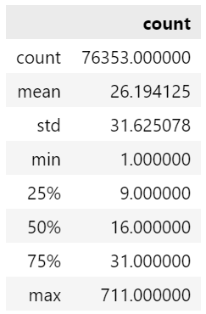
The above table shows the no of songs each user have exposed to .
The first we built was popularity based. Its performance was really bad when compared to other models. There is no novelty and serendipity. This model is only useful for new users but not the users who have been listened to music quite a long time because this method doesn’t take users preference into account.
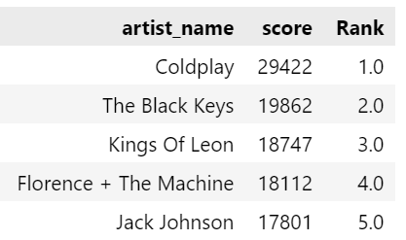
The next model we used is Collaborative filtering based on item-item similarity. This will used when most songs have been listened to by one or more users. This won’t work when the song is new.
The next approach is user-user based collaborative filtering. In order to save time and memory we have used K-Nearest Neighbors. When user is new this recommendation won’t work.
Though the theory behind SVD is quite compelling, there is not enough data for the algorithm to arrive at a good prediction. The median number of songs in a user’s play count history is sixteen this sparseness does not allow the SVD objective function to converge to a global optimum.

Conclusions
The memory-based collaborative filtering technique produced the greatest results for us. Our latent factor model, which is SVD-based, performs better than models based on popularity. Because the matrix was too sparse and prohibited objective functions from converging to the global optimum, it trailed behind the collaborative filtering technique. Even the popularity model outperforms our K-NN model in terms of performance. Due to the fact that we only have the characteristics for 10,000 songs—less than 3% of the entire dataset—just a few of these 10,000 songs could be suggested. This approach performs poorly since there is a severe paucity of information.
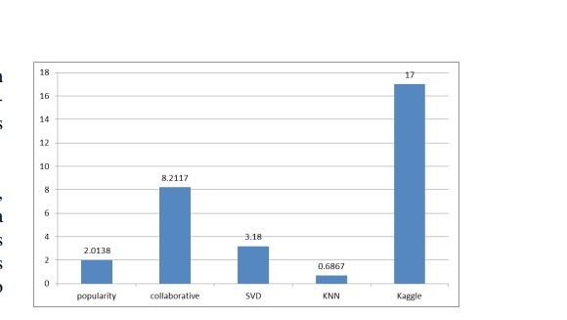
Fig: Precision vs model

Future Work
To parallelize the calculation, shorten the runtime, and take use of distributed memory, run the algorithms on a distributed system, such as Hadoop or Condor.Combine many approaches and determine how much of each should be weighted given the dataset. Create relevant features automatically. Create more recommendation algorithms based on various data (such as the user's mood or social recommendations, for example).

Acknowledgment
We would like to acknowledge our Data Analytics Course Professor Dr. Gowri Srinivasa for providing constant guidance during each phase of our project. We would also like to acknowledge our assistant professors who have prepared the course content and also the teaching assistants who have been constantly providing resources to practice the learnt concepts.

References

- Parmar Darsna "Music Recommendation Based on Content and Collaborative Approach & Reducing Cold Start Problem", IEEE 2nd International Conference on Intensive Systems and Control, 2018.
- https://ieeexplore.ieee.org/document/6921744
- Whitman B, Lawrence S. Inferring Descriptions and Similarity for Music from Community Metadata
- Popescu G, Pu P. What’s the Best Music You Have: Designing Music Recommendation for Group Enjoyment
- Sharadanand, U. and Maes, P., “Social Information Filtering: Algorithms for Automating ‘Word of Mouth’,” In Proceedings of CHI’95 Conference on Human Factors in Computing Systems, 1995, pp. 210–217.
- Kuo, F.F. and Shan, M.K., “A Personalized Music Filtering System Based on Melody Style Classification,” In Proceedings of IEEE international Conference on Data Mining, 2002, pp. 649–652.

Appendix

A.Contributions
Name: Druva Hegde – SVD recommendation, collaborative recommendation using KNN, user-based collaborative filtering and visualization.
Name: Himakar – Preprocessing, Auto-Arima, item-based collaborative filtering, popularity based filtering and final report.

B. Visualization
Top 20 artists
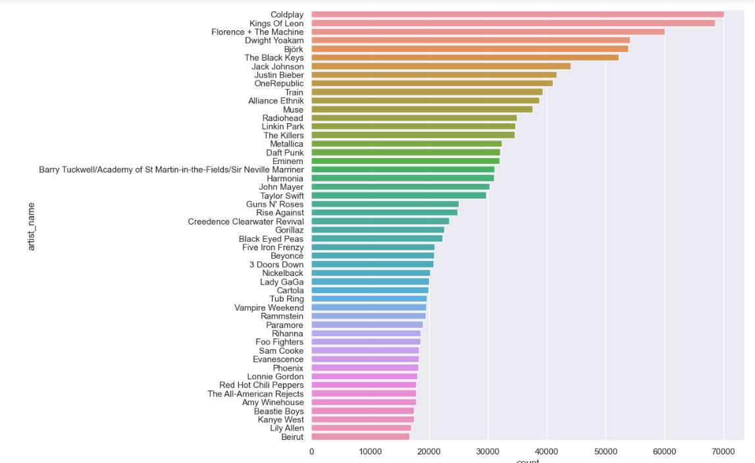
Top 20 songs
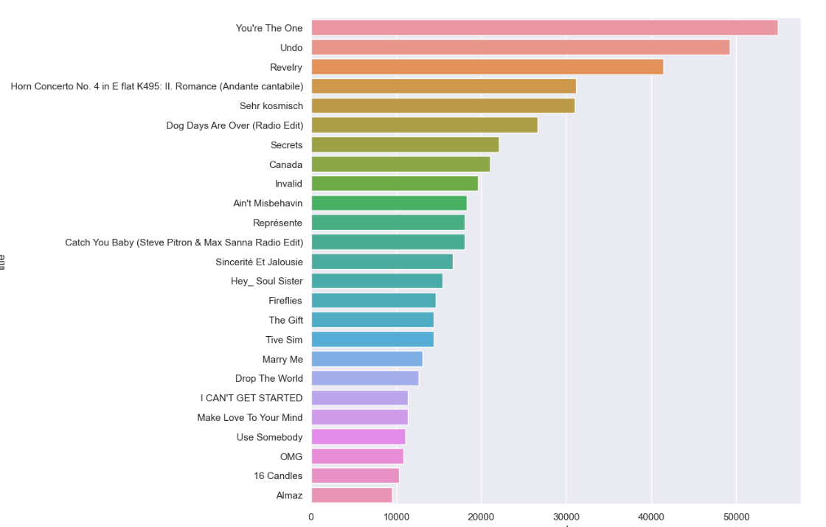

Popularity growth of Daft Punk
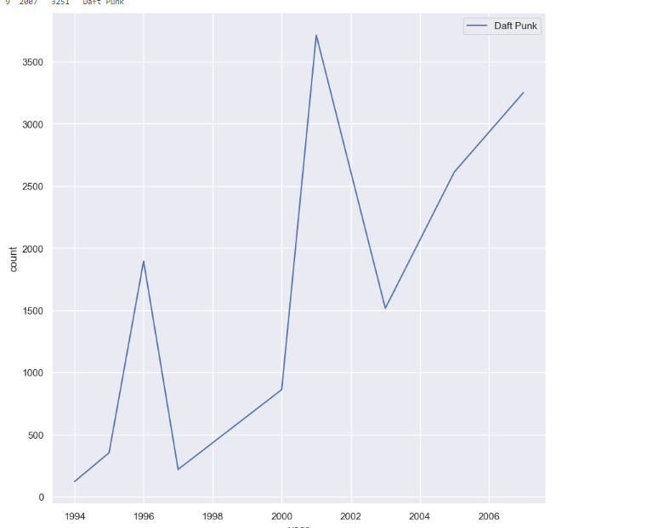
Popularity growth of Jack Johnson
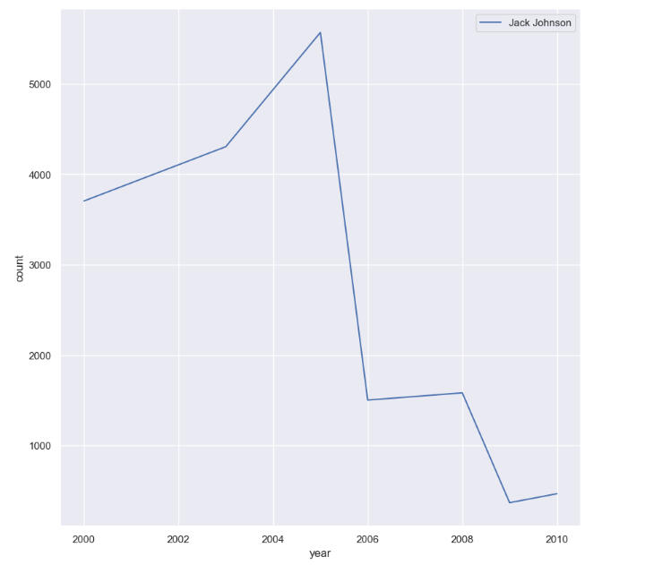

Kde plot of number of songs exposed
