

Internship at Capital Cloud India Pvt Ltd, Bottomline Company
“Automated Contract Testing Using AI”

Submitted by:
Druva S Kumar | PES1UG22CS199

Under the guidance of:
Name of the Guide: Saurabh Patel
Designation: Senior Software Engineer II
Company Name: Capital Cloud India Pvt Ltd, Bottomline Company
24 Weeks of Internship

DEPARTMENT OF COMPUTER SCIENCE AND ENGINEERING
FACULTY OF ENGINEERING
PES UNIVERSITY

(Established under Karnataka Act No. 16 of 2013)

100ft Ring Road, Bengaluru – 560 085, Karnataka, India

Internship Certificate of 6 months ( 24 weeks )
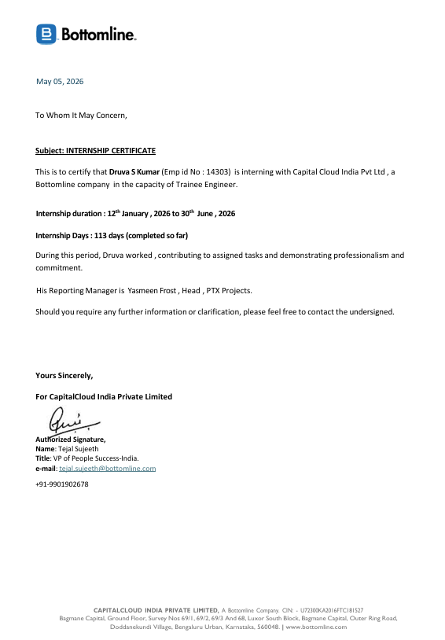

DECLARATION
I hereby declare that the project entitled “Automated Contract Testing Using AI” has been carried out at Capital Cloud India Pvt Ltd, Bottomline Company by me under the guidance of Saurabh Patel, Senior Software Engineer II and submitted in partial fulfillment of the credits for the degree of Bachelor of Technology in Computer Science and Engineering of PES University, Bengaluru during the academic semester 6 months/ 24 weeks. The matter embodied in this report has not been submitted to any other university or institution for the award of any degree.

PES1UG22CS199 | Druva S Kumar | 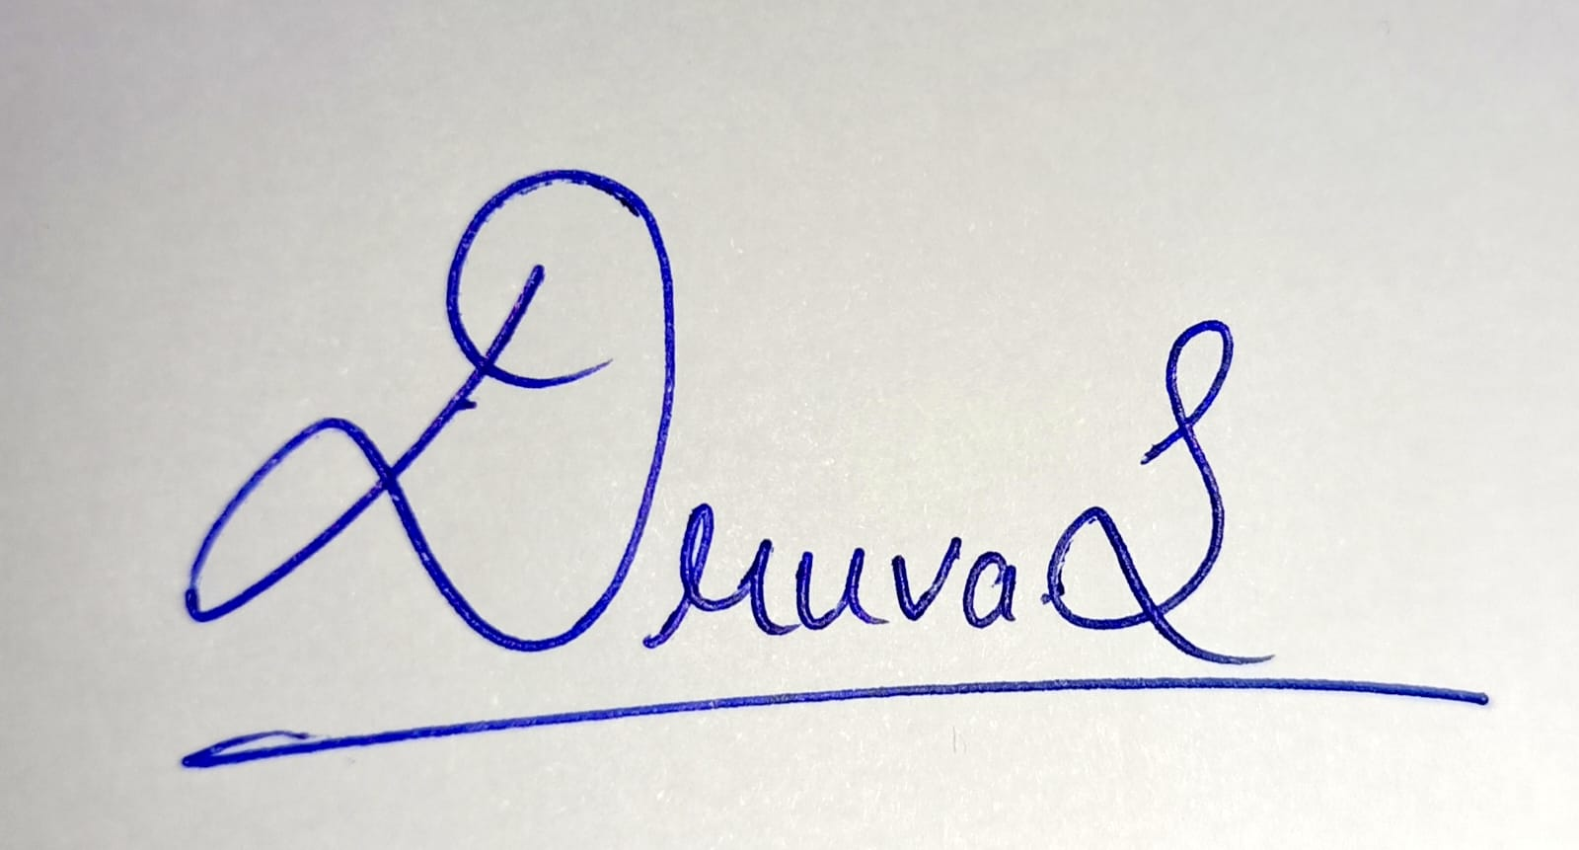

Acknowledgment

I would like to express my gratitude to my guide Saurabh Patel, Senior Software Engineer II, Capital Cloud India Pvt Ltd, Bottomline Company for their continuous guidance, assistance and encouragement throughout the development of this project.

I am grateful to the internship coordinator Prof Mahitha G and Dr Bhargavi M, Dept. of Computer Science and Engineering, PES University for organizing, managing and helping out with the entire process.

I take this opportunity to thank Dr. Shylaja S S, Chairperson, Department of Computer Science and Engineering, PES University, for all the knowledge and support I have received from the department.

I am deeply grateful to Prof Jawahar Doreswamy, Chancellor, PES University, Dr. Suryaprasad J, Vice-Chancellor, PES University for providing me various opportunities and enlightenment every step of the way.

Finally, this internship could not have been completed without the continual support and encouragement I have received from my parents and my friends.

ABSTRACT

In modern microservices architectures, ensuring API compatibility between services is critical to prevent production failures. Contract testing provides a mechanism to verify that API providers and consumers adhere to agreed-upon contracts. However, maintaining these contracts manually as APIs evolve is error-prone and time-consuming.
This internship project addresses this challenge by developing an AI-driven automation agent that manages the complete lifecycle of contract testing. The system uses Spring Cloud Contract for contract verification between a Provider API (User Service) and a Consumer API (Order Service), while a Python-based AI agent automates contract generation, drift detection, auto-remediation, CI/CD pipeline integration, and team notifications.
The project delivers a fully automated pipeline where contract drift is detected in real-time, fixes are generated and submitted as merge requests automatically, and developers are notified via email when issues are found. A web-based dashboard provides visibility into contract health across the system. This eliminates manual intervention in contract maintenance and reduces the risk of API-breaking changes reaching production environments.

TABLE OF CONTENTS

1. Introduction
2. Company Introduction
3. Internship Project Details
3.1 Project Title
3.2 Project Context
3.3 Roles and Responsibilities
3.4 Project Abstract and Scope
3.5 Project Design and Technologies Used
3.6 Implementation Details
3.7 Project Results and Learning Outcomes
4. Conclusion
5. References
LIST OF TABLES AND FIGURES

List of Tables
Table 1: Technologies Used in the Project
Table 2: CI/CD Pipeline Stages and Jobs
Table 3: AI Agent CLI Commands
Table 4: Notification Scenarios

List of Figures
Figure 1: High-Level System Architecture
Figure 2: Contract Testing Flow
Figure 3: CI/CD Pipeline Architecture
Figure 4: AI Agent Module Architecture
Figure 5: Contract Health Dashboard
Figure 6: Drift Detection and Auto-Fix Workflow

1. Introduction
Application Programming Interfaces (APIs) form the backbone of modern software systems, enabling communication between microservices, mobile applications, and third-party integrations. As organizations adopt microservices architectures, the number of inter-service API dependencies grows exponentially. A single breaking change in one service's API can cascade into failures across multiple dependent services, leading to production outages and degraded user experience.
Contract testing is a software testing methodology that addresses this challenge by defining explicit agreements (contracts) between API providers and consumers. These contracts specify the expected request and response formats, allowing each service to be tested independently against the contract rather than requiring full end-to-end integration tests.
However, maintaining contracts manually presents significant challenges. As APIs evolve, contracts can become outdated (drift), new endpoints may lack contracts (uncovered), and deleted endpoints may leave behind orphaned contracts. Detecting and fixing these issues manually is time-consuming and error-prone.
This internship project solves these challenges by building an AI-driven automation agent that manages the complete contract testing lifecycle — from generating contracts based on OpenAPI specifications, to detecting drift, auto-fixing issues, integrating with CI/CD pipelines, and notifying developers when action is required. The goal is to make contract compliance fully automated and zero-maintenance.

2. Company Introduction

Bottomline Technologies is a global financial technology company that provides cloud-based solutions for business payments, financial document automation, and digital banking. Headquartered in the United States, the company serves financial institutions, corporations, and banks across the world, helping them modernize their payment and financial processes.
The company's product portfolio includes solutions for payment processing, fraud detection, financial messaging, and regulatory compliance. Bottomline's engineering teams follow modern software development practices including microservices architecture, continuous integration/continuous deployment (CI/CD), and cloud-native development.
As part of the Core Services engineering division, the internship focused on improving the quality and reliability of inter-service API communication through automated contract testing. The team follows agile development methodologies with GitLab as the primary platform for source control, CI/CD, and collaboration.

3. Internship Project Details

3.1 Project Title

Contract Testing Automation Using AI-Driven Agent
3.2 Project Context

This project is part of the broader quality assurance and DevOps initiative within the engineering division. The organization's microservices ecosystem comprises multiple services that communicate via REST APIs. Ensuring API compatibility across services during rapid development cycles was identified as a key challenge. This project was initiated as an independent initiative to build tooling that automates contract testing and integrates it into the existing CI/CD workflow.
3.3 Roles and Responsibilities

As the sole developer on this project, the responsibilities encompassed the full software development lifecycle:
- Designing the system architecture for contract testing automation
- Developing the Provider API (User Service) and Consumer API (Order Service) as demonstration microservices
- Implementing Spring Cloud Contract for provider-side contract verification and consumer-side stub testing
- Building the Python-based AI agent with modules for contract generation, drift detection, report generation, and auto-remediation
- Designing and implementing the GitLab CI/CD pipeline with automated contract testing gates
- Developing a web-based dashboard for real-time contract health monitoring
- Implementing automated merge request creation for contract fixes
- Building a notification system for developer alerts via email
- Writing documentation and conducting end-to-end testing

3.4 Project Abstract and Scope
The project scope encompasses building a complete contract testing automation system consisting of three main components:
- Provider API (User Service): A Spring Boot REST API that manages user data with CRUD operations. It exposes an OpenAPI specification that serves as the source of truth for contract generation.
- Consumer API (Order Service): A Spring Boot REST API that depends on the Provider API. It uses the UserServiceClient to fetch user information for order processing, demonstrating real-world inter-service dependencies.
- AI Agent: A Python-based command-line tool that automates the entire contract testing lifecycle — generation, validation, drift detection, auto-fix, CI/CD integration, dashboard, and notifications.

3.5 Project Design and Technologies Used
The system follows a modular architecture where each component operates independently but integrates through well-defined interfaces. The design principles include:
- Separation of Concerns: Each module handles a single responsibility
- OpenAPI as Source of Truth: All contract generation derives from the live API specification
- Fail-Fast in CI/CD: Contract failures block deployment to prevent breaking changes
- Zero-Maintenance: Contracts are auto-generated and auto-fixed, requiring no manual intervention
- Observable: Dashboard and notifications provide visibility into system health

Technology | Version | Purpose
Java | 22+ | Provider and Consumer API development
Spring Boot | 3.2.5 | REST API framework with embedded server
Spring Cloud Contract | 4.1.3 | Contract verification and stub generation
Python | 3.x | AI Agent development
Flask | 3.x | Contract Health Dashboard web UI
Maven | 3.9 | Java project build and dependency management
GitLab CI/CD | - | Continuous integration and deployment pipeline
OpenAPI 3.0 | - | API specification standard
YAML | - | Contract file format
SMTP | - | Email notification delivery
Table 1: Technologies Used in the Project

3.6 Implementation Details (Modules)
The project was implemented in a phased approach, with each phase building upon the previous one. The system comprises the following key modules:
3.6.1 Provider API (User Service)
The Provider API is a RESTful web service built with Spring Boot that manages user entities. It exposes five endpoints for CRUD operations (Create, Read, Update, Delete) on user resources. The API automatically generates an OpenAPI 3.0 specification via SpringDoc, which serves as the single source of truth for contract generation. Spring Cloud Contract Maven plugin reads YAML contract files from the test resources directory, auto-generates JUnit verification tests, and produces a stubs JAR for consumer-side testing.
3.6.2 Consumer API (Order Service)
The Consumer API demonstrates a real-world service dependency. It provides order management functionality and depends on the Provider API to fetch user information. The UserServiceClient makes HTTP calls to the Provider. During testing, Spring Cloud Contract Stub Runner replaces the real Provider with a WireMock server loaded with stubs generated from the contracts. This enables isolated testing of the Consumer without requiring the Provider to be running.
3.6.3 AI Agent — Core Modules
The AI Agent is the central automation tool, implemented in Python with a command-line interface. It consists of the following modules:
OpenAPI Spec Reader: Fetches and parses the live OpenAPI specification from the running Provider API, extracting endpoint details including paths, methods, request/response schemas, and field types.
Contract Generator: Generates Spring Cloud Contract YAML files from the parsed OpenAPI specification. It creates contracts with regex-based matchers for flexible validation rather than hardcoded values.
Drift Detector: Compares existing contract files against the current OpenAPI specification to identify three types of issues: drifted contracts (schema mismatch), uncovered endpoints (no contract), and orphaned contracts (no matching endpoint).
Report Generator: Produces detailed reports showing contract health status, coverage percentage, and specific drift details with remediation suggestions.
CI Config Generator: Generates a complete GitLab CI/CD pipeline configuration with multi-stage builds, contract tests, drift detection, auto-fix, and deployment gates.
MR Creator: Automatically creates GitLab Merge Requests containing auto-fixed contracts, enabling a human-in-the-loop review process before changes are merged.
Notifier: Sends automated notifications to developers via email when contract drift is detected or tests fail, using the corporate SMTP relay for delivery.
3.6.4 CI/CD Pipeline
The GitLab CI/CD pipeline enforces contract compliance on every code push. It is organized into five stages:
Stage | Jobs | Purpose
Build | provider-build, consumer-build | Compile source code and detect compilation errors
Test | provider-contract-test, consumer-contract-test, ai-agent-drift-check | Run contract verification, stub testing, and drift detection
Report | contract-report, notify-team | Generate test reports and send notifications
Fix | auto-fix-contracts | Auto-remediate drifted contracts (manual trigger)
Deploy | deploy | Gated deployment — only if all tests pass
Table 2: CI/CD Pipeline Stages and Jobs

The pipeline uses a deployment gate pattern — contract test failures block deployment, ensuring that API-breaking changes cannot reach production. The auto-fix job provides a one-click remediation option that generates correct contracts and submits them as a merge request for review.
3.6.5 Contract Health Dashboard
A Flask-based web dashboard provides real-time visibility into contract health. It displays the overall health status (Healthy, Warning, Critical), coverage percentage, per-endpoint breakdown, drift detection results, and historical health trends. The dashboard fetches live data from the running Provider API and presents it in an intuitive web interface accessible at a configurable port.
3.6.6 Notification System
The notification module closes the feedback loop by alerting developers immediately when issues are detected. It supports email delivery via corporate SMTP relay and Slack webhooks. Notifications are triggered automatically by the CI/CD pipeline and include details about the drift, coverage metrics, and actionable remediation steps. When the SMTP server is not reachable (e.g., during local development), the system falls back to saving notification previews locally.

Command | Function | Auto-Notify
generate | Generate contract YAML files from OpenAPI spec | No
drift | Detect drift between contracts and live spec | Yes
report | Full contract health report | Yes
validate | Validate contracts for CI/CD | Yes
fix | Auto-fix drifted contracts + create merge request | Yes
notify | Send standalone notification | Always
ci | Generate GitLab CI/CD pipeline configuration | No
dashboard | Start web-based health dashboard | No
Table 3: AI Agent CLI Commands

3.7 Project Results and Learning Outcomes

3.7.1 Results
The project successfully achieved its objectives of automating the complete contract testing lifecycle. Key measurable outcomes include:
- 100% contract coverage achieved across all five API endpoints
- Automated drift detection with three severity levels (Healthy, Warning, Critical)
- End-to-end automated workflow: drift detection to fix to merge request creation in a single pipeline run
- Zero manual intervention required for contract maintenance during normal API evolution
- Real-time developer notifications enabling rapid response to breaking changes
- Web dashboard providing at-a-glance visibility into API contract health
- Complete CI/CD integration with deployment gates preventing broken APIs from reaching production

Scenario | Action | Notification
Drift detected (Critical) | Auto-fix + MR creation | Email with drift details
Drift detected (Warning) | Alert developer | Email with coverage report
All contracts healthy | No action needed | Confirmation email
Contract test failure | Block deployment | Email with failure details
Auto-fix completed | MR ready for review | Email with MR link
Table 4: Notification Scenarios

3.7.2 Learning Outcomes
Spring Cloud Contract Framework: Gained hands-on experience with consumer-driven contract testing, understanding the provider verification and consumer stub testing paradigms.
Microservices Architecture: Learned how services communicate via REST APIs and the challenges of maintaining compatibility across service boundaries.
CI/CD Pipeline Design: Designed and implemented a multi-stage GitLab CI/CD pipeline with dependency management, artifact passing, and deployment gates.
Python CLI Tool Development: Built a modular command-line application with argparse, multiple subcommands, and extensible architecture.
API Specification Standards: Worked extensively with OpenAPI 3.0 specifications and learned to parse and interpret schema definitions programmatically.
Git Workflow: Practiced feature branching, merge requests, code review workflows, and automated branch management via APIs.
DevOps Practices: Understood the importance of automated quality gates, fast feedback loops, and developer experience in modern software delivery.
SMTP and Notification Systems: Learned about email delivery mechanisms, corporate SMTP relays, and building reliable notification pipelines.

4. Conclusion

This internship project successfully demonstrates that contract testing can be fully automated using an AI-driven agent, eliminating the manual overhead traditionally associated with maintaining API contracts in microservices architectures. The system provides end-to-end automation from contract generation to drift detection, auto-remediation, and developer notification.
The key contribution of this project is the integration of multiple automation techniques into a cohesive pipeline. Rather than treating contract testing as an isolated activity, the system embeds it into the development workflow such that contract compliance is continuously verified, issues are automatically detected and fixed, and developers are immediately notified — all without requiring manual intervention.
The project has been deployed to the team's GitLab CI/CD pipeline and is actively being used to validate API contracts on every code push. Future enhancements could include support for additional contract formats (Pact, gRPC), integration with API gateway metrics for production drift detection, and machine learning-based contract generation that learns from API usage patterns.
This internship provided invaluable experience in full-stack development, DevOps practices, and automation engineering. The skills acquired — from Java/Spring Boot and Python development to CI/CD pipeline design and notification systems — form a strong foundation for a career in software engineering.

5. References

[1] Spring Cloud Contract Documentation, "Spring Cloud Contract Reference Guide", VMware, 2024. Available: https://docs.spring.io/spring-cloud-contract/
[2] OpenAPI Initiative, "OpenAPI Specification v3.0", The Linux Foundation, 2021. Available: https://spec.openapis.org/oas/v3.0.3
[3] S. Newman, "Building Microservices: Designing Fine-Grained Systems", O'Reilly Media, 2nd Edition, 2021.
[4] GitLab Documentation, "GitLab CI/CD Pipeline Configuration Reference", GitLab Inc., 2024. Available: https://docs.gitlab.com/ee/ci/
[5] Spring Boot Documentation, "Spring Boot Reference Guide v3.2", VMware, 2024. Available: https://docs.spring.io/spring-boot/docs/3.2.x/reference/
[6] M. Fowler, "ContractTest", Martin Fowler Blog, 2011. Available: https://martinfowler.com/bliki/ContractTest.html
[7] Python Software Foundation, "Python 3 Documentation", 2024. Available: https://docs.python.org/3/
[8] Flask Documentation, "Flask Web Framework", Pallets Projects, 2024. Available: https://flask.palletsprojects.com/

