**COMP6231 – Human and Computer Interaction (Flutter)**

**WG22-1**

**GitHub:** [**https://github.com/Druxturd/Qualif-Flutter-WG**](https://github.com/Druxturd/Qualif-Flutter-WG)

1. **Login Page**
   1. Logo, fields, checkbox, button

* 1. Empty Validation

* 1. Email ends with ‘@gmail.com’

* 1. Password length >= 5

* 1. Checkbox must be checked

1. **Home Page**
   1. Carousel, infographics

* 1. Toggle light/dark theme

* 1. Navigation Bar

1. **Items Page**

1. **Details Page**
   1. First Tab

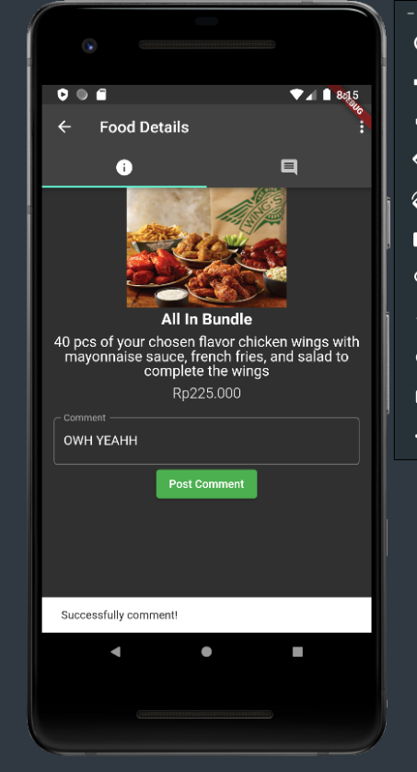

* 1. Second Tab

