Math 0910: Introduction Algebra

Prof. Francois Nguyen

Spring 2023

  
email: [Francois.nguyen@saintpaul.edu](mailto:Francois.nguyen@saintpaul.edu)  
web: MymathLab.com  
office hours: Th 9:30 to 11:00 am and by appointment  
office: 3460  
classroom: 4140  
classhours: T 9:00 am to 11:55 pm  
#photo:

# Overview:

This course is Introduction to Algebra Online course. The topics include real numbers, methods of solving equations and inequalities and their applications, exponents and polynomials, factoring polynomials, solving quadratic equations and their applications, rational expressions, rational exponents and radicals, and graphing functions (linear and quadratic).

# Define the cars vector with 5 values  
cars <- c(1, 3, 6, 4, 9)  
  
# Graph cars using blue points overlayed by a line   
plot(cars, type="o", col="blue")  
  
# Create a title with a red, bold/italic font  
title(main="Autos", col.main="red", font.main=4)

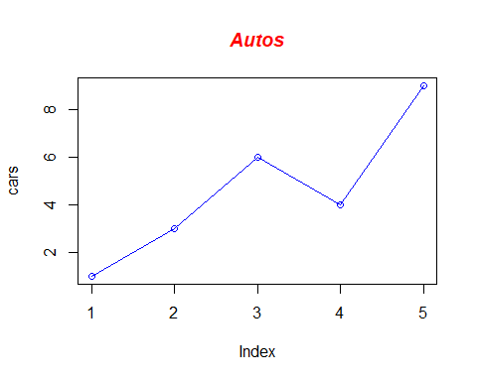

# Course Requirements

A minimum grade of C is required in this course to progress to COURSE.

# Course Objectives:

At the completion of this course, students will be able to:

* Identify and understand the basic concepts of algebraic expressions.
* Perform operations on polynomial and rational expressions.
* Apply the definition of absolute value to solve inequalities and equations involving absolute values.
* Find solutions to and graph systems of linear equations and inequalities.
* Solve equations involving first and second-degree polynomials and rational expressions.
* Manipulate radical expressions using laws of exponents.
* Understand basic properties of functions.
* Apply properties of rational and radical expressions, polynomials, and absolute value in the context of real-life

# Course Policies:

## General:

– Computers, Calculators are not to be used unless instructed to do so. – Quizzes and exams are closed book, closed notes.

## Grade:

makeup quizzes or exams will be given.

– Grades in the C range represent performance that meets expectations; Grades in the B range represent performance that is substantially better than the expectations; Grades in the A range represent work that is excellent.

– Grades will be maintained in the LMS course shell. Students are responsible for tracking their progress by referring to the online gradebook.

# Assignments

– Students are expected to work independently. Offering and accepting solutions from others is an act of plagiarism, which is a serious offense and all involved parties will be penalized according to the Academic Honesty Policy.

– Discussion among students is encouraged, but when in doubt, direct your questions to the professor, tutor, or lab assistant.

– No late assignments will be accepted under any circumstances.

# Attendance and Absences

## `geom_smooth()` using formula = 'y ~ x'

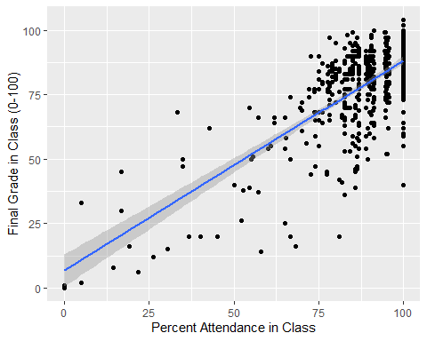

A Scatterplot of the Relationship between Class Attendance and Final Grade

– Attendance is expected and will be taken each class. You are allowed to miss 1 class during the semester without penalty. Any further absences will result in point and/or grade deductions.

– Students are responsible for all missed work, regardless of the reason for absence. It is also the absentee’s responsibility to get all missing notes or materials.

# Academic Honesty Policy Summary:

In addition to skills and knowledge, Saint Paul College aims to teach students appropriate Ethical and Professional Standards of Conduct. The Academic Honesty Policy exists to inform students and Faculty of their obligations in upholding the highest standards of professional and ethical integrity. All student work is subject to the Academic Honesty Policy. Professional and Academic practice provides guidance about how to properly cite, reference, and attribute the intellectual property of others. Any attempt to deceive a faculty member or to help another student to do so will be considered a violation of this standard.

# College Policy

The College’s academic honesty policies can be found in the catalog. Please be assured that there will be absolutely no tolerance for cheating in any way. All your quizzes and exams must be done independently with no help from anyone. Make sure you copy the code of honor statement below and send me an email with your name and date of the time to confirm you adhere to this course policy: “I will register for only one account on Mymathlab.com. My answers to homework, quizzes and exams will be my own work (except for assignments that explicitly permit collaboration).

I will not make solutions to homework, quizzes or exams available to anyone else. This includes both solutions written by me, as well as any official solutions provided by the course instructor. I will not engage in any other activities that will dishonestly improve my results or dishonestly improve/hurt the results of others. Your name. Dated on Jan/…/2023.

# Special Services and Math Tutoring

Special Accommodations: It is college policy to provide reasonable accommodations to students with disabilities. Please contact the office of Disability Resources and Access if you wish to discuss this policy. The Math Center (MC) will be open for drop-in tutoring in room 3125. This tutoring is FREE and no appointment is necessary.

# Online coursework Integrity Declaration

Online submission of, or placing one’s name on an exam, assignment, or any course document is a statement of academic honor that the student has not received or given inappropriate assistance in completing it and that the student has complied with the Academic Honesty Policy in that work.

# Consequences

An instructor may impose a sanction on the student that varies depending upon the instructor’s evaluation of the nature and gravity of the offense. Possible sanctions include but are not limited to, the following: (1) Require the student to redo the assignment; (2) Require the student to complete another assignment; (3) Assign a grade of zero to the assignment; (4) Assign a final grade of “F” for the course. A student may appeal these decisions according to the Academic Grievance Procedure. (See the relevant section in the Student Handbook.) Multiple violations of this policy will result in a referral to the Conduct Review Board for possible additional sanctions.

The full text of the Academic Honesty Policy is in the Student Handbook.

# Course Schedule

(See the addedum)

## Week 1, January 9: Introduction to the Course

*Assignment*:

1. [Bryan, Jennifer. 2016. Chapters 1-16.](http://happygitwithr.com) Read this carefully and follow its instructions to get set up with , RStudio, Git, and GitHub on your laptop before we meet.

## Week 2, January 16: The Replication Crisis and Reproducibility

*Readings*:

1. [Aschwanden, Christie, and Maggie Koerth-Baker. 2016. “How Two Grad Students Uncovered an Apparent Fraud—and a Way to Change Opinions on Transgender Rights.” *FiveThirtyEight*, April 7](http://fivethirtyeight.com/features/how-two-grad-students-uncovered-michael-lacour-fraud-and-a-way-to-change-opinions-on-transgender-rights/), and [Dimitrova, Velichka. 2013. “Reinhart-Rogoff Revisited: Coding Errors Happen—Key Problem Was in Not Making the Data Openly Available from the Start.” *LSE: The Impact Blog*, April 24.](http://blogs.lse.ac.uk/impactofsocialsciences/2013/04/24/reinhart-rogoff-revisited-why-we-need-open-data-in-economics/)
2. [Data Access and Research Transparency (DA-RT): A Joint Statement by Political Science Journal Editors.](http://journals.cambridge.org/action/displayAbstract?fromPage=online&aid=9911378&fulltextType=LT&fileId=S2049847015000448)
3. [*AJPS* Replication and Verification Policy](https://ajps.org/ajps-replication-policy/) and [*American Journal of Political Science* Guidelines for Preparing Replication Files.](https://ajpsblogging.files.wordpress.com/2015/03/ajps-guide-for-replic-materials-1-0.pdf)
4. [Gelman, Andrew, and Eric Loken. 2013. “The Garden of Forking Paths: Why Multiple Comparisons Can Be a Problem, Even When There Is No ‘Fishing Expedition’ or ‘*p*-Hacking’ and the Research Hypothesis Was Posited Ahead of Time.”](http://www.stat.columbia.edu/~gelman/research/unpublished/p_hacking.pdf)
5. [Leek, Jeffrey T., and Roger D. Peng. 2015. “Opinion: Reproducibile Research Can Still Be Wrong: Adopting a Prevention Approach.” *Proceedings of the National Academy of Sciences* 112(6):1645-1646](http://www.pnas.org.proxy.lib.uiowa.edu/content/112/6/1645) and [Patil, Prasad, Roger D. Peng, and Jeffrey T. Leek. 2016. “A Statistical Definition for Reproducibility and Replicability.” *bioRxiv*, July 29.](http://biorxiv.org/content/biorxiv/early/2016/07/29/066803.full.pdf)

## Week 3, January 23: Chapter-03

*Assignment*:

1. [Bryan, Jennifer. 2016. Chapters 1-16.](http://happygitwithr.com) Read this carefully and follow its instructions to get set up with , RStudio, Git, and GitHub on your laptop before we meet.

## Week 4, January 30: Chapter-04

*Readings*:

1. [Bryan, Jennifer. 2016. Chapters 1-16.](http://happygitwithr.com) Read this carefully and follow its instructions to get set up with , RStudio, Git, and GitHub on your laptop before we meet.
2. [Bryan, Jennifer. 2016. Chapters 1-16.](http://happygitwithr.com) Read this carefully and follow its instructions to get set up with , RStudio, Git, and GitHub on your laptop before we meet.

## Week 5, February 6: Chapter-05

*Readings*:

1. [Bryan, Jennifer. 2016. Chapters 1-16.](http://happygitwithr.com) Read this carefully and follow its instructions to get set up with , RStudio, Git, and GitHub on your laptop before we meet.

## Week 6, February 13: Chapter-06

*Readings*: [Bryan, Jennifer. 2016. Chapters 1-16.](http://happygitwithr.com) Read this carefully and follow its instructions to get set up with , RStudio, Git, and GitHub on your laptop before we meet.

## Week 7, February 20: Chapter-07

*Readings*: [Bryan, Jennifer. 2016. Chapters 1-16.](http://happygitwithr.com) Read this carefully and follow its instructions to get set up with , RStudio, Git, and GitHub on your laptop before we meet.

## Week 8, February 27: Chapter-08

*Readings*: [Bryan, Jennifer. 2016. Chapters 1-16.](http://happygitwithr.com) Read this carefully and follow its instructions to get set up with , RStudio, Git, and GitHub on your laptop before we meet.

## Week 9, March 6: Chapter-09

## Week 10, March 13: Chapter-10

## Week 11, March 20: Chapter-11

## Week 12, March 27: Chapter-12

## Week 13, April 3: Chapter-13

## Week 14, April 10: Chapter-14

## Week 15, April 17: Chapter-15

## Week 16, April 24: Chapter-16

## party  
## gender Democrat Independent Republican  
## M 762 327 468  
## F 484 239 477

mm <- matrix(c(94,100,80,93,73,79,50,60,00,60),ncol=2,byrow=TRUE,  
 dimnames = list(c("A", "B","C","D","F"),  
 c("Lower ", "Upper")))  
 mm

## Lower Upper  
## A 94 100  
## B 80 93  
## C 73 79  
## D 50 60  
## F 0 60

library(gridExtra)

##   
## Attaching package: 'gridExtra'

## The following object is masked from 'package:dplyr':  
##   
## combine

mm <- matrix(c(94,100,80,93,73,79,50,60,00,60),ncol=2,byrow=TRUE,  
 dimnames = list(c("A", "B","C","D","F"),  
 c("Lower ", "Upper")))  
   
 grid.table(mm)

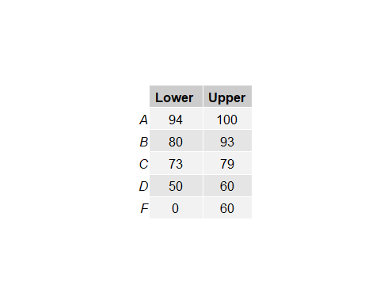

library(knitr)  
kable(table(state.division, state.region))

|  | Northeast | South | North Central | West |
| --- | --- | --- | --- | --- |
| New England | 6 | 0 | 0 | 0 |
| Middle Atlantic | 3 | 0 | 0 | 0 |
| South Atlantic | 0 | 8 | 0 | 0 |
| East South Central | 0 | 4 | 0 | 0 |
| West South Central | 0 | 4 | 0 | 0 |
| East North Central | 0 | 0 | 5 | 0 |
| West North Central | 0 | 0 | 7 | 0 |
| Mountain | 0 | 0 | 0 | 8 |
| Pacific | 0 | 0 | 0 | 5 |

library(knitr) kable(table(state.division, state.region))