2. Interpretation
Experimental Design
The network topology was instantiated within Mininet, and the aggregate throughput measurements were conducted using iperf via parallel TCP streams (with a duration of 15 seconds per test run). The experiment evaluates and compares two distinct routing paradigms:
- A Single-Path approach utilizing Dijkstar.
- A Multi-Path approach.
The test scenarios are deliberately designed to isolate specific hierarchical layers of the topology (Edge, Aggregation, and Core). This isolation allows for a structured verification of both path diversity and the impact of oversubscription effects under localized and global traffic patterns.
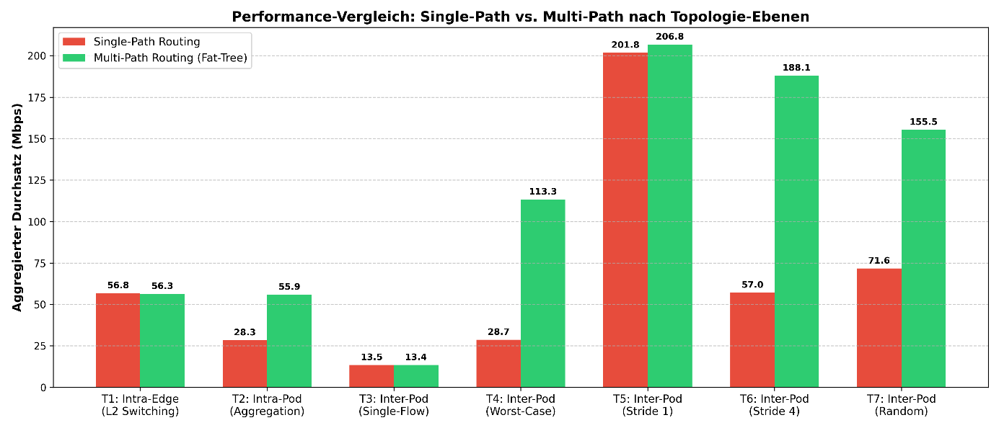
Discussion of Results
Test 1 (Intra-Edge) & Test 3 (Inter-Pod Single): Baseline Measurements
- Test 1: Hosts communicate within the same subnet on the same Top-of-Rack (ToR) switch. The traffic does not leave the edge layer. Both routing schemes perform identically at the hardware limit of the L2 switching fabric (~56.3 Mbps vs. ~56.8 Mbps).
- Test 3: An isolated inter-pod flow is generated across the topology. Since there is no path contention or resource competition, path latency and single-link capacity limit the bandwidth to ~13.4 Mbps for both configurations.
Test 2 (Intra-Pod): Aggregation-Layer Bottleneck
- Setup: Traffic crosses the edge switch towards the aggregation layer.
- Single-Path: Throughput degenerates to 28.29 Mbps. This occurs because Dijkstar enforces a single tree-like path, causing immediate flow collisions on a single aggregation uplink.
- Multi-Path: Utilizes two-level Routing, scaling the aggregate throughput to 55.9 Mbps (effectively a factor of 2 improvement).
Test 4 (Inter-Pod Bisection): Worst-Case Core Routing
- Setup: This scenario provokes maximum oversubscription via asynchronous communication between the left (Pods 0, 1) and right (Pods 2, 3) halves of the data center.
- Single-Path: Collapses to 28.68 Mbps. The root cause is that the spanning tree routes the entire bisection traffic through a single core switch, creating a massive bottleneck.
- Multi-Path: Scales the aggregate throughput linearly to 113.3 Mbps (a factor of ~4 improvement). This directly validates the core principle of the Fat-Tree architecture: with k=4, there are 4 available core switches. By leveraging a two-level routing, the load is uniformly distributed, quadrupling the available bisection bandwidth.
Tests 5 & 6 (Stride Patterns)
- Stride(1): Forces localized communication (often mapping to intra-pod or intra-edge communication depending on index indexing). Consequently, both architectures achieve high internal aggregate throughput (~201.85 Mbps for SP vs. ~206.8 Mbps for FT).
- Stride(4): Destinies shift across Pod boundaries, triggering core layer traversal.
  - Single-Path drops significantly to 57.04 Mbps due to deterministic path collisions.
  - Multi-Path maintains a high throughput of 188.07 Mbps, because the deterministic host shift perfectly scatters the flows across all orthogonal bisection paths.
Test 7 (Random)
- Setup: Simulates a realistic 1-to-1 mapping of all hosts across the network topology.
- Performance: Multi-Path heavily outperforms Single-Path (155.52 Mbps vs. 71.63 Mbps).
- Analysis: The variance results from the probability distribution of flows over redundant links. Single-Path forces deterministic bottlenecks at the root of the spanning tree, whereas Multi-Path exploits entropy through uniform pathing to achieve effective load balancing.

