Task 6, Week 1 Progress Report
Dataset access and first inspection: UCI Diabetes 130-US Hospitals, NHANES 2017-2018, NIDS Wave 5
Name: Yakubu Ahmadu
Registration number: 250270499
Date: 23 October 2026

1. Summary
This week I downloaded all three datasets, kept the original files unchanged, documented their sources, and ran a first inspection of each one. No cleaning or recoding has been done yet. The UCI Diabetes and NHANES files are public. NIDS Wave 5 was obtained through a DataFirst account and the public-use access form, and the Stata files are now in the project folder. The raw data are kept outside version control, and each raw folder has a SOURCE.txt with the link, date and files.
The first inspection shows that the three datasets differ a lot from UCI Adult. In UCI Diabetes the raw 30-day readmission rate is almost the same for the two main race groups (11.2% and 11.3%). In NHANES the share with HbA1c at or above 6.5 is higher in the non-Hispanic Black group (14.1%) than in the non-Hispanic White group (10.5%) in the unweighted sample. NIDS has many health variables, and I list candidates below so that the outcome can be approved before I build the target.

2. Access summary
 | UCI Diabetes 130-US Hospitals | CDC NHANES 2017-2018 | South African NIDS, Wave 5
Source | https://archive.ics.uci.edu/dataset/296/diabetes+130-us+hospitals+for+years+1999-2008 | https://wwwn.cdc.gov/nchs/nhanes/search/datapage.aspx?Cycle=2017-2018 | https://saldru.uct.ac.za/nids/data-access  https://datafirst.uct.ac.za/dataportal/index.php/catalog/712  DOI 10.25828/fw3h-v708 (reference ID zaf-saldru-nids-2017-v1.0.0)
Access route | Public download (ZIP), no registration | Public XPT downloads, no registration | Free DataFirst account, public-use access form and terms, then "Get Microdata" (Stata files)
Date obtained | 22 October 2026 | 22 October 2026 | 22 October 2026 (files). Account/approval: [date]
Files obtained | diabetic_data.csv (18.7 MB), IDS_mapping.csv | DEMO_J.xpt, BMX_J.xpt, GHB_J.xpt (3.3 MB, 1.4 MB, 0.1 MB); DIQ_J.xpt also downloaded, not used yet | Package nids-w5-v1.0.0-stata14.zip (43.17 MB), 9 Stata files, version V1.0.0 (Adult_W5_Anon 182 MB, indderived_W5_Anon 23 MB, Child, hhderived, HHQuestionnaire, HouseholdRoster, Admin, Link_File, Proxy)
Country and period | United States, 130 hospitals, 1999-2008 | United States, survey 2017-2018 | South Africa, household survey 2017
One row means | One hospital encounter (a patient can appear more than once) | One survey participant (SEQN) | One person (pid) in each file
Licence and terms | [licence as stated on the UCI page] | Public CDC data; terms on the CDC website | DataFirst public-use terms accepted in the access form; raw microdata are not shared publicly
Handling of raw data: the original files are not modified. They are stored under data/<dataset>/raw/ with a SOURCE.txt, and the repository ignores raw and processed data files so that no microdata (in particular NIDS) is uploaded to GitHub.

3. First inspection (before any cleaning)

3.1 UCI Diabetes 130-US Hospitals
Item | Result
Rows x columns | 101,766 x 50 (one row is one hospital encounter)
Unique encounter_id / unique patient_nbr | 101,766 / 71,518 (30,248 extra encounters from repeat patients, so the split must be made by patient)
readmitted | NO 54,864; >30 35,545; <30 11,357
Proposed target (1 = "<30") | 1: 11,357 (11.16%); 0: 90,409
Most missing values ("?") | weight 98,569 (96.9%); medical_specialty 49,949 (49.1%); payer_code 40,256 (39.6%); race 2,273 (2.2%); diag_3 1,423; diag_2 358; diag_1 21

Race (as recorded) | Encounters | Readmitted <30 | % readmitted
AfricanAmerican | 19,210 | 2,155 | 11.22
Caucasian | 76,099 | 8,592 | 11.29
Hispanic | 2,037 | 212 | 10.41
Asian | 641 | 65 | 10.14
Other | 1,506 | 145 | 9.63
Missing ("?") | 2,273 | 188 | 8.27
All | 101,766 | 11,357 | 11.16
Observations: the raw 30-day readmission rate is nearly the same for AfricanAmerican (11.22%) and Caucasian (11.29%) patients, which is very different from the Sex gap in UCI Adult. This is a statement about the raw labels only and says nothing yet about model performance. The weight column is almost entirely missing and payer_code has mixed value types, so both need a documented decision during cleaning. I also need to check the discharge-disposition codes in IDS_mapping.csv, because patients who died or went to hospice cannot be readmitted. The race labels describe patients in the United States and are not the same population as people living in Africa.

3.2 CDC NHANES 2017-2018
Item | Result
Rows and columns per file | DEMO_J 9,254 x 46; BMX_J 8,704 x 21; GHB_J 6,401 x 2; SEQN is unique in all three files
Joins on SEQN (left joins) | 9,254 rows before and after joining BMX_J and GHB_J; analysis table 9,254 x 9
Missing values | BMXBMI 1,249 (13.5%); LBXGH (HbA1c) 3,209 (34.7%); a missing HbA1c means no lab result, not a negative result
RIDRETH3 codes | 1: 1,367; 2: 820; 3 (non-Hispanic White): 3,150; 4 (non-Hispanic Black): 2,115; 6: 1,168; 7: 634
Participants with a measured HbA1c | 6,045 of 9,254; preview of the target (HbA1c >= 6.5): 751 elevated, 5,294 below

Group (with measured HbA1c) | Below cutoff | Elevated | Total | % elevated
Non-Hispanic Black (4) | 1,172 | 193 | 1,365 | 14.14
Non-Hispanic White (3) | 1,850 | 216 | 2,066 | 10.45
Both groups | 3,022 | 409 | 3,431 | 11.92
Observations: the elevated-HbA1c share is higher in the non-Hispanic Black group (14.1%) than in the non-Hispanic White group (10.5%). These are unweighted sample counts, so they are descriptive only and are not population prevalence. The table above still includes all ages (the first rows show young children without a lab value), so an age restriction is needed. The survey design variables (WTMEC2YR, SDMVSTRA, SDMVPSU) are kept for later. The 6.5 threshold is a preview that I will confirm against medical references.

3.3 South African NIDS, Wave 5
Item | Result
Adult file | Adult_W5_Anon_V1.0.0.dta: 30,110 rows x 1,144 columns; 30,110 unique pid, none missing
Individual-derived file | indderived_W5_Anon_V1.0.0.dta: 47,055 rows x 198 columns; 47,055 unique pid, none missing
Join on pid | One-to-one: 30,110 adult rows, 0 without a population-group code
w5_best_race (all 47,055 persons) | African 36,755; Coloured 6,272; Asian/Indian 946; White 3,060; special code -9 ("Don't know") 22
Health-related variables | 60 candidate columns found by keyword in the codebook labels (saved in health_variable_candidates.csv)
The population-group counts above are for the whole individual-derived file, not only adults; adult counts per group will be computed after the join. The categories are not identical to the NHANES RIDRETH3 categories.
Candidate outcome variables (adult file). Valid answers exclude special negative codes. The exact coding must be confirmed in the codebook before a binary target is defined.
Column | Codebook label | Valid answers | Special codes | Valid categories
w5_a_hldes | j1 - Respondent's perceived health status | 23,864 | 27 | 5
w5_a_hldia | j13_3_2 - Respondent was diagnosed with diabetes? | 23,350 | 118 | 2
w5_a_hlstrk | j13_4_2 - Respondent was diagnosed with a stroke? | 23,668 | 72 | 2
w5_a_hlcan | j13_7_2 - Respondent was diagnosed with cancer? | 23,667 | 66 | 2
w5_a_hlhrt | j13_6_2 - Respondent was diagnosed with heart problems? | 23,517 | 93 | 2
w5_a_hlast | j13_5_2 - Respondent was diagnosed with asthma? | 23,416 | 113 | 2
w5_a_bpsys_1 / w5_a_bpdia_1 | n4_1_1 / n4_1_2 - Blood pressure: systolic / diastolic, reading 1 | 23,531 / 23,530 | 361 / 362 | continuous
My two proposals for the outcome are (a) perceived health status (w5_a_hldes), which has five ordered answers and the most valid responses, possibly grouped as fair/poor against the other answers, and (b) doctor-diagnosed diabetes (w5_a_hldia), which is binary and closest to the other two datasets. I would like your approval before I code either target. A diagnosed-hypertension question and the blood-pressure measurements are also available and can be checked in the full candidate list.

4. Points on which I would like your guidance
- NIDS outcome: may I use perceived health status (w5_a_hldes) or doctor-diagnosed diabetes (w5_a_hldia) as the first binary target, and which groups should be compared (African versus White, with Coloured and Asian/Indian reported when counts allow)?
- NHANES: please confirm that I should restrict the analysis to adults and use HbA1c >= 6.5 as the elevated-HbA1c definition. I will check the age limit and the threshold against the NHANES documentation and medical references.
- UCI Diabetes: please confirm that a discharge-time prediction point is suitable, so that variables recorded after discharge are excluded and the split is made by patient_nbr.

5. Next steps
- Week 2: clean and explore UCI Diabetes (missing values, duplicates by patient, target, race groups, five figures, patient-safe train/validation/test split, leakage list).
- Week 3: the same for NHANES, including the survey design variables; confirm the NIDS outcome with you.
- Week 4: NIDS variable map, cleaning and exploration once the outcome is approved.
- Task 5 results, code and failed attempts stay unchanged in their own repository.

6. Repository and files
Project folder: yakubu_health_fairness (data, src, experiments, reports, outputs, screenshots, configs, notebooks). The inspection scripts are src/p1_inspect_uci.py, src/p1_inspect_nhanes.py and src/p1_inspect_nids.py; their outputs are saved in outputs/<dataset>/phase1/ as CSV files (overview, columns, target counts, merge audit, pid audit, race counts, health candidate variables). Git commit of the first inspection: c997a0e ("week 1: raw data documented and first inspection").
GitHub repository: https://github.com/Dryaksman/yakubu_health_fairness . Raw data are excluded from the repository.

7. Evidence (screenshots)
Figure 1. UCI Diabetes: raw folder (data\uci_diabetes\raw)
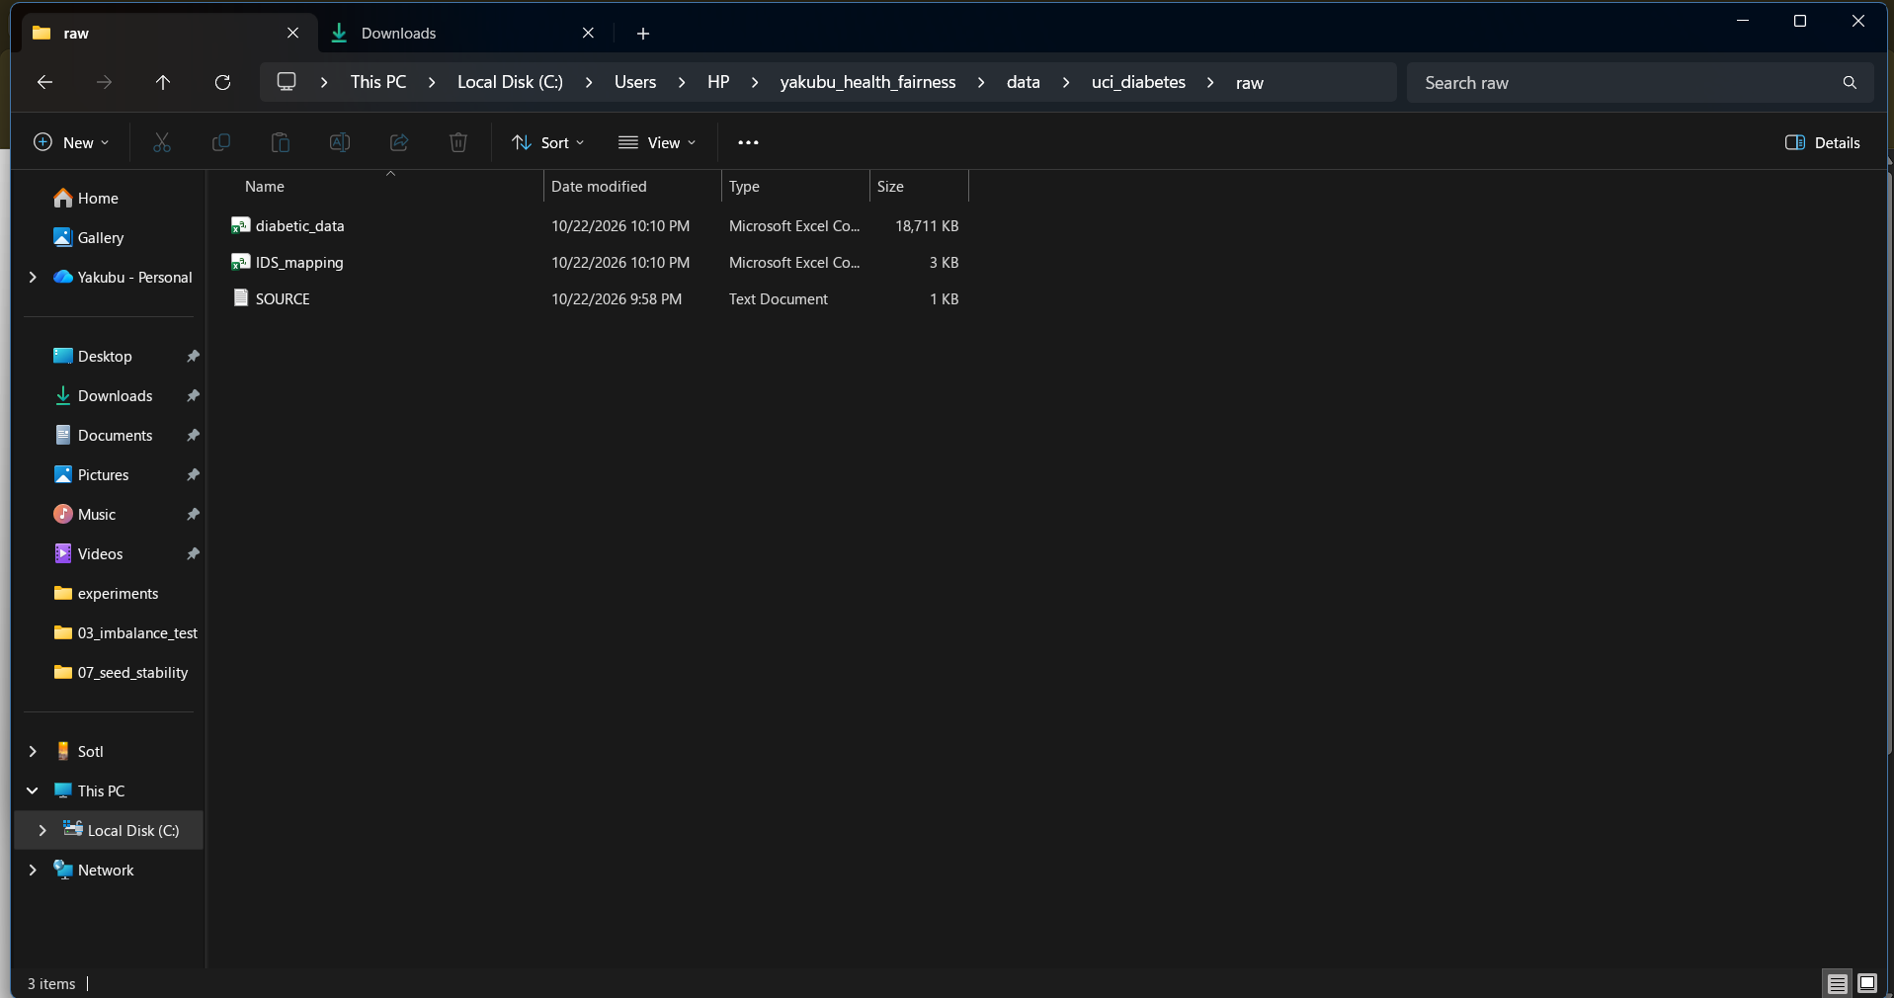
Figure 2. UCI Diabetes: first-inspection output (readmission by race, missing values, saved files)
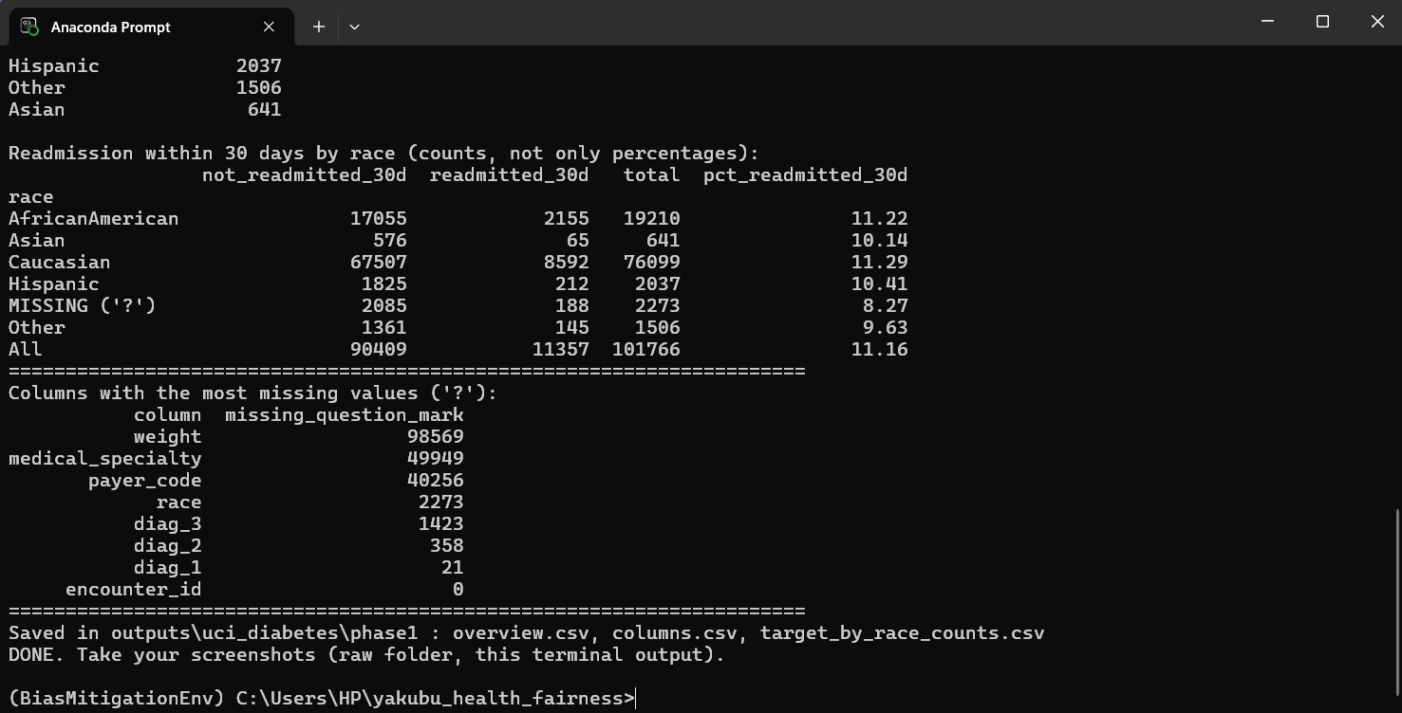
Figure 3. NHANES: raw folder (data\nhanes\raw)
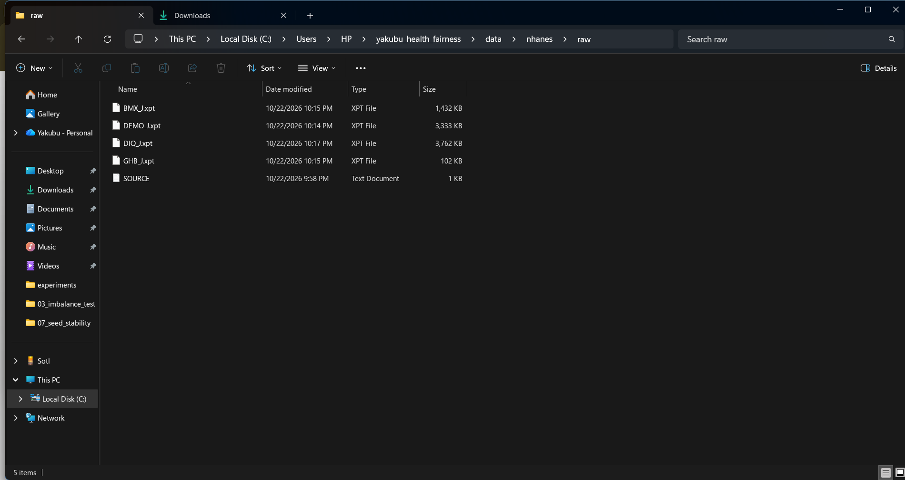
Figure 4. NHANES: first-inspection output (HbA1c preview, two-group counts, saved files)
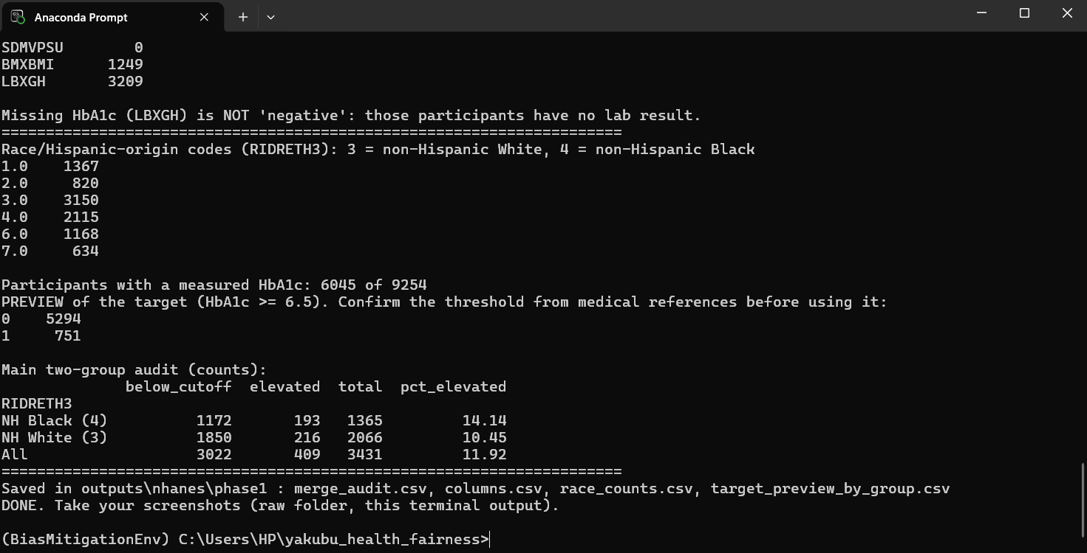
Figure 5. NIDS Wave 5: DataFirst account and "Get Microdata" page (access to the data files)
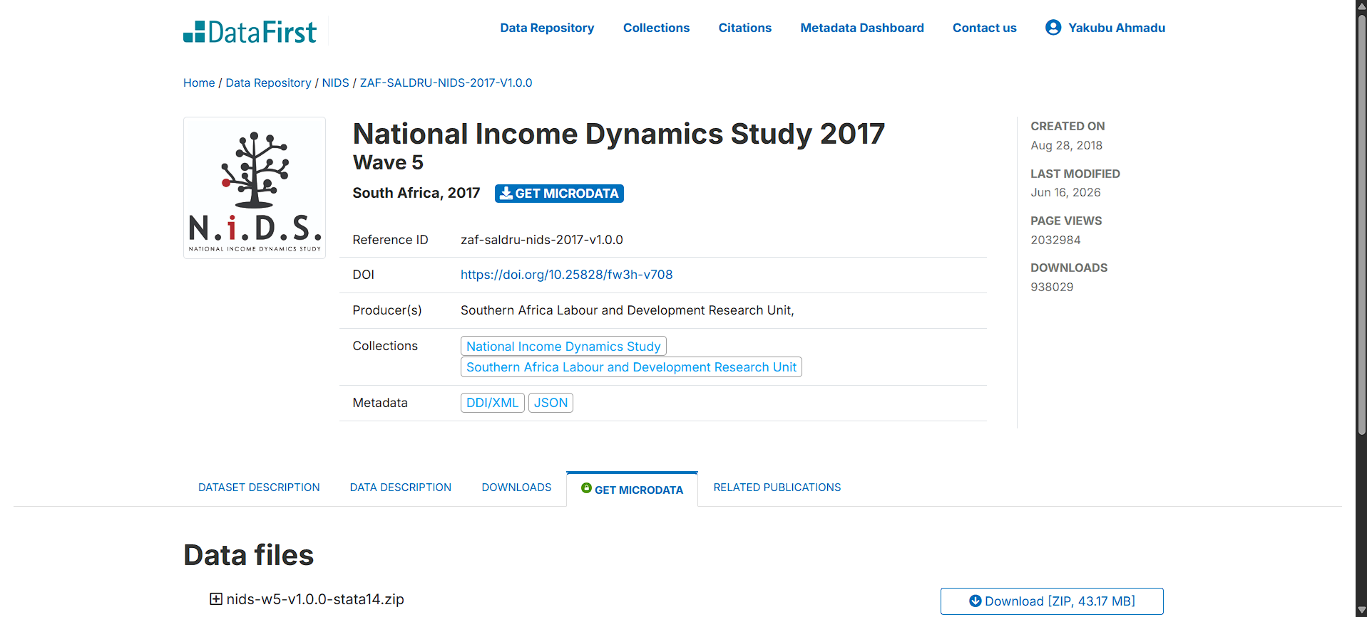
Figure 6. NIDS Wave 5: Stata data packages offered on DataFirst
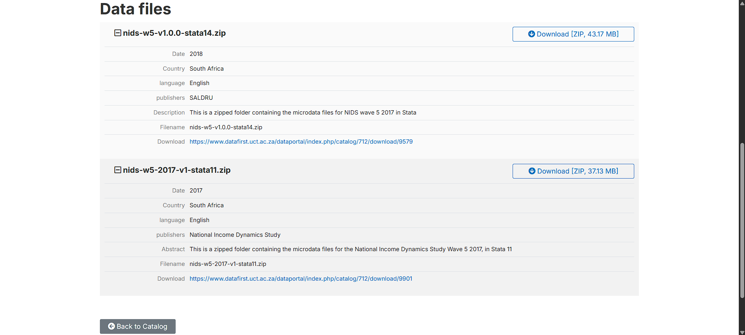
Figure 7. NIDS Wave 5: raw folder (data\nids\raw)
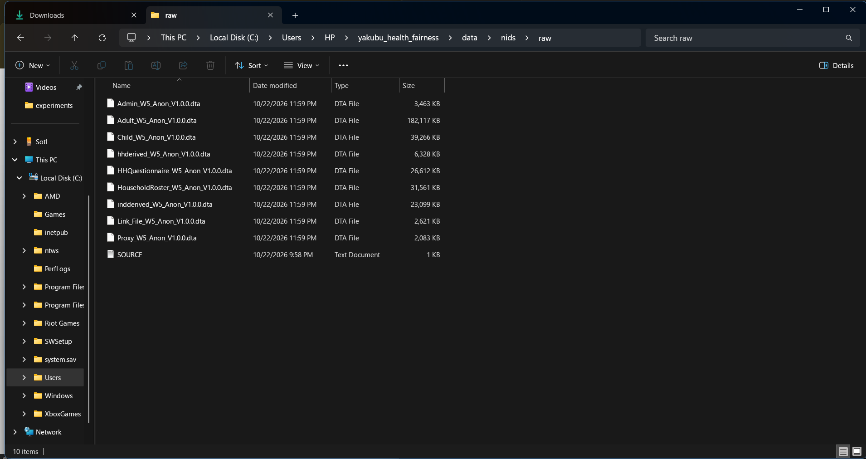
Figure 8. NIDS Wave 5: first-inspection output (end of the candidate-variable list and saved files)
