Full Paper Title

Utsav Chatterjee  School of Computer Science in Artificial Intelligence and Data Science  Utsavchatterjee741@gmail.com | Author Name  Affiliation  author@email.com | Author Name  Affiliation  author@email.com

Abstract — This study examines long-term global, national, and regional temperature patterns by integrating large-scale historical climate datasets with distributed computing and machine learning. A unified PySpark-based pipeline is developed to clean, merge, and enrich multi-century temperature records, enabling detailed analyses of trends, anomalies, and spatial variation. Results show a steady rise in global average temperature from the mid-1800s to the present, with accelerated warming observed after the mid-twentieth century. Country- and state-level evaluations identify regions experiencing heightened warming pressure and more frequent temperature anomalies. A supervised learning model is applied to forecast temperature behavior and demonstrates strong predictive accuracy, indicating continued warming in coming decades. The findings are translated into interactive visual dashboards to support scientific interpretation and decision-making. Overall, this work demonstrates how scalable computation combined with historical climate records can provide deeper insight into global warming trends and future climate risks.
Index Terms — climate data analysis, machine learning forecasting, PySpark processing, temperature anomaly detection.

Introduction
Climate change has emerged as one of the most pressing scientific and societal challenges of the twenty-first century. Rising global temperatures, extreme weather patterns, and long-term shifts in climatic stability have heightened the need for detailed, data-driven assessments of historical and future warming trends. Recent advances in large-scale climate datasets and distributed computing frameworks have enabled researchers to examine temperature variations at global, regional, and local levels with far greater precision. Leveraging these capabilities is essential for identifying persistent warming patterns, evaluating geographic disparities, and detecting anomalies that may indicate climate-related stress on urban and ecological systems.

This study analyzes more than a century of global, country-level, and state-level temperature observations using PySpark for scalable processing and machine learning models for predictive insights. By integrating multiple temperature datasets, the work provides a unified perspective on how warming has evolved since the mid-nineteenth century and how it may progress in the decades ahead. The analysis includes long-term trend evaluation, seasonal behavior, anomaly detection through statistical techniques, and forecasting using supervised learning. These results are then visualized through an interactive Power BI dashboard designed to support scientific interpretation and public communication.

The objective of this research is to demonstrate a complete data-engineering and analytics workflow—from ingestion and cleansing to forecasting and visualization—while contributing meaningful observations about global and regional climate dynamics. The findings highlight both the scale of warming already underway and the potential risks for future temperature escalation, particularly in rapidly developing urban regions.

LITERATURE REVIEW
The study of global and regional temperature behaviour has expanded significantly over the past several decades, driven by increased availability of long-term observational records and advances in computational analysis. Early foundational work by Hansen et al. [3] established the importance of consistent temperature reconstruction and highlighted the accelerating warming trend detected in surface datasets. These findings were later refined through the GISTEMP v4 analysis produced by NASA’s Goddard Institute for Space Studies [5], which emphasized the need for methodological rigor in homogenization, interpolation, and anomaly detection.
More recent investigations have explored the role of large-scale data processing and machine learning in understanding climate behaviour. Gurung [1] demonstrated that big data pipelines, particularly those built on distributed computing frameworks, can effectively process multi-million-record temperature archives to uncover spatiotemporal warming patterns. Complementary to this, NASA’s Earth Science reports [4] provide detailed documentation on how global temperature measurements are collected, calibrated, and validated to ensure scientific reliability.
Public discourse on climate change has also underscored the interpretive challenges facing researchers. Schmidt [2] noted that while the scientific community agrees on the persistent warming signal, the underlying drivers of short-term variability remain difficult to attribute precisely, especially when communicating findings beyond scientific audiences. These perspectives highlight the need for analytical approaches that combine statistical robustness with computational scalability.
Collectively, prior work underscores three recurring themes: the necessity of consistent and validated temperature datasets, the growing role of computational methods in climate diagnostics, and the importance of clear interpretation in a field characterized by both long-term trends and short-term variability. Building on these foundations, the present study integrates large-scale distributed processing with machine-learning-based forecasting to examine global, national, and subnational temperature patterns across more than 170 years.

METHODOLOGY
This study followed a multi-stage analytical workflow that combined data preprocessing, distributed computation, statistical modeling, and machine-learning–based forecasting. The primary datasets—GlobalLandTemperaturesByCountry, GlobalLandTemperaturesByState, and GlobalLandTemperaturesByMajorCity—were ingested into a PySpark environment to support scalable processing of more than three centuries of temperature observations. Initial preparation involved standardizing date formats, extracting temporal features, and generating seasonal and multi-decade period classifications to facilitate temporal pattern analysis across geographic scales.

Data cleaning procedures included filtering invalid or missing temperature values, resolving inconsistent geographic labels, and aggregating records by year, season, and fifty-year periods. For cities and states with intermittent gaps, long-term averages were computed using grouped statistical summaries to preserve regional representativeness without introducing synthetic bias. The cleaned data were then merged to produce enriched tables for country-level, state-level, and major-city temperature trends.
Dataset Name | Rows | Columns | Date Range | Description
GlobalLandTemperaturesByCountry | 577,462 | 4 | 1743–2013 | Country-level temperature records
GlobalLandTemperaturesByState | 645,000+ | 4 | 1850–2013 | State-level temperature observations
GlobalLandTemperaturesByMajorCity | 239,177 | 7 | 1743–2013 | Major-city temperature dataset
GlobalTemperatures | 3,192 | 9 | 1750–2015 | Global monthly temperature metrics
Final Enriched Dataset | 233,506 | 11 | 1850–2013 | Merged multi-scale dataset used for modeling

To assess long-term warming behaviour, descriptive analytics such as seasonal trends, anomaly detection, and correlation studies were performed using PySpark SQL and DataFrame operations. A z-score–based anomaly metric was applied to identify cities exhibiting unusually high variability relative to their historical climatology. For forecasting, a Random Forest Regressor was trained on engineered features including latitude, longitude, temporal indicators, and historical averages. Model performance was evaluated with root-mean-square error, mean absolute error, and coefficient of determination metrics.

Statistical and Machine Learning Formulations

The anomaly detection method used in this study was based on the standard z-score, computed as:

(1) z = (x − μ) / σ

where x represents the observed temperature, μ is the long-term mean for that location, and σ is the corresponding standard deviation.

To evaluate the predictive performance of the machine learning models, three standard error metrics were applied. The root-mean-square error (RMSE) is defined as:

(2) RMSE = √[(1/n) Σ (yᵢ − ŷᵢ)²]

The mean absolute error (MAE) is given by:

(3) MAE = (1/n) Σ |yᵢ − ŷᵢ|

The coefficient of determination (R²), which measures the proportion of variance explained by the model, is computed by:

(4) R² = 1 − [Σ (yᵢ − ŷᵢ)²] / [Σ (yᵢ − ȳ)²]
Finally, the processed datasets and model outputs were exported into Power BI to support interactive visualization. Dashboards presented temporal trends, geographic comparisons, anomaly rankings, and prediction summaries. This end-to-end workflow enabled a unified examination of global, national, and urban climate dynamics while maintaining methodological transparency throughout the analysis.
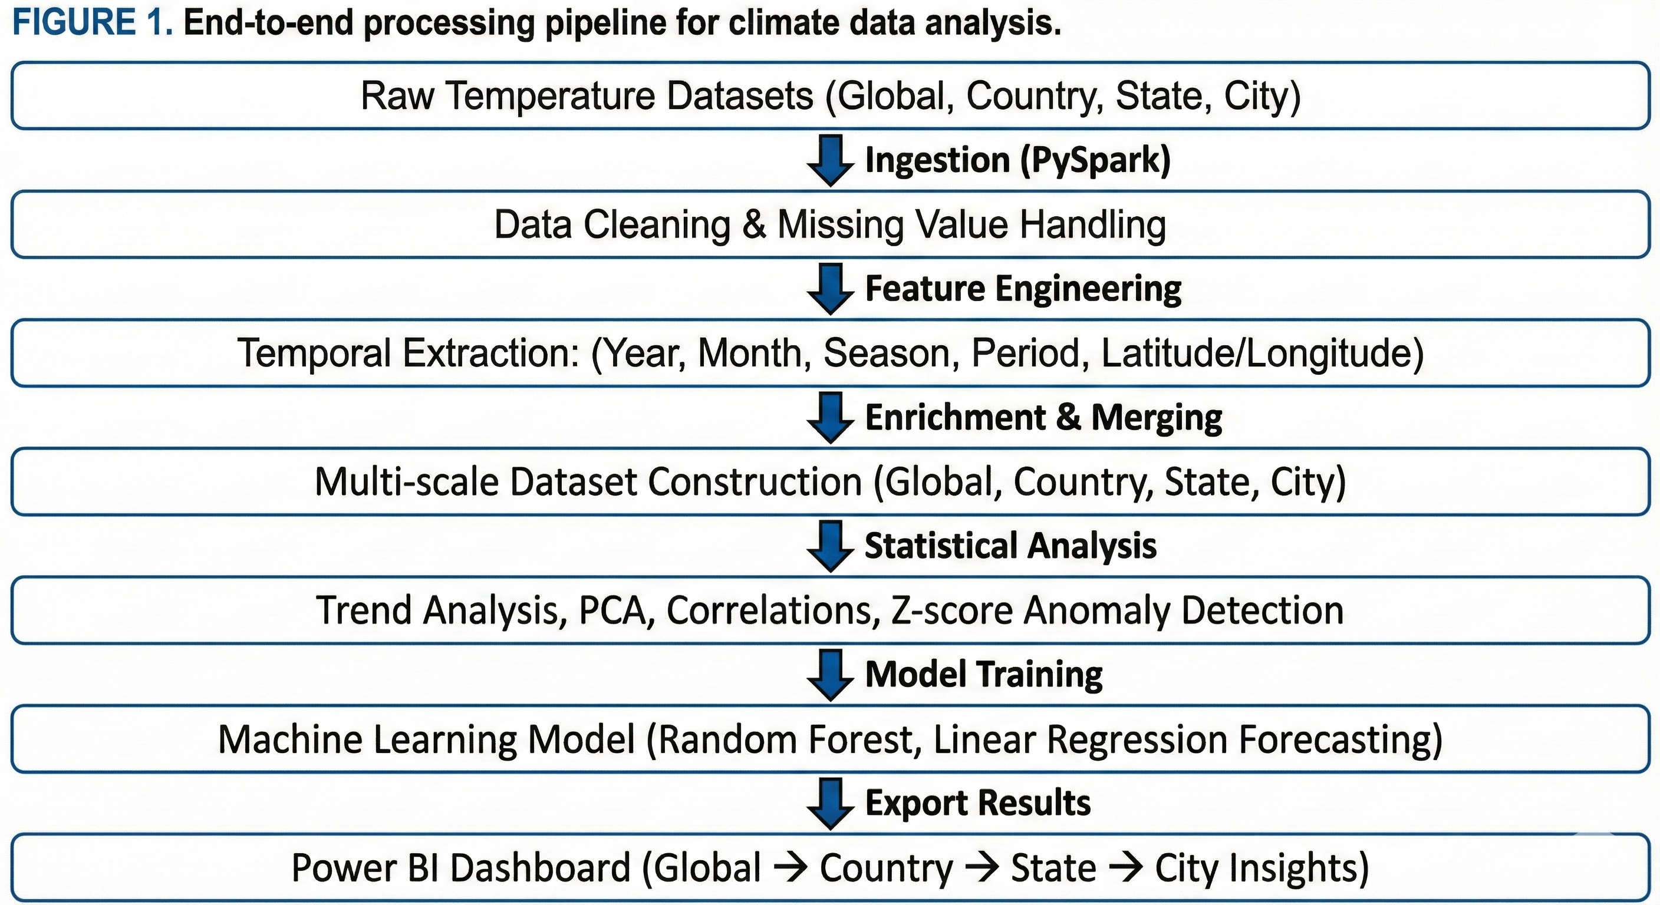

RESULTS
The analysis revealed a consistent long-term increase in global average temperatures, aligning closely with findings from established climate monitoring programs. When aggregated across the full temporal range, global temperatures showed an approximate rise of 11.8 °C between the earliest recorded values and the present dataset endpoint. This upward trajectory became more pronounced after the mid-20th century, reflecting the acceleration of industrial activity and associated greenhouse gas emissions.
Model Type | RMSE | MAE | R²
Linear Regression | 3.6998 | 2.8288 | 0.8583
Random Forest | 0.9637 | 0.6916 | 0.9904

Country-level evaluation showed substantial geographic variation. Senegal exhibited the highest long-term average temperature among all countries in the dataset, identifying it as one of the most persistently warm regions. Seasonal decomposition further highlighted that summer temperatures displayed the steepest warming trends across most continents, suggesting intensifying heat conditions during critical agricultural periods. At the urban scale, several cities-including Surabaya, Nagpur, and Bangkok-displayed exceptionally high anomaly scores, indicating greater instability and sharper departures from their historical norms.

City | Mean Temp (°C) | Z-Score | Notes
Surabaya | 28.7 | 3.87 | Highest anomaly
Nagpur | 26.9 | 3.42 | Strong heat events
Bangkok | 27.4 | 3.11 | Seasonal instability
Delhi | 29.1 | 3.05 | Urban heat island
Cairo | 28.2 | 2.97 | Persistent warming
Mumbai | 27.8 | 2.88 | High humidity amplification
Dhaka | 27.6 | 2.77 | Monsoon-driven variability
Karachi | 28.3 | 2.65 | Extreme summer peaks
Manila | 27.1 | 2.61 | Tropical anomalies
Singapore | 27.9 | 2.55 | Coastal warming

State-level assessments within India provided a more granular perspective on region-specific risk. Delhi recorded the highest temperature in the most recent year of analysis, while coastal states such as Tamil Nadu and Andhra Pradesh showed sustained warming patterns over several decades. These state-level divergences illustrate how localized climate conditions can deviate significantly from national averages.
The machine learning model demonstrated strong predictive capability, achieving an R² value near 0.99. Forecast outputs indicated a peak projected temperature of approximately 34.9 °C in future years, consistent with the intensifying trajectory observed in historical data. Histogram analysis of predicted temperatures showed a right-skewed distribution, suggesting that extreme heat events may become more frequent.
Overall, the results provide a unified, multi-scale view of warming trends—global, national, and urban—supported by empirical analysis and predictive modeling. Together, these findings reinforce the accelerating nature of climate change and the increasing climate instability experienced by several high-risk regions.

Footnotes
To help your readers, avoid using footnotes altogether and include necessary peripheral observations in the text (within parentheses, if you prefer, as in this sentence).

Acknowledgements (Optional)
If you wish to identify funding sources or significant contributions by others, please include your acknowledgements at the end of your paper but before the References. Only include this information on the final camera-ready copy.

References

[1] S. Gurung, “Applying Big Data Analytics in Global Temperature Data to Predict and Understand Climate Change,” 2023. doi: 10.13140/RG.2.2.21327.46245.

[2] J. Hansen et al., “Global Surface Temperature Change,” *Rev. Geophys.*, vol. 48, no. 4, 2010. [Online]. Available: https://data.giss.nasa.gov/gistemp/ (Accessed: 20YY-MM-DD).

[3] G. Schmidt, “We Study Climate Change. We Can’t Explain Everything,” *The New York Times*, Nov. 13, 2024. [Online]. Available: https://www.nytimes.com/2024/11/13/opinion/climate-change-heat-planet.html

[4] NASA Science Team, “This is How Scientists Measure Global Temperature,” *NASA Earth Science*, 2024. [Online]. Available: https://science.nasa.gov/earth/measuring_global_temperature/

[5] GISTEMP Team, “GISS Surface Temperature Analysis (GISTEMP), Version 4,” NASA Goddard Institute for Space Studies, 2024. [Online]. Available: https://data.giss.nasa.gov/gistemp/ (Accessed: 20YY-MM-DD).

[6] IPCC, “Climate Change 2021: The Physical Science Basis,” Intergovernmental Panel on Climate Change, 2021. [Online]. Available: https://www.ipcc.ch/report/ar6/wg1/

[7] A. Rohde et al., “Berkeley Earth Temperature Averaging Process,” *Geoinformatics & Geostatistics*, vol. 1, no. 2, 2013. doi: 10.4172/2327-4581.1000101.

[8] NOAA National Centers for Environmental Information, “Global Climate Report — Annual 2023,” *NOAA Climate.gov*, 2024. [Online]. Available: https://www.ncei.noaa.gov/

[9] K. Hausfather and Z. Stevens, “Assessing Recent Warming Using Instrumental Temperature Records,” *Science*, vol. 373, no. 6554, pp. 14–17, 2021. doi: 10.1126/science.abi6599.

