AI10 — MODULE 16
Machine Learning Operations Engineer Associate (AI-300)
Day 2: Pipelines, Hyperparameter Tuning, Responsible AI & MLOps Automation

Instructor: | Kiran Dambal (Azure ML Master Trainer)
Student Name: | ____________________________________________
Session Date: | 6 September 2026
Total Duration: | Full Day (~4.5 Hours of Lecture & Hands-On Engineering)
Certification Track: | Microsoft Certified: Azure MLOps Engineer Associate (Exam AI-300)
Enterprise Analytics & Production MLOps Curriculum
Official Course Handout — Azure Machine Learning Python SDK v2 & CLI v2

Table of Contents
01 | Session Overview & Official AI-300 Exam Mapping | 3
02 | Day 2 Learning Objectives | 3
03 | Topic 1: Day 2 Roadmap & Course Structure | 4
04 | Topic 2: Refactoring Exploratory Notebooks to Production Python Scripts | 5
05 | Lab 1: Training Classification Model via Clean Script Architecture | 6
06 | Topic 3: Experiment Tracking & Autologging with MLflow | 7
07 | Lab 2: Custom Logging vs. Autologging in Azure ML Studio | 8
08 | Topic 4: Executing Production Training via Azure ML Command Jobs | 9
09 | Lab 3: Parameterized Script Execution via CLI v2 & Argparse | 10
10 | Topic 5: Modular Orchestration with Azure Machine Learning Pipelines | 11
11 | Lab 4: Building Reusable YAML Components & Connecting Pipeline Jobs | 12
12 | Topic 6: Scalable Hyperparameter Tuning with Sweep Jobs | 13
13 | Lab 5: Search Space Design, Sampling Strategies & Early Termination | 15
14 | Topic 7: Designing an Enterprise MLOps Architecture & Production Monitoring | 16
15 | Topic 8: Responsible AI (RAI) in Azure Machine Learning | 18
16 | Lab 6: Responsible AI Insights Pipeline, Error Analysis & Explanations | 19
17 | Topic 9: CI/CD Automation with GitHub Actions & Azure ML CLI v2 | 21
18 | Student Contribution Tables & Live Class Discussions | 23
19 | Comprehensive Glossary of Key Terms | 24
20 | 10-Question Exam-Style Multiple Choice Knowledge Check | 25
21 | Key Takeaways & AI-300 Certification Exam Guide | 27
22 | Official References & Suggested Microsoft Learn Modules | 28
23 | Closing Summary | 28

Session Overview & Official Exam Mapping
Welcome to Day 2 of the AI-300: Machine Learning Operations Engineer Associate training program. Building directly upon the foundational modeling concepts established on Day 1 (where we explored problem definition, data ingestion, compute selection, and Automated Machine Learning), Day 2 elevates our engineering focus from exploratory modeling to production-grade enterprise MLOps.
In industrial AI deployments, training a high-performing model inside a Jupyter notebook represents only a fraction of the total operational lifecycle. Real-world machine learning systems demand: Reproducibility (eliminating ad-hoc notebook cell execution in favor of version-controlled, parameterized scripts), Observability (automatically capturing hyperparameters, runtime metrics, loss curves, confusion matrices, and model binaries using industry-standard MLflow protocols), Modular Orchestration (decoupling complex workflows into reusable pipeline components that execute across heterogeneous compute targets), Scalable Optimization (systematically exploring hyperparameter search spaces using intelligent sampling and early termination), Fairness & Governance (auditing model error cohorts and demographic disparities using Responsible AI), and Continuous Delivery (automating testing, model registration, and training job dispatching via GitHub Actions CI/CD).
Microsoft AI-300 Certification Exam Objective Domains
Exam Domain | Weight | Key Skills Covered on Day 2
Design & prepare a machine learning solution | 20–25% | Compute cluster sizing, container environments, CLI argument parameterization, GitHub source control integration.
Explore data and train models | 35–40% | Refactoring scripts, submitting command jobs, configuring sweep jobs (search spaces, sampling, termination), orchestrating Azure ML pipelines.
Prepare a model for deployment | 20–25% | Registering models, generating Responsible AI insights dashboards, diagnosing error cohorts, evaluating model fairness and interpretability.
Deploy and retrain a model | 10–15% | Designing enterprise MLOps architecture, distinguishing data drift from concept drift, configuring automated GitHub Actions workflows.

Day 2 Learning Objectives
- Deconstruct and Refactor Notebooks: Transition exploratory code into modular, production-ready Python scripts using standard entry points (main()), functions, and CLI argument parsing (argparse).
- Implement Enterprise Observability with MLflow: Integrate MLflow tracking inside Azure ML, distinguish between automated telemetry (mlflow.autolog()) and explicit logging (mlflow.log_metric, mlflow.log_param, mlflow.log_figure), and register training artifacts.
- Execute Remote Command Jobs: Formulate Azure ML CLI v2 / Python SDK v2 command specifications, dynamically mounting data assets (AssetTypes.URI_FILE), target compute clusters, and curated container environments.
- Author Modular Pipeline Workflows: Create reusable component definitions in YAML (prep-data.yml, train-model.yml), load them dynamically via load_component(), and wire multi-step execution graphs using the @dsl.pipeline decorator.
- Optimize Hyperparameter Search Spaces: Formulate discrete (Choice) and continuous (Uniform, Normal, LogUniform) hyperparameter spaces, select between Grid, Random (Sobol-seeded), and Bayesian sampling, and prune suboptimal runs using Bandit, Median Stopping, and Truncation Selection early termination policies.
- Architect Resilient MLOps Lifecycles: Structure the 6-stage MLOps lifecycle (Setup, Inner Loop, CI, Outer Loop, CD, Monitoring), diagnose covariate shift (data drift) versus concept drift, and configure automated retraining triggers.
- Evaluate Models with Responsible AI: Construct an end-to-end Responsible AI pipeline in Azure ML to compute SHAP feature attributions, detect cohort error imbalances with Error Analysis trees, and generate counterfactual examples.
- Automate Training Workflows with GitHub Actions: Implement trunk-based branch management, configure secure Service Principal credentials (AZURE_CREDENTIALS), and construct GitHub Actions workflow files to trigger remote Azure ML jobs automatically on push or workflow dispatch.

Topic 1: Day 2 Roadmap & Course Structure
Day 2 shifts our architectural trajectory towards operationalization, automation, and governance. In enterprise production environments, data scientists do not manually click buttons in a graphical user interface to trigger retraining; nor do they leave trained models sitting inside ephemeral compute notebooks. Instead, machine learning engineers build automated pipelines that ingest verified data, run distributed training, perform rigorous hyperparameter optimization, audit models for fairness and transparency, and automatically publish deployable artifacts via continuous integration and continuous deployment (CI/CD) pipelines.
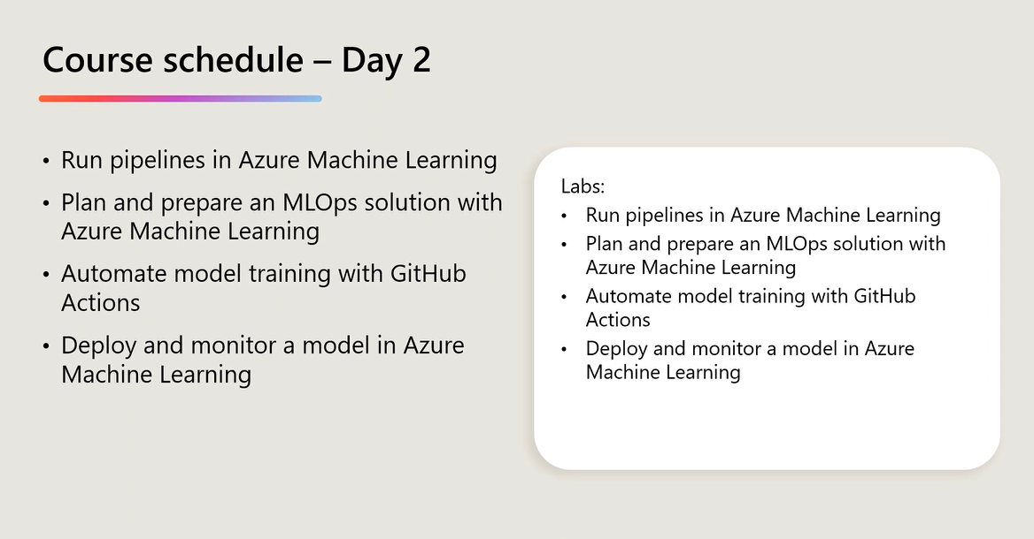
Figure 1.1: Day 2 Course Schedule and Module Breakdown (Instructor Slide)
As shown in Figure 1.1, the curriculum is organized into four foundational operational pillars: (1) Run Pipelines in Azure Machine Learning, (2) Plan and Prepare an MLOps Solution, (3) Automate Model Training with GitHub Actions, and (4) Deploy and Monitor a Model in Azure Machine Learning. Each lecture pillar is directly accompanied by a hands-on lab.
TEACHER'S NOTE — KIRAN DAMBAL
"Today we have a very packed and highly practical agenda. In terms of our workflow, we will complete the architectural theory for our core modules first, and then execute the hands-on labs back-to-back immediately. This prevents us from repeatedly waiting for compute clusters to spin up and spin down between individual topics, maximizing our active engineering time."

Core Architectural Components
Component | Architectural Role | Production Significance
Compute Instance | Dedicated single-node development VM equipped with JupyterLab and terminal. | Used exclusively for exploratory coding, authoring scripts, and debugging; not intended for production batch training.
Compute Cluster | Managed pool of autoscaling multi-node virtual machines (scales 0 to N nodes). | The standard compute target for production command jobs, pipelines, and sweep jobs. Scales to zero when idle to eliminate cost.
Command Job | Non-interactive execution of a script inside an isolated Docker container. | The fundamental unit of remote execution in Azure ML; encapsulates code, compute, environment, and CLI inputs.
Pipeline Component | Reusable, versioned building block defined by a YAML manifest and execution script. | Enables modular microservice architectures in ML; allows data prep and model training to execute independently on optimal compute.
Sweep Job | Automated hyperparameter tuning orchestrator across defined search spaces. | Evaluates multiple parallel child trials using Grid, Random, or Bayesian sampling paired with early termination policies.
Inner vs. Outer Loop | Separation of experimental prototyping from production release engineering. | Inner loop is iterative and hypothesis-driven; outer loop is automated, gated by CI/CD, and governed by strict compliance checks.

Topic 2: Refactoring Exploratory Notebooks to Production Python Scripts
Jupyter Notebooks are the undisputed standard for initial data exploration, rapid prototyping, and interactive visualization. However, in an enterprise MLOps ecosystem, notebooks are unsuitable as production training targets. Non-linear cell execution introduces hidden in-memory state; hardcoded local file paths fail when executed inside isolated Docker containers; and verbose exploratory print statements pollute automated CI/CD execution logs.
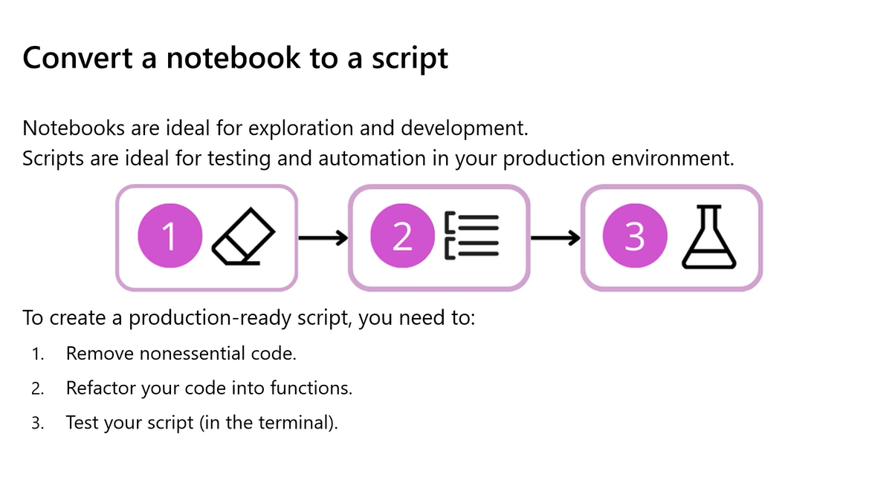
Figure 2.1: The 3-Step Lifecycle for Converting a Notebook to a Production Script
As shown in Figure 2.1, converting an exploratory notebook into a production script requires adhering to a strict 3-step protocol: (1) Remove non-essential code (strip df.describe(), exploratory plots, and interactive magic commands), (2) Refactor code into functions (get_data(), split_data(), train_model(), eval_model(), main()), and (3) Test script in the terminal (execute locally with explicit CLI arguments before submitting to cloud clusters).
Lab 1 Walkthrough: Training a Classification Model via Clean Script Architecture
In this lab (derived from Train classification model.ipynb), we examine the production-ready script architecture used to train a binary diabetes classification model using Scikit-Learn's LogisticRegression and evaluate discriminative performance using Area Under the ROC Curve (ROC AUC).
import argparse
import pandas as pd
import numpy as np
from sklearn.model_selection import train_test_split
from sklearn.linear_model import LogisticRegression
from sklearn.metrics import roc_auc_score, roc_curve
def get_data(data_path: str) -> pd.DataFrame:
print(f"Ingesting training data from: {data_path}")
return pd.read_csv(data_path)
def split_data(df: pd.DataFrame, test_size: float = 0.30, random_state: int = 0):
features = ['Pregnancies', 'PlasmaGlucose', 'DiastolicBloodPressure',
'TricepsThickness', 'SerumInsulin', 'BMI', 'DiabetesPedigree', 'Age']
target = 'Diabetic'
X = df[features].values
y = df[target].values
return train_test_split(X, y, test_size=test_size, random_state=random_state)
def train_model(reg_rate: float, X_train: np.ndarray, y_train: np.ndarray) -> LogisticRegression:
print(f"Fitting LogisticRegression with reg_rate (C) = {reg_rate}...")
model = LogisticRegression(C=1.0/reg_rate, solver="liblinear", max_iter=1000)
model.fit(X_train, y_train)
return model
def eval_model(model: LogisticRegression, X_test: np.ndarray, y_test: np.ndarray):
y_scores = model.predict_proba(X_test)[:, 1]
auc = roc_auc_score(y_test, y_scores)
print(f"Model Evaluation Metric — ROC AUC: {auc:.4f}")
fpr, tpr, _ = roc_curve(y_test, y_scores)
return auc, fpr, tpr
def main():
parser = argparse.ArgumentParser(description="Train a diabetes classification model.")
parser.add_argument("--training_data", type=str, required=True, help="Input CSV path.")
parser.add_argument("--reg_rate", type=float, default=0.01, help="Regularization rate.")
args = parser.parse_args()
df = get_data(args.training_data)
X_train, X_test, y_train, y_test = split_data(df)
model = train_model(args.reg_rate, X_train, y_train)
auc, fpr, tpr = eval_model(model, X_test, y_test)
print("Training and evaluation successfully completed.")
if __name__ == "__main__":
main()

TEACHER'S NOTE — KIRAN DAMBAL
"When students transition from notebooks to scripts, the most common mistake is leaving print(df.head()) or print(df.shape) inside loops. In your local terminal, that looks harmless. But in Azure Machine Learning, those logs are streamed over WebSocket connections to Azure Monitor. A job printing 50,000 lines of junk slows down log streaming, makes debugging impossible, and incurs unnecessary log storage costs."

Topic 3: Experiment Tracking & Autologging with MLflow
MLflow is an open-source platform for managing the complete machine learning lifecycle. Azure Machine Learning provides native, zero-configuration integration with MLflow: when running inside Azure ML, the tracking URI is automatically wired directly to the workspace's managed backend.
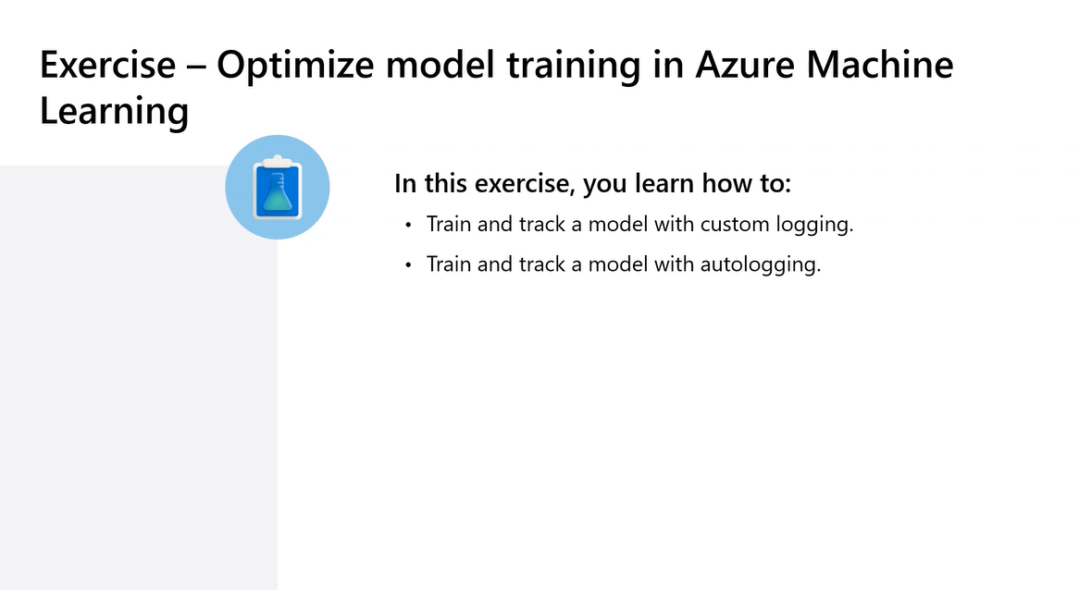
Figure 3.1: Exercise Roadmap — Optimizing Model Training in Azure ML with Custom Logging & Autologging
As outlined in Figure 3.1, engineers can utilize two complementary tracking approaches: Autologging (mlflow.autolog()), which captures framework defaults (parameters, metrics, and models) with a single line of code, and Custom Logging (mlflow.log_metric, mlflow.log_param, mlflow.log_figure, mlflow.log_artifact), which provides granular control over recorded business metrics, custom image plots, and metadata files.
Lab 2 Walkthrough: Custom Logging vs. Autologging in Azure ML
In this lab (derived from Track model training with MLflow.ipynb), students implement custom logging for a Decision Tree classifier, logging hyperparameters, ROC AUC metrics, an ROC curve plot artifact, and arbitrary metadata:
import mlflow
import mlflow.sklearn
import matplotlib.pyplot as plt
from sklearn.metrics import roc_curve, roc_auc_score
from sklearn.tree import DecisionTreeClassifier
# Disable autologging for explicit, granular control
mlflow.sklearn.autolog(disable=True)
mlflow.set_experiment(experiment_name="diabetes-custom-logging-experiment")
with mlflow.start_run(run_name="decision-tree-custom-run"):
# 1. Log Hyperparameters
max_depth = 5
min_samples_leaf = 10
mlflow.log_param("estimator", "DecisionTreeClassifier")
mlflow.log_param("max_depth", max_depth)
mlflow.log_param("min_samples_leaf", min_samples_leaf)
# 2. Train Estimator
clf = DecisionTreeClassifier(max_depth=max_depth, min_samples_leaf=min_samples_leaf, random_state=42)
clf.fit(X_train, y_train)
# 3. Log Performance Metric
y_scores = clf.predict_proba(X_test)[:, 1]
auc = roc_auc_score(y_test, y_scores)
mlflow.log_metric("roc_auc", auc)
# 4. Log Matplotlib Figure Artifact
fpr, tpr, _ = roc_curve(y_test, y_scores)
fig, ax = plt.subplots(figsize=(6, 4))
ax.plot([0, 1], [0, 1], 'k--')
ax.plot(fpr, tpr, label=f"Decision Tree (AUC = {auc:.3f})", color="#00C9A7", lw=2)
ax.set_title("ROC Curve — Diabetes Prediction")
ax.legend(loc="lower right")
mlflow.log_figure(fig, "visualizations/roc_curve.png")
plt.close(fig)
# 5. Log Arbitrary Artifact Files
with open("model_metadata.json", "w") as f:
f.write('{"trained_by": "Kiran Dambal", "environment": "AzureML-v2"}')
mlflow.log_artifact("model_metadata.json", artifact_path="metadata")

TEACHER'S NOTE — KIRAN DAMBAL
"Why do we use MLflow rather than writing custom Azure ML tracking code? Because MLflow is a completely open standard. If your organization decides tomorrow to run workloads on-premises or migrate across clouds, your training scripts do not change. In Azure ML, Microsoft implemented the MLflow REST endpoints behind the scenes. Your code speaks pure open-source MLflow, while Azure ML provides enterprise security, RBAC, and infinite cloud storage."

Topic 4: Executing Production Training via Azure ML Command Jobs
In Azure Machine Learning v2, the foundational execution mechanism for executing training scripts on remote cloud compute is the Command Job. A command job takes a code snapshot, injects input data assets, provisions a target compute resource, instantiates an isolated Docker container environment, and executes a shell command.
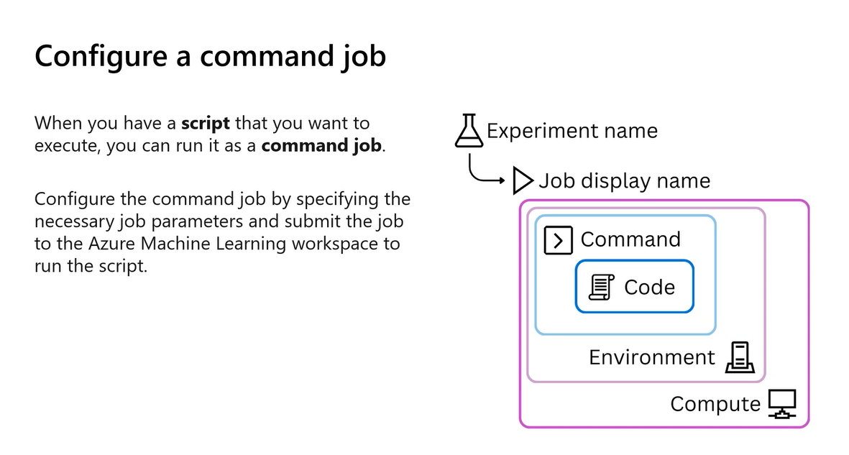
Figure 4.1: Structural Hierarchy of an Azure Machine Learning Command Job
As illustrated in Figure 4.1, a command job follows a strict nested containment hierarchy: Experiment Name $\rightarrow$ Job Display Name $\rightarrow$ [Compute Target (outer VM cluster) $\rightarrow$ Environment (Docker image & Conda packages) $\rightarrow$ Command (terminal instruction) $\rightarrow$ Code (source scripts)].
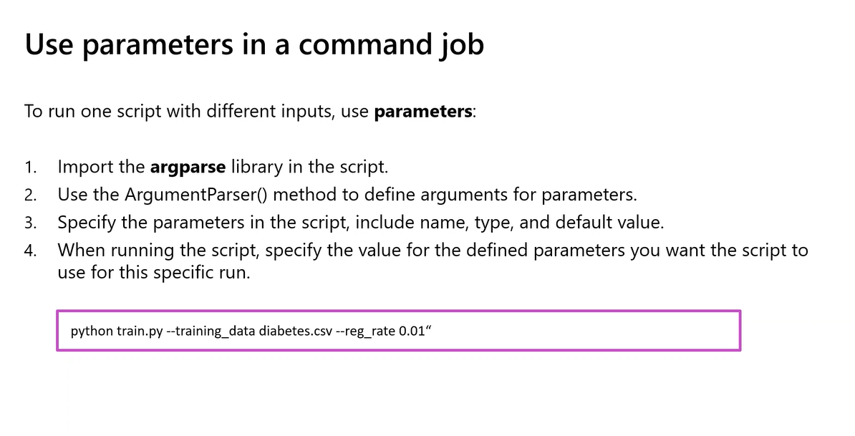
Figure 4.2: Four-Step Protocol for Implementing CLI Parameters in Command Jobs
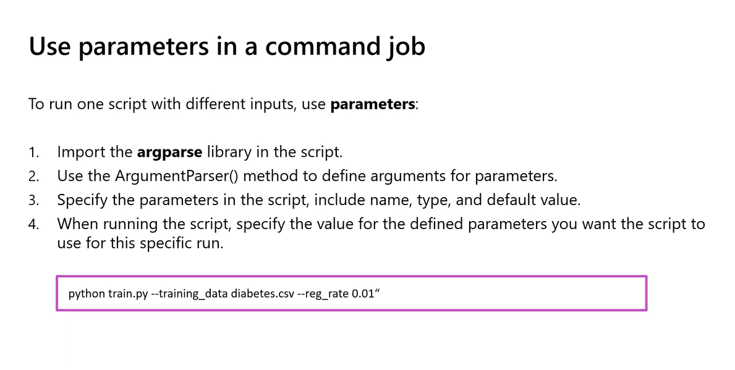
Figure 4.3: Terminal Execution of Parameterized Training Script with CLI Arguments
As shown in Figure 4.2 and Figure 4.3, scripts are parameterized via Python's argparse module: (1) import argparse, (2) instantiate ArgumentParser(), (3) specify parameter names, types, and default values, and (4) parse and pass values dynamically (e.g., python train.py --training_data diabetes.csv --reg_rate 0.01).
Lab 3 Walkthrough: Submitting a Parameterized Command Job via Python SDK v2
In this lab (derived from Run script as a command job.ipynb), students submit an automated command job targeting an Azure ML Compute Cluster (aml-cluster):
from azure.ai.ml import command, Input
from azure.ai.ml.constants import AssetTypes
# Define input data asset dynamically
training_data_input = Input(type=AssetTypes.URI_FILE, path="azureml:diabetes-data:1")
# Configure command job specification
job = command(
code="./src",
command="python train.py --training_data ${{inputs.training_data}} --reg_rate ${{inputs.reg_rate}}",
inputs={
"training_data": training_data_input,
"reg_rate": 0.05,
},
environment="AzureML-sklearn-1.0-ubuntu20.04-py38-cpu:1",
compute="aml-cluster",
display_name="diabetes-train-mlflow",
experiment_name="diabetes-training-experiment"
)
# Submit to Azure Machine Learning
returned_job = ml_client.jobs.create_or_update(job)
print(f"Job Status: {returned_job.status}")
print(f"Monitor Job at Studio URL: {returned_job.studio_url}")

TEACHER'S NOTE — KIRAN DAMBAL
"In training environments where multiple students spin up clusters simultaneously, Azure core quotas can occasionally be hit. If your compute cluster remains in a 'ResizeFailed' or 'Queued' state, you can seamlessly redirect your command job to run directly on your Compute Instance by simply updating compute='your-compute-instance-name'. The exact same container and script execute without modifying a single line of your application code."

Topic 5: Modular Orchestration with Azure Machine Learning Pipelines
Combining data ingestion, feature engineering, model training, and evaluation into a single monolithic script wastes expensive GPU compute during lightweight data preparation, prevents cross-team code reuse, and forces rerunning the entire workflow if the final evaluation step fails. Azure Machine Learning Pipelines solve these bottlenecks by orchestrating modular, independently versioned Components into Directed Acyclic Graphs (DAGs).
Anatomy of Reusable YAML Pipeline Components
A pipeline component consists of the execution code (.py) and a declarative specification manifest (.yml). Below are the component manifests for data preparation and model training:
Component Manifest: prep-data.yml
$schema: https://azuremlschemas.azureedge.net/latest/commandComponent.schema.json
name: prep_data_component
display_name: Clean and Prepare Tabular Data
version: 1
type: command
inputs:
raw_data:
type: uri_file
outputs:
clean_data:
type: uri_folder
code: ./src
environment: azureml:AzureML-sklearn-1.0-ubuntu20.04-py38-cpu:1
command: >-
python prep-data.py
--raw_data ${{inputs.raw_data}}
--clean_data ${{outputs.clean_data}}

Component Manifest: train-model.yml
$schema: https://azuremlschemas.azureedge.net/latest/commandComponent.schema.json
name: train_model_component
display_name: Train Diabetes Classification Model
version: 1
type: command
inputs:
training_data:
type: uri_folder
reg_rate:
type: number
default: 0.01
outputs:
model_output:
type: uri_folder
code: ./src
environment: azureml:AzureML-sklearn-1.0-ubuntu20.04-py38-cpu:1
command: >-
python train-model.py
--training_data ${{inputs.training_data}}
--reg_rate ${{inputs.reg_rate}}
--model_output ${{outputs.model_output}}

Lab 4 Walkthrough: Building and Executing an Azure ML Pipeline Job
In this lab (derived from Run a pipeline job.ipynb), students load the YAML components using load_component() and wire them together using the @dsl.pipeline decorator:
from azure.ai.ml import load_component, dsl, Input
from azure.ai.ml.constants import AssetTypes
# 1. Dynamically load YAML components
prep_data_component = load_component(source="./prep-data.yml")
train_model_component = load_component(source="./train-model.yml")
# 2. Wire pipeline architecture using @dsl.pipeline
@dsl.pipeline(
name="diabetes-modular-training-pipeline",
display_name="Diabetes Data Prep & Training Pipeline",
compute="aml-cluster"
)
def diabetes_pipeline(pipeline_input_data: Input, pipeline_reg_rate: float = 0.05):
# Step 1: Clean data
prep_step = prep_data_component(raw_data=pipeline_input_data)
# Step 2: Train model (Connect prep output directly to train input)
train_step = train_model_component(
training_data=prep_step.outputs.clean_data,
reg_rate=pipeline_reg_rate
)
return {"pipeline_trained_model": train_step.outputs.model_output}
# 3. Instantiate and submit pipeline
pipeline_job = diabetes_pipeline(
pipeline_input_data=Input(type=AssetTypes.URI_FILE, path="azureml:diabetes-data:1"),
pipeline_reg_rate=0.01
)
returned_pipeline = ml_client.jobs.create_or_update(pipeline_job)
print(f"Pipeline job submitted! Tracking URL: {returned_pipeline.studio_url}")

TEACHER'S NOTE — KIRAN DAMBAL
"The greatest superpower of Azure ML pipelines is heterogeneous compute assignment. Notice that while we assigned a default cluster at the pipeline level (compute='aml-cluster'), you can override compute on a per-step basis! For instance: prep_step.compute = 'cpu-cluster-high-ram' and train_step.compute = 'gpu-cluster-v100'. Each microservice runs on its optimal hardware target."

Topic 6: Scalable Hyperparameter Tuning with Sweep Jobs
Hyperparameters are external configuration variables set prior to training that govern the algorithm's learning mechanics (e.g., regularization rate $\lambda$, learning rate, maximum depth), distinct from model parameters learned directly from data.
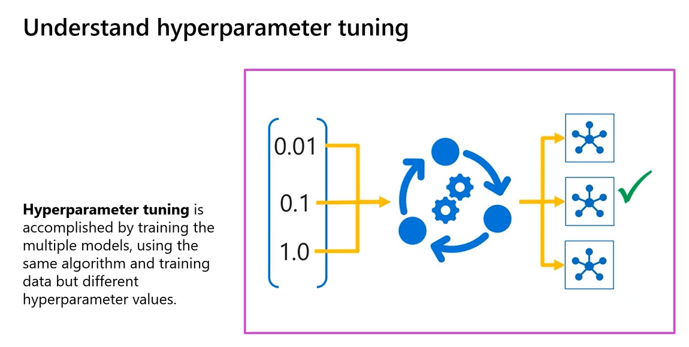
Figure 6.1: Conceptual Mechanics of Hyperparameter Tuning across Search Spaces
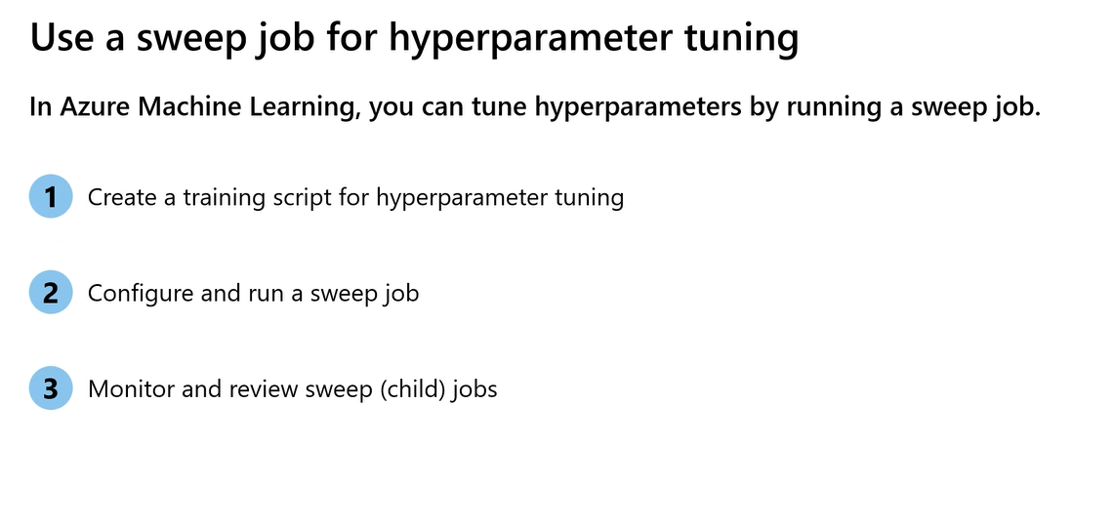
Figure 6.2: Three Sequential Steps to Execute an Azure ML Sweep Job
As shown in Figure 6.2, executing a sweep job involves: (1) creating a parameterized training script, (2) configuring the sweep job with search spaces, sampling methods, and limits, and (3) monitoring child trial execution in Azure ML Studio.
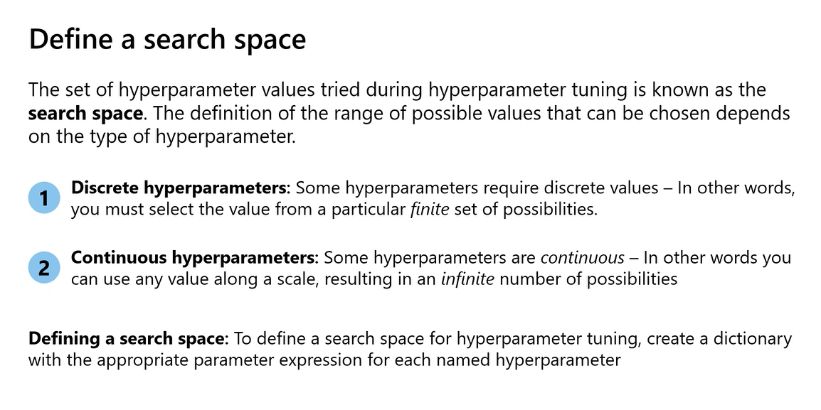
Figure 6.3: Categorization of Search Spaces: Discrete vs. Continuous Hyperparameters
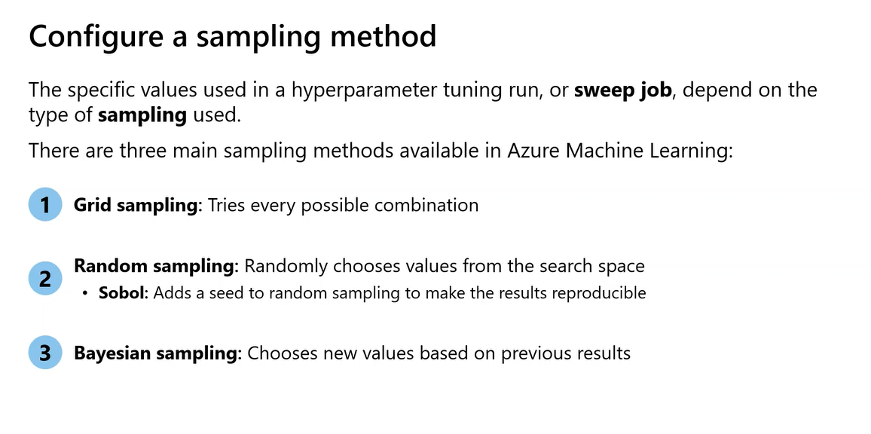
Figure 6.4: Three Primary Sampling Algorithms in Azure Machine Learning
As shown in Figure 6.4, Azure ML supports three sampling algorithms: Grid Sampling (exhaustive testing across discrete values), Random Sampling (efficient exploration of discrete and continuous spaces; supports Sobol sequences for uniform coverage), and Bayesian Sampling (intelligent surrogate modeling of objective functions).
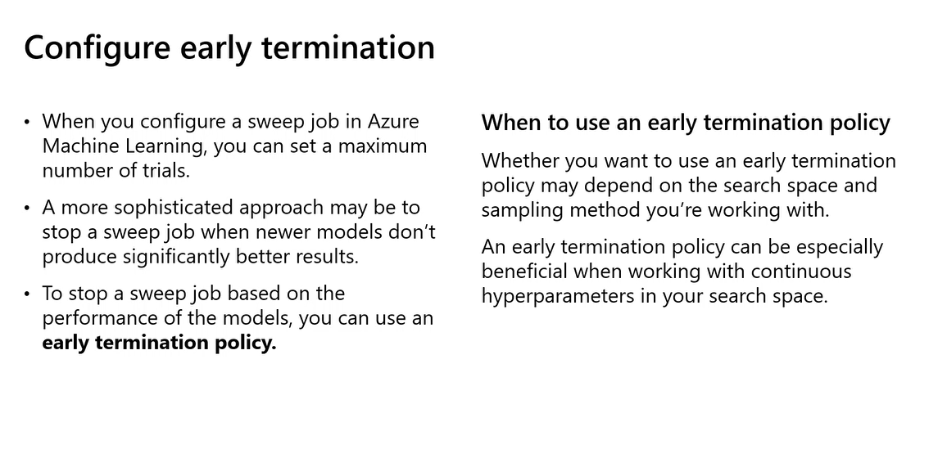
Figure 6.5: Early Termination Strategies for Cost Optimization
As illustrated in Figure 6.5, Early Termination Policies automatically prune suboptimal trials before they run to completion, slashing cloud compute costs: Bandit Policy (prunes trials lagging outside a specified slack factor of the best run), Median Stopping Policy (cancels trials performing below running median), and Truncation Selection Policy (cancels lowest percentage of trials at each interval).
Lab 5 Walkthrough: Configuring and Submitting an Azure ML Sweep Job
In this lab (derived from Hyperparameter tuning.ipynb), students overlay a hyperparameter search space and early termination policy onto a base command job:
from azure.ai.ml import command, Input
from azure.ai.ml.constants import AssetTypes
from azure.ai.ml.sweep import Choice, BanditPolicy
# 1. Define base command job with parameter placeholder
base_job = command(
code="./src",
command="python train.py --training_data ${{inputs.training_data}} --reg_rate ${{inputs.reg_rate}}",
inputs={
"training_data": Input(type=AssetTypes.URI_FILE, path="azureml:diabetes-data:1"),
"reg_rate": 0.01
},
environment="AzureML-sklearn-1.0-ubuntu20.04-py38-cpu:1",
compute="aml-cluster"
)
# 2. Overlay search space and configure sweep parameters
sweep_job = base_job.sweep(
sampling_algorithm="random",
primary_metric="Accuracy",
goal="Maximize",
search_space={"reg_rate": Choice([0.001, 0.005, 0.01, 0.05, 0.1, 0.5, 1.0])}
)
# 3. Configure trial limits and Bandit early termination
sweep_job.set_limits(max_total_trials=10, max_concurrent_trials=2, timeout=1800)
sweep_job.early_termination = BanditPolicy(slack_factor=0.15, evaluation_interval=1, delay_evaluation=3)
# 4. Submit sweep job to Azure ML
returned_sweep = ml_client.jobs.create_or_update(sweep_job)
print(f"Sweep Job submitted! Leaderboard URL: {returned_sweep.studio_url}")

TEACHER'S NOTE — KIRAN DAMBAL
"Be very careful with max_concurrent_trials. If your compute cluster has a maximum capacity of 4 nodes and you set max_concurrent_trials=10, 6 of your trials will sit queued in pending state until nodes become free. Always align your concurrency limits with your cluster's maximum node ceiling to optimize resource utilization."

Topic 7: Designing an Enterprise MLOps Architecture & Production Monitoring
Machine Learning Operations (MLOps) represents the union of DevOps principles, data engineering, and machine learning science. In traditional software engineering, system behavior is governed purely by code; in machine learning, system behavior is governed by Code + Data + Models.
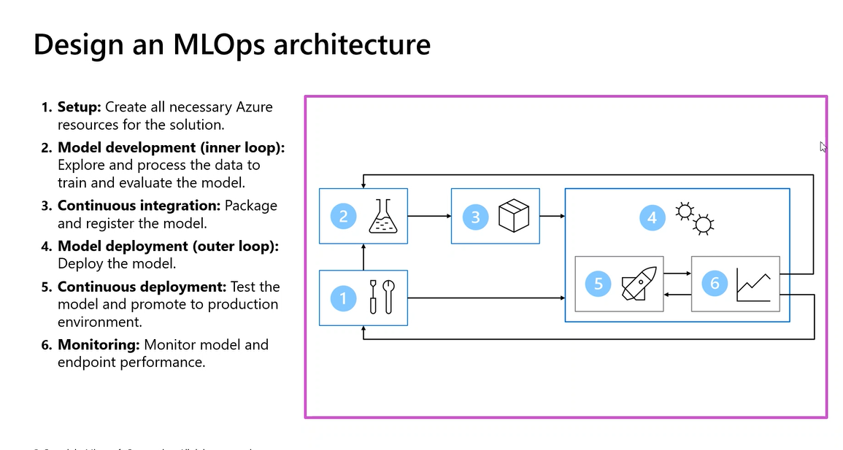
Figure 7.1: The 6-Stage Enterprise MLOps Architecture Lifecycle
As shown in Figure 7.1, the MLOps lifecycle spans six stages: (1) Setup (IaC provisioning of Azure ML resources), (2) Model Development / Inner Loop (iterative data prep, training, sweep jobs), (3) Continuous Integration (packaging, automated unit tests, model registration), (4) Model Deployment / Outer Loop (containerization and endpoint creation), (5) Continuous Deployment (canary testing and production promotion), and (6) Monitoring (streaming metrics and drift alerts feeding back into Stage 2).
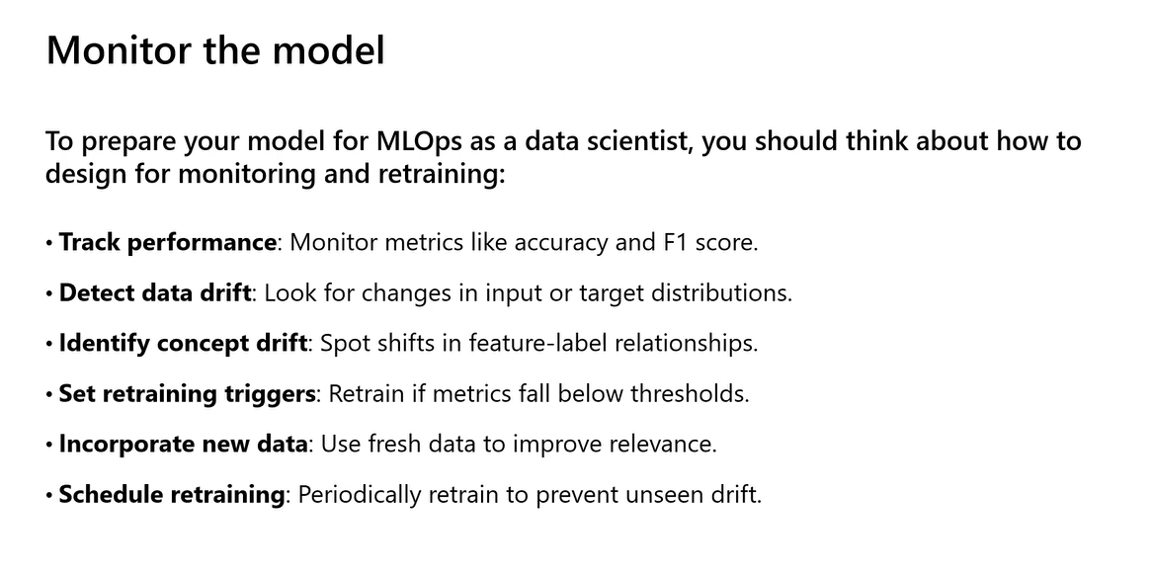
Figure 7.2: Production Model Monitoring Principles and Retraining Strategies
As categorized in Figure 7.2, production monitoring systems must actively distinguish between two fundamental forms of degradation: Data Drift (Covariate Shift), where input distributions $P(X)$ change while $P(Y|X)$ remains constant (e.g., patient demographics aging), and Concept Drift, where the relationship between features and labels $P(Y|X)$ shifts (e.g., economic crises altering spending patterns). Retraining is governed by threshold triggers (statistical distance metrics) or scheduled recurring pipelines.

Topic 8: Responsible AI (RAI) in Azure Machine Learning
High-performing models deployed in healthcare, finance, or hiring cannot rely solely on accuracy. Models must be audited against Microsoft's six core principles of Responsible AI: Fairness, Reliability & Safety, Privacy & Security, Inclusiveness, Transparency, and Accountability.
The Azure ML Responsible AI Toolbox Components
Toolbox Component | Diagnostic Purpose | Analytical Output
Error Analysis | Discovers cohort-specific performance degradation across feature spaces. | Interactive decision tree separating low-error data cohorts from high-error clusters.
Model Overview & Fairness | Assesses demographic parity, equalized odds, and subgroup performance. | Disaggregated evaluation charts comparing False Positive/Negative rates across sensitive groups.
Model Explanations (SHAP) | Unpacks model decision mechanics using Shapley Additive Explanations. | Global feature importance rankings and local per-instance feature attribution waterfalls.
Counterfactual What-If | Explores minimum feature interventions required to flip a prediction outcome. | Synthetic hypothetical instances demonstrating closest boundary changes to reverse a label.
Causal Analysis | Distinguishes correlation from true causal mechanisms under treatment conditions. | Average treatment effect (ATE) estimates and individual treatment response curves.

Lab 6 Walkthrough: Constructing a Responsible AI Dashboard via Pipeline
In this lab (derived from Create Responsible AI dashboard.ipynb), students build an end-to-end Azure ML pipeline using built-in registry components to audit a registered diabetes model:
from azure.ai.ml import MLClient, dsl, Input
from azure.ai.ml.entities import Model
from azure.ai.ml.constants import AssetTypes
# 1. Register candidate model in workspace
model = ml_client.models.create_or_update(
Model(path="./model/diabetes_model.pkl", name="diabetes_model", type=AssetTypes.CUSTOM_MODEL)
)
# 2. Retrieve built-in RAI components from global azureml registry
reg_client = MLClient(credential=credential, registry_name="azureml")
rai_constructor = reg_client.components.get(name="rai_insights_constructor", label="latest")
rai_explanation = reg_client.components.get(name="rai_insights_explanation", label="latest")
rai_erroranalysis = reg_client.components.get(name="rai_insights_erroranalysis", label="latest")
rai_gather = reg_client.components.get(name="rai_insights_gather", label="latest")
# 3. Wire RAI Dashboard Pipeline
@dsl.pipeline(name="rai-diabetes-pipeline", compute="aml-cluster")
def rai_pipeline(model_id: str, train_data: Input, test_data: Input):
construct_step = rai_constructor(
title="Diabetes Model Audit", task_type="classification",
model_info_path=model_id, train_dataset=train_data, test_dataset=test_data,
target_column_name="Diabetic"
)
explain_step = rai_explanation(rai_insights_dashboard=construct_step.outputs.rai_insights_dashboard)
error_step = rai_erroranalysis(rai_insights_dashboard=construct_step.outputs.rai_insights_dashboard)
gather_step = rai_gather(
constructor=construct_step.outputs.rai_insights_dashboard,
insight_1=explain_step.outputs.explanation,
insight_2=error_step.outputs.error_analysis
)
return {"dashboard": gather_step.outputs.dashboard}
# 4. Submit RAI job
rai_job = rai_pipeline(
model_id=f"{model.name}:{model.version}",
train_data=Input(type=AssetTypes.URI_FILE, path="azureml:diabetes-train:1"),
test_data=Input(type=AssetTypes.URI_FILE, path="azureml:diabetes-test:1")
)
returned_rai = ml_client.jobs.create_or_update(rai_job)
print(f"RAI Pipeline submitted! Tracking URL: {returned_rai.studio_url}")

TEACHER'S NOTE — KIRAN DAMBAL
"Responsible AI is no longer optional. Under regulations like the EU AI Act and healthcare compliance standards, you cannot deploy a black-box model without proving that you evaluated it for bias and error distribution. The RAI dashboard in Azure ML gives your compliance and legal teams an interactive, auditable report directly linked to the registered model version."

Topic 9: CI/CD Automation with GitHub Actions & Azure ML CLI v2
Enterprise MLOps establishes strict boundaries: Git Repositories (GitHub) store version-controlled code, manifests, and CI/CD workflows, while the Azure ML Workspace stores versioned data assets, container images, model weights, and execution logs.
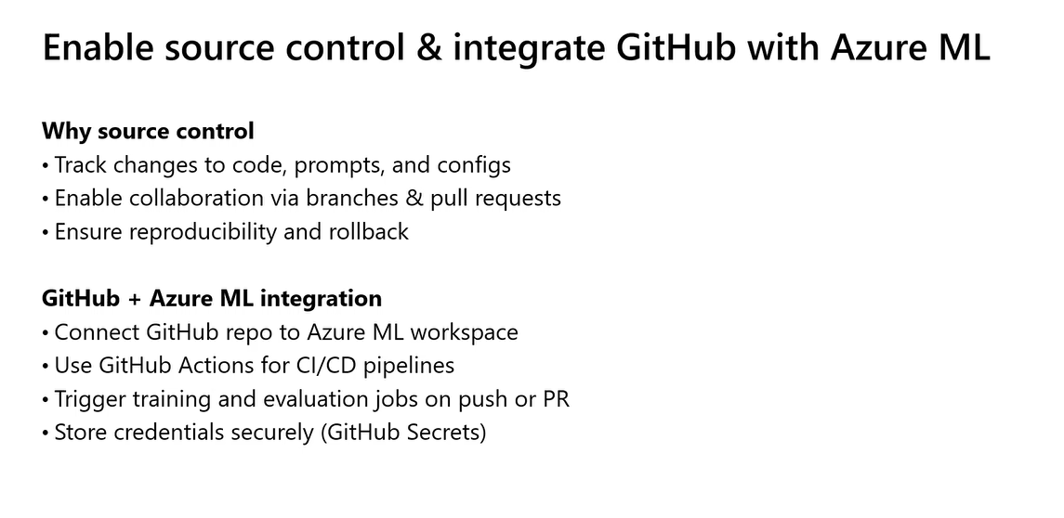
Figure 9.1: Strategic Drivers for Integrating GitHub Source Control with Azure Machine Learning
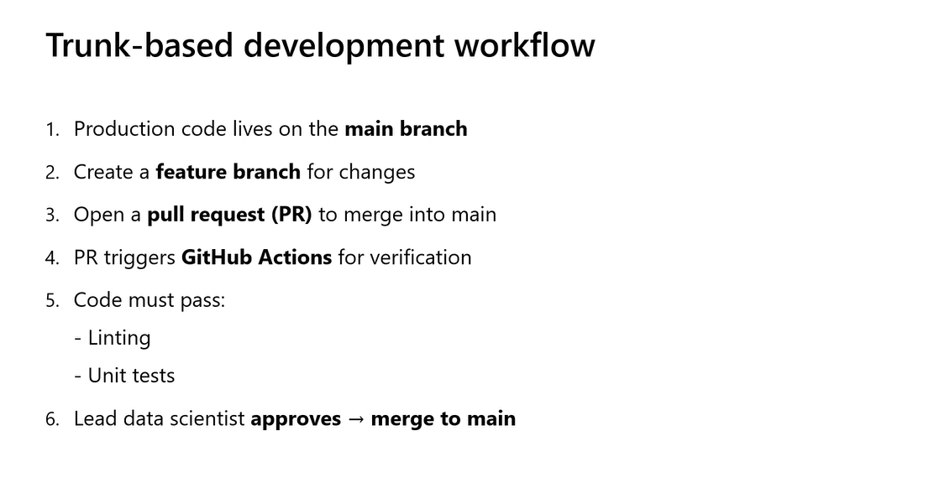
Figure 9.2: Six-Step Trunk-Based Development Protocol for Machine Learning
As shown in Figure 9.2, teams utilize Trunk-Based Development: (1) production code lives on main, (2) short-lived feature branches are created, (3) pull requests (PRs) are opened, (4) PRs trigger GitHub Actions runners, (5) automated linting (flake8) and unit tests (pytest) must pass, and (6) Lead Data Scientist approval merges code to main.
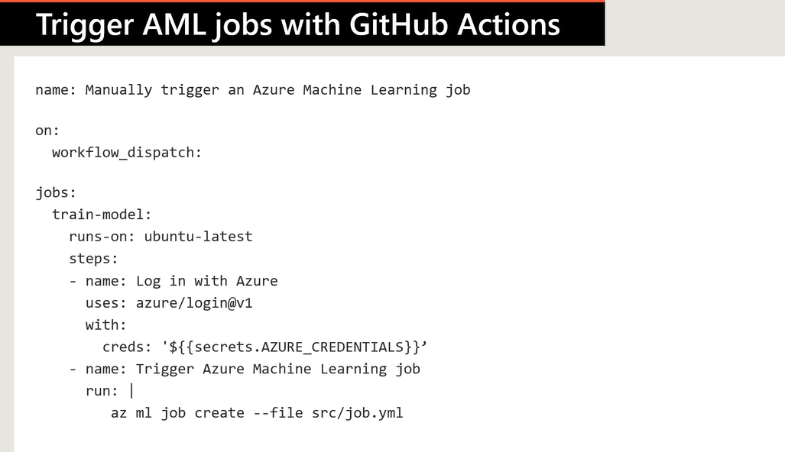
Figure 9.3: Production GitHub Actions Workflow for Triggering Azure ML CLI v2 Jobs
As shown in Figure 9.3, the automated GitHub Actions workflow (.github/workflows/train.yml) authenticates to Azure via an encrypted Service Principal secret (AZURE_CREDENTIALS) and triggers the remote training job using the Azure ML CLI v2 (az ml job create --file src/job.yml):
name: Manually trigger an Azure Machine Learning job
on:
workflow_dispatch:
push:
branches: [ main ]
jobs:
train-model:
runs-on: ubuntu-latest
steps:
- name: Check out repository
uses: actions/checkout@v3
- name: Log in with Azure
uses: azure/login@v1
with:
creds: '${{ secrets.AZURE_CREDENTIALS }}'
- name: Install Azure ML CLI v2
run: az extension add -n ml -y
- name: Trigger Azure Machine Learning job
run: az ml job create --file src/job.yml

Student Contribution Tables & Instructor Q&A Debriefs
The following tables capture technical discussions and troubleshooting dialogues between instructor Kiran Dambal and participating engineers (Prakash Koneti, Subhajit Dey, and Ujwal) across the Day 2 sessions.
Session 4 & 5 Dialogue: Refactoring, Compute Allocation & Pipelines
Time | Participant | Inquiry / Observation | Instructor Resolution | Engineering Takeaway
09:49 | Ujwal | How to clean up compute instances and clone the lab repository without environment errors? | Always clone repositories inside /home/azureuser/cloudfiles/code so workspaces persist across compute restarts. | Cloned Git repos in Azure ML must reside on the user's persistent NFS storage mount.
10:04 | Prakash Koneti | Why did local terminal execution fail when running python train.py from root? | Script relied on relative data paths; pass explicit CLI arguments via argparse instead. | Never assume working directories in Python scripts; parameterize all file paths.
10:18 | Subhajit Dey | Compute cluster was stuck in 'Queued' status during peak class hours. | Temporarily substitute compute instance name into compute='<instance-name>' to bypass shared cluster quota starvation. | Compute instances can double as emergency single-node training targets if cluster quotas are exhausted.
11:46 | Prakash Koneti | Do pipeline steps always re-run if one downstream parameter changes? | Azure ML hashes step inputs, environment, and code; unchanged steps are marked 'Reused' and skipped. | Modular pipeline steps maximize cache hits, dramatically reducing cloud execution duration and billing.

Session 6 & 7 Dialogue: MLOps, Responsible AI & GitHub Actions
Time | Participant | Inquiry / Observation | Instructor Resolution | Engineering Takeaway
14:28 | Subhajit Dey | How often should production models be evaluated for data drift vs. concept drift? | Data drift (covariate shift) can be monitored daily on streaming inputs; concept drift requires delayed ground-truth labels. | Implement automated statistical alerts on input feature distributions (PSI/KS-test) as early warning proxies.
15:02 | Ujwal | Can Responsible AI dashboards be generated for deep learning models? | Tabular models have native turnkey support; computer vision and NLP models require specialized explainer components. | Standardize tabular classification models on Scikit-Learn/LightGBM when regulatory auditability is mandatory.
16:12 | Prakash Koneti | How does GitHub Actions securely authenticate to Azure without checking passwords into Git? | Create an Azure Service Principal via az ad sp create-for-rbac and map JSON output to encrypted GitHub Secrets (AZURE_CREDENTIALS). | Enforce strict role-based access control (RBAC) on CI/CD service principals, limiting access strictly to the Azure ML workspace scope.

Comprehensive Glossary of Key Terms
KEY TERMS & DEFINITIONS
• Argparse: Python built-in module for parsing CLI flags, enabling scripts to accept dynamic parameters without source edits.
• Azure ML CLI v2: Cross-platform command-line extension for Azure ML, enabling declarative YAML management of assets and jobs.
• Bandit Policy: Early termination policy that cancels sweep trials whose primary metric lags outside a specified slack factor of the best run.
• Bayesian Sampling: Sequential hyperparameter optimization algorithm fitting Gaussian process models to explore high-performing parameter regions.
• Compute Cluster: Managed pool of autoscaling VMs (0 to N nodes) executing distributed batch training and sweep jobs.
• Compute Instance: Managed single-node cloud VM equipped with JupyterLab and terminal, tailored for interactive development.
• Concept Drift: Model degradation where the relationship between features and target labels P(Y|X) shifts over time.
• Continuous Deployment (CD): Automated testing, promotion, and canary traffic routing of qualified models to production endpoints.
• Continuous Integration (CI): Automated validation of code commits via linting, unit testing, and component packaging on PR merge.
• Data Drift: Covariate shift where the marginal distribution of production input features P(X) diverges from training baseline.
• Error Analysis: Responsible AI component training surrogate decision trees to expose cohorts exhibiting high error rates.
• GitHub Actions: CI/CD automation platform in GitHub executing declarative workflow YAML files on isolated cloud runners.
• Inner Loop: Iterative data science development phase: exploratory analysis, feature engineering, modeling, and sweep jobs.
• Outer Loop: Operational MLOps phase: model packaging, containerization, endpoint deployment, and production monitoring.
• MLflow: Open-source framework natively integrated into Azure ML to capture experiment runs, parameters, metrics, and artifacts.
• Responsible AI Dashboard: Unified visual suite in Azure ML Studio consolidating explanations, error analysis, fairness, and counterfactuals.
• Sweep Job: Automated Azure ML job evaluating multidimensional hyperparameter search spaces across parallel child trials.

10-Question Exam-Style Multiple Choice Knowledge Check
Question 1: You are refactoring an exploratory data science notebook into a production script for Azure ML. Which of the following is NOT a recommended best practice?
A) Removing inline visualization calls (plt.show()) and unneeded df.head() prints.
B) Packaging the training workflow into modular functions like split_data() and train_model().
C) Hardcoding the training data CSV path directly inside the script.
D) Using Python's argparse module to pass regularization parameters and dataset paths dynamically.
Correct Answer: C — Rationale: Hardcoding local file paths causes scripts to fail when executed on remote compute clusters where local paths do not exist. File paths must be passed dynamically via command-line arguments.
Question 2: You want to log performance metrics, hyperparameter values, and a custom ROC curve plot from an Azure ML training script using MLflow. Which statement accurately describes the required logging calls?
A) mlflow.autolog() logs parameters and metrics, but custom matplotlib figures require mlflow.log_figure(fig, 'roc.png').
B) mlflow.log_metric() is used for strings, while mlflow.log_param() is used exclusively for floating-point numbers.
C) mlflow.autolog() automatically saves all local files in the current working directory as registered model artifacts.
D) MLflow metrics cannot be viewed in Azure Machine Learning Studio unless an external MLflow server is deployed.
Correct Answer: A — Rationale: While mlflow.autolog() automatically records standard parameters and metrics, custom matplotlib figures require explicit calls to mlflow.log_figure().
Question 3: In Azure Machine Learning v2, what is the correct architectural hierarchy of containment within a Command Job?
A) Environment -> Compute -> Command -> Code -> Experiment Name
B) Experiment Name -> Compute -> Environment -> Command -> Code
C) Code -> Command -> Environment -> Compute -> Workspace
D) Pipeline -> Sweep Job -> Environment -> Compute
Correct Answer: B — Rationale: Runs are grouped under an Experiment Name. The outer execution boundary is the Compute cluster, inside which an Environment container runs the Command, which executes the Code.
Question 4: You are designing an Azure ML Pipeline with two components: prep-data and train-model. What mechanism ensures that intermediate data is passed correctly between steps in the @dsl.pipeline function?
A) Writing intermediate data to a hardcoded local path /tmp/clean.csv in both scripts.
B) Passing the output property of the prep step (prep_step.outputs.clean_data) directly into the input argument of the train step.
C) Storing intermediate data in an external SQL database and querying it in the second step.
D) Pipelines cannot pass data between steps; all steps must independently ingest the raw dataset.
Correct Answer: B — Rationale: Azure ML pipeline DAGs pass output references of upstream components directly into input parameters of downstream components, allowing Azure ML to manage mounting automatically.
Question 5: You are configuring a Sweep Job for hyperparameter tuning. You have continuous hyperparameters and want the search to intelligently prioritize promising parameter spaces based on past trial performance. However, you do not require early termination. Which sampling algorithm should you configure?
A) Grid Sampling
B) Random Sampling
C) Bayesian Sampling
D) Sobol Sampling
Correct Answer: C — Rationale: Bayesian sampling models objective functions using Gaussian processes to focus search efforts on high-performing regions. It does not support early termination policies.

Key Takeaways & AI-300 Certification Exam Guide
- Never Deploy Raw Notebooks: Modularize training logic into functions (get_data, train_model, eval_model) and expose hyperparameters via argparse.
- Centralize Telemetry with MLflow: Always initiate an MLflow run in training scripts. Use autologging for rapid benchmarking, and explicit logging for critical business metrics and image artifacts.
- Decouple via Pipelines: Avoid monolithic training scripts. Decouple data preparation and training into independent YAML components; leverage Azure ML step caching to eliminate redundant compute costs.
- Intelligent Hyperparameter Optimization: Choose Random Sampling with Sobol sequences paired with Bandit early termination for cost-effective exploration of continuous hyperparameter spaces.
- Architect for Drift: Implement automated statistical drift detection on production inference endpoints; differentiate between data drift (input shifts) and concept drift (label relationship shifts).
- Enforce Governance with Responsible AI: Use the Azure ML RAI pipeline to audit model explanations (SHAP) and error cohorts before promoting models to production endpoints.
- Automate via Trunk-Based CI/CD: Maintain a clean main trunk, enforce automated linting and unit test gates on PRs, and dispatch remote Azure ML CLI v2 training jobs via GitHub Actions.
Official References & Suggested Microsoft Learn Modules
- Microsoft Learn: Optimize model training with Azure Machine Learning
https://learn.microsoft.com/en-us/training/modules/optimize-model-training-azure-machine-learning/
- Microsoft Learn: Run pipelines in Azure Machine Learning
https://learn.microsoft.com/en-us/training/modules/run-pipelines-azure-machine-learning/
- Microsoft Learn: Tune hyperparameters with Azure Machine Learning
https://learn.microsoft.com/en-us/training/modules/tune-hyperparameters-azure-machine-learning/
- Microsoft Learn: Plan an MLOps solution with Azure Machine Learning
https://learn.microsoft.com/en-us/training/modules/plan-mlops-solution-azure-machine-learning/
- Microsoft Learn: Automate model training with GitHub Actions
https://learn.microsoft.com/en-us/training/modules/automate-model-training-github-actions/
- Microsoft Learn: Assess models with the Responsible AI dashboard
https://learn.microsoft.com/en-us/training/modules/evaluate-models-responsible-ai/
- Azure Machine Learning Python SDK v2 Documentation
https://learn.microsoft.com/en-us/python/api/overview/azure/ai-ml-readme
Closing Summary
This concludes the AI-300: Machine Learning Operations Engineer Associate — Day 2 curriculum. By mastering script refactoring, experiment tracking, pipeline orchestration, hyperparameter optimization, Responsible AI auditing, and GitHub Actions CI/CD automation, you possess the full technical arsenal required to design, deploy, and govern production-grade machine learning solutions on Microsoft Azure.

