AI10 — Module 16: Machine Learning Operations Engineer Associate (AI-300)

Day 3: MLOps Deployment, GenAIOps & Agentic Operations

Instructor: Kiran Dambal
Student: Utsav
Date: 12 September 2026
Duration: ~4 hours 42 minutes (4 sessions)

Table of Contents
[Right-click → Update Field after opening in Microsoft Word]

Session Overview
- This handout covers Day 3 of the AI-300 certification training, encompassing both Azure Machine Learning deployment and Generative AI Operations (GenAIOps).
- The first half of the session provided a comprehensive recap of Azure ML Workspace architecture, authoring tools (Notebooks, AutoML, Designer), data assets, environments, and compute types.
- Key topics included hyperparameter tuning via sweep jobs, the three sampling strategies (Grid, Random, Bayesian), and model deployment to managed online endpoints.
- MLflow was covered as the central framework for model lifecycle tracking, covering auto-logging, custom logging (log_params, log_metrics, log_artifact), and deployment workflows.
- The second half transitioned into GenAIOps — planning, building, deploying, and operating AI agents using Microsoft Foundry, Azure CLI (AZ), and Azure Developer CLI (AZD).
- Prompt version control and context engineering were introduced as critical practices for reducing token consumption and optimising agent performance across V1 (basic), V2 (enhanced), and V3 (production) system instructions.
- Students performed hands-on labs deploying models to real-time endpoints via GitHub Actions and setting up GenAIOps infrastructure using AZD commands with Bicep scripts.

Learning Objectives
After this session, you will be able to:
- Explain the architecture of an Azure Machine Learning Workspace and identify all five associated resources (Storage Account, Key Vault, Application Insights, Log Analytics, Container Registry) and their roles.
- Differentiate between the three authoring tools (Notebooks, AutoML, Designer) and select the appropriate one for a given ML workload.
- Configure and execute a hyperparameter tuning sweep job using discrete, continuous, Grid, Random, and Bayesian sampling strategies.
- Deploy a trained model to a managed online endpoint using both the MLflow and custom model deployment approaches, and articulate the differences between them.
- Implement MLflow logging (auto-logging and custom logging with log_params, log_metrics, log_artifact) to track model training experiments.
- Write and explain the purpose of a scoring script with init() and run() functions for real-time inferencing endpoints.
- Distinguish between Azure CLI (AZ) for infrastructure provisioning and Azure Developer CLI (AZD) for application deployment within the GenAIOps lifecycle.
- Apply prompt version control (V1 Basic, V2 Enhanced, V3 Production) to optimise agent system instructions and reduce token consumption without sacrificing accuracy.
- Navigate the GenAIOps lifecycle stages (Discover, Build, Deploy, Operate) and identify the tools relevant to each stage.
- Evaluate AI agents using A/B testing, smoke tests, and rubric-based scoring to assess reasoning, knowledge, tool integration, and language capabilities.

TOPIC 1: Azure Machine Learning Workspace Architecture
Azure Machine Learning is a cloud-based Platform as a Service (PaaS) that provides a unified workspace for training, optimising, and deploying machine learning models. Understanding the workspace architecture is foundational to every subsequent topic in this course, as every compute, data, and deployment operation occurs within this environment. This recap establishes the five core associated resources and the optional Container Registry, providing the structural context needed for the deployment and GenAIOps topics that follow. The instructor emphasised that Azure ML is a one-stop solution where every workload requirement in the ML lifecycle has a corresponding workspace component.
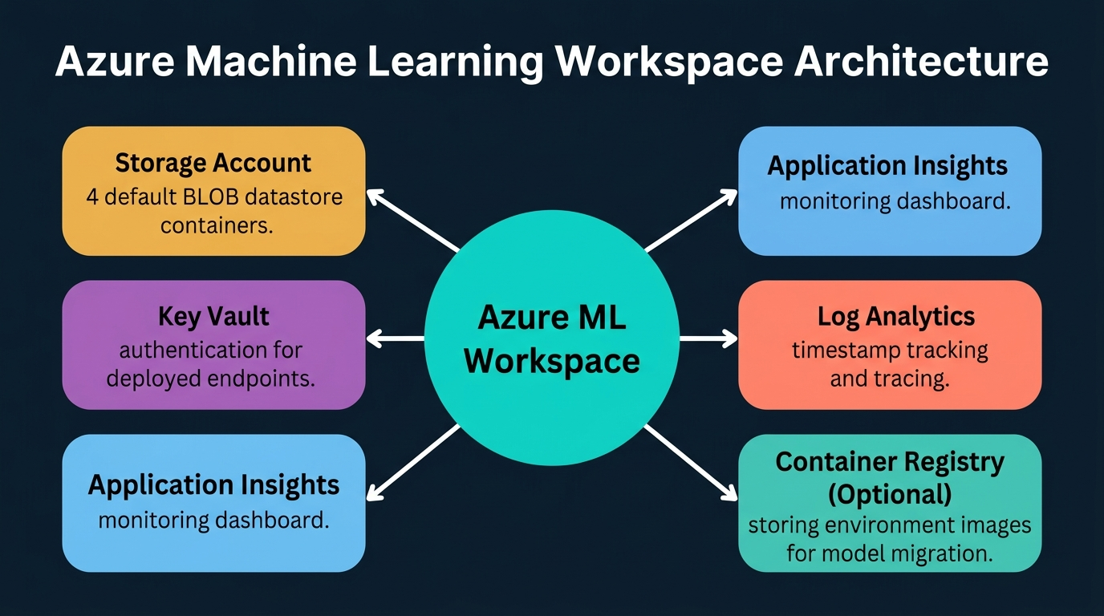
Figure 1. Azure Machine Learning Workspace Architecture: Central workspace connected to Storage Account, Key Vault, Application Insights, Log Analytics, and Container Registry. Generated infographic — AI-300 lecture series.
- Azure Machine Learning is a cloud-based Platform as a Service (PaaS) that acts as a one-stop solution for training, optimising, and deploying ML models, with every workload requirement having a corresponding workspace component.
- When creating an Azure ML Workspace, five associated resources are automatically provisioned: a Storage Account, Key Vault, Application Insights, Log Analytics, and the workspace itself.
- The Storage Account provides the storage layer for the workspace, creating four default BLOB containers known as data stores that hold artefacts produced during model training, input data, and various files.
- Key Vault serves as an additional layer of authentication and verification specifically for deployed model endpoints, providing secure key management for real-time hosted models rather than for the workspace itself.
- Application Insights functions as a monitoring dashboard that collects telemetry data from every operation performed within the Azure ML Workspace, providing visual representations of the entire ML pipeline.
- Log Analytics acts as a tracker or tracer service that maintains timestamped records of every event occurring inside the Azure Machine Learning Workspace, enabling comprehensive audit trails.
- Container Registry is an optional sixth resource that becomes necessary when migrating models to production environments, as it stores container images of the model environment and configuration.
- The workspace contains three primary authoring tools: Notebooks (a Jupyter-like interface for Python SDK interaction), AutoML (a low-code/no-code tool), and Designer (a drag-and-drop pipeline builder).
- AutoML supports five supervised learning task types — classification, regression, time series forecasting, computer vision, and NLP — but notably does not include clustering or unsupervised learning, which must be configured separately.
- When configuring AutoML, users must specify the compute type, input data with a designated target column, the number of models to train, the primary evaluation metric, maximum timeout, and individual trial timeout.
- Designer provides a visual pipeline-building interface where components are dragged, dropped, and connected to construct reusable ML training pipelines, resembling a gaming-style component assembly interface.
- Data assets in the workspace are categorised into data stores (blank storage mediums created with the workspace) and data assets (actual training data), with three data asset types: URI File, URI Folder, and ML Table.
- URI File is used when uploading a single CSV file directly; ML Table is used when the CSV is referenced through a pointer configuration; URI Folder is used when uploading both types together in a single folder.
- Environments in Azure ML come in two types: curated environments (pre-configured for standard workloads) and custom environments (user-defined configurations for specific package and dependency requirements).
- The workspace provides five types of compute: Compute Instance, Compute Cluster, Attached Compute, Kubernetes Cluster, and Serverless Compute, each suited to different engagement models and workload requirements.
- Compute Cluster is the most prominent compute type because it supports multiple instances, enabling distributed learning and parallel processing across nodes defined by the max_instances parameter.
- Models trained in the workspace must be registered in the Models section before deployment; registration creates a versioned record of the model that can then be selected for endpoint hosting.
- Endpoints in Azure ML come in two types: real-time endpoints (for immediate response to individual data points) and batch endpoints (for scheduled or trigger-based bulk processing).
- The workspace operates as PaaS — users select and configure infrastructure but do not manage the underlying hardware; this contrasts with SaaS (e.g., Copilot) and IaaS (direct infrastructure management).
- Azure CLI commands follow the pattern "az ml [resource] create" for workspace provisioning — for example, "az group create" for resource groups, "az ml workspace create" for workspaces, and "az ml compute create" for compute resources.
📌 TEACHER'S NOTE
"Azure Machine Learning is kind of a one-stop solution — an online-based cloud platform as a service interface — where we will be able to train, optimise, and deploy the model training process."
— Kiran Dambal

KEY TERMS
AZURE ML WORKSPACE — The central management hub in Azure for all machine learning operations, providing integrated access to compute, data, environments, models, and endpoints within a single interface.
DATA STORE — A pre-configured BLOB storage container within the Azure ML Workspace; four are created by default and serve as the storage backend for all workspace artefacts and data.
COMPUTE CLUSTER — A multi-instance compute resource in Azure ML that supports parallel processing and distributed training, distinguished from Compute Instance by its max_instances parameter.
AUTOML — A low-code/no-code automated machine learning tool that trains multiple models across different algorithms and hyperparameters, then selects the best-performing model based on a specified primary metric.

TOPIC 2: Hyperparameter Tuning and Sweep Jobs
Hyperparameter tuning is the systematic process of finding optimal values for the configuration parameters that control the model training process, such as learning rate, batch size, and regularisation coefficients. Unlike model parameters that are learned from data, hyperparameters have no fixed formula and must be determined through trial and error. Azure Machine Learning addresses this challenge through sweep jobs — a specialised job type that executes multiple child training runs in parallel, each with different hyperparameter combinations. This topic connects directly to the cost optimisation and compute management themes of the AI-300 certification.
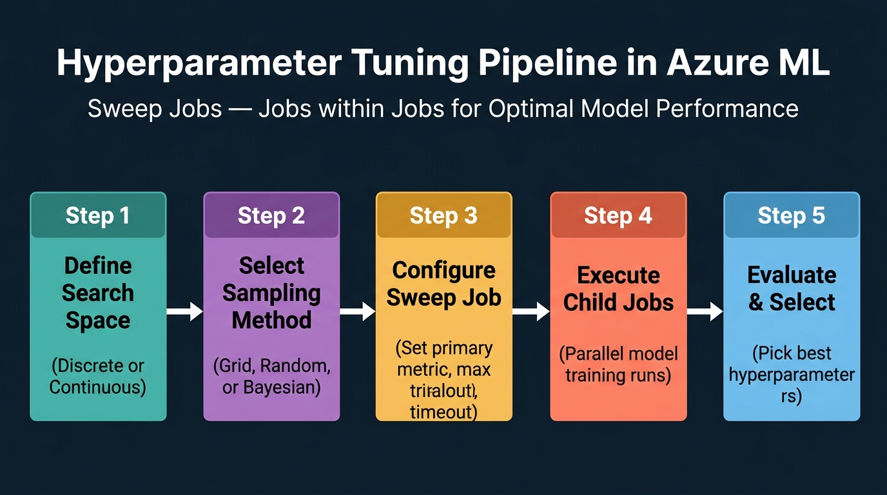
Figure 2. Hyperparameter Tuning Pipeline in Azure ML: Five-stage process from search space definition through sampling to evaluation. Generated infographic — AI-300 lecture series.
- Hyperparameter tuning addresses the fundamental challenge that no fixed formula exists for determining optimal hyperparameters — values like learning rate, regularisation strength, and tree depth must be found through systematic experimentation.
- In Azure Machine Learning, hyperparameter tuning is executed through sweep jobs, which are the only job type that contains child jobs within a parent job, enabling parallel exploration of the hyperparameter space.
- Azure ML defines three job types: normal jobs (simple execution), command jobs (isolated execution with dedicated compute and environment), and sweep jobs (parent-child architecture for hyperparameter exploration).
- The search space defines the range of hyperparameter values to explore and comes in two varieties: discrete (an explicit list of specific values) and continuous (a range with a specified count of samples to draw).
- Discrete search space requires the user to provide a fixed list of candidate values — for example, learning rates of [0.01, 0.05, 0.1, 0.5] — and the sweep job trains a model for each combination.
- Continuous search space specifies a range (e.g., 0 to 1) and a count (e.g., 4), from which the system randomly samples values within that range, providing more flexible exploration than discrete enumeration.
- Grid sampling identifies every unique combination of hyperparameter values and trains a model on each; if all 10,000 rows in a dataset are unique, grid sampling will load all 10,000, making it inefficient for large-scale datasets.
- Random sampling ignores data patterns and relationships, selecting a specified number of rows entirely at random; while computationally efficient, it risks missing important variable distributions in the sampled subset.
- Bayesian sampling overcomes the limitations of both grid and random sampling by selecting new data points based on the performance of previously acquired samples, creating an iteratively improving selection process.
- The primary purpose of hyperparameter tuning is dual: reducing compute consumption costs (by not training on the full dataset) and reducing training time (by efficiently exploring only the most promising parameter regions).
- Sweep jobs require configuration of several parameters: the primary metric to optimise (e.g., accuracy, F1 score), the maximum number of trials, the maximum total timeout, and the maximum timeout per individual trial.
- Each child job within a sweep job trains a model with a different hyperparameter combination; after all child jobs complete, the parent sweep job compares results and identifies the optimal configuration.
- Bayesian sampling is considered the superior approach because it learns from each completed trial, directing subsequent trials toward regions of the hyperparameter space that are more likely to yield better results.
- The search space is defined programmatically using the Azure Python SDK, where discrete distributions use the choice() function and continuous distributions use uniform(), loguniform(), or normal() functions.
- Grid sampling is deterministic and exhaustive but scales poorly — with k hyperparameters each having n values, grid sampling requires n^k total trials, making it impractical for high-dimensional search spaces.
- Random sampling provides a fixed computational budget regardless of the search space dimensionality, making it suitable for initial exploration when the relationship between hyperparameters and performance is unknown.
- Early termination policies can be applied to sweep jobs to halt underperforming child trials before completion, further reducing compute cost by abandoning configurations that show poor intermediate results.
- The results of a completed sweep job include a ranked list of all child jobs with their hyperparameter configurations and corresponding metric values, enabling transparent comparison and selection.
- Sweep jobs integrate with MLflow logging, meaning each child job automatically tracks its hyperparameters (as parameters), performance metrics (as metrics), and trained model files (as artefacts).
- Hyperparameter tuning is relevant to the AI-300 exam despite not being a primary syllabus topic; questions about sweep jobs, sampling strategies, and the relationship between tuning and compute cost appear in the certification.
📌 TEACHER'S NOTE
"There are no specific formula, fixed template to decide what is the right kind of hyperparameter — always we have to do trial and error itself. Doing that one after the other takes time. For that, they introduced sweep jobs."
— Kiran Dambal

KEY TERMS
SWEEP JOB — A specialised Azure ML job type that contains child jobs within a parent job, each child training a model with a different hyperparameter combination for systematic optimisation.
SEARCH SPACE — The defined range or list of hyperparameter values that a sweep job will explore; can be discrete (explicit list) or continuous (range with sampling count).
BAYESIAN SAMPLING — A sampling strategy that selects subsequent hyperparameter values based on the performance of previously completed trials, iteratively focusing exploration on promising regions.
GRID SAMPLING — A deterministic sampling strategy that exhaustively evaluates every unique combination of hyperparameter values, guaranteeing coverage but scaling poorly with dimensionality.

TOPIC 3: MLflow Logging and Model Lifecycle Tracking
MLflow is an advanced Python library that serves as the central framework for machine learning operations, providing capabilities for monitoring, logging, tracing, registering, and tracking model deployments throughout the entire ML lifecycle. In the context of Azure ML, MLflow integrates directly with the workspace to provide both automated and custom logging of every aspect of the model training process. Understanding MLflow is critical because it directly determines the deployment approach — models logged with MLflow auto-logging require significantly fewer manual steps for endpoint deployment. The instructor noted that while MLflow is not exclusively an Azure concept, its logging types are frequently tested in both the DP and AI-300 certification exams.
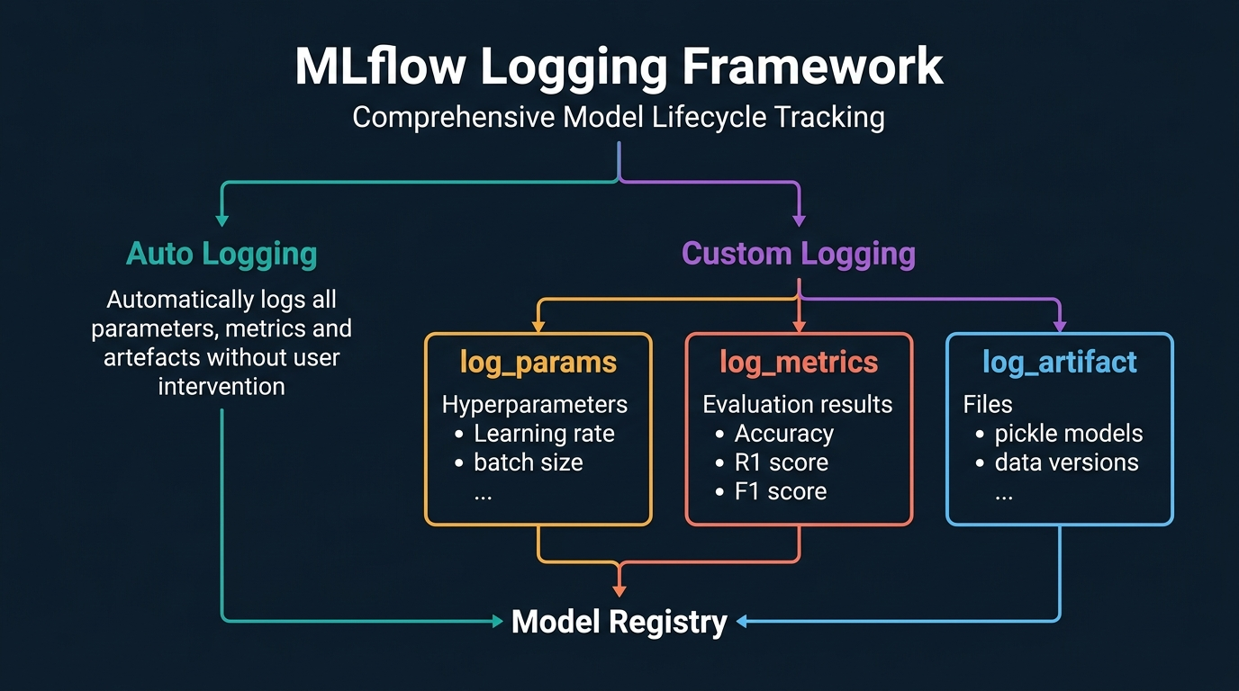
Figure 3. MLflow Logging Framework: Auto Logging vs Custom Logging (log_params, log_metrics, log_artifact) flowing to Model Registry. Generated infographic — AI-300 lecture series.
- MLflow is a versatile Python library used across the entire machine learning operations lifecycle, providing integrated functionality for monitoring, logging, tracing, registering, and tracking model deployments.
- MLflow supports two fundamental logging modes: auto-logging (which automatically captures all training parameters, metrics, and artefacts without user code) and custom logging (which gives users granular control over what is recorded).
- Auto-logging is invoked with a single function call (mlflow.autolog()) and automatically records hyperparameters, evaluation metrics, trained model files, and all environment configuration details without any additional code.
- Custom logging provides three specialised methods, each designed for a different category of training information: log_params for hyperparameters, log_metrics for evaluation results, and log_artifact for files.
- The log_params method records numerical configuration values such as learning rate, batch size, train-test split ratio, and regularisation coefficients — any value that controls the training process rather than being learned from data.
- The log_metrics method captures evaluation results including accuracy, R-squared score, F1 score, mean squared error, and any other quantitative measure of model performance on validation or test data.
- The log_artifact method stores files generated during the training process, including serialised model files (pickle format), data version snapshots, feature importance plots, and confusion matrices.
- When auto-logging is enabled, five critical artefact files are automatically saved: the pickle model file, configuration.yml, conda.yml, python_environment.yml, and requirements.txt.
- The pickle file contains the serialised trained model; conda.yml stores high-level environment configuration; configuration.yml captures Python dependency details; python_environment.yml records the Python version and kernel; requirements.txt lists pip-installable packages.
- These five artefact files are essential for model deployment — without them, a model cannot be hosted as an endpoint in Azure Machine Learning, making auto-logging the preferred approach for streamlined deployment.
- Without auto-logging, all five artefact files must be created manually: the pickle file is generated during training, but the remaining four configuration files require explicit creation and population by the developer.
- MLflow logging integrates with sweep jobs, meaning each child job in a hyperparameter tuning sweep automatically records its unique hyperparameter combination and corresponding performance metrics.
- The MLflow Model Registry provides versioned storage of trained models, enabling teams to compare model versions, transition models between stages (Staging, Production, Archived), and maintain a complete model lineage.
- MLflow tracking experiments are organised into runs, where each run represents a single training execution with its associated parameters, metrics, artefacts, and metadata, enabling reproducible experiment comparison.
- Custom logging is preferred when the user wants to selectively record only specific metrics (e.g., only accuracy rather than all possible metrics) or when file storage needs to be minimised.
- Auto-logging is preferred for production pipelines where completeness and reproducibility are more important than storage efficiency, as it guarantees no critical information is accidentally omitted.
- MLflow is not Azure-specific — it is an open-source project that integrates with multiple cloud platforms, but within Azure ML, it receives first-class support and direct integration with the workspace.
- The instructor explicitly noted that MLflow logging questions appear on both the DP and AI-300 certification exams, particularly questions about the three custom logging methods and the difference between auto and custom logging.
- MLflow UI provides a web interface for exploring tracked experiments, comparing runs visually, and inspecting logged artefacts, although in Azure ML this functionality is integrated into the workspace Studio interface.
- The choice between auto-logging and custom logging directly affects the model deployment pathway: auto-logged models can be deployed as MLflow models (3 steps) while manually logged models require the custom deployment path (5 steps).
📌 TEACHER'S NOTE
"MLflow is a very interesting and very advanced Python library used for machine learning operations, monitoring, logging, tracing, registering, and tracking deployment. Everything is done with respect to this particular MLflow."
— Kiran Dambal

KEY TERMS
MLFLOW — An open-source Python library for the complete ML lifecycle, providing experiment tracking, model registry, and deployment tooling; integrated as a first-class component in Azure Machine Learning.
AUTO-LOGGING — An MLflow mode that automatically records all training parameters, metrics, and artefact files without any explicit logging code, invoked with mlflow.autolog().
LOG_PARAMS — An MLflow custom logging method for recording hyperparameter values (learning rate, batch size, etc.) that control the training process.
LOG_ARTIFACT — An MLflow custom logging method for storing files such as serialised model pickle files, data version snapshots, and generated visualisations.

TOPIC 4: Model Deployment to Managed Online Endpoints
Model deployment to managed online endpoints represents the culmination of the machine learning lifecycle, where trained and validated models are made available for real-time inferencing through HTTPS endpoints. This topic is arguably the most exam-relevant section of the Azure ML portion of AI-300, as the instructor observed that nearly all deployment-related questions test a single critical concept: managed online endpoints manage all underlying infrastructure automatically. Two deployment approaches exist — MLflow model deployment (3 steps) and custom model deployment (5 steps) — and understanding their differences is essential for both the exam and practical implementation. The scoring script, with its init() and run() functions, serves as the bridge between the deployed model and incoming prediction requests.
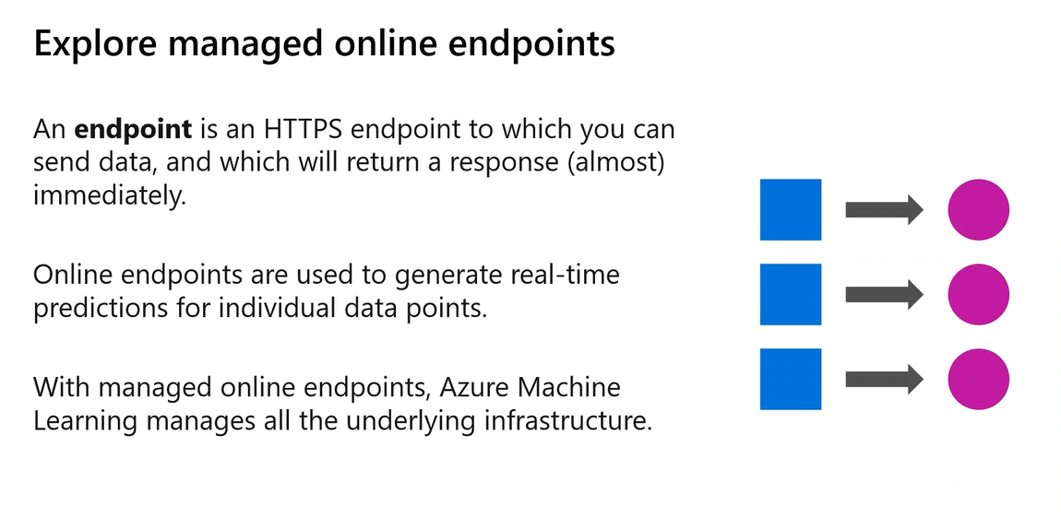
Figure 4. Explore Managed Online Endpoints: An endpoint is an HTTPS endpoint to which you can send data and which will return a response almost immediately. Course slide — AI-300 lecture.
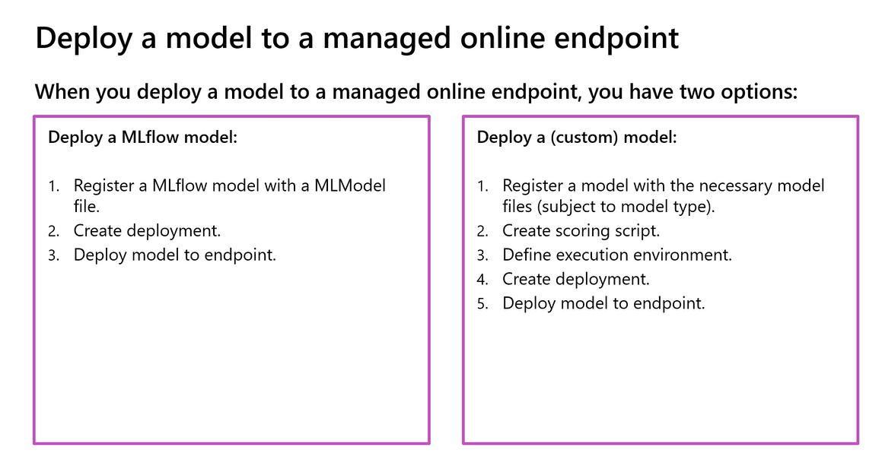
Figure 5. Deploy a Model to a Managed Online Endpoint: Comparison of MLflow (3 steps) and Custom (5 steps) deployment approaches. Course slide — AI-300 lecture.
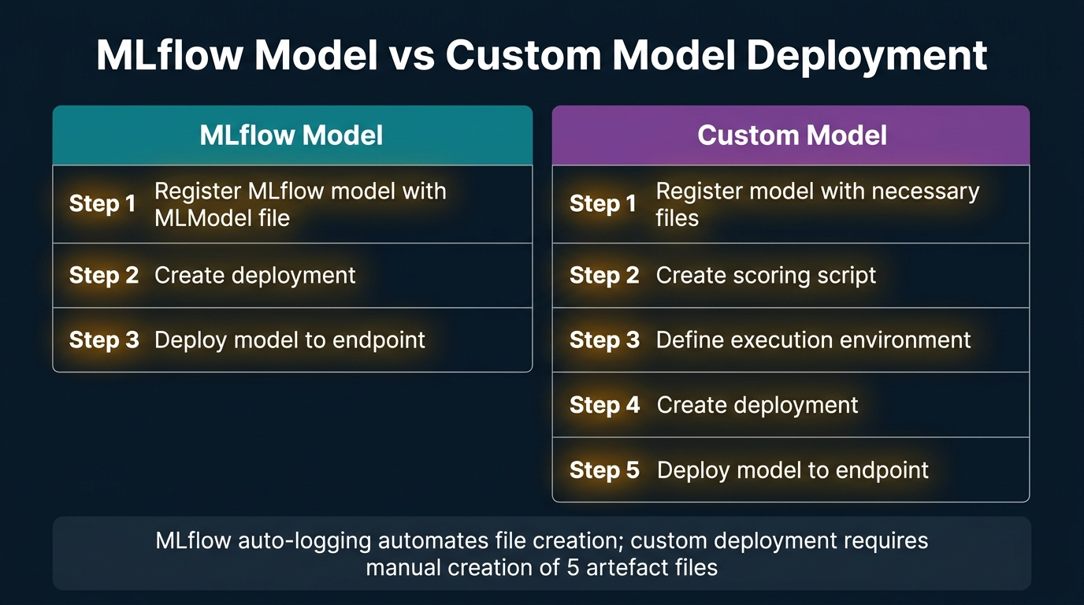
Figure 6. MLflow Model vs Custom Model Deployment: Side-by-side comparison showing the step reduction achieved through MLflow auto-logging. Generated infographic — AI-300 lecture series.
- Azure Machine Learning supports two types of model deployment: real-time (online) endpoints that return predictions immediately, and batch endpoints that accumulate requests and process them on a schedule or trigger.
- Managed online endpoints are HTTPS endpoints that accept input data and return prediction responses almost immediately, making them suitable for real-time applications such as weather forecasting and recommendation systems.
- The critical exam-relevant concept is that with managed online endpoints, Azure Machine Learning manages all the underlying infrastructure — compute, storage, networking, and scaling — without user intervention.
- If a question describes a scenario where the user must manage their own infrastructure for model hosting, the answer is Azure Kubernetes Service (AKS), not a managed online endpoint.
- Real-time endpoints are the dominant deployment pattern in modern ML applications because users expect immediate responses; batch endpoints are rarely chosen except for cost-sensitive, latency-tolerant workloads.
- The instructor noted that batch endpoints keep appending input data to a queue and generate all outputs at once when triggered, either by a time-based schedule (e.g., every Saturday at 6 PM) or by manual admin initiation.
- Deploying an MLflow model requires only three steps: (1) register the MLflow model with the MLModel file, (2) create the deployment configuration, and (3) deploy the model to the endpoint.
- Deploying a custom model requires five steps: (1) register the model with all necessary files, (2) create the scoring script, (3) define the execution environment, (4) create the deployment configuration, and (5) deploy to the endpoint.
- The scoring script is a Python programme containing two essential functions: init() (which loads the model when the endpoint starts) and run() (which processes individual prediction requests and returns results).
- The scoring script differs from the Score Model component in Designer: Score Model processes bulk test data (30% of a dataset), while the scoring script handles one individual prediction request at a time.
- The init() function controls the interpreter to understand when to initialise the model loading process, ensuring the model is loaded only once when the endpoint starts rather than on every request.
- Five artefact files are required for deployment: the pickle model file, configuration.yml, conda.yml, python_environment.yml, and requirements.txt — all automatically created with MLflow auto-logging.
- Without MLflow auto-logging, the developer must manually create four of the five files (the pickle file is always generated during training), increasing the risk of human error in environment and dependency specification.
- The MLflow deployment approach is both easier (fewer steps) and safer (reduced human error) because MLflow has been specifically tuned to create correct scoring scripts and deployable model files.
- Azure ML manages all infrastructure for managed online endpoints including compute provisioning, storage for the artefact BLOB store (one of the four default data stores), and the HTTPS connectivity layer.
- Users can select the compute SKU (e.g., Standard DS11 v2 with 14GB RAM and 28GB storage) but cannot modify individual hardware components; they choose between predefined sizes.
- Auto-scaling is available for managed online endpoints, with the scaling behaviour depending on the use case; high-traffic applications (like weather apps making predictions every 5 minutes) may require serverless compute.
- The exam frequently uses the terms "deployment" and "endpoint" interchangeably within the same question to test whether candidates understand that both refer to the same hosted model configuration.
- Testing a deployed endpoint can be done through the Azure ML Studio interface (via the "Test" tab on the endpoint page) or programmatically through API calls using the endpoint URL and authentication key.
- Model deployment can also be performed through the Azure ML Studio UI: register the model from local files or a data store, then create an endpoint by selecting the registered model and configuring hosting parameters.
📌 TEACHER'S NOTE
"Always expect — the deployment is nothing but endpoint. They will try to confuse you in the same question using the terms. In some sentence they use deployment, in some sentence they use endpoint — both are relevant to the same thing."
— Kiran Dambal

KEY TERMS
MANAGED ONLINE ENDPOINT — An HTTPS endpoint in Azure ML where all underlying infrastructure (compute, storage, networking) is automatically managed by the platform, returning real-time predictions for individual data points.
SCORING SCRIPT — A Python programme with init() and run() functions that loads a trained model and processes individual prediction requests for a deployed real-time endpoint.
BATCH ENDPOINT — A model hosting option where input data is queued and processed in bulk on a schedule or manual trigger, suitable for latency-tolerant workloads.
INIT() FUNCTION — The initialisation function in a scoring script that loads the trained model into memory when the endpoint starts, ensuring the model is ready to serve prediction requests.

TOPIC 5: Planning and Preparing a GenAIOps Solution
Generative AI Operations (GenAIOps) extends the principles of MLOps to the domain of large language models and AI agents, focusing on the systematic monitoring, testing, evaluation, and deployment of agent-based applications. Unlike traditional ML model operations, GenAIOps introduces unique challenges around token consumption, prompt engineering, multi-agent orchestration, and the iterative nature of conversational AI systems. This session marks the transition from Azure Machine Learning (model training and deployment) to Microsoft Foundry (agent building and management), representing the second major section of the AI-300 curriculum. The instructor emphasised that GenAIOps is fundamentally about trial-and-error testing — building agents, testing interactions, and iterating on system instructions to achieve optimal cost-performance balance.
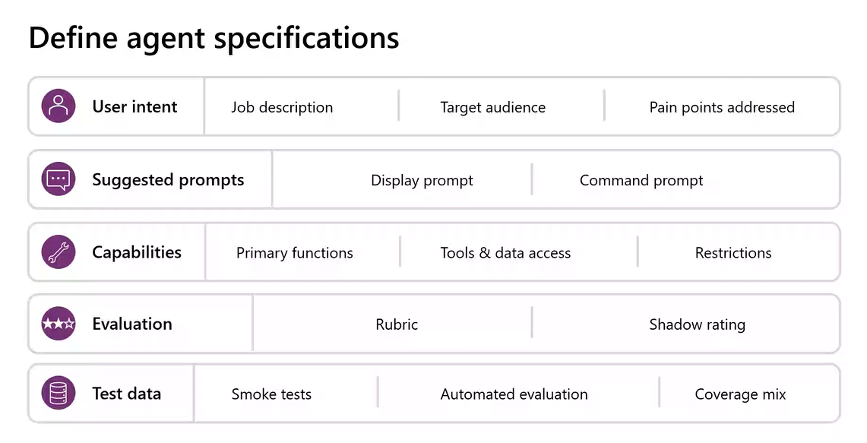
Figure 7. Define Agent Specifications: Five categories of agent specification — User Intent, Suggested Prompts, Capabilities, Evaluation, and Test Data. Course slide — AI-300 lecture.
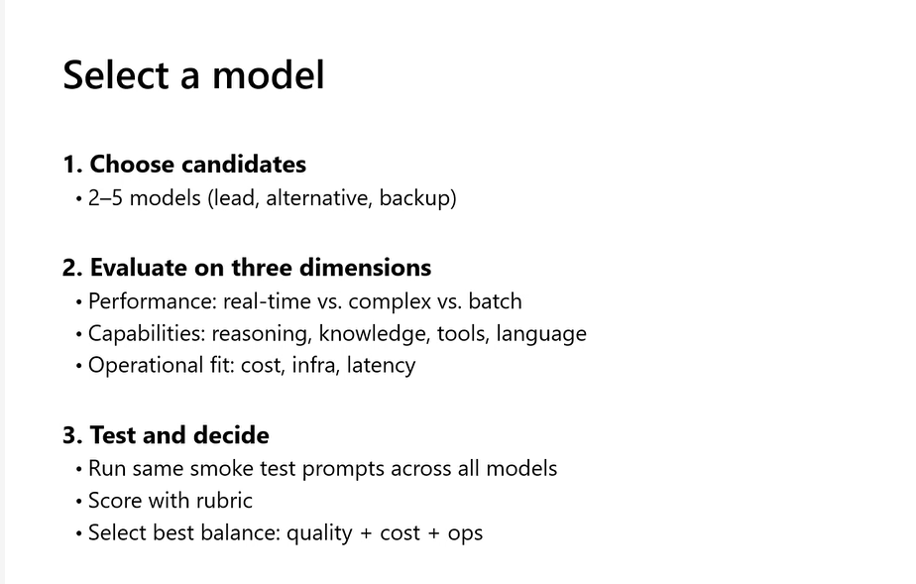
Figure 8. Select a Model: Three-step framework for model selection — Choose Candidates, Evaluate on Three Dimensions, Test and Decide. Course slide — AI-300 lecture.
- Generative AI Operations (GenAIOps) encompasses the practices and tools for optimising, deploying, and maintaining AI agent-based applications, extending traditional MLOps principles to the domain of large language models.
- GenAIOps is fundamentally a trial-and-error methodology: building agents, testing interactions, evaluating responses, and iterating on configurations to achieve the optimal balance between cost and performance.
- Agent specifications define five categories: user intent (job description, target audience, pain points), suggested prompts (display and command), capabilities (functions, tools, data access), evaluation criteria, and test data.
- Display prompts are pre-configured sample questions visible when a user first opens a chatbot interface; command prompts are manually typed queries entered by users during live interaction.
- Agents differ from standard generative AI applications by having two additional components: tools (for external actions) and memory (for maintaining conversation context across interactions).
- Agent tools are classified into two categories: knowledge-based tools (for retrieving context and data) and action-based tools (for performing operations like sending emails or updating databases).
- Model selection for scalable agents requires choosing 2–5 candidate models serving as lead, alternative, and backup, ensuring continuity when a primary model reaches its token limit or becomes unavailable.
- Model evaluation occurs across three dimensions: performance (real-time vs. complex vs. batch processing), capabilities (reasoning, knowledge, tools, language), and operational fit (cost, infrastructure, latency).
- Reasoning capability measures how well an agent understands the semantic meaning of a request regardless of phrasing variations — a critical quality because the same question can be expressed in thousands of different formulations.
- A/B testing is the primary evaluation method for GenAIOps, comparing benchmark outputs (expected correct answers) against agent-generated outputs for the same input to measure accuracy and consistency.
- Smoke testing involves randomly throwing diverse and unexpected prompts at the agent to verify basic operational stability before proceeding to more structured evaluation methods.
- Rubric-based scoring provides a structured evaluation framework where agent responses are rated against predefined criteria, enabling quantitative comparison across model versions and configurations.
- Agent cost is inherently higher than standard generative applications because agents make multiple LLM calls per user request — each tool invocation, knowledge retrieval, and reasoning step triggers a separate API interaction.
- If an agent enters an infinite loop of LLM interactions (continuously trying to refine its response), the token cost can escalate exponentially, making prompt engineering and context engineering critical cost controls.
- Context engineering is the emerging discipline of minimising unnecessary LLM interactions by crafting precise system instructions that reduce the number of tool calls and reasoning loops required per request.
- Latency is a critical operational metric: the time a user waits for an agent response directly impacts user experience, and production agents must balance response quality with acceptable response times.
- The GenAIOps lifecycle consists of four stages: Discover (identify the business use case and test prompts), Build (create agents, add tools, fine-tune), Deploy (customise code, evaluate, publish), and Operate (monitor, protect, integrate).
- The inner loop of GenAIOps corresponds to the development lifecycle (iterating on agent configuration until satisfied), while the outer loop encompasses the production lifecycle (monitoring and retraining in production).
- Infrastructure management for GenAIOps uses three methods: shell scripting (CLI via setup.sh), Bicep scripts (ARM templates via AZD), and the Azure Portal UI, each appropriate for different operational contexts.
- The instructor explicitly noted that 80% of AI-300 exam questions for a recent test-taker came from the exam dumps, but lab experience is essential for understanding the practical context behind the questions.
📌 TEACHER'S NOTE
"It is not something where which comes with respect to pre-configured details around. It is kind of a trial and error method, trial and test method where we are going to build the agent, we are going to test the management, how they are going to work."
— Kiran Dambal

KEY TERMS
GENAIOPS — Generative AI Operations — the set of practices and tools for monitoring, testing, evaluating, deploying, and maintaining AI agent-based applications in production environments.
A/B TESTING — An evaluation method comparing two outputs (benchmark vs. generated) for the same input to measure agent accuracy and response quality.
SMOKE TEST — A preliminary testing approach that sends random, diverse prompts to an agent to verify basic operational stability before conducting structured evaluation.
CONTEXT ENGINEERING — The discipline of crafting precise system instructions to minimise unnecessary LLM interactions, reducing token consumption and cost without sacrificing response accuracy.

TOPIC 6: The GenAIOps Lifecycle and Tooling Ecosystem
The GenAIOps lifecycle provides a structured framework for the entire agent development process, from initial discovery and problem identification through building, deployment, and ongoing operations. This lifecycle mirrors the software development lifecycle (SDLC) but is specifically adapted for the unique requirements of AI agent systems, including model selection, prompt versioning, and multi-agent orchestration. Understanding the tooling ecosystem across each lifecycle stage is essential for the AI-300 certification, as questions frequently test which tool is appropriate for which phase. The critical distinction between Azure CLI (AZ) for infrastructure and Azure Developer CLI (AZD) for application deployment underpins the entire hands-on lab experience.
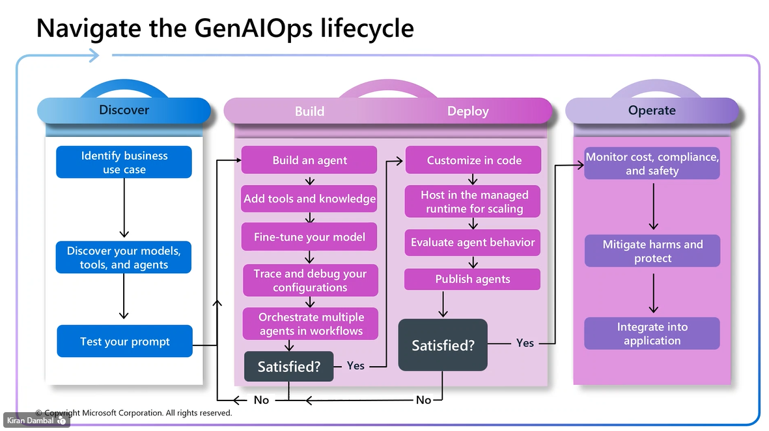
Figure 9. Navigate the GenAIOps Lifecycle: Four-stage lifecycle — Discover, Build, Deploy, Operate — with inner loop (development) and outer loop (production) iterations. Course slide — AI-300 lecture.
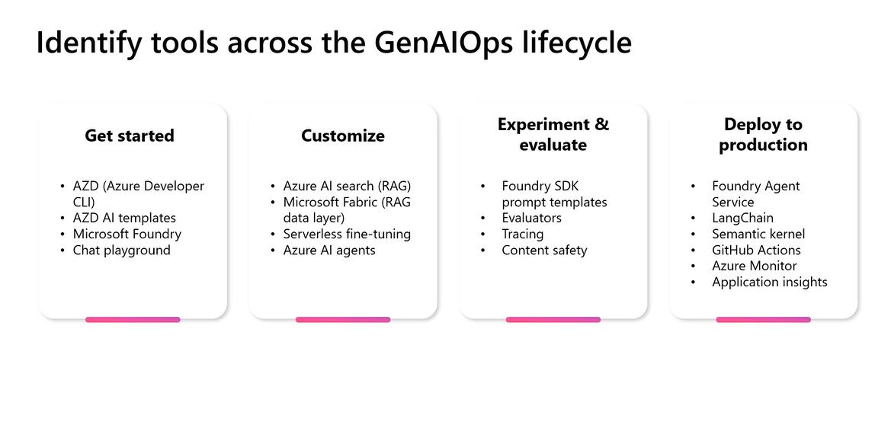
Figure 10. Identify Tools Across the GenAIOps Lifecycle: Tools mapped to four phases — Get Started, Customise, Experiment & Evaluate, Deploy to Production. Course slide — AI-300 lecture.
- The GenAIOps lifecycle consists of four sequential stages: Discover, Build, Deploy, and Operate, each containing specific activities and decision points that determine whether to iterate or advance.
- The Discover stage involves three activities: identifying the business use case, discovering available models, tools, and agents, and testing initial prompts to validate the feasibility of the proposed solution.
- The Build stage encompasses five activities: building the agent, adding tools and knowledge sources, fine-tuning the model, tracing and debugging configurations, and orchestrating multiple agents in workflows.
- The Deploy stage includes four activities: customising code, hosting in the managed runtime for scaling, evaluating agent behaviour in a pre-production environment, and publishing the agent for end users.
- The Operate stage covers three activities: monitoring cost, compliance, and safety metrics; mitigating harms and protecting against adversarial inputs; and integrating the agent into broader applications.
- The inner loop (development iteration) cycles between Build and the "Satisfied?" decision point; if the team is not satisfied, they return to the Build stage to refine the agent configuration.
- The outer loop (production iteration) cycles between Deploy and Operate; if production monitoring reveals issues, the agent is rolled back through Discovery for a complete reassessment.
- Azure CLI (AZ) is used exclusively for infrastructure provisioning — creating resource groups (az group create), workspaces (az ml workspace create), compute (az ml compute create), and other Azure resources.
- Azure Developer CLI (AZD) is used for application-level operations within existing infrastructure — creating agents, deploying models, and configuring applications inside the resources provisioned by AZ.
- The simplest way to understand the distinction: AZ creates the Foundry project; AZD creates the agent inside the Foundry, configures it, and deploys the application code.
- The "Get Started" phase uses four tools: AZD (Azure Developer CLI), AZD AI templates, Microsoft Foundry, and Chat Playground for initial setup and experimentation.
- The "Customise" phase leverages Azure AI Search (for RAG), Microsoft Fabric (RAG data layer), serverless fine-tuning, and Azure AI agents for adding knowledge and capabilities.
- The "Experiment & Evaluate" phase employs Foundry SDK prompt templates, evaluators, tracing, and content safety tools for systematic testing and quality assessment.
- The "Deploy to Production" phase uses Foundry Agent Service, LangChain, Semantic Kernel, GitHub Actions, Azure Monitor, and Application Insights for production hosting and monitoring.
- Bicep scripts (the .bicep format) represent Azure Resource Manager (ARM) templates and serve as the second method for infrastructure provisioning, alongside CLI and UI methods.
- The AZD up command is the primary deployment command that provisions all infrastructure resources — resource group, Foundry project, Log Analytics, and Application Insights — and deploys the application in a single operation.
- The AZD auth login command authenticates the developer to Azure for AZD operations, similar to az login for Azure CLI, but using a separate authentication flow.
- Infrastructure provisioning through Bicep scripts is defined in the infra/main.bicep file, which specifies allowed regions, resource configurations, and deployment parameters.
- The GenAIOps labs in the AI-300 course are designed as a continuous sequence: Lab 1 creates the foundation, and each subsequent lab builds incrementally on the previous one.
- All five GenAIOps labs use the same agent (trail-guide) and progressively add prompt versioning, evaluation, monitoring, and optimisation capabilities to demonstrate the complete lifecycle.
📌 TEACHER'S NOTE
"AZ is only used to control the infrastructure. After building the infrastructure, inside the infrastructure, if you want to configure and build some applications into it — consume the platforms — you use AZD."
— Kiran Dambal

KEY TERMS
AZ (AZURE CLI) — The command-line interface for provisioning and managing Azure infrastructure resources such as resource groups, workspaces, and compute instances.
AZD (AZURE DEVELOPER CLI) — The command-line interface for deploying and managing applications within Azure infrastructure, including creating agents, deploying models, and configuring Foundry projects.
BICEP — A declarative infrastructure-as-code language that compiles to Azure Resource Manager (ARM) templates, used for defining Azure resource deployments in the GenAIOps labs.
INNER LOOP / OUTER LOOP — Development lifecycle terminology: the inner loop covers iterative development and testing; the outer loop covers production monitoring and redeployment.

TOPIC 7: Prompt Version Control and Context Engineering
Prompt version control is the systematic practice of maintaining multiple versions of agent system instructions (prompts) to optimise the balance between response quality and token consumption cost. This practice, closely related to the emerging field of context engineering, represents one of the most important operational concerns in production AI agent systems. The instructor described a three-version progression — V1 (basic), V2 (enhanced), V3 (production) — that mirrors the iterative refinement process used in professional agent development. Understanding this topic is essential for the AI-300 exam, as questions test the rationale for prompt versioning and the relationship between system instruction complexity and operational cost.
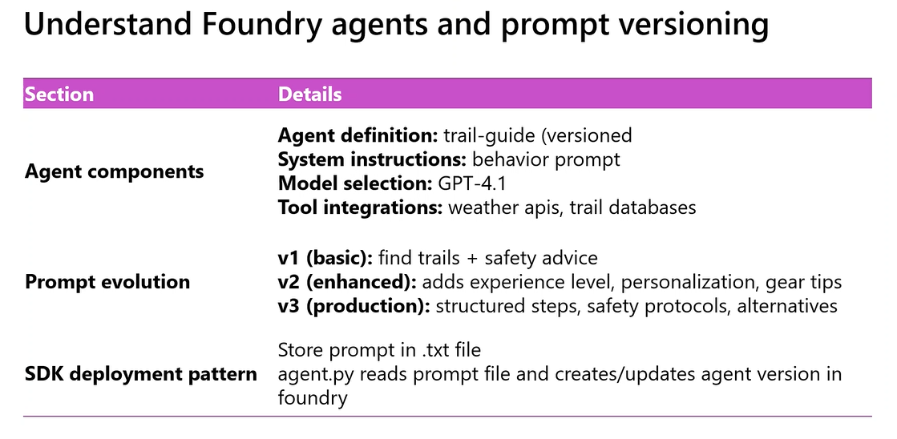
Figure 11. Understand Foundry Agents and Prompt Versioning: Agent components, prompt evolution (V1 → V2 → V3), and SDK deployment pattern. Course slide — AI-300 lecture.
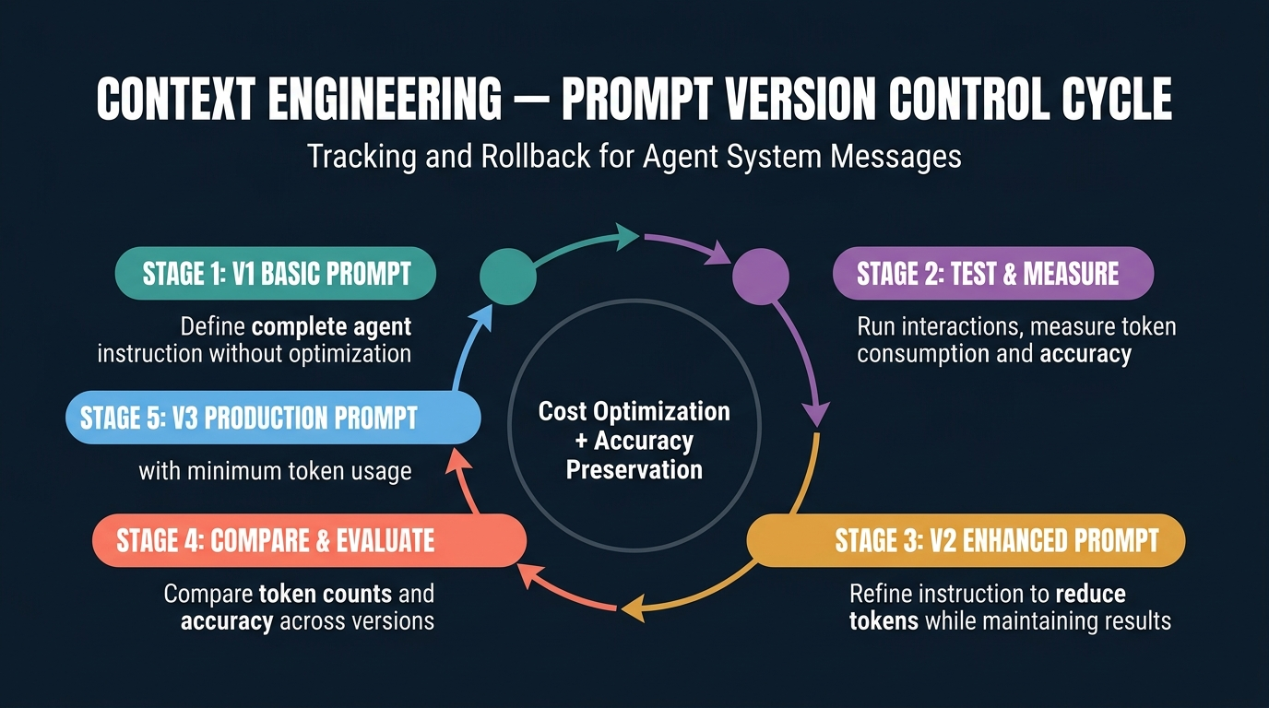
Figure 12. Context Engineering — Prompt Version Control Cycle: Five-stage iterative cycle from basic prompt through testing, enhancement, evaluation, to production-grade prompt. Generated infographic — AI-300 lecture series.
- Version control for agent prompts is critical because agents have unrestricted access to the LLM, making uncontrolled system instructions a significant cost liability through excessive token consumption.
- Unlike standard chatbot applications where users control interaction frequency, agents autonomously decide when and how often to interact with the LLM, potentially entering infinite loops of unnecessary API calls.
- The V1 (basic) prompt is written without optimisation concerns — its sole purpose is to achieve correct responses, regardless of instruction length or token consumption.
- The V2 (enhanced) prompt takes the proven V1 and refines it to reduce token consumption while maintaining the same response accuracy, representing the first optimisation pass.
- The V3 (production) prompt is the final optimised version that achieves the minimum possible token consumption while preserving response quality, ready for deployment to production environments.
- Version comparison involves measuring three dimensions: token consumption per interaction, response accuracy against benchmark outputs, and response latency for each prompt version.
- If V2 consumes fewer tokens than V1, the developer takes V2 as the new baseline and attempts further reduction in V3; if V3 unexpectedly increases tokens, the developer rolls back to V2 and tries a different approach.
- The rollback capability is the primary reason for maintaining version history — each version is preserved so developers can revert to a known-good configuration when new versions degrade performance.
- Context engineering, a specific application of prompt version control, focuses on crafting system instructions that minimise unnecessary LLM interactions by being more precise about when external tools should be invoked.
- A practical example of context engineering: specifying "refer Wikipedia only if you do not have an internal answer" instead of "refer Wikipedia" — the first formulation reduces unnecessary API calls to Wikipedia.
- Agent system instructions (prompts) are stored in separate text files (.txt or .md format) rather than hardcoded in application code, enabling version management through standard file-based version control.
- Configuration and metadata files use YAML or JSON format, dynamic templates use Python or Jinja2 format, and documentation uses Markdown format, following established DevOps conventions.
- The recommended repository structure places agents under src/agents/[agent_name]/ with the agent script (trail_guide_agent.py) and a prompts/ subdirectory containing versioned instruction files.
- Naming conventions use version prefixes (v1_, v2_, v3_) with clear, descriptive names, keeping prompts grouped with their corresponding deployment scripts for organisational clarity.
- The SDK deployment pattern reads the system instruction from a text file, passes it to the project_client.agents.create_version() method along with the model name, creating the agent version in Foundry.
- Code reviews for prompt changes are as important as code reviews for application logic — a poorly worded system instruction can cause cascading cost increases that are difficult to detect without monitoring.
- Environment separation (development vs. production) enables safe experimentation with new prompt versions without risking disruption to the live agent serving real users.
- The safe prompt deployment workflow follows four steps: (1) create a branch, (2) edit prompts and test locally, (3) commit with clear messages and open a pull request, (4) merge to main after approval and deploy.
- The trail-guide agent used in the course labs demonstrates all three versions: V1 finds trails and provides safety advice, V2 adds experience level personalisation and gear tips, V3 adds structured steps and safety protocols.
- Cost is the single most important reason for prompt version control — unoptimised prompts can multiply LLM interaction costs by orders of magnitude, making iterative refinement an economic necessity.
📌 TEACHER'S NOTE
"Context engineering is very much booming where engineers are going to understand, with a trial and error method, how to minimise the interactions with the LLM to reduce the cost. That is what we call context engineering."
— Kiran Dambal

KEY TERMS
PROMPT VERSION CONTROL — The systematic practice of maintaining multiple versions of agent system instructions (V1, V2, V3) to optimise the balance between response quality and token consumption cost.
SYSTEM INSTRUCTION — The configuration text (also called system message or agent instruction) that defines how an AI agent should behave, what tools to use, and how to format responses.
ROLLBACK — The ability to revert an agent to a previous prompt version when a newer version degrades performance, enabled by maintaining version history in the repository.
DISPLAY PROMPT vs COMMAND PROMPT — Display prompts are pre-configured sample questions shown in the chatbot UI; command prompts are manually typed by users during interaction.

TOPIC 8: Hands-On Lab — GenAIOps Infrastructure and Agent Deployment
The hands-on lab component of Day 3 covered two major practical exercises: deploying a trained ML model to a managed online endpoint via GitHub Actions, and setting up GenAIOps infrastructure using Azure Developer CLI (AZD) commands with Bicep scripts. While both labs encountered authentication challenges due to the preview nature of the course content, the procedural understanding gained is directly applicable to the AI-300 certification exam. The instructor demonstrated the alternative approach of using Azure ML Studio UI for model deployment when the GitHub Actions integration was unstable. Students also installed prerequisites (Azure CLI and Azure Developer CLI) and set up local development environments for the GenAIOps portion of the course.
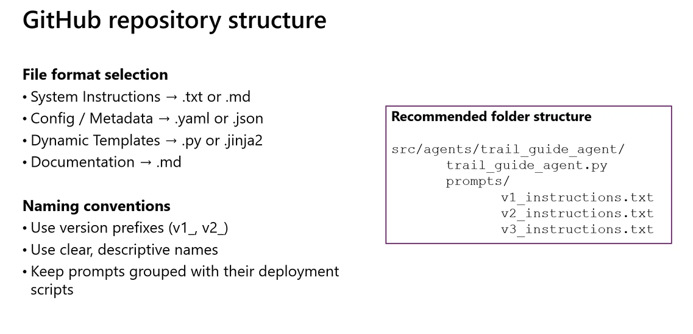
Figure 13. GitHub Repository Structure: File format conventions and recommended folder structure for GenAIOps agent projects. Course slide — AI-300 lecture.
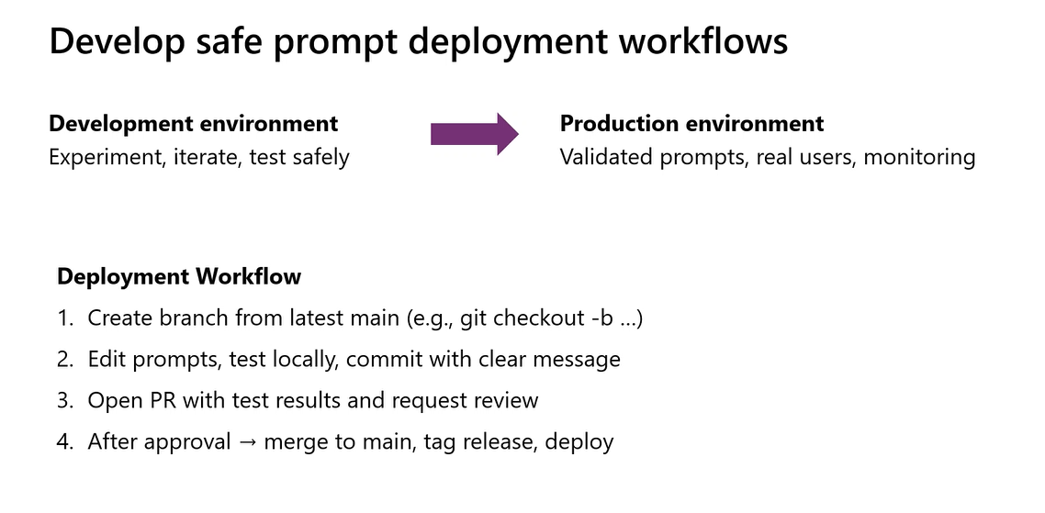
Figure 14. Develop Safe Prompt Deployment Workflows: Development to production pipeline with four-step deployment workflow. Course slide — AI-300 lecture.
- The ML deployment lab used GitHub Actions to automate the model deployment pipeline, connecting a GitHub repository to Azure Machine Learning through service principal secrets stored in the repository settings.
- The lab workflow involved creating a GitHub repository from a Microsoft Learning template, configuring development and production environments with Azure credentials, and triggering deployments through pull request comments.
- Pull request comments served as deployment triggers: "/train-dev" initiated model training in the development environment, "/train-prod" triggered production training, and "/deploy-prod" deployed the model to an online endpoint.
- The GitHub Actions workflow executed train_dev.yml and job.yml configurations along with train_model_parameters.py to orchestrate the automated training and deployment pipeline.
- Authentication issues between GitHub Actions and Azure ML Workspace were common during the session because the integration feature was in preview stage, not yet fully stable for production use.
- The instructor demonstrated an alternative deployment approach through Azure ML Studio: upload model files to a data store, register the model from the data store, then create an endpoint selecting the registered model.
- The GenAIOps infrastructure lab began with installing two prerequisite CLI tools: Azure CLI (installed via PowerShell using the winget command) and Azure Developer CLI (installed separately via winget).
- The verification process involved running version-check commands for all required tools: Python, Git, Azure CLI (az --version), and Azure Developer CLI (azd version) in a command prompt.
- The infrastructure deployment used three sequential commands: "azd auth login" (authenticate to Azure), "az login" (authenticate CLI to Azure subscription), and "azd up" (provision all infrastructure and deploy the application).
- The "azd up" command orchestrated the complete infrastructure provisioning from the infra/main.bicep file: creating the resource group, Foundry project, Log Analytics workspace, and Application Insights instance.
- The Bicep file (infra/main.bicep) contained a list of allowed regions (lines 19–44), which students modified to include only their subscription-allowed region before executing the deployment.
- Three methods for building cloud infrastructure were demonstrated: shell scripting (setup.sh using AZ CLI), Bicep scripting (main.bicep using AZD), and the Azure Portal UI, each appropriate for different contexts.
- The agent creation process used a Python script (trail_guide_agent.py) that called the project_client.agents.create_version() method, reading the agent name and model name from the .env file.
- The .env file was generated by the "azd env get-values > .env" command and required manual addition of two values: AGENT_NAME and MODEL_NAME (the deployed GPT model name).
- The requirements.txt for GenAIOps labs included numerous packages: Azure AI Project, Azure Identity, Azure Core, Azure Management Resource, OpenTelemetry, Pandas, NumPy, Scikit-Learn, PyTest, and others.
- The trail-guide agent project contained versioned prompt files under src/agents/trail_guide_agent/prompts/ with v1_instructions.txt (basic), v2_instructions.txt (enhanced), and v3_instructions.txt (production grade).
- Students encountered issues with GPT model access (GPT 5.5 quota limitations on student subscriptions), prompting the instructor to announce that remaining labs would be conducted as instructor-led demonstrations.
- The instructor committed to creating consolidated lab documentation combining all five GenAIOps labs into a single session for the following day, with proper documentation for exam preparation.
- Soft deletion of Azure resources has a 12-hour retention period, meaning deleted resources remain in a "soft delete" state and may conflict with new deployments within that window.
- The session concluded with the understanding that GenAIOps labs are in preview stage with known issues, but the conceptual understanding of the workflow is sufficient for certification preparation alongside the provided exam dumps.
📌 TEACHER'S NOTE
"Just because the content is getting updated — the particular lab was not there two and a half weeks back. They had directly hosting the real-time endpoint through the Python SDK. Now they have made it complicated with GitHub Actions. Still, it is in kind of a preview stage."
— Kiran Dambal

KEY TERMS
GITHUB ACTIONS — A CI/CD automation platform integrated into GitHub repositories, used in the AI-300 labs to automate model training and deployment workflows through pull request triggers.
AZD UP — The Azure Developer CLI command that provisions all infrastructure resources and deploys the application in a single operation, reading configuration from Bicep template files.
.ENV FILE — An environment configuration file storing key-value pairs (endpoint URLs, model names, API keys) that are loaded by application code at runtime, keeping sensitive configuration out of source code.
BICEP SCRIPT — A declarative Azure infrastructure-as-code file (.bicep) that specifies resource configurations and is executed by the AZD CLI to provision cloud infrastructure.

Glossary of Key Terms
A/B TESTING — An evaluation methodology that compares two outputs (benchmark expected answer vs. agent-generated answer) for the same input prompt to quantify accuracy and consistency.
APPLICATION INSIGHTS — An Azure monitoring service that collects telemetry data from Azure ML workspace operations and GenAIOps agent interactions, providing dashboards for performance analysis.
AUTO-LOGGING (MLFLOW) — An MLflow feature that automatically records all training parameters, metrics, and artefact files without explicit logging code; invoked by mlflow.autolog().
AUTOML — An Azure ML low-code/no-code tool that automatically trains and evaluates multiple ML models across algorithms and hyperparameters to identify the best performer for supervised learning tasks.
AZ (AZURE CLI) — The command-line interface for provisioning Azure infrastructure: resource groups, ML workspaces, compute instances, data assets, and other platform-level resources.
AZD (AZURE DEVELOPER CLI) — The command-line interface for deploying applications within Azure infrastructure: creating agents, deploying models, and managing Foundry project configurations.
BATCH ENDPOINT — A model hosting option where prediction requests are accumulated and processed in bulk on a schedule or manual trigger, suitable for cost-sensitive, latency-tolerant workloads.
BAYESIAN SAMPLING — A hyperparameter sampling strategy that selects subsequent parameter values based on the performance of previously completed trials, iteratively converging on optimal regions.
BICEP — A declarative infrastructure-as-code language compiling to ARM templates, used to define Azure resource deployments in GenAIOps labs.
COMMAND JOB — An Azure ML job type that runs in isolation with dedicated compute and environment resources, suitable for single-execution training workflows.
COMPUTE CLUSTER — A multi-instance Azure ML compute resource supporting distributed training and parallel processing, configured with a max_instances parameter.
CONTAINER REGISTRY — An optional Azure resource that stores container images of model environments and configurations, required for model migration to production environments.
CONTEXT ENGINEERING — The discipline of crafting precise agent system instructions to minimise unnecessary LLM API interactions, reducing token consumption cost while preserving response accuracy.
CURATED ENVIRONMENT — A pre-configured Azure ML environment with standard packages installed, suitable for common ML workloads without custom dependency requirements.
DATA STORE — A pre-configured BLOB storage container within Azure ML; four are created by default with the workspace to store training data, model artefacts, and configuration files.
DISPLAY PROMPT — Pre-configured sample questions displayed in a chatbot interface when a user first opens it, designed to guide initial interaction.
GENAIOPS — Generative AI Operations — the set of practices, tools, and processes for systematically building, deploying, monitoring, and maintaining production AI agent systems.
GRID SAMPLING — A deterministic hyperparameter sampling strategy that evaluates every unique combination of values, providing exhaustive coverage but scaling poorly with dimensionality.
INIT() FUNCTION — The initialisation function in a scoring script that loads the trained model into memory when an endpoint starts, executed once during deployment startup.
INNER LOOP — The development iteration cycle in MLOps/GenAIOps: planning, building, testing, and refining until the model or agent meets quality criteria before advancing to deployment.
KEY VAULT — An Azure service providing secure storage and management of authentication credentials, used in Azure ML for endpoint security and API key management.
LOG ANALYTICS — An Azure service that maintains timestamped records of all events in an Azure ML workspace, enabling audit trails and operational debugging.
LOG_ARTIFACT — An MLflow custom logging method that stores files (pickle models, data snapshots, plots) as tracked artefacts in the experiment run.
LOG_METRICS — An MLflow custom logging method that records numerical evaluation results (accuracy, F1, MSE) as tracked metrics in the experiment run.
LOG_PARAMS — An MLflow custom logging method that records hyperparameter values (learning rate, batch size) as tracked parameters in the experiment run.
MANAGED ONLINE ENDPOINT — An Azure ML HTTPS endpoint where all infrastructure is managed by the platform, accepting input data and returning real-time predictions.
MLFLOW — An open-source ML lifecycle management platform providing experiment tracking, model registry, and deployment tooling; integrated as a first-class component in Azure ML.
OUTER LOOP — The production iteration cycle: deploying, monitoring, and retraining when production performance degrades, potentially triggering a complete reassessment through the inner loop.
PROMPT VERSION CONTROL — Maintaining multiple versions (V1/V2/V3) of agent system instructions to optimise cost-performance balance through systematic iteration.
RANDOM SAMPLING — A hyperparameter sampling strategy that selects values randomly from the search space, providing fixed computational budget regardless of dimensionality.
RUN() FUNCTION — The prediction function in a scoring script that processes individual input requests, passes them to the loaded model, and returns prediction results.
SCORING SCRIPT — A Python file with init() and run() functions that serves as the interface between a deployed model and incoming prediction requests on an endpoint.
SEARCH SPACE — The defined range or list of hyperparameter values explored during a sweep job; can be discrete (explicit list) or continuous (range with sampling).
SMOKE TEST — A preliminary testing approach sending diverse random prompts to an agent to verify basic operational stability before structured evaluation.
SWEEP JOB — An Azure ML job type containing child jobs, each training a model with different hyperparameters; the parent job compares results to identify optimal configuration.
SYSTEM INSTRUCTION — The configuration text defining agent behaviour, tool usage, response format, and operational constraints; also called system message or agent instruction.

Key Takeaways from This Session
If you remember nothing else from this session, remember these:
- Azure ML Workspace is a PaaS ecosystem with five auto-provisioned resources (Storage, Key Vault, Application Insights, Log Analytics, Container Registry); understanding their roles is essential for infrastructure questions on the AI-300 exam.
- Hyperparameter tuning through sweep jobs uses the "jobs within jobs" architecture; Bayesian sampling is the superior strategy because it learns from previous trials, but Grid and Random sampling have their use cases for initial exploration.
- MLflow is the bridge between training and deployment: auto-logging creates all five artefact files automatically, enabling the streamlined 3-step MLflow deployment path instead of the 5-step custom deployment path.
- The single most important fact about managed online endpoints is that Azure manages all underlying infrastructure; if a question describes self-managed infrastructure, the answer is AKS, not managed online endpoints.
- The terms "deployment" and "endpoint" are used interchangeably in exam questions — both refer to the same hosted model configuration. Do not be confused by questions that switch between these terms in the same scenario.
- Scoring scripts require exactly two functions: init() (loads the model once at startup) and run() (processes individual prediction requests); this is different from the Score Model component that processes bulk test data.
- GenAIOps extends MLOps to agent systems with a critical new concern: token cost control. Agents autonomously interact with LLMs, making uncontrolled system instructions an exponential cost risk.
- Context engineering — the practice of crafting precise system instructions to minimise LLM interactions — is the key cost optimisation technique for production agents, and prompt version control (V1/V2/V3) is the mechanism.
- AZ creates infrastructure (resource groups, workspaces); AZD deploys applications within that infrastructure (agents, models). This distinction is fundamental to the GenAIOps lifecycle and appears in exam questions.
- The GenAIOps lifecycle (Discover → Build → Deploy → Operate) has inner loops (development iteration) and outer loops (production iteration); knowing which tools belong to which stage is an exam-relevant competency.
- The five artefact files required for model deployment (pickle, configuration.yml, conda.yml, python_environment.yml, requirements.txt) represent the complete deployment package — missing any one prevents endpoint creation.
- Agent evaluation uses A/B testing (comparing expected vs. generated outputs), smoke testing (random prompts for stability), and rubric scoring (structured criteria for quality assessment) as the three primary methods.

Suggested References
The following texts and resources were mentioned or implied during the session. Additional references are suggested for deeper study.

Microsoft Learn. Azure Machine Learning documentation — Deploy a model to a managed online endpoint.
- Relevance: Official documentation for the model deployment workflow covered in Topic 4.

Microsoft Learn. GenAIOps lifecycle and tooling documentation — Generative AI Operations.
- Relevance: Official reference for the Discover-Build-Deploy-Operate lifecycle covered in Topics 5-6.

MLflow Documentation. MLflow Tracking and Model Registry — mlflow.org.
- Relevance: Official reference for the MLflow logging framework covered in Topic 3.

AI-300 Exam Dumps. (Shared in course WhatsApp group) — approximately 146 questions.
- Relevance: The instructor confirmed that ~80% of a recent test-taker's questions matched the dumps.

Microsoft Learn. Azure CLI (AZ) and Azure Developer CLI (AZD) reference documentation.
- Relevance: CLI commands and distinctions covered in Topics 6 and 8.

Closing Summary
Day 3 of the AI-300 certification training represented a pivotal transition from Azure Machine Learning model operations to Generative AI Operations (GenAIOps), covering the complete spectrum from model deployment to agent lifecycle management. The session began with a comprehensive recap of the Azure ML Workspace architecture, reinforcing the foundational understanding of the five associated resources and their roles, before progressing through hyperparameter tuning via sweep jobs, MLflow logging frameworks, and the critical concepts of managed online endpoint deployment.
The central analytical framework introduced was the distinction between infrastructure provisioning (AZ) and application deployment (AZD) within the GenAIOps lifecycle. This framework, combined with the four-stage lifecycle model (Discover, Build, Deploy, Operate) and its inner/outer loop iteration patterns, provides students with a structured mental model for understanding how AI agent systems are developed, tested, and maintained in production environments. The concept of prompt version control — progressing from V1 (basic) through V2 (enhanced) to V3 (production) — operationalises the broader principle of context engineering as a cost optimisation discipline.
The practical significance of this session extends beyond certification preparation: the skills covered — model deployment, endpoint management, MLflow tracking, agent lifecycle management, and prompt engineering — represent the core competencies required for Machine Learning Operations Engineers in enterprise environments. As the instructor noted, the course content is evolving rapidly with new services still in preview, making hands-on familiarity with the conceptual frameworks and operational procedures more valuable than memorisation of specific UI steps that may change.
Students should focus their exam preparation on understanding the relationships between concepts rather than isolated facts: the connection between MLflow auto-logging and simplified deployment, the relationship between prompt version control and token cost reduction, and the distinction between AZ infrastructure commands and AZD application commands. These conceptual bridges, combined with the exam dumps shared in the course materials, provide a comprehensive preparation strategy for the AI-300 certification.

