AI-300 — Machine Learning Operations Engineer Associate

Module 16: Generative AI Ops — Day 4

Session Title: Generative AI Operations — Labs & Hands-On Demonstrations

Instructor: Kiran Dambal
Student: Utsav
Date: 13 September 2026
Duration: 2 hours 39 minutes (Session 1: 1h 26m + Session 2: 1h 12m)
Course: AI10 — Module 16 — AI-300 MLOps Engineer Associate

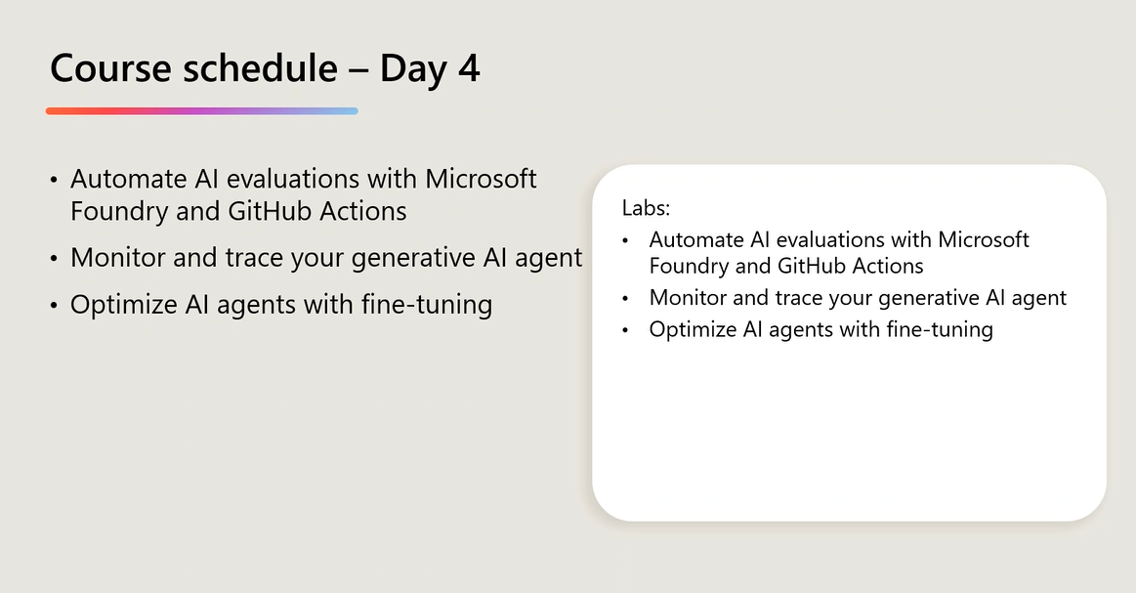
Figure 0. Course Schedule — Day 4: Automate AI evaluations, Monitor & trace generative AI agents, Optimise AI agents with fine-tuning.

Table of Contents
- 1. Session Overview
- 2. Learning Objectives
- 3. Topic 1: Infrastructure Setup & Agent Deployment (Lab 1)
- 4. Topic 2: Agent Prompt Versioning — V1, V2, V3 (Lab 2)
- 5. Topic 3: Prompt Optimisation & Model Comparison (Lab 3)
- 6. Topic 4: Automated Cloud Evaluation with Foundry Evaluators (Lab 4)
- 7. Topic 5: Monitoring, Tracing & Fine-Tuning Lifecycle (Lab 5)
- 8. Student Activity: Q&A and Interactive Discussion
- 9. Glossary of Key Terms
- 10. Key Takeaways from This Session
- 11. Suggested References
- 12. Closing Summary

Session Overview
- This session covered the complete Generative AI Operations (GenAI Ops) lifecycle across five hands-on labs in the AI-300 MLOps Engineer Associate certification programme.
- Lab 1 established the infrastructure by creating a GitHub repository from a Microsoft template, cloning it to VS Code, authenticating to Azure, deploying resources via AZD Up (Bicep/ARM templates), and creating the first Trail Guide AI agent.
- Lab 2 introduced agent prompt versioning, progressing from a basic V1 system prompt through an enhanced V2 to a production-ready V3, with each version tracked through Git commits and tags.
- Lab 3 focused on prompt optimisation and cost analysis, comparing a V3 baseline, V4 optimised concise prompt on GPT 5.1, and a V4 prompt on the cheaper GPT 4.1 model — demonstrating the trade-off between token consumption (9000 vs 8000 vs 3000) and response quality.
- Lab 4 automated evaluation at scale using Microsoft Foundry Cloud evaluators on an 89-entry JSONL dataset, scoring for intent resolution, relevance, and groundness, with integration into GitHub Actions as a CI/CD quality gate.
- Lab 5 covered monitoring, tracing, and fine-tuning using Application Insights, Log Analytics, and the continuous improvement lifecycle for production generative AI agents.
- The session was demo-based due to Azure student account subscription limitations; detailed step-by-step documents were shared via WhatsApp for independent reference.

Learning Objectives
After this session, you will be able to:
- Set up a complete GenAI Ops development environment by creating a GitHub repository from a Microsoft template, cloning it to VS Code, and authenticating to Azure using AZ Login and AZD Auth.
- Deploy Azure infrastructure as code using AZD Up with Bicep/ARM templates, provisioning resource groups, Microsoft Foundry resources, Foundry projects, Application Insights, and Log Analytics workspaces.
- Create and deploy AI agents programmatically using the Python SDK, specifying system instructions, model configurations, and agent metadata through the Azure AI Foundry project client.
- Implement prompt versioning by maintaining multiple system instruction versions (V1 basic, V2 enhanced, V3 production-ready) and tracking changes using Git commits and tags.
- Design and execute prompt optimisation experiments by comparing agent performance across different prompt versions and model configurations using batch testing.
- Analyse cost-quality trade-offs between high-capability models (GPT 5.1) and cost-effective alternatives (GPT 4.1), measuring token consumption and response quality metrics.
- Automate agent evaluation at scale using Microsoft Foundry Cloud evaluators with quality metrics including intent resolution, relevance, and groundness on large JSONL datasets.
- Integrate automated evaluation into CI/CD pipelines using GitHub Actions with OIDC authentication and service principals to enforce quality gates before deployment.
- Distinguish between deterministic (rule-based) and probabilistic (LLM-as-a-judge) evaluation approaches, selecting the appropriate method based on response complexity.
- Configure monitoring and observability for production agents using Application Insights and Log Analytics to establish a continuous improvement lifecycle.

Topic 1: Infrastructure Setup & Agent Deployment (Lab 1)
The foundation of any Generative AI Operations workflow is a robust infrastructure that connects version-controlled code repositories, cloud compute resources, and AI model endpoints into a single deployable unit. In this first lab, the instructor demonstrated the complete end-to-end pipeline for setting up a GenAI Ops environment — from creating a GitHub repository using a Microsoft-provided template to deploying a functional Trail Guide AI agent inside Microsoft Foundry. This topic establishes the critical operational baseline upon which all subsequent labs build, ensuring that infrastructure provisioning is automated, reproducible, and traceable. Understanding this pipeline is essential because, in production environments, manual infrastructure setup introduces configuration drift, security gaps, and deployment failures that automated Infrastructure-as-Code (IaC) pipelines are specifically designed to eliminate.
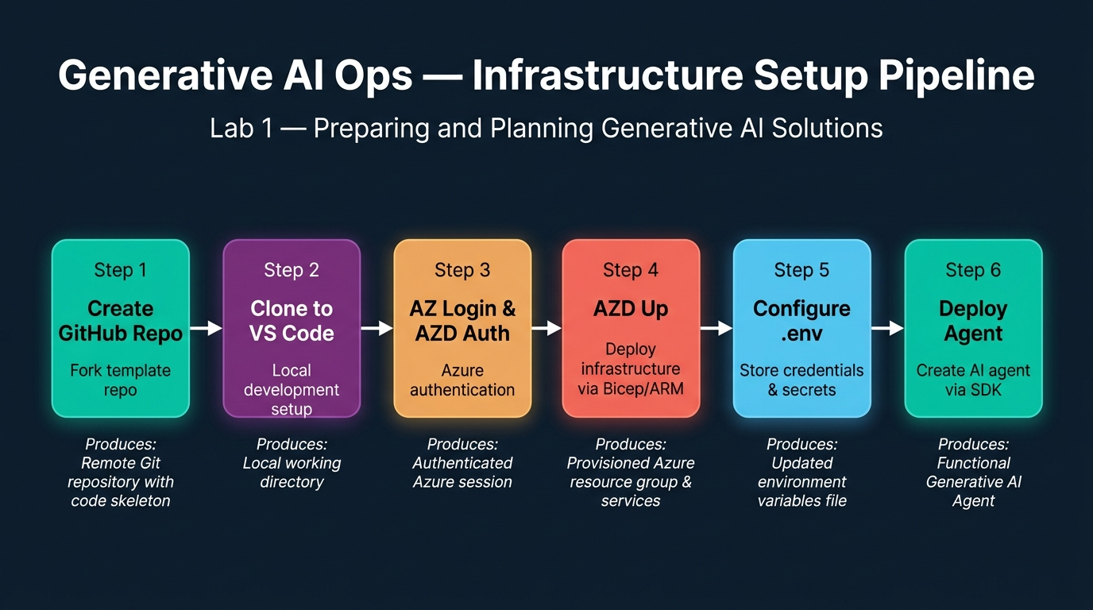
Figure 1. Generative AI Ops — Infrastructure Setup Pipeline: Six-step process from GitHub repository creation through Azure authentication and infrastructure deployment to agent creation. Generated infographic — AI-300 GenAI Ops lecture series.
- The GenAI Ops infrastructure setup begins with creating a GitHub repository from the Microsoft-provided mslearn-genaiops template, which contains pre-configured folder structures, Bicep scripts, prompt files, test scenarios, and agent code — providing a standardised starting point for all labs.
- Repository cloning to Visual Studio Code is performed using the Git Clone command (Ctrl+Shift+P → Git Clone), establishing a local development environment that mirrors the remote repository structure and enables local code editing before deployment.
- Azure authentication requires two separate login steps: AZ Login (which authenticates the Azure CLI and prompts for subscription selection) and AZD Auth Login (which authenticates the Azure Developer CLI for infrastructure deployment) — both are necessary because they serve different toolchains.
- The AZD Up command is the centrepiece of Infrastructure-as-Code deployment, reading the config.yaml file and executing Bicep scripts to automatically provision all required Azure resources in a single command, analogous to Docker Compose but for Azure infrastructure.
- Infrastructure provisioning through AZD Up creates five essential resources: a Resource Group (logical container), a Microsoft Foundry Resource (AI platform), a Foundry Project (workspace), Application Insights (monitoring), and a Log Analytics Workspace (telemetry) — taking approximately 4–5 minutes to complete.
- The AZD Up command also deploys a GPT 5.1 model as part of the infrastructure provisioning, as specified in the Bicep template — this is distinct from agent creation because the model is a shared resource that multiple agents can reference.
- Azure infrastructure can be provisioned through three methods: the Azure Portal UI (clicking buttons), the Azure CLI (AZ commands in Cloud Shell), or ARM/Bicep templates (Infrastructure-as-Code) — with IaC being the preferred production approach because it is version-controlled and repeatable.
- Bicep templates serve the same purpose as Terraform but are Azure-native, whereas Terraform is cloud-agnostic and can provision resources across multiple cloud providers including AWS, GCP, and Azure.
- The .env file is created using the AZD Env Get Values command, which extracts all deployment credentials, secrets, endpoint URLs, and resource identifiers from the terminal cache and writes them to a local environment file for SDK authentication.
- The .env file must be manually appended with two additional variables — the agent name (trail_guide) and the model name (GPT-5.1) — because these are application-level configurations not captured by infrastructure deployment outputs.
- A critical encoding issue was encountered: Visual Studio Code defaults to UTF-16 encoding for .env files, which prevents proper loading of environment credentials during Azure authentication — the file must be manually changed to UTF-8 encoding to resolve authentication failures.
- Agent creation is performed through a Python SDK script (trail_guide_agent.py) that authenticates to the Azure AI Foundry project client using the endpoint and default credentials from the .env file, then calls agents.create_version() to deploy the agent.
- The agent creation script requires three key parameters: the agent name (loaded from .env), the model identifier (GPT-5.1), and the instruction file path (V1 instruction.txt) — which together define the agent's identity, capability, and behaviour.
- System prompt instructions are stored as separate text files (V1_instruction.txt, V2_instruction.txt, V3_instruction.txt, V4_optimised_concise.txt) rather than hardcoded in the Python script, enabling version-controlled prompt management without code changes.
- Agent testing is performed using a separate script (interact_with_agent.py) that creates a conversation thread, submits a user query, and streams the agent's response — demonstrating the request-response pattern used in production agent interactions.
- The interact_with_agent.py script loads only the agent name (not a specific version), which causes it to default to the latest deployed version — a design pattern that simplifies testing but requires awareness of which version is currently active.
- The test query "I want to go hiking this weekend near Seattle, any suggestions?" was used to validate the Trail Guide agent, which responded with location-specific hiking recommendations based on the GPT 5.1 model's knowledge — confirming successful deployment.
- The entire Lab 1 workflow — from GitHub template creation to agent testing — follows a reproducible six-step pipeline: Create Repo → Clone to VS Code → Authenticate → AZD Up → Configure .env → Deploy & Test Agent.
- Python package dependencies (azure-ai-projects, azure-identity, openai) must be installed in the local environment using pip, and the instructor noted that using a virtual environment is optional but recommended to avoid dependency conflicts.
- The complete infrastructure deployment creates a traceable, auditable, and reproducible environment that can be torn down and recreated identically — a fundamental requirement for MLOps practices where environment parity between development, staging, and production is critical.

Infrastructure Provisioning & Tooling Architecture
Component / Tool | Resource Type / Service | Provisioning Mechanism | Primary Configuration File | Role in GenAI Ops
Azure Developer CLI (AZD) | Developer Orchestrator | azd auth login & azd up | azure.yaml / config.yaml | Single-command multi-resource environment provisioning
Bicep / ARM Templates | Infrastructure-as-Code | Compiled & executed via AZD | infra/main.bicep | Declarative definition of Foundry, AI services, and keys
Microsoft AI Foundry | Unified AI Platform | Azure AI Services hub | Foundry Portal / Project SDK | Model deployment catalogue, agent host, and evaluation hub
GPT 5.1 Deployment | LLM Inference Model | Azure OpenAI Service | models.bicep / Model Catalogue | Core language model powering Trail Guide agent completions
Environment Cache (.env) | Application Configuration | azd env get-values | .env (UTF-8 encoded) | Local credentials for Python SDK agent connection

📌 TEACHER'S NOTE
"AZD Up is exactly similar to Docker Compose itself — we're just doing it on the Azure end of things. It reads the config.yaml, finds the Bicep scripts, and builds everything for you. Infrastructure as Code is not optional in production."
— Kiran Dambal

KEY TERMS
AZD Up — An Azure Developer CLI command that reads a project's config.yaml and Bicep/ARM template files to automatically provision, configure, and deploy all required Azure resources in a single command — analogous to Docker Compose for Azure infrastructure.
Bicep Template — An Azure-native Infrastructure-as-Code language that compiles to ARM (Azure Resource Manager) templates, enabling declarative definition of Azure resources with a cleaner syntax than raw JSON ARM templates.
Microsoft Foundry — Microsoft's unified AI platform (formerly Azure AI Studio) that provides project workspaces for deploying models, creating agents, managing evaluations, and monitoring AI applications.
.env File — A local environment configuration file containing sensitive credentials, API endpoints, and resource identifiers used by Python SDK scripts to authenticate and interact with deployed Azure resources.
Trail Guide Agent — A demonstration AI agent built on GPT 5.1 that provides hiking trail recommendations, safety tips, and gear suggestions — used throughout the five GenAI Ops labs as the target application for versioning, testing, and evaluation workflows.

Topic 2: Agent Prompt Versioning — V1, V2, V3 (Lab 2)
Prompt engineering is not a one-time activity but an iterative development process that mirrors software versioning practices. In Lab 2, the instructor demonstrated how to systematically evolve an AI agent's behaviour by progressing through three distinct prompt versions — from a basic one-line instruction (V1) through an enhanced prompt with additional context (V2) to a production-ready prompt with full constraints and capabilities defined (V3). Each version was deployed as a new agent iteration, tracked through Git commits and tags, and tested against the same query to measure response quality improvements. This topic is critical because, in production generative AI applications, the system prompt is the single most impactful lever for controlling agent behaviour, and managing it without version control leads to untraceable regressions.
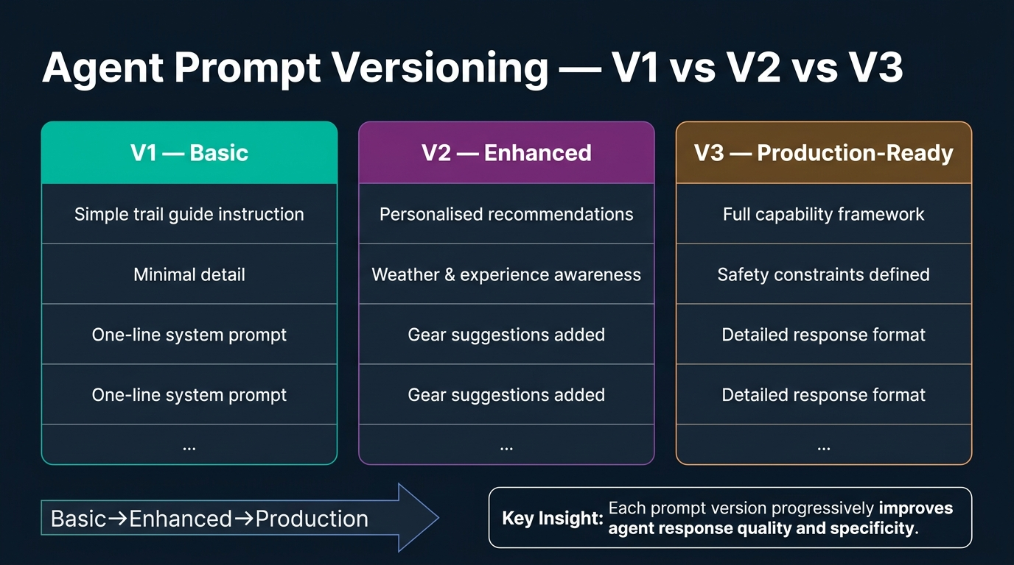
Figure 2. Agent Prompt Versioning — V1 vs V2 vs V3: Comparison of three prompt instruction levels showing the progression from basic to enhanced to production-ready system prompts. Generated infographic — AI-300 GenAI Ops lecture series.
- Prompt versioning follows the same principles as software versioning: each version represents a deliberate, documented change to the agent's behaviour specification, stored in version-controlled text files and tracked through Git commits and tags.
- Version 1 (V1) of the Trail Guide agent uses a basic, one-line system prompt: "You are a helpful trail guide assistant for Adventure Works, an outdoor gear company. Help users with basic trail recommendations, safety tips, and gear suggestions for hiking and outdoor activities. Keep responses informative but concise."
- The V1 prompt represents the "basic stage" of prompt development — it establishes the agent's identity and general capabilities but provides minimal guidance on response format, depth, or personalisation, resulting in generic and shallow responses.
- Version 2 (V2) is the "enhanced stage" that adds personalisation dimensions including experience level awareness, weather condition considerations, available gear assessment, time constraints, and location preferences — significantly improving response relevance.
- The V2 prompt also introduces behavioural directives such as "always prioritise safety and provide specific, actionable advice" and "include gear recommendations from the Adventure Works catalogue when relevant" — adding guardrails that were absent in V1.
- Version 3 (V3) is the "production-ready stage" that provides a comprehensive agent specification including explicit capabilities, a recommendation framework, constraint definitions, and detailed response formatting guidelines — leaving minimal room for ambiguous behaviour.
- Agent deployment for each version uses the same Python script (trail_guide_agent.py) with only one line changed: the instruction file reference is updated from V1_instruction.txt to V2_instruction.txt to V3_instruction.txt before re-executing the script.
- Each deployment creates a new numbered version of the agent within Microsoft Foundry (version 1, version 2, version 3), all sharing the same agent name (trail_guide) but with different system instructions — enabling version-specific rollback and comparison.
- If no specific version is requested when interacting with the agent, the system automatically loads the latest version — a convenience for testing but a potential risk in production where version pinning is essential for stability.
- To request a specific version, the agent name can be appended with a version suffix (e.g., trail_guide/V1) — enabling parallel testing of different versions against the same queries without affecting the production deployment.
- Git commits are used to snapshot each prompt change, and Git tags (V1, V2, V3) provide human-readable markers for each deployment — creating an auditable trail of exactly which prompt was active at any point in time.
- The git log --oneline --decorate command displays the version history showing the progression: V1 (main/HEAD) → V2 (Deploy Trail Guide Agent V2 with enhanced capabilities) → V3 (Deploy Trail Guide Agent V3 with production features).
- Comparative testing of all three versions using the same query ("I want to go hiking this weekend near Seattle, any suggestions?") revealed that V1 produced brief, generic suggestions, V2 added structured detail with safety tips, and V3 delivered comprehensive, formatted responses with personalised recommendations.
- The response length and depth increased substantially with each version: V1 produced a short paragraph, V2 generated structured bullet points with categories, and V3 delivered a multi-section response with headings, detailed trail descriptions, and safety protocols.
- The instructor emphasised that prompt versioning is not just about making prompts longer — each version should address specific deficiencies identified in the previous version's outputs, guided by measurable quality criteria rather than arbitrary additions.
- In production environments, prompt changes should be treated with the same rigour as code changes: they require review, testing, approval, and deployment through a controlled pipeline — not ad-hoc modifications in the Foundry console.
- The agent versioning mechanism in Microsoft Foundry maintains all versions simultaneously, allowing operators to switch between versions without redeployment — enabling rapid rollback if a new prompt version causes quality degradation.
- Multiple versions of an agent cannot share different system prompts simultaneously under the same active session — each conversation thread is bound to the version that initiated it, ensuring consistency within a single interaction.
- The three-stage prompt development framework (Basic → Enhanced → Production-Ready) provides a repeatable methodology applicable to any domain, not just trail guide applications — the structure applies equally to customer service, medical advisory, or legal compliance agents.
- The cumulative effect of prompt versioning is a documented, testable, and reversible evolution of agent behaviour that transforms prompt engineering from an art into a disciplined engineering practice with clear quality metrics.

Prompt Evolution Stages & Behavioral Profile
Prompt Stage | Version Identifier | Prompt Characteristics | Behavioral Capabilities | Git Versioning Artifact
Basic Stage | Version 1 (V1) | One-line system prompt | Minimal guidance, plain text responses, generic answers | Git commit & tag: v1.0
Enhanced Stage | Version 2 (V2) | Multi-paragraph prompt | Safety warnings, gear suggestions, structured markdown | Git commit & tag: v2.0
Production Stage | Version 3 (V3) | Comprehensive prompt | Difficulty classification, emergency protocols, tailored advice | Git commit & tag: v3.0 (Production baseline)

📌 TEACHER'S NOTE
"You cannot use the same agent for two different scenarios with different system prompts. What you can do is maintain versions. One agent with your first system prompt, the other a second version with a different system prompt. If you just provide the agent name without a version, it takes the latest version."
— Kiran Dambal

KEY TERMS
System Prompt (Agent Instruction) — A predefined instruction set loaded into an AI agent before user interaction begins, defining the agent's identity, capabilities, constraints, and response format — the primary mechanism for controlling agent behaviour without model retraining.
Prompt Versioning — The practice of maintaining multiple distinct system prompt configurations as version-controlled files, each representing a deliberate evolution in agent behaviour from basic (V1) to production-ready (V3+).
Git Tag — A named reference point in a Git repository's commit history used to mark specific agent prompt versions (e.g., V1, V2, V3) for easy identification, comparison, and rollback.
Production-Ready Prompt — A comprehensive system instruction (V3 or higher) that specifies the agent's complete capability framework, behavioural constraints, response formatting requirements, and safety guardrails — leaving minimal room for ambiguous or uncontrolled behaviour.

Topic 3: Prompt Optimisation & Model Comparison (Lab 3)
Once a production-ready prompt has been established, the next operational challenge is optimising it for cost, latency, and quality — three dimensions that frequently conflict. In Lab 3, the instructor demonstrated a structured experimentation framework for comparing agent performance across two optimisation axes: prompt refinement (V3 baseline vs V4 optimised concise prompt on GPT 5.1) and model substitution (V4 prompt on GPT 5.1 vs GPT 4.1). This topic introduces the concept of experiment branches in Git, batch testing with multiple prompts, and quantitative comparison of token consumption and evaluation metrics. Mastering this optimisation workflow is essential because production AI applications must balance response quality against operational cost and latency — and these trade-offs must be measured, not guessed.
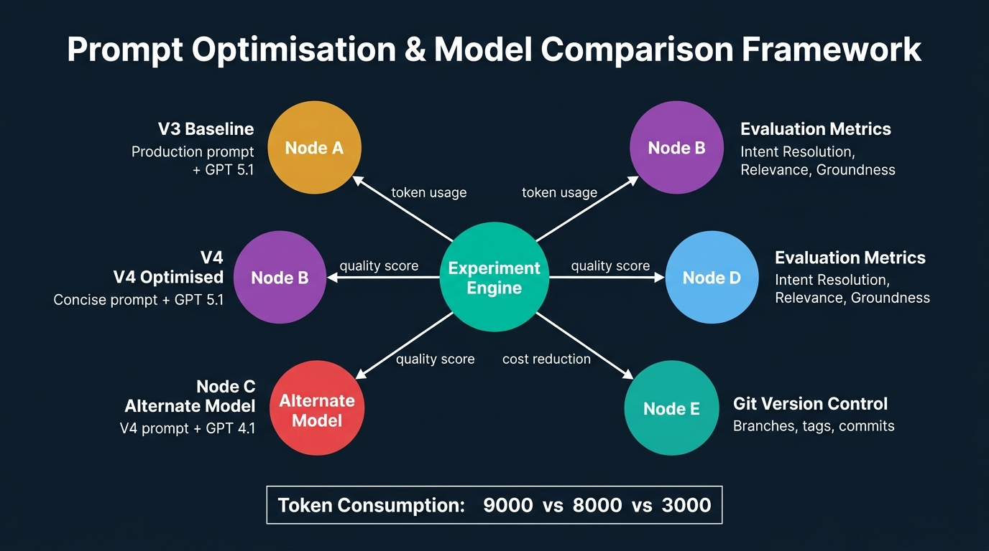
Figure 3. Prompt Optimisation & Model Comparison Framework: Architecture showing the Experiment Engine connecting V3 Baseline, V4 Optimised, and Alternate Model experiments with evaluation metrics and Git version control. Token consumption comparison: 9000 vs 8000 vs 3000. Generated infographic — AI-300 GenAI Ops lecture series.
- The optimisation workflow uses the V3 production-ready prompt as the baseline against which all experiments are measured — establishing a reference point ensures that improvements and regressions can be objectively quantified.
- Git branching is used to isolate experiments: the main branch retains the baseline (V3), while experiment branches (experiment/optimised-concise, experiment/alternate-model) contain modified configurations — preventing experimental changes from contaminating the production configuration.
- Batch testing uses five pre-defined test scenarios stored as text files (day_hike_gear.txt, overnight_camping.txt, three_day_backpacking.txt, trail_difficulty.txt, winter_hiking.txt) that are submitted to the agent in sequence, with results saved as JSON for comparison.
- The run_batch_test.py script automates the testing pipeline: it loads all test prompt files, submits each to the currently active agent version, captures the full response including token counts, and writes results to an experiment-specific folder (experiments/baseline/, experiments/optimised_concise/, or experiments/alternate_model/).
- The V3 baseline experiment consumed approximately 7,994 tokens across five test prompts, establishing the reference token budget that subsequent optimised versions aim to reduce without proportional quality loss.
- The V4 optimised concise prompt was designed to produce equally relevant but more concise responses, reducing unnecessary elaboration while preserving core information — representing prompt engineering for token efficiency rather than just quality improvement.
- Experiment results are stored as agent_response.json files within experiment-specific subdirectories, containing the complete prompt, response text, token counts, and metadata for each of the five test scenarios.
- Evaluation results are recorded in CSV files (evaluation.csv) with columns for test prompt, agent response excerpt, intent resolution score, relevance score, groundness score, and comments — though in this lab, evaluation scores were synthetic (manually assigned) rather than computed.
- The alternate model experiment tests the same V4 optimised prompt but deployed on GPT 4.1 instead of GPT 5.1, isolating the impact of model capability on response quality while holding the prompt constant.
- GPT 4.1 was manually deployed in the Microsoft Foundry model catalogue because the Bicep template only provisions GPT 5.1 by default — this step was not included in the official lab instructions but was necessary for the cost comparison experiment.
- Token consumption dropped dramatically from approximately 9,000 tokens (V3 on GPT 5.1) to approximately 3,000 tokens (V4 on GPT 4.1) — a 67% reduction, demonstrating that both prompt optimisation and model selection contribute to cost control.
- The cost reduction achieved by using GPT 4.1 came with measurable quality trade-offs: responses were less elaborative, less detailed, and scored lower on relevance and groundness — confirming that model capability directly impacts output quality.
- The instructor emphasised that cost optimisation is not simply about choosing the cheapest model — it requires balancing the cost-quality trade-off against the specific requirements of the use case, with some applications tolerating lower quality for significant cost savings.
- Three distinct experiment configurations were compared: (1) V3 baseline prompt on GPT 5.1, (2) V4 optimised concise prompt on GPT 5.1, and (3) V4 optimised concise prompt on GPT 4.1 — each providing a different point on the cost-quality Pareto frontier.
- The winning experiment (V3 baseline on GPT 5.1) was selected and merged back to the main branch, while experimental branches were preserved for reference — demonstrating the principle that optimisation experiments should inform production decisions, not automatically replace them.
- Git branch management commands (git checkout, git branch, git merge, git tag, git push) were used throughout the experiment lifecycle to create, switch, compare, and merge experimental configurations — integrating prompt optimisation into standard software development workflows.
- The experiment results were pushed to the remote GitHub repository, making the experiment branches visible to all team members and creating a permanent record of the optimisation analysis that informed the production decision.
- Cost reduction strategies for generative AI applications fall into two categories: prompt-level optimisation (reducing token consumption through concise prompts) and model-level optimisation (using less expensive models for acceptable quality) — both should be evaluated independently.
- Load balancing was clarified as an infrastructure-level concern (AZ-104 Azure Administrator certification) unrelated to agent-level operations — an important distinction because agent scaling and infrastructure scaling are governed by different teams and tools.
- The structured experimentation framework demonstrated in Lab 3 is reusable for any optimisation scenario: define baseline → create experiment branch → modify configuration → run batch test → compare metrics → decide → merge winner — a repeatable, version-controlled optimisation workflow.

Experiment Results Comparison Matrix
Experiment Configuration | Prompt Version | Base Model | Token Budget (5 Prompts) | Response Quality & Depth | Production Decision
1. Baseline Experiment | V3 Production-Ready | GPT 5.1 | ~7,994 – 9,000 tokens | High depth, rich formatting, thorough trail advice | Selected & merged to main (Winner)
2. Optimised Concise | V4 Concise Prompt | GPT 5.1 | ~7,500 – 8,000 tokens | High quality, succinct responses, moderate savings | Retained on experiment branch for reference
3. Alternate Model | V4 Concise Prompt | GPT 4.1 | ~3,000 tokens (-67%) | Lower depth, less elaborate, reduced groundness | Rejected for primary agent; viable for low-cost tier

📌 TEACHER'S NOTE
"We reduced cost, but what did we do? We compromised with respect to our accuracy, data latency, as well as the depth of our response. Cost optimisation is always a trade-off — you must measure what you are giving up."
— Kiran Dambal

KEY TERMS
Batch Testing — The practice of submitting multiple pre-defined test prompts to an AI agent in sequence and recording all responses with metadata (token counts, latency) for systematic performance comparison across versions or configurations.
Token Consumption — The total number of language model tokens (input + output) used during an agent interaction, directly determining the cost of the API call — a primary optimisation target in production generative AI applications.
Experiment Branch — A Git branch created specifically to isolate an experimental configuration change (prompt modification or model substitution) from the production baseline, enabling safe testing without affecting the main deployment.
Cost-Quality Trade-off — The fundamental tension in production AI operations between minimising operational cost (through smaller models or shorter prompts) and maintaining response quality (accuracy, relevance, depth) — requiring measured, data-driven decisions rather than assumptions.
Pareto Frontier — The set of optimal configurations where no improvement in one dimension (cost or quality) can be achieved without degradation in the other — used to identify the best available trade-off for a given use case.

Topic 4: Automated Cloud Evaluation with Foundry Evaluators (Lab 4)
Manual evaluation of AI agent responses does not scale beyond a handful of test cases, and subjective human judgement introduces inconsistency across evaluators and evaluation sessions. Lab 4 addressed this challenge by introducing Microsoft Foundry's Cloud Evaluators — automated, LLM-as-a-judge evaluation pipelines that score agent responses against quality criteria at scale. The instructor demonstrated how to upload a 89-entry JSONL evaluation dataset, define evaluation criteria (intent resolution, relevance, groundness), execute a cloud evaluation run (which took approximately 55–60 minutes), and retrieve the scored results. This topic is pivotal because automated evaluation is the foundation of continuous deployment for generative AI — without it, every prompt change or model update requires expensive, slow, and inconsistent manual review.
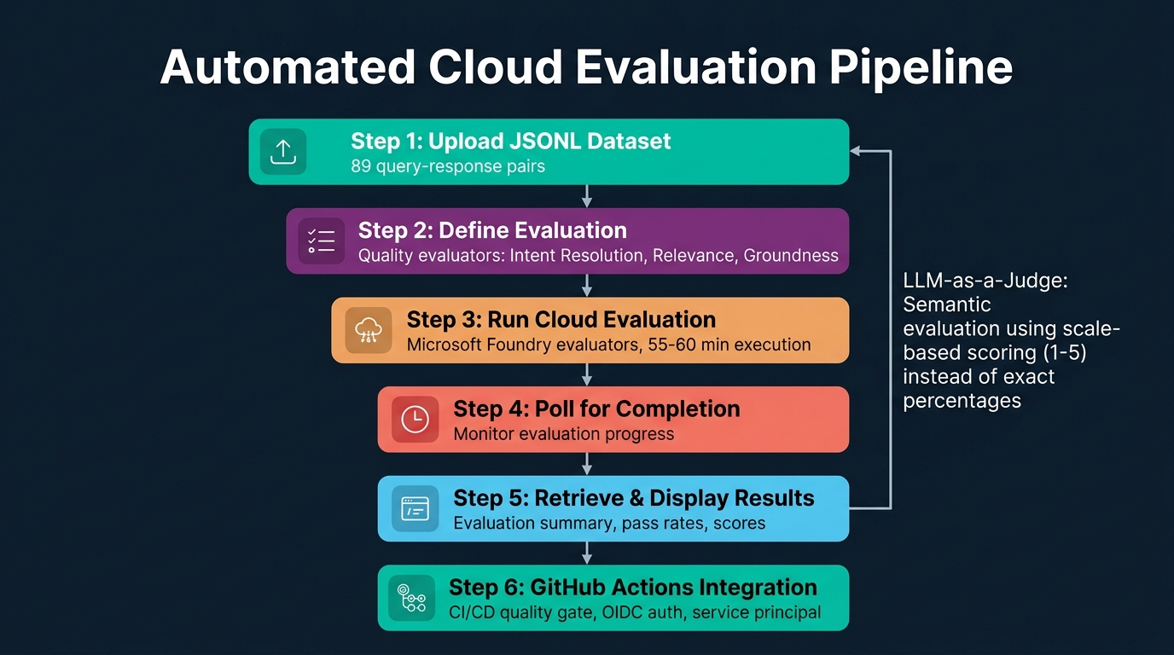
Figure 4. Automated Cloud Evaluation Pipeline: Six-step process from JSONL dataset upload through evaluation definition and cloud execution to GitHub Actions integration as a CI/CD quality gate. LLM-as-a-Judge semantic evaluation uses scale-based scoring (1–5). Generated infographic — AI-300 GenAI Ops lecture series.
- Cloud evaluation replaces the manual, synthetic scoring approach used in Lab 3 with automated, LLM-powered assessment that can process large datasets (89 entries in this lab) without human intervention — a prerequisite for production-scale quality assurance.
- The evaluation dataset is stored in JSONL (JSON Lines) format, with each line containing a query-response pair representing one test case — the query is the user input and the response is the agent's actual output to be evaluated.
- Three quality evaluators are used by default in Microsoft Foundry: Intent Resolution (does the response address the user's stated need?), Relevance (is the content topically appropriate?), and Groundness (are the stated facts accurately supported by the model's knowledge?).
- The evaluate_agent.py script orchestrates the entire cloud evaluation pipeline: it uploads the JSONL dataset to the Foundry project, defines the evaluation with quality evaluators, initiates the evaluation run, polls for completion, and retrieves the results.
- Dataset uploading uses the Foundry project client to register the JSONL file as a named dataset with a version number, enabling multiple evaluation runs against different dataset versions — supporting regression testing as datasets evolve.
- Evaluation definition uses the DataConfigCustom function from the Azure AI types library, specifying a custom schema with three required properties: query, response, and ground_truth — defining the data contract between the dataset and the evaluators.
- Each evaluator (IntentResolution, Relevance, Groundness) is an Azure-built-in quality evaluator that uses a large language model to semantically assess the agent's response against the specified criterion, producing a numerical score on a defined scale.
- The evaluation run is initiated asynchronously: the client.evals.runs.create() method starts the evaluation and returns a run ID, after which the script must poll for completion using a loop that checks the run status periodically.
- Cloud evaluation execution time depends on model capacity, quota allocation, and regional demand — in the instructor's experience, evaluating 89 entries took approximately 3,300 seconds (55 minutes), and the official documentation estimates 15–60 minutes.
- The polling mechanism periodically calls client.evals.retrieve() with the run ID to check the status field, transitioning through states from "running" to "completed" — a pattern common to all asynchronous Azure operations.
- Results are displayed as an evaluation summary including the evaluation ID, run ID, total items processed (89), error items (0), scored items (89), and aggregate scores — providing a quick overview of evaluation quality before detailed analysis.
- Evaluation results can also be viewed in the Microsoft Foundry portal under the project's Evaluations section, which provides a graphical dashboard with per-item scores, score distributions, and detailed per-metric breakdowns.
- The LLM-as-a-judge evaluation approach is inherently probabilistic — running the same evaluation multiple times may produce slightly different scores because the evaluating LLM generates different assessments each time, unlike deterministic rule-based metrics.
- To account for probabilistic variability, LLM-based evaluations use scale-based scoring (1–5) rather than exact percentage values — accepting that a score of 4.2 and 4.3 are functionally equivalent, while a drop from 4 to 2 signals a genuine quality regression.
- Deterministic evaluation methods (BLEU, ROUGE, exact match) are appropriate for short, structured responses where the expected output is clearly defined, while LLM-as-a-judge is preferred for long-form, semantically complex responses that cannot be assessed through string matching.
- The choice between deterministic and probabilistic evaluation depends on the response type: one-sentence Q&A with known answers favours rule-based metrics, while multi-paragraph advisory responses with acceptable variation require semantic evaluation.
- GitHub Actions integration enables the evaluation pipeline to run automatically whenever a prompt change or model update is proposed via a pull request, using OIDC authentication and service principals for secure, credential-free Azure access.
- The quality gate pattern blocks deployment of agent changes that fail to meet minimum evaluation thresholds — preventing regressions in production by enforcing automated quality checks before any change reaches the live environment.
- Evaluation results are stored locally in evaluation_results.txt and committed to the Git repository alongside the code and prompt changes that produced them — creating a permanent, traceable record of quality metrics for every deployment.
- The automated evaluation workflow transforms agent quality assurance from a manual, subjective, and unscalable process into an automated, consistent, and continuous practice that can be integrated into standard CI/CD pipelines — a fundamental capability for enterprise GenAI Ops.

Microsoft Foundry Evaluation Metrics Summary
Evaluation Metric | Evaluation Type | Scoring Model | Target Range / Scale | Operational Objective
Intent Resolution | Semantic Quality (Cloud) | LLM-as-a-Judge | Scale 1–5 (Range-based) | Verify response addresses user's primary inquiry/goal
Relevance | Semantic Quality (Cloud) | LLM-as-a-Judge | Scale 1–5 (Range-based) | Ensure content is topically focused without divergence
Groundness | Factual Accuracy (Cloud) | LLM-as-a-Judge | Scale 1–5 (Range-based) | Detect hallucinations; confirm context/source support
Evaluation Execution | Asynchronous Cloud Run | Foundry Service Polling | 89 Entries (~55 mins) | Automated quality gate before CI/CD deployment

📌 TEACHER'S NOTE
"In terms of traditional ML, we specifically concentrate upon accuracy being a percentage value. But in terms of LLM, we cannot do that — every time the value changes. That is why we maintain a scale. Give it a range, and if it falls within that range, it is acceptable."
— Kiran Dambal

KEY TERMS
Cloud Evaluator — A Microsoft Foundry service that uses a large language model to automatically assess AI agent responses against defined quality criteria (intent resolution, relevance, groundness), producing numerical scores at scale without human intervention.
Intent Resolution — An evaluation metric that measures whether the agent's response adequately addresses the user's stated need or question — assessing functional completeness rather than factual accuracy.
Groundness — An evaluation metric that assesses whether the facts, claims, and recommendations in an agent's response are accurately supported by the model's knowledge base and the provided context, rather than being fabricated (hallucinated).
LLM-as-a-Judge — An evaluation paradigm where a large language model is used to semantically assess another model's outputs, providing human-like quality judgements at machine scale — particularly useful for long-form, complex responses that resist deterministic scoring.
Quality Gate — A CI/CD checkpoint that automatically blocks deployment of code or configuration changes that fail to meet minimum quality thresholds, preventing regressions from reaching the production environment.

Topic 5: Monitoring, Tracing & Fine-Tuning Lifecycle (Lab 5)
Deploying a generative AI agent is not the end of the MLOps lifecycle but the beginning of a continuous monitoring and improvement loop. Lab 5 introduced the monitoring, tracing, and fine-tuning capabilities that close the GenAI Ops cycle, using Application Insights for telemetry collection, Log Analytics for query-based investigation, and the Microsoft Foundry portal for observing evaluation trends over time. This topic connects the deployment and evaluation phases covered in earlier labs to the ongoing operational practices required for maintaining production AI quality. Without monitoring, degradation in agent performance — caused by data drift, model staleness, or infrastructure issues — goes undetected until users report failures, making proactive observability a critical operational requirement.
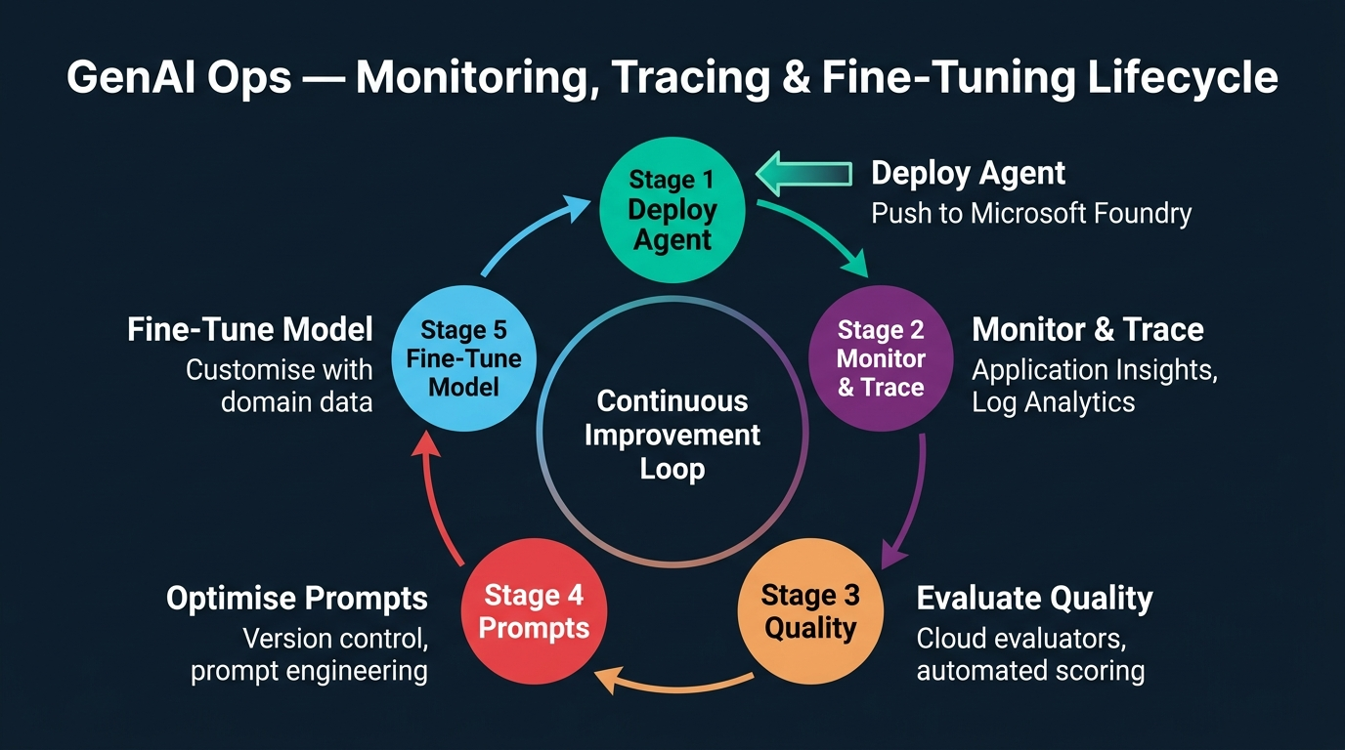
Figure 5. GenAI Ops — Monitoring, Tracing & Fine-Tuning Lifecycle: A continuous improvement cycle showing five stages from agent deployment through monitoring, evaluation, prompt optimisation, and fine-tuning. Generated infographic — AI-300 GenAI Ops lecture series.
- The GenAI Ops lifecycle is a continuous five-stage cycle: Deploy Agent → Monitor & Trace → Evaluate Quality → Optimise Prompts → Fine-Tune Model → (repeat) — with each stage feeding information into the next for iterative improvement.
- Application Insights is provisioned during AZD Up as part of the infrastructure deployment, automatically collecting telemetry data including request latency, token consumption, error rates, and user interaction patterns from the deployed agent.
- Log Analytics Workspace receives structured log data from the agent, Foundry project, and Application Insights, enabling KQL (Kusto Query Language) queries for detailed investigation of specific interactions, error patterns, or performance anomalies.
- The monitoring stack was deployed alongside the Foundry resources in Lab 1, but its value becomes apparent only in Lab 5 where accumulated telemetry data enables retrospective analysis of agent behaviour across all preceding labs.
- Tracing refers to the end-to-end capture of a single agent interaction from user query through model inference to response delivery, including intermediate processing steps, token counts, and latency breakdowns — essential for debugging production issues.
- The check_traces.txt test file (mentioned in the prompt test directory) is specifically designed to trigger trace-generating interactions that validate the monitoring pipeline's ability to capture and record agent activity.
- The Microsoft Foundry portal provides a visual evaluation dashboard that displays historical evaluation results, score distributions, and per-metric trends — enabling operators to detect gradual quality drift that might not be visible in individual evaluation runs.
- Evaluation history in the Foundry portal shows the evaluation ID, run status, total items processed, error counts, and aggregate scores for each evaluation run — creating a time-series view of agent quality that supports trend analysis.
- Fine-tuning is the process of customising a base language model with domain-specific training data, producing a specialised model variant that generates more accurate, relevant, and consistent responses for the target use case.
- Fine-tuning differs from prompt engineering in that it modifies the model's internal weights rather than just its instructions — producing more fundamental behavioural changes that persist across all prompts, at the cost of requiring training data and compute resources.
- The decision to fine-tune should be based on evidence from the monitoring and evaluation pipeline: if prompt optimisation has reached diminishing returns and evaluation scores plateau below acceptable thresholds, fine-tuning is the next lever.
- The continuous improvement loop ensures that no single optimisation action is treated as final — every deployment is followed by monitoring, every anomaly triggers investigation, and every investigation may lead to prompt refinement or model update.
- Production monitoring should track both technical metrics (latency, token consumption, error rates) and quality metrics (evaluation scores, user satisfaction) — because an agent can be technically healthy but producing low-quality responses.
- Alert configurations in Application Insights can be set to trigger notifications when key metrics exceed defined thresholds — for example, if average response latency exceeds 5 seconds or if the error rate exceeds 1% over a 15-minute window.
- The instructor emphasised that the labs demonstrated the complete GenAI Ops pipeline from infrastructure setup through versioning, optimisation, automated evaluation, to monitoring — representing the full lifecycle that a production AI operations team must manage.
- The five labs collectively covered the Day 4 course schedule: automating AI evaluations with Microsoft Foundry and GitHub Actions, monitoring and tracing generative AI agents, and optimising AI agents with fine-tuning.
- The distinction between development-time activities (prompt versioning, optimisation experiments) and runtime activities (monitoring, tracing, alerting) is critical for organisational role separation: MLOps engineers manage runtime, while AI engineers manage development.
- The GenAI Ops lifecycle integrates with broader MLOps practices including model registry management, A/B testing, canary deployments, and blue-green deployments — which were covered in earlier days of the AI-300 course.
- The session was conducted as a demo-based lab due to Azure student subscription limitations, with the instructor providing pre-executed results for long-running steps (e.g., the 55-minute evaluation) and sharing detailed step-by-step documents via WhatsApp.
- The complete Day 4 workflow — from infrastructure provisioning through agent versioning, prompt optimisation, automated evaluation, and monitoring — represents a production-ready GenAI Ops reference architecture that can be adapted for any enterprise generative AI application.

GenAI Ops Observability & Monitoring Matrix
Monitoring Layer | Azure Service / Technology | Telemetry Collected | Inspection Interface | Operational Action
Application Telemetry | Application Insights | Request rates, token usage, latency, failure rates | App Insights Dashboard & Alerts | Proactive alerting on latency spikes or error thresholds
Structured Logging | Log Analytics Workspace | Full transaction logs, error stack traces, execution spans | Azure Monitor & KQL Queries | Deep investigative querying into anomaly patterns
End-to-End Tracing | OpenTelemetry / Jaeger | Multi-span breakdown per agent call, tool invocations | Span visualizer (as demonstrated) | Identify latency bottlenecks across orchestrator and tools
Model Tuning | Azure AI Fine-Tuning | Domain dataset iterations, loss curves, updated weights | Foundry Fine-Tuning Studio | Address quality plateaus when prompt engineering hits limits

📌 TEACHER'S NOTE
"So in the lab one we built our infrastructure, agent, and deployed a model. In lab two, we tested it with three different variants of a prompt. In lab three, we optimised it with the optimised prompt as well as a cheaper model. This is the complete flow — this is how GenAI Ops works in production."
— Kiran Dambal

KEY TERMS
Application Insights — An Azure monitoring service that automatically collects telemetry data (request rates, latency, errors, token consumption) from deployed AI agents and applications, providing dashboards, alerting, and diagnostic tools for production observability.
Log Analytics Workspace — An Azure service that stores and enables KQL (Kusto Query Language) queries against structured log data from Azure resources, enabling detailed investigation of agent interactions, error patterns, and performance anomalies.
Fine-Tuning — The process of further training a pre-trained language model on domain-specific data to improve its performance on targeted tasks, modifying internal model weights rather than just system instructions.
Continuous Improvement Loop — An operational lifecycle pattern where deployed agents are continuously monitored, evaluated, optimised, and redeployed in iterative cycles — ensuring that production quality improves over time rather than degrading.

Student Activity: Interactive Q&A Discussion
Throughout the session, several students engaged in substantive Q&A exchanges with the instructor that produced valuable clarifications and additional learning points. These interactions, particularly from Santanu Jena, Ganesh Giri, and Abhinav Anand, addressed fundamental concepts including infrastructure deployment mechanics, agent versioning strategies, evaluation methodology, and the distinction between deterministic and probabilistic evaluation. The table below captures the key exchanges and their educational significance.
Student | Question/Topic | Instructor's Response | Key Learning Point
Santanu Jena | How does AZD Env Get Values retrieve credentials? | During AZD Up, deployment outputs (subscription ID, tenant ID, endpoints) are stored in the terminal's cache memory. AZD Env Get Values reads from this cache and writes to the .env file. | Infrastructure deployment outputs are cached in the terminal session and must be explicitly extracted to persistent configuration files.
Ganesh Giri | Is AZD Up similar to Docker Compose? | Exactly, it is similar to Docker Compose — we're just doing it on the Azure end. It reads config.yaml and builds everything. | AZD Up is the Azure-native equivalent of Docker Compose for infrastructure orchestration.
Ganesh Giri | Can we use ARM or Terraform interchangeably? | Yes, ARM is Azure-specific templating, Terraform is global and cloud-agnostic. You can also use CLI shell scripting. | Three IaC options exist: ARM/Bicep (Azure-native), Terraform (cloud-agnostic), and Azure CLI (scripting-based).
Santanu Jena | Can we use the same agent for different scenarios with different system prompts? | We cannot do that directly, but we can maintain versions. One agent with the first system prompt, the second version with the second system prompt. | Agent versioning enables multiple behaviour profiles under a single agent identity through version-specific system prompts.
Santanu Jena | What was the UTF-16 vs UTF-8 issue? | VS Code defaults to UTF-16 for .env files, which prevents proper loading of environment credentials. It must be changed to UTF-8. | File encoding mismatches can cause silent authentication failures in Azure SDK scripts.
Ganesh Giri | Is the evaluation LLM-based or deterministic? | Here we are considering LLM itself as a judge. It is semantic-based evaluation, not deterministic. | Microsoft Foundry Cloud evaluators use LLM-as-a-judge (probabilistic) rather than rule-based (deterministic) scoring.
Ganesh Giri | How do we handle probabilistic evaluation variability? | We don't depend on exact values like 98%. We maintain a scale — on 1 to 5, what do you rate? That's why we give a range, and if it falls within the range, it is acceptable. | Probabilistic LLM evaluation uses scale-based scoring with acceptable ranges rather than exact percentage thresholds.
Abhinav Anand | Does load balancing apply to agent operations? | No, load balancing is infrastructure-level (AZ-104). It is related to Azure infrastructure, not agent-level operations. | Agent scaling and infrastructure scaling are distinct concerns governed by different Azure services and certifications.

Key Lessons from Student Activity
- Infrastructure credential management requires explicit extraction from deployment caches to persistent .env files, with careful attention to file encoding (UTF-8, not UTF-16).
- Agent versioning is the correct mechanism for supporting multiple behaviour profiles under a single agent identity — each version maintains its own system prompt while sharing the agent name.
- Evaluation methodology selection (deterministic vs probabilistic) depends on response complexity: short, structured answers favour rule-based metrics, while complex, open-ended responses require LLM-as-a-judge.
- Probabilistic evaluation inherently produces variable scores across runs, which is addressed by using scale-based scoring with acceptable ranges rather than exact thresholds.
- The distinction between infrastructure-level concerns (load balancing, scaling) and application-level concerns (agent versioning, prompt optimisation) maps to different Azure certifications and operational roles.

Glossary of Key Terms
ARM Template — Azure Resource Manager template — a JSON-based Infrastructure-as-Code format for defining Azure resources declaratively; Bicep is the cleaner syntax alternative that compiles to ARM.
AZ Login — The Azure CLI authentication command that establishes an authenticated session with an Azure subscription, enabling subsequent CLI commands to operate on Azure resources.
AZD Auth Login — The Azure Developer CLI authentication command, separate from AZ Login, used specifically for AZD toolchain operations including infrastructure deployment via AZD Up.
AZD Up — An Azure Developer CLI command that provisions, configures, and deploys all Azure resources defined in a project's config.yaml and Bicep templates in a single command.
Agent (AI Agent) — A software entity built on a large language model that receives user queries, processes them according to system instructions, and generates contextually appropriate responses — functioning as an autonomous conversational interface.
Application Insights — An Azure monitoring service that collects and analyses telemetry data from deployed applications, providing dashboards, alerting, and diagnostics for production observability of AI agents.
Batch Testing — Submitting multiple pre-defined test prompts to an AI agent in sequence, recording all responses with metadata for systematic performance comparison.
Bicep — An Azure-native Infrastructure-as-Code language offering cleaner syntax than ARM JSON templates; compiled to ARM before deployment.
Cloud Evaluator — A Microsoft Foundry service using LLM-as-a-judge to automatically score AI agent responses against quality criteria at scale.
Continuous Improvement Loop — An operational pattern where deployed agents are continuously monitored, evaluated, optimised, and redeployed in iterative cycles.
Cost-Quality Trade-off — The balance between operational cost (model pricing, token consumption) and response quality (accuracy, relevance, depth) in production AI applications.
Experiment Branch — A Git branch isolating experimental configuration changes from the production baseline for safe testing.
Fine-Tuning — Further training a pre-trained model on domain-specific data to improve targeted task performance by modifying internal weights.
GPT 4.1 — A cost-effective large language model used as an alternative to GPT 5.1 in model comparison experiments, offering lower token costs with reduced response depth.
GPT 5.1 — The primary large language model deployed in the GenAI Ops labs, offering high-capability responses with higher token costs.
Git Tag — A named reference in Git commit history marking specific versions (e.g., V1, V2, V3) for identification and rollback.
Groundness — An evaluation metric assessing whether facts in an agent's response are supported by the model's knowledge rather than fabricated.
Intent Resolution — An evaluation metric measuring whether an agent's response addresses the user's stated need.
JSONL — JSON Lines format — a file format where each line is a valid JSON object, used for evaluation datasets with query-response pairs.
LLM-as-a-Judge — An evaluation paradigm using a large language model to semantically assess another model's outputs at machine scale.
Log Analytics Workspace — An Azure service for storing and querying structured log data using KQL (Kusto Query Language).
Microsoft Foundry — Microsoft's unified AI platform for deploying models, creating agents, managing evaluations, and monitoring AI applications.
OIDC Authentication — OpenID Connect — a federated identity protocol used by GitHub Actions to authenticate with Azure without storing secrets.
Prompt Versioning — Maintaining multiple system prompt configurations as version-controlled files, each representing an evolution in agent behaviour.
Quality Gate — A CI/CD checkpoint blocking deployment of changes that fail to meet minimum quality thresholds.
Relevance — An evaluation metric assessing whether agent response content is topically appropriate to the user's query.
Service Principal — An Azure identity used by applications (including GitHub Actions) to authenticate and access Azure resources programmatically.
System Prompt — A predefined instruction loaded into an AI agent before interaction, defining its identity, capabilities, and constraints.
Token Consumption — The total number of language model tokens used during an interaction, directly determining API call cost.
Trail Guide Agent — The demonstration AI agent built throughout the five GenAI Ops labs, providing hiking recommendations.
UTF-8 Encoding — A character encoding standard that must be used for .env files in VS Code to ensure proper loading of Azure credentials; VS Code's default UTF-16 causes authentication failures.

Key Takeaways from This Session
If you remember nothing else from this session, remember these:
- GenAI Ops is not just about deploying an AI agent — it is a complete lifecycle of infrastructure provisioning, prompt versioning, experimentation, automated evaluation, monitoring, and continuous improvement, all managed through version-controlled pipelines.
- AZD Up is the single most important command in the infrastructure setup phase: it reads config.yaml, executes Bicep templates, and provisions all required Azure resources (resource group, Foundry, models, monitoring) in one command — making infrastructure deployment reproducible and auditable.
- System prompts are the primary lever for controlling AI agent behaviour, and they must be managed with the same rigour as source code: versioned in Git, tested against defined scenarios, compared with metrics, and promoted through controlled deployment pipelines.
- The three-stage prompt development framework (Basic V1 → Enhanced V2 → Production-Ready V3) provides a repeatable methodology for evolving agent behaviour from prototype to production quality, applicable to any domain or use case.
- Cost optimisation in generative AI has two independent axes: prompt-level optimisation (reducing token consumption through concise instructions) and model-level optimisation (using less expensive models like GPT 4.1 instead of GPT 5.1) — both must be measured, not assumed.
- Token consumption dropped 67% (from 9,000 to 3,000 tokens) when switching from GPT 5.1 to GPT 4.1, but response quality metrics (relevance, groundness, depth) declined proportionally — confirming that cost reduction always involves a quality trade-off that must be quantified.
- Automated cloud evaluation using LLM-as-a-judge is essential for production GenAI Ops because manual evaluation does not scale, is inconsistent across evaluators, and cannot be integrated into CI/CD pipelines for automated quality gating.
- LLM-based evaluation is probabilistic, not deterministic — running the same evaluation twice may produce different scores. This is addressed by using scale-based scoring (1–5) with acceptable ranges rather than exact percentage thresholds.
- The GitHub Actions integration transforms evaluation from a manual quality check into an automated quality gate: every pull request proposing a prompt or model change automatically triggers evaluation, blocking deployment if quality falls below thresholds.
- Monitoring with Application Insights and Log Analytics is not optional in production — it is the only way to detect gradual quality drift, latency increases, error rate spikes, and other degradation patterns before they are reported by end users.
- File encoding matters: Visual Studio Code's default UTF-16 encoding for .env files silently breaks Azure credential loading, causing authentication failures that are not immediately obvious from error messages — always verify UTF-8 encoding.
- Infrastructure concerns (load balancing, scaling, resource management) and agent concerns (prompt versioning, evaluation, fine-tuning) are distinct operational domains governed by different Azure certifications (AZ-104 vs AI-300) and managed by different teams.
- The five labs collectively represent a production-ready GenAI Ops reference architecture: Infrastructure Setup → Prompt Versioning → Optimisation Experiments → Automated Evaluation → Monitoring & Continuous Improvement.

Suggested References
The following resources were mentioned or implied during the session. Additional references are suggested for deeper study.
Microsoft Learn — mslearn-genaiops Template Repository.
- Relevance: GitHub template used throughout all five labs; contains the complete project structure including Bicep templates, agent scripts, test scenarios, and evaluation code.
Microsoft Azure AI Foundry Documentation.
- Relevance: Official documentation for the Microsoft Foundry platform covering project setup, agent deployment, evaluation, and monitoring.
Azure Developer CLI (AZD) Documentation.
- Relevance: Reference for AZD Up, AZD Auth Login, AZD Env Get Values, and other Azure Developer CLI commands used in Lab 1.
Azure Bicep Language Documentation.
- Relevance: Syntax reference and best practices for writing Bicep Infrastructure-as-Code templates that compile to ARM.
OpenAI API Reference — Chat Completions & Agents.
- Relevance: API documentation for the OpenAI-compatible SDK used to create, version, and interact with agents in Microsoft Foundry.
GitHub Actions Documentation — OIDC Authentication with Azure.
- Relevance: Guide for configuring federated credentials between GitHub Actions and Azure using OpenID Connect and service principals.

Closing Summary
This session was fundamentally about operationalising generative AI — transforming an AI model from a standalone capability into a production system with the same engineering discipline applied to any enterprise software. The five labs progressively built a complete GenAI Ops pipeline, starting from infrastructure provisioning (Lab 1), through systematic prompt versioning (Lab 2), structured cost-quality optimisation (Lab 3), automated cloud evaluation (Lab 4), and closing with monitoring and continuous improvement (Lab 5).
The key analytical framework introduced was the experiment-driven optimisation methodology: define a baseline, create isolated experiment branches, modify one variable at a time (prompt or model), run batch tests, compare metrics quantitatively, and promote the winning configuration to production. This framework applies not only to prompt engineering but to any dimension of AI operations where multiple configurations compete for deployment — including model selection, hyperparameter tuning, data augmentation strategies, and retrieval pipeline designs.
In real-world practice, the patterns demonstrated in this session are deployed by AI operations teams managing hundreds of agents across enterprises. The GitHub Actions integration ensures that every prompt change is automatically evaluated before deployment. Application Insights and Log Analytics provide continuous visibility into agent health. The version-controlled experimentation framework prevents ad-hoc changes from reaching production. Together, these practices transform generative AI from a prototype-stage technology into an enterprise-grade operational discipline.
As the instructor summarised at the close of the session: the path from a working AI model to a production AI system runs through versioning, testing, evaluation, monitoring, and continuous improvement. Skipping any stage in this pipeline does not save time — it creates technical debt that manifests as untraceable quality regressions, uncontrolled costs, and silent failures that erode user trust. The GenAI Ops lifecycle is the discipline that prevents these failures and ensures that AI applications deliver consistent, measurable, and improving value over time.

HANDOUT ASSEMBLY COMPLETE.

